Patient-level simulation and model comparison for robust incremental cost estimation
  - Online Resource 5: Usage Example
Charité - Universitätsmedizin Berlin
Institute of Public Health
Hans-Aloys Wischmann, Toivo Glatz
Edited: 2026-11-11, Executed: 2026-11-11
This R markdown script demonstrates the practical use of our proposed helper functions to estimate incremental costs between two groups in a realistic dataset.
- glmx_start() estimates starting values to overcomes errors (glm, glm2) or suboptimal fits (glmmTMB).
- get_best_model() returns the model with the lowest RSS (sum of squared response residuals) from all valid models (non-NULL, converged, and valid RSS).
- glmx() fits multiple regression models using four different packages (stats::glm(), glm2::glm2(), mgcv::gam(), glmmTMB::glmmTMB()) and returns the best fitting model.
- glmx_events() fits multiple regression models for the first stage of a two stage model (number of events with non-zero costs) using Gaussian with identity-link and Poisson with identity and log-link, and returns the best fitting model.
- glmx_pcosts() fits multiple regression models for the second stage of a two stage model (positive costs) using Gamma with identity and log-link, and returns the best fitting model.
- marginal_one_stage() predicts marginal cost difference between groups for a single stage model based on a population sample (here, the study sample).
- marginal_two_stage() predicts marginal cost difference between groups for a two stage model based on a population sample (here, the study sample).

Setup and Libraries

Robust Regressions
Infrastructure and utility functions (skip ahead to example usage)

Real-World Dataset
Agency for Healthcare Research and Quality
- Medical Expenditure Panel Survey (MEPS) https://meps.ahrq.gov/mepsweb/
- Variables: IPDIS (number of inpatient hospital discharges), IPFTCH (inpatient hospital charges), INSCOV (insurance status), POVCAT (income category), BORNUSA, AGELAST, SEX, and DATAYEAR
- No weighting is performed
- MEPS codes missing values as negative numbers, and any such records are excluded (>0)
- Only records with (0 costs and 0 stays) or with (positive stays and positive costs) are included
- Costs are shifted by +0.01 USD for Gaussian(log) and Gamma regressions (pcost)
- Costs per event (ecost) are defined as the cost per inpatient discharge (cost / N), and they are used as the outcome of the second stage of the two-stage model
[1] "MEPS - Years: 2022, 2023, 2024, Rows: Total = 60490, Complete = 60272"
study_group | n | prop_zero | mean_cost
control | 39,223 | 91.21 | 65,687.76
intervention | 9,419 | 94.24 | 67,520.45

Placebo Study
We used a “placebo design” with real data: persons were randomly allocated two groups (intervention and control), so that the true cost difference is zero by construction. This follows the logic of placebo analyses (Bertrand et al., 2004; Eggers et al., 2024) and of randomization methods based on repeated random assignment. All regressions are adjusted for age, sex, and calendar year.

Results
Placebo study (MEPS 2022-2024): Metrics in USD, N_SIM=1000
Type | N | Metric | Gaussian (identity) | Gaussian (log) | Gamma (identity) | Gamma (log) | Two-Stage Poisson-Gamma
RCT | 2,000 | Bias | -165.42 [-373.63; 39.46] | -422.35 [-1063.12; 5.49] | -0.71 [-75.15; 75.06] | -87.36 [-285.70; 110.82] | -49.17 [-190.90; 99.58]
RCT | 2,000 | MAE | 1880.78 [1744.76; 2024.06] | 2743.07 [2393.74; 3339.69] | 477.80 [417.45; 539.70] | 1863.57 [1745.54; 1990.18] | 1419.93 [1331.08; 1511.37]
RCT | 2,000 | RMSE | 2549.15 [2349.02; 2747.82] | 6492.59 [3313.64; 11370.07] | 899.90 [814.89; 980.03] | 2399.34 [2245.52; 2556.40] | 1791.09 [1681.77; 1896.46]
Registry | 48,642 | Bias | 43.81 [-0.31; 89.07] | 57.04 [-10.87; 125.91] | 17.55 [-15.68; 50.40] | 29.87 [-8.34; 68.10] | 22.32 [-7.39; 53.21]
Registry | 48,642 | MAE | 438.93 [413.06; 465.54] | 694.20 [654.94; 734.56] | 327.42 [307.65; 347.27] | 380.79 [358.45; 404.45] | 294.41 [277.39; 312.52]
Registry | 48,642 | RMSE | 543.46 [514.17; 571.96] | 849.45 [806.71; 892.52] | 408.05 [387.38; 428.07] | 474.63 [447.89; 501.10] | 365.40 [344.94; 385.90]

Figure
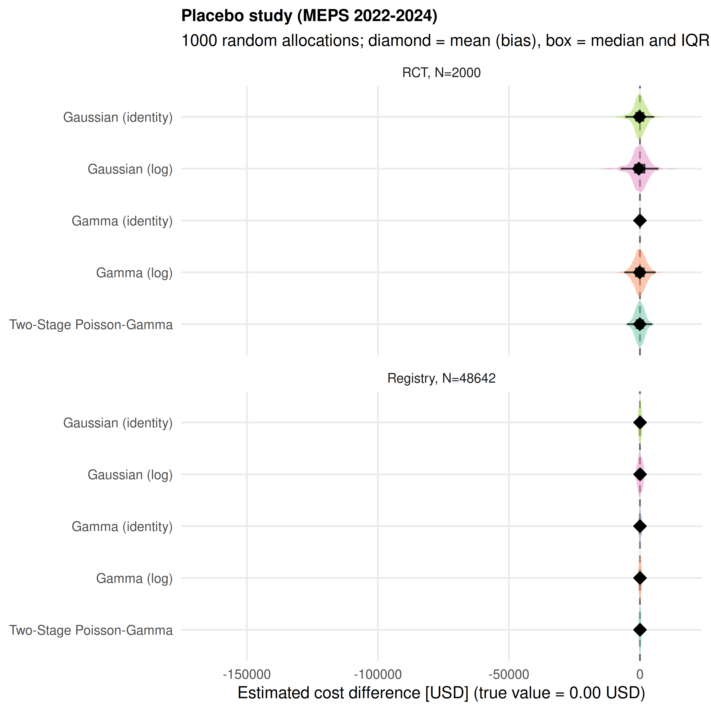
Warning: Removed 239 rows containing non-finite outside the scale range
(`stat_ydensity()`).
Warning: Removed 239 rows containing non-finite outside the scale range
(`stat_boxplot()`).
Warning: Removed 239 rows containing non-finite outside the scale range
(`stat_summary()`).
Warning: Removed 239 rows containing non-finite outside the scale range
(`stat_ydensity()`).
Warning: Removed 239 rows containing non-finite outside the scale range
(`stat_boxplot()`).
Warning: Removed 239 rows containing non-finite outside the scale range
(`stat_summary()`).


