Introducing the Pattern Book 7
Welcome Jugglers and Friends 7
About the Project 7
The Madison Area Jugglers 9
Version History 9
Updates in Version 4.0 10
The Editors 10
Preliminaries 11
How To Read Patterns 11
Counts/Cycles/Who-Passes-to-Whom 11
Pattern Metrics 12
Pattern Tables 15
Messing with the Base Beat 19
Site Swaps, Causal Diagrams, and Manipulators: The Undiscovered Country 20
Glossary: Secret Juggling Code Words and Phrases 20
Random Tips on Passing Patterns 24
Mastering the Craft 25
Passing Pattern Philosophy 26
Internet Passing Resources 27
Three Person Patterns 28
Stationary Three Person Patterns 29
Basic Feed 29
Ryan's Feed 29
Rotating Feed (i.e. Feast for 3) 30
Basic Triangle 30
Pulsar 31
Puzzle Feeder 31
Puzzle Feast 32
Mel in the Middle 32
Peter’s Backcrosses 33
Siteswap Feeds 33
Extra Clubs Stationary Three Person Patterns 34
4 Count Popcorn Feed 34
6 Count Popcorn Feed 34
5 Count Popcorn Feed (one variation) 35
Why Not + 5 count 35
Extra clubs chocolate bar feed 35
Extra Club Rotating Feed (for 3 jugglers) 36
10 Club 3 Count Triangle 36
10 Club 4-Count Triangle 37
11 Club 2 of 3 Count Triangle 37
12 Club 1-Count Triangle 38
10 Club Triangle with Triple-Single-Single 38
6-Count Popcorn Triangle 38
5-Count Popcorn Triangle 39
Swiftly Tilting Popcorn 40
Line Variations 40
An Extra Club Line 41
Up-Up-Over 41
Moving Three Person Patterns 42
Change-sides feeds 42
Change Sides Variant (Ryan’s feed) 42
Turbo Variant 42
Turbo 43
Bruno's nightmare 44
2pi/3 44
Mel’s variations of 2pi/3 varies when you cross…lengthens cycle 44
Laxative 45
Extra Club Moving Three Person Patterns 45
10-Club Turbo 46
Another 10-Club Turbo 47
Luke’s GDP 48
Laura’s Weave 49
Graham's 3 stuff 50
Change Sides Double-3 Count Feed Plus 50
Change Sides RRLRLRLLRLRL 50
Safe Beast of Arg 51
Four Person Patterns 52
Stationary Four Person Patterns (no extra clubs) 52
Feeds 53
Windshield Wiper Feed 53
Typewriter Feed 53
Boxes 53
Standard Asynchronous Box 54
Standard Synchronous Box 55
Less Boxy Boxes 55
Rotating feed (for 4 ) 55
Feast (for 4) 56
Picnic 56
Bermuda Quadrangle 56
Maya 57
Interlocking Triangles 57
Rush and Rest 58
Gustav **LUKE, PLEASE CHECK; I THINK D/B need to switch?** 59
Two on Two Double Three Count 60
Y (aka Oogle) 60
Luke’s Oogle 61
Y2K 62
Canoe 63
Anklet 63
Extra Club Four Person Stationary Pattern 63
Extra Club Boxes 64
Extra Club Less Boxy Boxes! 65
Spider Web 65
Extra Club Feeds 66
Typewriter Extra Club Feed 66
Ultimate Feed Plus 66
Ultimate Feed Plus Plus 66
Popcorn Feed 67
Gorilla (for 4) 68
Extra club rotating feed (4) 69
Extra club Y’s (Slingshots) 69
Slingshot 69
Slingshot Minus 70
Slingshot Plus 70
Slingshot Plus Plus 71
Extra Club Lines 71
Death from Above 71
Locked Lines 72
Popcorn Lines 72
Popcorn Dropback Lines 73
Other oddities 74
Here’s a 4 person variation of one of the 3-person classics by Martin Frost! 74
Martin's Madness/Mildness 74
Moving Four Person Patterns 75
Switch Sides Feeds 76
Eggbeater, no handle 77
Unicycle 78
Benzene Ring (for 4) 79
Chocolate Stir 79
2pi/3 with a Post 80
Oogle Boogie 81
Shooting Star 82
Weave 83
Close cousins of the weave 85
Dresser Drawer Weave 85
Inside Out Weave 86
That’s a Good One 87
That’s a Really Good One 88
Gandini Weave (basic) 89
6-count Mondo Weave 90
Three Leaf Clovers 90
Three Leaf Clover (Standard and Run-Over) 91
Zero in Zero Out (ZIZO) Clover 94
Less Popular Clovers 95
Mike’s Original Clover 95
Dreamy Clover (aka Seven) 95
Peter’s Clover 96
Steve’s Clovers 97
*YET ANOTHER WEIRD CLOVER* 97
El Niño 98
El Turbo 99
Tomahawk 100
El Turmeric Weave 100
Extra-Club Moving 4-Person 101
Extra Club Switch Sides Feed 101
Extra Club Weaves 101
Standard Extra-Club Weave 102
3-count/9-count Extra Club Weave 102
Popcorn Weave 102
Unicycle Plus 103
14 Club Oogle Boogie 104
Extra-Club Three Leaf Clover (slow) 105
Hyper Clover 106
2(pi)/3 with a Post + 1 107
El Nino Plus (slow) 107
El Nino Plus (fast) 108
Five Person Patterns 108
Stationary 5-Person Patterns 110
Apollos 110
Original Apollo 110
Cockeyed Apollo 110
Patterns in a circle 111
Star 111
Feast (for 5) 112
Picnic 112
Feast-Star 112
Selfless Star 113
Stationary Isla Vista Weaves 113
2454 Isla Vista Weave 114
Chocolate Feeds 115
Chocolate bar 3-count feed: aka Chocolate Box 115
Double chocolate double 3-count feed 115
Semi-Sweet Chocolate 3-count feed (aka The New One) 115
Yet another variation 116
Extra Club Stationary 5 Person Patterns 116
Extra club 5-count star 117
Two extra club 5/2-count star [also PSPSS star] 117
Extra club 5-count star with crispy extra passes 118
Extra club 4-count star 118
Apollo Plus 119
2 v 3 with extra clubs 120
Overlapping 10-club feeds 120
Up-Up-Over-5 121
Extra Clubs Feast-Like 121
Extra Club Rotating Feed 122
Extra Clubs Feast, I 123
Extra Clubs Feast, II 124
Extra Clubs Feast, III 125
Extra-club chocolate feed 125
Extra challenging extra-club stars 125
Triply Star, I 126
Triply Star, II 127
20 Club Star 127
Moving 5 Person Patterns 127
Weaves 127
Dr. Inside Dr. Outside Weave 128
Apollo Weave 128
Twister Weave 130
Double-Time Twister 130
Mondo Twister 131
Involuted Twister 132
Tree Twister 132
Ivy Pi Weave 133
2-by-4 weave 134
Eggbeaters 134
Eggbeater (original) 135
3-4-5 Eggbeater 135
Eggbeater – handle-in-the-batter 135
Involuted Eggbeater 136
Deathbeater 137
Four Leaf Clover 138
Three Leaf Clover with One Orbiter (the after-feed orbiter) 139
Gauntlet 140
Strange Attractor/Estranged Tractors 141
El Turbo with one post 142
5-person laxative-V1 143
Decagon: 5-person laxative-V2 144
Twirly Star 145
Quincunx 146
Meltic Knot 147
Chocolate Swirl-I 148
Chocolate Swirls (II and III) 149
Isla Vista Weave 150
Eye of Buffon’s Needle 151
Extra Club Moving 5 Person Patterns 152
Eggbeater Plus 153
Apollo Plus Weave 154
Twister Plus 155
Double Time Twister Plus 156
Mango Swirl (aka Mangled Squirrel) 157
Whirling Melvish 158
Cathedral 159
Twister Popcorn 160
Twister Popcorn Weave 161
SEE PART 2 FOR SIX PERSON AND MORE PATTERNS 161

Introducing the Pattern Book

Welcome Jugglers and Friends

Welcome to the Madison Area Jugglers' Pattern Book, a collection of club-passing patterns for intermediate to advanced passers. These patterns are part of our juggling repertoire. Many we learned or adapted from other jugglers; we include them because
it's fun trying to juggle them. But very many of the patterns in this book were born in Madison, Wisconsin, conjured up at Thursday/Sunday juggling sessions or at 47th Annual Madfests, annual events since 1992. The book offers some record of the evolution of club passing in Madison.


All jugglers are welcome to play with, use, distribute, extend, and otherwise enjoy all the club-passing patterns described in Madison Area Jugglers' Pattern Book, Version 4, which is licensed by its creators, the Madison Area Jugglers, under the Creative Commons Attribution 3.0 Unported License . You may access the book online, or check the latest updates at our GitHub repository.

If you have questions, comments or suggestions relating to this book, please contact the Madison Area Jugglers. Where possible we have given credit to the creators of the patterns described here, though for many these origins were unknown to us. If we have erred in our attributions, please let us know.

This collection is a living document. New contributions are welcome for the next version, so please join the team and provide some pattern descriptions. give an easy instruction on how to add

About the Project
Originally we wrote down the patterns just to save time arguing over exactly how we did the pattern last time. (Don't worry...there's still plenty of arguing, even with the book.) We were pleasantly surprised to find other people found our book helpful too! The pattern book can be used as a club passing guide or just a library of the patterns that we originated or find interesting. If you're from Madison, then it's a handbook to what we do twice a week, on Thursdays and Sundays, and if you don't know the patterns already then you probably will. This book is not intended to be an encyclopedia of all possible passing patterns (that would be a big book)! In fact, we don't include patterns just because they are theoretically possible; we include them if we have done them!

The Madison Area Jugglers (MAJ) have been attempting, inventing, and recording juggling patterns for longer than most of us can remember. In 1997, when our memories were already getting strained by the variations, Michael Newton (aka Prof Mike) compiled our first Pattern Catalogue to record the patterns for four or more jugglers. This morphed into the first Pattern Book by him in January 1999, but the hand-written collection (Version 0.1) was in a pretty limiting format. By October of that year, Steve Otteson created the first computerized collection by reformatting and expanding Mike's hand-written notes. Melonhead still carries around a tattered printout of Version 1.0. Steve made a few version updates, for example adding a bunch of extra-club patterns by Peter Kaseman and Luke Emery; the unusual computer format of Steve's version and his departure from Madison slowed down subsequent updates, even though the MAJ continued to create new patterns at a steady rate. The next big contribution was Luke Emery's version (Version 2.0, 2012). Though it was not widely distributed, Luke's version contained all kinds of new additions: more patterns for all numbers of jugglers, more on site-swap, more on specialized extra-club patterns, and tips for creating and doing patterns.

In 2015 Matt Hemke and Evan Driscol created a Github repository for the project, converted Luke's version into a repo, and updated the collection further. Chan Wilson, Jeff Adamus, and Melonhead began tracking the patterns we do at Thursday and Sunday MAJ practices. It's an amazing collection, and for those who remember the code words, like 1-5-1 Foie Graham or 4-5 Twister, it's enough to figure out what we really did. But most of us forget the code words after a while, except for the frequently juggled ones, and this was an impetus for the Version 3.0 update by Prof Mike in 2018. Since then, we've suffered through two years of COVID restrictions and two lost Madfests (only 1 lost if you count spring ‘22). But we kept juggling and discovered some cool new patterns that work well with face masks! Nathan Nard's rejuvenating and inventive contributions helped to launch Version 3.1 in 2023.

All along the editors have had substantial input from the Madison Area Jugglers and friends, and we are indebted to them for helping enhance this collection. Club passing
is a social pastime that needs a group of similarly inclined jugglers. Many of these patterns are inspired by other jugglers and patterns or created in collaboration with other jugglers. We hope that these patterns will help inspire new club passing ideas and help more jugglers all over the world enjoy club passing!

The Madison Area Jugglers

*An intro paragraph or two on the MAJ*

Version History

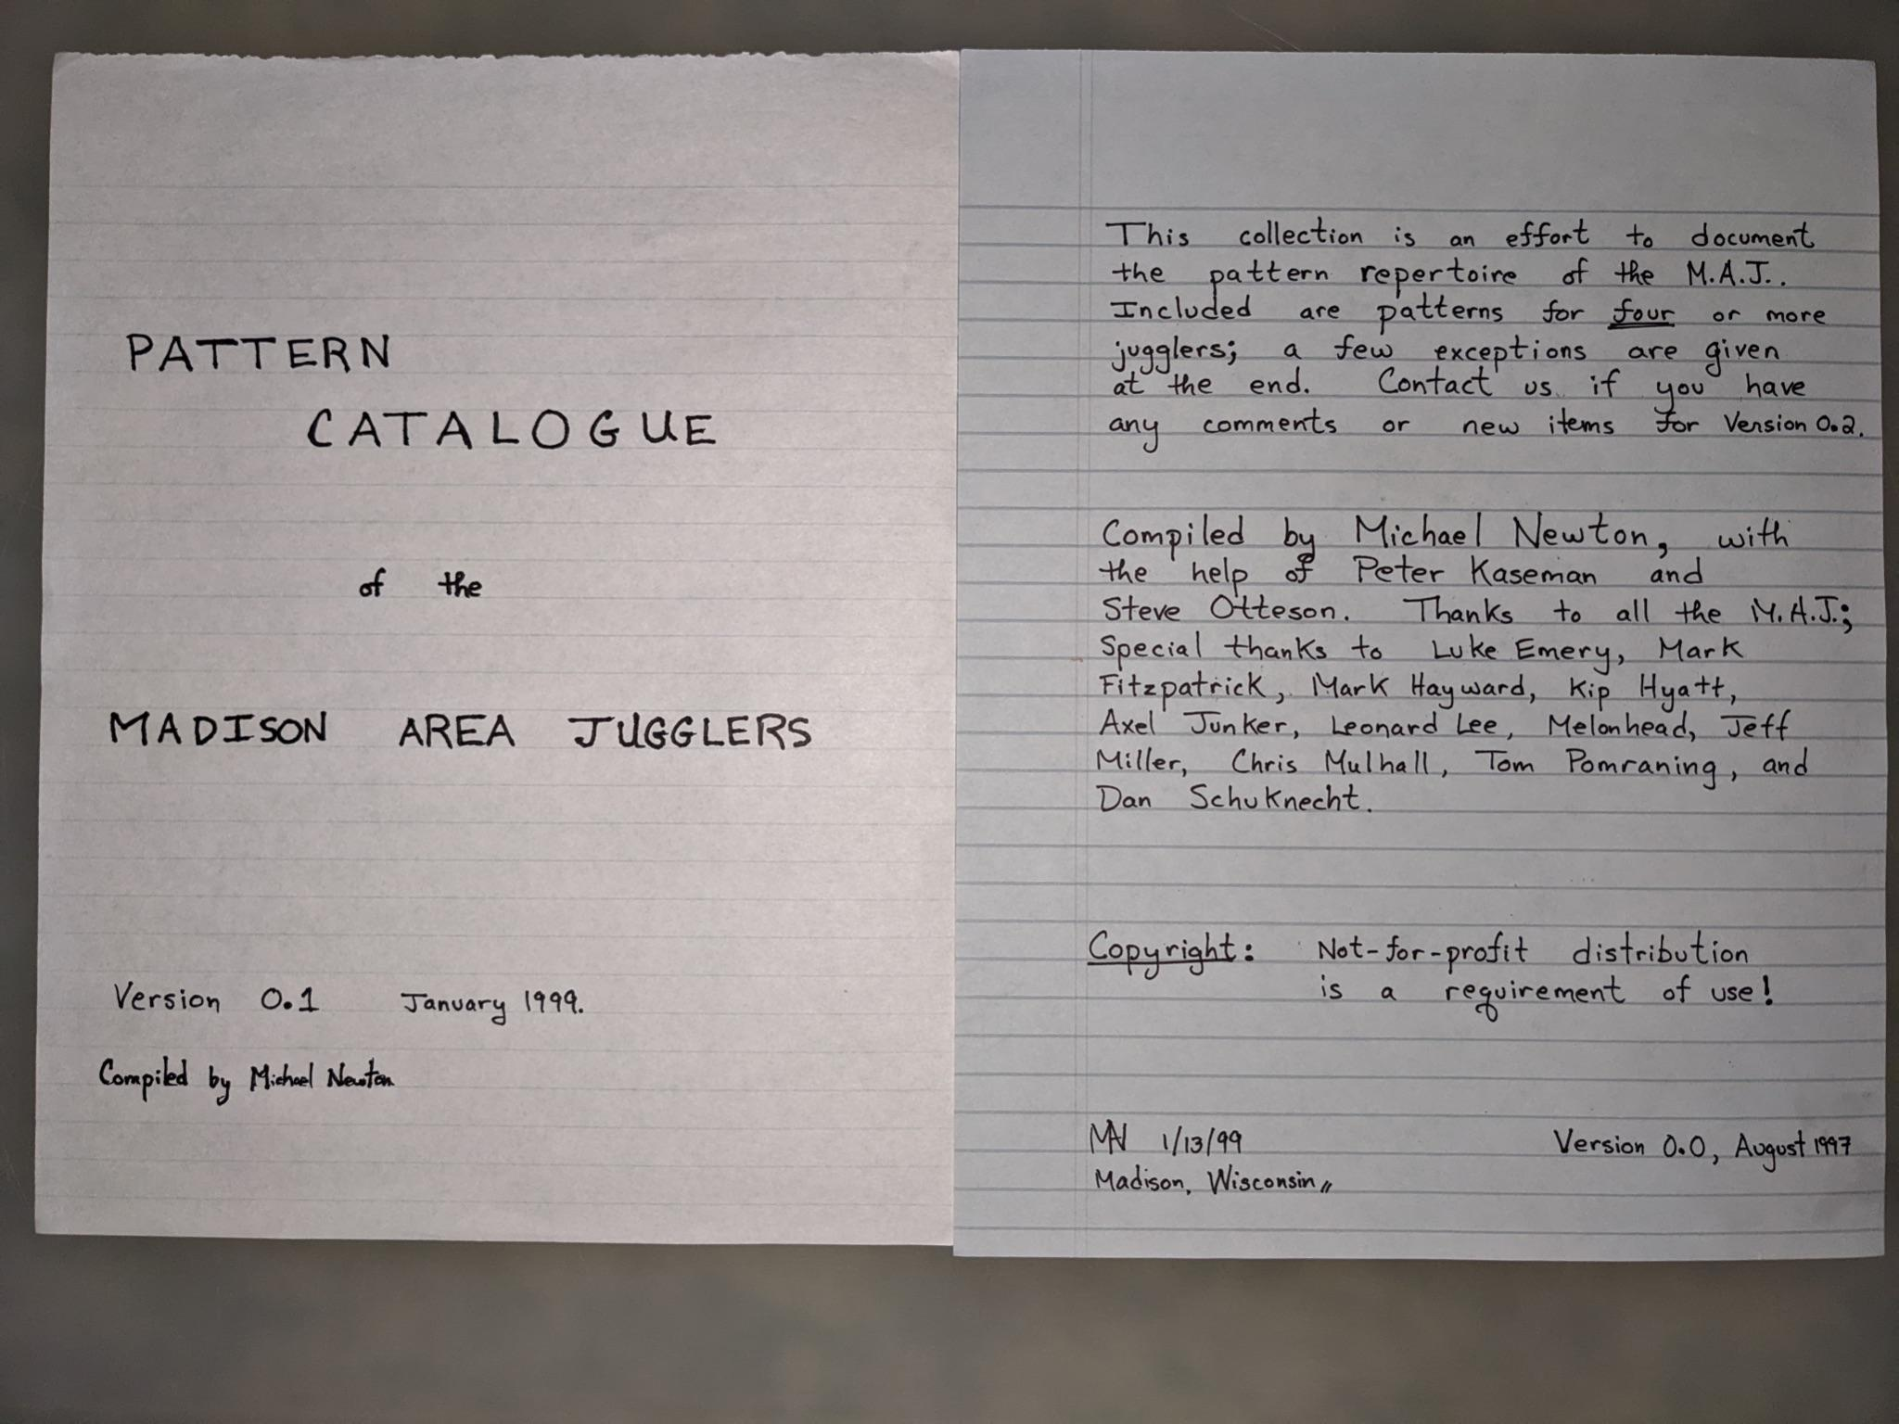

* Madison, Wisconsin, August 1997 Version 0.0
* Madison, Wisconsin, January 1999 Version 0.1
* Madison, Wisconsin, October 1999 Version 1.0
* Madison, Wisconsin, January 2001 Version 1.1
* Madison, Wisconsin, March 2001 Version 1.2
* Madison, Wisconsin, January 2012 Version 2.0
* Madison, Wisconsin, January 2018 Version 3.0
* Madison, Wisconsin, January 2023 Version 3.1

Updates in Version 3.1:

We added a bunch of new patterns (e.g., laxatives, the pollinator, the zigzag, sneaky-snake, that's-a-really-good-one, fully-loaded-blast, Mel's-dream, and more). We added more on big patterns, including on the super-fun 24-person hex-of-clovers. At recent practices we've experimented a lot with colors, in which jugglers each start with a distinct set of clubs, and we see how long it takes to move the colors around. This version has some details on the substructure of a few of our cool patterns.

Thanks to Jeff Adamus for posting YouTube recordings of a bunch of our patterns; we've added links *where* (Thanks to Jeremy, Jessie, and ? others for great camera work!) . *other animations?*

Like all earlier versions, the current version contains mistakes and unfortunate omissions, which we have yet to discover and for which the Editors take responsibility. We hope that future versions will correct these shortcomings.

Updates in Version 4.0
**google doc version..prep for real book…new patterns …more uniform pics/tabular descriptions; pattern metrics** [lead by MAN]; still missing manipulator patterns…waiting for the right expertise to join the editors!

The Editors
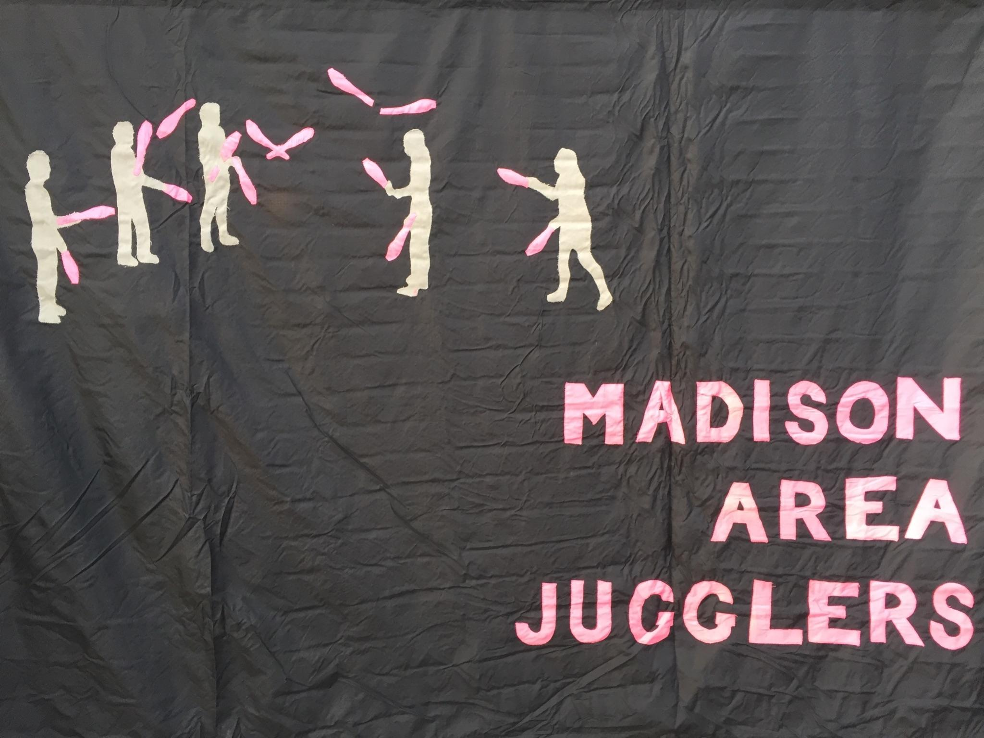
Michael Newton (aka Prof Mike), Luke Emery, and the Madison Area Jugglers, especially (in alphabetical order): Jeff Adamus, Nick Aikens, Josh Casey, Steve Clipson, Evan Driscol, Mark Hayward, Matt Hemke, Peter Kaseman, Melonhead, Nathan Nard, Graham Paasch, Steve Otteson, and Chan Wilson. You can be an editor too by working on the next version!

Preliminaries

How To Read Patterns
There seems to be an indefinite number of ways a single juggler can juggle, so it's not surprising that a juggling pattern, which combines the efforts of multiple jugglers, can also take many many forms. There are many exceptions -- and we cover a lot of them – but to develop our intuition it's convenient to start with standard formulations. Say each juggler is throwing three clubs, alternating hands right-left-right-left etc, and juggling in sync with the others (i.e., all are doing right-left-right-left...). In this standard formulation, passes are single-spin exchanges between jugglers, either right-to-left or left-to-right throws. Even without adding extra clubs or unusual throws (heff's, zips, simuls, etc), there is an incredible variety of fun patterns found by varying where jugglers are and who passes to whom when.

Counts/Cycles/Who-Passes-to-Whom
A basic passing descriptor is the count, which tells the juggler how frequently to make a pass. In simple patterns each juggler's count is constant, but even simple patterns can be very difficult on a fast count. We say you are passing on an m/n-count if you make n passes in a cycle of m beats, counting on both hands. For example, 2/1-count means, pass-self, then repeat. When the denominator n is 1 we just say m-count, as in the familiar 1-count, 2-count, 3-count, and so on. Double-three count is a popular count, which in this notation is 3/2-count. Stating the count does not necessarily imply what hands are doing what, how many clubs are being juggled, or the starting configuration. For example, many jugglers find left-hand 2-count more awkward than right-hand 2-count, probably owing more to the way people learn to pass than anything fundamental. Odd counts (i.e., odd m) are nicely balanced for the hands; then the only issue is the start, which we usually do out of the right.

Even when not everyone is passing at the same time, there is a useful concept of a base count for the whole pattern. It’s a sort of time signature that tells the group how frequently passes may happen somewhere in the pattern. As we advance through the various passing and moving elements, passes happen only on some whole-number multiple of the base count. For instance, the 4-person Windshield Wiper Standard Feed, with 3 feedees, usually proceeds on a right-handed 2-count base, which happens to be the passing count of the feeder. The middle feedee is on 4-count, and the end feedees are on 8-count, and thus pass on every other and every 4th base-count beat, respectively. We do not insist on passes happening on every base-count beat, but only that passes can only happen on base-count beats. In getting patterns to work, we often call out the beat, counting on that base count. It would be superfluous (and annoying!) to call out every count on a 1-count base, for example, if passes only happen on multiples of 4-count.

Mortal jugglers, like us, can only do patterns that repeat. That repeatable unit is called a cycle, and it takes some total number of beats to complete on whatever is the base count of the pattern. Patterns with longer cycles are usually harder to remember and therefore harder to do, but not always. In many patterns each juggler does something relatively simple (i.e., a shorter local cycle) even if the whole pattern takes a long time to complete. Those are cool!

In this edition of the pattern book we introduce two exceptions that prove the rule about pattern cycles. Mark Hayward’s 6-person Kill Screen is the first. Its beautiful design assures that the pattern collapses in a mass collision at precisely 37 beats in! Usually this is accompanied by a great cheer, celebrating successful completion of the pattern. The second exception is the 4-person Unending Clover, which has an infinite cycle length, thanks to its alternation of ever-longer segments of right-hand then left-hand two count (we’ve yet to complete a cycle!).

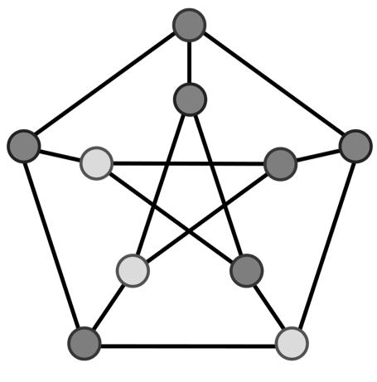
A pattern is not fully described if the rules about who passes to whom (and when and where) are not provided. The essence of the pattern book is to provide reasonably concise descriptions of these rules. We sometimes invoke a mathematician’s perspective and consider a graph (the nodes/edges kind), with nodes for jugglers and edges indicating the presence of any pass during the pattern, but we don’t geek out too much on the graph theory!

Pattern Metrics
Juggling patterns have many defining characteristics; some patterns are more difficult to master; some are more appealing than others depending on your skill level or interests. In this collection we track a few key properties to help us think quantitatively about what distinguishes patterns and also what makes them similar. We aim to record these metrics systematically throughout the Pattern Book as patterns are described, and we collect them together in Chapter ** for a more global take on the whole business.

Number of Jugglers, J: self explanatory. To avoid trivialities, the who-passes-to-whom-graph ought to be connected, otherwise we would want to consider the connected components to be separate patterns; i.e. having a solo juggler in the middle of a pattern doing tricks but not passing to anyone does not count as a member of the pattern, at least by the MAJ rules! That said, we make exceptions when passing lanes overlap, such as in boxes, double weaves, and hex. So much for rules!

Clubs per Juggler, CJ: Total number of clubs divided by total number of jugglers in the pattern (larger is usually harder!) Equals 3 for most basic patterns! (Also a character in Bay Watch; Remember Borat’s refrain, “Be careful CJ!”)

Cycle Length: number of counting beats (in the base count) that occur until a pattern repeats. Patterns with longer cycles tend to be harder, well at least they are harder to remember unless they have short local cycles!

Passes per Beat per Juggler, PBJ: This is the number of passes divided by the number of 1-count beats in a full cycle. It’s a number in (0,1], with larger numbers usually corresponding to more difficult patterns. PBJ is specific to each role in a pattern, and its average over jugglers is a pattern-specific difficulty measurement (also a good sandwich!). (Note, avoiding 0 is related to not counting superfluous non-passing jugglers above!). PBJ is also the proportion of all releases (passes and selves) that are passes to another juggler; so it’s one minus the proportion of all releases that are self throws.

Other Jugglers, OJ: number of passers per passer, averaged over jugglers in the pattern (greater than 0 and less than or equal to the number of jugglers minus 1). It is the average degree in the who-passes-to-whom graph, ignoring edge direction. Also a refreshing drink! Patterns tend to be more enjoyable social events when OJ is relatively high, though a lot of OJ is tough for beginners! Our efforts at “Big Patterns” aim to have a lot of OJ to increase the fun-factor while having a short local cycle to be easy to learn on the spot.

Pass Heights, pH: We take this to be 1 in non-extra-club patterns, and the average spin associated with each passed club (e.g., 2 for doubles, 3 for triples, etc). Mortal patterns tend to be acidic, with pH below 3!

Roles, R: The J jugglers in a pattern take on some number R of different roles. For instance R=1 in a Feast, since everyone does the same sequence over the course one cycle a pattern, even if possibly out of phase or in different positions. In a Standard Weave, there’s a feeder and three weavers, and thus J=4 and R=2. To keep things simple, we don’t use handedness to distinguish roles; a right-handed 2-count is the same in this regard as left-handed 2-count. But jugglers who perform a different count sequence, modulo the pattern cycle, have different roles. E.g., pass-self-self in a cycle 3 pattern is the same role as self-pass-self, but that’s a different role than pass-pass-self. We allow metric changes to distinguish roles, such as the top feeder vs the two corners in a 5-person Apollo. Both roles involve a 4 count feed to two spots, but top-feeder has a higher spin to cover the increased angle. Tracking R is also a surrogate for tracking the variance of the juggler-specific metrics like PBJ, motion, or spin. In two patterns with other metrics being equal, the one with larger R might be a good choice when you have jugglers with different skill levels, since surely some roles will be harder than others. On the other hand, for Big Patterns, we usually want a small R to minimize complexity.

Motion, in passing units, pu (pee-EW!) : A measure of distance traveled during a juggling pattern. When two jugglers meet to pass, the typical (i.e., comfortable) distance between them is one pu, by definition. It’s 6 to 8 feet, or so (in earth’s gravity), possibly more for extra clubs. (We’re not talking about distance passing competitions!) By our calculations, two jugglers standing side-by-side as feedees in a pattern are about ½ a pu apart (between their centers of mass, say!). You cover about 1 pu when you switch sides in the Switch-Sides Feed. We estimate that weavers set up at about $1/\sqrt{2}$ $≃0.7$pu apart (i.e. a bit more than in a stationary feed), in order to have room to move, for example. Different models of motion give different results. For instance, a Standard Weave could be viewed as side-by-side circles, each of diameter $1/\sqrt{2}$ pu, which gives a total perimeter for one cycle equal to $π\sqrt{2}$ $≃$ 4.4 pu. However, the weave may be more shallow than that, like a lemniscate, with perimeter $\sqrt{2}ϖ ≃ 3.7$pu. Splitting the difference to be pragmatic, we consider a weave motion to be about 4 pu, and likewise any two jugglers moving around each other (e.g., like a pair in an Eggbeater) cover a motion of about 2 pu per cycle. These motion metrics are approximate, of course. They are useful when we set very large patterns and need to know what fits in a given space! They might also be good if you are keeping track of steps!
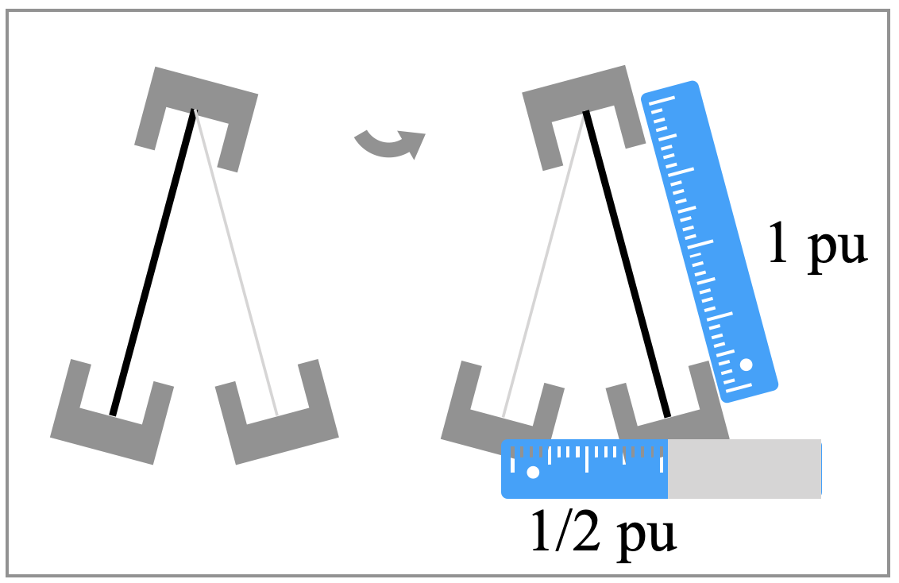
Spin: A measure of how much turning you do to complete a juggling pattern, reported in total angle traversed through the pattern (allowing changes in direction), and measured in radians (because we’ve always liked radians better than degrees)! Initially our model held that stationary patterns or moving patterns lacking directional change have zero spin. However, this is a poor approximation to real patterns whose difficulty is related to the amount of a juggler’s rotation. We recognize that jugglers do some rotation in most patterns; exceptions are like the standard Box or the standard Double Weave, where each juggler passes only to someone directly opposite them. Even a Basic Feed with two feedees (left) entails a small rotation on the part of the feeder (often imperceptible, and done without moving one’s feet) as they swivel back and forth. Considering that feedees set up about ½ pu apart, and that a circle of radius 1 pu has perimeter just over 6 pu, we estimate the feeder rotates about 2$π$/12 radians going from one feedee to another. (Alternatively, the sine of ½ that angle is ¼, according to the set up dimensions, which gives an angle close to $π/6$.) The back and forth to complete a cycle means the feeder’s spin is $π$/3 radians (30$°$). The feedees have 0 spin, so we assign spin to the pattern equal to the average spin of its jugglers. This simple 1-feeds-2 has spin $π$/9 radians. Mel-in-the-Middle is a 3-person pattern with jugglers set up in a line, the two ends facing and the middle juggler (Mel) facing one of the ends. The ends don’t spin, but the Mel in the middle does two ½ pirouettes to complete a cycle, making the pattern’s spin $2π$/3.

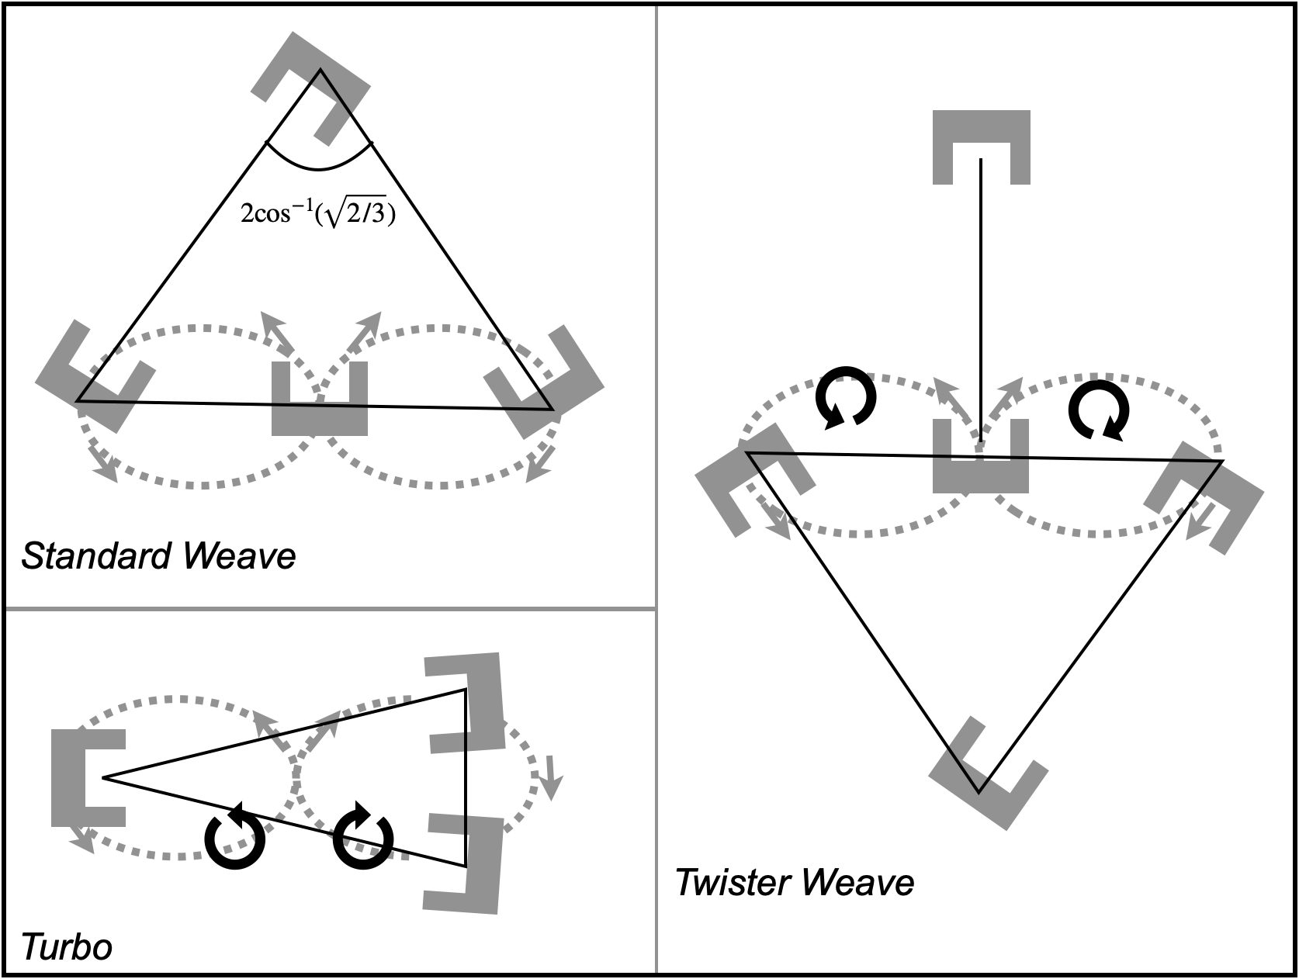
A juggler can always increase spin by doing pirouettes, but even without such embellishments every juggling role corresponds to some non-negative spin. It is curious that patterns with a similar overall shape may have quite different spins. For example, the 4-person Standard Weave, the 3-person Turbo, and the 5-person Twister Weave, all have 3 jugglers moving through a figure-8 shape. Movers in the Standard Weave stay facing the one feeder, and have just modest spin (0.96 rads = 55 degrees on each side). But each mover in the other patterns completes a full rotation (2$π$ rads = 360 degrees) over the same figure-8 motion. The spin metric we record is an accumulated amount of turning throughout one full cycle of the pattern, per juggler, and then averaged over jugglers. As we’ll see in the detailed pattern descriptions, the Turbo full cycle is 18 2-count beats while the Twister Weave is 12 such beats, with both having movers’ motion = 4 pu (one figure 8) and spin=2$π$. You could argue that moving in the Twister Weave requires more turning; indeed (for the movers) its spin per beat is higher than the Turbo. On the other hand, turns in the Turbo are sharper, in the sense that you spin 180 on a 4-count compared to the same turn on a 6-count in the Twister Weave. Since the movers in a Twister Weave have no feeder role, they can spread out their turns! See the relatively recent 2$π$/3 pattern for more spinning on a shorter cycle; and for a longer cycle, movers spin the full circle (spin = 2$π$) in Big Lemniscate, but the loops are so big one hardly even seems to be turning!

Being able to rotate while you juggle is a great skill, which you can improve by focusing on good self throws. Having a spin metric allows us to measure pattern difficulty according to this skill. Beginners ought to start in a role with 0 motion and 0 spin. We contemplate tracking the number of jugglers with such roles in a pattern, e.g., ${J_{0}}_{}$, but this is not implemented yet in V4

Pattern Tables
Throw timing, throw destination, and juggler position over time have to be recorded to describe a juggling pattern. We use tables to express this information, often organized like the generic annotated table below, with jugglers (letters) on the rows and passing beat (numbers) on the columns. We sometimes reverse row and column in patterns with a long cycle.

Name of Pattern
LAYOUT  where the jugglers are in space |  | Beat, base count
LAYOUT  where the jugglers are in space | Juggler | 1 | 2 |  | … |  | N-1 | N=Length of cycle
LAYOUT  where the jugglers are in space | A
LAYOUT  where the jugglers are in space | B
LAYOUT  where the jugglers are in space | … |  | Who passes to whom and when
LAYOUT  where the jugglers are in space | Last juggler
- Helpful comment #1
- Helpful comment #2,
- …

Metrics: J = # jugglers, CJ= # clubs per juggler, cycle= length of full cycle, OJ = other juggler (average # passers passed to by a passer), pH = average pass height per throw, R = # distinct roles in the pattern, PBJ = passes per beat per juggler (averaged), motion = distance covered by jugglers in passing units (averaged), spin = amount of turning to complete one cycle, averaged over jugglers, and usually in radians.
The patterns we describe require jugglers to sync up. Commonly, this has everyone releasing a club from the right hand at the same time, and likewise everyone releasing a left at the next time step. For some patterns with extra clubs, there is still a syncing of releases, but with a subset of jugglers releasing from rights and others from lefts (e.g., 3-person 10-club Feed). In that case we say jugglers are out-of-phase. In any case, these patterns have a base count which refers to a way of counting the time steps of these releases. For instance, right-handed 2-count is a common base, or right-handed 4-count, or a variety of more interesting counts (e.g., 1-3 on a 5 count). Typically passes happen on the named count, though not every juggler may be passing. And we may have time steps (beats) on that named count where no-one is passing. Patterns can be described in different base counts; often when learning a more complicated pattern we start with a slow base (e.g. 6 or 8 count), and then speed it up to a faster count as we learn.

Other pattern descriptors can be more detailed and informative, and these are good for elaborate passing between 2 or 3 jugglers with extra clubs. But most of what we describe in this collection does not aim to record, for example, the state of every club at every time. Primarily, we are content with knowing who throws to whom when, and where everybody is. (But see Chapter ** with Nathan Nard’s piano rolls to see a neat variation where all the clubs are tracked in elaborate patterns; we use these rolls to figure out the full cycle of a pattern; i.e. the number of beats to get back to the beginning.)

Reading Tables

Here’s a well-known pattern described in our format.

Standard feed  aka windshield wiper or 1-v-3 feed |  |  |  |  |  | Decoding the table.  -Rows for jugglers  -Columns for beats  -Or vice versa!  -Entries for recipients  -Empty cell for self throw
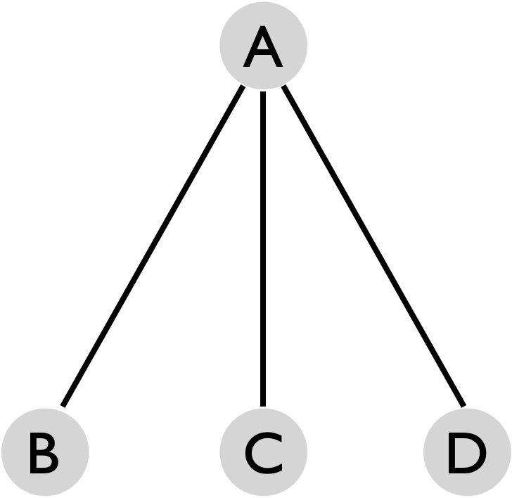  [Edges indicate passes at some point in the pattern’s cycle.] |  | Beat, 2-count base
 | Juggler | 1 | 2 | 3 | 4
 | A | B | C | D | C
 | B | A
 | C |  | A |  | A
 | D |  |  | A
A starts with B. Right-handed 2-count by A and right-handed 6-count for feedees. [Tips]
Metrics: J=4 [4 jugglers=#rows in table], CJ=3 (i.e. no extra clubs), pH=1 [passes are singles], OJ=3/2 [3 other jugglers for feeder and 1 for each feedee; also, it’s the average number of distinct entries per row in the table], cycle length = 4 on 2-count base [#columns in table], PBJ=¼ [# non-empty cells/((#cells)(base count); it’s also the fraction of non-empty cells in the table when the table is converted to a 1-count base], R=3 roles [feeder A, 2 8-count feedees (B,D), and a 4-count feedee (C)], motion=0 pu [no one moves their centers of mass], spin=0.46 rads (27°) [From our motion model where the feedee line covers 1 pu, A sets up 1 pu away from C, and to get through the full cycle A sweeps through an angle 4$θ$where cos$(θ)=2/\sqrt{5}$ ; only A has non-zero spin (106°)]

Without belaboring the point, an entry in the table above identifies the juggler who receives a pass from the row juggler at that beat within the pattern cycle. Since left hand passes are not made in the Standard Feed, we save space by not tabulating them. Right-hand self throws are indicated with a blank entry in this case. For example, if I was juggler C in the above pattern, I would read along the 3rd row to see where to pass. On the first pass (column 1), I have a self throw (the empty box represents a self throw). For the next right-hand throw (column 2), I pass to A. For the next two right-hand throws, I do a self throw followed by a pass to A. The table rolls over, so that the fifth pass is the same as the first; i.e. the pattern has a 4-beat cycle.

Unless otherwise specified, all passes are single spins, do not cross (i.e. right-to-left or left-to-right), and jugglers start with right-hand releases on the first beat (though there are many exceptions that will be duly noted). Doubles and triples to juggler A are sometimes indicated by d-A and t-A respectively and are also straight throws unless noted. We document any special instructions like different counts, double selves, crossing passes or starting instructions in the table annotations.

For some patterns, the same who-passes-to-whom-when information can be presented in different tables. For example, the two versions below are equivalent for the Standard Feed. Since everyone is synced up and not passing on the even 1-count beats (i.e., the lefts), we omit them in the more compact table without loss of information. We sometimes say “right-hand counting” for descriptions on the 2-count base and “both hands counting” for the 1-count base.

 | Beat, 2-count base
Juggler | 1 | 2 | 3 | 4
A | B | C | D | C
B | A
C |  | A |  | A
D |  |  | A
 | Beat, 1-count base
 | 1 | 2 | 3 | 4 | 5 | 6 | 7 | 8
A | B |  | C |  | D |  | C
B | A
C |  |  | A
D |  |  |  |  | A

When at least one passing event happens on every 1-count beat, as in the next example, there are no hidden columns holding would-be all self throws in the pattern table. Usually, this is set up so that odd beats are right hands and even beats are for left-hand releases. As juggler D, for instance, you would read the fourth row to see that you start with a right-hand self (column under beat 1), followed by a left-hand pass to B (column under 2), and so on. Aside from the detailed who-passes-to-whom-when information within the table, there’s often a common passing signature or rule that some or all of the jugglers follow; the rule here is right across, left right, right across, self, right left, self, which all jugglers do, but offset in time. (Here, left2right means make a left pass to the person on your right side.)

A Funny Left/Right Box |  |  |  |  |  |  |  | Metrics: J=4, CJ=3, OJ=3, pH=1,R=1, cycle=6 on 1-count, PBJ=⅔, motion=0, spin=$π$ rads ($180°$).  Rule: right across, left2right, right across, self, right2left, self
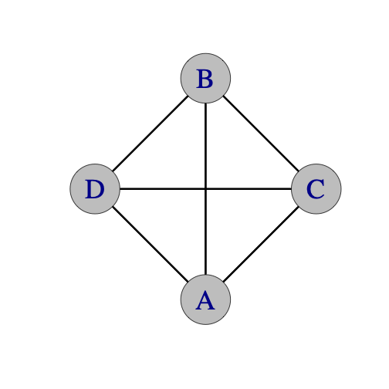 | Beat, 1-count base
 | Juggler | 1 | 2 | 3 | 4 | 5 | 6
 | A | B | C | B |  | D
 | B | A | D | A |  | C
 | C |  | A |  | D | B | D
 | D |  | B |  | C | A | C

Messing with the Base Beat
We’ve had immeasurable fun sorting out juggling variations by changing who passes to whom when and who moves where when. Subsequent to Pattern Book Version 3.1 (since around 2024), we have experimented a lot with patterns that share both positions-over-time and the passing sequence of a standard pattern, but they vary specific beats when these passes happen.

For instance, a Standard 1-v-3 Feed discussed above could be described as having passes at “1 on a 2 count”, which is at beats 1, 3, 5, 7 counting both hands. In “1-3-on-a-5 count”, by contrast, the feeder A and the feedees B, C, and D pass as before, but there’s no passing on beats 2, 4, or 5 within each 5-count base cycle (non-passing are shaded). A passes right, self, right, self, self, left, self, left, for example, thus extending what was an 8-beat (both hands counting) full cycle to a 10-beat full cycle. Notice that the time gaps change between passing beats, if we just stack columns of the table where passes happen and delete all the grays, then the reduced table does not change. This messing with the base beat gets really interesting in some of the moving patterns. This works nicely in patterns whose passing sequence is well practiced; then we just call out the count to 5 to know when our specific passes happen, such as on beats 1 and 3.

Standard Windshield Wiper Feed of 3
messing with the base
 | Beat |  |  |  |  |  |  |  |  |  |  |  |  |  |  | Base
 | 1 | 2 | 3 | 4 | 5 | 6 | 7 | 8 | 9 | 10 | 11 | 12 | 13 | 14 | 15 | 1-count
Juggler | 1 | 2 | 3 | 4 | 5 | 1 | 2 | 3 | 4 | 5 | 1 | 2 | 3 | 4 | 5 | 1-3-on-a-5-count
A | B |  | C |  |  | D |  | C |  |  | B |  | C
B | A |  |  |  |  |  |  |  |  |  | A
C |  |  | A |  |  |  |  | A |  |  |  |  | A
D |  |  |  |  |  | A

Site Swaps, Causal Diagrams, and Manipulators: The Undiscovered Country
**I THINK WE NEED TO SAY WE REALLY DON’T TAP INTO THIS WORLD IN THIS BOOK, EXCEPT FOR A FEW EXTRA-CLUB STATIONARY PATTERNS ; WE CAN ALSO SAY WE DON’T YET TOUCH THE MANIPULATOR PATTERNS!**

Occasionally we tap the wonderful world of site-swap notation https://en.wikipedia.org/wiki/Siteswap to describe patterns. For example, 7 club 2-count is 4p 3 | 3 4p (2<sup>nd</sup> juggler starts with left hand). There are a number of different site swap notations out there for passing. We use whatever seems to make sense to us at the moment and make no guarantee of consistency!

**NOTE WE DON’T USE CAUSAL DIAGRAMS .. REFERENC for tracking clubs, but sometimes we mention NATHAN’S PIANO ROLLS**

Glossary: Secret Juggling Code Words and Phrases

advisory dots. Those flexible, colorful, plastic floor markers used to mark key positions in a moving pattern (often provided by Prof Mike). (According to Mel, tagging up is not required!) Especially helpful in patterns like Fast Forward, Decagon, and Slippery Knot.

baby position. The least challenging task in a juggling pattern, if there is one.

Bernardos. Unnecessary solo juggling tricks performed while other jugglers are trying to start a pattern. Named after Paul Bernardo, an expert of the craft.

Canadian catch. An impressive catch that would have been difficult for most mortal jugglers. (Guess who that’s named after!)

carriage return. A style of feeding where the feeder returns to the first feedee in the line after passing in sequence to all feedees. (also called typewriter)

chalant. To drop a perfectly fine pass due to lack of focus. The opposite of nonchalant.

chocolate bar. pass--pass--self--self; a 4/2-count. By convention, this starts with the right-hand pass.

CJ. clubs per juggler. Property of a juggling pattern equal to the total number of clubs divided by total number of jugglers. (Also a star in Bay Watch.)

colors. The restriction that each juggler starts the pattern with a visually distinct (usually by color) set of clubs.

cross. A left-to-left or right-to-right pass.

cycle. The amount of juggling after which the pattern repeats. (See global or local versions)

Doc Blanchard/Glenn Davis. Mr. Inside/Mr. Outside. (Now, Dr. Inside/Dr. Outside!)

double 3-count. pass-pass-self: Academics insist that this is a 3/2-count not 2/3-count.

Dr. Inside/Dr. Outside. The two feeding positions of a doubly-fed weave (formerly Mr. Inside/Mr. Outside.)

encroachment. Premature lane-crossing between two passing jugglers in a moving pattern. Usually entails a 5-yard penalty.

everies. 2-count

every-others. 4-count

exclusion principle. No two jugglers can occupy the same place at the same time.

extra clubs. When the number of clubs for the pattern exceeds three times the number of jugglers.

feast. A pattern having only feeders, usually arranged in a circle.

feed. A passing configuration where one juggler passes to multiple others.

feedee. One who passes with a feeder.

feeder. One who feeds. Usually this juggler is stationary.

global cycle: Number of beats before the whole pattern repeats.

hup. The vocalization that signals the end of the pattern.

immaculate assumption. When you think that a juggler is about to move or pass...maybe they even give you the look...you know, the **look**...but then they don't!

Inverted. A non-standard moving convention in a weave: move forward on the end and back through the middle. The standard convention is back on the end forward through the middle.

I blame society. An excuse for some juggling failure (usually by Mel).

last jugglers' try. The last attempt at a pattern, but only if it goes well enough.

leader. One who calls out, jugglers ready: up, down, ... at the beginning of a pattern.

local cycle: Number of beats before a juggler repeats what they’re doing in a pattern.

Mel catch. The act of catching the fat end after a 2.5 spin triple up.

mustard. Energy, power, spice, velocity or chi added to throws. As in, "Your corner
passes need more mustard." Also, crispy. The opposite of mustard is mayonnaise.

NFP. Nice Pass (Thanks Tom Pomraning!)

No, this is a club. Said while pointing to a juggling club and talking to a curious
passer-by who asks about the group, "Is this a club?".

OJ. The number of other jugglers passed to, averaged over jugglers in the pattern. Also a refreshing drink.

olive. In a stacked, sandwich-style pattern, a single feeder on one side of the pattern.

orbiter. A juggler who orbits a standard moving pattern and passes to others on some of their would-be self throws.

out-of-phase. While juggling to a base beat, some jugglers release the right-hand throw when others release from the left, e.g. as in 7-club doubles between 2.

phantom. A feedee placeholder who isn't really there. A feeder, for example, may feed 2 real feeders and a phantom in a sweep feed: pass-pass-self-pass and repeat.

PBJ. Passes per beat per juggler. A statistic to measure one aspect of the difficulty of a pattern. Measured relative to a 1-count base beat per cycle, and is a fraction in (0,1]; literally # passes divided by # beats in a cycle. (Also a favorite sandwich!)

pH. Pass height per throw (e.g., 1 for singles, 2 for doubles, etc). Also a measure of acidity!

plus. A suffix added to indicate an extra club added to the base pattern.

post. A stationary orbiter.

run it. Continue juggling for an indefinite number of cycles.

scheisse. An utterance of frustration, possibly by Dan Schuchnect.

Someone passed me a bad self. An excuse for dropping.

southern Wisconsin convention. When changing sides from a feedee position in a standard count, do so on an outside-throw/inside-catch; e.g. on a right-hand throw/left-hand reception when on the right side of the feedee line.

spin. A statistic to measure one aspect of the moving difficulty of a juggling role within a pattern, measured as the total absolute change in angle per cycle (radians preferred!). As a pattern metric, we average the spin of the jugglers. Also the number of rotations a club undergoes from release to catch.

straight. A right-to-left or left-to-right pass.

sweenish. A fancy final move in a pattern, preferably clean.

three-count. In Madison, the default passing count between two jugglers. Sometimes called the waltz.

tomify. Replace a pass-self or a pass-self-self with pass-pass-pass to the same recipient. (thanks Tom Pomraning)

triple up. The showy last action in a pattern, after the hup, in which each juggler lofts a triple self.

ultimate. 1-count

walk it through. To perform a slow-motion instance of a pattern, with juggling replaced by the holding of clubs, with passes replaced by pointing to where you would pass, and following a slow, deliberate count by the leader. Done while setting up a pattern in order for jugglers to figure out what they are supposed to do.

weave. A most popular moving pattern with three feedees and a feeder, which is the basis of many multi-person patterns. The 3 feedees move in a figure 8 while juggling.

windshield wiper. The more common style of feeding where the feeder first feeds the line in sequence, and then returns in reverse order. Windshield wiper and carriage return are the same with two feedees, but differ for three or more feedees.

who passes to whom graph. A graph-theory construct with nodes per juggler in the pattern and directed edges from passers to (non-self) recipients. Clubs follow paths in this graph as the pattern is juggled.

wuss. The amount of gentleness, tenderness and love added to a juggling throw. Compare to mayonnaise. Also, the quality of passes you would make to your favorite grandmother. As in, "Please add some wuss to your middle passes. You're hurting my catching hand!"

You herniated my ZOC. Said if a pass forced extension and excessive effort in the catching.

ZOC. Zone of Catchability. The volume near a juggler in which successful catches are probable, as in, “Peter Kaseman has the largest ZOC in Madison.”

ZOOS. (sounds like the Greek god Zeus) Zone of occupied space. Space occupied by a moving juggler.

Random Tips on Passing Patterns

Better never than late.
If you miss a passing beat, don't pass on the next throw! Instead, wait for the pass opportunity to come around again in the regular cycle of the pattern.

Always keep your eye on Mel.
Don't pick up the clubs until you're sure the pattern is over, unless you know you can pick up and keep juggling. Even when you're not juggling, it's wise to keep an eye on Mel.

Juggle slow, move fast.
You get it. There's a tendency to speed up your juggling when you move. Don't.

Lift your selves.
So you slow down!

Juggling means never having to say you're sorry.
No, really. Don't say you're sorry unless you draw blood. (However, if you draw blood then you do have to say you're sorry.) Beginners often apologize profusely for their lack of skill. It’s ok! We already know you’re a beginner. But we like passing with other people and passing with beginners too. You’ll get better soon and the best way is with lots of passing! If people want to do a hard pattern that is too advanced for beginners then they will, and you'll be left out of that one. Just do a pattern with somebody else. If we're juggling with you it's because we want to, not because we have to. Most patterns have positions of varying skill requirements, so if you're a beginner in a bigger or more advanced pattern, we'll try to put you in the best spot for your level. Just try to do the best you can, and if you drop, try to keep the timing anyway.

Mike's the leader.
Unless he's not.

Throw global, catch local.
A prescription for happy passing.

The wind is our friend.
Remember this when juggling outside.

Mastering the Craft

Timing: It may already be obvious, but good timing is critical to group passing patterns. One of the best tools to keep timing is your ears. For many patterns, the catches should happen at the same time. When the juggling is well synchronized, the sound of catching clubs is a metronome for the pattern. Otherwise, find a juggler in your field of vision and make sure you throw at exactly the same time as they do (either passes or selves). Make sure all the passes of the same spin go to the same height. For many patterns, selecting a juggler to count out loud as a metronome can be very helpful. And follow the leader!

MAJ timing: We estimate 0.9 seconds per right-hand-beat for no-extra-club passing. This is a little slower than at most North American sites and a little faster than at some European sites! It’s a tempo of about 67 beats per minute. This slower timing is especially beneficial in moving patterns where there’s a lot of other things to do aside from throwing clubs! Lift your self throws to slow down.

Leads: The second most important skill is for the passer to lead the catcher in the direction they are moving. The amount of lead varies based on the height of the throw, the tempo of the juggling, and how fast the weaver is moving. Outside leads are the easiest, because they are thrown away from the catcher's pattern. Inside leads are trickier, because they are thrown towards the catcher's pattern, and if the passer is exchanging clubs with the catcher, the two passes are prone to collision. (For some patterns, such as the Cyclone, the weavers are
moving so fast that the inside leads go all the way on the other side of the incoming pass.)

One key to throwing good leads is to be able to see where your passes land. That's a difficult skill at first, and especially hard for some patterns with high throws, but your target will certainly appreciate the effort. Otherwise, good communication (especially for dropbacks or other blind passes) helps fine tune lead throws. Remember that in a feed, the feedee on the same side as the feeder's pass must throw an inside and/or deep pass to give the feeder room to throw underneath to the next feedee.

Turning: Twister Weaves and other fun patterns are all about turning. In addition to the spin metric, difficulty may be recorded in how many selves are allocated to turn 180 degrees (i.e., $π$ radians). For example, the Standard Twister Weave has 5 selves (weaving in 6-count). The Fast Spiral has 3 selves (weaving in 4-count). The Tempered Chocolate Swirl has 1 self (crossing sides in double 3 count). The direction of your turn is an individual choice; one direction is usually easier than the other, but we recommend jugglers learn both turns whenever possible. Learn turning in easy patterns like the Twister Weave and then you can apply those to Clovers or Strange Attractors and other more advanced weaves. It is also helpful to practice turning while juggling solo. How many selves does it take for you to turn 180 degrees while spinning continuously?

Learning: Take advantage of opportunities to pass with jugglers better than you. That's how you'll learn timing. Take advantage of opportunities to pass with jugglers less skilled than you. That's how you'll learn catching. Be sure to pass with jugglers at the same level as you. That's how you know how good you really are. :)

Lots of passing patterns benefit from solo skills too. You'll need to be able to juggle 4 clubs comfortably in triple singles, double singles and the fountain to do a lot of the 7 and 8 club based passing patterns.

Passing Pattern Philosophy

We're occasionally asked at juggling conventions, where do you come up with all these patterns? Actually, they sort of make themselves once you invite the opportunity. Here are some tips on how to make new passing patterns and have fun doing it. We discuss some other pattern generation techniques in Chapter 12.

Mutate

- Start with a classic juggling pattern or any geometric figure (box, triangle,
star, Y, W, line, etc.).
- Think about everybody juggling 3 or 4 clubs.
- Replace any selves with a pass to another juggler doing a self.
- Switch the positions of jugglers, but retain the passing sequence.
- Try the same movement in a different count, or left handed.
- Try the same passing sequence in a different movement.

Complicate

Why not make things harder? You get better at basic patterns if you try harder variations; plus they can be interesting if they're not too hard. (We estimate that a success rate of 1/3 is optimal for making progress and retaining interest!)

- Replace any 3-count with a double 3-count.
- Replace any feed with an extra club feed.
- Replace any extra club feed with a 2 extra club feed.
- Make stationary jugglers move (circles, clovers, figure eights, or any juggling siteswap just to name a few).
- The clubs can be passed in any juggling pattern or siteswap (admittedly, patterns get challenging quickly once you get past the easier siteswaps).

Combine patterns: Replace any position with a set of jugglers that spits out that same count. E.g. replace one person doing a 4-count with one side of a Twister Weave; or replace a 2-count person with a Weave (assuming there is room!). This is the source of many fun big patterns, such as the Eggbeater-Twister.

Stacking: Weaves-of-three and spinning-pairs are pattern components that emit passes on either side of a line. They are naturally combined into multi-layer patterns by stacking them up against each other in parallel. Then feeders (sometimes called olives) or same-facing movers anchor either end of the stack. We get simple descriptors for quite elaborate patterns, such as 1-2-3-2-1, or 1-2-2-2-2-2-1. (See later chapters for more details.)

Starting: There's nothing that saps mojo more than a long discussion about how to start or progress through a pattern. Keep instructions simple, informative, and clear. Warm up by doing parts of a pattern in isolation. Walk it through and minimize the Bernardos.

For very big patterns, we use two decks of playing cards: one is used to mark starting positions by taping cards to the floor; a matched set from the second deck is handed out to the participants. The leader just instructs jugglers to find their positions, and they usually self-organize! We also use tape on the floor to mark movements or passing lanes to keep it clear. And we’ve found that a jazzy metronome can help keep jugglers in time. (We tried a few times having a live drummer; that makes for a lot of fun and entertainment, but it did not really help our timing!)

Make it interesting

- Many of our favorite patterns are group collaborations where lots of people gave ideas for new ways to move or pass.
- Share your favorite club passing patterns with other jugglers and listen to their ideas too.
- Recognize the skill level of your participants and do patterns in which everyone can be challenged while also having fun.

Antonio Vivaldi, in 1725, titled his Opus 8, 12 Concerti for chamber orchestra and violin, Il cimento dell'armonia e dell'inventione, or, The contest between harmony and invention. (Thanks Rick Chappell for this quote!) There's no evidence that Vivaldi was juggling, but there is a connection to our endeavor. To be worked on, a juggling pattern has to be sufficiently novel that it is interesting and engaging for the participants, but also sufficiently regular that it can be mastered with reasonable effort. The fact that the Pattern Book has grown is testament to the fact that jugglers regularly pass clubs in Madison; for this activity to persist there must be invention of new things; and as well there must be consistent elements -- count signatures or motion elements -- that we master and then recombine in interesting and enjoyable ways.

Internet Passing Resources

The world of juggling has many contributors and contributions that we have failed to identify in this collection. Some important ones we know about are:

- [Flying Karamozov Brothers](http://www.fkb.com/)
- [Gandini Juggling Project](http://www.gandinijuggling.com/)
- [Martin Frost's Youtube channel](https://www.youtube.com/user/elgra2)
- [JiBe's passingDB site](https://www.passingdb.com/)
- [International Juggling Association site](http://www.juggle.org)
- [Will Murray's site](http://www.csulb.edu/~wmurray/)
- [Mark Weston's passing collection](http://www.varietyartsdirectory.com/resources/PassingPatternsAug06.pdf)
- ANY MORE CURRENT? Yes!

- See also, https://jugglingfan.org/pmwiki/
- **puGLOID IS SUPER ADVANCED BY VERSION 4, AT LEAST ON STATIONARY PATTERNS…

OPTION: MOVE INTERNET PASSING TOGETHER WITH SITESWAP puST BEFORE PRELIMINARIES, INDICATIN WHAT THIS COLLECTION IS NOT MORE CLEARLY…NOTING TON OF DEVELOPMENTS SINCE FIRST PATTERN BOOK COPIES CIRCULATED IN 1999

Three Person Patterns

Big patterns come from little patterns, so we start small! Arrangements for three stationary jugglers are limited, with the most popular arrangement being the feed (one feeder A exchanges with two feedees B, C). Polls indicate that triangles and lines are fun but less popular! Exchanges happen between any pair of jugglers in triangles, and lines – well lines usually require some brave person in the middle who doesn’t mind risking injury from an errant pass! Even without any moving among positions, there’s an impressive variety of feeds, triangles, and lines to delight any juggling trio. We provide details of some of our favorites below.

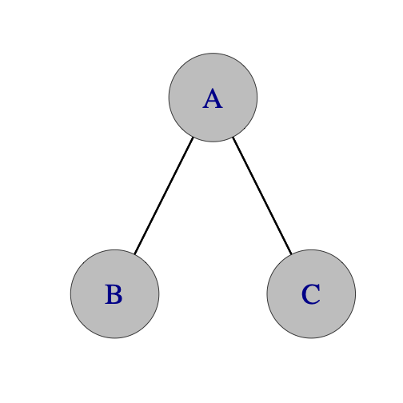Feed | 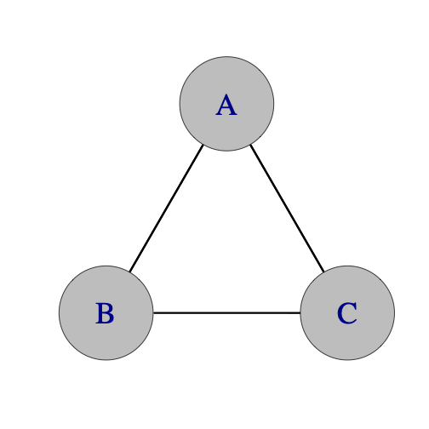Triangle | 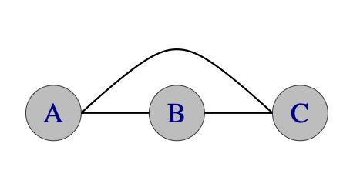  Line

- Edges in each graph indicate possible exchanges between the jugglers.

Stationary Three Person Patterns

Basic Feed
The feed for 3 jugglers is the simplest 3 person pattern and maybe the first one you try.
Feeder A passes alternatively to feedees B and C on some prespecified base count. The most common base is 2-count rights, so feedees are then doing 4-count. Popular variations include left-handed, 3/2-count base (feedees in 3-count), or more elaborate ones with feeder in 1-count passing once, twice (chocolate bar), or three times (Tom’s) to each feedee.
 | Beat, base count |  |  | Metrics: J=3, CJ=3, OJ=4/3, cycle length=2, pH=1, PBJ=⅓ [2-count base] and ⅔ [1-count base], R=2, spin=$π/9$, motion=0.  The feed is a great building block for all kinds of other patterns.
 | Juggler | 1 | 2
 | A | B | C
 | B | A
 | C |  | A

Here’s a variation that’s been popular in Madison since Version 3.0.
Ryan's Feed  ?by Chuck? |  |  |  |  |  |  |  |  |  | Think 1-5-8 and 3-6-7 for the two feedees. One variation is to swap B and C. Change side and turbo variants [see ahead]  Metrics: J=3, CJ=3, OJ=4/3, cycle length=8 on 1-count, pH=1, PBJ=½, R=2, spin=$π/9$, motion=0
 |  | Beat, both hands counting (i.e. 1-count base)
 | Juggler | 1 | 2 | 3 | 4 | 5 | 6 | 7 | 8
 | A | B |  | C |  | B | C | C | B
 | B | A |  |  |  | A |  |  | A
 | C |  |  | A |  |  | A | A
See also, https://jugglingfan.org/pmwiki/pmwiki.php?n=Patterns.RyansFeed

Rotating Feed (i.e. Feast for 3)
Everyone feeds everyone else!
 | Beat,  right hand counting |  |  |  | This feast is clockwise from above. 2-count is the standard base, but 4-count is pleasant and 3-count is nicely balanced. Try going counter-clockwise!
 | Juggler | 1 | 2 | 3
 | A | B |  | C
 | B | A | C
 | C |  | B | A
Metrics: J=3, CJ=3, OJ=2, pH=1, cycle-length=2 (on 2-count), PBJ=⅓, R=1, spin=$2π/3$, motion=0

Basic Triangle
3-count base is the default pattern for 3 jugglers in Madison!
 | Beat,  Any odd count |  |  | As is, this is a pleasant insides triangle, which involves passing/receiving from different people. Outsides triangles are harder on your peripheral vision, but they would emerge if you swap R and L. Staying on an event count just selects one column.
 | Juggler | 1 (R) | 2 (L)
 | A | C | B
 | B | A | C
 | C | B | A
Metrics: J=3, CJ=3, OJ=2, pH=1, cycle=2 on odd count (e.g. 3), PBJ=1/3, R=1, spin=$2π/3$, motion=0

Pulsar |  |  |  |  |  |  |  |  | Feeder is shaded in table.
Jugglers take turns as 2-count feeders: A first, then C, then B (repeat), with feed sequence alternating between feeders (left,right) to (right,left). The feed itself moves clockwise (from above). Calling out what you’re doing (e.g., right-left or left-right) helps everyone. Here, right/left refer to positions not hands!
 | Beat, 2-count base (rights)
Juggler | 1 | 2 | 3 | 4 | 5 | 6 | 7 | 8 | 9 | 10 | 11 | 12
A | B | C |  | C |  | B | C | B | C |  | B
B | A |  | C |  | C | A |  | A |  | C | A | C
C |  | A | B | A | B |  | A |  | A | B |  | B
Metrics: J=3, CJ=3, OJ=2, pH=1, cycle=12 on 2 count, PBJ=1/3, R=1, spin=$2π$, motion=0
Pattern by Steve Otteson and MAJ, 1993. Try it on 1-count for a challenge!

Puzzle Feeder
 |  | Beat, both hands counting (1-count base)
 | Juggler | 1 | 2 | 3 | 4 | 5 | 6 | 7 | 8 | 9 | 10 | 11 | 12
 | A | C |  | C | B |  | C | B |  | B | C |  | B
 | B |  |  |  | A |  |  | A |  | A |  |  | A
 | C | A |  | A |  |  | A |  |  |  | A
A is the feeder on 3/2 count. B and C are doing the 2-person Three Piece Puzzle pattern six throws out of phase, which amounts to 4-3-2-3 count sequence. Three-Piece Puzzle and Puzzle Feeder patterns are by Jim Brennen. Steve Otteson in the mid-90’s promoted this pattern; but it’s not juggled frequently.

Metrics: J=3, CJ=3, OJ=4/3, pH=1, cycle length=12 on 1-count, PBJ=4/9, R=2, spin=$π/9$, motion=0

Puzzle Feast
 |  | Beat, both hands counting (1-count base)
 | Juggler | 1 | 2 | 3 | 4 | 5 | 6 | 7 | 8 | 9 | 10 | 11 | 12
 | A | C | B |  | C | B |  | B | C |  | B | C
 | B | A | C |  | A | C |  | C | A |  | C | A
 | C | B | A |  | B | A |  | A | B |  | A | B
All 3 jugglers are doing what the feeder did in Puzzle Feeder. Pattern by Steve Otteson.

Metrics: J=3, CJ=3, OJ=2, pH=1, cycle length=12 on 1-count, PBJ=⅔, R=1, spin=$2π/3$, motion=0

Mel in the Middle |  |  |  |  |  |  |  | A double 3-count feed with a moving juggler in the middle spinning around. With Mel as B (Mel is always B), starting facing A, then it is as in table.  It’s good exercise for 3/2 count passing.  Variations: slow it down or don’t spin every time.
 |  | Beat, 1-count base
 | Juggler | 1 | 2 | 3 | 4 | 5 | 6
 | A | C | B |  | C
 | B (Mel) |  | A |  |  | C
 | C | A |  |  | A | B
Metrics: J=3, CJ=3, OJ=2, pH=1, PBJ=4/9, cycle=6 on 1 count, R=2, spin=$2π/3$, motion=0

Peter’s Backcrosses |  |  |  | Fun with backcrosses.
 |  | Beat,  3-count base |  | All jugglers are in 3-count (or a slower odd count, like 5 count). A’s rights have to be lofty over B’s selfs: ditto for C’s lefts. A’s lefts (likewise C’s rights) go behind Peter, who is facing down [relative to layout shown]  Variation: 1-count, only a dream!
 | Juggler | 1 (R) | 2 (L)
 | A | B | C
 | B (Peter) | C | A
 | C | A | B
Metrics: J=3, CJ=3, OJ=2, pH=1, cycle length=2 on 3-count base, PBJ=⅓. Difficulty is in the backcrosses and in the precision needed by A and C. R=1, spin=0, motion=0.

Siteswap Feeds
2 of many
441 (double, double, zip)
Beat, 1 count base |  |  |  | A does 441 (double pass, double pass, shuffle=zip). Right start.  Variations: A can throw cross double passes and B and C can throw cross passes too (starting on opposite hands).  Metrics: J=3, CJ=3,OJ=4/3, cycle=6 (½ shown) on 1-count, PBJ=4/9, pH=3/2,R=2, spin=$2π/9$, motion=0.
Juggler | 1 | 2 | 3
A | d-B | d-C | zip
B |  | A
C |  |  | A
5px3px1 (triple, single, zip)
A | t-C | B | zip | Alternatively, A can throw straight passes and B and C can throw cross passes (starting on opposite hands).  Same metrics as above (even average passing height!)
B |  | A
C |  |  | A

Extra Clubs Stationary Three Person Patterns
The most popular extra-club feed in Madison has been the 10 club right-handed two-count feed in doubles. The only tip is for the feedee on the feeder’s right (B) to send slightly loopy doubles in order to avoid collisions with the feeders pass to the feedee (C) on their left. Adding clubs without modifying the structure requires throwing higher, faster, and with more spins!

The likes of Peter Kaseman, Nick Aikens, and Steve Clipson can routinely juggle more elaborate extra-club variations, such as the following. There are 4-count feeds in triples and popcorn feeds in 5-count, 6-count and 7-count. And 7 club double 3-count feeds in pass, pass, pause. And extra club chocolate bar feeds. Here are some more. **COMMENT ON SITE SWAP NOTATION**

4 Count Popcorn Feed |  |  |  | B starts with 4  t-self means triple to self
 | Beat,  right hand counting |  |  | B starts with 4  t-self means triple to self
 | Juggler | 1 | 2 | B starts with 4  t-self means triple to self
 | A | C | B | B starts with 4  t-self means triple to self
 | B | A | t-self | B starts with 4  t-self means triple to self
 | C | t-self | A | B starts with 4  t-self means triple to self

6 Count Popcorn Feed |  |  |  |  | B starts with 4  Variations: you can replace any triple self, self, single pass with a triple pass, single self to make things more interesting, or with double straight self, double straight self, pass (533p, 5p33, 443p, 44px3 all work).
Beat,
right hand counting
 | Juggler | 1 | 2 | 3
 | A | C | t-self | B
 | B | A |  | t-self
 | C | t-self | A

5 Count Popcorn Feed (one variation) |  |  |  |  |  |  | A and C start with 4  The timing is a bit wonky, B and C should delay slightly at the start.  (4.5p:B 3 4.5p:C 3 3 | 3 5 3 4.5p:A 3 | 3 4.5p:A 3 5 3)
 |  | Beat, both hands counting
 | Juggler | 1 | 2 | 3 | 4 | 5
 | A | d-B |  | d-C
 | B |  | t-self |  | d-A
 | C |  | d-A |  |  | t-self

Why Not + 5 count
**add the variation where feeder is doing WHY NOT**

Extra clubs chocolate bar feed |  |  |  |  |  | A and C start with 4 clubs. A throws all crossing doubles (dx). B and C throw chocolate bar, then double self, double self. The double selves are straight throws. (Heff?)
 |  | Beat, both hands counting
 | Juggler | 1 | 2 | 3 | 4
 | A | dx-B | dx-B | dx-C | dx-C
 | B | A | A | d-self | d-self
 | C | d-self | d-self | A | A

Other feeds: Fast/Slow Feeds, Gorilla Feeds, Site-Swap Feeds...we’ve tried a lot of them in Madison, but they haven’t made it into the Pattern Book!

Extra Club Rotating Feed (for 3 jugglers)
 |  | Beat, both hands counting
 | Juggler | 1 | 2 | 3 | 4 | 5 | 6 | 7 | 8 | 9
 | A | d-B |  | d-C |  | d-C |  | d-s | pause
 | B |  | d-A |  | d-s | pause |  | d-C |  | d-C
 | C | d-s | pause |  | d-A |  | d-B |  | d-B
Right hand starts for A and C. B starts with left hand. Each juggler does a double self (d-s) at some point in the cycle.

Variations: Once you're comfortable with this pattern, try pirouetting under the double self, or instead of throwing the double self, do two single selves and an early triple straight pass instead (followed by a pause), or both! Pattern by Luke Emery, 1999.

There are a lot of nice extra-club triangle variations. Here are a few examples to play with.

10 Club 3 Count Triangle |  |  |  |  | Jugglers start in sync with right hands; A has 4. All passes double spin crossing passes.  If that isn't challenging enough. Add more clubs and passes. A and C start with 4.
 |  | Beat, both hands counting
 | Juggler | 1 | 2 | 3
 | A | dx-C
 | B |  |  | dx-A
 | C |  | dx-B

10 Club 4-Count Triangle |  |  |  |  |  |  |  | s = right-self
Jugglers are offset by ⅓ of a right-handed beat, sending 4-count doubles to the person on their left. |  | Beat, right-hand counting
 | Juggler | 1 |  |  | 2
 | Juggler | 0 | 1/3 | 2/3 | 0 | 1/3 | 2/3
 | A | d-C |  |  | s
 | B |  |  | d-A |  |  | s
 | C |  | d-B |  |  | s
This may be the easiest of the extra club triangles. It’s the basis of the 6-person Bubbler of David.

11 Club 2 of 3 Count Triangle |  |  |  |  | Jugglers start in sync with right hands; A, B have 4  All passes double spin crossing passes.
 |  | Beat, both hands counting
 | Juggler | 1 | 2 | 3
 | A | dx-C | dx-C
 | B | dx-A |  | dx-A
 | C |  | dx-B | dx-B

12 Club 1-Count Triangle |  |  |  | This is a high-level pattern!  The 10 club version has been around for some time. We learned it from some fellow club passers at a convention. 11 Club and 12 Club variations are by Luke Emery, 2005, although it seems likely that other jugglers have also tried them.  There are corresponding extensions to a 5 person star in the chapter on 5 Person Patterns.
 |  | Beat, both hands counting
 | Juggler | 1(R) | 2(L)
 | A | dx-C | dx-C
 | B | dx-A | dx-A
 | C | dx-B | dx-B

10 Club Triangle with Triple-Single-Single
 |  | Right hand counting |  |  | A starts with 4  You can skip all the single passes until the triple passes are reliable.  A tough back and forth demanding precise triples.
 | Juggler | 1 | 2 | 3
 | A | t-C | B | C
 | B | C | A | t-A
 | C | B | t-B | A

6-Count Popcorn Triangle
 |  | Right hand counting |  |  | - A starts with 4  - You can skip all the single passes until the triple passes are reliable.
 | Juggler | 1 | 2 | 3
 | A | C |  | t-self
 | B |  | t-self | A
 | C | t-self | B

5-Count Popcorn Triangle |  |  |  |  |  |  | A starts with 4 and a right throw.  C starts with left and B starts with right. All passes are crossing and alternate hands. C should wait a bit before the first triple self (t-s), throw high lofty single crossing passes (3.3px3 3 5 3).
 |  | Both hands counting
 | Juggler | 1 | 2 | 3 | 4 | 5
 | A | C |  |  | t-s
 | B |  |  | t-s |  | A
 | C | t-s |  | B
Timing is wonky (hands really aren't all synced up, so the table is a little misleading!!). Another 5-Count triangle is to throw crossing triples to the left in 5-count. This timing is also wonky 1 2/3 count or some such difference between each juggler. The pattern should be possible in 5-count with triple crossing passes too...Hmmm... But fast...

Extra club version of Mel in the Middle, except in 4-count instead of 3-count. Inside person whirls with half pirouettes under doubles while outsides do popcorn. All passes are right handed.

\footnotesize
| **Juggler/beat** | **1** | **2** | **3** | **4** | **5** | **6** | **7** | **8** | **9** | **10** | **11** | **12** | **13** | **14** |
|-------------|-------|--------|-------|-------|--------|-------|--------|-------|-------|--------|--------|--------|--------|--------|
| **A** | D-C | | B | | D-C | | T-self | | D-C | | D-C | | B | |
| **B** | | | A | | D-self | ½ P | | C | | D-self | ½ P | | A | |
| **C** | | T-self | | D-A | | D-A | | B | | D-A | | D-A | | T-self |
\normalsize

> * Both hands counting
> * A starts with 4 clubs, right hand
> * B starts facing A, right hand
> * C starts with left hand
> * ½ P marks half pirouette underneath the double
> * 1 is the same as 11. This is just one possible variation of spinning underneath popcorn.

Swiftly Tilting Popcorn
**CHECKING TO MATCH ABOVE BUt OUt OF SYNC
 |  | Beat, both hands counting
 | Juggler | 1 | 2 | 3 | 4 | 5 | 6
 | A | C | B |  | C
 | B (Mel) |  | A |  |  | C
 | C | A |  |  | A | B

- A starts with 4 clubs, and right hand
- B starts facing A, and right hand
- C starts with left hand
- ½ P marks the half pirouette underneath the double
- 1 is the same as 11??

Line Variations

- Dropback Line: A passes to B. B drops back to C. C passes to A. You can do a dropback line in any count: 2-count, 4-count, 3-count, chocolate bar. It's a nice pattern to add clubs to as well. Try up to 3 extra clubs with doubles or one extra club in 3-count (A and B cross, C throws straight).
- Line Feeds: You can do any of the feed variations in a line layout instead of a V. Some will be useful for more complex patterns. Also see 4 person Lines.

An Extra Club Line
 |  | Beat, both hands counting
 | Juggler | 1 | 2 | 3 | 4
 | A | d-C |  | B
 | B |  |  | A
 | C |  | t-self |  | d-A

- A starts with 4 clubs; B faces A
- A alternates right hand doubles to C and singles to B. B does right hand 4-count to A. C alternates right triple selves and doubles to A (fast popcorn)
- What do you do if there are 3 club passers and one is more advanced, one is intermediate and the third is a beginner. This is a nice pattern to accommodate everyone!

Up-Up-Over  A curious pattern to exercise your 4-club columns skill. |  |  |  |  |  |  |  | Simultaneous double throws (all jugglers). A and B both start with 4 clubs. C starts with 2, waits to receive the two incoming from A and then responds with up-up-over. Feeder A is doing a slow two-hand doubles feed, starting with C. Juggler B starts in sync with A and does up-up-over.  Vertical arrows indicate synced double self throws.
Beat, 1-count base
Sync rights and lefts
 | Juggler | 1 | 2 | 3 | 4 | 5 | 6
 | A | C |  |  | B
 | B | ↑ |  | A |  | ↑
 | C |  | ↑ |  | ↑ |  | A
Metrics: J=3, CJ=3 ⅓, OJ=4/3, pH=2, cycle=6 on 1-count, PBJ=4/9, motion=0, spin=$π/9$rad

Prof Mike and Steve Otteson did this first in the early 90's, when Madfest was still in the Memorial Union. See an animation of (a variation of!) Up-Up-Over at (http://juggloid.com/editor/?s=yhIKp1)

Moving Three Person Patterns

Now for some moving patterns.

-change side feeds **discuss this is the first moving pattern, but we don’t describe it super carefully**

Change-sides feeds

When you have mastered change-side feeds, you’re ready for the Turbo, one of the Madison favorites. A Turbo is a group of 3 weaving jugglers who feed themselves. It is also a Two-leaf Clover or a continuous change-sides feed through the middle. In the standard version, you pass every right hand throw when you are feeding, and every other when you are moving.

Change Sides Variant (Ryan’s feed)

In this variant, the feedees take turns moving across like in the traditional change sides feed. However with each transition the pattern will be flip flopping between the original Ryan's Feed and the inverted variant. All 3 juggler's will need to pay attention to what variant they are transitioning to. As to when the feedees should make their transition, we found there are multiple times when the feedees can take turns moving across. The easiest time to transition is after the feedee does their two 1-count throws (EG, Juggler C's 6 and 7 throws in the original pattern).

Turbo Variant

It is theoretically possible to turbo the change sides variant by having the feedees transition through the middle. However in practice we found it difficult; but the nice thing is the pattern doesn't invert itself after each transition like in the change sides variant.

Turbo |  |  |  |  | 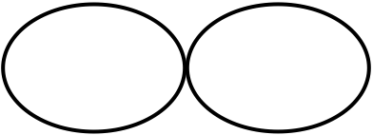
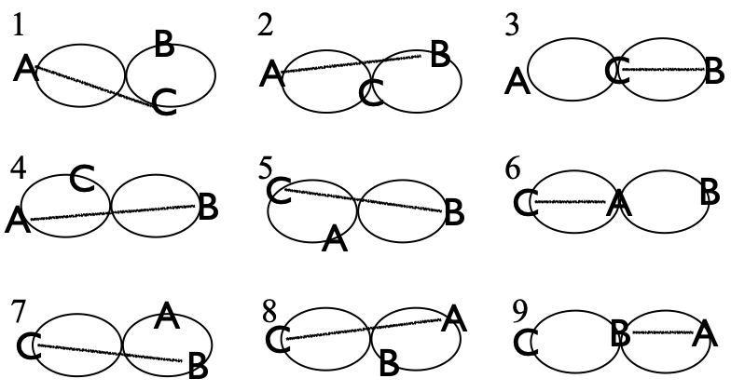 |  | Beat, base count (2-count rights is standard; ½ cycle shown)
 |  | 1 | 2 | 3 | 4 | 5 | 6 | 7 | 8 | 9
 | A | C | B |  | B |  | C |  | C | B
 | B |  | A | C | A | C |  | C |  | A
 | C | A |  | B |  | B | A | B | A
The standard Turbo is performed right-handed on a 2-count base (Peter’s start is shown, which has the first recipient feedee, C, becoming the first mover!) It's 18 right-hand beats for a full cycle; 9 beats to repeat the passing sequence, but flipped in orientation. When a juggler moves to the other side, he or she cuts across in front of the old feeder, and turns around to pass to the new feeder. We’ve tried many variations but often return to the standard!
- Left-handed – Same as standard, but mirror image.
- 3-count – Feeder does 3 count, feedees do 6 count.
- Chocolate bar – Fun! (pass-pass-self-self replaces pass-self)
- Double 3 count – Tricky. There are 2 different ways to do the transitions. Usually we have the movers stay in 3-count and move on the inside hand throw. You can also do this pattern where the movers transition in 4 count and move on the outside hand throw. Feels a little like the El Nino.
- Tom's Turbo – Feeder is in 1-count and does 3 passes in a row to each feeder. Have each juggler start with a different set of clubs. (Created by Tom Pomraning.)
- 10-Club Turbo – See below.
- Also see Interlocking Turbos in 6-person patterns and Strange Attractor in 5-person patterns.
- Timing variations: Recent innovations, like pass only on beats 1-3 on a 5-count cycle or 1-4 on a 7 count cycle
Jazzing it up: When changing sides the mover has the option of clockwise or counter-clockwise turns. Try both. One is harder and cooler. The standard (inside) turn is usually easier for right-handers off the right side of the feed and harder for right-handers off the left side. Try double or triple earlies before entering the middle. Try a behind-the-back pass when moving off the right side. For a cool animation (thanks Nick Aikens), see https://www.passingdb.com/patterns.php?id=49 2 http://juggloid.com/editor/?s=npRW7l
Metrics: J=3, CJ=3, OJ=2, pH=1, PBJ=⅓ (standard); 2-count base. Full cycle is 18 base beats, motion=4 pu, spin=2$π$.
History: We’re not sure. Turbo may have developed inadvertently when in the early 90’s we tried, unsuccessfully, to recreate Bruno’s Nightmare from faulty memory. The main difference between Bruno’s Nightmare and Turbo is when you turn. In Turbo you turn before entering the middle. In Bruno’s Nightmare you turn after exiting the middle, which lengthens the cycle and makes the pattern easier by some measures. There are also variations of Bruno’s Nightmare that we’ve heard about but the MAJ doesn’t juggle much!

Bruno's nightmare

We haven't juggled this much in Madison, but we mention it for reference. It used to be popular in Europe! See [PassingDB](https://www.passingdb.com/patterns.php?id=49)

2pi/3  (or better, 2$π/3).$Maybe it’s cooler than the Turbo! |  | 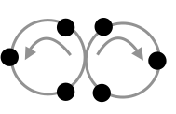
Read this two pi on three. This one is a late bloomer, considering how simple it is and how long people have been juggling and moving in groups of three. |  | Beat, base count (½ cycle in table)
 | 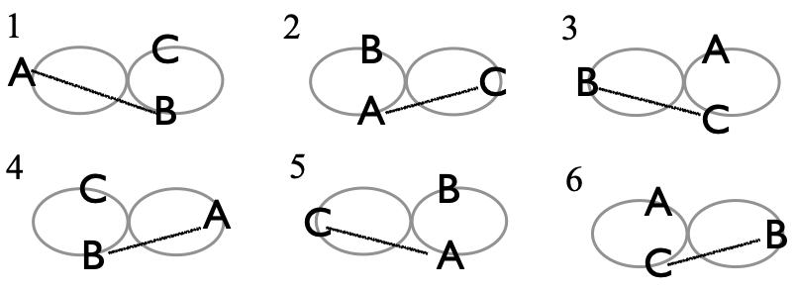 |  | 1 | 2 | 3
 |  | A | B | C
 |  | B | A |  | C
 |  | C |  | A | B
Three jugglers, A, B, and C, all move through the figure eight over the course of six beats on the base count. In contrast to a Turbo, there is not a feeder being swapped here; all folks are moving all the time. Relative to the figure in top right, there are six positions, and at any point jugglers occupy three alternating positions. The rule is pass and move to the next position. Any count works; 5-count is pleasant, 4-count is fun, 3-count is more fun! Recent variations alternate the count, such as 1-4 on a 7 for a 3-count/4-count alternation. In any count, it’s pass-one, pass-the other, self (i.e. phantom). Whatever is the base count, the pattern has a gap where you can plug in any other juggler or pattern that matches that count (including three other jugglers doing a 2$π$/3). Looks like two pies when viewed from above, and it’s 3 jugglers. Plus, each circle in the layout is divided into 3, hence the name. Prof Mike invented 2$π$/3 in summer 2017, but the popular version is Mel’s variation (shown above), in which the first recipient in the pair moves through. In the original, the first recipient goes backwards and the non-recipient goes through (equivalently, start the passing sequence with A-C. This is a curiously different and more difficult version owing to backwards moves out of the middle..
Metrics: J=3, OJ=2, CJ=3, PBJ=2/(3*base count), cycle length=6, pH=1, R=1, motion = 4 pu, spin = 2$π$.

Mel’s variations of 2pi/3 varies when you cross…lengthens cycle

Laxative | 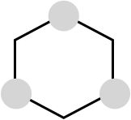
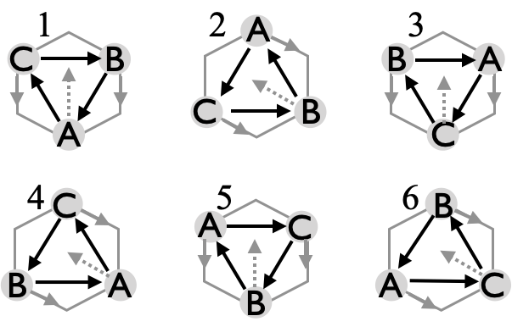
This one makes you go go go, hence the name.
 | Beat  base is 5 or 7 count | Juggler
 | Beat  base is 5 or 7 count | A | B | C
 | 1-6 | C | A | B
 | Metrics: J=3, CJ=3, OJ=2, pH=1, PBJ=1/count, cycle length=6, motion =4 pu, spin=(10/3)$π$ rad.
Laxative is a dynamic 3-person moving pattern in which everyone is synced up and passing on the same odd count. We usually do this on 7-count, which allows plenty of time to move; 5-count also works well; 3-count is still a dream! Because of the constant movement, the to-from passes never change. A always passes to C, who always passes to B, who always passes to A. The movement and the odd-count allows that these passes are all inside-triangle passes. There are 6 total passing beats, during which each juggler traverses the 6 positions, though the local cycle (wrt who moves) is three beats. Those movements entail crossing between the other two jugglers (which goes in turn A then B then C), and then moving along the edges of the hexagon (either twice to left or twice to the right), in order to make space for the next mover. It’s surprisingly challenging for such a simple pattern! Beginners often get confused about which way to go along the edge, or whose turn it is to move across!

Pattern by Prof Mike, sometime after 2018. Frequently juggled by Mike, C, Mel, B, and Conor or Nathan, A [performed at Madfest 2025]

Extra Club Moving Three Person Patterns

Patterns in this section are uniformly difficult, but also tremendously satisfying when they work! We open with the 10 Club Turbo, which starts as a 10-club feed, and invokes continuous change-sides, each of which cuts in front of the prior feeder to generate a figure-8 motion. It’s a dynamic extra-club version of the Turbo, and one of the favorites when Prof Mike, Peter Kaseman, and Luke Emery are passing.
10-Club Turbo  A next-level change-sides extra-club feed |  |  |  |  |  |  | 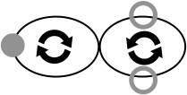
Juggler |  |  |  | 1-count base, A starts right with 4; B & C start left with 3 each  Passes are all right-handed, either doubles or triples (d-/t- in table; grey/black in figure).
Beat | A | B | C | Standard start: A to B who responds and moves immediately.  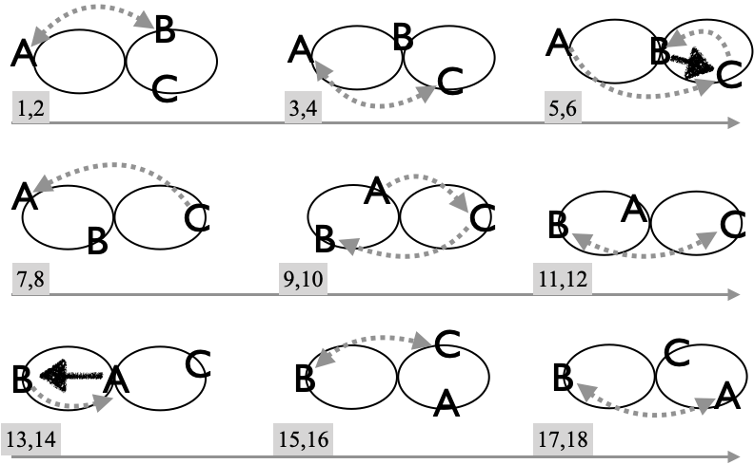
1 | d-B
2 |  | d-A
3 | d-C | ⇧
4 |  | ⇧ | d-A
5 | d-C | ⇧
6 |  | t-C | d-B
7 |  | –
8 |  |  | d-A
9 | d-C
10 | ⇧ |  | d-B
11 | ⇧ | d-C
12 | ⇧ |  | d-B
13 | t-B | d-A
14 | – |  |  | A starts part way through their feed, alternating 2-count doubles to feedees, who are on 4-count. In giving up the feed when a mover (e.g., B) initiates the change-side, the feeder passes twice (on 2-count) to the non-moving feedee (e.g. C). On the change-side move, the mover (e.g, B) stays in 4-count, but after a sharp turn releases a triple back to the new feeder (e.g., C), followed by a pause (--) in order to get onto the appropriate feedee timing opposite the new feeder. Good placement of this triple is key; usually aiming for a path “right up the gut” on turns off the feedee’s right, as in B’s first turn, and aiming “up the outside” on opposite turns. (Double pass-double self is a much less popular alternative for the change-side.)
15 |  | d-C
16 |  |  | d-B
17 |  | d-A | ⇧
18 | d-B |  | ⇧
19 |  | d-A | ⇧
20 | d-C |  | t-A
21 |  |  | –
… | Feeder cells grey  Mover cells black
Try this with single passes at 7-club 2-count speed.

Metrics: J=3, CJ=3 ⅓, cycle length=42 on 1-count base (not all shown), OJ=2, pH= 2 ⅓ , R=1, motion = 4, spin=$2π$, PBJ=⅓ . Pattern by Luke Emery, 1999.

We worked out an 11-Club Turbo variation with triple selves on the transitions, but it's too hard for us to run more than a couple transitions at a time. Maybe we'll get it in a future version of the book!

Another 10-Club Turbo  Not the real 10-club Turbo, but fun with pirouettes |  |  |  |  |  |  |  |  |  |  |  |  |  |  |  |  |  |  |  |  |  |  | 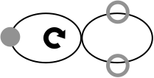
 | beat, 1-count base (1/2 cycle=21) |  |  |  |  |  |  |  |  |  |  |  |  |  |  |  |  |  |  |  |  |  |  |  |  | …
 | 1 | 2 | 3 | 4 | 5 | 6 | 7 | 8 | 9 | 10 | 11 | 12 | 13 | 14 | 15 | 16 | 17 | 18 | 19 | 20 | 21 | 22 | 23 | 24 | 25 | …
A | B |  | C |  | B |  | C |  | C |  |  |  | C |  | ds |  |  | B |  |  |  | B |  | C |  | …
B |  | A |  |  |  | A |  | ds |  |  | C |  |  |  | C |  | A |  | C |  | A |  | A |  |  | …
C | ds |  |  | A |  |  |  | A |  | B |  | A |  | B |  | B |  |  |  | B |  | ds |  |  | A | …
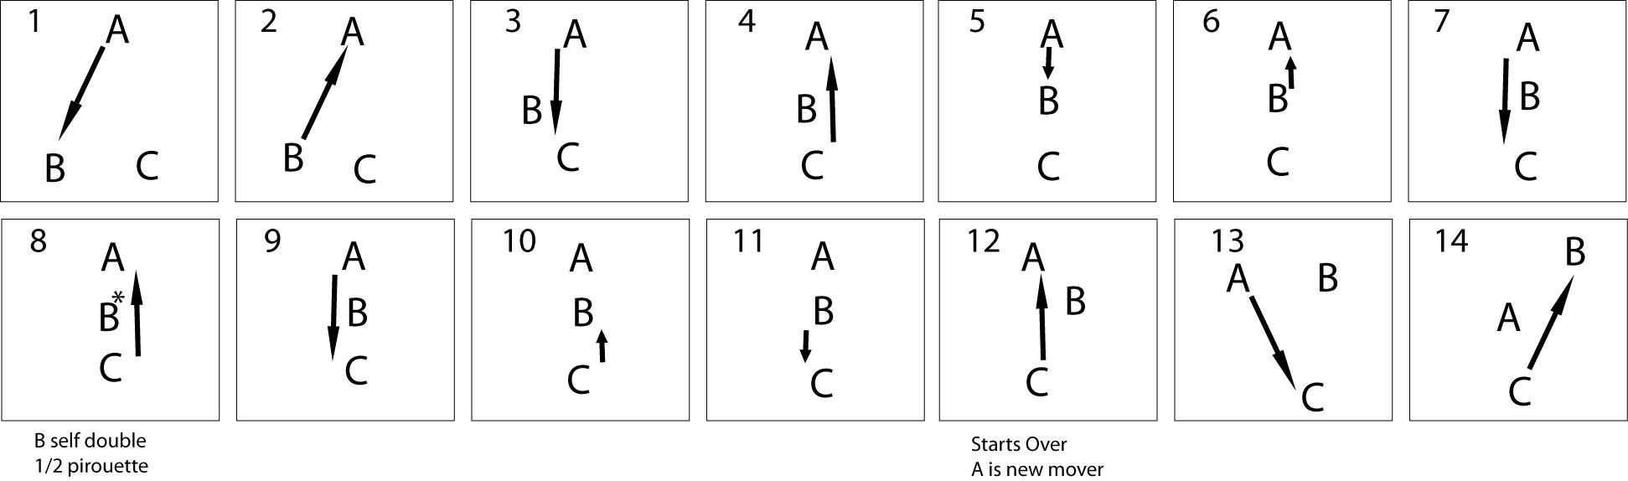 |  |  |  |  |  |  |  |  |  |  |  |  |  |  |  |  |  |  |  |  |  |  |  |  |  | …
1-count base, A starts right with 4; B & C start left with 3 each (though steady state in table C would start in sync with A and double self to get offset). Shading indicates feeder. Passes are all right-hand straight doubles. This pattern is interesting because transitions through the middle are made by doing a half pirouette underneath a right-to-left double self (ds). The feedee who is moving (e.g. B) steps into the middle of the pattern directly between the feeder and the non-moving feedee. After one pass the mover does a half pirouette underneath a double right-to-left self throw, then steps back to complete a single turbo transition. When you do the half pirouette, make sure to throw the double more inside than usual and have the outside passers pass a little on the wide side to reduce collision risk.

Metrics: J=3, CJ=3 ⅓ (one extra), cycle=42 on 1-count base, OJ=2, R=1, pH=2 (all doubles), PBJ=⅓, motion = 4 pu, spin=2$π$.

Pattern by Luke Emery, 2002.

Luke’s GDP  An ideal pairing with the 10-club Turbo |  |  |  |  |  |  | 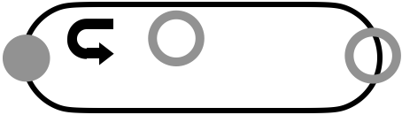
Juggler |  |  |  | 2-count base. A starts right with 4; B & C face A, and start right with 3 clubs each. Passes are all right-handed triples or singles.
Beat | A | B | C | 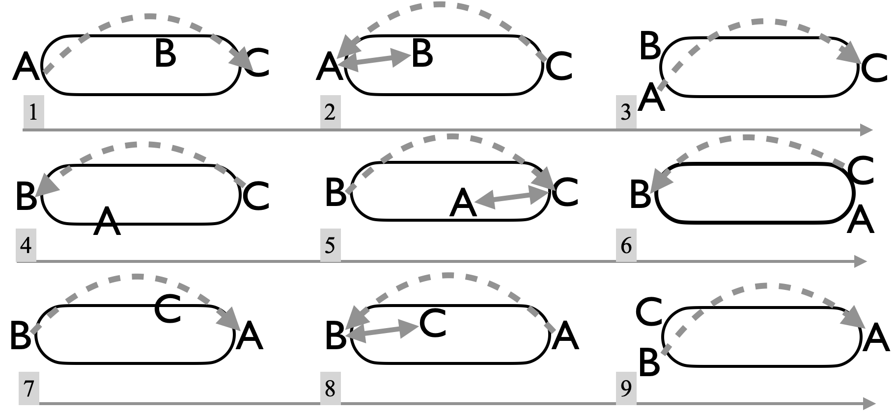  Start in a line, with B and C facing A, who is feeding triple-single to recipients, with B spinning a ½ turn on 6-count (black cells in table) to take up a position next to A while C becomes the new feeder. Be careful to keep your triples from hitting the non-recipient by pushing them toward the new mover!
1 | t-C
2 | B | A | t-A
3 | t-C | ↶
4 |  | ↶ | t-B
5 | C | t-C | A
6 | ↶ |  | t-B
7 | ↶ | t-A
8 | t-B | C | B
9 |  | t-A | ↶
½ way
Feeder cells grey
Mover cells black
Variations: Throw doubles instead of triples (this has the 7-club 4-count cadence for two). Also, a whole bunch of tricks can be done while moving into the center (such as an early triple followed by a pirouette when entering the middle). See also a variation we call Cathedral in the 5 Person Patterns. Why not make it a figure-8?

Metrics: J=3, CJ=3 ⅓, cycle length=18 on 2-count base (½ shown), OJ=2, pH=2 ⅕ , R=1, motion $≃$ 3 pu, assuming A and C start about $\sqrt{2}$ pu apart, spin=2$π$ rad. PBJ=5/18. Pattern by Luke Emery, 1999.

Laura’s Weave  A birthday present with triples |  |  |  |  |  |  | 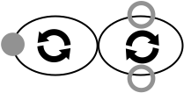
Juggler |  |  |  | 2-count base. A starts right with 4; B & C face A, and start right with 3 clubs each. All passes and some selves are right-handed triples.
Beat | A | B | C | 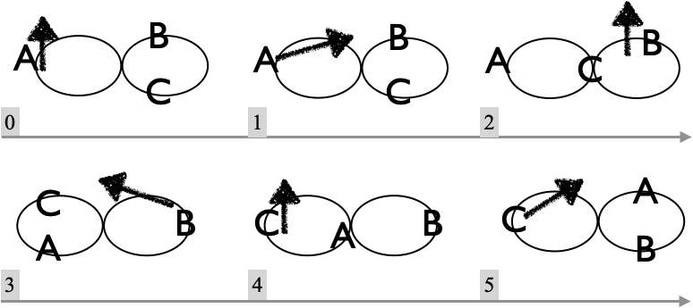
0 | t-self |  | ↶
1 | t-B |  | ↶
2 | ↶ | t-self | ↶
3 | ↶ | t-C | ↶
4 | ↶ | ↶ | t-self
5 | ↶ | ↶ | t-A
½ way
Tripler cells grey
Mover cells black
Start on beat `1` above. In the steady state, it's triple self, triple pass, then four single selves as you move over to the other side, all on right-hand counting. Gazelle-like movement is recommended! (C can cheat by starting next to A.)

This same sequence can be done with straight-up passes in the middle of the weave.

Metrics: J=3, CJ=3 ⅓, cycle length=12 on 2-count base (½ shown), OJ=2, pH=3 , R=1, motion $≃$ 4 pu, spin=2$π$ rad, PBJ=1/12 (not counting triple selves). Pattern by Peter Kaseman, as a birthday present to Laura in 2010.

Graham's 3 stuff

Here are some challenging patterns for 3 jugglers by Graham Paasch, in his original notes.

Change Sides Double-3 Count Feed Plus
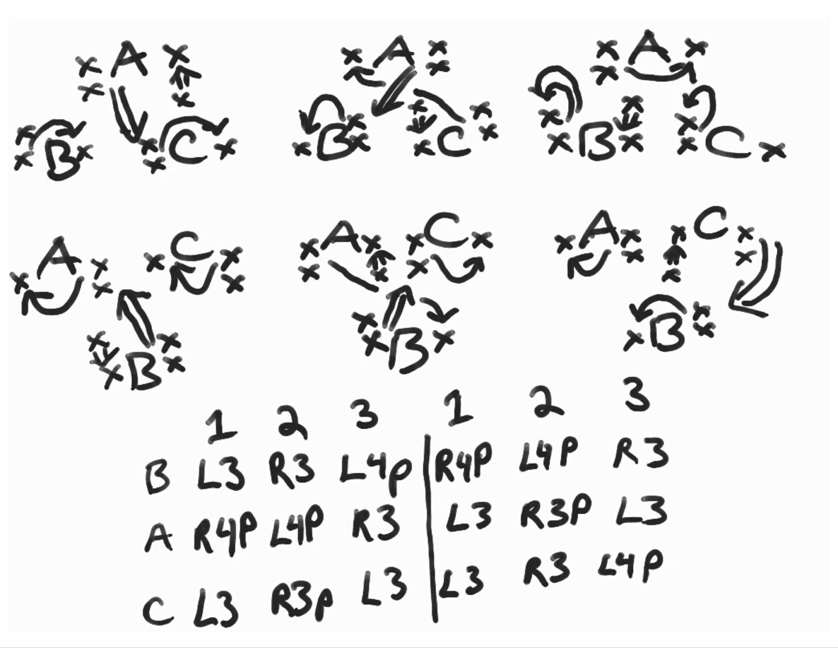
./media/ChangeSidesDouble3FeedPlus.jpg

Change Sides RRLRLRLLRLRL
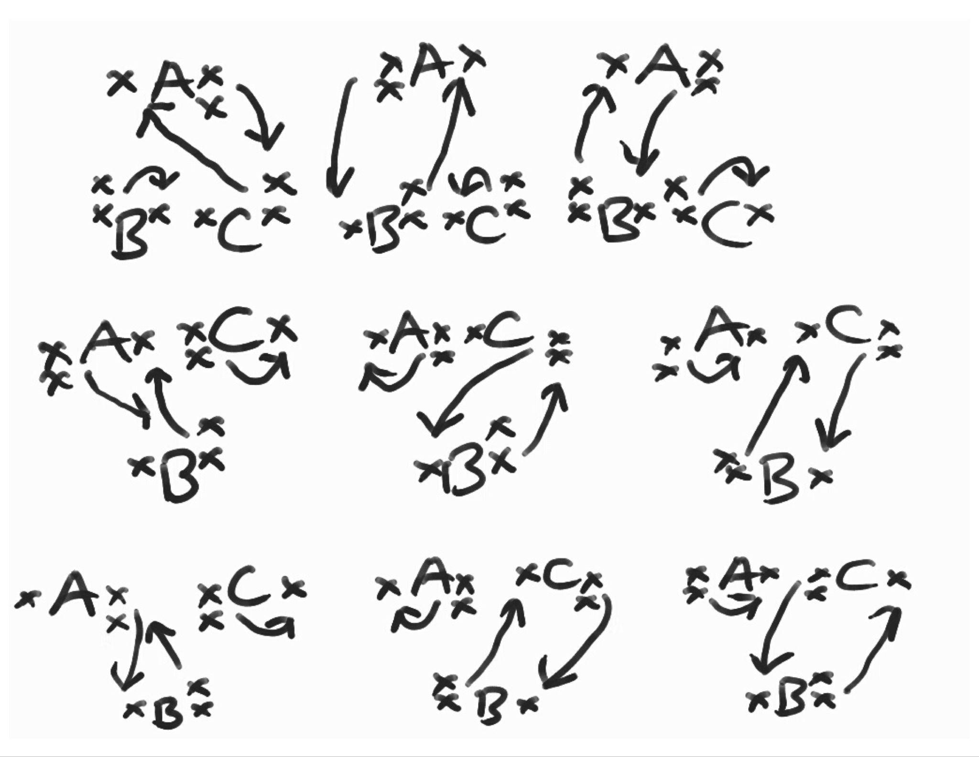
./media/ChangeSidesRRLRLRLLRLRL.jpg

Safe Beast of Arg
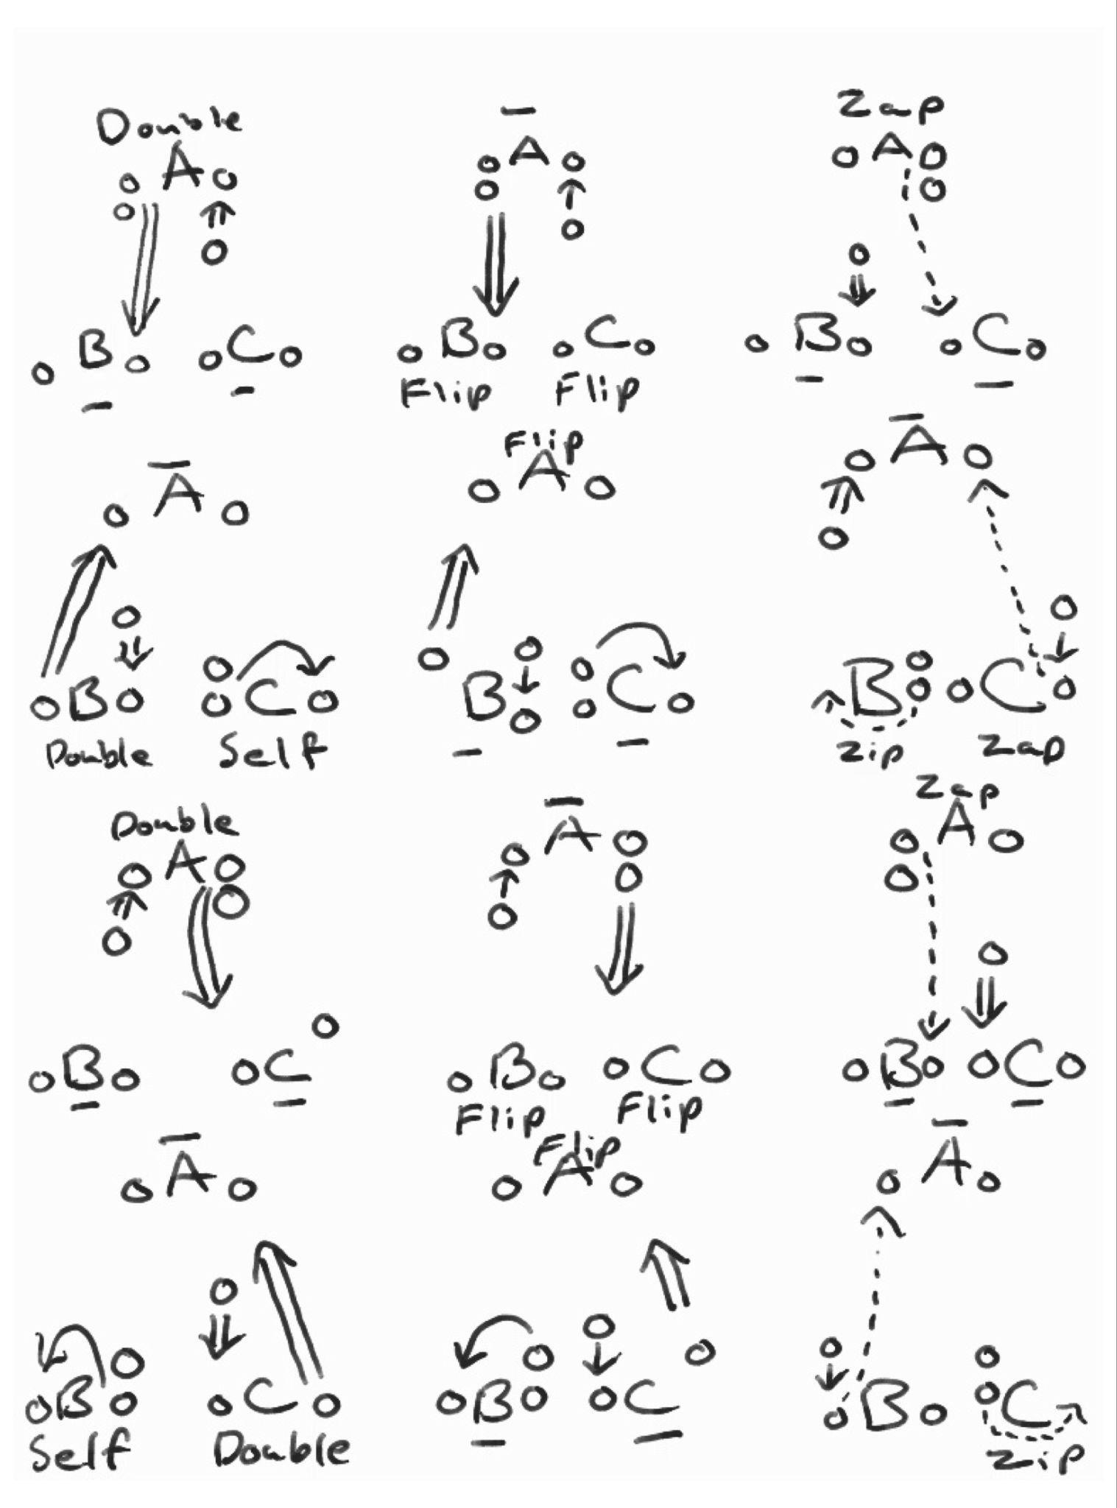
./media/SafeBeastofArg.jpg

Four Person Patterns

Stationary Four Person Patterns (no extra clubs)

Here are some classic arrangements for four stationary jugglers

Box | 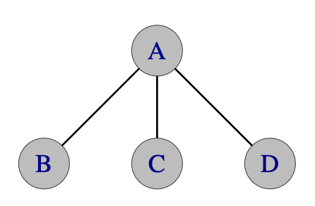  Feed | 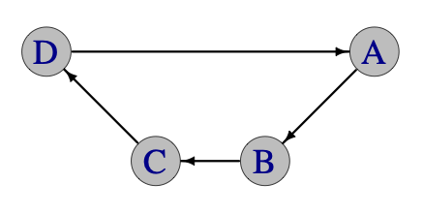  Canoe
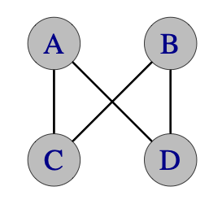  2 v 2 | 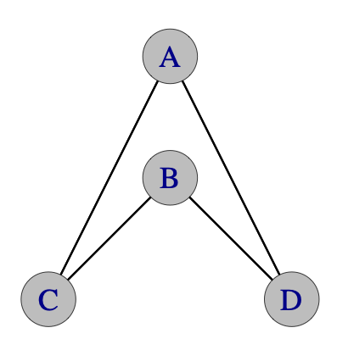  Y (Oogle) | 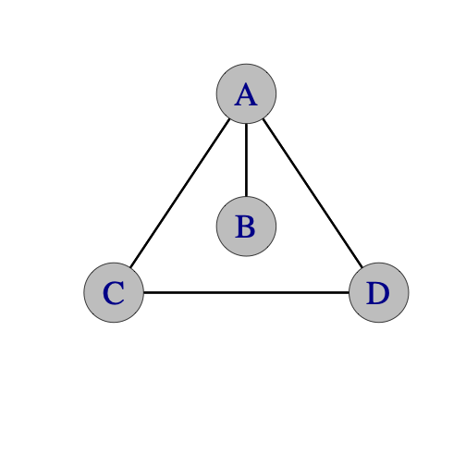  Anklet
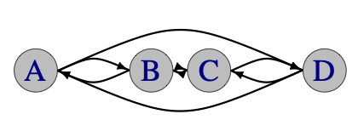
Locked lines
Edges in each graph indicate possible exchanges between the jugglers. Not all edges are active in a given pattern. We sometimes call these who-passes-to-whom graphs, whose average degree is the other jugglers (OJ) metric. As displayed they also encode spatial arrangements.

As shown, the Y format is more of an upside-down Y! In some patterns (e.g. Y2K) B can also send dropbacks to A, though that’s not indicated above.

Feeds
Windshield Wiper Feed |  |  |  |  |  | A (the feeder) faces B, C, and D (the feedees). Usual start is right-handed.  This pattern probably predates all the other 4-person patterns in this chapter! We don’t know its origin story, but it’s a great go-to for 4 and a prerequisite for all kinds of other patterns. 2-count lefts is good practice! Other count bases are possible but rarely done except for the 1-count, ultimate feed; where C does 2-count lefts and B and D do 4-count.
 | Beat, 2-count base
 | Juggler | 1 | 2 | 3 | 4
 | A | B | C | D | C
 | B | A
 | C |  | A |  | A
 | D |  |  | A
Metrics: J=4, CJ=3, OJ=3/2, cycle=4 on 2-count, pH=1, PBJ=8/(16*base) [¼ in 2-count; ½ on 1-count], R=3, motion=0, spin$≃$27° [owing to A’s sweeping through 4$θ$, where cos$(θ)=2/\sqrt{5}$; this follows when B and D set up at the same distance as A and C.]

Typewriter Feed |  |  |  |  | Also called the carriage return feed; both names make sense if you ever used an old-fashioned typewriter! A (the feeder) faces B, C, and D (the feedees). The 1-count base version has the feedees doing 3-count, which is nice; such a 1-count base is also called an ultimate feed, and is a pre-requisite for El Nino and other cool moving patterns.
 | Beat (2-count base)
 | Juggler | 1 | 2 | 3
 | A | D | C | B
 | B |  |  | A
 | C |  | A
 | D | A
Metrics: J=4, CJ=3, OJ=3/2, cycle=3 on 2-count, pH=1, PBJ=6/(12*base) [¼ in 2-count; ½ on 1-count], R=2, motion=0, spin$≃$27°, as in Windshield Wiper.

Boxes
Even though they mostly predate the MAJ, these patterns are go-to’s for 4 jugglers of any level, especially to get warmed up before a moving pattern!
Standard Asynchronous Box  A starting point for 4 |  |  |  | A box is characterized by having jugglers face and pass to each other as in the figure, on opposite ends of a box’s diagonals. Later we talk about box-like patterns where passes go along the perimeter, but they are less boxy!  In the standard 2-count asynchronous box, A-B are out of phase from the D-C pair; i.e. one pair is on lefts while the other is on rights. Purists like to have A-B starting each with 2 in the right hand and passing, while D-C start with two in the left at the same time and selfing, but it’s easier for D-C just to watch and throw from right on queue (i.e. when A-B are on their first left self).
Beat, base count
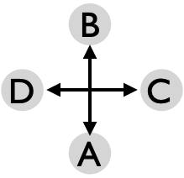 | Juggler | 1 | 2
 | A | B
 | B | A
 | C |  | D
 | D |  | C
Any regular count slower than 1-count involves gaps, and so the pairs may be offset for a successful box; e.g. 2-count lefts, and 3-count work nicely. But the gaps need to balance out; e.g., 3/2 count doesn’t work for both pairs because if A-B do 3/2 then there’s only 1 gap in 3 beats for D-C [but D-C can do 3-count in that case] (e.g., we recently did a Why Not box!) The 4-count box is a great place to start, and it’s also a popular box when you have audience volunteers (e.g., revelling students on Library Mall). You put the volunteer right in the middle and pass around on all sides! Remember when Mel dinged one of the Channel 15 news anchors in the head! (Was it Mike McKinney?) Pistons and the Minuet are moving patterns derived from the asynchronous box.

Metrics: J=3, CJ=3, OJ=1, pH=1, R=1, cycle=2, standard 2-count box is on a 1-count base, PBJ=½ [generally, 1/(2*base)], motion=0, spin=0.

Standard Synchronous Box  It’s about timing |  |  | Now the A-B pair is doing exactly the same thing as the D-C pair, and at the same time. The jugglers can pass on any standard timing (1-count, 2-count, 3-count are most common). Owing to the synchrony, collisions are much more likely, and wide throws reduce collision risk. A good technique to regulate the timing is to focus on the pass release by the person to your right (at least at right-handed throw beats). Your release should be synced with theirs, and then your club will pass just behind their club, owing to the configuration
Beat, base count
 | Juggler | 1
 | A | B
 | B | A
 | C | D
 | D | C
Metrics: J=3, CJ=3, OJ=1, pH=1, R=1, cycle=1, standard 2-count box is on a 2-count base, PBJ=½ [generally, 1/(base)], motion=0, spin=0.

Less Boxy Boxes
Set up like a Box, but passes include those along the perimeter as well as across the diagonal.
Rotating feed (for 4 )  An ancient pattern |  |  |  |  |  |  | Though easier to juggle than related patterns like the Feast (below), this one requires more attention to keep track of who is feeding, which makes it a bit more error prone!
Juggler
Beat | A | B | C | D | In the table, the active feeder is highlighted in dark grey.
1 | D |  |  | A | Juggler A starts the feed, sending passes from their left to right (clockwise from above), with the pass to the final feedee converting that juggler into the new feeder. The feeder position quietly circulates counter clockwise, even though each feeder is sending passes clockwise. Rotating feed (both directions work; left-right from feeders perspective is shown)  Beat is the preferred count (often a right-hand 2-count base)  Metrics: J=4, CJ=3, OJ=3, pH=1, R=1, cycle=8 on base count, PBJ=¼ on 2-count base, motion=0, spin= $π$ rad (i.e., ¼ turn and back).
2 | B | A
3 | C |  | A
4 |  |  | D | C
5 |  | C | B
6 | B | A
7 |  | D |  | B
8 |  |  | D | C

Feast (for 4)
Everyone feeds everyone else!
 | Beat (base) |  |  |  | Any agreeable count works. 4 count is nice for rookies, but 3-count is more popular in Madison.
Juggler | 1 | 2 | 3 | 4
A | D | B | C
B | C | A | D |  | This version is clockwise (from above); counterclockwise works too. For beginners, the Feast is a notch harder than the asynchronous box because you have to swivel through 90 degrees during each cycle.
C | B |  | A | D
D | A |  | B | C
Metrics: J=4, CJ=3, OJ=3, pH=1, R=1, cycle=4 on base count, PBJ=3/(4*base), e.g., ¼ on 3-count, motion=0, spin= $π$ rad (i.e., ¼ turn and back).

Picnic
Picnic is a nice 3-count variation where A and C start passing crosses (right-right or left-left) and B and D start with straight passes. When you complete your cycle and restart after your self beat, you switch from whatever you were doing (e.g. crosses then straights, or straights then crosses).

Bermuda Quadrangle
Tricky angles!
 | Beat, 1-count base |  |  |  |  | Right-hand start is standard.  Pattern by Laura and Becky Provance, Barry Friedman, and Steve Otteson.  Metrics: J=4, OJ=3, CJ=3, pH=1, R=1, cycle=4, PBJ=¾, motion=0, spin= $π$ rad.
 | Juggler | 1 | 2 | 3 | 4
 | A | B | C | D
 | B | C |  | A | D
 | C | A | D |  | B
 | D |  | A | B | C

Maya  A gift from Tom |  |  |  |  |  |  |  | Right-hand start is standard.  Metrics: J=4, CJ=3, OJ=3, pH=1, R=1, cycle=6, PBJ=⅔, motion=0, spin= $π$ rad.  Maya by Tom Pomraning (`Coach`) was published in Jugglers World [**date**]. Tom was an incredible chocolatier and juggler!
 |  | Beat, 1-count base
 | Juggler | 1 | 2 | 3 | 4 | 5 | 6
 | A | D |  | B | C |  | B
 | B | C |  | A | D |  | A
 | C | B | D |  | A | D
 | D | A | C |  | B | C
Interlocking Triangles |  |  |  | 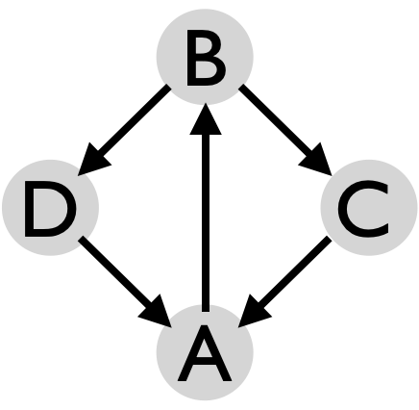
Beat, 2-count base
 | 1 | 2
A | B | B | Metrics: J=4, CJ=3, OJ=3/2, pH=1, R=3, cycle=2 on 2-count base, PBJ=¾ motion=0, spin>0 only for B, whose spin is $π$ rad (so whole pattern spin=$π/4$ rad).  D and C don’t spin, by our motion model, but their heads are swivelling to catch and release on the sharp corner
B | D | C
C |  | A
D | A

Rush and Rest
The Rush and Rest patterns are box-like with everyone doing 4 of 6 passing beats, with a 1-count section (rush) followed by an easier section (rest).
Original |  |  |  | Beat, 1-count base |  |  |  |  |  | Metrics: J=4, CJ=3, OJ=3, pH=1, R=1, cycle=6 on 1-count base, motion=0, PBJ=⅔, spin=$π$ rad, which curiously are the same for all variations shown here. Goes to show that there’s more to a pattern than the metrics!  Since Steve Otteson left Madison we don’t juggle these so often.
 |  | Juggler |  | 1 | 2 | 3 | 4 | 5 | 6
 |  | A |  | B | C | B |  | D
 |  | B |  | A | D | A |  | C
 |  | C |  |  | A |  | D | B | D
 |  | D |  |  | B |  | C | A | C
1st variation, feast-like |  |  |  |  |  |  |  | 2nd variation
 | 1 | 2 | 3 | 4 | 5 | 6 |  |  | 1 | 2 | 3 | 4 | 5 | 6 | Patterns by Steve Otteson and MAJ, 1998
A | B | B | C |  |  | D |  |  | D | D | B |  | C |  | Patterns by Steve Otteson and MAJ, 1998
B | A | A | D |  |  | C |  |  | C | C | A |  | D |  | Patterns by Steve Otteson and MAJ, 1998
C |  |  | A | D | D | B |  |  | B | B |  | D | A |  | Patterns by Steve Otteson and MAJ, 1998
D |  |  | B | C | C | A |  |  | A | A |  | C | B |  | Patterns by Steve Otteson and MAJ, 1998

Gustav **LUKE, PLEASE CHECK; I THINK D/B need to switch?**
 |  | Beat (both hands counting)
 | Juggler | 1 | 2 | 3 | 4 | 5 | 6
 | A | t-D |  | C | t-D |  | C
 | B | D |  | D
 | C |  |  | A |  | A
 | D | B | t-A |  | B | t-A
- This is a double 3 count extra club3 extra clubs?check
- Both hands counting
- A starts with 4 clubs, and throws triple crosses
- B throws triple straights
- C and D start slightly after A and B – timing is a bit wonky **Are they doing singles or triples?**
- Pattern by Luke Emery, 2008, and named after the hurricane

Two on Two Double Three Count |  |  |  |  | Let’s start eliminating those self throws!
 | Beat, 1-count base |  |  |  | Right-hand start is standard. All jugglers do 3/2 count.  This is the left-to-right feed version, but right-to-left works too. It’s a pre-req for El Nino, La Nina, Martin’s Madness, and lots more.  Dates to July 1997 in MAJ, but probably earlier by others
 | Juggler | 1 | 2 | 3
 | A | C |  | D
 | B | D | C
 | C | A | B
 | D | B |  | A
Metrics: J=4, CJ=3, OJ=2, PBJ=⅔, pH=1, R=1, cycle=3 on 1-count, motion=0, spin=$π/3$ rad.

Y (aka Oogle) |  |  |  | Comfort for 4.
 |  | Beat |  | On whatever count you prefer (e.g. 3-count is pleasant), pass as tabulated, noting you pass to a different person than you receive from. B has to relax as they receive crossing throws from close range. C and D have to take care with long passes to A and lofty passes to B.
 | Juggler | Right | Left
 | A | C | D
 | B | D | C
 | C | B | A
 | D | A | B
This stationary Y is the basic building block for the Oogle Boogie moving patterns.

Metrics: J=4, CJ=3, pH=1, cycle = 2 (1) on odd (even) base, OJ=2 (1). PBJ=1/base. R=1, aside from slight spin variations, and motion=0. Standard positioning puts the angle ∠ACB at $φ=asin(1/4)≃$ 0.25 rad (14.5°), and ∠ACD about 1.3 rad (75.5°), making the following spins for one (odd-count) cycle: A: 4$φ$, B: 8$φ$, C and D: 2$φ$, giving the pattern spin = 4$φ$$≃$58°. (spin=0 for even count.) [distance A to C = $\sqrt{2}$ pu, distance C to D = $1/\sqrt{2}$ pu]

Goofy Variation: Have B juggle out-of-phase, releasing lefts whenever everyone else releases rights. Then passes to and from B have to cross (e.g., right-to-right or left-to-left), but B’s position allows that to proceed without difficulty!

Luke’s Oogle  Dropbacks are fun. |  |  |  |  |  | Set up as shown with right-hand start, and with B eventually passing dropbacks (right-to left and left-to-right) to A. 3-count is standard, but 5-count is nice. You can piece together rearrangements like in Oogle Boogie.  Pro tip: For B’s dropbacks, bring the throwing hand close to your nose and release the club as late as possible without hitting yourself!  Pattern by Luke Emery, 1998.
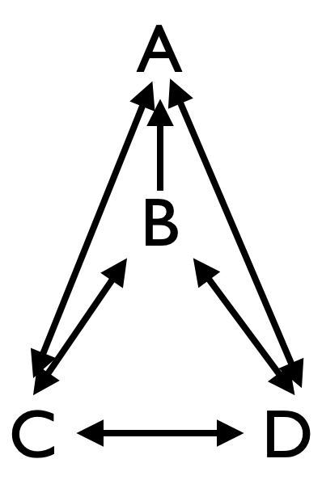 |  | Beat (3-count base)
 | Juggler | 1 | 2 | 3 | 4
 | A | C | D | C | D
 | B | D | C | A | A
 | C | B | A | D | B
 | D | A | B | B | C
Metrics: J=4, CJ=3, OJ=11/4, pH=1, R=3, cycle=4 (odd count), PBJ=1/count, motion=0. Referring back to the Y, juggler spins are: A: 4$φ$, B: 0, C & D: 10$φ$, so pattern spin=6$φ$$≃$87°.

Y2K |  | The dropbacks and dropforwards make this one of the most difficult non-extra-club stationary patterns that we know!
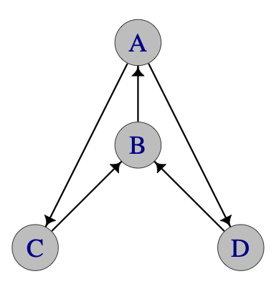 |  | Juggler |  |  |  | A and B are out of phase from C and D, as in call-response.  Pattern by Prof Mike, December 31, 1999 (hence the name!).  Doable if Peter Kaseman is B!
 | Beat | A | B | C | D
 | 1 |  |  | B | B
 | 2 | C,D | A,A
Version 1
  - A and B both face same direction, towards C and D
  - Synchronous 1-count passes from A to C and D
  - Synchronous 1-count dropbacks from B to A
  - C and D are on crossing 2-count
  - C on 2-count rights to B’s right hand
  - D on 2-count lefts to B’s left hand
Version 2
  - B, C, and D all face A
  - A passes synchronous 1-count to C and D as before
  - B passes synchronous 1-count to A
  - C and D drop forward over B’s shoulders to B!
At B’s discretion, B rotates ${180^{0}}^{}$so as to alternate between version 1 and version 2! The passer-receiver pairs are all the same in the two versions, but B is turned around! Y2K generalizes the synchronous 1-count feed, so it’s a call-response pattern (i.e., passer/receiver’s are offset wrt release time). Switch positions so that everyone can experience the challenge!

Metrics: J=4, OJ=5/4, CJ=3, pH=1, cycle=2 on 1-count base, PBJ=¾, R=3, motion=0. Ignoring B’s pirouette to change versions, juggler spins are all 0, since no directional changes occur within a cycle.

Canoe | Have 2 dropbackers and 4 passers? This could be for you!
 |  | Beat | A is facing B, C, and D, who are all facing A. On whatever count you like, proceed as above. B and C are passing dropbacks. You can add extra clubs or people and use a variety of passing counts. Switching direction might do better for this shape with right-hand passes. Unknown origin, but we have been doing it since at least 1993.
 | Juggler | 1
 | A | B
 | B | C
 | C | D
 | D | A
Metrics: J=4, CJ=3, OJ=1, cycle=1, R=2, PBJ=1/count, pH=1, motion=0, spin=0.
The difficulty is in dropbacks!

Anklet  4 person variation of the 6 person Argyle Sock |  |  |  | This is a good stationary pattern to sharpen your 3-count/double-3-count passing.
 |  | Beat (1-count base) |  |  |  |  |  | All jugglers are synced up, with B facing A.  Pattern by MAJ.
 | Juggler | 1 | 2 | 3 | 4 | 5 | 6
 | A | C | B |  | D | B
 | B |  | A |  |  | A
 | C | D | D |  | A | D
 | D | A | C |  | C | C
Standard version: The corners A, C, D are doing a 3-count outside triangle, and A picks up an extra 3-count with B, so A is doing 3/2 count. (In this version the extra, “grey” passes don’t happen between D and C.) Harder version: Everyone except B does 3/2 count (i.e., include “grey” passes)
Metrics: J=4, CJ=3, pH=1, OJ=2, cycle=6 on 1-count, PBJ=5/12 (standard); 7/12 (harder), R=3, motion=0, spin=$2π/3=$120° per corner and 0 for B, gives spin=$π/2$=90° .

Extra Club Four Person Stationary Pattern

Extra Club Boxes
Classic patterns for four
J=4, OJ=1, R=1, cycle=2, motion=0, spin=0
14 club box (standard): Set up is basically like the Standard Asynchronous Box, but jugglers A and D start each with 4 clubs. To find the best gaps and avoid collisions, each juggler keeps an eye on the juggler to their right (in the right-handed version!), and releases their double straight pass just after that next-spot juggler so that the clubs cross passing lines in an orderly fashion. With the right-handed version, A starts and passes a double to B; then at about a ¼ beat, D passes a double to C; by then B is ready to respond to A while also being behind C, so B passes next back to A; finally B chases C and passes back to A to complete the cycle. Simply, chase the person on your right. Collisions happen when someone misses a gap, so make sure you keep an eye on each release on the right side (rather than on the mess of clubs in the middle). Timing can get screwed up too if one pair juggles higher than another, but when it works it’s a beautiful pattern. The Mad-5 did a version where after 10 rights, one of each pair would collect all 7 clubs, and spin to show the collected clubs for a rousing applause!
Metrics: CJ=3 ½, pH=2, PBJ=½
14 club box (4-count): The 4-count means it’s easy; there are big gaps for each pair to use (more juggling with oneself, and less opportunity for exciting collisions!). But the timing and extra clubs make this challenging; usually it’s done with triples, but doubles are possible for passers with better hand speed! The two pairs are 1 beat away from each other (A and B's rights are synchronized with C and D's lefts).
Metrics: CJ=3 ½,, pH=2, PBJ=¼
16 club box (standard): A thing of beauty! There are variations for the talented numbers jugglers, but the one we like is set up like the 14 club box, but with A and D doing triples and C and B responding with singles. Nice steady triples are key; chasing your neighbor on the right is the same rule as before, but it’s harder to keep triples steady. All jugglers tend to stare at the triples, and it’s easy for the single passers (B and C) to over charge their singles. Triplers start, with D chasing A; singlers should wait as long as possible to release on the start.
Metrics: CJ=4 (that’s big!), pH=2 (averaging triples and singles), PBJ=½.
Really hard boxes! You can also do a 16 club box pattern with all the jugglers synchronized in 8 club 2-count singles, doubles or triples. Nice! Pass either straight across, or to the juggler on the left. With 9 club triples 2 count and each juggler offset ½ beat, you get an 18-club box! If the timing is perfect, it is possible to do a 14 club box in 1-count, with right hand doubles across the box and left hand singles along the edges of the box (BUT THEN YOU PASS TO TWO PEOPLE, SO NOT WE DESCRIBE LATER)

Extra Club Less Boxy Boxes!

Spider Web
 |  | Beat (both hands counting)
 | Juggler | 1 | 2 | 3 | 4
 | A | t-C |  | d-B
 | B |  | t-D |  | d-C
 | C | d-D |  | t-A
 | D |  | d-A |  | t-B
- 15 clubs (3 extra)
- Both hands counting, passes with rights
- A and C start with right; B and D start with left
- A, B, and C start with 4 clubs
- Check with Luke on origin and start for B; is this coded correctly? Seems like triples should cross and doubles should go right…

And
more [include Luke’s 14-club 1-count box from V3.0 ****CHECK WITH LUKE on Version 3.0 book entry*
Throw a little wide on the double passes and make sure that everyone has
metronome perfect timing and it actually works! Pattern by Luke Emery, 2007. **Q. Luke. C is not on A's left; should C-D swap?**

Extra Club Feeds

Typewriter Extra Club Feed |  |  |  |  |  |  |  | Feeder A starts with 4, passing doubles left-to-right (in version shown) to feedees B, C, D, who do 6-count doubles in return.  Feedees are out-of-sync with A, releasing lefts on A’s rights. Passes by C and D ought to be lofty/deep to avoid collisions with A’s passes to B and C.
All throws are straight doubles | Beat, 1-count base
 | Juggler | 1 | 2 | 3 | 4 | 5 | 6
 | A | D |  | C |  | B
 | B |  | A
 | C |  |  |  | A
 | D |  |  |  |  |  | A
Metrics: J=4, CJ=3 ¼, OJ=3/2, cycle=6 on 1-count, pH=2, PBJ=¼, R=2, motion=0, spin$≃$27°, as in other 1-v-3 feeds.

Ultimate Feed Plus
**Luke, are these good for both windshield wiper and typewriter?**

Add one extra club to the Ultimate Feed by having all the feedees throw crosses. Alternatively (the feeder can throw crosses while the feedees throw straight). The extra club feed can be done with many different spins.
- All passes in singles. (Timing is a bit wonky. Throw a little outside, especially on the middle throws.)
- Feeder and feedees all in double passes. (Feeder rights synchronized with feedee lefts.) Feels like 7 club 3-count.
- Feeder in triples ultimates, feedees in singles. (Feeder rights synchronized with feedee rights.)
- Feeder in single ultimates, feedees in triples. (Feeder rights synchronized with feedee rights.)

Ultimate Feed Plus Plus

- To add another club (14 total), throw all passes as doubles and all passes are straight from both feeder and feedees.

- Theoretically you could keep adding more clubs and higher throws, and just switching back and forth from straight to cross feedee passes with each extra club, but it gets challenging quickly.

Popcorn Feed  Get those triple self throws working! |  |  |  |  |  |  |  | Feeder A starts with 4 clubs and passes right doubles to the line in a (backwards) typewriter feed.  Feedees each do 6-count popcorn.
 |  | Beat, 1-count base
 | Juggler | 1 | 2 | 3 | 4 | 5 | 6
 | A | d-B |  | d-C |  | d-D
 | B |  | t-self |  | d-A
 | C |  |  |  | t-self |  | d-A
 | D |  | d-A |  |  |  | t-self
Recall that 6-count popcorn between 2 jugglers is a 7-club pattern where each juggler passes a double spin to partner, a single spin to self, and a triple spin to self, with the two jugglers out of phase (i.e., rights of one release on lefts of the other). Think 3-2-1 out of the right; the left hand throws are all single spin self throws. The triple self gets released in response to the incoming double from the feeder. Note the feedees distribute the three popcorn throws 3-2-1 among themselves on the right-hand beats. Works well when A sends crispy doubles!

This is a spectacular pattern, and could be a basis for a popcorn El Nino (future work!)
Variation: Low Popcorn Feed: Do single passes and double selves instead of doubles/triples. It’s fast!
Metrics: J=4, CJ=3 ½, OJ=1 ½, pH=2, cycle=6, R=2, PBJ=¼, motion=0, spin=27°

Gorilla (for 4) |  |  |  |  |  | This is an MAJ variation on the 3-person Gorilla, involving 1 extra club.  E.g., C,xD means A passes right to C’s left at the same time as a (x) crossing left to D’s left.
 | Juggler | Beat, 1-count base
 | A | C,xD |  | B,xC
 | B |  |  |  | Ax
 | C |  | xA |  | A
 | D |  | A
A starts with the extra club and throws synchronous ultimates. C throws right handed 2-count. B and D throw right handed 4-count.

A throws synchronous ultimates to C's left hand and D's left hand; then synchronous ultimates to B's left hand and C's left hand. C starts a little after A's first throws, with a right hand throw to A's right hand, then the next right hand throw is to A's left hand. In the steady state, C alternates feeding A's right hand and A's left hand with 2 count right hand throws.
D starts a little after A's first throw (in time with C) and throws to A's left hand. (B and D could switch, at greater collision risk.) After that, D stays in 4 count with A's left hand. B starts a little after A's first throw with a right hand self. After that, B does 4-count with A's right hand.
Metrics: J=3, CJ=3 ¼, R=3, pH=1, cycle=4, OJ=3/2, PBJ=½, motion=0, spin=27°
LUKE PLEASE CHECK

1-count base/juggler |  |  |  |  | Extra club rotating feed (4)
Beat | A | B | C | D | All throws are right-hand straight doubles.  d-s indicates double right-left self throws.  – indicates pause to reset left/right timing.
1 | B |  | d-s
2 |  | A | __ | d-s
3 | D |  |  | __ | A starts with 4 clubs, A and B start with right hand, C and D start with left hand. The steady state right-hand sequence is: pass across, pass left, self, pass across, self.  Metrics: J=4, CJ=3 ⅓, pH=2, OJ=2, R=1, cycle=12 on 1-count, PBJ=¼, motion=0, spin=$π$.  Pattern by Luke Emery, 1999.
4 |  | d-s | A
5 | d-s | __ |  | C
6 | __ |  | C
7 |  | C |  | d-s
8 | B |  | d-s | __
9 |  | A | __
10 | d-s |  |  | C
11 | __ | d-s | A
12 |  | __ |  | B

Extra club Y’s (Slingshots)

Slingshot |  |  |  | 14 club variation of the Y (Oogle).  Usually right-hand counting (could be left!). All jugglers are synced up, with A and B facing C and D. A starts with 4 clubs and does a triple feed to C and D. D starts with 4 and feeds triples to A, singles to B. C has a similar job to D, but starts with single to B. B feeds C and D in singles.  By Peter Kaseman, 1999.
 | Beat (2-count base)
 | Juggler | 1 | 2
 | A | t-C | t-D
 | B | C | D
 | C | B | t-A
 | D | t-A | B
Metrics: J=4, CJ=3 ½, OJ=2, cycle=2 on 2-count, pH=2, R=3, PBJ=½, motion=0, spin=58°.

Slingshot Minus
 |  | Beat (2-count base) |  |  |  | 13 club variation of Slingshot; should be easier!  Usually right-hand counting (could be left!)  D starts with 4 clubs; all jugglers on 4-count
 | Juggler | 1 | 2 | 3 | 4
 | A |  | t-C |  | t-D
 | B | C |  | D
 | C | B |  | t-A
 | D | t-A |  | B
Metrics: J=4, CJ=13/4, OJ=2, pH=2, R=3, cycle=4 on 2-count, PBJ=¼, motion=0, spin=58°

Slingshot Plus
 |  | Beat (1-count base) |  |  |  | 14 club variation of Slingshot Minus; should be easier!  Both hands counting; all jugglers in 2-count rights. B starts left handed, and then proceeds in 2-count doubles rights to C and D
 | Juggler | 1 | 2 | 3 | 4
 | A | t-C |  | t-D
 | B |  | d-C |  | d-D
 | C | d-B |  | t-A
 | D | t-A |  | d-B
Metrics: J=4, CJ=7/2, OJ=2, cycle=4 on 1-count, pH=2.5 (that’s high!), PBJ=½, motion0, spin=58°.

Slingshot Plus Plus  Triple time! |  |  |  | All right hands are triple passes  All jugglers are synced up, with A and B facing C and D. All jugglers start with 4 clubs and do 2-count rights. A does a triple feed to C and D (as above).  Prerequisite: 8-clubs triple passing with partner  Created June, 1999 by MAJ.
Beat
(2-count base)
 | Juggler | 1 | 2
 | A | t-C | t-D
 | B | t-D | t-C
 | C | t-B | t-A
 | D | t-A | t-B
Metrics: J=4, CJ=4, OJ=2, pH=3, R=3, cycle=2 on 2-count base, PBJ=½, motion=0,spin=58°

Extra Club Lines
Death from Above  Triples back-to-back! |  |  |  | This is a fun but challenging pattern with 2 extra clubs. It requires two jugglers who are comfortable with 7 clubs 4-count back to back passing and who aren't pansies like some Madison Area Jugglers I could mention!  Pattern by Luke Emery, 1999.
A faces B  B and C are back-to-back  C faces D |  | Beat  2-count base
 | Juggler | 1 | 2
 | A | t-D | B
 | B | t-C | A
 | C | D | t-B
 | D | C | t-A
A and B start with 4 clubs each and start passing at the same time. C and D each start with 3 clubs. A passes triple to D, then single to B. B passes triple back-to-back to C, single to A. C passes single to D, triple back-to-back to B. D passes single to C, triple to A.
Metrics: J=4, CJ=3 ½, OJ=2, cycle=2 on 2-count, pH=2, R=2, motion=0, spin=0

Locked Lines |  |  | A and B face right;  C and D face left; 2 extra clubs
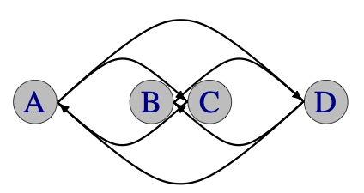 |  | Beat, 1-count base |  |  |  | All passes right-hand doubles; A and B each start with 4; C and D start with 3, with left-hand self on beat 1.
 | Juggler | 1 | 2 | 3 | 4
 | A | d-C |  | d-C
 | B | d-D |  | d-D
 | C |  | d-A |  | d-A
 | D |  | d-B |  | d-B
To avoid dangerous collisions, A and B should throw at exactly the same time, and C and D should respond at exactly the same time. A and D can control the timing the best since they have the best visibility.
Variation: Do 4-count triples instead of 2-count doubles (performed by Steve, Mike, Nick, and Keenan in the 2025 Madfest show.)
Metrics: J=4, CJ=3 ½, pH=2, OJ=1, cycle=4 on 1-count, PBJ=½, R=1, motion=0, spin=0.

Popcorn Lines
 |  | Beat, 1 count base |  |  |  | A and B face right; C and D face left; passes are rights  B and C start with 4; A and D start with 3
 | Juggler | 1 | 2 | 3 | 4
 | A |  | t-self |  | d-C
 | B | d-D |  | C
 | C | d-A |  | B
 | D |  | t-self |  | d-B
Version 2 |  |  |  |  |  | Common metrics:  J=4, CJ=3 ½, cycle=4 on 1-count, R=2,  motion=0, spin=0
OK, this is a non-trivial stationary pattern!  Variation: Switch back and forth between the two versions! | A |  | t-D |  | d-C
 | B | d-D |  | C
 | C | d-A |  | B
 | D |  | t-A |  | d-B
Other Metrics: v1: OJ=3/2, PBJ=⅜, pH=10/6. v2: OJ=2, PBJ=½, pH=2

Popcorn Dropback Lines  B and C throwing dropbacks! |  | → ← |  |  |  |  | A and B face right; C and D face left (from reader’s perspective!)  All right-hand throws.
A and D start with 4,  B and C start left with 3.  Shifting B and C off the line to be more diamond shaped helps.  t-S = triple self |  | Beat, 1-count base |  |  |  |  |  | Common Metrics: J=4, CJ=3 ½, cycle=6 on 1-count, motion=0, spin=0.  Version 1: pH=2, OJ=1, PBJ=⅙.  Version 2: pH=2.5, OJ=2, PBJ=⅓  Version 3: pH=2.2, OJ=2, PBJ=5/12  A big difficulty is in the triple self throws (they’re not counted as passes in the standard metrics!).  Well the dropbacks are hard too!
 | Juggler | 1 | 2 | 3 | 4 | 5 | 6
 | A | d-C |  |  |  | t-S
 | B |  | t-S |  | d-A
 | C |  | t-S |  | d-D
 | D | d-B |  |  |  | t-S
Version 2 [triples over the top!]
 | A | d-C |  |  |  | t-D
 | B |  | t-C |  | d-A
 | C |  | t-B |  | d-D
 | D | d-B |  |  |  | t-A
Version 3 [why not add more passes!]
 | A | d-C |  |  |  | t-D
 | B |  | t-C |  | d-A |  | C
 | C |  | t-B |  | d-D |  | B
 | D | d-B |  |  |  | t-A

Other oddities

***********NEEDS CONFIRMING************************************************************
Luke: Not sure if I believe this one!!

Here’s a 4 person variation of one of the 3-person classics by Martin Frost!

Martin's Madness/Mildness
 | Beat (both hands counting)
Juggler | 1 | 2 | 3 | 4 | 5 | 6 | 7 | 8 | 9 | 10 | 11 | 12
Al
Ar
Bl
Br
Cl
Cr
Dl
Dr
- 12 clubs
- Both hands counting; right hand starts

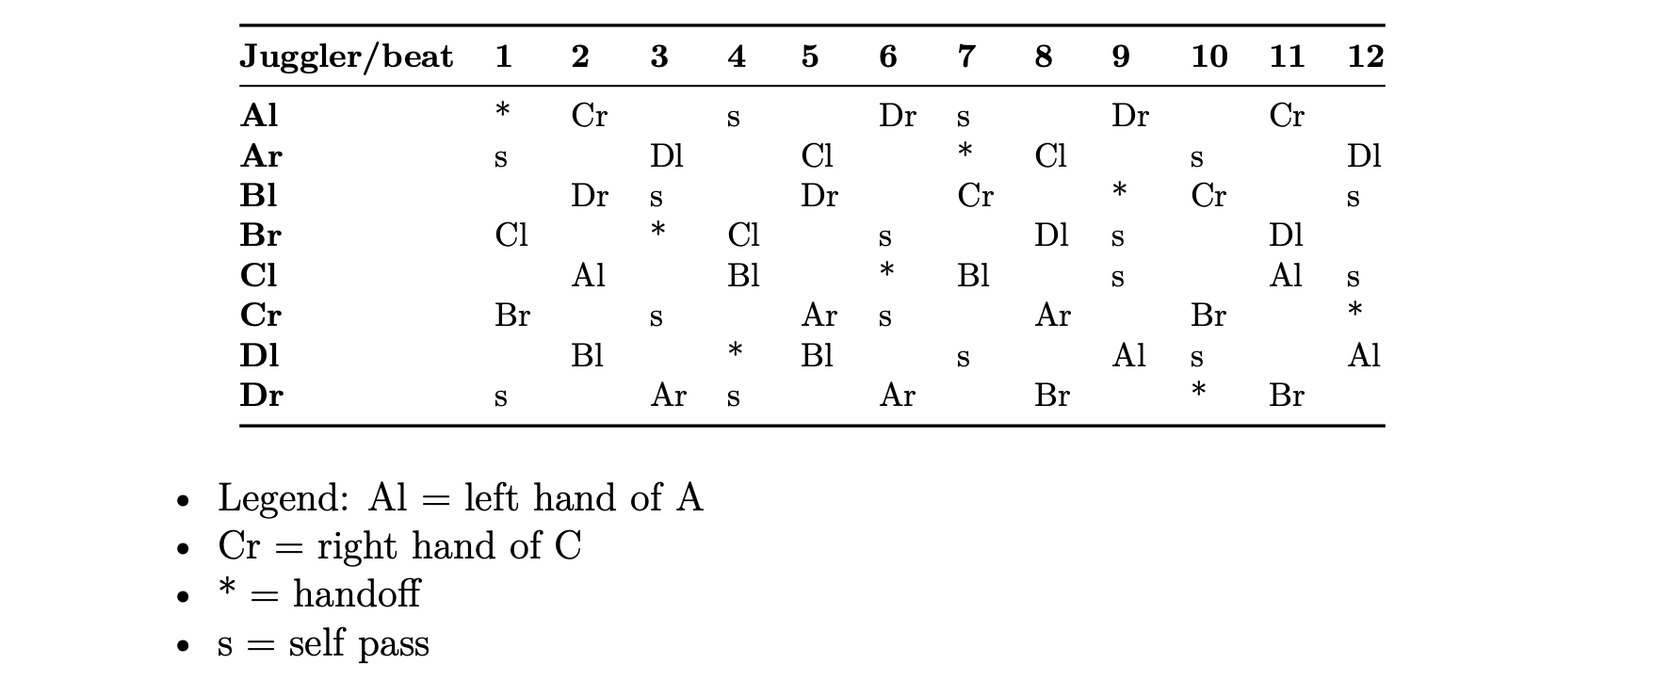

After we learned Martin's Madness, we put 4 jugglers in the positions shown and
tried to figure out if all 4 jugglers could be the feeder as in Martin's Madness
at the same time. The pattern below is what we ended up with.

Notes:
* A and B are doing Martin's Mildness, out of sync. (straights)
* C and D are doing Martin's Madness, out of sync. (crosses)
* A and D are in sync, as are B and C.

Martin Frost created Martin's Madness and the variation on this page dates to 4/98 by MAJ. Martin has innovated many interesting feeds and other patterns, often with hurries and zips. Look them up, or best of all, find a Stanford juggler to help out. Also see the 3 person Siteswap Feeds.
***************************************************** NEEDS CONFIRMING ABOVE*************

Moving Four Person Patterns

Let’s start with some 12-club classics (i.e. no-extra clubs yet).
Switch Sides Feeds |  |  |  |  |  | Starts like a stand 1-v-3 feed, and then the end feedees start switching sides. No extra clubs, right-hand passing is standard.
Windshield Wiper Version
 | juggler/beat (2-count base) |  |  |  |  |  |  |  |  | 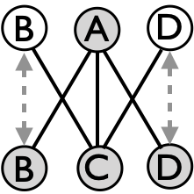
 |  | 1 | 2 | 3 | 4 | 5 | 6 | 7 | 8
 | A | B | C | D | C |  | C |  | C
 | B | A | move |  |  | C | move
 | C |  | A |  | A | B | A | D | A
 | D | … |  | A | move |  |  | C | …
Movers B and D, who go back and forth on 8 count; A and C are stationary, and they alternate being feeders. The movers have a switch-side approaching 180° rotation on each move on a slow 8-count. Compared to the 3-person change-sides feed, there needs to be a bit more coordination between the movers; one has to follow another or it breaks! Formally D could start moving from the C feed, but that’s showing off!
Typewriter Version. Now feeders A and C alternate typewriter feeds, and moving feedees C and D are on a quicker 6-count switch. |  |  |  |  |  |  |  | Metrics: J=4, CJ=3, pH=1, OJ=5/2, R=2,  PBJ=¼, motion=1 pu spin=$π$ rad=180$°$.  The only difference between versions is cycle length (8 v 6), both on 2-count base.  For motion, B and D cover 2 pu per cycle, while A and C are fixed.  See ahead for extra-club variations that are pretty fun!
 |  | 1 | 2 | 3 | 4 | 5 | 6
 | A | B | C | D |  | C
 | B | A | move |  | C | move
 | C |  | A |  | B | A | D
 | D | move |  | A | move |  | C
On the spin, note from calculations for 1-v-3 feed, feeders (here A and C) sweep through 4$θ$ per feed cycle where $cos(θ)=2/\sqrt{5}$ (assuming distance from A-C equals distance from B-D, i.e. a box of side length 1 pu) Likewise, movers B and D don’t cover a full 180° rotation in each respective change sides, but something closer to 127° (2$φ$, where $cos(φ)=1/\sqrt{5}$). Averaging over jugglers per cycle, spin=$2(θ+φ)=π$ rad=180$°$. How curious!

Eggbeater, no handle |  |  | This 4 person variation of the Eggbeater gets you moving around a partner.
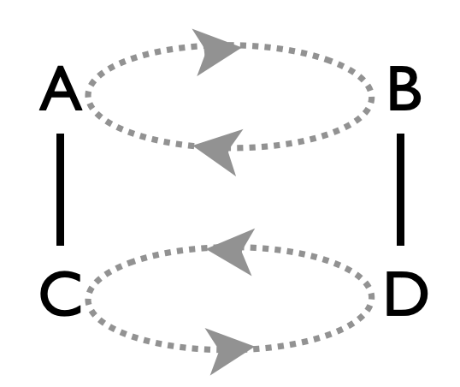  Starting configuration  A facing C, B facing D |  | Beat  (count of choice, e.g. 2-count is nice) |  |  |  |  |  |  |  | A and B start as no-stickers and C and D start as stickers
 | Juggler | 1 | 2 | 3 | 4 | 5 | 6 | 7 | 8 | A and B start as no-stickers and C and D start as stickers
 | A | C |  | D |  | C |  | D |  | A and B start as no-stickers and C and D start as stickers
 | B | D |  | C |  | D |  | C |  | A and B start as no-stickers and C and D start as stickers
 | C | A |  | B |  | A |  | B |  | A and B start as no-stickers and C and D start as stickers
 | D | B |  | A |  | B |  | A |  | A and B start as no-stickers and C and D start as stickers
Rule: pass twice then move; moves are all lateral (arrows), there’s no rotation. Shallow moves risk you knocking down your partner's pattern! 2-count base is fast for beginners (jugglers are on 4 count), but you can slow it down as you like.

Metrics: J=4, CJ=3, pH=1, R=1, cycle=8 on 2-count (local = 4), PBJ=¼ (on 2-count); spin=0; motion$≃2$pu, assuming pairs start $1/\sqrt{2}$ pu apart (width) and approximate a shallow circle.
Pattern by Prof Mike and MAJ, 1997

Unicycle |  |  |  | A pleasant moving pattern showcasing 3-count and backdrops.
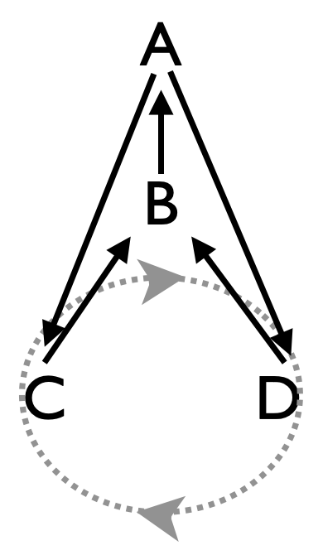starting configuration |  | Beat (3-count base) |  |  |  |  |  |  |  | Pattern by MAJ, 1996. Performed by Mad-5+1 at the 1999 Madfest.
 | Juggler | 1 |  | 2 |  | 3 |  | 4
 | A | C |  | C |  | D |  | D
 | B | A |  | A |  | A |  | A
 | C | B |  | B |  |  |  |  | 
 | D |  |  |  |  | B |  | B
A=seat, B=post, C and D are the wheel
A and B stay in position, C and D move (arrows)
B is doing 3-count back-drops to A. C and D each do 2 passes to B (right then left) followed by two phantoms while on the bottom of the wheel, moving steadily for a smooth ride!

Prior versions of Pattern Book had the wheel spinning counter-clockwise; both versions work, but the one here seems more standard! The 3-count version is hard for beginning movers; 5-count is cleaner; even counts are ok but they require more lateral movement in order for the common-hand passes to clear B’s space!

Metrics: J=4, CJ=3, pH=1, OJ=5/4, R=3, cycle=4 (on 3-count base), PBJ=¼; motion$≃2$ pu per mover, with C and D starting $1/\sqrt{2}$ pu apart, gives pattern motion=1. Referring to angles in the stationary Y, A sweeps over the cycle 4$φ≃58$°, with $sin(φ)=1/4$, and C and D wobble 4$φ$ in order to square up passes to B, who has zero spin, making the pattern spin=$3φ≃0.76 rad=43.4$°.

Benzene Ring (for 4)  Aka Spinning 3-count |  |  |  |  |  | The smallest of a family of Benzene rings, in which movers trace a shallow circle in between two feeders
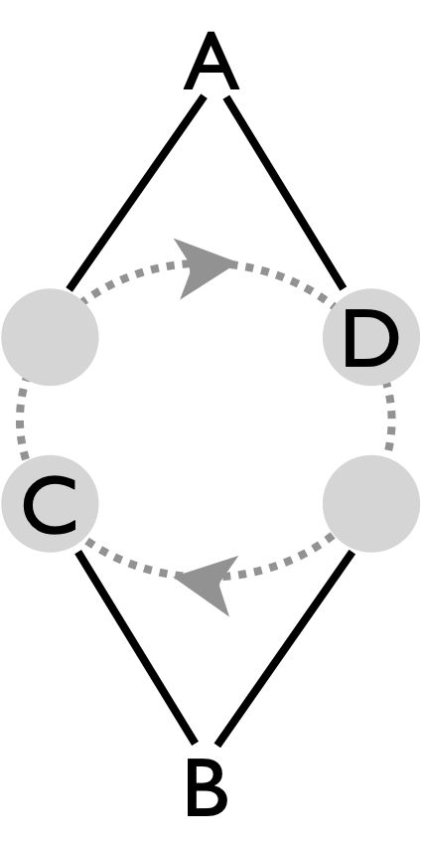 |  | Beat,  3-count base |  |  |  | Each feeder passes twice to each mover. Movers pass twice then turn. 3-count or slower works well.  Pro tip: Feeders pass their odd (right-side) throws deep to help the movers turn  3-count pattern created July, 1997 by MAJ. Performed by Peter, Mel, Mike and Dan at Madfest 1998.
 | Juggler | 1 | 2 | 3 | 4
 | A | D | C | C | D
 | B | C | D | D | C
 | C | B | A | A | B
 | D | A | B | B | A
The Benzene Ring for Six and for Eight are easier patterns to learn for beginners, but this Benzene Ring for Four is more fun. It’s also a 2-seated unicycle without the seats, going backwards! And it’s a precursor for the Razor.

Metrics: J=4, CJ=3, pH=1, R=2, OJ=2, cycle=4 on 3-count, PBJ=⅓, motion=1pu (averaging 2 with 0). For spin, movers each turn a full circle, and if feeders are 1 pu from the midline of C and D, with C and D about $1/\sqrt{2}$pu apart, then each feeders sweeps out $4β$ per cycle with $cos(β)=\sqrt{2/3}$. Averaging over jugglers, pattern spin=$π+2β$$≃4.4 rad=251$°.

Chocolate Stir |  |  |  | Pass-pass-self-self is chocolate bar, so with the ½ pirouette’s we get Chocolate Stir
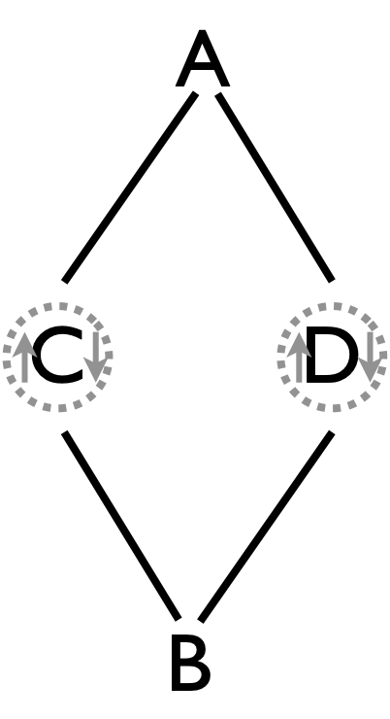 |  | Beat, 1-count base |  |  |  |  |  |  |  | ½ p = half pirouette  Metrics: J=4, CJ=3, OJ=2, pH=1, cycle=8 on 1-count, motion=0, R=2, spin=$π/2$ rad.  Pattern by Luke Emery
 | Juggler | 1 | 2 | 3 | 4 | 5 | 6 | 7 | 8
 | A | C | C |  |  | D | D
 | B | C | D |  |  | D | C
 | C | A | A | ½ p |  | B | B | ½ p
 | D | B | B | ½ p |  | A | A | ½ p

2pi/3 with a Post  Cooler than the Weave? The short cycle makes it a winner! |  | 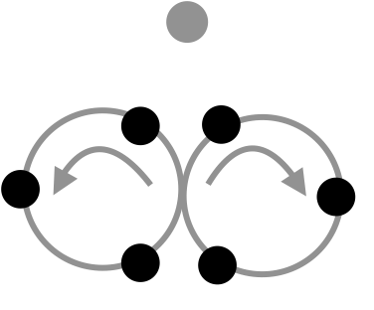
Recall the 3-person $2π/3$ pattern. Add a stationary post (juggler D) who feeds the same count as everyone else, but who alternates passes to the left and right side of the figure-8. Starting positions might be like this: B passes to A and moves through, picking up post D on the second throw. The 5-count base has been our standard. |  | Beat, base count (½ cycle in table)
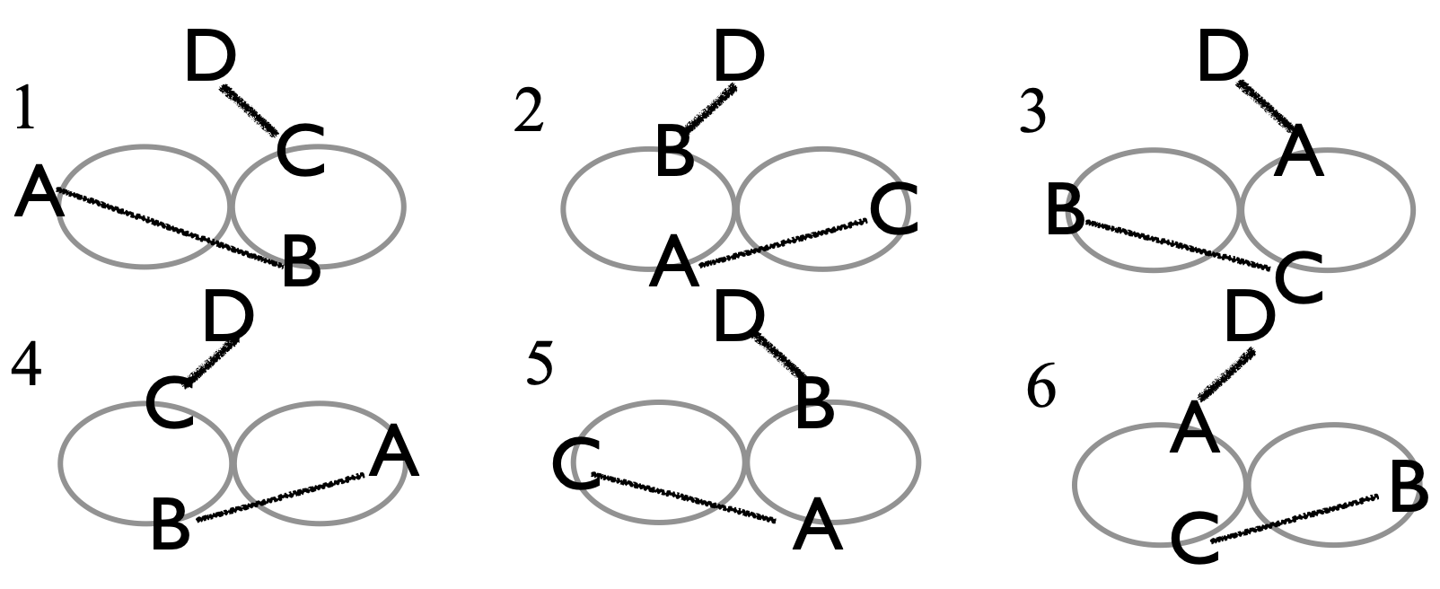  Ideally, D wobbles a bit back and forth, about $1/\sqrt{2}$ pu from each mover’s close passing point.. |  |  | 1 | 2 | 3
 |  | A | B | C | D
 |  | B | A | D | C
 |  | C | D | A | B
 |  | D | C | B | A
Metrics: J=4, CJ=3, OJ=3, pH=1, cycle=6 on base count, R=2, PBJ=1/base, motion=3. Spin is 2$π$ for each mover averaged with D’s wobble (about $2π/3$), giving a pattern spin of (⅚)($2π)rad.$ Pattern by Prof. Mike and the MAJ.

Oogle Boogie | Rotating Y pattern in which jugglers make 3 repeated passes and then move to the next position.
Positions/Passes  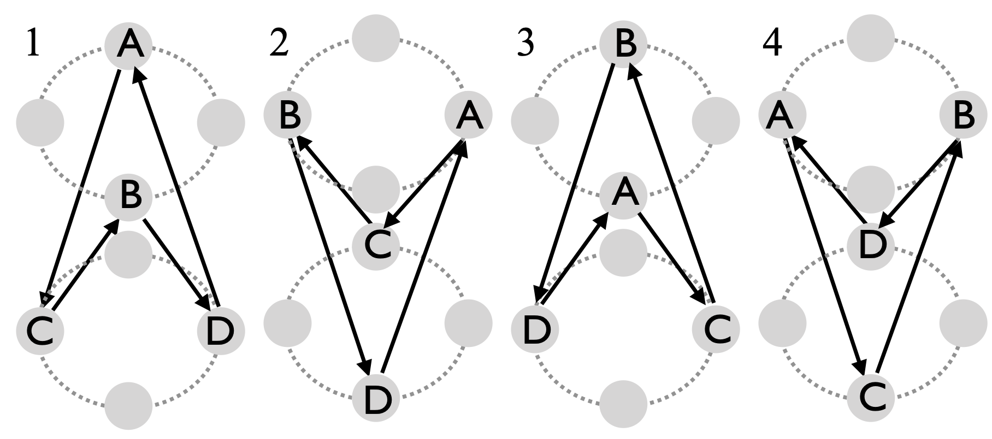 |  | Beat  2-count base is standard
 | Juggler | 1 | 2 | 3 | 4 | …
 | A | C | C | C | move | …
 | B | D | D | D | move | …
 | C | B | B | B | move | …
 | D | A | A | A | move | …
The version shown is for right-handed passing; usually 2-count, but slower is fine for starters. 3-count is nice, but then the arrows all change directions on the left-hand beats. A nice feature of Oogle Boogie, as evidenced by the passing table, is that in spite of the moves, each juggler has one person they always pass to and another person they always receive from (those folks alternate in odd-count versions). There’s no particular reason for 3 stationary passes per local cycle, except that’s how we have always done it! The space (phantom beat) allows jugglers to move leisurely to their next position.

Variations: The Fast Oogle Boogie drops the space (4th) beat. Alternatively, reducing the stationary beats from 3 to 1 gives a constantly moving Y, which goes nicely on a 4-count or 5-count base (and has 4-beat full cycle). Slowing things down, we can also have an intermediate 2-on-2 configuration in between each Y configuration (Slow Oogle Boogie). As shown, both wheels are clockwise (from above); both could be counterclockwise (arguments might arise on the proper choice!), or one could be clockwise and one counterclockwise. In the first two cases, you retain that nice feature of passing always to the same person.

Metrics: J=4, CJ=3, pH=1, R=1, OJ=2, cycle=16, on 2-count, local cycle=4, PBJ = ⅜ (standard version); motion = 2 pu (if you think of moving on the diamond of side length ½ pu, or $π/\sqrt{2}$ $≃$ 2.2 pu if you think of moving in a circle where pairs (e.g. C-D) start $1/\sqrt{2}$ pu apart); spin $≃π rad$, considering the rotations each mover makes to square up with their receiver.

MAJ have been doing this since 1991, but its origin is unknown to the authors; the Mad-5 performed Oogle Boogie at Madfest in 1997.

Shooting Star | A fun variation of the Star when you’re missing a juggler!
Positions:  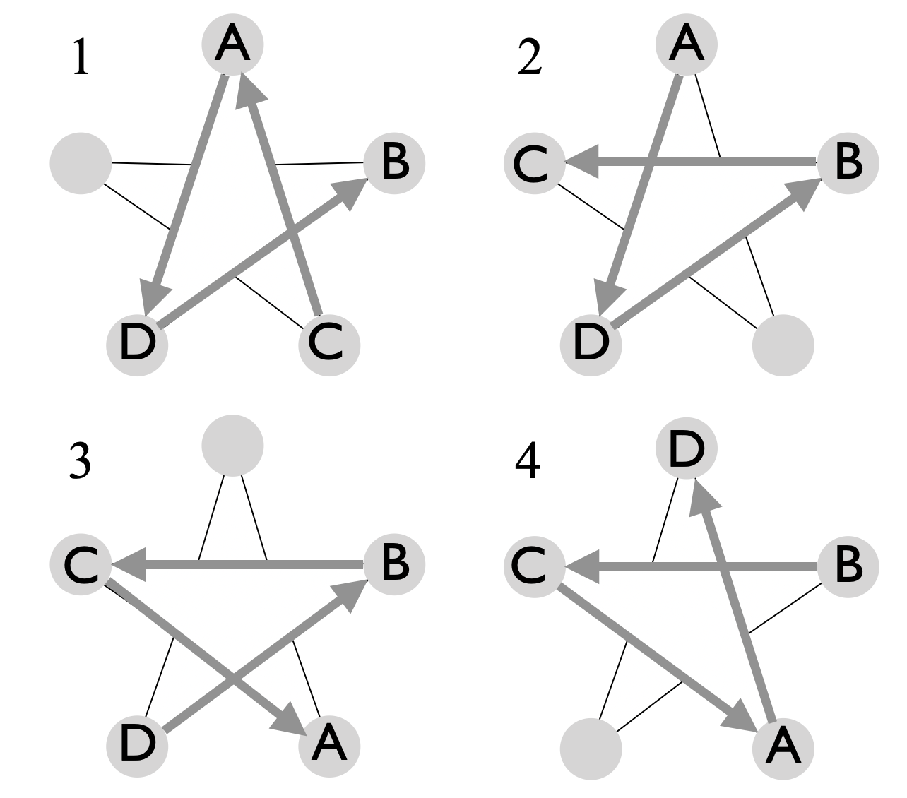  After step (4), notice B moves, and we’re back to the configuration of (1), but rotated 2 clicks (each 2$π$/5) clockwise, i.e. 144 degrees. Blanks in passing table are where you don’t have enough clubs; and you don’t pass [in the steady state, that’s where you move]. Shooting Star was created by Bryan Olson in 1993 (not in Madison!!) | Position |  | Juggler
 |  | Beat  2-count | A | B | C | D
 | 1 | 1 | D |  | A | B
 | 1 | 2 | D |  | A | B
 | 1 | 3 | D |  | A | B
 | 2 | 4 | D | C |  | B
 | 2 | 5 | D | C |  | B
 | 2 | 6 | D | C |  | B
 | 3 | 7 |  | C | A | B
 | 3 | 8 |  | C | A | B
 | 3 | 9 |  | C | A | B
 | 4 | 10 | D | C | A
 | 4 | 11 | D | C | A
 | 4 | 12 | D | C | A
A, C, and D, each start with 3 clubs; B starts with none; right hand 2-count. A will run out of clubs since no-one is passing to them. When out of clubs, A moves to the empty spot. The pattern continues so that each juggler will run out of clubs and move to a newly vacated empty spot. When you pass, you always pass to the same person. Because you need to avoid passing lanes and you pass-receive from different people, most beginners find this one more difficult than Oogle Boogie or Weave.
Metrics: J=4, CJ=2 ¼ (3 missing!), pH=1, OJ=1, R=1, cycle =60 (local 12) on 2-count base, PBJ=⅜, spin=0 (rotations happen when you’re not turning), motion=$5\sqrt{2}$ pu assuming star points are $\sqrt{2}$ pu apart on set up.
Variations: Add some flair by pirouetting through the middle! Drop 2 clubs instead of 3 clubs and always move with one; this makes each block a 2-beat block instead of 3 as above. Add multiple clubs and up the passes to doubles and/or triples, but those options have been mostly theoretical!
Pro Tip: Move to the center as you throw your last club, and just after a club whizzes by in front of you; then turn around 180 and move out backwards just after the next pass whizzes by the back of your head. (Some jugglers [e.g., Mel!] try to run through quickly to avoid getting hit in the head, but that usually ends in disaster!) It’s best to make it a two-step move: one step into the middle after releasing your last club, then one step out backwards after the next pass (where you’re on a self).

Weave  Here’s where the fun really begins! | 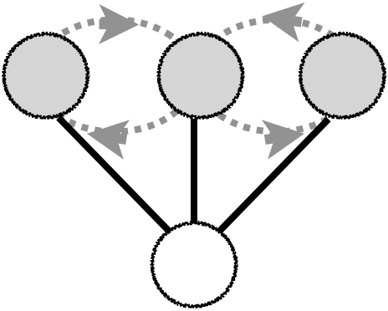
½ cycle movement  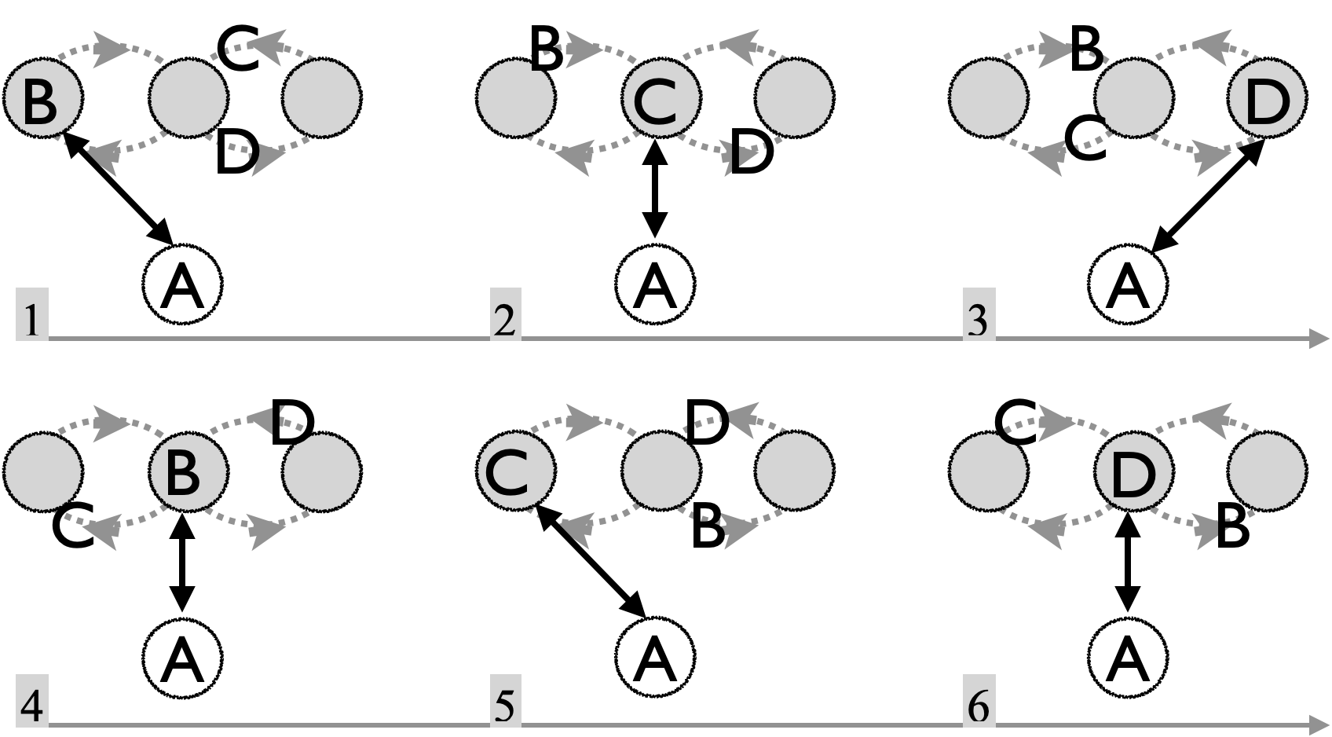 | 2-count base beat | Juggler
 | 2-count base beat | A | B | C | D
 | 1 | B | A
 | 2 | C |  | A
 | 3 | D |  |  | A
 | 4 | B | A
 | 5 | C |  | A
 | 6 | D |  |  | A
This Standard Weave uses right-hand start and 2-count base (so weavers are on 6 count). This is a great pattern to master; it leads to many other exciting patterns, and it’s probably the most popular 4-person moving pattern! Thinking of jugglers as props, the weave is like a giant’s cascade pattern. The feeder, A, throws to the end, middle, end, middle and then repeats, passing on the base beat, which is ordinarily a 2-count right. Each weaver, (B,C,D), passes in their current position and then moves (black squares) to the next position. For the standard weave, the three weavers pass in a 6-count, | 7 | B | A
 | 8 | C |  | A
 | 9 | D |  |  | A
 | 10 | B | A
 | 11 | C |  | A
 | 12 | D |  |  | A
Rule: Move back on the ends and forward in the middle in a figure-8 pattern. When starting, the middle weaver moves towards the side that passes to the feeder first.
Pro tip: Beginning weavers have a tendency to move well side-to-side but not so well backwards and forwards; think of the pattern more like a bowtie than a figure 8 to avoid that problem. Beginning feeders often fail to provide appropriate leads to the weavers; usually they want deep on the ends, loopy and in the right direction in the middle.
Drops: They happen, but don’t change the flow of the pattern to pick up; just wait till you weave again close to the dropped pass to do so, or just steal from the feeder!
Variations: There are tons of variations of the Weave. For starters, you can change the direction (so-called inverted weave), which has forward on the end and back in the middle as the basic rule. After passing on an end, be sure to wait for the middle pass before you move into the middle, else you’ll get hit!. Whether standard or inverted, there are all sorts of timing variations that amount to modifying the base beat; these all involve a 12-base-beat cycle, but could be slower or faster (or weirder!) than the standard. For example 3-count base has the feeder on 3-count and each weaver on 9-count–very pleasant for sure, but 9 is fairly slow and some of us have trouble counting that high! We often do a 3/2 base beat (i.e., feeder on pass-pass-self), which then leads to an interesting alternating 4-count/5-count cycle for the weavers. There are two ways to do that; we usually prefer the feeder starts pass-self-pass-pass, and so that makes a 5 count after you pass on the end and a 4-count off the middle. (We call that a 4-5 weave.) Faster bases are basically impossible for mortal jugglers; for instance the hyper-weave is on a 1-count base, with weavers on 3-count. More feasible is the 1-2-on-a-4-count base, where the feeder is doing chocolate-bar (pass-pass-self-self); more pleasant is 1-3-on-a-5-count base, which nicely balances hands. Also, 1-3-5-on-a-5-count makes the weavers all do 5-count, and the feeder then has 3-passes on 2-count followed by a 1-count switch. Something for experts is 1-2-3-on-a-4-count, which has the weavers flying on 4-count and the feeder simply doing pass-pass-pass-self; note one weaver does 4-count lefts in that variation!
Tricks: Pass a self-triple with the right just after passing in the middle position, which allows you to pass again to the feeder on the next right-hand opportunity. Other fun involves switching out who is feeder on the fly!
Metrics: J=3, CJ=3, OJ=3/2, pH=3, cycle=12 on 2-count base (local = 3), PBJ = ¼ (standard) [PBJ=⅜ for the 4-5 weave]. Motion is about 4 pu per weaver per cycle (see weave discussion in metrics section) , assuming the width of weaver line is $\sqrt{2}$ pu, giving a pattern average motion=3 pu. Rotation is modest for weavers; each one wobbles about $θ=asin(\sqrt{2/3) }$ $≃$55° over the cycle; if the feeder sets up 1 pu from the weaver line. The feeder rotates $4acos(\sqrt{2/3) }$$≃141$° to complete 1 sweep back and forth (there are 3 sweeps per cycle), making the pattern average spin$≃$147°. R=2 (feeder and weavers).

Origin: The standard weave is an old pattern. For sure the Flying Karamazov Brothers were weaving in the 1980's, and maybe earlier. Prof. Mike saw them at a show in Seattle in the late 80's and became hooked on club juggling after that! The MAJ have been weaving since 1992, or earlier!

Close cousins of the weave

Dresser Drawer Weave | This weave variation has the same passes as the standard weave, but the weavers move side-to-side like dresser drawers instead of through a figure eight.  We sometimes debate whether B is the socks or underwear drawer!
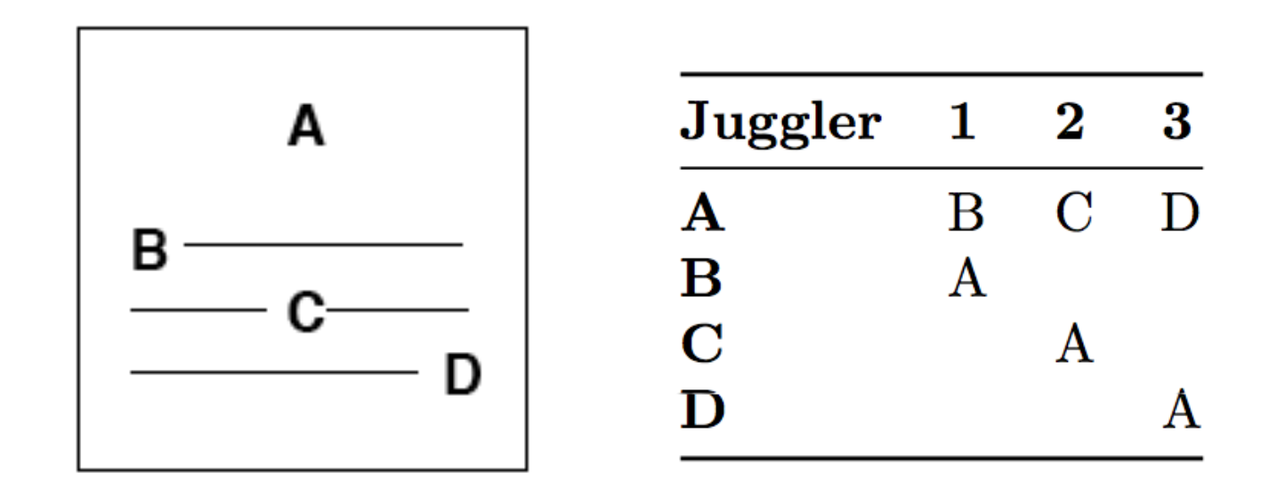
Each juggler has its own slot (i.e., drawer) to move on. Each slot has three positions: left, middle, and right. Weavers move back and forth on their slots. Moves are made to the next position after the pass is made from the current position.

Metrics: J=4, CJ=3, OJ=3/2, pH=1, cycle=12 (local=3) on 2-count base, PBJ=¼, R=2, motion=3/$\sqrt{2}$ = 2.1 pu; spin is approximately as in the standard weave: $≃$147°. The mover spots are not quite as exchangeable as in the standard weave; D makes long throws and has a smaller spin than B, for example.

Inside Out Weave |  | Take the figure-8 path of a standard weave and imagine warping space so that one of the loops shrinks while the other grows. Then fold the smaller loop back inside larger, and you get the Inside-Out Weave. Now what was the middle (M) of the weave is situated on the feeder’s right. Rule: As feeder, think small-middle-big-middle.  Pattern by Prof Mike.
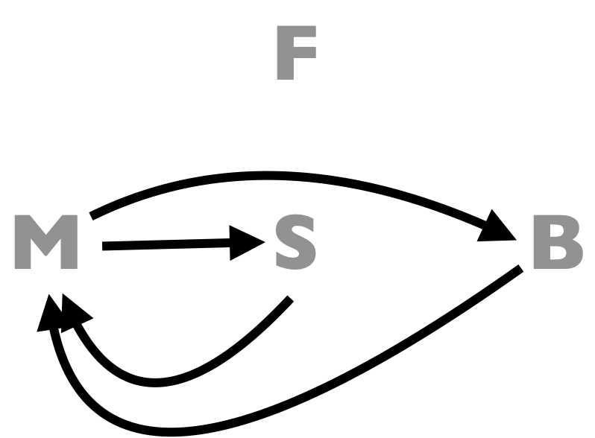 | 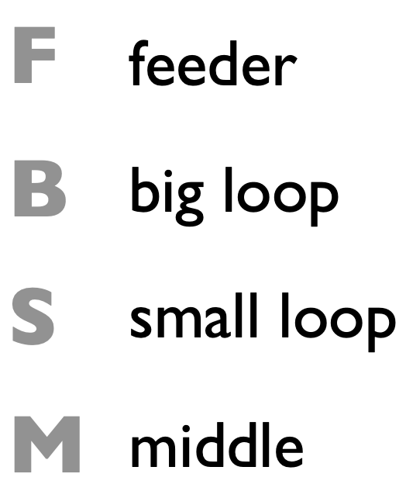
The count and the passes are exactly as in the Standard Weave, but the jugglers move in a small loop from the new center (which is in the middle, but has the count and movement for an end) to the “middle” (which is now on the outside), and then in a large loop back (the other end) . In the loops, always move forwards for the “middle” and backwards from the “ends”. The passing lanes can be somewhat narrow, so be careful, or you might bruise your ZOC. If the feeder is on a 3 or 4-count base it’s quite manageable. The 2-count base is how we started, and is a good exercise of your moving technique!

Metrics: Same as Standard Weave. It seems there’s more motion, but in fact the motion is just non-uniform, so going in and out of the big loop takes some quick steps!
Variations: El Turmeric weave, which continuously swaps the mover/feeder roles.

That’s a Good One  Aka It’s a good one |  |  |  |  |  |  |  |  |  |  |  |  | A count challenge in the standard weave formation.  Feeder (A) passes 2-count, twice in a row to each feedee on each side. Feedees (B,C, D) throw: 2 throws of 2-count, 3-count transition, left-handed 4-count, 3-count transition, and repeat on the other side.
 | Beat (1-count base, ½ cycle shown)
Juggler | 1 | 2 | 3 | 4 | 5 | 6 | 7 | 8 | 9 | 10 | 11 | 12
A | C |  | C |  | B |  | B |  | D |  | D
B |  | D |  |  | A |  | A |  |  | C
C | A |  | A |  |  | D |  |  |  | B
D |  | B |  |  |  | C |  |  | A |  | A
Set up with A facing weavers B, C, D, with C in the middle, moving forward and to the left. Positions at a few steps shown below:
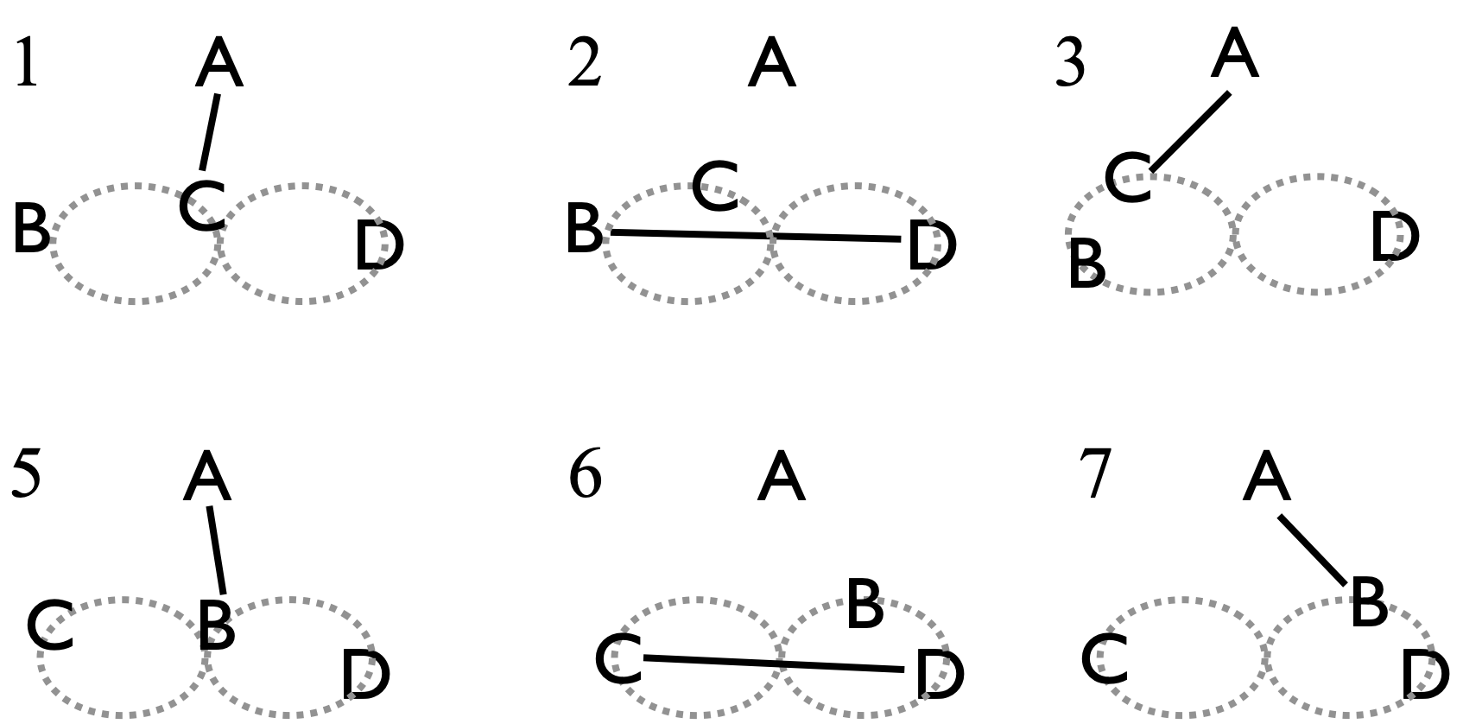 |  |  |  |  |  |  |  |  |  |  |  |  | Metrics: J=4, CJ=3, pH=1, OJ=3, R=2, 24 count full cycle on 1-count. PBJ=3/8. Motion is 3 pu as in standard weave, but there’s more turning. Weavers have two sharp 90 degree turns beyond standard weave; spin$≃282$°

That’s a Really Good One  Refer to the passing sequence from That’s a Good One, but allow weavers to convert to feeders as they come off the right loop. Noting there’s no pass on beats 4, 8, 12, etc, below is the first passing section in which juggler C switches from coming off the right loop through the middle and then into and out of the feed position. C does 6 2-count throws while completing a 360 degree turn.  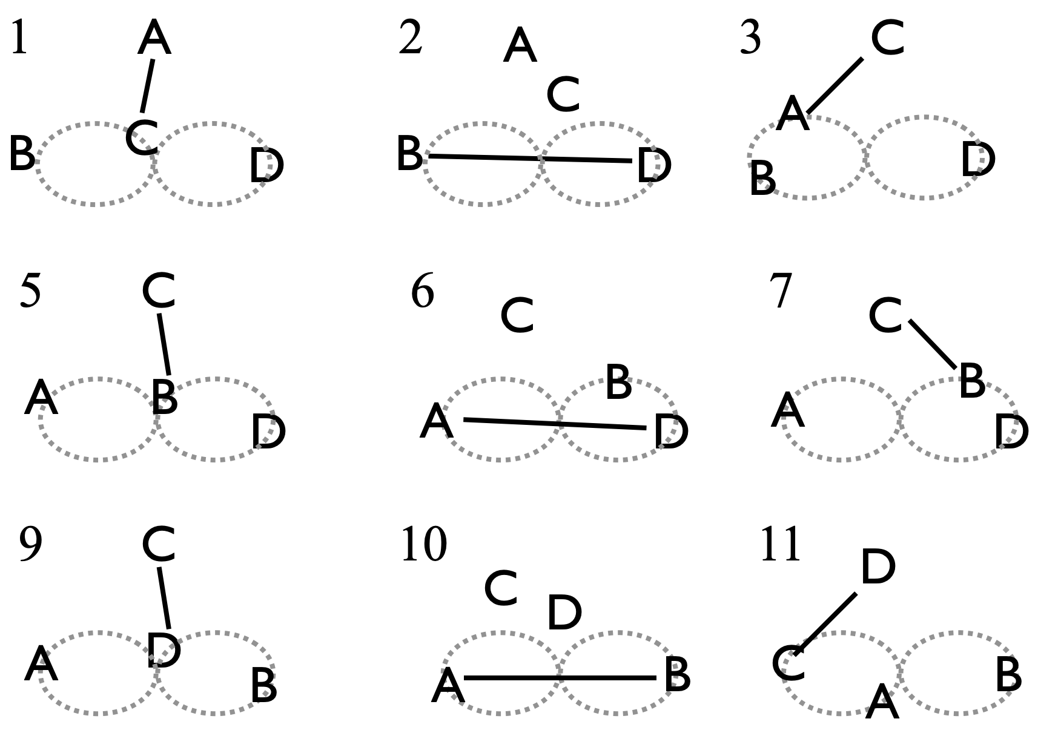  In each cycle each juggler does:  6 throws (5 2-count gaps); 1 3 count gap  1 throw; 4 count gap  1 throw; 3-count gap  2 throws on a 2-count gap; 1 3-count gap  1 throw; 4-count gap, 1 throw  Back to start.  Inspection confirms that 12 throws are done by each juggler per full cycle; each full cycle is 32 beats (both hands).  Pattern by MIke, Steve C, Mel, and Conor on Dec 13, 2018. (btw, the pattern degenerates if you try to swap from both sides of the weave). | This is a challenging, no-extra-club moving pattern. It starts in the same set up as That's a Good One, but the feeder also gets to move. In the favored version, every weaver coming into the middle from the right (i.e., weaver's right; feeder's left) passes to the feeder and then moves into the feeder position to become the (temporary) feeder, completing a 1/2 turn in order to face the weavers. Meanwhile, the former feeder vacates the feeding position and continues to the (weaver) left, the destination of the person who he/she just exchanged with, had they not swapped spots.  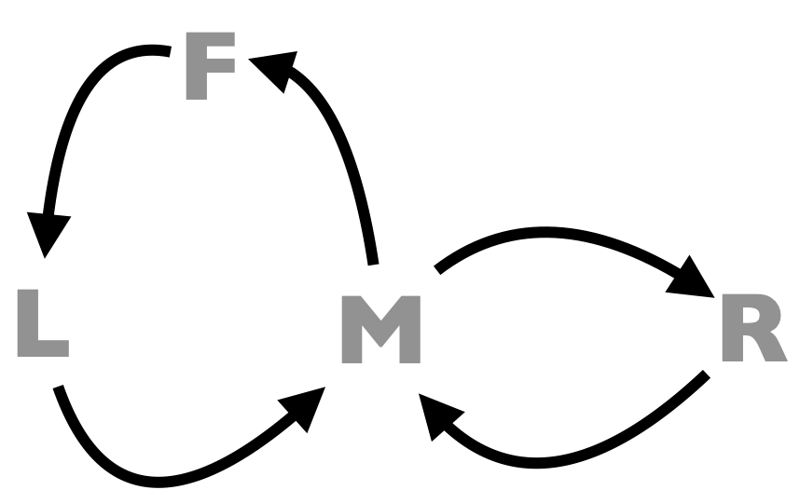  In the figure, F is the feeder spot, M the middle, L the left (weaver perspective) and R the right from that perspective.  You find in running this that the maneuver into and out of the feed entails a series of 6 2-count passes in a row while moving in a tight circle (see left). It's pretty fun!  Metrics: J=4, CJ=3, OJ=3, pH=1, R=1. Each juggler moves through 5 spots to complete a cycle (twice in M), and totals a full 360 degree rotation along the way. Full cycle is 32 1-count beats to get all 4 jugglers swapping into and out of the feeder spot. Motion is about 6 pu (4 for weave + feeder switch), spin=$2π$.

Gandini Weave (basic) |  |  |  |  |  |  |  | The Gandini Juggling Project has contributed immeasurably to the juggling world. We record just a few patterns in our collection, ones that have fortunately become part of the MAj repertoire. We learned them while juggling with Sean and the Project in 2000. Thanks!!
 | Beat, base count (2 or 3) |  |  |  |  |  | 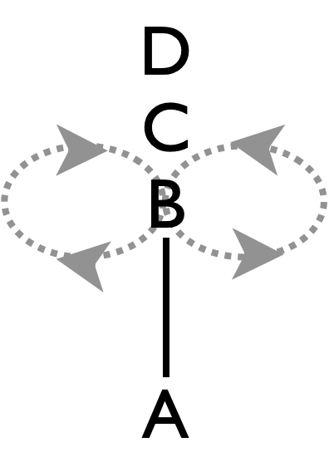
Juggler | 1 | 2 | 3 | 4 | 5 | 6
A | B | B | C | C | D | D
B | A | A
C |  |  | A | A
D |  |  |  |  | A | A
We call any weave a Gandini Weave if the weavers always pass in the middle of the figure 8 loop, although the Gandini's have innovated many other interesting weaves besides what we know. We don't know even know what the Gandini's call them! This is a simple Gandini Weave that is a great foundation for other patterns.

In this weave, all the weavers move in a figure 8, but they always pass from the middle and never from an end. With the feeder is in 2-count, the feedees throw 2 right hand passes in a row, and then 4 right hand selves (PPSSSS). It's easiest to start with the weavers stacked in a line all facing the feeder.

- Feeder (A) passes twice to the first weaver (B), then that weaver goes to the right.
- A then passes twice to the second weaver (C), then that weaver goes to the left.
- A then passes twice to the third weaver (D), who follows B.
- Then repeat, with each weaver passing twice to the feeder and then moving in the
opposite direction of the previous weaver.

Metrics: J=4, CJ=3, pH=1, OJ=3/2, R=2, cycle=6 on 2-count, PBJ=¼ on 2-count. Motion through figure-8 as in standard weave, giving pattern motion=3 pu. Since passes are always in the midline there’s no spin at all (spin=0).

Timing variations are many, though too slow is a bit boring and easy for weavers to lose count, and too fast is, well, too fast. Putting the feeder on a 3-count base is nice, but see Gandini Site Swaps for more on that.

6-count Mondo Weave  A new favorite weave |  |  |  |  |  |  |  |  |  |  |  |  |  |  |  | I’m not sure how long they’ve been juggling this one in Minneapolis, but it was new to the MAJ when we visited Mondo (Feb 2026) and learned the pattern from Tom.  The feeder starts on the right side of the weave in the sequence: right left right self self left right left self self, at which point the movers are ⅓ of the way through the full cycle (figure). The result for the weavers is 3 passes on a 6-count gap followed by a 3-count stick on each end. They end up doing three rights in a row as they move right, and three lefts in a row to return.  Very nice!
Juggler |  |  | Beat, 1-count base (½ cycle tabulated)
 | 1 | 2 | 3 | 4 | 5 | 6 | 7 | 8 | 9 | 10 | 11 | 12 | 13 | 14 | 15
A | D |  |  |  |  |  | D |  |  |  |  |  | D
B |  | D |  |  |  |  |  | D |  |  | D
C |  |  | D |  |  | D |  |  |  |  |  | D
D | A | B | C |  |  | C | A | B |  |  | B | C | A
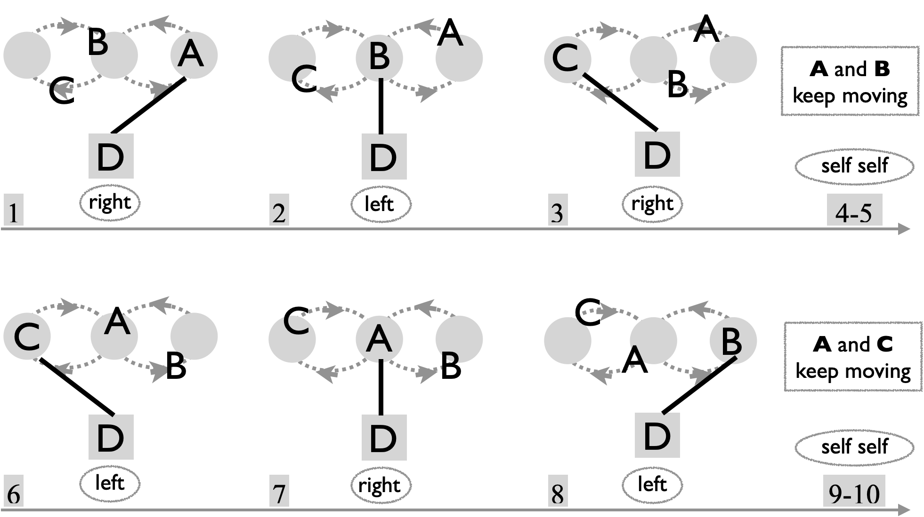
Metrics: J=4, CJ=3, pH=1, R=2, PBJ=0.3, cycle length=30 on 1-count base, OJ=1.5. As in the Standard Weave, average motion=3 pu, and spin$≃$147°. Movers average 5-count, and the feeder is doing a 5/3 count.

Three Leaf Clovers
Clovers are a distinctly Madison innovation in club passing. There are many variations, but most entail every juggler moving through a clover-leaf trajectory and all offset but following the same passing sequence.

The clover leaf patterns have a juggler on each leaf, and one in the middle, all moving. As the pattern progresses, the juggler in the middle trades places with a juggler on a leaf, pushing that juggler out of his/her leaf and back into the middle towards the next leaf in the sequence, and passing along the way. There are a variety of passing sequences that fit into this clover motion sequence, but this one has become our default (it’s about the 4th one in the clover evolution!)

Three Leaf Clover (Standard and Run-Over) |  |  |  |  |  | 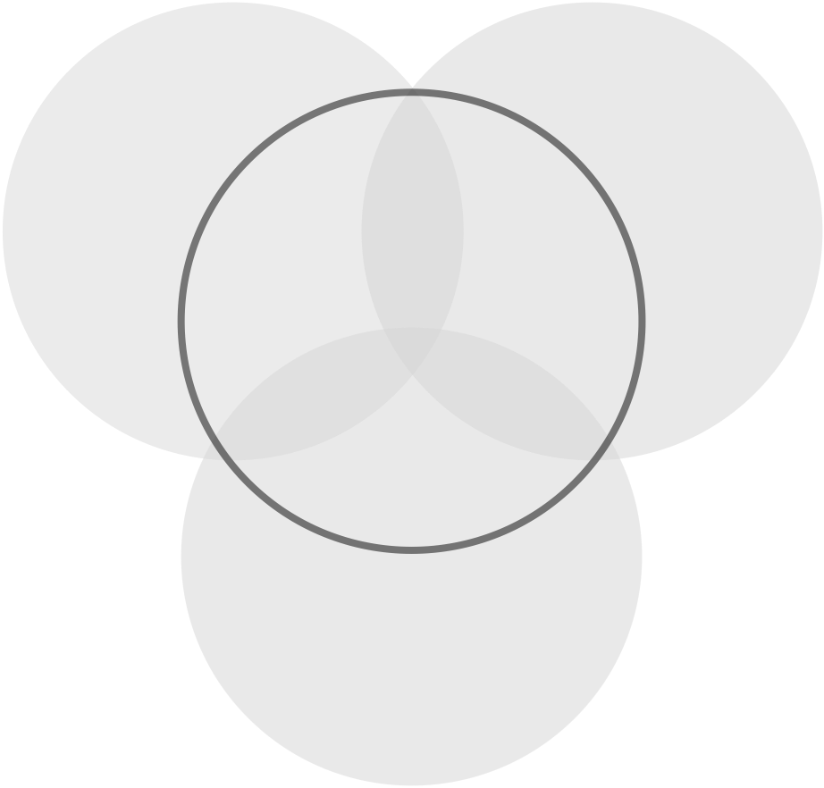
Set up 1 per leaf and one middle.  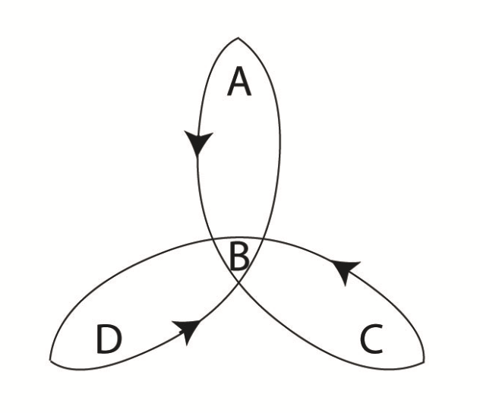 |  | Beat, base (e.g. 2 count)
 | Juggler | 1 | 2 | 3 | 4 | 5 | 6 | 7 | 8
 | A | D | B | C | B |  | B |  | B
 | B |  | A |  | A | C | A | D | A
 | C |  | D | A | D | B | D |  | D
 | D | A | C |  | C |  | C | B | C
Rule: Feeder sweeps right to left, then 2-in-2-out move along arc to replace the person on your left.
Pro tip: After your feed, move out to about 2 o’clock to your right, and also rotate clockwise (from above), opening up to your middle pass as you translate left.
Variations: The standard version is a 2-count base beat, but 3-count and 4-count are fun too. Over the last year or so we often do this on one of the variable counts, like 1-3-on-a-5-count, or 1-3-5-on-a-7-count. Additional (grey) passes are optional; we call that a Run-Over-Clover; it makes the move 1-in-1-out, which goes nicely on a 3-count base rather than the faster 2-count. Watch the 3-count run-over-clover with colors, recorded during the COVID pandemic: https://www.youtube.com/watch?v=bJLnODIlHMI
Metrics: J=4, CJ=3, OJ=3, R=1, pH=1, full cycle = 24 beats (on base count); 8 beat local cycle. 4 passes/8 base beats per juggler (2-count standard has PBJ = ¼ ); the 3-count base run-over-clover has PBJ=¼ also! spin 2$π$ to complete the three leaves; $2π/3$ per leaf, not counting rotation as the feeder. Overall spin is about 2.5 $π$ rad per cycle. Motion per cycle is three times the arc length from one leaf to the next, which can be seen to equal the circumference of the smallest circle containing the three leaves. The radius of this circle is surely less than 1 pu; perhaps 1/$\sqrt{2}$ pu is about right, which makes the motion per cycle = $π\sqrt{2}≃$ 4.4 pu; alternatively, if we use 2 pu per loop as in weave etc, we get 6 pu per cycle. Let’s call it 5 pu to split the difference.
Origin: Prof Mike created this clover in 2000, then the run-over in 2001 with the MAJ. This is not the original clover; it was called the new one in earlier versions of the pattern book, but it’s become the MAJ standard!
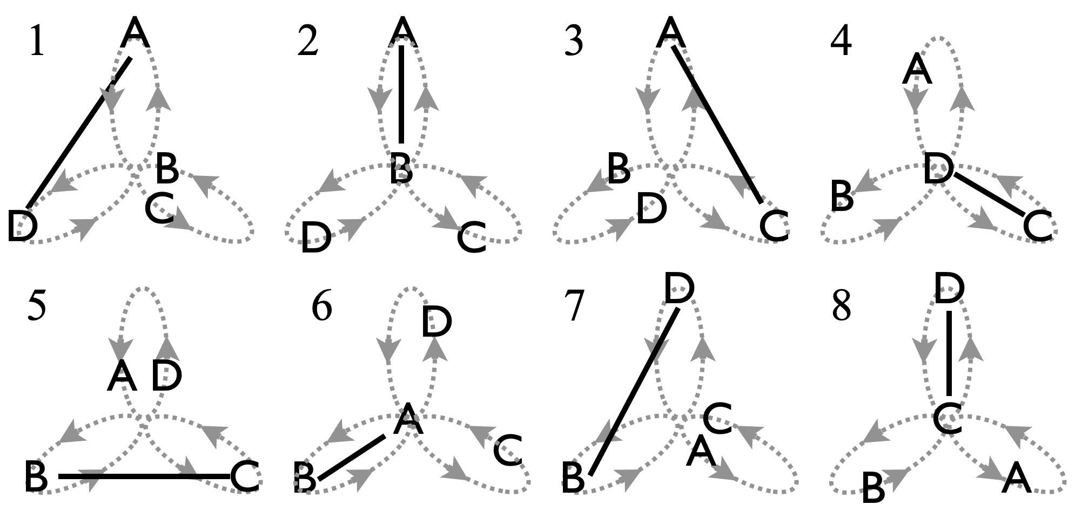
Local cycle: A starts the feed and ends one leaf to the left ready to start a second feed.

Check out Nathan's piano roll **WHERE** to see also the trajectory of all 12 clubs, and how long it takes to get them back in order.

Extra detail on the standard clover…
Standard Three Leaf Clover: Detailed View
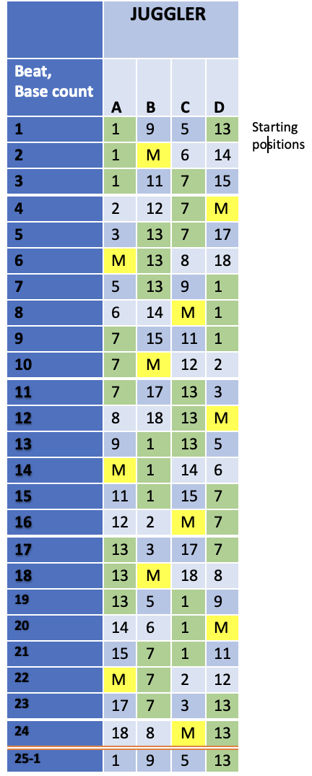 | 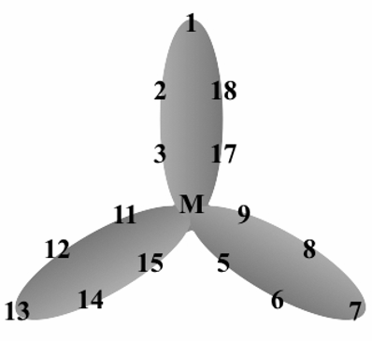  There are 18 positions in the standard 3-leaf clover. Jugglers move from leaf to leaf. Positions 1, 7, and 13 are the tips of the leaves; in the standard clover, you are a feeder for three beats while in one of those spots. After your feed, you have two beats to enter the middle (M=4, 10, 16), and then two more to get to the next tip, on the leaf to the left of your previous feed. Feeds overlap, with the last pass of one feeder being the first pass of the next feeder; and so the feed itself moves clockwise around the tips.  We conceived this as a 2-count pattern, but we find it's great to learn on a slower 3 or 4 count, and that opens up opportunities for more passes (see zigzag, and pollinator).  Passes are either between two feeders or a feeder and someone transitioning through the middle. The 8 beat local cycle resets the jugglers into their original relative positions, but it takes 24 beats for the pattern to get back to its original state.  This standard is not the first MAJ clover, but it’s the best one! There's a beautiful symmetry to the pattern once it gets going. We hope you enjoy it as much as we do!

Zero in Zero Out (ZIZO) Clover  aka ZigZag; get rid of those pesky self throws! |  |  |  |  |  | Same set up/motion as the Standard Clover, but all empty beats are filled in. This creates major rotation challenges, and is only workable on a slower count; we like 5-count, where all lefts go to the same person and your rights alternate. The passing cycle repeats after 4 base counts, leaf switches after 8, and 24 is a full cycle.
starting configuration |  | Beat, 5-count base,  ⅙ of full cycle
 | Juggler | 1 | 2 | 3 | 4
 | A | D | B | C | B
 | B | C | A | D | A
 | C | B | D | A | D
 | D | A | C | B | C
Metrics: J=4, CJ=3, OJ=3, pH=1, R=1, cycle=24 (full) on 5-count base, PBJ=⅕ on 5-count, but the Motion is as in the Standard Clover = 5 pu. Spinning makes this pattern super hard; spin may be $π+2π/3$ per local cycle per juggler, giving a full cycle pattern average (over jugglers) spin=$5π$. [link the ZIZO video/ the piano role/remember Mark laughing as we try get it to work!]

Less Popular Clovers
Mike’s Original Clover |  |  |  |  |  | Like with Standard Clover, motion happens as one juggler moves into a leaf and pushes another out. A nice feature of Mike’s Original is that every juggler is a feeder passing a windshield wiper feed to the other 3 jugglers (on the base count).  Pattern by Prof. Mike.
Starting positions |  | Beat, 4-count base
 | Juggler | 1 | 2 | 3 | 4
 | A | B | D | C | D
 | B | A | C | D | C
 | C | D | B | A | B
 | D | C | A | B | A
Metrics: J=4, CJ=3, pH=1, OJ=3, R=1, full cycle=24 beats on base (e.g. 2-count), but a 4-beat local passing cycle, and 8 beats to reset leaf positions. PBJ=¼. Motion is the same as standard (about 5 pu). More spin than standard (about 3$π$ per cycle). Performed by Mad-5 at 1998 Madfest (4-count base version). Faster than 4-count is hard. 5 count is nice!
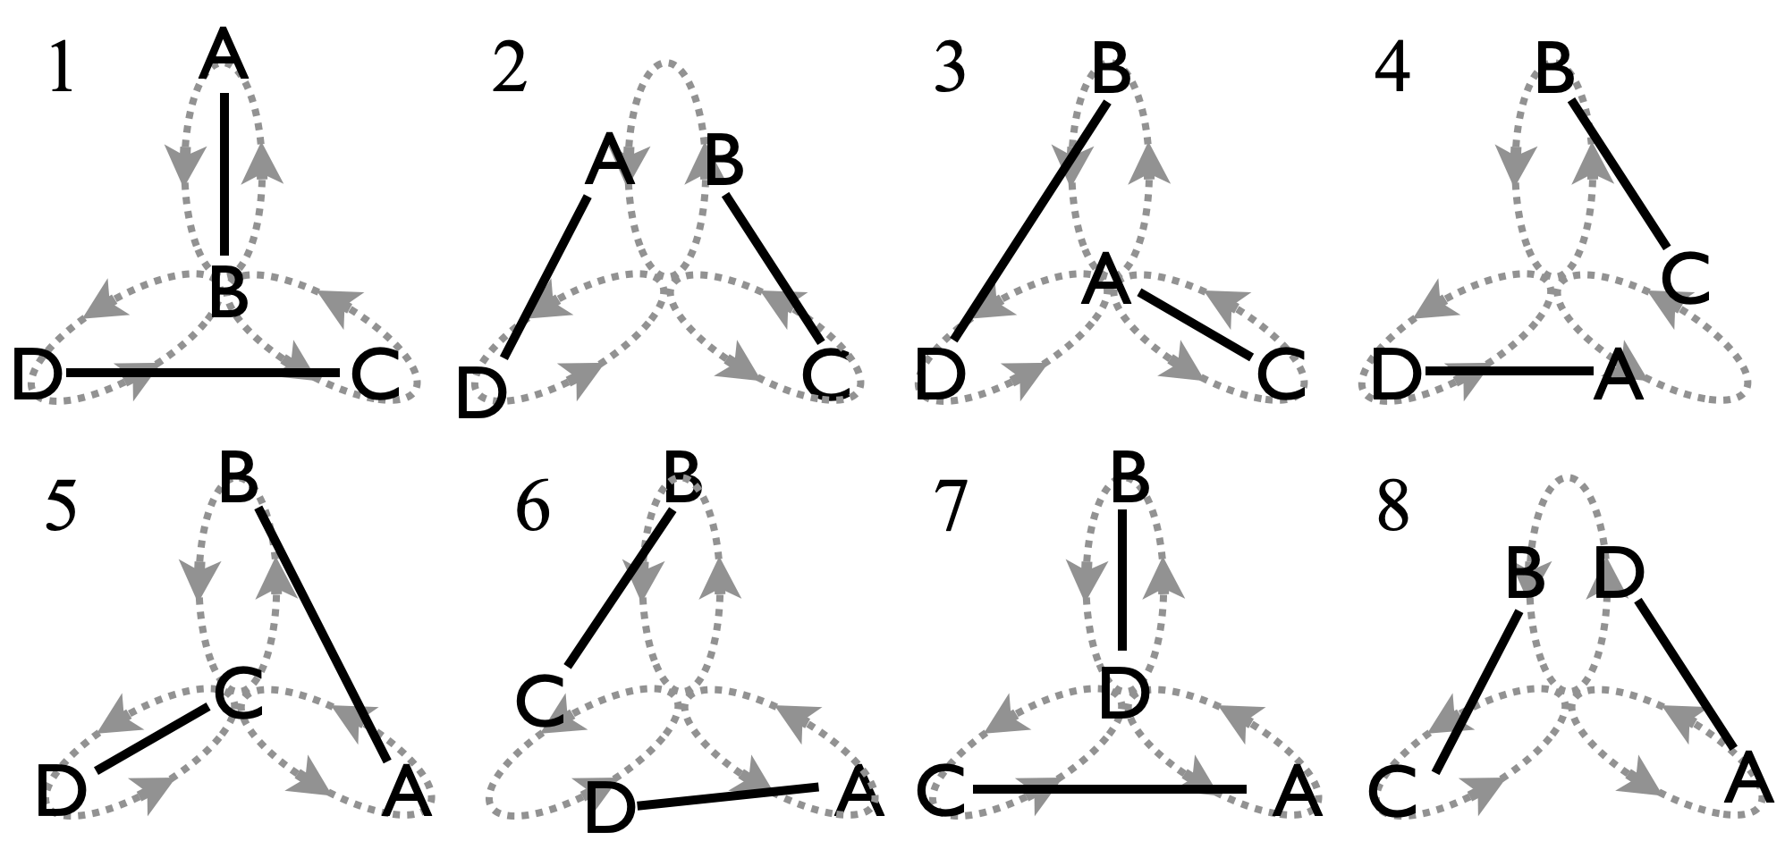 |  |  |  |  |  | Two local cycles shown left: After first pass, B pushes A off the top leaf, A moves on to push C, who pushes D, and so on.

Dreamy Clover (aka Seven)
At Thursday practice June 25, 2026, Mel reported having seen a pattern in a dream! (Not the first time, in fact the 7th time!!). Though Mel did not appreciate it initially, this Dreamy Clover turns out to be a variation of Mike’s Original Clover. Specifically, take the odd passing beats above (i.e., 1,3,5,7), drop all the even beats, and proceed over the 4 sampled beats on a 6-count.
Metrics: As above essentially, except OJ=2, PBJ=⅙, and full cycle is 12 on 6-count base.

Peter’s Clover |  | While traversing the leaves, everyone feeds a modified typewriter to the other 3 jugglers.
starting configuration  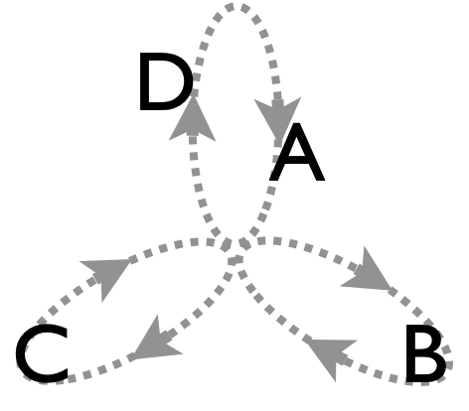 |  | Beat (4-count base) |  |  |  |  |  | Metrics: J=4, CJ=3, OJ=3, pH=1, R=1, cycle=6 (local passing), 12 to reset leaves, 36 full, on base count (e.g. 4 count). PBJ=¼. Motion and spin are about the same the standard clover: motion=5 pu, spin=$2π$ rad.
 | Juggler | 1 | 2 | 3 | 4 | 5 | 6
 | A | B | C | D | B | D | C
 | B | A | D | C | A | C | D
 | C | D | A | B | D | B | A
 | D | C | B | A | C | A | B
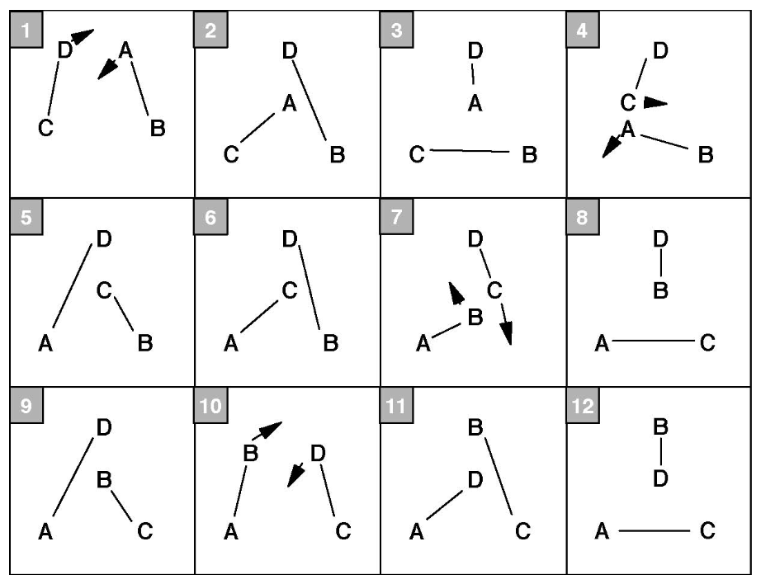 |  |  |  |  |  |  | The movement around the leaves is reversed from all the other clovers we do! The starting positions are also different, but the leaf-push rule is the same. The MAJ juggles the Standard Clover more often than this appealing but slightly harder-to-remember variant.

Steve’s Clovers |  |  | Elaborate clovers with built-in triangles!
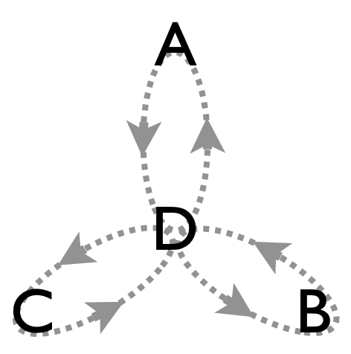  Starting configuration, D heading into C’s leaf. |  | Beat, 4-count base (⅓ cycle)
 | Juggler | 1 | 2 | 3 | 4 | 5 | 6 | 7 | 8
 | A | D | B | D |  | D | D | D | B
 | B | C | D | C | D | C |  | C | C
 | C | B |  | B | B | B | A | B | A
 | D | A | A | A | C | A | C | A
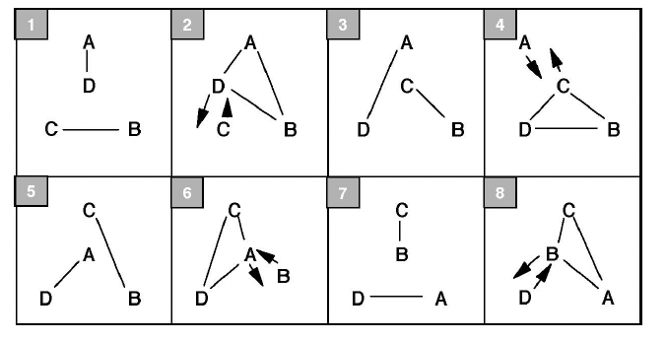 |  |  |  |  |  | Metrics: J=4, CJ=3, OJ=3, 8 4-count beats to complete ⅓ of a full rotation where relative positions reset; 24 beats in full cycle. PBJ=7/32, pH=1, motion=5 pu, spin $≃2π$ rad. Pattern by Steve Otteson.
The passing rate and movement along the leaves is the same as in Mike's original clover. On the odd-numbered beats in Steve's versions, A and D always pass to each other, and likewise B and C. For the even-numbered passes, three jugglers pass to each other in a triangle, and the left-out juggler gets bumped off its leaf. You get three variations based on inside-only, outside-only, or alternating passes. (Tabulated above on even beats are for the insides-triangle version.) Idea: Try the three-person laxative in place of each insides triangle!

*YET ANOTHER WEIRD CLOVER*
See church video Oct 17, 2024
El Patterns
We saw El Turmeric Weave in the weave section earlier in the book. That’s one of a series of 4-person advanced moving patterns. The first and coolest in that series is El Niño, which was created during the famous 1997 meteorological event by the same name.
El Niño |  | El Niño is a rotating 1-count feed and one of the crown jewels of the MAJ.
 | Beat, 1-count base, left-hand start, grey=feeder, black=mover |  |  |  |  |  |  |  |  |  |  |  |  |  |  |  | El Niño dates to August, 1997, by Peter Kaseman and MAJ
Juggler | 1 | 2 | 3 | 4 | 5 | 6 | 7 | 8 | 9 | 10 | 11 | 12 | 13 | 14 | 15 | 16 | El Niño dates to August, 1997, by Peter Kaseman and MAJ
A | C | D | B | C |  | B | ⇒ |  | C |  |  | C | ⇒ |  | D |  | El Niño dates to August, 1997, by Peter Kaseman and MAJ
B | ⇒ |  | A |  | D | A | C | D |  | C | ⇒ |  | D |  |  | D | El Niño dates to August, 1997, by Peter Kaseman and MAJ
C | A |  |  | A | ⇒ |  | B |  | A | B | D | A |  | D | ⇒ |  | El Niño dates to August, 1997, by Peter Kaseman and MAJ
D |  | A | ⇒ |  | B |  |  | B | ⇒ |  | C |  | B | C | A | B | El Niño dates to August, 1997, by Peter Kaseman and MAJ
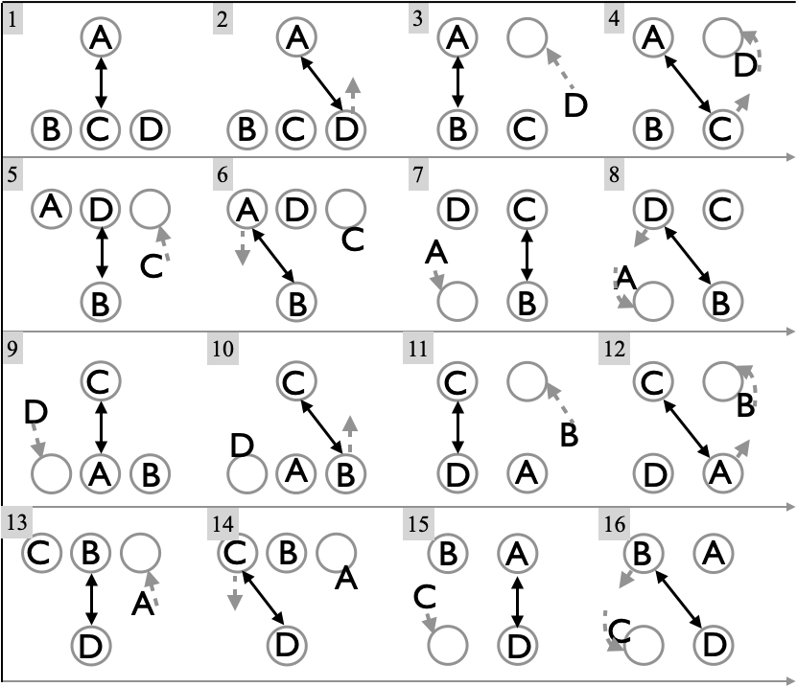 |  |  |  |  |  |  |  |  |  |  | Start left-handed (the modern start!). Notice there’s a single switch-side move connecting a typewriter-1-count feed of 3-counters and a 2-on-2 double three count box. Initially, the version here was considered the “fast version”, with slower versions stepping between the feed and box. The version reported here smooths all this into a beautiful 16 beat moving pattern.  Rule: Move forward off the feeder’s left side of the feed, while passing a right and similarly receiving a pass into your inside (left) hand.
This challenging pattern is quite doable once passers master the stationary 1-count feed and the 2 on 2 double 3-count box. It is essentially a continuous switch-sides 1-count feed. A fun 5-person practice has 4 doing El Niño and 1 sub who tags in for the first person to drop!
Metrics: J=4, CJ=3, OJ=3, pH=1, R=1, cycle=16 on 1-count base, PBJ=½, motion $≃3$ pu , On spin, the two switch sides per cycle gives spin$≃$$2π$; not shown is the precession which happens (like in Tempered Chocolate), which reduces that spin over each cycle; however there’s the extra spin associated with the feeder sweep, so spin $≃$$2π$ is about right.
Variations: The mirror image (1-count feeding left to right), sometimes called La Niña. Move on left throws instead of rights and start with a right pass in the middle. El Niño was often performed by the MAD-5; a longer version with 2-v-2 box transitions was part of the championship routine in 1999!
There are other fun ways to rotate a 1-count feed. Tarim? demonstrated a pattern similar to 1-count El Nino where the mover transitions in 4-count instead of 3-count (leaving on a left hand throw in the above picture instead of a right, and joining the double three count box on the opposite count. He also goes the wrong direction like La Nina! :)

El Turbo  A turbo-fied version of El Niño. | The idea is to cross through the center of the pattern when you make your change-side, as in the 3-person Turbo.
It may not be theoretically possible at the El-Niño 1-count base, so we usually do this one in a right-handed 2-count or more gently in a 3-count. We often count it 1-2-3-4, four times on the base beat, with each set corresponding to one person being the feeder. For example, juggler A starts as the feeder (first row in figure), then it goes to C, B, and D, in that order. Notice that beats 1 and 4 of each feed go to the same feedee. The pattern is chiral, by which we mean that it has a specific orientation; a backwards version would be different. In the figure, for example, movement through the middle always goes left to right. Movers (e.g., C at the start) need to move swiftly into their next position immediately after the feeder passes their first throw. Watch 3-count El Turbo with colors: https://www.youtube.com/watch?v=5ORfAzSpCcU
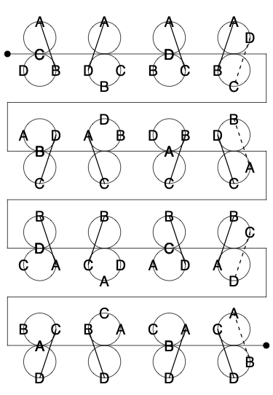  Metrics: 16 beat cycle, best on 2-count, but nice on 3-count. J=4, CJ=3, OJ=3, pH=1, R=1, PBJ = ¼ on 2-count, ⅙ on 3-count; with extra passes $10/32$ (2-count), $10/48$ (3-count). spin=$2π$; motion $≃$ 5 pu per cycle (2 loops). | Two extra passes per cycle per juggler fit in nicely (grey in table and dashed lines in figure) make a more difficult pattern, including 6 passes in a row on the base beat. (These passing opportunities are not available in ordinary El Nino!) There are also opportunities to pass to stationary jugglers on the left or right side of the pattern, making 5 or 6 person variants. See El Turbo ++.  Motion is slightly bigger than for weaves etc to account for more moving bodies!  Created by the MAJ on 8/25/2011. | Base Beat | Juggler
 |  | Base Beat | A | B | C | D
 |  | 1 | B | A
 |  | 2 | D |  |  | A
 |  | 3 | C |  | A
 |  | 4 | B | A | D | C
 |  | 5 |  |  | D | C
 |  | 6 | C |  | A
 |  | 7 |  | C | B
 |  | 8 | B | A | D | C
 |  | 9 | B | A
 |  | 10 |  | C | B
 |  | 11 |  | D |  | B
 |  | 12 | B | A | D | C
 |  | 13 |  |  | D | C
 |  | 14 |  | D |  | B
 |  | 15 | B |  |  | A
 |  | 16 | B | A | D | C

Tomahawk  (Not the overhand throws!) |  |  | An El Turbo variation in honor of Tom Pomraning.
Slow down the 2-count El Turbo base to 3-count; then tomify by replacing each pass-self-self with a pass-pass-pass. It has nice club-color coordination like Tom's Turbo. It's pretty heavy duty; e.g. as you cycle into your feeder position you end up doing 1-count for 12 passes! Metrics: Same as El Turbo, except cycle length is 48 on 1-count base, and, ignoring extra (grey) passes, PBJ=½. A slightly easier version replaces the 3-count passing with pass-pass-self to the same person, all within the El Turbo cycle.

El Turmeric Weave  Like the spice, this pattern is good for inflammation! |  |  |  |  |  |  |  |  | 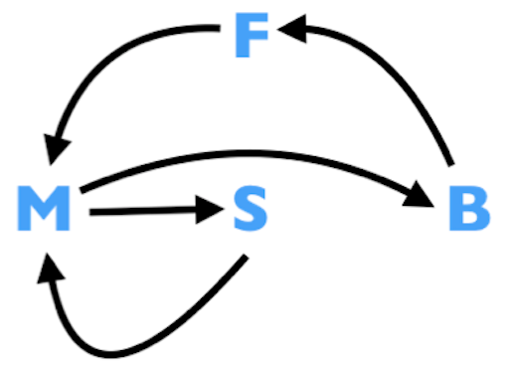
Juggler  position | Beat, standard is 2-count base; 3-count is more comfy!
Juggler  position | 1 | 2 | 3 | 4 | 5 | 6 | 7 | 8 | 9 | 10 | 11 | 12 | 13 | 14 | 15 | 16
A | C | B | D | C | ⇒ | D | ⇒ |  | C | ⇒ |  | C | ⇒ |  | B | ⇒
A | F | F | F | F | ⇒ | M |  |  | S |  |  | M |  |  | B | ⇒
B |  | A | ⇒ |  | D | ⇒ |  | D | ⇒ |  | C | ⇒ | D | C | A | D
B | M | M |  |  | S |  |  | M |  |  | B | ⇒ | F | F | F | F
C | A | ⇒ |  | A | ⇒ |  | D | ⇒ | A | D | B | A | ⇒ | B | ⇒
C | S |  |  | M |  |  | B | ⇒ | F | F | F | F | ⇒ | M
D |  |  | A | ⇒ | B | A | C | B | ⇒ | C | ⇒ |  | B | ⇒ |  | B
D | B |  | B | ⇒ | F | F | F | F | ⇒ | M |  |  | S |  |  | M
This fun moving pattern comes from the Inside-Out-Weave, where we add continuous feeder-weaver exchanges from the big loop, B. As you move through the feeder position, F, you pass 4 times, with 2-count gaps, the first and fourth of which are to the same juggler (as with all the El patterns). Feeder passes to small (S), middle (M), big (B), middle (M). You move into or out of the feeder position F on 4-count, and you move through the weave positions with three throws on 6-count gaps (black boxes). Prof Mike, Mellonhead, Jeff Adamus, and Nathan Nard created this on September 8, 2022. Metrics: J=4, CJ=3, OJ=3, pH=1, R=1, PBJ=¼ on 2-count or ⅙ on 3-count, cycle=16 on 2 or 3-count base, spin $≃2π$ rad owing to everyone facing all clock directions in one cycle. For motion, each weaver would do 4 pu per cycle, but getting in and out of F expands that closer to 6 pu.

Extra-Club Moving 4-Person

Extra Club Switch Sides Feed
Windshield Wiper Version.
Alternating feeders A and C stay still while end feedees B & D move back and forth.
In this spectacular pattern, A and C alternate feeding (grey shading) a line of 3, while end feedees B and D move back and forth (black), all passing doubles and occasional double self throws to maintain the phase difference between the two sides of the pattern.
 | Beat, 1-count base (A & D start right; B & C start left) |  |  |  |  |  |  |  |  |  |  |  |  |  | ½ P is half pirouette under a right to left double self; d-s is a stationary double self
Juggler | 1 | 2 | 3 | 4 | 5 | 6 | 7 | 8 | 9 | 10 | 11 | 12 | 13 | 14
A | d-B |  | d-C |  | d-D |  | d-C |  |  |  | d-C
B |  | d-A |  | d-s | ½ P |  |  |  | d-C |  | d-s | ½ P
C |  |  |  | d-A |  |  |  | d-B |  | d-A |  | d-D |  | d-A
D | d-s | ½ P |  |  |  | d-A |  | d-s | ½ P |  |  |  | d-C
All passes are straight right doubles; A starts with 4 clubs. B, C, and D each start with 3 clubs, with 2 in the left. The sides are out of phase, with the A-side on left selves when the C-side is on rights, and vise versa. Movers B and D, who go back and forth on 6-count.

Metrics: J=4, CJ=3 ¼, pH=2, R=2, 14-beat cycle on 1-count base, OJ=2 ½, pattern spin $π$rad and motion = 1 pu (as in no-extra club version). Overall PBJ=¼. Pattern by Luke Emery.

.

Extra Club Weaves
Set up and motion as in the Standard Weave, with three weavers moving through a figure-8/lemniscate opposite one feeder.

Standard Extra-Club Weave
The feeder starts with 4 clubs and passes 2-count right doubles, windshield-wiper style, deep on the ends and loopy in the middle. The three weavers are out-of-phase (i.e. rights in time with feeder’s lefts), and respond in 6-count doubles back to the feeder. Performed by the Gentleman Jugglers (Mark Hayward, Matt Henry, **, **) at the first 47th annual Madfest (January, 1992); also performed by Peter Kaseman, Prof Mike, Mellonhead, and Nathan Nard **which show** in 2024. Good exercise: Do with lefts not rights!
Metrics: J=4, CJ=3 ¼, OJ=3/2, pH=2, cycle=12 on 2-count, R=2, motion=3 pu, spin$≃$147°.

3-count/9-count Extra Club Weave
Feeder starts with 4 clubs and passes 3-count straight doubles, windshield-wiper style, deep on the ends and loopy in the middle. The three weavers are in phase with the feeder, and respond in 9-count crossing doubles back to the feeder. Works especially well with Nick Aickens as the feeder! It’s slower than the Standard Extra-Club Weave, but somehow more finicky, probably because we’re still not as sharp as we should be with lefts!
Metrics: J=4, CJ=3 ¼, OJ=3/2, pH=2, cycle=12 on 3-count, R=2, motion=3 pu, spin$≃$147°.

Popcorn Weave
Consider the stationary Popcorn Feed, and imagine weaving the feedees. This Popcorn Weave is a very challenging 2-extra-club pattern, not for the faint of heart! Though the feed version is windshield wiper, here the feeder passes 2-count doubles windshield-wiper style to the three weavers who are all doing 6-count-popcorn. Recall the right-hand mantra for this is 3-2-1, triple self, double pass, single self, then repeat (all lefts are single selves). The challenge is that the weaver also needs to weave to the next spot in the time it takes to complete the 3-2-1. Feeder and the third weaver both start with 4 clubs. The weaver’s rule is to launch a triple self in response to the feeder's double pass; note too that all passes are doubles, and they need to be fairly crispy for this pattern to work! The Popcorn Weave dates to September, 1999, by Luke Emery and the MAJ.
Metrics: J=4, CJ=3 ½, OJ=3/2, R=2, pH=2, cycle=*, motion=3 pu, spin$≃$147°.

Unicycle Plus
A very fun and doable 1-extra club moving pattern for 4 with dropbacks.
Juggler |  | Beat (1-count base)
 | 1 | 2 | 3 | 4 | 5 | 6 | 7 | 8 | 9 | 10 | 11 | 12 | 13 | 14 | 15 | 16
A |  |  | t-C |  |  |  | t-D |  |  |  | t-D |  |  |  | t-C
B |  | d-A |  |  |  | d-A |  |  |  | d-A |  |  |  | d-A
C | d-B | ⇒ |  |  | d-B | ⇒
D | ⇒ |  |  |  |  |  |  |  | d-B | ⇒ |  |  | d-B | ⇒
C starts with 4; others with 3 clubs; B is out of phase, starting with left self; A and D start with right selves. C and D form the wheel (they move!), with 2 passes to the post B (on 4-count rights) followed by two phantoms while on the bottom of the wheel; moving steadily for a smooth ride! A (the seat) passes 4-count triples to both sides of the wheel. B faces the wheel and is doing 4-count backdrops to A; A and B are both stationary.

Metrics: J=4, CJ=3 ¼ (1 extra), cycle=16 beats on 1-count base, R=3, pH=2 ⅓ (4 triples and 8 doubles), PBJ=¼ for A and B and ⅛ for C and D. Overall PBJ=3/16. Distance travelled by movers approximates the circumference of the circle whose diameter is $1/\sqrt{2}$ pu, giving a pattern average motion about 1 pu. B does not spin owing to straight dropbacks. Referring to angles in the stationary Y, the angle swept out by A, C, and D per cycle is about $8φ$, where$φ=asin(1/4)$$≃$0.25 rad=14.5°, for a pattern average spin $≃$ 1.5 rad = 86°.

14 Club Oogle Boogie
Positions/Passes  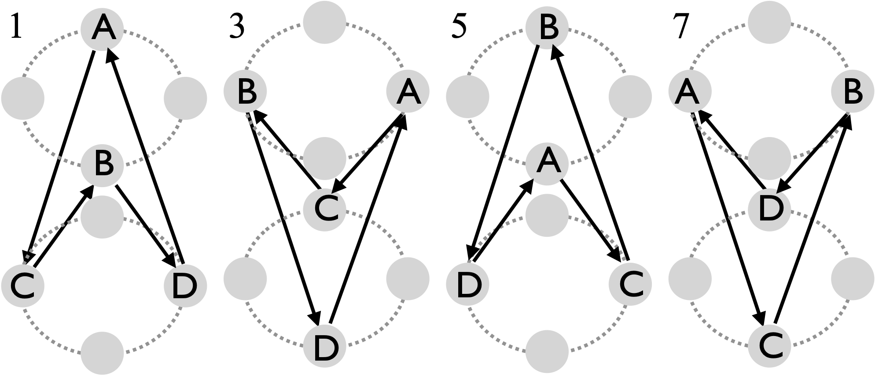  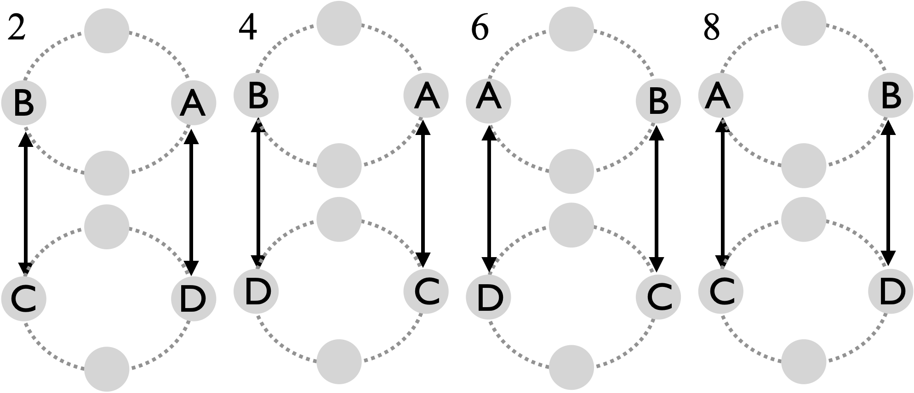  Pattern by Luke Emery, 2000 [?performed at Cascade of Stars, 2000 IJA?] | 1. C and D start with 4 clubs each, and pass 3 times on 2-count then triple self. A and B start (1/2 beat after C and D) with 3 clubs each, do 3 passes, then move to position 2.  2. A, B do 3 passes, then triple self. C, D do 4 passes, then move to position 3.  3. A, B do 3 passes, then triple self. C, D do 3 passes, then move to position 4.  4. A, B do 4 passes, then move to position 5. C, D do 3 passes, then triple self.  All passes are double spin passes. Four passes are needed to transfer the extra clubs to the team that is not moving.  It's probably helpful to be comfortable with 7 club popcorn variations before learning this pattern!
This has the same movement sequence as the standard (Slow) Oogle Boogie, but it makes for a spectacular pattern with 2 extra clubs, doubles passes (like 7 2-count), and some triple selves to support the moves. (Prior editions of the pattern book have jugglers rotating in the opposite direction; both versions work!) In principle, it's possible to do a regular fast Oogle Boogie instead of the slow version, but you need jugglers who are really comfortable moving while throwing self triples! Still a dream for the MAJ.

Metrics: J=4, CJ=3 ½, , pH=2, R=1, OJ=2, cycle=16, on 2-count, PBJ = ⅜ ; motion = 2 pu; spin $≃π rad$, considering the rotations each mover makes to square up with their receiver.

Here’s an extra club version of the Standard 3-leaf Clover, where each feeder doubles up passes to the feedees in order to reduce the speed of movement through the leaves.
Extra-Club Three Leaf Clover (slow) |  | 1st half |  |  |  |  | 2nd half
 |  | A | B | C | D |  | A | B | C | D
All passes are right-hand straight doubles. The feeder-like position (A to start, grey) is out of phase (left-v-right) with the others; adjustments are indicated: s = double self; - = pause. A and C start with right; B and D start with left; A starts with 4 clubs. All jugglers do same local sequence, but shifted in time:  1. Feed from right to left: pass once to the end, twice to the middle, twice to the other end.  2. Self double, pause.  3. Two right selves to move into the middle, then pass twice  4. Self double, pause  5. Two right selves to move out of the middle  6. Repeat!  Move beats indicated with black shading. Note double-self/pause can happen at various spots within the move. One leaf-shift (⅓ cycle) shown. | 1 | D |  | s |  | 15 |  | C |  | s
 | 2 |  |  | - | A | 16 |  |  | B | -
 | 3 | B |  |  |  | 17 |  | A
 | 4 |  | A |  | s | 18 | B |  | s
 | 5 | B |  |  | - | 19 |  | A | -
 | 6 |  | A |  |  | 20 | B
 | 7 | C |  |  |  | 21 |  | D
 | 8 |  | s | A |  | 22 | s |  |  | B
 | 9 | C | - |  |  | 23 | - | D
 | 10 |  |  | D |  | 24 |  |  |  | C
 | 11 | s |  |  | C | 25 |  | s | D
 | 12 | - |  | D |  | 26 |  | - |  | C
 | 13 |  |  |  | C | 27 |  |  | D
 | 14 |  |  | B |  | 28 |  |  |  | A
Start and move path | Pro tip: Make the last feed throw deep and loopy to give enough room to the new feeder.  Metrics: J=4, CJ=3 ¼, OJ=3, R=1, pH=2, local cycle=28 1-count gets us to switch by one-leaf; so full cycle=84, motion 5 pu and pattern spin $≃2π$ rad per cycle.  Performed by…**  Pattern by Luke Emery, 2001

Here’s another extra club version of the standard clover but without the doubling up…a super challenging pattern to get the leads just right!
Hyper Clover |  |  | Juggler
 |  |  | A | B | C | D
Both hands counting (i.e., 1-count base). All right hands are either double passes or double selves. A starts with left hand; B starts with pause, then left hand (for start, B can just start with right self); C starts with left hand; D starts with right hand and 4 clubs.  All passes right-hand straight doubles. s = double self; - = pause;  These adjustments maintain timing since feeder-position rotates and feedees must be on lefts when feeder is on rights (i.e. out-of-phase).  All jugglers do the same local sequence on shifted time. As you start your feed, you receive from the last feeder but return fire to the middle person then end. It’s all in making good loopy leads!  Pro tip: Make the end throws and self throws especially loopy; leads are key!  Pattern by Luke Emery, 2001. |  | 1 |  | - |  | A
 |  | 2 | B |  | s
 |  | 3 |  | A | - | s
 |  | 4 | C |  |  | -
 |  | 5 |  | s | D
 |  | 6 | s | - |  | C
 |  | 7 | - |  | B
 |  | 8 |  | A |  | s
 |  | 9 | B |  | s | -
 |  | 10 |  | D | -
 |  | 11 | s |  |  | C
 |  | 12 | - | s | D
This was one of the first extra club clover variations we tried. The first attempt was Prof Mike, Peter Kaseman, Luke Emery and Ilka from Luka Luka at a juggling convention. Peter, Luke and Ilka are all fantastic club passers, but discovering the difficulty motivated the slow version described above. More recent attempts that emphasize good leads have gone well.

Metrics: J=4, CJ=3 ¼, OJ=3, R=1, pH=2, local cycle=12 1-count gets us to switch by one-leaf; so full cycle=36, motion $≃5$ pu and pattern spin $≃2π$ rad per cycle.

2(pi)$π$/3 with a Post + 1
Triples galore; gazelle-like motion is necessary!
 | Beat, 2 count (½ cycle) |  |  |  |  |  |  | D starts with 4.  All passes are right singles among movers and right triples with the post.  Pattern by Prof. Mike and the MAJ.
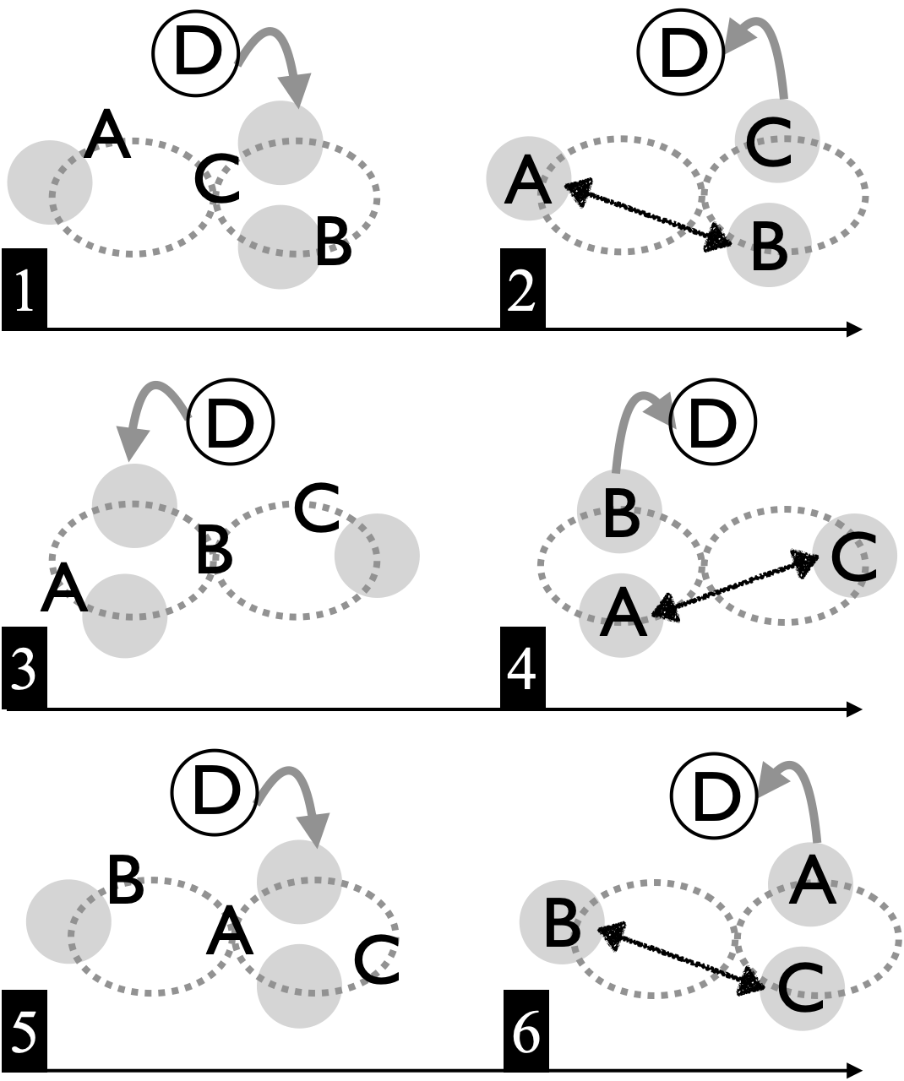 |  | 1 | 2 | 3 | 4 | 5 | 6
 | A |  | B |  | C |  | t-D
 | B |  | A |  | t-D |  | C
 | C |  | t-D |  | A |  | B
 | D | t-C |  | t-B |  | t-A
The relatively fast moving 4-count 2$π$/3 with the post is purpose built for an extra club, with post D offset sending right-hand triples into the movers, who each return fire (from close range!). Locating triples well is key.
Metrics: J=4, CJ=3 ¼, OJ=3, R=2, pH=2, PBJ=½, cycle=12 beats on 2-count, motion=3 pu, spin=(⅚)($2π) ≃5.24 rad.$

El Nino Plus (slow)
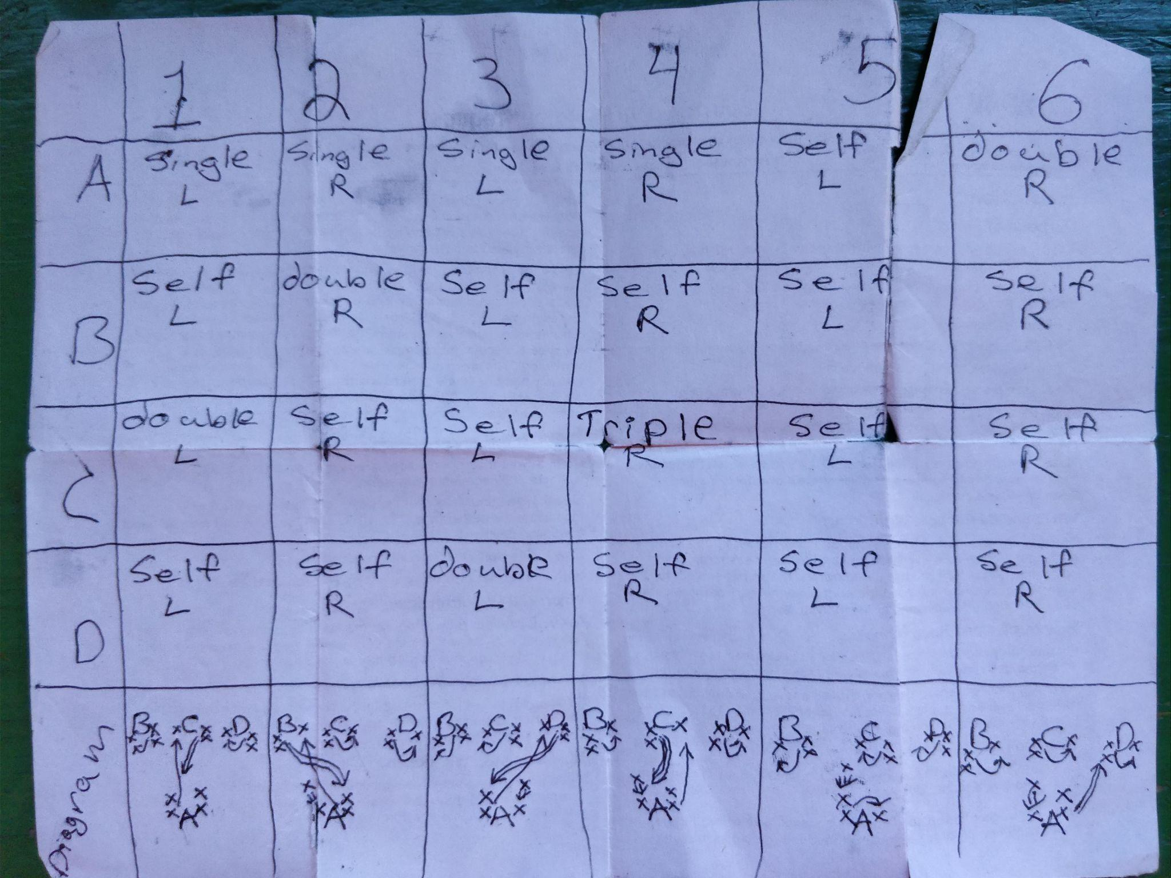

El Nino Plus (fast)
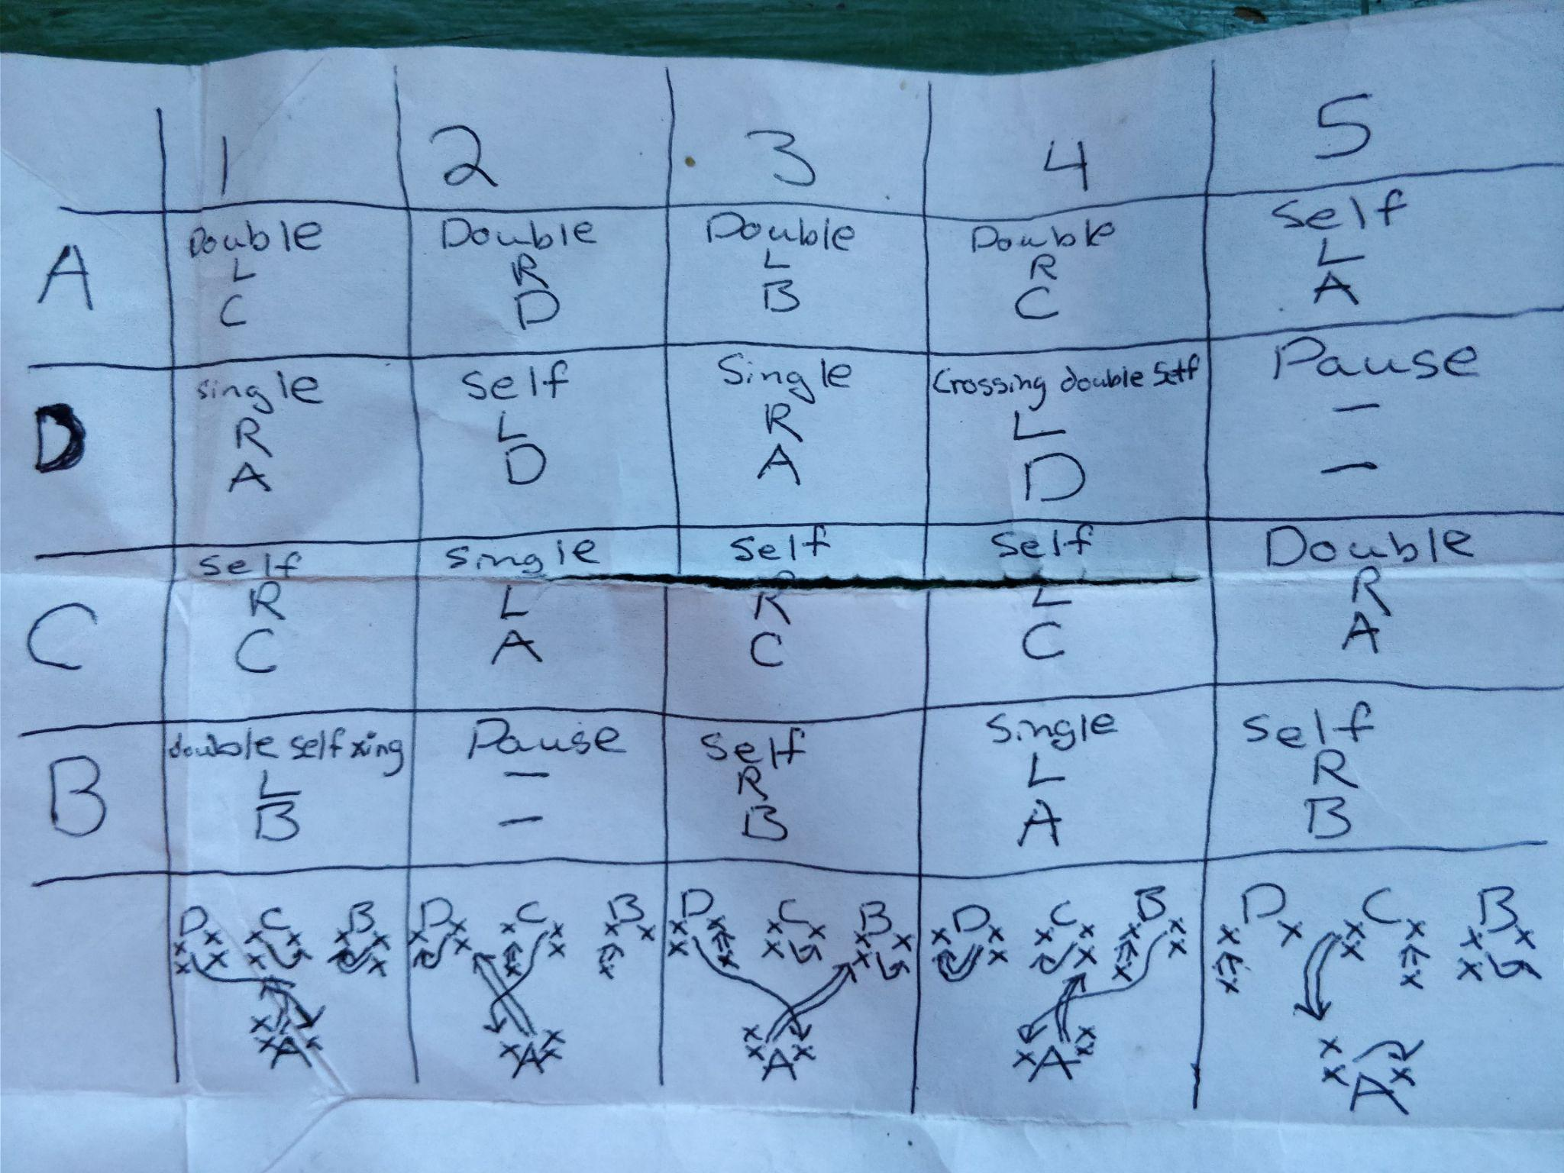

El Nino Plus patterns by Graham Paasch. **Q. Graham, where are the transitions?**

Five Person Patterns

Some classic configurations for jugglers A, B, C, D, and E.

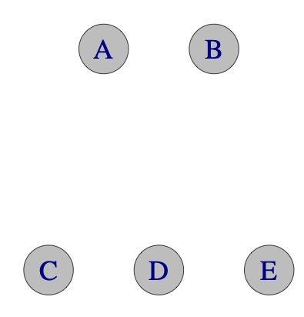  2 on 3 (feed) | 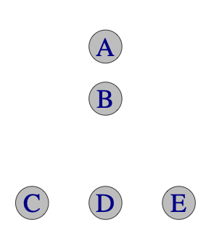  Apollo | 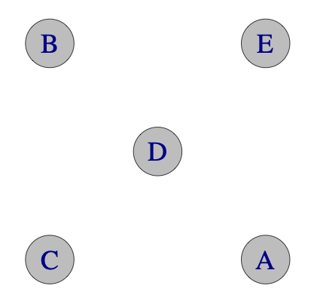  Quincunx/Twister (set up)
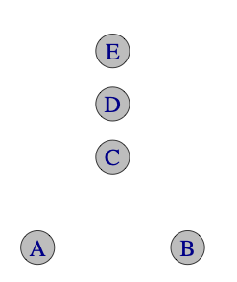  Wedgee | 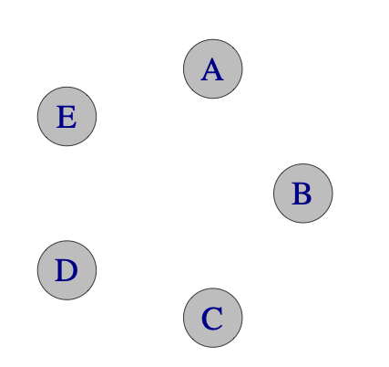  Circle/Star | 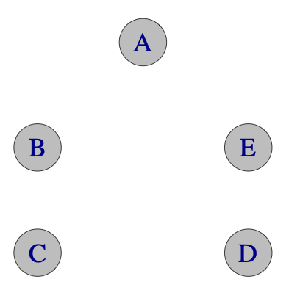  Egg Beater (set up)

Stationary 5-Person Patterns
Apollos  The Apollo was invented by N.A.S.A. Apollo juggling was invented by the Gemini Jugglers in 1991. |  |  |  |  |  | A great MAJ standard for beginning passers (the shape is reminiscent of the Apollo command module reentry vehicle!) The layout of jugglers is also called a 1-1-3, for obvious reasons!  A and B face the heat shield C, D, and E. Usual start is right-handed. B is an ordinary feeder, while A alternates in 4-count to the ends.  A fun exercise is to master passing with one assignment of jugglers to positions, and then to rotate positions, repeatedly, so that everyone gets to try every position!
Original Apollo  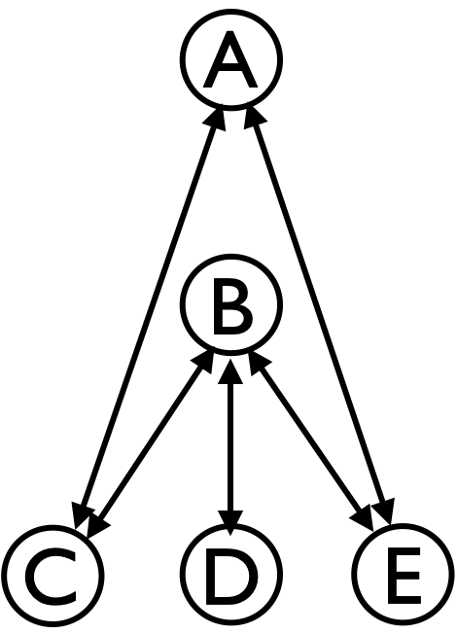 | Beat (2-count base)
 | Juggler | 1 | 2 | 3 | 4
 | A | E |  | C
 | B | C | D | E | D
 | C | B |  | A
 | D |  | B |  | B
 | E | A |  | B
Metrics: J=5, CJ=3, OJ=1.4, cycle=4 on 2-count, R=4, PBJ=0.3, motion=0, spin=$0.87rad (50$°).
Cockeyed Apollo |  | 1 | 2 | 3 | 4 | Change the outside throws to be in a Y and the Apollo becomes cockeyed, so named because the middle feeder (B) has to throw and catch from opposite directions. Notice the switcheroo in the passing table for jugglers C and E. Same metrics.
Same layout,  but different who-passes-to-whom. | A | E |  | C
Same layout,  but different who-passes-to-whom. | B | C | D | E | D
Same layout,  but different who-passes-to-whom. | C | A |  | B
Same layout,  but different who-passes-to-whom. | D |  | B |  | B
Same layout,  but different who-passes-to-whom. | E | B |  | A
The spin calculation assumes A to D is $\sqrt{2}$pu, that B sets up at the midpoint, and that C to E is 1 pu. Then angle ∠CAB has measure $φ=atan(1/(2\sqrt{2}))$, ∠CBD has measure $ψ=atan(1/\sqrt{2})$, and in one cycle A sweeps $4φ$, B sweeps $4ψ$, D has zero spin, and C and E both sweep out $2(ψ-φ)$, for a pattern average spin $(6ψ+4φ)/5.$

Patterns in a circle
Star  A classic 5-person variation of the synchronized 4-person box |  |  |  |  |  |  | Any beat of choice works, and throws are simultaneous.  Right throws go to the person two spots to your right; left throws to the one two spots to the left.
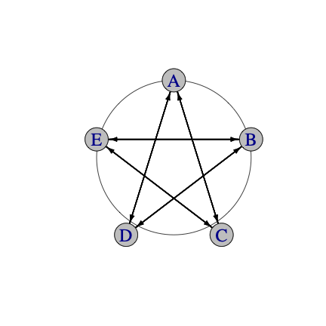 |  | Juggler
 | Beat | A | B | C | D | E
 | Rights | D | E | A | B | C
 | Lefts | C | D | E | A | B
 | Metrics: J=5, CJ=3, pH=1, R=1, PBJ=1/[base-count]. On even base, OJ=1 and cycle length=1; on odd base (e.g., 3-count), OJ=2 and cycle length=2. Motion=0, and spin=0 on even counts; but jugglers need some rotation on odd counts to sweep between their counterparts. We estimate spin = $2π/5$ rad = $72$° for full cycle.
Collisions are certainly a possibility with this classic pattern, and so the need for precise timing makes it a bit difficult for beginning passers, even on a slow beat. (You’re also not passing to the same person you receive from.) When well timed, your right throws will pass just behind the right throw of the juggler on your right, so keep an eye out! By the same token, any left throws pass immediately behind the left throw of the juggler on your left. As with the synchronous 4-person box, having a wider ZOC reduces collisions.

All counts are fun; the MAJ has a love-hate relationship with the 1-count star; it was one of those failed patterns in the Mad-5 routine when they competed for the IJA teams competition in 1999 (Urgh!) We had fun with the 2-count LED star at the 2025 homecoming parade.

Feast (for 5)  Everyone feeds everyone else (clockwise-from-above version) |  |  |  |  |  |  | Pass sequentially around the circle, including yourself in the count. Any base count of choice works; 3 and 4 count are pleasant; 2-count requires some good passers and good timing. 1-count is a dream!  This is a classic generalization of a rotating feed (which itself we rarely do; it’s harder to remember, less fun, and not even documented in the book!) MAJ have been juggling feasts since at least 1992, though their origin is unknown to us!
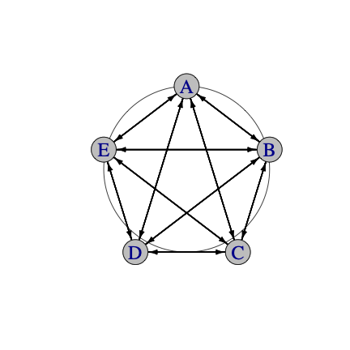 |  | Juggler
 | Beat | A | B | C | D | E
 | 1 | B | A | E |  | C
 | 2 | C |  | A | E | D
 | 3 | D | C | B | A
 | 4 | E | D |  | B | A
 | 5 |  | E | D | C | B
Metrics: J=5, CJ=3, pH=1, OJ=4, R=1, cycle length=5 on base count; PBJ=$[4/5]/[base]$, e.g., $0.27$ on 3-count; $0.2$ on a 4-count, motion=0. Some spin is needed to square up with your counterpart around the circle; over the cycle, spin = $6π/5$ rad = 216°.

Variations include:

Picnic
Start by practicing a 3-count feast. In the picnic, you complete one cycle throwing right-right or left-left crossing passes, then you switch on the next cycle (after doing your self beat) to do a round of straight passes (right-left or left-right). To set up, note that each pair of passers must include one straighter and one crosser. Picnic leads to all kinds of interesting Jim’s jams, including long sequences of only left throws or only right throws. Just remember, pass back the club you catch! [Homework: figure out the cycle length!]

Feast-Star
Here is an excellent brain game (and a favorite among MAJ-ers). Interleave a Feast with a Star by passing one feast beat, followed by one star beat, followed by the second feast beat, then then second star beat, and so on. This doubles the cycle length and provides for endless fun as people get confused about where they are in that cycle! E.g., for the popular 4-count, the cycle is 10 4-count beats, with PBJ equal $[5(4) +5(5)]/[5(40)]=$0.225. Because you have two partners in a 3-count star, the 3-count feast-star is even more difficult. Of late (August 2025), Nick Aikens and Steve Clipson have had us doing a Feast-Feast-Star or a Feast-Feast, where the two feasts are going in opposite directions!!

Selfless Star
 |  | Beat (3-count base) |  |  |  | We have been doing this pattern since at least 1992 and are unsure of its origins.  Metrics: J=5, CJ=3, OJ=4, R=1, pH=1, PBJ=⅓, cycle-length=4 on 3-count, motion=0, spin =  $6π/5$ rad = 216°
 | Juggler | 1 | 2 | 3 | 4
 | A | B | C | D | E
 | B | C | D | E | A
 | C | D | E | A | B
 | D | E | A | B | C
 | E | A | B | C | D
This variation is somewhere in between a feast and a star. You do not pass to the same person you receive from, and the passes to neighbors are at a pretty sharp angle, making this pattern difficult even on the 3-count. It’s possible but even harder on 2-count or 1-count. Passes move around the circle like in a feast, though unlike a feast you do not count yourself (hence selfless!).

Stationary Isla Vista Weaves
A non-MAJ non weave!
In these circle patterns, a 2-count feed (grey) travels around the circle. No juggler passes to either of their adjacent neighbors; all jugglers follow the same sequence, but time-shifted.
2666 version |  | Beat, 2-count base
 |  | 1 | 2 | 3 | 4 | 5 | 6 | 7 | 8 | 9 | 10 | 1333 version: Use the same passing table, but do so on a 1-count base, which is pretty challenging!
 | A | D | C |  |  | C |  |  | D
 | B |  |  | E | D |  |  | D |  |  | E
 | C |  | A |  |  | A | E |  |  | E
 | D | A |  |  | B |  |  | B | A
 | E |  |  | B |  |  | C |  |  | C | B
 | Metrics:
J=5, CJ=3, OJ=2, pH=1, R=1, PBJ=⅕ (2666) and ⅖ (1333), motion=0, spin = $2π/5$ rad = $72$°

2454 Isla Vista Weave  For those seeking to challenge their memory! |  |  |  |  |  |  |  |  |  |  |  |  |  |  |  | Code indicates your count sequence.
 | Beat, 1-count base (½ cycle)
 | 1 | 2 | 3 | 4 | 5 | 6 | 7 | 8 | 9 | 10 | 11 | 12 | 13 | 14 | 15
A | D |  | C |  |  |  | C |  |  |  |  | D
B |  |  |  | E |  | D |  |  |  | D |  |  |  |  | E
C |  |  | A |  |  |  | A |  | E |  |  |  | E
D | A |  |  |  |  | B |  |  |  | B |  | A
E |  |  |  | B |  |  |  |  | C |  |  |  | C |  | B
Metrics: J=5, OJ=2, CJ=3, R=1, pH=1, PBJ=4/15, cycle=30 (on 1-count), motion=0, spin = $2π/5$rad (72°).

Here are some fun 5 person stationary patterns with 2 feeders and 3 feedees that work both-hand passing. Originally (and most easily) these are set up in opposing lines (standard positions; 2-v-3), but the more uncomfortable wedgee positions are a good challenge (They used to work well when we juggled on chairs in 3650 Humanities!) Chocolate feeds are great 2nd-stage (i.e., not the easiest) stationary patterns, and they are especially good for getting your timing locked in without worrying about moving and leads.

Chocolate Feeds  Good patterns to improve your timing on a fast count.  Common metrics:  J=5, CJ=3, R=2, pH=1, motion=0 |  |  |  |  |  |  | 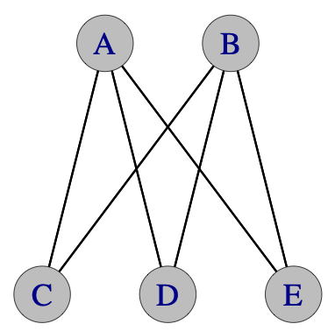  Standard formation |  |  |  |  |  | 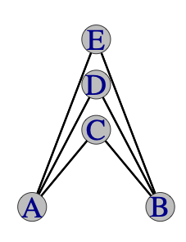  Wedgee formation!
Chocolate bar 3-count feed: aka Chocolate Box  2 feeders share a 1-count feed |  |  |  |  |  |  |  |  |  |  |  |  | Feedees C, D, E are in 3-count, twice in a row to each feeder, in steady state. Feeders A and B do chocolate bar, with a nice overlapping pattern to feedees  Pattern by Steve Otteson and MAJ. Performed by Mad-5 at ‘97 Madfest, and elsewhere
 | Base beat, 1-count, right-hand start
Juggler | 1 | 2 | 3 | 4 | 5 | 6 | 7 | 8 | 9 | 10 | 11 | 12
A | C | D |  |  | D | E |  |  | E | C
B |  |  | E | C |  |  | C | D |  |  | D | E
C | A |  |  | B |  |  | B |  |  | A
D |  | A |  |  | A |  |  | B |  |  | B
E |  |  | B |  |  | A |  |  | A |  |  | B
Metrics: PBJ=⅖, OJ=2.4, spin=2.1 rad (122°). See a nice animation by Aidan Burns at https://www.juggle.org/passing-post-feeding-on-chocolate-bars/

Double chocolate double 3-count feed
 | 1 | 2 | 3 | 4 | 5 | 6 | 1-count base, right-hand start
A | C | C | D | C | C | D | Feedees C, D, and E are on 3/2 count (i.e. double 3-count). Feeders A and B are on 1-count (i.e. double chocolate!)  Pattern by Steve Otteson and MAJ. Performed by Mad5+1 at ‘99 Madfest.  Metrics: PBJ=⅘ (that’s high), OJ=2, spin=0.59 rad = 34°
B | E | D | E | E | D | E
C | A | A |  | A | A
D |  | B | A |  | B | A
E | B |  | B | B |  | B

Semi-Sweet Chocolate 3-count feed (aka The New One)
 | 1 | 2 | 3 | 4 | 5 | 6 | 1-count base, right-hand start
A | E | C |  | E | D |  | Feeders A and B are on 3/2 count. Middle feedee D is doing simple 3-count alternating between feeders. Corners alternate 3-count:3/2-count  Pattern by Prof Mike. Metrics: PBJ=$8/15=0.53$, OJ=2.4, spin=2.1 rad (122°) cycle=6 on 1-count.
B |  | D | C |  | E | C
C |  | A | B |  |  | B
D |  | B |  |  | A
E | A |  |  | A | B

Yet another variation
 | 1 | 2 | 3 | 4 | 5 | 6 | 1-count base, right-hand start
A | C |  | E |  | D |  | Feeders in 2-count (one left and one right).  Feedees in 3-count  Pattern by Steve Otteson and MAJ  Metrics: PBJ=$2/5=0.4$, OJ=2.4, cycle=6 on 1-count, spin=2.1 rad (122°)
B |  | D |  | C |  | E
C | A |  |  | B
D |  | B |  |  | A
E |  |  | A |  |  | B
On the spin calculations (standard formation), we assume the feeder/feedee lines are separated by 1 pu, and jugglers are ½ pu apart within each line. With ∠CAD equal to ∠EBD and ∠ADB all of measure $φ$, and ∠DAE of measure $ψ$, we get $φ=2 atan(1/4)$,$ψ=atan(3/4) - atan(1/4)$. In the Double-Chocolate Double 3-count, feedees C and E don’t spin, so we get pattern average over one cycle as $6φ/5 = 0.59$ rad (34°). The other patterns sweep a greater overall angle, $12(φ+ψ)/5=2.1$rad = 122°

Extra Club Stationary 5 Person Patterns

There are lots of extra club variations of the patterns introduced earlier, but the MAJ go-to most popular stationary 5-person extra club pattern over the last few years is this 5-count star.
Extra club 5-count star |  |  |  |  |  |  | A popular standard
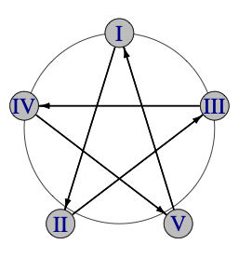 |  | Beat, 1-count base,  ½ cycle |  |  |  |  | Each juggler passes to one other juggler (2 spots to right) and receives from a different one. All passes are crossing (i.e., left-left or right-right) as 5-count double throws, and jugglers hands are in sync.
 | Juggler | 1 | 2 | 3 | 4 | 5
 | I | d-II
 | II |  | d-III
 | III |  |  | d-IV
 | IV |  |  |  | d-V
 | V |  |  |  |  | d-I
Notice we rename jugglers using numbers here, since we usually identify the jugglers with numbers as we do the pattern. In fact, for timing we often will call out our number as we throw. It can be seen as a 5-person version of the 3-person extra club 3-count triangle. A full cycle lasts 10 1-count beats in order for each juggler to pass both a right-hand pass and a left-hand pass. This is a great pattern for 5 jugglers who are comfortable passing doubles from either hand. Metrics: J=5, CJ=16/5=3.2, pH=2, R=1, cycle=10 beats on 1-count, PBJ=⅕, OJ=1, motion=0, spin=0.
Variations: See the next two patterns, which either add a club or add some single passes
Origin: Unknown to us, but probably not Madison.

Two extra club 5/2-count star [also PSPSS star]
 | Beat (1-count base); ½ cycle |  |  |  |  |  | Like the previous pattern, each juggler passes to one other juggler (2 spots to right) and receives from a different one. All passes are crossing double throws, and jugglers hands are in sync.
 | Juggler | 1 | 2 | 3 | 4 | 5
 | I | d-II |  | d-II
 | II |  | d-III |  | d-III
 | III |  |  | d-IV |  | d-IV
 | IV | d-V |  |  | d-V
 | V |  | d-I |  |  | d-I
A full cycle lasts 10 1-count beats in order for each juggler to pass both a right-hand pass and a left-hand pass. This one is an order of magnitude more difficult than the 5-count extra club star, but it works well with the right team. We find the spacing benefits from having a short gap between your passes within the pass-self-pass sequences; i.e. throw the first one a titch late and second a titch early!

Metrics: J=5, CJ=17/5=3.4, OJ=1, pH=2, R=1, cycle length=10 on 1-count, PBJ=⅖, motion=0, spin=0. Variations: Note each juggler is doing PSPSS here. Any S (self) can theoretically be converted to a P (pass) by adding a club, but it makes things super hard!

This variation goes back to one extra club, but adds a bunch of extra single passes.

Extra club 5-count star with crispy extra passes
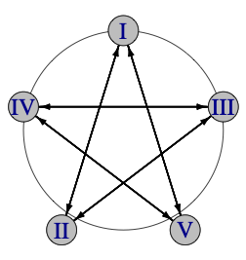 | Beat (1-count base); ½ cycle |  |  |  |  |  | Notice how many selves are in the 5-count extra-club star, above. This variation soaks some of those selves with zippy single-spin (straight) throws to an appropriate partner.
 | Juggler | 1 | 2 | 3 | 4 | 5
 | I | d-II | V | II
 | II |  | d-III | I | III
 | III |  |  | d-IV | II | IV
 | IV | V |  |  | d-V | III
 | V | IV | I |  |  | d-I
Each single-pass event happens almost orthogonal to the same-time double, which minimizes collision potential. It leads to the neat per-juggler sequence of double single - single, with the first and third passes going to the same person. (Make the doubles loopy and the singles crispy!) Metrics: J=5, CJ=3.2, pH=4/3, R=1, OJ=1, cycle=10 on 1-count, PBJ=⅗, motion=0, spin=$2π/5$ rad = 72°. Prof Mike suggested the singles, and others (probably Nathan and Steve), realized if you pack singles you get this nice double-single-single sequence. Recent addition (2024).

In this variation, each juggler passes in a 4-count across and to the right. This pattern has only right hand passes and right to left double selves.

Extra club 4-count star
 | Beat, 1-count base |  |  |  |  |  | A starts with 4; A, E start with right; B, C, D start with left (B starts with a pause (--), so B actually starts with a right on beat 2). All passes straight doubles. d-s indicates double self.
 | Juggler | 1 | 2 | 3 | 4 | 5
 | A | d-D |  | d-s | –
 | B | – |  | d-E |  | d-s
 | C |  | d-s | – |  | d-A
 | D |  | d-B |  | d-s | –
 | E | d-s | – |  | d-C
Metrics: J=5, CJ=3.2, PBJ=1/5, cycle=5 on 1-count, OJ=2, pH=2, R=1, motion=spin = 0.

Apollo Plus
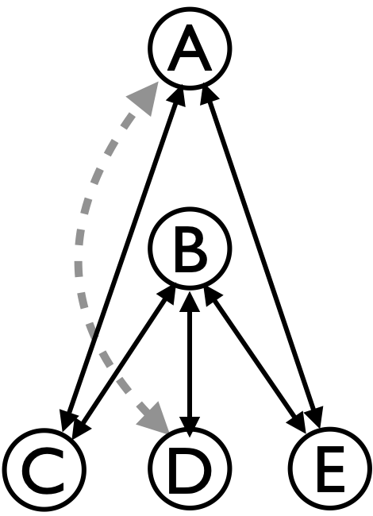 | Beat (2-count base) |  |  |  |  | Take the standard Apollo, and add triple-spin passing between A and D! D starts with 4 (1 extra club).  Metrics: J=5, CJ=3.2, OJ=2.4, R=4, pH=1.5, cycle=4 on 2-count, motion=0, spin=$0.87rad$ (50°). See Apollo notes for the spin calculation.
 | Juggler | 1 | 2 | 3 | 4
 | A | E | t-D | C | t-D
 | B | C | D | E | D
 | C | B |  | A
 | D | t-A | B | t-A | B
 | E | A |  | B
Variation: It’s conceivable but super hard to do the Cockeyed Apollo version. Alternatively, try an Apollo Plus Plus by adding another club to the inner feed (all the passes with B are doubles) so it is a 2-count extra club feed. All metrics stay the same except for increases in clubs per juggler and pass heights: CJ=3.4, pH=2.

2 v 3 with extra clubs
Overlapping 10-club feeds |  |  |  |  |  | Feeders A and B start with 4 each, passing in 2-count. Others start with 3 clubs, either with 2 in left hand and self or just delay and respond to feeders; the ends C and E do 4 count, while D is the anchor, and connects the two feeds in 2-count. This is one of the easiest 2-extra club patterns; the lines are offset like a call-response with double throws.
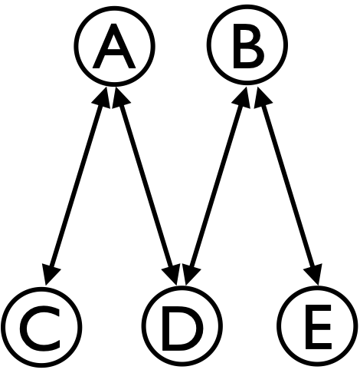  All throws are straight right hand doubles. | Beat (1-count base)
 | Juggler | 1 | 2 | 3 | 4
 | A | C |  | D
 | B | D |  | E
 | C |  | A
 | D |  | B |  | A
 | E |  |  |  | B
Metrics: J=5, CJ=3.4 (2 extra), OJ=1.6, cycle=2 (on 2-count), R=2, PBJ=8/20=0.4, pH=2, motion=0, spin=0.59 rad = 34° (refer to Chocolate Feeds). Perfecting this pattern sets you up for more complex patterns like the Mango Swirl/Mangled Squirrel, which involves continual change sides from this base pattern!

Up-Up-Over-5 |  |  |  |  |  |  |  | Refer to Up-Up-Over for 3 jugglers; recall this one involves simultaneous double throws from both hands. Expand from 2 facing 1 to 3 facing 2 jugglers. Now only the outside jugglers C and D do Up-Up-Over; the other three are Over-only feeders. Remember, these are simultaneous (right and left) double throws.
All passes are synchronous doubles. | Beat (1-count base)
 | Juggler | 1 | 2 | 3 | 4 | 5 | 6
 | A | D |  |  | C
 | B | E |  |  | D
 | C | ⇑ |  | A |  | ⇑
 | D |  | A |  |  | B
 | E |  | ⇑ |  | ⇑ |  | B
⇑ is a simultaneous double self (i.e. both hands double self, like in synchronous 4-clubs). A, B, and C start with 4 clubs each; D and E start with 2 clubs each.

Metrics: J=5, OJ=1.6, R=2, CJ=3.2 (1 extra), pH=2, PBJ=16/30=0.53, counting each passing beat as 2 considering clubs are passed in pairs (but not counting double selves! Motion=0 and spin=0.59 rad = 34° as above.

Extra Clubs Feast-Like
Following are some gems by Luke Emery from 1999. They take an awful lot of concentration and are beyond most MAJ groupings, but they are classic extra-club stationary patterns.

Extra Club Rotating Feed

Any feed or feast can be done with an extra club by replacing single passes with doubles and following every feedee pass and every feeder cycle with a self-double (d-s)/pause (--) to restore the left-right phase. The version shown is clockwise (from above). 1-count base (i.e., both hands counting)
Juggler |  |  |  |  |  |  | Juggler |  |  |  |  |  | All passes are doubles, and also each d-s is a double self, followed by pause (--) to adjust the left-right phase. A starts with 4; A and E start with rights; B, C, and D each start with their left hand. The steady state right hand sequence is: feed 3 passes, d-s, pause, then self pass, d-s, pause, twice, then repeat.
Beat | A | B | C | D | E |  | Beat | A | B | C | D | E
1 | C |  |  |  | d-s |  | 14 | d-s | D
2 |  | d-s | A |  | – |  | 15 | – |  |  | C
3 | D | – |  |  |  |  | 16 |  | d-s | E
4 |  |  | d-s | A |  |  | 17 |  | – |  | d-s | C
5 | E |  | – |  |  |  | 18 |  |  | A | —
6 |  |  |  | d-s | B |  | 19 | C |  |  |  | d-s
7 | d-s | E |  | – |  |  | 20 |  |  | B |  | –
8 | – |  |  |  | C |  | 21 | d-s | D
9 |  | d-s | E |  |  |  | 22 | – |  | d-s | B
10 |  | – |  |  | D |  | 23 |  | E | – |  |  | 1-extra club
11 |  |  | d-s | A |  |  | 24 |  |  |  | d-s | B | 1-extra club
12 | D |  | – |  | d-s |  | 25 |  | A |  | – |  | 1-extra club
13 |  |  |  | B | – |  | Feeder is marked in dark grey. |  |  |  |  |  | 1-extra club
Metrics: J=5, CJ=3.2, PBJ=⅕, cycle length=25 on 1-count base, R=1, pH=2. Now OJ=3 (everyone passes to 3 other jugglers, though everyone is involved with exchanges between all 4 other jugglers.) Motion=0 and spin is about $π$ rad (180°), and somewhat less than the ordinary 5-person Feast owing to not needing to square up to one adjacent feedee in each cycle.

Extra Clubs Feast, I  The feast is an extension to the 5 juggler Feast and the 5 juggler Extra Club Rotating Feed. The feeders alternate straight across right hand triples and doubles to keep the timing working.  Wow. Remember, if it were easy, then anyone could do it! |  | 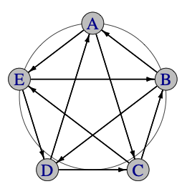
- Both hands counting  - All right hands are double or triple passes  - D and E start with 4 clubs and right hands  - On the very start only, A skips the pause and starts with a d-C on 1 with right hand  - B and C start with left hand |  | Beat (1-count base)
 | Juggler | 1 | 2 | 3 | 4 | 5
 | A | pause |  | d-E |  | t-C
 | B |  | t-D | pause |  | d-A
 | C |  | d-B |  | t-E | pause
 | D | t-A | pause |  | d-C
 | E | d-D |  | t-B | pause
Metrics: J=5, CJ=3.4, PBJ=⅖, R=1, OJ=2. This is a case where the `other jugglers` OJ metric is an oversimplification because although you each pass to two jugglers, you also receive from two different jugglers. Cycle length=5 on 1-count base. pH=2.5 (i.e., half doubles and half triples!). Motion=0, spin=$4π/5$ rad = 144° per cycle to cover the sweep back and forth to two recipients per juggler (would be more if we count angles to receive!)

Beat  1-count | Juggler |  |  |  |  | Extra Clubs Feast, II
Beat  1-count | A | B | C | D | E | Here’s a less intense version of the previous pattern!  Both hands counting.
1 | C |  |  |  | D
2 |  | s | A | E
3 | C | – |  |  | D
4 |  |  | B | A
5 | D | C |  |  | s
6 |  |  | B | A | – | All right hands are double passes or double selves (s); lefts are single selves. A and E start with 4 clubs and right hands B,C and D start with their left hand. Each double self (s) is followed by a pause to reset the left-right phase. Interestingly, this is a stationary version of the Mangled Squirrel, which we arrived at by adding change sides to a 2 on 3 feed!  Metrics: J=5, CJ=3.4 (2 extra), PBJ=⅖, R=1, cycle=15 on 1-count, OJ=4, pH=2, motion=0, spin = $6π/5$ rad = 216° as in standard Feast for 5.
7 | E | D
8 |  |  | s | B | A
9 | E | D | –
10 |  |  |  | C | B
11 | s | E | D
12 | – |  |  | C | B
13 |  | A | E
14 | B |  |  | s | C
15 |  | A | E | –

Extra Clubs Feast, III  Here's a version that might be easier than I or II. |  | 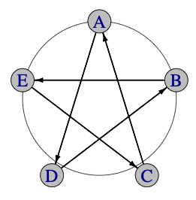
Both hands counting. All passes are rights. All right hands are double or triple passes  D and C start with 4 clubs and right hands. On the very start only, E does a pause on 1 and a left self on 2  A and B start with left hand self |  | Beat (1-count base)
 | Juggler | 1 | 2 | 3 | 4 | 5
 | A |  | t-D | pause |  | d-D
 | B |  | d-E |  | t-E | pause
 | C | t-A | pause |  | d-A
 | D | d-B |  | t-B | pause
 | E | pause |  | d-C |  | t-C
Metrics: J=5, CJ=3.4, PBJ=⅖, R=1, OJ=2, cycle length=5 on 1-count base, pH=2.5, motion=0, spin=0 (since you are passing to only one other).

Extra-club chocolate feed

Aidan Quinn worked out an extra club variation of the Chocolate Bar 3-count Feed. Basically the feeders share an extra club ultimate feed, alternating two passes as chocolate bar. Feeders pass straight and feedees pass cross. This pattern is also called the Chocolate Box. See https://www.juggle.org/passing-post-feeding-on-chocolate-bars/

Metrics: **PBJ=?; OJ=?; THJ=?

A version with 2 extra clubs should be theoretically possible, with all passes straight doubles.

Extra challenging extra-club stars

Triply Star, I  1 extra club |  | 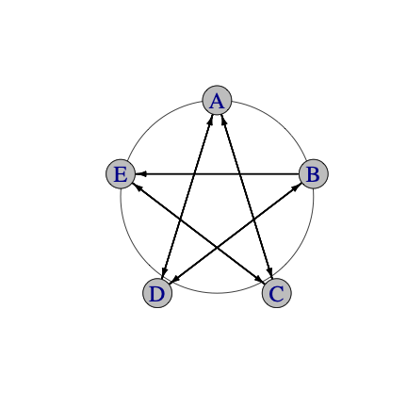
Right hand counting. A starts with 4  Metrics: J=5, PBJ=3/10, OJ=2, R=1, pH=5/3, CJ=3.2, cycle=5 on 2-count, motion=0, spin=$2π/5$ rad = 72° (or spin=0 if you drop the singles).  Patterns by Luke Emery |  | Beat (2-count base)
 | Juggler | 1 | 2 | 3 | 4 | 5
 | A | t-D |  |  | C | D
 | B | D | E | t-E
 | C |  |  | E | A | t-A
 | D | B | t-B |  |  | A
 | E |  | B | C | t-C
If you want to get crazy, note that each juggler has 2 right selves in a row, exactly enough time to do a triple self with a pirouette and stay in time. If you need to mellow it out, you can remove all the single passes and just pass a triple around in 10-count.

Triply Star, II

Make the triples right selves instead of passes.
C starts with 4.
Metrics: J=5, PBJ=3/10, OJ=2, pH=1, R=1, CJ=3.2, cycle=5 on 2-count, motion=0, spin=$2π/5$ rad = 72°.  There are many interesting star variations based on siteswaps that are passed from one star point to the next. Luke has seen a few demonstrated at European conventions. Pattern by Luke Emery. |  | Beat (2-count base)
 | Juggler | 1 | 2 | 3 | 4 | 5
 | A | t-self | D |  | C | D
 | B | D | E | t-self | E
 | C | A |  | E | A | t-self
 | D | B | t-self | B |  | A
 | E |  | B | C | t-self | C

20 Club Star

One of the great 5-person 5-extra club patterns!
This classic pattern is a star where every juggler starts with 4 clubs and in sync does 2-count doubles to the juggler across and to the right. It's a good study in timing. Passes cross just behind those of the person on your right.
- Right hand counting  - All start with 4, rights | Juggler | A | B | C | D | E
- Right hand counting  - All start with 4, rights | Beat: 1 | D | E | A | B | C
Metrics: J=5, PBJ=1/2, OJ=1, pH=2, CJ=4, R=1, cycle length 1 (on 2-count base), motion=0, spin=0. Origin unknown

Moving 5 Person Patterns

Weaves

Dr. Inside Dr. Outside Weave  Apollo Weave |  | Juggler
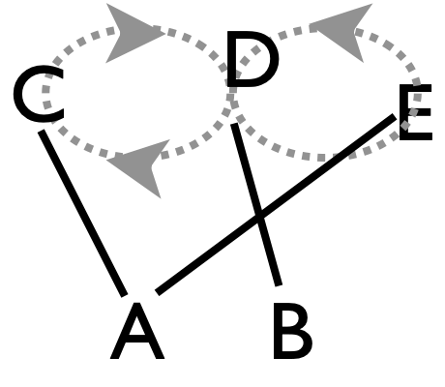  Standard Formation | 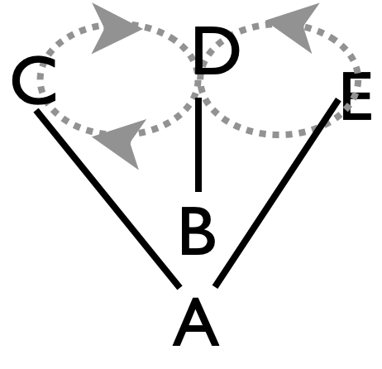  Apollo Formation | Base beat | A | B | C | D | E
 |  | Base beat |  |  | Start position
 |  |  |  |  | 1 | 9 | 5
 |  | 1 | C₁ |  | A
 |  | 2 |  | D₁₀ |  | B
 |  | 3 | E₇ |  |  |  | A
 |  | 4 |  | C₄ | B
This modifies the 4-person Standard Weave by dividing the feeder into two: A passes to the outside positions and B passes to the middle, with both feeders on 4-count in the standard version. Weavers C, D, and E proceed as in Standard Weave. Right-handed 2-count base is standard. Positions:  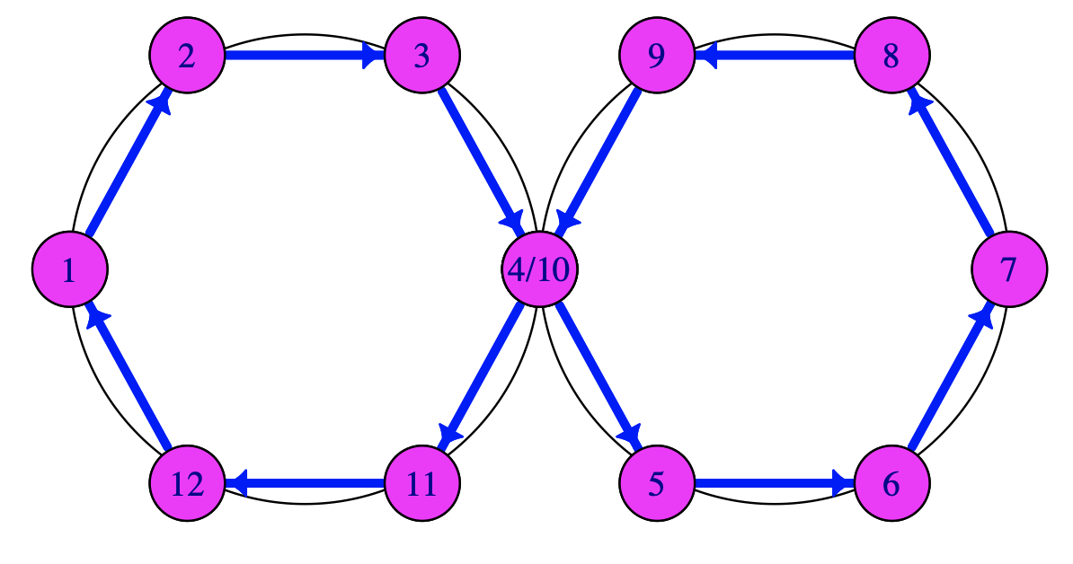 |  | 5 | D₁ |  |  | A
 |  | 6 |  | E₁₀ |  |  | B
 |  | 7 | C₇ |  | A
 |  | 8 |  | D₄ |  | B
 |  | 9 | E₁ |  |  |  | A
 |  | 10 |  | C₁₀ | B
 |  | 11 | D₇ |  |  | A
 |  | 12 |  | E₄ |  |  | B
 |  | This pattern is a necessary warm up pattern for the Twister Weave.
Variations: There are tons of variations of this two-feeder weave as in the Standard Weave. For starters, you can change the direction (so-called inverted weave), which has forward on the end and back in the middle as the basic rule. After passing on an end, be sure to wait for the middle pass before you move into the middle, else you’ll get hit!. Whether standard or inverted, there are all sorts of timing variations that amount to modifying the base beat; these all involve a 12-base-beat cycle, but could be slower or faster (or weirder!) than the standard. For example, 3-count base has feeders splitting a 3-count (so each is on 6 count) and each weaver on a 9-count–very pleasant for sure, but 9 is fairly slow and some of us have trouble counting that high! We often have A and B both on 3-count, which then leads to an interesting alternating 4-count/5-count cycle for the weavers. There are two ways to do that; we usually prefer the feeders start pass-self-pass-pass, and so that makes a 5 count after you pass on the end and a 4-count off the middle. (We call that a 4-5 weave.) Faster bases are basically impossible for mortal jugglers. One that is feasible is the 1-2-on-a-4-count base, where the feeders split chocolate-bar (pass-pass-self-self); more pleasant is 1-3-on-a-5-count base, which nicely balances hands. Also, 1-3-5-on-a-5-count makes the weavers all do 5-count, and the feeders sort out a split of that timing; e.g. the PSPSP weave has feeders alternate 3-count and 4-count so movers are on (the notation means one feeder passes on each P beat and both self on the S beat).

Metrics: PBJ = ⅙ per weaver, ¼ per feeder; mean=⅕; likewise OJ=2, pH=1, R=2. Like for the Standard Weave, movers set up about 1/$\sqrt{2}$ pu apart (i.e. a bit wider than for a stationary feed; width of weaver line = $\sqrt{2}$ pu; remember pu = passing unit = distance separating typical passers!), and traverse about 4 pu to complete the figure 8. Feeders don’t move, so the pattern’s average motion = 12/5= 2.4 pu. As a first approximation there’s no spin, but on closer inspection weavers rotate a bit to square up to A, and A also rotates similarly; only B has no spin. Each of these modest rotations sweep about $4φ$ rad per cycle, where $sin(φ)=1/\sqrt{5}$, considering the Apollo formation and A positioned about $\sqrt{2}$ pu from the weave line. Then pattern average spin is about 1.5 rad (85°) per cycle.

Origin: Both the Standard Weave and these 2-feeder variations are old, pre-MAJ patterns The MAJ have been weaving since 1992, or earlier! Historically (thanks Tom Pomraning), juggler A was also called Glen Davis (Mr. Outside) and B is called Doc Blanchard (Mr. Inside), college football players from the 1940s with the same nicknames! Recently Maya Biskowitz suggested and we realized that Dr. Inside/Dr. Outside are better monikers.

Twister Weave | 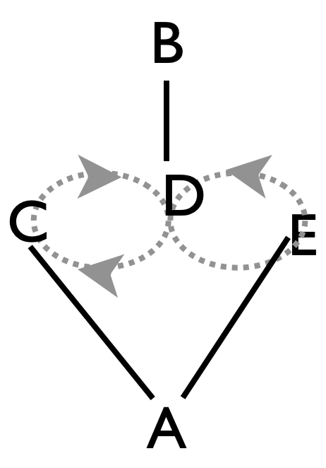  Animation  (http://juggloid.com/editor/?s=sU0PC0).  Watch SJRI  (https://www.youtube.com/watch?v=hmP4aZVFGJc)  Base pattern by Prof. Mike, variations by MAJ.
The original Twister Weave is one of the great MAJ discoveries. It has the exact same passing table as above in the Dr. Inside Dr. Outside Weave. However, Dr. Inside (B) and Dr. Outside (A) are on opposite sides of the weavers, so the weavers (on 6-count) turn around after every pass. When we first tried this on Library Mall (August 24, 1992), it seemed incredibly hard, probably because we hadn't yet mastered moving patterns involving rotations (good self throws make the difference; and there’s usually both an easy and a hard turn direction!) Oogle Boogies and other weaves had moves but no rotations; Egg Beaters had 90 degree rotations; Quincunx had a full rotation but it was very slow. Twister Weave is a durable and easy to remember pattern. MAJ often juggle it in parades, shows, and whenever 5 like-minded jugglers show up to practice! Performed by Mad-5 at 1996 Madfest, and many times by many jugglers since then!

Double-Time Twister
Feeders on 2-count, passing twice in a row to each weaver; weavers pass 2-rights out of every 3, with one right-hand self (i.e. 4-count) to turn. (Passing lanes become possible here where they would create collisions in the original Dr. Inside Dr. Outside.)
Other variations: All the timing variations as noted for Dr. Inside Dr. Outside are possible. A comfortable slow one is weavers on 9-count, feeders on 6-count; a faster one is feeders on 3-count and weavers alternative 4-5-count. MAJ records show some very challenging variations that are reserved for the best jugglers warmed up and in the best mood! There’s the fast twister, with weavers on 4-count and feeders each 8/3 count (PSPSPSSS and PSSSPSPSS), the ultra-twister, with weavers alternating 4-3-count and feeders on 7/3-count (PSSPSPSS and PSPSPSS), and the hyper-twister, with weavers on 3-count and feeders on out-of sync 2-count! This is a master-class pattern, owing to 180 degree turns after every pass and on 3-count. Good leads are essential!

Metrics: All the same as Dr. Inside Dr. Outside Weave, except with spin 4$π$ per weaver and about $2π$ for A, which is a pattern average about $3π$ rad per cycle. Motion=2.4, OJ=2, CJ=3, pH=1, PBJ=⅕ (standard) ⅖ (double-time) 13/90 (9-count/6-count) 4/15 (4-5/3 count) 13/40 (fast twister), R=2.

**Add a plot sequence for the 4-5, styled like the updated weave sequence**

Mondo Twister |  |  |  |  |  |  |  | A pleasant twister derived by splitting the Mondo-weave feeder into two doctors.
 | Base beat (1-count); ⅓ cycle |  |  |  |  |  |  |  |  |  | Dr. Outside, A, is doing a 5/2-count, pass-self-pass-self-self-repeat (which we sometimes call a 10/4 count, thinking of CB radios and truckers!). Dr. Inside, B, likewise does a nice 5-count, and the weavers pass according to the Mondo weave rule: 2 passes on each end on a 3-count gap, followed by weaving and passing on 2 6-count gaps.
 | 1 | 2 | 3 | 4 | 5 | 6 | 7 | 8 | 9 | 10
A | E |  | C |  |  | C |  | D
B |  | D |  |  |  |  | E
C |  |  | A |  |  | A
D |  | B |  |  |  |  |  | A
E | A |  |  |  |  |  | B
*show initial steps* |  |  |  |  |  |  |  |  |  |  |  | Set up like a Twister Weave, with D facing B and C and E both facing A.  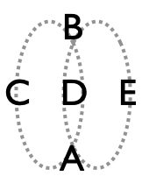
Metrics: J=5,
…found in Madison, summer 2026

Involuted Twister |  |  |  |  |  |  |  |  |  |  | Tree Twister
 | Base beat (3-count standard); ½ cycle |  |  |  |  |  |  |  |  |  | The involuted twister came about by doing a continuous feeder/weaver swap within a standard twister weave. The 2-count base of the twister is a bit too fast for standard, but 3-count is nice! The Tree variation comes by adding all those grey passes (table), while doing the same movement. Passes down the center go back and forth like branches, hence the name! (4-count is an ideal start for the tree.)
 | 1 | 2 | 3 | 4 | 5 | 6 | 7 | 8 | 9 | 10
A | E | C | B | D |  | E | C | B | D
B |  | D | A | E | C |  | D | A | E | C
C | D | A | E |  | B | D | A | E |  | B
D | C | B |  | A | E | C | B |  | A | E
E | A |  | C | B | D | A |  | C | B | D
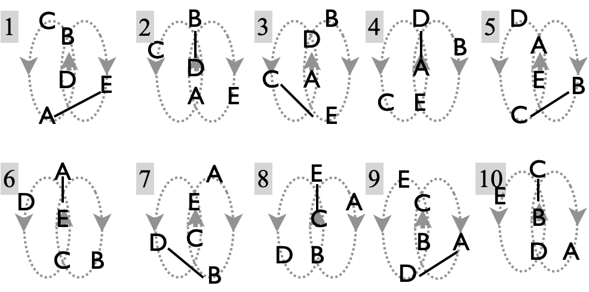 |  |  |  |  |  |  |  |  |  |  |  | Set up like a Twister Weave, with D facing B and C and E both facing A.
Metrics: J=5, OJ=2 (involuted), OJ=4 (tree), CJ=3, full cycle=20 (local passing cycle=5), PBJ=1/15 (3-cnt involuted), 4/15 (3-cnt tree), 4/20=⅕ (4-cnt tree). All jugglers do the same thing (R=1). Per cycle, motion is about 10 pu and spin =$4π$. There’s more spin in the Tree Twister, about an extra $π$ rad per cycle for every juggler.

Involuted Twister by Prof Mike and Mel, August, 2022. The Tree Twister was born on 10/16/25, juggled on 4-count by Mike, Nathan, Mel, Mark and Carly at the church.

Ivy Pi Weave  Here's a fun variation on 2$π$/3. We figured it out by adding one and then a second feeder to fill the gap in that 3-person pattern. Then we noticed you could have everyone move through all the positions. | 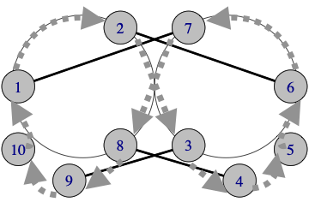
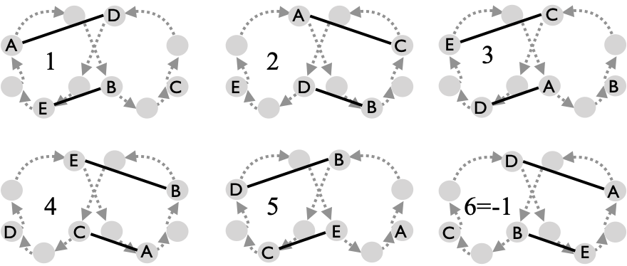 |  | Beat, base count (4-count standard)
 |  | 1 | 2 | 3 | 4 | 5
 | A | D | C | D | C
 | B | E | D |  | E | D
 | C |  | A | E | A | E
 | D | A | B | A |  | B
 | E | B |  | C | B | C
Metrics: J=5, Full cycle 10 beats; local cycle 5. PBJ=⅕ (on 4-count base), CJ=3, OJ=2, spin 5$π$ (were it not for sharp turns at 3 and 8, spin would be 4$π$, but in fact it takes more rotating to get through one cycle); motion is a bit longer than a weave or eggbeater, at about 6 pu per cycle.

First tried Aug 27, 2017 by Mike, Mel, Conor, Nick, and Jason. We usually do this on a 4-count base to keep the moves doable. So, e.g., each juggler passes 4 in a row on that count, and then has a break. But each juggler only passes to 2 other jugglers. Note the sharp turns going from positions 2-to-3 and 7-to-8. Add a post to soak up the self beats if you have one more juggler!

2-by-4 weave  Aka stuffed weave |  | Juggler
Each mover passes 4 times to one feeder, moves back off the end during two phantom beats, and then comes forward passing 4 times again to the 2nd feeder. | 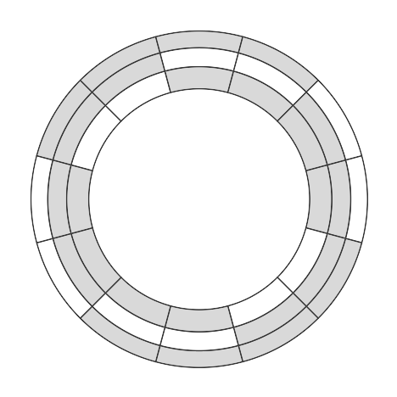 | Base beat | A | B | C | D | E
 |  | 1 | C | E | A |  | B
 |  | 2 | D | E |  | A | B
 |  | 3 | D | E |  | A | B
Concentric rings show pass sequence of three movers. |  | 4 | D | C | B | A
Concentric rings show pass sequence of three movers. |  | 5 | D | C | B | A
Show starting configuration  …good for strong weavers … feeders have to modulate the distance, since feeders moving in arc as the go from inside to out |  | 6 | E | C | B |  | A
 |  | 7 | E | C | B |  | A
 |  | 8 | E | D |  | B | A
 |  | 9 | E | D |  | B | A
 |  | 10 | C | D | A | B
 |  | 11 | C | D | A | B
 |  | 12 | C | E | A |  | B
A late bloomer in the weave collection, first juggled by Laura and Owen (as feeders) and Chan, Mike, and Nathan (weavers), on August 30, 2026, at the Madison Circus Space.

Eggbeaters

Eggbeater (original)
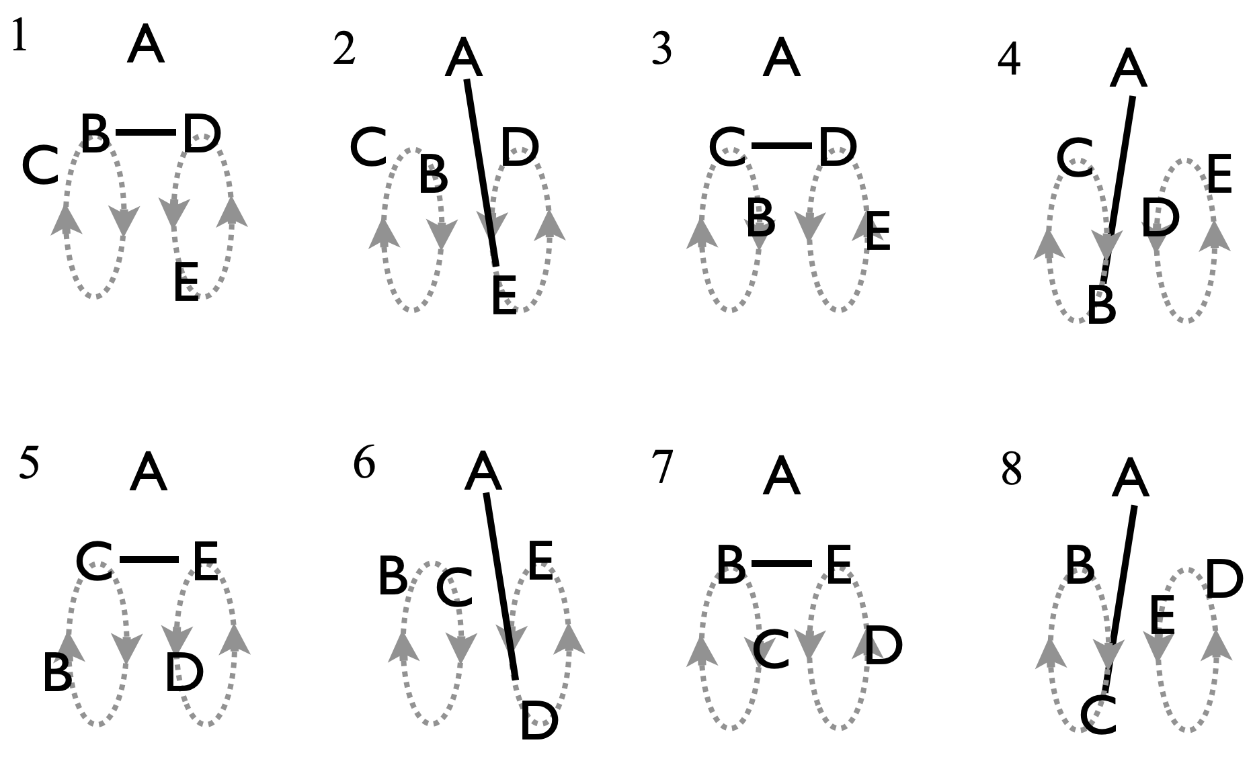 |  |  |  |  |  |  |  |  |  | Feeder A - the handle - passes to 4 movers in 2 pairs of 2 spinning around each other. B and C form one beater, and D and E another. It's pretty good for beginner movers on the original base count (2-count), but you have to think because your count changes as you go: 6-count; 4-count; 6-count. Performed by Mad-5 at 1997 Madfest.
 | Beat (2-count base) |  |  |  |  |  |  |  | 3-4-5 Eggbeater
 | 1 | 2 | 3 | 4 | 5 | 6 | 7 | 8 | A beautiful variation emerges if A speeds up to 3-count from 4-count. Then movers have a 3-count gap between their stationary passes, a 4-count gap to move to the bottom of the bowl, and a 5-count gap to come back to the top. It’s fast and uses both hands!  The standard 2-count base, 8-beat cycle eggbeater is written on a 1-count base in the table below (row 2). The third shows how the 3-4-5 eggbeater works out on that 1-count base. In other words, it’s the same table as left except on a 3/2-count base!  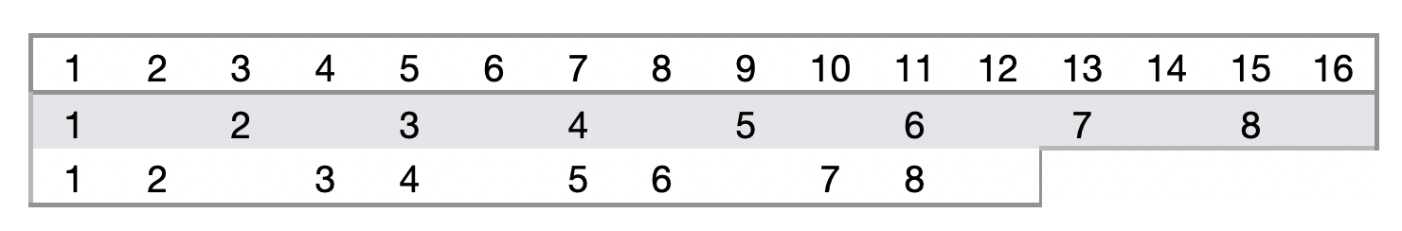
A |  | E |  | B |  | D |  | C
B | D |  | E | A | D |  | E
C | E |  | D |  | E |  | D | A
D | B |  | C |  | B | A | C
E | C | A | B |  | C |  | B
Light grey are extra passes in a Martin Frost variation born at 1996 Madfest. 3-4-5 was born about 2016. Mad-5 performed the original in the 90's. Mike proposed the handle-in-the batter, and possibly the 3-4-5.

Eggbeater – handle-in-the-batter
For this variation, move A to the bottom of the bowl, but retain the passing sequence.
Metrics: J=5, cycle = 8, OJ=3.4, CJ=3, pH=1, R=2, PBJ=⅕ (original) 4/15 (3-4-5), 3/10 (Martin’s). Base is 2-count or 3/2 count. For the movers, motion is 4 pu (2 loops) and spin is $π$ rad per cycle, giving pattern averages 3.2 pu and 0.9$π$ rad, considering no motion but swiveling by A.
**NATHAN’S NOTES ON THE CLUB SEQUENCES, RETURNS, AND PIANOS**

Involuted Eggbeater |  |  |  |  |  |  |  |  | This pattern is a cool way to get the handle into the action by continuously swapping with the beaters!
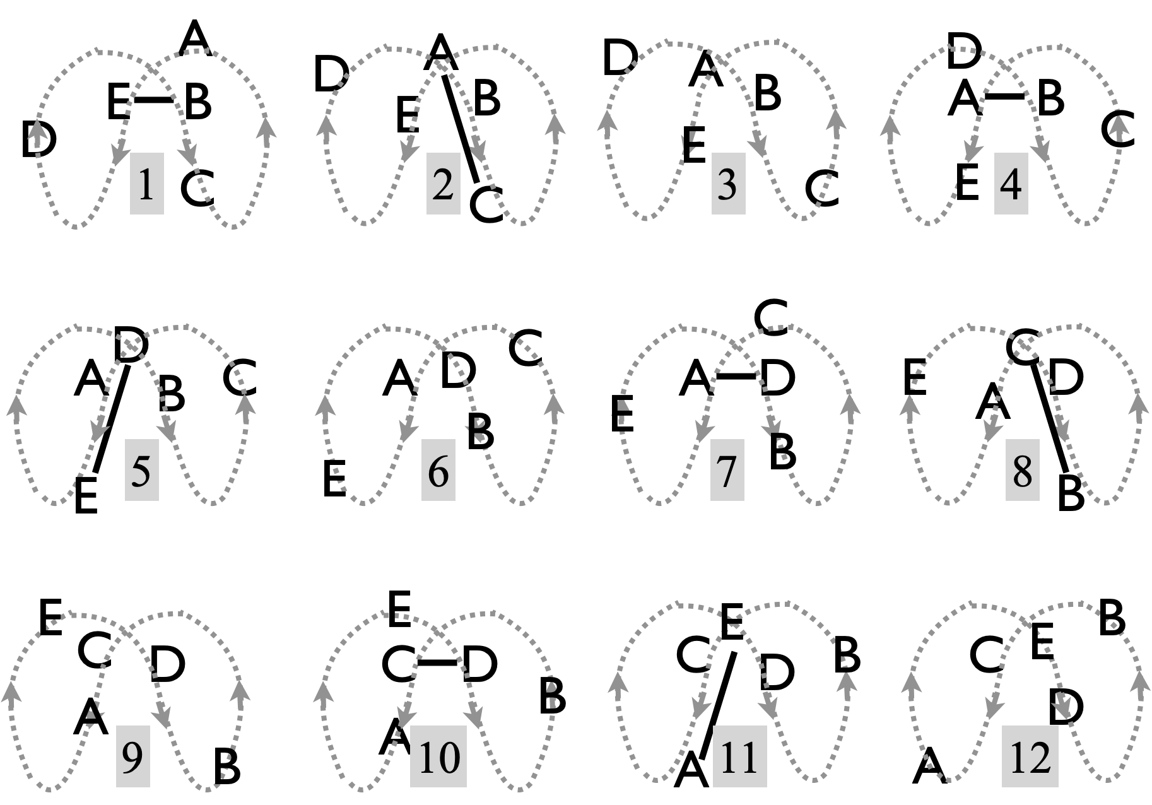 |  |  |  |  |  |  |  |  |  |  |  |  |  |  |  | 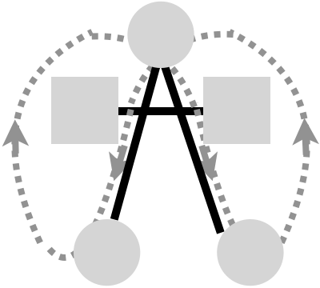  On the 2-count base, there’s a 4-count gap from the handle (top circle) into an upper beater position [upper square] (e.g. A’s start), then 2 passes there on a 6-count gap, then an 8-count to get to the bottom of the bowl (lower circle), and a 12-count gap to get back to the top! There are 30 right hand beats to get around, which seems excessive but doesn’t feel so bad when juggling, thanks to symmetries I guess. First done Nov 2, 2017 (long after the original eggbeater) by Graham=A, Mel=B, Mike=C, Jeff=D, Nick=E; , and more recently done with lights on Library Mall, Aug 25, 2022!
 | Base beat (2-count is standard); ½ cycle
 | 1 | 2 | 3 | 4 | 5 | 6 | 7 | 8 | 9 | 10 | 11 | 12 | 13 | 14 | 15
A |  | C |  | B |  |  | D |  |  |  | E
B | E |  |  | A |  |  |  | C |  |  |  |  |  | D
C |  | A |  |  |  |  |  | B |  | D |  |  | E
D |  |  |  |  | E |  | A |  |  | C |  |  |  | B
E | B |  |  |  | D |  |  |  |  |  | A |  | C
Metrics: J=5, R=1, CJ=3, OJ=4, PBJ=4/30 (that’s low!), pH=1, cycle length=30 (local is 15) on 2-count base. Motion and spin are relatively large owing to 2 big loops: per full cycle, the motion is about 6 pu and spin is $4π$ rad. Maybe because of the long cycle, other eggbeater variations have become more popular than this one (e.g., the Deathbeater), but this one is still a classic!

Deathbeater  Make sure you have mastered the regular eggbeater before you attempt this riskier version! |  |  |  |  |  |  |  |  |  |  |  | 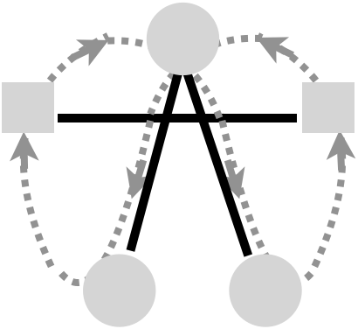
 | Base beat  (2-count standard) ½ cycle |  |  |  |  |  |  |  |  |  | 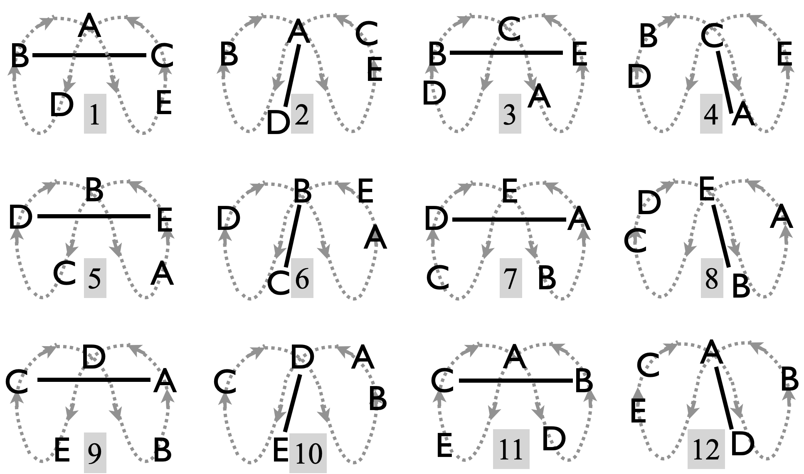
 | 1 | 2 | 3 | 4 | 5 | 6 | 7 | 8 | 9 | 10
A |  | D |  | C |  |  | D |  | C
B | C |  | E |  |  | C |  | E
C | B |  |  | A |  | B |  |  | A
D |  | A |  |  | E |  | A |  |  | E
E |  |  | B |  | D |  |  | B |  | D
All jugglers do the same sequence, shifted in time, and they move through all five positions, completing a full cycle in 20 passing beats. What used to be the stationary handle is now being constantly replaced by jugglers shifting into that position; a juggler moves into the handle after completing the two crossing (odd-beat) passes (two squares). The handle position (top circle) passes to receivers in the bottom of the bowl (bottom circles), and on their turn they pass and move out immediately in order to clear the next pass that occurs between the two sides. That special pass/move role is pretty tricky (even beats). All jugglers do the same 5-beat sequence, but out of phase: pass-phantom-pass-phantom-phantom, and each juggler passes to two of the other four. The pattern has the same pass-twice then move as the egg-beater, but movement is completely different. (We could say self instead of phantom, but we’re referring to the base passing beat, so phantom seems more appropriate.) In the inaugural running of this pattern (by Mike, Mel, Mark, Carly, and Chan, March 20, 2025), we started on a 4-count base. It's amusing to watch people hesitate in the top spot and miss their opportunity to move down to the bottom of the bowl.

Metrics: J=5, cycle length=20 (local is 10), base count=2 (standard) (4 for starters!), OJ=2, CJ=3, pH=1, PBJ=4/20=0.2, R=1; motion and spin are as in the Involuted Eggbeater, at 6 pu and
4$π$ rad per cycle; since the cycle is shorter that makes it harder! Not a pattern for beginners.

Four Leaf Clover
The deal with clover patterns is that the number of jugglers is one more than the number of leaves; there's always one juggler on each leaf and one extra in the middle, about to swap places with one of the leaves. This is a very pleasant 5 person moving pattern on a 2-count or 3-count base; all jugglers do the same thing in the steady state: feed three (right to left); 2-selves to move into middle; pass in middle; 4 selves to get out. That's a 2-in-4-out, in contrast to the 2-in-2-out three-leaf clover for four jugglers.
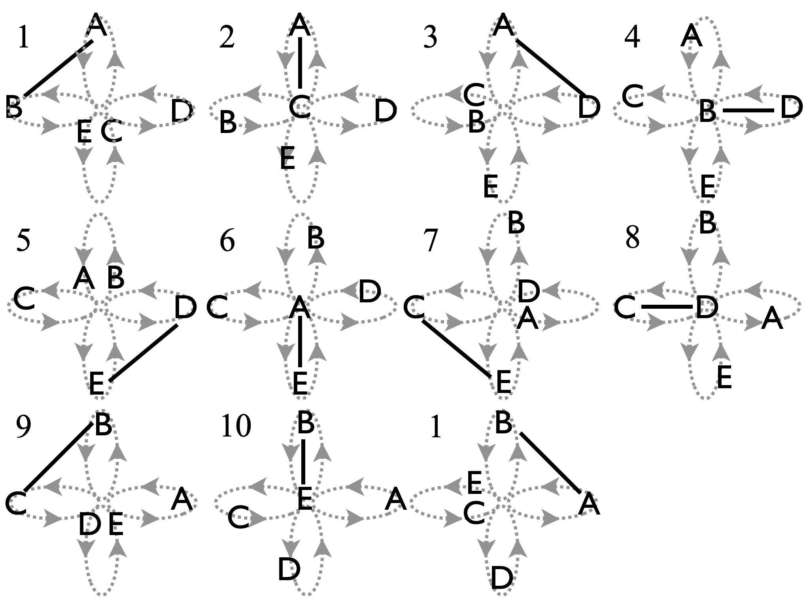 |  |  |  |  |  |  |  |  |  |  | Shown left are 10 beats (local cycle) of 40 required to get everyone situated at the same place. The 11th beat has the whole pattern rotated a ¼ turn (technically, the passing sequence has completed a full cycle, even though the jugglers are repositioned!).  After feeding, you have 2 beats to move straight across, then 4 easy beats to move out left and set up for the next cycle. It can clog up in the middle if you’re not careful with those 2 entering beats.  Patterns by MAJ.
 | Beat (base count; e.g. 2 count) |  |  |  |  |  |  |  |  |  | Variations: Aside from count variations (2 and 3 most common), extra passes are available to jugglers moving through (one version is noted in grey in table left).  Watch the 4-leaf clover on 3-count (https://www.youtube.com/watch?v=ikqU-CTVB9o)
 | 1 | 2 | 3 | 4 | 5 | 6 | 7 | 8 | 9 | 10
A | B | C | D | C |  | E |  | E
B | A | E |  | D |  | D |  |  | C | E
C |  | A |  | A |  |  | E | D | A | D
D |  |  | A | B | E | B |  | C |  | C
E |  | B |  |  | D | A | C | A |  | B
Metrics: J=5, local cycle=10, full cycle=40, base count=2 (standard), OJ=4, CJ=3, R=1, pH=1, PBJ=4/20=1/5, (standard, 2-count base); PBJ=⅕ (standard) or 3/10 (extra passes). Motion is a bit less than 2 pu per arc, so roughly 7 pu per cycle. Accounting for rotation during the feed and ¼ turns from leaf to leaf, each juggler rotates about $3π$ rad per cycle.

Three Leaf Clover with One Orbiter (the after-feed orbiter) |  |  |  |  |  |  |  |  |  |  | 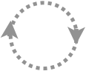
Revisit the 4-person 3-leaf clover, but add a juggler to absorb some of those pesky self throws! One orbiter, E, passes to the person who has just finished their feed; in this version the orbiter is on an inside small loop going clockwise (from above perspective!). The orbiter passes D, A, C, B, repeat; there’s also an outside big loop, also going clockwise, as an alternative…big circle flying around the outside clockwise also (often Nick!) [start the outside just beyond A, then move to pass to C, B, then D, A.

Here the orbiter isn’t really ‘orbiting’ at all, they are smack in the middle of the pattern. As drawn, E is on a small circle of diameter perhaps 1pu or less; but it also works with E more or less stationary, just rotating around on the ½ count to make all the necessary passes. Then the clover-movers just need to be sure to avoid this person; for them it becomes a 1-in-2-out clover. 2-count is doable but 3-count is much more relaxing!
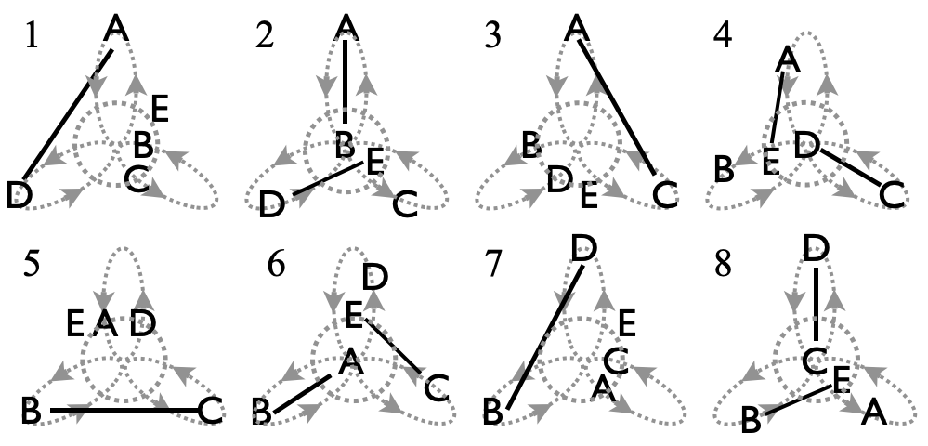 |  |  |  |  |  |  |  |  |  | Alternatively, an outside orbiter can encircle the whole pattern, starting at the tip of the lower right leaf, and maintaining the same passing sequence while having to run to keep up with the others! Two other variations emerge by having the orbiter pass just before the feed starts.
 | Beat (base count; 2 or 3 count) |  |  |  |  |  |  |  | Metrics: J=5, cycle=8, base count = 2 or 3, OJ=4, CJ=3, pH=1, R=2, PBJ=0.3 (2-count), 0.2 (3-count). Motion inherits from 3 Leaf Clover (5pu and 2.5$π$ rad per full cycle). Orbiter E completes the equivalent of 4 circles over the three local cycles, giving pattern average at about 6pu per cycle. Likewise the average spin is 3.6$π$ rad per cycle, considering the small circle traversed by the orbiter. Feeder is indicated by grey, and orbiter E picks up a pass at the end of each feed.
 | 1 | 2 | 3 | 4 | 5 | 6 | 7 | 8
A | D | B | C | E |  | B
B |  | A |  |  | C | A | D | E
C |  |  | A | D | B | E |  | D
D | A | E |  | C |  |  | B | C
E |  | D |  | A |  | C |  | B

Gauntlet | An easy to juggle but need-to-pay-attention moving pattern, which the Cool Guyz used once to exit the Madfest stage.
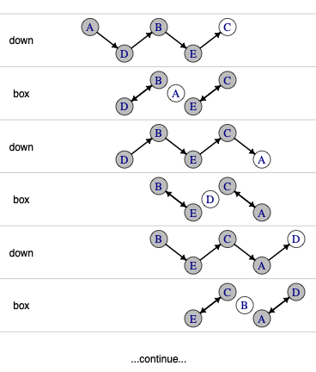 | It’s a 5-person 4-count pattern. On each passing beat, one juggler (clear circle in figure) has 2 clubs, and doesn’t pass. (That’s C at the top of the pattern.) These blank beats occur twice in a row for each juggler, as he/she moves through the middle and waits to receive a pass at the bottom of the pattern. The leader calls out down, box, down, box on passing beats, and the passes and movements proceed as the whole pattern moves across the room/stage!  The passing sequence repeats after 10 4-count beats, but at that point the jugglers have moved across the room and flipped orientation. The orientation flips back after 20 4-count beats, which ordinarily would describe the full cycle, except that the constant translation means that the pattern never really repeats (or maybe not until you circle the earth!)  Origin: Ask Mel!
Metrics: J=5, CJ=14/5, pH=1, R=1, passing cycle=20 beats on 4-count, PBJ=⅕. Over a full passing cycle each juggler moves two spans of the pattern, perhaps 4pu, and rotates about two full turns, spin $≃4π$ rad.

Strange Attractor/Estranged Tractors |  |  |  |  | 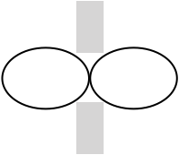
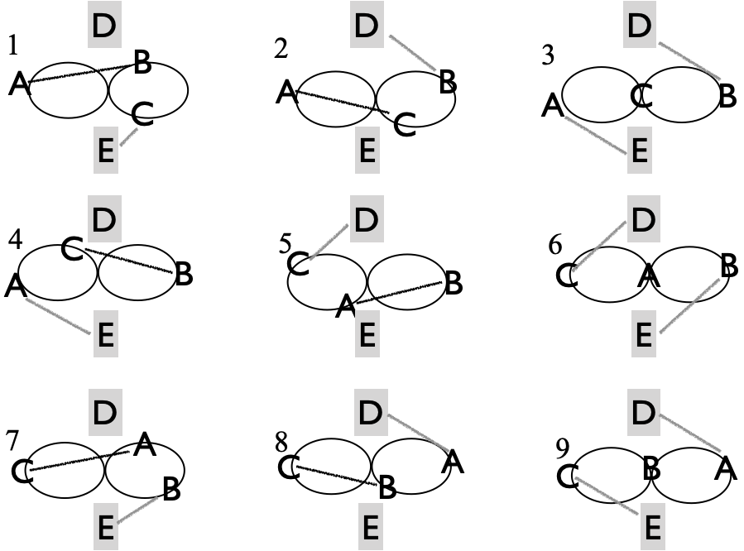 |  | Beat, base count  (2-count rights is standard)
 |  | 1 | 2 | 3 | 4 | 5 | 6 | 7 | 8 | 9
 | A | B | C | E | E | B | ↻ | C | D | D
 | B | A | D | D | C | A | E | E | C | ↻
 | C | E | A | ↻ | B | D | D | A | B | E
 | D |  | B | B |  | C | C |  | A | A
 | E | C |  | A | A |  | B | B |  | C
This came from trying to fill in the self gaps of a Turbo using two stationary jugglers D and E. But on close inspection you’ll see that movers A, B, C are actually doing a variation of the Turbo; a lot of work for them, with just one self-beat to turn (↻) within each ½ cycle.

Metrics: J=5, cycle=18 beats (½ shown); PBJ is high! [(3)(8)+2(6)]/[(2)(5)(9)]=0.4; CJ=3, OJ=4, pH=1, R=2. The three movers cover 4 pu per cycle, as 3-person Turbo, for a pattern average of 2.4 pu. Likewise the movers rotate $2π$ per cycle; feeders D and E both swivel back and forth 4 times, for about the same total rotation per cycle, making a pattern average of 2$π$ rad per cycle. Pattern by MAJ.

El Turbo with one post
 |  | Beat, base count: 2-count rights is standard;3-count is pleasant!
 |  | 1 | 2 | 3 | 4 | 5 | 6 | 7 | 8 | 9 | 10 | 11 | 12 | 13 | 14 | 15 | 16
 | A | B | D | C | B | E | C |  | E | B |  | E | B |  | E | D
 | B | A |  | E | A |  | E | C |  | A | C | D | A | E | D |  | E
 | C |  | E | A |  | D | A | B | D | E | B |  | E | D |  | E | D
 | D | E | A |  | E | C |  | E | C |  | E | B |  | C | B | A | C
 | E | D |  | B |  | A |  | D |  | C |  | A |  | B |  | C
 | E |  | C |  | D |  | B |  | A |  | D |  | C |  | A |  | B
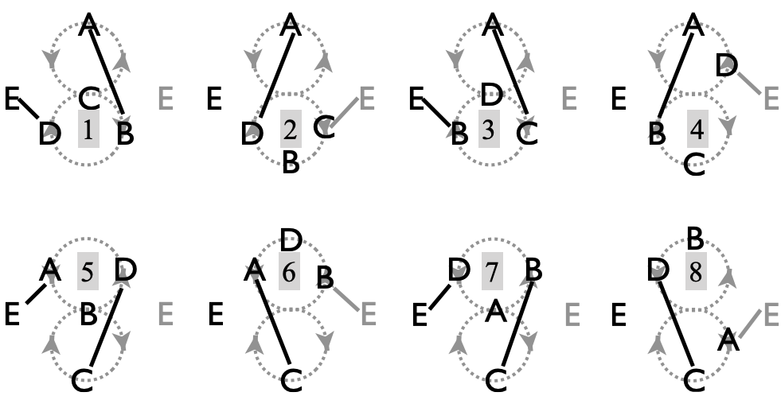  ½ cycle shown. A, B, C, and D do the El Turbo, and E is the post picking up some selves. The figure/table allows two different positions for that single post (see ahead to 6-person patterns where we add 2 posts). But here there’s either an odd-beat post (E), or an even-beat post (E). Pattern by MAJ. See El Turbo (4-person) for more on the base pattern. |  |  |  |  |  |  |  |  |  |  |  | Metrics: J=5, cycle=16, PBJ=0.3, CJ=3, OJ=4, pH=1, R=2. Movers travel 5 pu per mover, for a pattern average motion of 4 pu. Movers also rotate a full turn and the post swivels a ½ turn per cycle, for a pattern average spin of 1.8$π$ rad.  As in El Turbo, each juggler feeds 4 spots (with #1 and #4 the same person), before moving on. Those feeds are highlighted (shading) in the passing table.

5-person laxative-V1 |  |  |  |  |  |  |  |  |  |  |  | 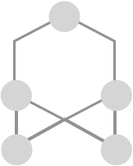
Beat, base count (7-count or 5-count)
 | 1 | 2 | 3 | 4 | 5 | 6 | 7 | 8 | 9 | 10 | Take the original 3-person Laxative, and allow two orbiter-like folks to swap in and out.  While you’re in the laxative portion, you pass three times to the same person (grey box shading), and you receive three times, though from three different folks who move in/out of the laxative.  OK, we’ve not actually juggled this on yet (as of November 2025), and one worries it might go the way of the dodo-bird and the Quincunx, since both the moving and the passing sequence take some memory!  But it looks great, right!  Another, more streamlined extension of the 3-person laxative is shown next.  Metrics: J=5, Cycle=10, CJ=3, OJ=4, R=1, pH=1, PBJ=1/count, motion=5 pu, spin is $10π/3$ rad like in Laxative.  Pattern by Prof. Mike, April 16,2020.
A | B | B | C | D | C | B | C | E | D | B
B | D | E | D | C | D | A | E | C | C | C
C | E | D | E | B | A | D | D | D | E | A
D | A | C | B | E | E | E | A | B | A | E
E | C | A | A | A | B | C | B | A | B | D
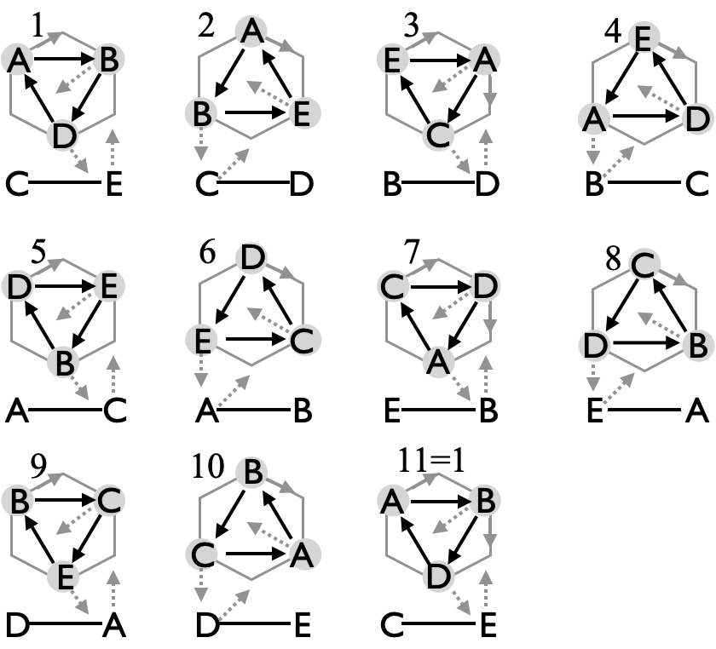

Decagon: 5-person laxative-V2 |  | 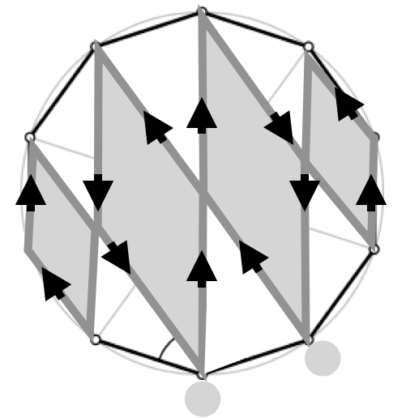
A very cool non-trivial extension of the 3-person laxative. As in the 3-person version, the who-passes-to-whom graph is always the same (i.e., a local passing cycle of 1 beat). But the moves, oh, the moves take some practice! We set up with 2 sets of 5 floor markers to get it going.
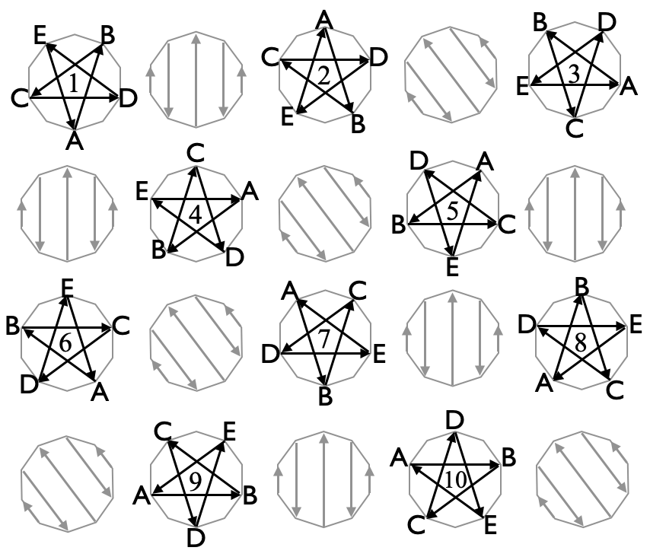 | Beat, base count,  (9 or 7 count)
 |  | right | left
 | A | B | B
 | B | C | C
 | C | D | D
 | D | E | E
 | E | A | A
 | Metrics: J=5, cycle=10, CJ=3, pH=1, OJ=1, PBJ=1/count, motion 8 pu, spin 5.2$π$ rad. Pattern by Nathan/Peter
It’s a bit tricky remembering who goes next; lead moving goes in order: A, B, C, D, E, but everyone moves across or shifts after every pass (grey above). Everyone occupies every corner of a decagon for a full cycle (i.e., 10 beats on some convenient odd count). There’s an earlier version where a single person moves across and every one else shifts, but you don’t retain the nice who-to-whom constancy like in this version! Moves are long-cross, short-cross, slide, slide, short-cross, repeat. Interestingly, this motion traces the edges of three rhombuses (rhombi?), as the figure upper right shows. These edges are also called diagonals of the decagon, and their lengths are well known functions of the Golden Ratio $ϕ=(1+\sqrt{5})/2≃1.6$. If the edges connecting neighboring vertices of the decagon are at distance $a$, then the longest diagonal (the long cross), which spans 5 outer edges, is of length $d_{5}=2aϕ≃3.2a,$ and a diagonal that spans 3 outer edges (the short cross) has length $d_{3}=aϕ^{2}≃2.6a$ To complete a full cycle each juggler moves a distance $4a+4d_{3}+2d_{5}$. Note also that passes happen along diagonals of length $d_{4}= aϕ\sqrt{2+ϕ}≃3.1a.$ To balance the need for space between jugglers and easy moves and passes, taking $a$ equal to about ⅓ to ½ of a passing unit; so gives a total motion about 8 pu for each juggler. Jugglers also rotate extensively, doing a ½ turn ($π$ rad) through a long cross, a bit less ($3π/5$ rad) on each short cross, and $π/5$ rad for each slide, making a total spin per cycle 5.2$π$ rad, which is more than 2 and a ½ full turns per cycle.

Twirly Star
Here's a fun variation on the 4-person Shooting Star, but with 5 people and with moves restricted to spinning in place! These pirouette’s ↻ happen while you have 2 clubs.
E starts with 2 clubs  ↻ = pirouette | Beat (2-count right-hand base) |  |  |  |  |  | Make sure to keep the count after the ↻! At first you can just pause for 2 counts instead of pirouetting.  Metrics: J=5, OJ=1, motion=0, PBJ=0.4, CJ=14/5. spin=$π$ rad.  Pattern by Luke Emery.
 |  | 1 | 2 | 3 | 4 | 5
 | A | D | D | ↻ | D | D
 | B | E | E | E | E | ↻
 | C | A | ↻ | A | A | A
 | D | B | B | B | ↻ | B
 | E | ↻ | C | C | C | C

Quincunx  An uncomfortable word to pronounce, but recall it’s the shape of five dots on dice. |  |  |  |  |  |  |  |  |  |  |  |  |  |  |  |  | 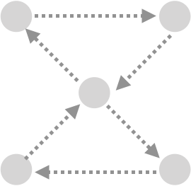
Beat, base count (4-count rights is standard)
 | 1 | 2 | 3 | 4 | 5 | 6 | 7 | 8 | 9 | 10 | 11 | 12 | 13 | 14 | 15 | 16 | 17 | 18 | 19 | 20
A | E | C | C |  |  | D | D | B | B | C |  | B | B | D | C | E | E |  | D | E
B | D | E |  | D | D | C | E | A | A |  | C | A | A | E | E |  |  | C | C | D
C |  | A | A | E | E | B |  | E | E | A | B | D | D |  | A | D | D | B | B
D | B |  | E | B | B | A | A |  |  | E | E | C | C | A |  | C | C | E | A | B
E | A | B | D | C | C |  | B | C | C | D | D |  |  | B | B | A | A | D |  | A
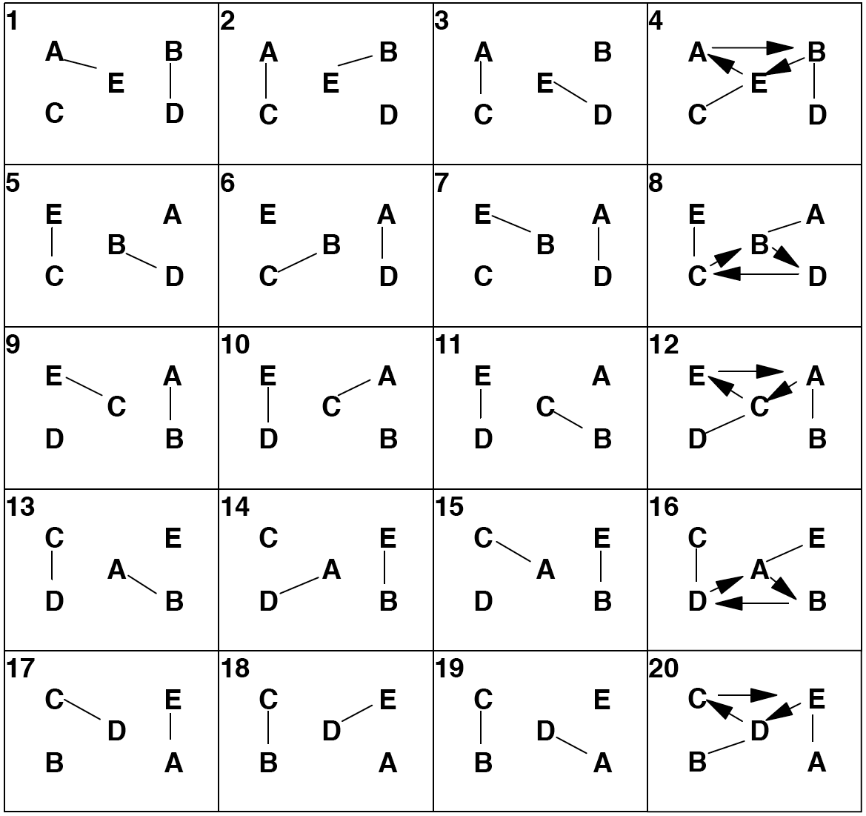 |  |  |  |  |  |  |  |  |  |  |  | Arrows left indicate motion. Jugglers take turns entering the middle, sweeping around the corners, and then backing out of the middle. Each such move entails 6 passes in a row (shaded in table), including two repeats on the entry and two repeats while backing out on the exit.  Metrics: J=5, Cycle=20, CJ=3, OJ=4, pH=1, PBJ=⅕. If corners are about $\sqrt{2}$ pu apart, then as each mover advances through two internal triangles they move ($4+2\sqrt{2} )≃6.8$ pu , and spin no less than a full turn ($2π$ rad) to complete a cycle  Pattern by Prof. Mike.
Ahhh...Quincunx. We don't actually juggle this pattern much anymore. We just talk about it.
Whenever we can't think of a pattern to try, someone inevitably says, “Let's do Quincunx!” Then we all laugh. Ha, ha! Ok, seriously. What should we do? With no disrespect for Mike intended, this is kind of a dumb pattern. It's complicated and almost impossible to remember for a full cycle. Though we rarely juggle this pattern, it was an early non-weave moving pattern, and it surely prepared the Mad-5 for the rigors of more serious passing!

Meltic Knot  A recent edition from the desk of Mellonhead! |  |  |  |  |  |  |  |  |  |  |  |  |  |  |  |  | 
Beat, base count (5-count is standard)
 | 1 | 2 | 3 | 4 | 5 | 6 | 7 | 8 | 9 | 10 | 11 | 12 | 13 | 14 | 15 | 16 | 17 | 18 | 19 | 20
A | C | E | B | D | ⬆ | 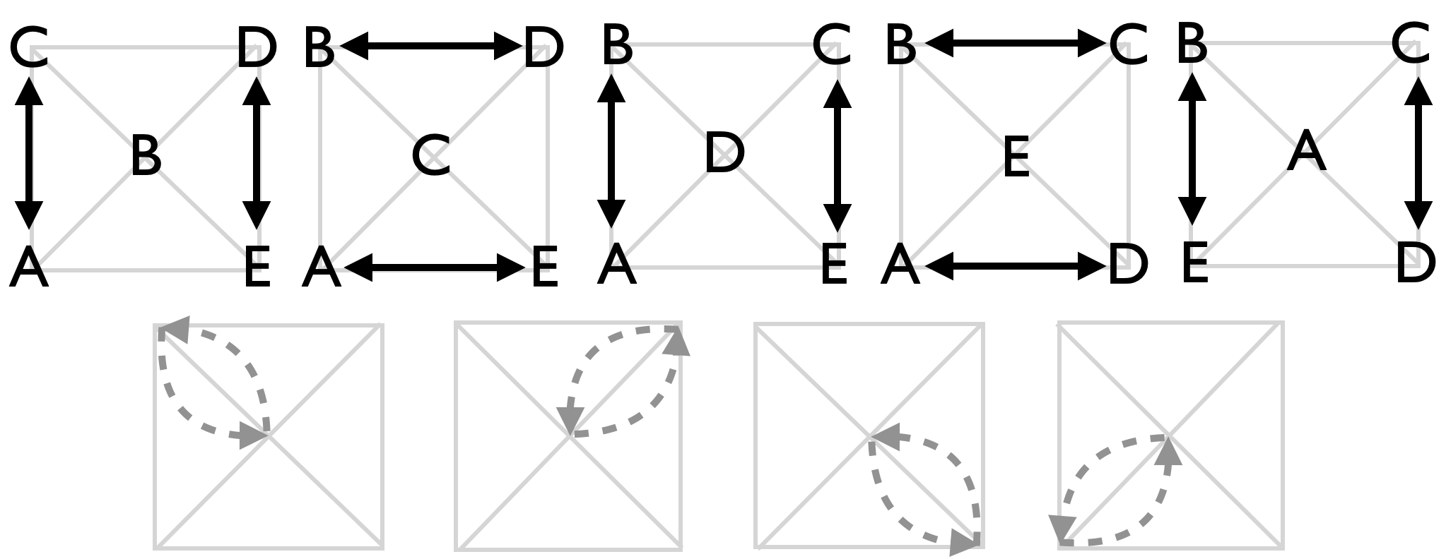
B | ⬆ | D | A | C | E
C | A | ⬆ | E | B | D
D | E | B | ⬆ | A | C
E | D | A | C | ⬆ | B
Local cycle = 5 beats
This is a nifty variation of the six-person Celtic Knot, though shaped like a Quincunx. It’s surprisingly easy to remember and also a bit tricky to perform. Even forgetting the move in and out of the middle (shaded box and arrow), you are constantly swinging back and forth through a ¼ circle to pass to your neighboring corner.

Metrics: J=5, cycle=20, CJ=3, pH=1, OJ=4, PBJ=⅕. With sides about $\sqrt{2}$ pu on the box, each juggler covers about 8 pu to get back to the start. There’s also a lot of ¼ turns to alternate corners for passing, making total spin = $6π$ rad. Pattern by Mellonhead (who prefers 6-count!) December 11, 2025.

Meltic Knot + Orbiter: We do this exceedingly cool 6-person variation (see ahead) by having a rip-sticker moving quickly around the pattern (clockwise, from above), passing in to each emerging middle-person on each side. The rip-sticker leads the pattern first passing to B across the C-D line, then to C across the D-E line, and so on.

Chocolate Swirl-I |  |  |  |  |  |  |  |  |  |  |  |  |  |  | Here’s a nice but not-often juggled 2-v-3 pattern with change side moves, based on the double-chocolate double-3-count stationary pattern. Owing to different ways to reset the 2-v-3 after a move, we get several variations.  Jugglers need to shift through an arc as one by one they change sides.  Original pattern by Luke Emery; variations here by Prof Mike aim to respect the Southern Wisconsin Convention (SWC).
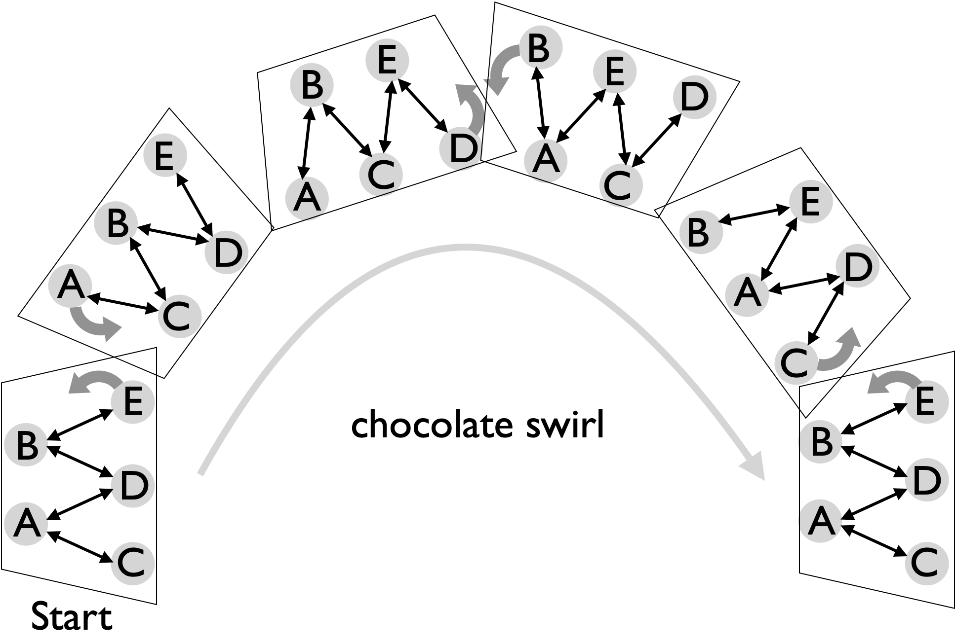
In moving patterns like this, the SWC holds that a switch-sides move off the right side of a line (from the perspective of those in the line) occurs as the mover is receiving a pass into their left hand and releasing a pass from their right. (Likewise, but not applicable in the current pattern, moves off the left side of the line occur as a mover passes a left while receiving a pass into the right (i.e., inside) hand.) Luke Emery’s original chocolate swirl (see v 3.0) had a long cycle and violated SWC (and we didn’t juggle it much!). The version shown here approximates Luke’s, but loses a feature involving the 1-self switch sides (but see below!); here, after a switch, there are 6 counts from a standard start, then switch, then repeat. ⅗ of pattern is tabulated. Without some adjustment the pattern will drift across the room as the passing cycle repeats (a bit like the Gauntlet)
 | Beat, 1-count base (feeders in italics)
 |  |  | 1 | 2 | 3 | 4 | 5 | 6 | 7 | 8 | 9 | 10 | 11 | 12 | 13 | 14 | 15 | 16 | 17 | 18
A | C | C | D | C | C | D | C | C | C | C | - | C | C |  | - | B | B | - | B | B
B | E | D | E | E | D | E | E | D | D | - | C | D | - | C | C | A | A | C | A | A
C | A | A/ | - | A | A | - | A | A | A | A | B | A | A | B | B | - | E | B | - | E
D |  | B | A | - | B | A | - | B | B | E | E | B | E | E | E | E | - | E | E
E | B |  | B | B | - | B | B |  | - | D | D | - | D | D | D | D | C | D | D | C
Metrics: J=5, CJ=3, pH=1, cycle=30 on 1-count, PBJ=0.8 , OJ=4, spin = $2π$, motion $≃1$ pu per passing cycle.

Chocolate Swirls (II and III) |  |  |  |  |  |  |  |  |  |  | Born from changing sides in a 2-v-3 double-chocolate double 3-count, these patterns are A level with 1-count passing and movement (respecting the Southern Wisconsin Convention). Chocolate Swirl II is more or less a chocolate bar feast. In this variation, the change sides use 2 selfs (like El Nino, i.e. on 3-count).  Chocolate Swirl III, AKA Tempered Chocolate, maintains the 1-self change side (from Luke’s original)  Rule: move-three-one-self-one-three. (1st done at MCS 11/30/2025 by Mike, Luke, Mel, Nathan, and Mark.) Both variations have a pretty short cycle! Feeders below are in italics (and shaded). Moves are on black.
Version II (1-count base) |  |  |  |  |  |  |  |  |  |  | Version III (1-count base)
 | 1 | 2 | 3 | 4 | 5 | 6 | 7 | 8 | 9 | 10 |  | 1 | 2 | 3 | 4 | 5 | 6 | 7 | 8 | 9 | 10
A | D | C | C | ⬆ |  | B | B | E | E | D |  | C | C | C | ⬆ | B | B | B | E |  | D
B | E | D | D | C | C | A | A | ⬆ |  | E |  | E | D |  | C | A | A | A | ⬆ | E | E
C |  | A | A | B | B | E | E | D | D | ⬆ |  | A | A | A | B |  | E | D | D | D | ⬆
D | A | B | B | E | E | ⬆ |  | C | C | A |  |  | B | E | E | E | ⬆ | C | C | C | A
E | B | ⬆ |  | D | D | C | C | A | A | B |  | B | ⬆ | D | D | D | C |  | A | B | B
Metrics: J=5, CJ=3, pH=1, cycle=10, base=1-count, PBJ=⅘, OJ=4, spin = $2π$, motion $≃1$ pu per passing cycle.

Isla Vista Weave  Make a weave out of the Stationary Isla Vista Weave! |  |  |  |  |  |  |  |  |  |  |  | 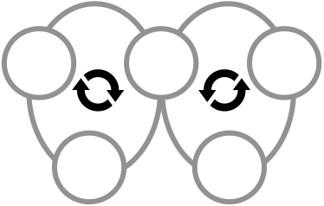
2666 version |  | Beat, 2-count base, ½ cycle |  |  |  |  |  |  |  |  |  | Metrics: J=5, OJ=2, CJ=3, pH=1, R=1, PBJ=1/10, full cycle is 20 beats, local is 10, and there’s a natural 4-beat sequence that repeats 5 times to get to the start. Loops are bigger than the regular weave, say with about circumference 3pu, making the pattern average motion 6pu; and with 2 complete turns the pattern average spin is about 4$π$ rad.  Origin uncertain, but not MAJ. **add more**
Take the Stationary Isla Vista weave, which has jugglers in a circle, and have them alternate though 2-v-3 formations with feeders in the 2 and then moving out in figure 8 after feed. There’s a natural count to 4, after which the physical passing lanes repeat. |  | 1 | 2 | 3 | 4 | 5 | 6 | 7 | 8 | 9 | 10
 | A | D | C |  |  | C |  |  | D
 | B |  |  | E | D |  |  | D |  |  | E
 | C |  | A |  |  | A | E |  |  | E
 | D | A |  |  | B |  |  | B | A
 | E |  |  | B |  |  | C |  |  | C | B
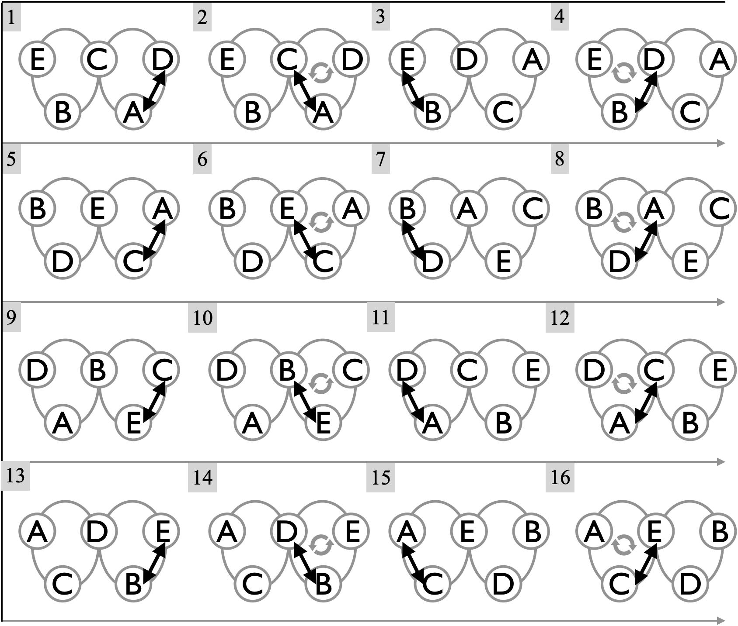

Eye of Buffon’s Needle  A name to invoke the randomness in $π$ and the Eye of the Needle |  |  |  |  | 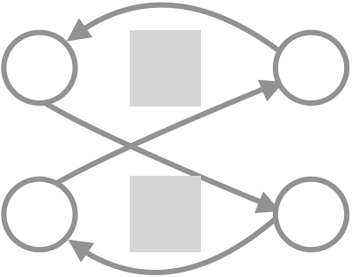
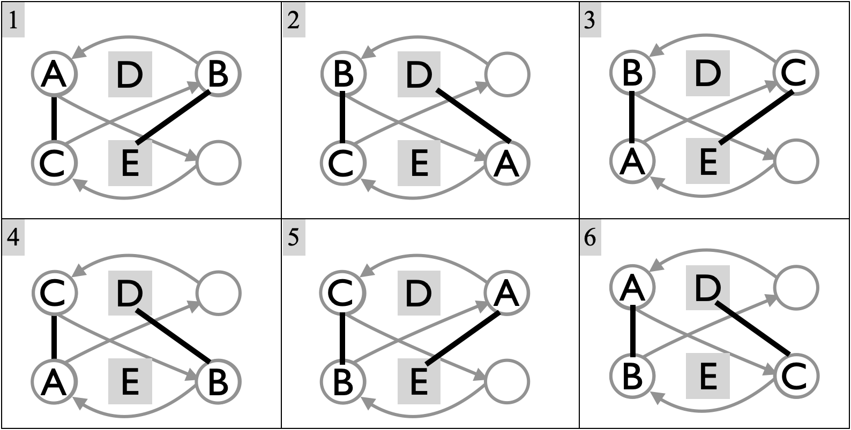  Grey in the figure are `needles`; grey in the table is the pass after which you stick. |  | Beat, base count
 |  |  | 1 | 2 | 3 | 4 | 5 | 6
 |  | A | C | D | B | C | E | B
 |  | B | E | C | A | D | C | A
 |  | C | A | B | E | A | B | D
 |  | D |  | A |  | B |  | C
 |  | E | B |  | C |  | A
When three movers (A, B, C) get good at 2pi/3, here’s an extension with two stationary friends (D and E) that’s a lot of fun. Notice that if we would remove the ‘needles’ D and E, and (continuously) morph the positions, the pattern becomes just 2pi/3. Adding these needles is reminiscent of the 7-person Eye of the Needle, though here the needles don’t pass with each other. The version above has the three movers each sticking for two passing beats on one side of the pattern and then crossing over to the opposite corner, doing a single pass, and then sliding back around to the stick-side again. It’s amusing to watch people forget whether they’re on the sticky side (left above) or the non-stick side!

A new contribution by Prof Mike, May 2026.

Metrics: J=6, CJ=3, pH=1, R=2, OJ=3 ⅗, PBJ = (⅘)*(1/base). Standard base is 6 count (PBJ=2/15), but 5 or 4 are possible for really good movers! Cycle=6 beats. There's no motion or spin for the needles, but movers (A,B,C) cover a lot of ground! Considering loop expansion, we estimate motion=6pu per mover, for a pattern average motion = 3 ⅗ pu per cycle. Spin for the movers inherits from 2pi/3, for a pattern average spin=$6π/5$ rad.

Extra Club Moving 5 Person Patterns

Eggbeater Plus
The ideal entry-level extra club moving pattern!
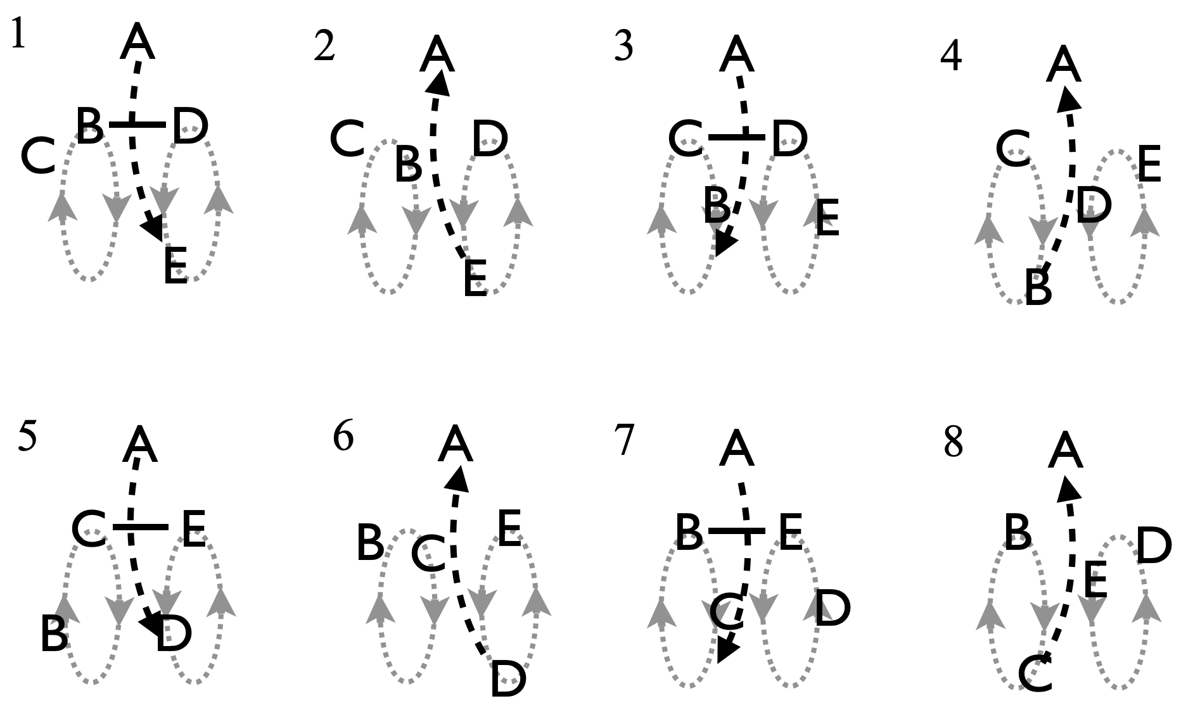 |  |  |  |  |  |  |  |  |  | Feeder A - the handle - starts with 4 clubs and passes to 4 movers in 2 pairs of 2 spinning around each other. B and C form one beater, and D and E another. Same as the original eggbeater, except all passes to and from A are triples!  Pattern by Luke Emery
 | Beat, 2-count base (right-hand) |  |  |  |  |  |  |  | Metrics: J=5, cycle length=8, base count=2 , OJ=3 ⅕, CJ=3 ⅕ , PBJ=⅕, pH=2, R=2. As in original Eggbeater, motion = 3.2 pu and spin = 0.9 $π$ rad  Shaded passes are optional singles; they’ve not become popular!
 | 1 | 2 | 3 | 4 | 5 | 6 | 7 | 8
A | t-E |  | t-B |  | t-D |  | t-C
B | D |  | E | t-A | D |  | E
C | E |  | D |  | E |  | D | t-A
D | B |  | C |  | B | t-A | C
E | C | t-A | B |  | C |  | B

Apollo Plus Weave
Here's a nice but non-trivial extra-club weave pattern for triple lovers!
Start with the Apollo (1-1-3 formation) and have B feed a standard weave of C, D and E. Then A can add an extra club and throw 4-count triples to the ends. A starts with 4 and a triple to whichever end B doesn't start with. All the weavers will have the following sequence (starting from the outside): B, self, self, B, self, triple to A, B.

Metrics: J=5, OJ=2.4, PBJ=0.3, motion=2.4 pu (as in standard Apollo Weave) pH=4/3, R=3. On spin, feeder B sweeps back and forth 4 times per cycle, for a full turn ($2π$ rad). Weavers and A have modest rotation, at about $4φ$ rad per cycle, with $φ=asin(1/\sqrt{5})$, for a pattern average spin 2.7 rad (160°).
 | Beat, 2-count base (right-hand counting) |  |  |  |  |  |  |  |  |  |  |  | 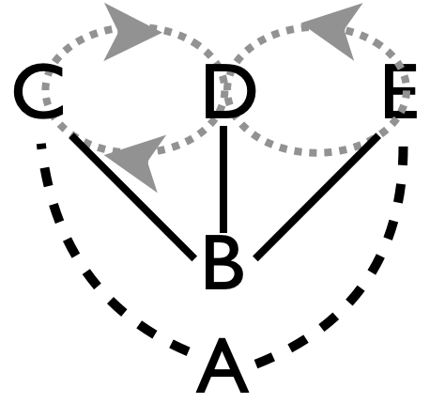  Pattern by Luke Emery.
Juggler | 1 | 2 | 3 | 4 | 5 | 6 | 7 | 8 | 9 | 10 | 11 | 12
A | t-E |  | t-D |  | t-C |  | t-E |  | t-D |  | t-C
B | C | D | E | C | D | E | C | D | E | C | D | E
C | B |  |  | B |  | t-A | B |  |  | B |  | t-A
D |  | B |  | t-A | B |  |  | B |  | t-A | B
E |  | t-A | B |  |  | B |  | t-A | B |  |  | B
Expands nicely to 1-2-3 Apollo for 6 jugglers and the 1-2-4 Apollo for 7 jugglers.

Twister Plus |  |  |  |  |  |  |  |  |  |  |  |  |  | 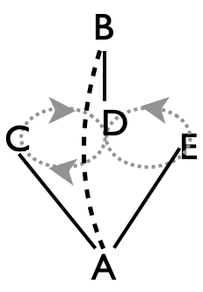
In this beautiful variation of the Twister Weave, stationary feeders A and B replace their right-hand selves with triple passes back and forth over the top of the weave, in 7-club 4-count style (i.e., 1 extra club). The weaving pattern is exactly the same as the original Twister Weave; i.e. 6-count, alternating to A and B as weavers C, D, and E move through a figure 8. B starts with 4 clubs, tripling to A; all others start with 3 clubs. A starts with C then triples back to A.

Pattern by MAJ. Performed by Mad-5 at 1999 IJA, and elsewhere.
 |  | Beat (2-count base); ⅔ cycle |  |  |  |  |  |  |  | A nice motion variation is for the weavers to do ½ pirouettes under a triple right to left self throw for their turn out of the middle.  Metrics: J=5, OJ=2.4, CJ= 16/5=3.2, PBJ=3/10, cycle length=12 on 2-count base. pH=5/3 , average spin= 3$π$, and motion 2.4 pu, as in Twister Weave.
Juggler |  | 1 | 2 | 3 | 4 | 5 | 6 | 7 | 8
 | A | C | t-B | E | t-B | D | t-B | C | t-B
 | B | t-A | D | t-A | C | t-A | E | t-A | D
 | C | A |  |  | B |  |  | A
 | D |  | B |  |  | A |  |  | B
 | E |  |  | A |  |  | B
Luke’s variations: All triples: add 2 clubs to the standard Twister Weave and make the passes from A and B to the weavers be triples (7 club 4-count between each side of the weave and the feeder), and the return passes triples too; then feeders are doing 2-count triples. Alternatively, add 2 extra clubs and have the feeders do 4-count in fast popcorn (534p3).

Double Time Twister Plus  Raining doubles! |  |  |  |  |  |  |  |  | Pattern by Luke Emery and MAJ.
This Twister variation eliminates triple passes between feeders but adds all double passes into the weavers, who now have to make precise double throws back with very little time to turn (4-count)! Feeders A and B are offset from the weavers, and both start with 3, with left-hand self-throws on first beat. Weavers C and E both start with 4 and lead off with right doubles.
Juggler |  | Beat, 1-count base: ½ cycle shown
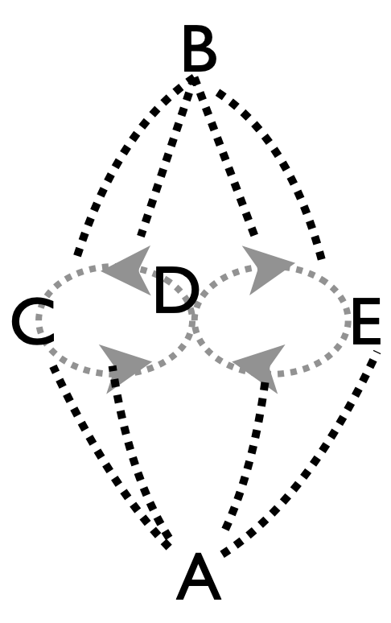 |  | 1 | 2 | 3 | 4 | 5 | 6 | 7 | 8 | 9 | 10 | 11 | 12
 | A |  | C |  | E |  | E |  | D |  | D |  | C
 | B |  | D |  | D |  | C |  | C |  | E |  | E
 | C | A |  | A |  |  |  | B |  | B
 | D |  |  | B |  | B |  |  |  | A |  | A
 | E | B |  |  |  | A |  | A |  |  |  | B
 | All passes are doubles!
Metrics: J=5, cycle length=24 on 1-count base, OJ=2.4, CJ=3.4, pH=2, PBJ=⅖ ,R=3. Motion=2.4 pu as in Twister Weave. Weavers spin two full turns per cycle ($4π$ rad); now both feeders swivel also making a pattern average near $3.2π$ rad.

Mango Swirl (aka Mangled Squirrel) |  |  |  |  |  |  |  |  |  |  |  |  | Everybody in the action!  Triple 2-1-2
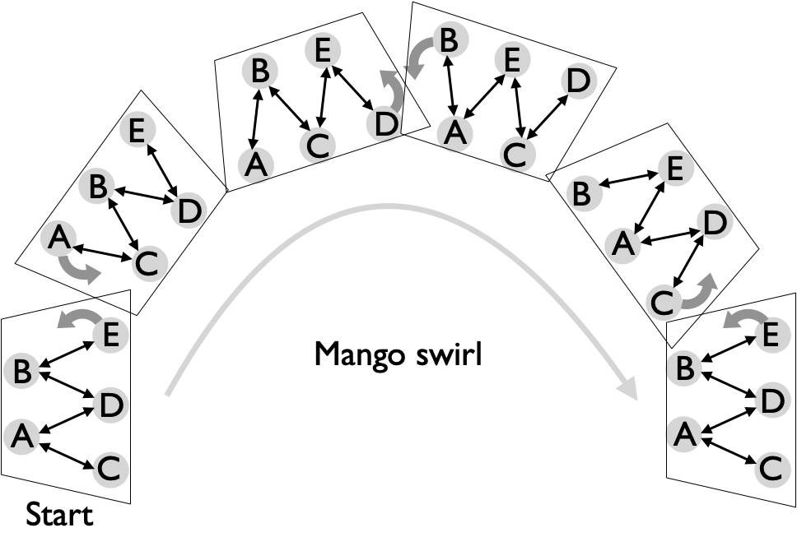  In this high-end extra-club/moving pattern, the difficulty is balanced, and all 5 jugglers have to be good! (Practice change-side 10-club feed with 3 jugglers for warm up.)  The basic set up is a 2-v-3, like the Chocolate Swirl, but now with 2 extra clubs. Continuously, the juggler on the feeders’ left switches sides creating flipped 2-v-3. A and B start with 4, and sync up passing to responders D and E, respectively, to start. In steady state, B is on a pause for beat 1, but throws a double to E to start the pattern. Also, C ordinarily is moving on beat 1, with hands synced like A, but C can start where they would have ended up (and double respond on beat 4 if they prefer). Moves are all on 4-count change-side, with triples back to reset the timing.  Rule: move, triple pass, 2 doubles to one, 1 double to the next, 2 doubles to the next. That is, Triple-2-1-2.  Our first attempts were more mangled than mango,and more squirrelly than swirly and thus its alternate name. Pattern by Luke Emery. |  |  |  |  |  |  |  |  |  |  |  |  |  |  |  | Beat  1-cnt | Juggler
 |  |  |  |  |  |  |  |  |  |  |  |  |  |  |  | Beat  1-cnt | A | B | C | D | E
 |  |  |  |  |  |  |  |  |  |  |  |  |  |  |  | 1 | D | E
 |  |  |  |  |  |  |  |  |  |  |  |  |  |  |  | 2 |  |  |  | A | B⬆
 |  |  |  |  |  |  |  |  |  |  |  |  |  |  |  | 3 | C | D | t-A |  | ⬆
 |  |  |  |  |  |  |  |  |  |  |  |  |  |  |  | 4 |  |  | – | B | ⬆
 |  |  |  |  |  |  |  |  |  |  |  |  |  |  |  | 5 | C | D |  |  | ⬆
 |  |  |  |  |  |  |  |  |  |  |  |  |  |  |  | 6 | ⬆ |  | B | E | t-D
 |  |  |  |  |  |  |  |  |  |  |  |  |  |  |  | 7 | ⬆ | C |  |  | –
 |  |  |  |  |  |  |  |  |  |  |  |  |  |  |  | 8 | ⬆ |  | B | E
 |  |  |  |  |  |  |  |  |  |  |  |  |  |  |  | 9 | t-B | A |  | ⬆ | C
 |  |  |  |  |  |  |  |  |  |  |  |  |  |  |  | 10 | – |  | E | ⬆
 |  |  |  |  |  |  |  |  |  |  |  |  |  |  |  | 11 |  | A |  | ⬆ | C
 |  |  |  |  |  |  |  |  |  |  |  |  |  |  |  | 12 | E | ⬆ | D | t-C
 |  |  |  |  |  |  |  |  |  |  |  |  |  |  |  | 13 |  | ⬆ |  | – | A
 |  |  |  |  |  |  |  |  |  |  |  |  |  |  |  | 14 | E | ⬆ | D
 |  |  |  |  |  |  |  |  |  |  |  |  |  |  |  | 15 |  | t-E | ⬆ | A | B
 |  |  |  |  |  |  |  |  |  |  |  |  |  |  |  | 1 | D | – | ⬆
 |  |  |  |  |  |  |  |  |  |  |  |  |  |  |  | All passes are right doubles, except for the right triples indicated with `t`. The change sides are indicated with a black-shaded box and up arrow. Note jugglers hands are offset. For instance A and B pass rights on beat 1, while C, D, and E are synced up but start with left self throws. The grey-shaded boxes and `-` indicate pauses where the hand timing switches.
Metrics: J=5, CJ=3.4, cycle=15, base=1-count, PBJ=⅖ , OJ=4, spin = $2π$ rad, motion $≃1$ pu, TH=2 ⅙ (that’s a lot!), R=1.

Whirling Melvish |  |  |  |  |  |  |  |  |  |  |  |  | 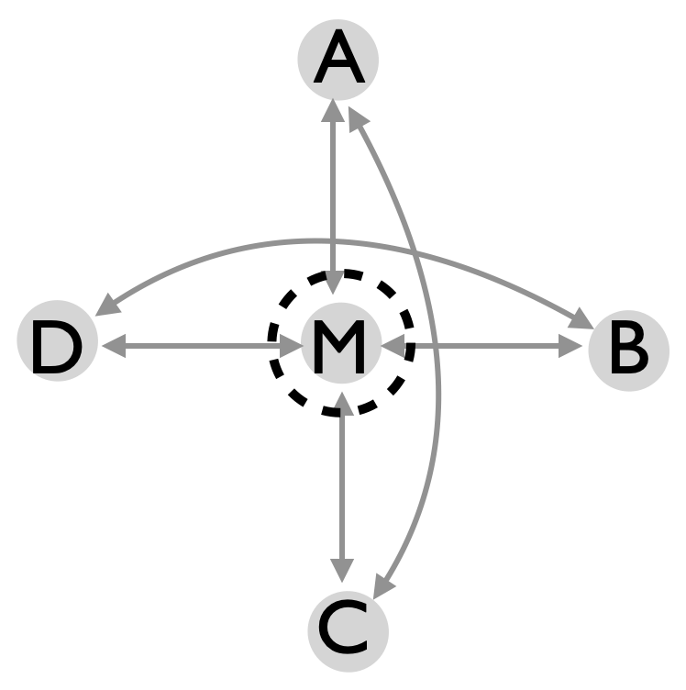
In the 14 club triples/4-count box there’s room in the middle for one or two extra jugglers. Having them pass with the corners while turning through a circle is the Whirling Melvish.
In this version, one Melvish, M (the juggler in the middle, who may or may not be named Melonhead), passes twice to each corner, then rotates a ¼ turn and repeats. A and B start with 4. A and C release rights on beat 1. B and D start on beat 2 with their rights, or start with the others on beat 1, but with lefts.
Beat, 1-count base; partial (4/9) cycle shown
 | 1 | 2 | 3 | 4 | 5 | 6 | 7 | 8 | 9 | 10 | 11 | 12 | 13 | 14 | 15 | 16
A | t-C |  | M |  | t-C |  | M |  | t-C |  |  |  | t-C
B |  | t-D |  |  |  | t-D |  |  |  | t-D |  | M |  | t-D |  | M
C |  |  | t-A |  |  |  | t-A |  |  |  | t-A |  |  |  | t-A
D |  |  |  | t-B |  |  |  | t-B |  |  |  | t-B |  |  |  | t-B
M |  | d-A | pa |  |  |  | A | ¼ turn |  |  | d-B | pa |  |  |  | B
On beat 2, M passes a straight right double, then pauses (grey box, pa), then does a standard 4-count pass to one corner (A in this case), then turns and throws an early straight double in 4-count to the next corner, then pauses again and resumes the 4-count. Moving after every 2 passes (1 double and 1 single) is a nice timing. Each passing segment by M to one of the outside jugglers takes 9 1-count beats. With the local 4-count cycle for the outside jugglers, the full cycle becomes 36 1-count beats.

Variation (for 6): Add a second whirling melvish juggler in the middle back to back to the original mover. That juggler starts in a 4-count with C and does the same thing as M, 2 beats later

Metrics: J=5, cycle=36 on 1-count, CJ=3.4, OJ=2.4, R=2, PBJ=0.29, pH=2.5, Motion=0 and spin=$2π/5$ rad, since only the melvish rotates. Pattern by Luke Emery, 2000.

Cathedral  A spectacular but challenging pattern! |  |  |  |  |  |  |  |  |  |  |  |  | 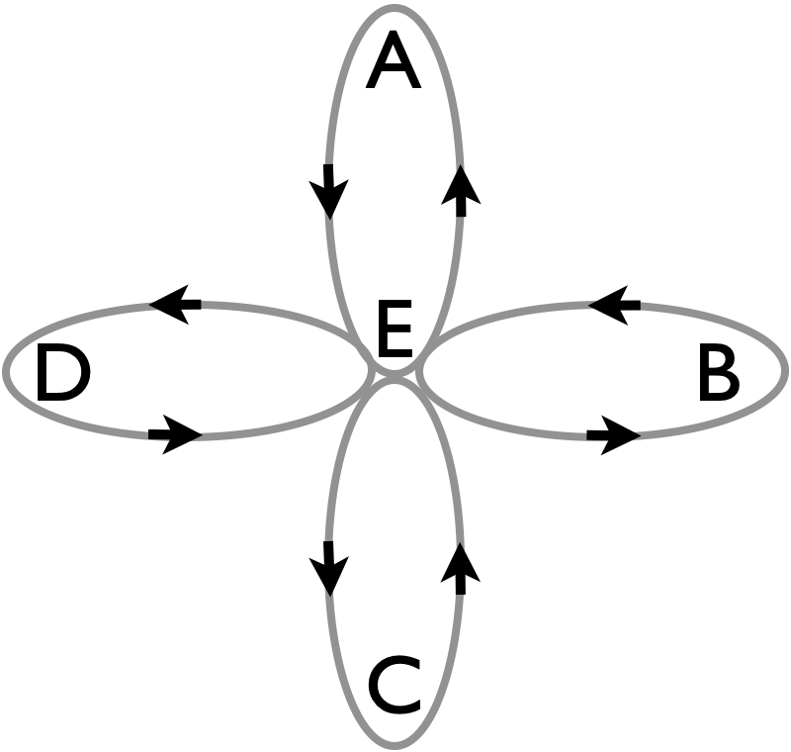
This extension of the 3-person GDP to 5 jugglers has moves like a 4-leaf clover; but it’s more boxy than clovery with 2 extra clubs and all triple passes over the top. The 4 outer jugglers maintain a 14 club box in 4-count triples. The center juggler passes once with a leaf (double) and then replaces that leaf in a 6-count turn.
The table shows two transitions, where E replaces A, and then A pushes out B. All passes are rights, so B, D, and E start 1 count after A and C. A and B start with 4 clubs each.
Beat, 1-count base
 | 1 | 2 | 3 | 4 | 5 | 6 | 7 | 8 | 9 | 10 | 11 | 12 | 13 | 14 | 15 | 16 | 17 | 18
A | t-C |  | E |  | t-C |  |  |  |  |  | d-B | – |  |  |  |  |  | t-D
B |  | t-D |  |  |  | t-D |  |  |  | t-D |  | A |  | t-D
C |  |  | t-A |  |  |  | t-A |  |  |  | t-E |  |  |  | t-E
D |  |  |  | t-B |  |  |  | t-B |  |  |  | t-B |  |  |  | t-B
E |  | d-A | – |  |  |  |  |  | t-C |  |  |  | t-C |  |  |  | t-C
Metrics: J=5, cycle=45 (that’s long!)l, CJ=3.4, OJ=4, PBJ=0.24, R=1, pH=2.7, motion=8 pu, spin=$6π$ rad (i.e., 3 full turns).

Pattern by Luke Emery, 2000.

Twister Popcorn  A popcorn pirouette challenge! |  |  |  |  |  |  |  |  |  |  |  | Like the stationary Popcorn Feed, but with 2-feaders (A and B) and with 6-count popcorners (triple self, double pass, single self, counting the right side) C, D, and E alternating throws to A and B, who both typewriter feed.  A and E start with 4, and C starts with triple self. Popcorners respond to incoming double with a triple self.  Pattern by Luke Emery and MAJ.
Beat, 2-count base (rights) |  |  |  |  |  |  | 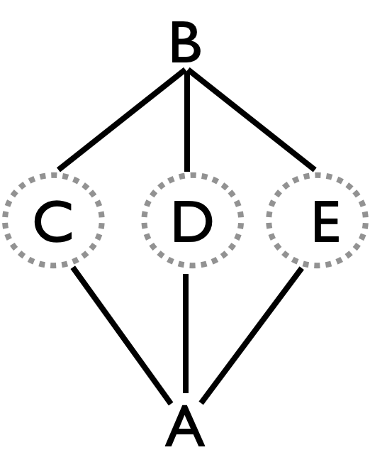
 | 1 | 2 | 3 | 4 | 5 | 6
A | d-C |  | d-E |  | d-D
B |  | d-D |  | d-C |  | d-E
C | t-s | d-A |  | t-s | d-B
D |  | t-s | d-B
E | d-B |  | t-s | d-A |  | t-s
Local cycle 6 beats
The hardest position is D, because he/she cannot cheat as much into the turns. You can either turn fast during the single self, throw a right to left single straight up in the air and do a ½ pirouette underneath it, or throw a behind the back self to turn.

Metrics: J=5, cycle=12 on 2-count base , CJ=3.4, OJ=2.4, PBJ=0.18 (not counting triple selves); pH=2, motion=0, but spin is excessive at about $2π$ on average, with D alone spinning $4π$ rad per cycle, R=2.

Twister Popcorn Weave  Super challenging, but theoretically possible! |  |  |  |  |  |  |  |  |  |  |  | Weavers C, D, and E are all doing 6-count popcorn (triple self, double pass, single self, counting the right side) while weaving!  A and E start with 4, and C starts with triple self. Weavers respond to incoming double with a triple self.  With only one right-self to switch sides while navigating your self triple and the doubles, this pattern is exceedingly difficult!  Pattern by Luke Emery
Beat, 2-count base (rights) |  |  |  |  |  |  | Feeders A and B  Drs. Inside/Outside  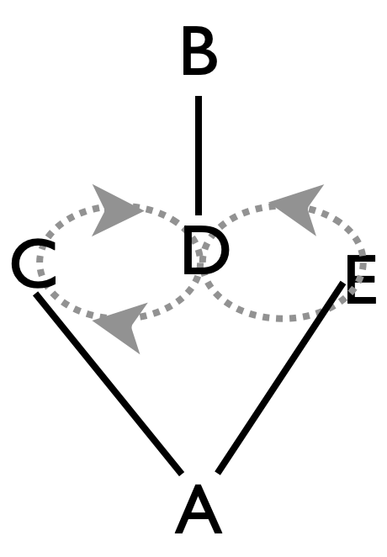  Weavers C, D, E
 | 1 | 2 | 3 | 4 | 5 | 6
A | d-C |  | d-E |  | d-D
B |  | d-D |  | d-C |  | d-E
C | t-s | d-A |  | t-s | d-B
D |  | t-s | d-B
E | d-B |  | t-s | d-A |  | t-s
Local cycle 6 beats
Metrics: J=5, cycle=12 on 2-count base , CJ=3.4, OJ=2.4, PBJ=0.18 (not counting triple selves); pH=2. Motion=2.4 pu and spin= $3π$ rad per cycle, as in Twister Weave. (Note the difficulty of triple selves while moving is not really captured by the standard metrics.)

SEE PART 2 FOR SIX PERSON AND MORE PATTERNS

