Introducing the Pattern Book 4
Welcome Jugglers and Friends 4
About the Project 4
The Madison Area Jugglers 6
Version History 6
Updates in Version 4.0 7
The Editors 7
***SEE PART 1 for PRELIMINARIES AND ALL THE STUFF THROUGH 5-PERSON PATTERNS*** 8
Six Person Patterns 9
Stationary Six Person Patterns 9
1-2-3 Apollo 9
Hex 10
Kill Screen 11
Feast (for 6) 11
Picnic 12
Star of David 13
Feasts of David 13
Overlapping Y’s 14
Overlapping feeds 14
Mel’s Big Woody 15
Argyle Socks 15
Extra Club Stationary Six Person Patterns 16
Overlapping extra club 4-count triangles 16
Bubbler of David 16
Trompe l’oeil 17
Theater-style Popcorn 18
Moving Six Person Patterns 18
Ball Bearing 19
Benzene Ring (for 6) 20
Two-handled eggbeater 21
Two-seated unicycle 22
Razor 22
Electric Razor 23
Peter Feeds 5 24
Standard Double Weave 25
Inverted and Dresser Drawer Double Weaves 26
Cross Corner Double Weaves 27
Unweave 28
Stick on the End Double Weave 29
Mondo Double Weave 30
Combinatorial Double Weaves 31
Double Gandini Weave 32
Double Gandini Site-Swap Weave 33
Twister 4 Weave 34
5 Weaves 35
Spiral Weave 36
Interlocking Turbos 37
Windy Two Holer 38
Fast Forward 39
Foie Graham 40
Side-by-Side 2pi/3 41
Interlocking 2pi/3 42
Celtic Knot 43
Slippery Knot 44
Disco Knot 45
Meltic Knot + Orbiter 46
El Turbo with 2 posts 47
Ivy Pi Weave + Post 48
Pollinator 49
Four leaf clover with 1 orbiter 50
Five leaf clover 51
Extra Club Moving Six Person Patterns 52
Extra Club Double Weave 52
Stationary Seven Person Patterns 53
3 v 4 lines 53
1-2-4 Apollo 54
Hinge 54
Feast for 7 55
7-point star 56
Overlapping Chocolate Bar 3-count feeds 57
Extra Club Stationary Seven Person Patterns 57
7-count 7-point Star 58
Moving Seven Person Patterns 58
Open face sandwich with olive 59
The Blast 60
Broken Hearted Blast 61
Eye of the Needle 62
Twister 5 63
Iron Cross Weave 64
Four-Loop Weaves 64
Intersecting Weaves 65
1-5-1 Foie Graham 66
Wonky Benzene Ring 67
Extra Club Moving Seven Person Patterns 67
Big Mangled Squirrel 67
Eight Person Patterns 68
Stationary 8 68
Extra-Club Stationary 8 68
Moving 8 68
Extra Club Moving 8 68
Patterns for an indefinite number of jugglers! 68
Pattern Statistics 69

Introducing the Pattern Book

Welcome Jugglers and Friends

Welcome to the Madison Area Jugglers' Pattern Book, a collection of club-passing patterns for intermediate to advanced passers. These patterns are part of our juggling repertoire. Many we learned or adapted from other jugglers; we include them because
it's fun trying to juggle them. But very many of the patterns in this book were born in Madison, Wisconsin, conjured up at Thursday/Sunday juggling sessions or at 47th Annual Madfests, annual events since 1992. The book offers some record of the evolution of club passing in Madison.


All jugglers are welcome to play with, use, distribute, extend, and otherwise enjoy all the club-passing patterns described in Madison Area Jugglers' Pattern Book, Version 4, which is licensed by its creators, the Madison Area Jugglers, under the Creative Commons Attribution 3.0 Unported License . You may access the book online, or check the latest updates at our GitHub repository.

If you have questions, comments or suggestions relating to this book, please contact the Madison Area Jugglers. Where possible we have given credit to the creators of the patterns described here, though for many these origins were unknown to us. If we have erred in our attributions, please let us know.

This collection is a living document. New contributions are welcome for the next version, so please join the team and provide some pattern descriptions. give an easy instruction on how to add

About the Project
Originally we wrote down the patterns just to save time arguing over exactly how we did the pattern last time. (Don't worry...there's still plenty of arguing, even with the book.) We were pleasantly surprised to find other people found our book helpful too! The pattern book can be used as a club passing guide or just a library of the patterns that we originated or find interesting. If you're from Madison, then it's a handbook to what we do twice a week, on Thursdays and Sundays, and if you don't know the patterns already then you probably will. This book is not intended to be an encyclopedia of all possible passing patterns (that would be a big book)! In fact, we don't include patterns just because they are theoretically possible; we include them if we have done them!

The Madison Area Jugglers (MAJ) have been attempting, inventing, and recording juggling patterns for longer than most of us can remember. In 1997, when our memories were already getting strained by the variations, Michael Newton (aka Prof Mike) compiled our first Pattern Catalogue to record the patterns for four or more jugglers. This morphed into the first Pattern Book by him in January 1999, but the hand-written collection (Version 0.1) was in a pretty limiting format. By October of that year, Steve Otteson created the first computerized collection by reformatting and expanding Mike's hand-written notes. Melonhead still carries around a tattered printout of Version 1.0. Steve made a few version updates, for example adding a bunch of extra-club patterns by Peter Kaseman and Luke Emery; the unusual computer format of Steve's version and his departure from Madison slowed down subsequent updates, even though the MAJ continued to create new patterns at a steady rate. The next big contribution was Luke Emery's version (Version 2.0, 2012). Though it was not widely distributed, Luke's version contained all kinds of new additions: more patterns for all numbers of jugglers, more on site-swap, more on specialized extra-club patterns, and tips for creating and doing patterns.

In 2015 Matt Hemke and Evan Driscol created a Github repository for the project, converted Luke's version into a repo, and updated the collection further. Chan Wilson, Jeff Adamus, and Melonhead began tracking the patterns we do at Thursday and Sunday MAJ practices. It's an amazing collection, and for those who remember the code words, like 1-5-1 Foie Graham or 4-5 Twister, it's enough to figure out what we really did. But most of us forget the code words after a while, except for the frequently juggled ones, and this was an impetus for the Version 3.0 update by Prof Mike in 2018. Since then, we've suffered through two years of COVID restrictions and two lost Madfests (only 1 lost if you count spring ‘22). But we kept juggling and discovered some cool new patterns that work well with face masks! Nathan Nard's rejuvenating and inventive contributions helped to launch Version 3.1 in 2023.

All along the editors have had substantial input from the Madison Area Jugglers and friends, and we are indebted to them for helping enhance this collection. Club passing
is a social pastime that needs a group of similarly inclined jugglers. Many of these patterns are inspired by other jugglers and patterns or created in collaboration with other jugglers. We hope that these patterns will help inspire new club passing ideas and help more jugglers all over the world enjoy club passing!

The Madison Area Jugglers

*An intro paragraph or two on the MAJ*

Version History

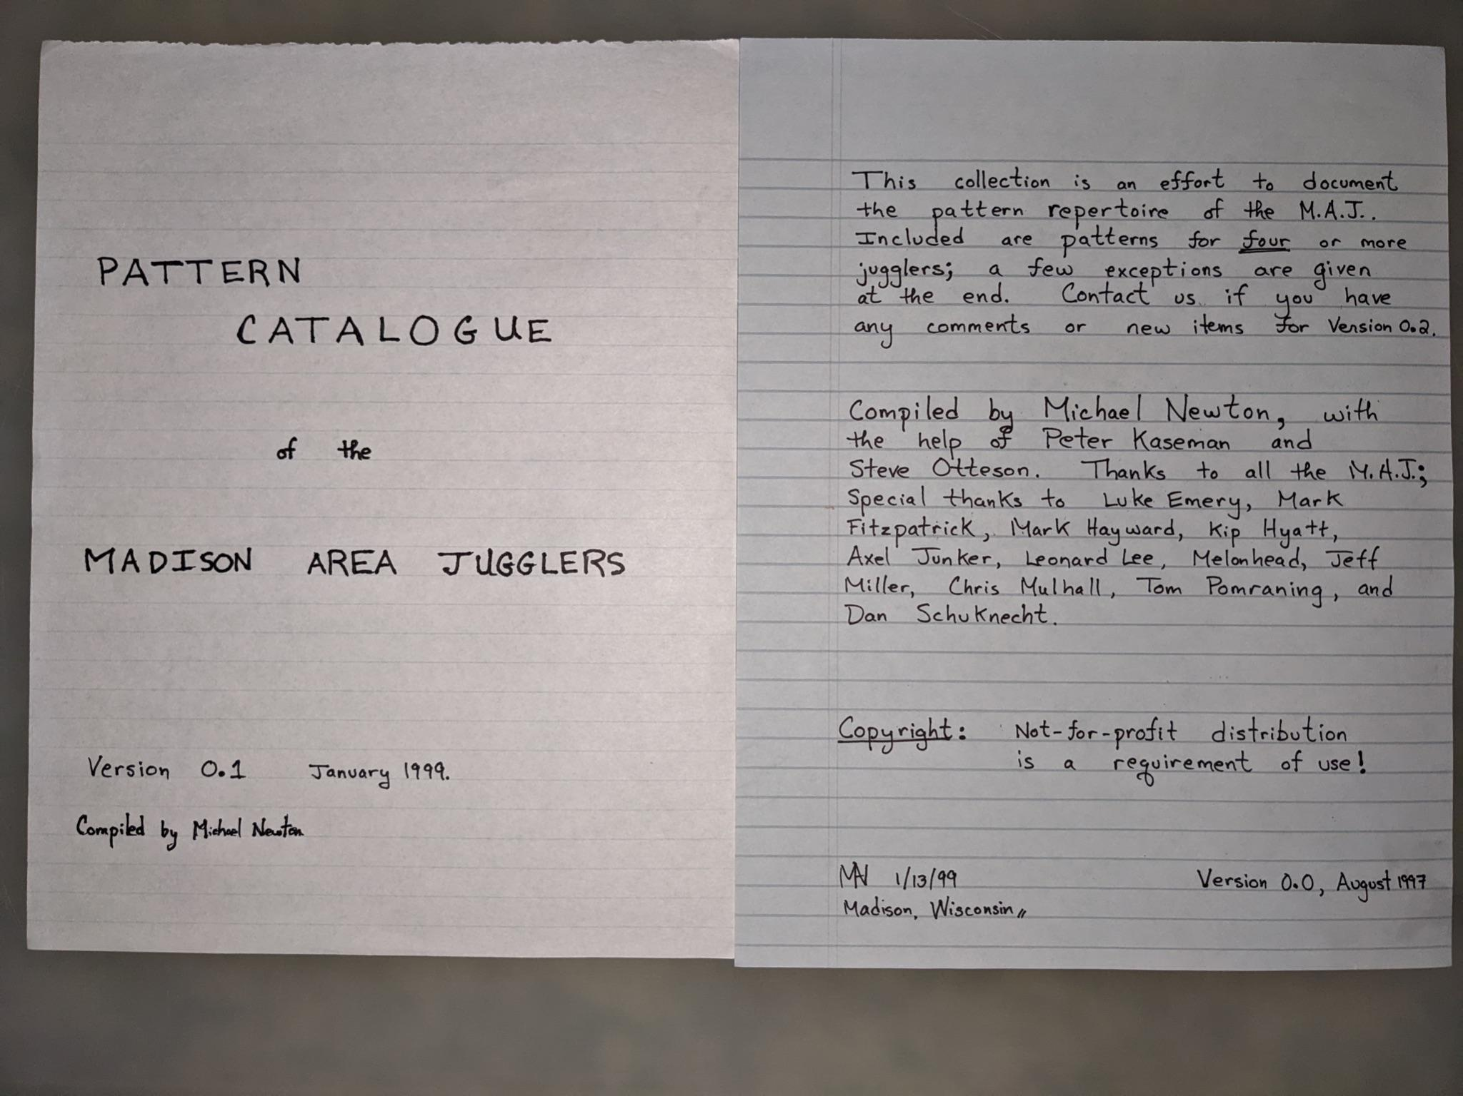

* Madison, Wisconsin, August 1997 Version 0.0
* Madison, Wisconsin, January 1999 Version 0.1
* Madison, Wisconsin, October 1999 Version 1.0
* Madison, Wisconsin, January 2001 Version 1.1
* Madison, Wisconsin, March 2001 Version 1.2
* Madison, Wisconsin, January 2012 Version 2.0
* Madison, Wisconsin, January 2018 Version 3.0
* Madison, Wisconsin, January 2023 Version 3.1

Updates in Version 3.1:

We added a bunch of new patterns (e.g., laxatives, the pollinator, the zigzag, sneaky-snake, that's-a-really-good-one, fully-loaded-blast, Mel's-dream, and more). We added more on big patterns, including on the super-fun 24-person hex-of-clovers. At recent practices we've experimented a lot with colors, in which jugglers each start with a distinct set of clubs, and we see how long it takes to move the colors around. This version has some details on the substructure of a few of our cool patterns.

Thanks to Jeff Adamus for posting YouTube recordings of a bunch of our patterns; we've added links *where* (Thanks to Jeremy, Jessie, and ? others for great camera work!) . *other animations?*

Like all earlier versions, the current version contains mistakes and unfortunate omissions, which we have yet to discover and for which the Editors take responsibility. We hope that future versions will correct these shortcomings.

Updates in Version 4.0
**google doc version..prep for real book…new patterns …more uniform pics/tabular descriptions; pattern metrics** [lead by MAN]; still missing manipulator patterns…waiting for the right expertise to join the editors!

The Editors
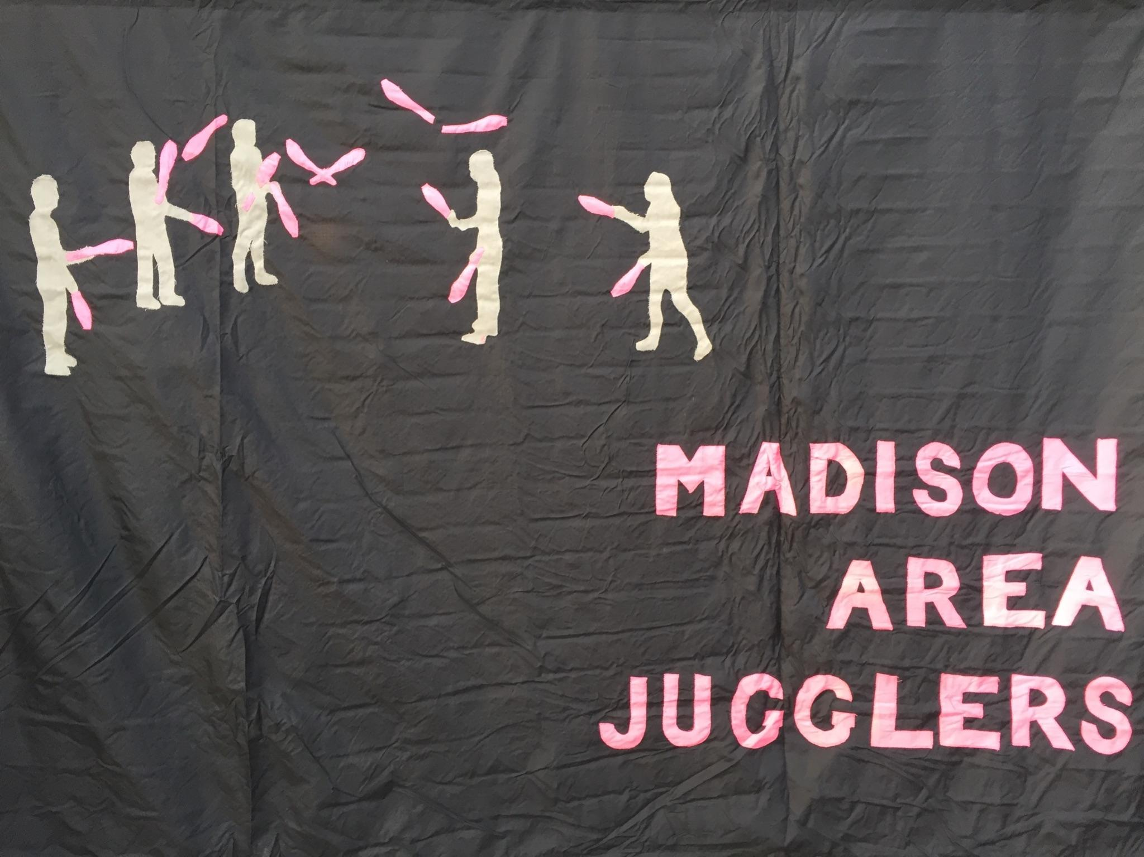
Michael Newton (aka Prof Mike), Luke Emery, and the Madison Area Jugglers, especially (in alphabetical order): Jeff Adamus, Nick Aikens, Josh Casey, Steve Clipson, Evan Driscol, Mark Hayward, Matt Hemke, Peter Kaseman, Melonhead, Nathan Nard, Graham Paasch, Steve Otteson, and Chan Wilson. You can be an editor too by working on the next version!

***SEE PART 1 for PRELIMINARIES AND ALL THE STUFF THROUGH 5-PERSON PATTERNS***

Six Person Patterns

Stationary Six Person Patterns

1-2-3 Apollo  Nice and easy for six jugglers |  |  |  |  |  |  | Everyone is on 4-count passing to 2 other jugglers over the pattern cycle, with exchanges going between pairs (i.e., pass to and receive from the same person.) Positions differ a bit, owing to the passing distances and the turning required. A is most difficult, followed by F and D, followed by easiest spots B, C, and E, which are ideal for first-time passers.  It keeps people engaged to rotate jugglers to new positions after a successful run; that way everyone gets a feel for each of the spots (and stays more alert!).  Pattern by the MAJ, we think.
Beat |  |  | 4-count base  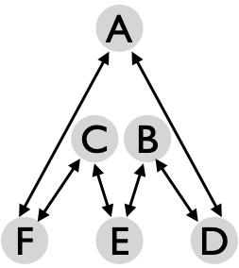
 | 1 | 2
A | D | F
B | E | D
C | F | E
D | A | B
E | B | C
F | C | A
Metrics: J=6, CJ=3, pH=1, cycle=2 on a 4-count base, OJ=2, PBJ=¼, and motion=0. To a first approximation, R=1 (i.e., there’s just one role), but in fact A ought to oscillate left-right a bit to simplify passes to F and D, and juggler spin and passing distances vary. To square up to their partner on each beat, A, B, C, and E each swivel through an angle of measure about $4ϕ$ per cycle, where $sin(ϕ)=1/\sqrt{5}$, assuming the distance from A to E is about the same as the distance from F to D. That gives a pattern average spin $8ϕ/3≃1.24$ rad = 71°.

Hex  The six person box. |  |  |  |  |  |  |  | Jugglers are on 3-count (standard) or 6 count (slow), each to one partner.  Hex is a pleasant pattern for six, in which everyone is doing the same thing (R=1), and there’s neither motion nor any spin. It’s easier than the Feast or the Apollo, but it does require good timing to avoid collisions.
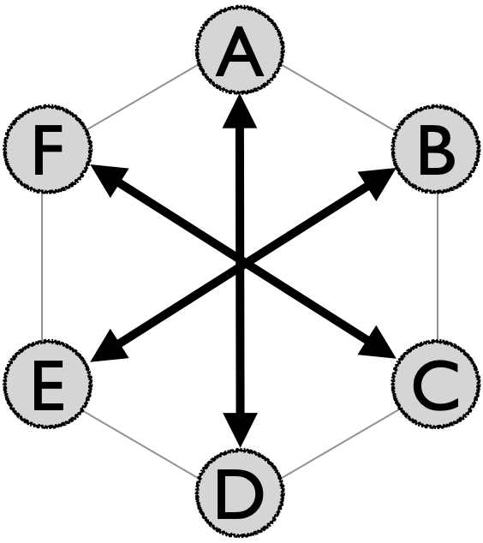 |  | Juggler
 | Beat | A | B | C | D | E | F
 | 1 | D |  |  | A
 | 2 |  | E |  |  | B
 | 3 |  |  | F |  |  | C
Metrics: J=6, CJ=3, pH=1, OJ=1, R=1, cycle length=3 on 1-count base (standard) or 2-count base (slow), PBJ=⅓ (standard), ⅙ (slow). Motion and spin are both 0.

Once performed with Laptop Dave in the center wearing a helmet! In principle versions can be done with simultaneous throws on various counts, as with 4-person Box variations, but this requires more precision timing than a typical group of six will give you!

Kill Screen  A non-repeatable pattern! |  |  | This pattern has a lifespan rather than a cycle! It is designed to crash out at exactly 37 1-count beats.
 | 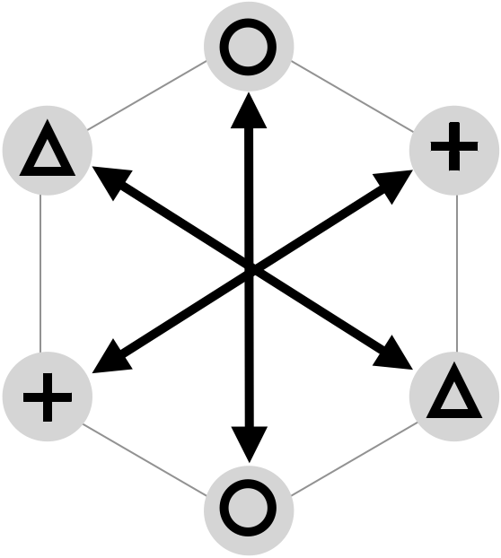 |  | The brainchild of Mark Hayward and with specific passing sequence by Prof Mike, the Kill Screen pattern mimics the feature in older arcade and 80s console games that renders a level impossible to complete due to bugs or integer overflows. In this juggling rendition, pair (A,D) pass on 6-count, pair (C,F) pass on 7-count, starting on beat 2, and pair (B,E) pass on alternating 6-count/5-count, starting on beat 4.
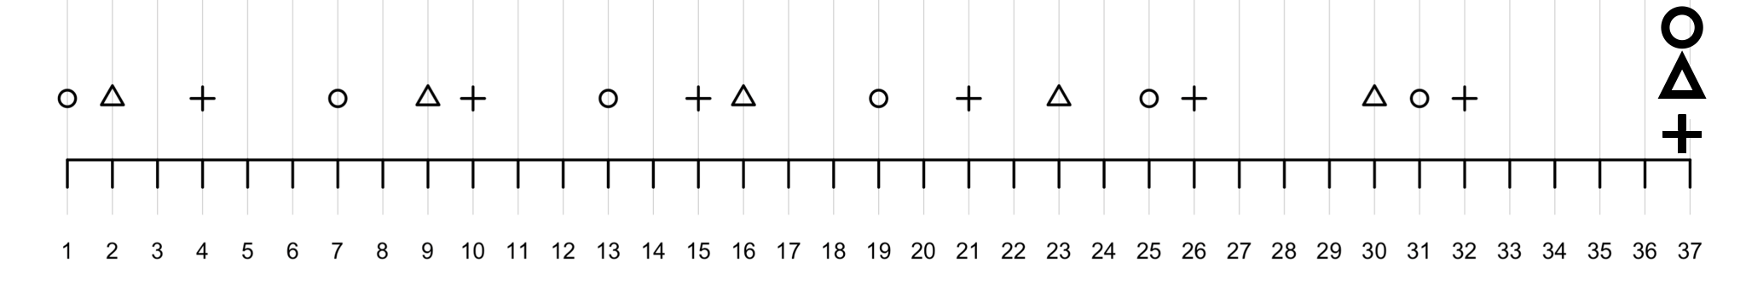
The consequence of this particular passing sequence is that clubs avoid one another until the critical beat 37, at which point all passes collide in the middle to a tremendous cheer. It can be helpful to have a metronome to keep precise timing (remember, we like 127 bpm.) As Nathan Nard predicted theoretically and we confirmed empirically, if a common club color is in the 1st release position of all six jugglers, then that common club is also released into the collision on beat 37. Further, if passes are too precise they can actually all miss even on beat 37! One way to avoid this unhappy event is to have jugglers release more towards the centerline of their passing zone.

Metrics: J=5, pH=1, CJ=3, R=3, motion=0, spin=0, PBJ=0.18. Pattern born February 2024.

Feast (for 6)  Everyone feeds everyone else (clockwise-from-above version) |  |  |  |  |  |  |  | Pass sequentially around the circle, including yourself in the count. Any base count of choice works; 3 and 4 count are pleasant; 2-count requires some good passers and good timing. 1-count is a dream!  MAJ have been juggling feasts since at least 1992, though their origin is unknown to us! Feast on a friendly count is a great first pattern when a group of non-beginner passers starts a session.
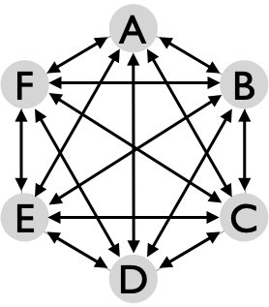 |  | Juggler
 | Beat | A | B | C | D | E | F
 | 1 | B | A | F | E | D | C
 | 2 | C |  | A | F |  | D
 | 3 | D | C | B | A | F | E
 | 4 | E | D |  | B | A
 | 5 | F | E | D | C | B | A
 | 6 |  | F | E |  | C | B
Metrics: J=6, CJ=3, pH=1, OJ=5, R=1, cycle length=6 on base count; PBJ=$[5/6]/[base]$, e.g., 0.28 on 3-count; 0.21 on a 4-count.. Some spin is needed to square up with your counterpart around the circle; considering the interior angles of a hexagon, everyone spins $4π/3$ rad = 240° per cycle. As presented the motion=0, but with 6 or more jugglers, we start to see an amoeba effect in which each juggler moves through a small circle in order to get closer to their passing partner as they proceed around the pattern. This motion reduces the variation in throw lengths. Let’s say motion = $ϵ$ for a small number $ϵ$, probably less than 1 pu in this 6-person version.

Variations include switching the direction, or, on 3-count:

Picnic
Start by practicing a 3-count feast. In the picnic, you complete one cycle throwing right-right or left-left crossing passes, then you switch on the next cycle (after doing your self beat) to do a round of straight passes (right-left or left-right). To set up, note that each pair of passers must include one straighter and one crosser. Picnic leads to all kinds of interesting Jim’s jams, including long sequences of only left throws or only right throws. Just remember, pass back the club you catch! [Homework: figure out the cycle length!]

Star of David  A classic 6-person variation of the synchronized 4-person box |  |  |  |  |  |  |  | Any beat of choice works. Throws are simultaneous. In the outsides triangles version, right throws go to the person two spots to your right; left throws to the one two spots to the left. Feels like the 5-person Star, but club interference is a bit more likely; if trouble, try an insides triangles version.
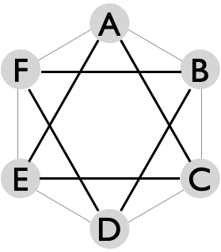 |  | Juggler
 | Beat | A | B | C | D | E | F
 | Rights | E | F | A | B | C | D
 | Lefts | C | D | E | F | A | B
 | The outsides triangles version is shown; switch rights and lefts for the insides triangles version.
Metrics: J=6, CJ=3, pH=1, R=1, PBJ=1/[base-count]. On an even base, OJ=1 and cycle length=1; on an odd base (e.g., 3-count), OJ=2 and cycle length=2. Motion=0, and spin=0 on even counts; but jugglers need some rotation on odd counts to sweep between their counterparts. We estimate spin = $2π/6$ rad = $120$° for full cycle.
Collisions are certainly a possibility with this classic pattern, and so the need for precise timing makes it a bit difficult for beginning passers, even on a slow beat. (You’re also not passing to the same person you receive from.) When well timed, your right throws will pass just behind the right throw of the juggler on your right, so keep an eye out! By the same token, any left throws pass immediately behind the left throw of the juggler on your left.

Feasts of David
Like the Feast-Star combinations for 5 jugglers, there’s a lot of fun to be had by alternating Feast and then Star of David passes!

Overlapping Y’s  An old MAJ pattern from the archive |  |  |  |  |  |  |  | Recall the 4-person Y pattern, and imagine 2 copies where A and E are in both, being on one side of a Y with C and F and on the other side of a Y with B and D. Each Y is doing its own thing, and the overlap works as long as the AE passes are at different points in the two Y’s. The standard is a bit tough; each Y is on 3-count, so A and E end up being both on 3/2 count with some tricky throws. Right-handed 4-count Y’s are easier, and then the overlap is lopsided (e.g., A receives from D but never passes to D in that version.)
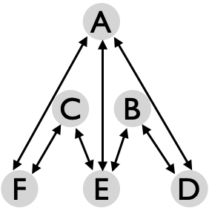 |  | Juggler
 | Beat | A | B | C | D | E | F
 | 1 | E | D |  | A | B
 | 2 | E |  | F |  | C | A
 | 3
 | 4 | D | E |  | B | A
 | 5 | F |  | E |  | A | C
 | 6
1-count base above for standard version
Goofy variation: Like in the 4-person Goofy Y, B and C can be out of phase with the others, releasing lefts when everyone else is releasing rights. All the passes to and from B and C have to cross (right to left, etc), but owing to the positioning it all works out nicely!

Metrics: J=6, CJ=3, pH=1, R=2, OJ=2 ⅓, PBJ=4/9, cycle=6 1-counts, motion=0. Considering the swept angles for the ordinary Y and some distortion to fit everybody, the pattern average spin is about $π/3$ rad = 60°.

Overlapping feeds  An old pattern of unknown origin! |  |  |  |  |  |  |  | We have two 1 v 3 feeds that share jugglers. A feeds (B,C,D) and C, likewise feeds (E,A,F), presented here as windshield wiper feeds. The long middle passes make this one a bit challenging for A and C. Shortening the distance doesn’t help too much owing to passing angles. We also add passes between the ends to keep them engaged! Standard is 2-count right-handed, but other timing works too.
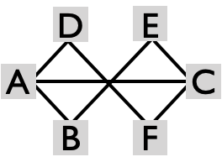 |  | Juggler
 | Beat | A | B | C | D | E | F
 | 1 | B | A | E | F | C | D
 | 2 | C |  | A
 | 3 | D | E | F | A | B | C
 | 4 | C |  | A
Metrics: J=6, CJ=3, pH=1, R=2, cycle=4 on 2-count, OJ=2 ⅓, PBJ=⅓, motion=0, spin $≃π$ rad per cycle.

Mel’s Big Woody |  |  |  |  |  |  |  | The three corners F, D, E have an easy 6-count to two interior feeders. These interior feeders A, B, and C are doing a 2-count sweep feed of 4 spots, and have a fair bit of rotation to get through each cycle. Note that the middle two beats of the sweep each forms a triangle.  Metrics: J=6, CH-3, R=2, pH=1, OJ=3, cycle = 6 on 2 count, PBJ=⅓, motion=0, spin=full turn per interior and less for the corners, with average $4π/3$ rad.
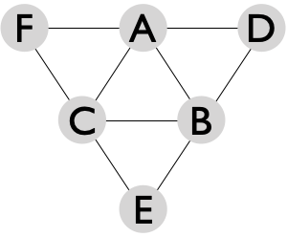  Right-handed 2-count base |  | Juggler
 | Beat | A | B | C | D | E | F
 | 1 | D | E | F | A | B | C
 | 2 | B | C | A
 | 3 | C | A | B
 | 4 | F | D | E | B | C | A
 | 5 | C | A | B
 | 6 | B | C | A
It takes a lot of skill on the inside triangle; a 3 or 4-count base is simpler but a bit slow on the corners! The corners have plenty of time; one variation is for them to pass triples to each other while the inside triangle is active, for instance on the same line as your last pass. E.g., E passes a triple to F after passing a single to C.

Argyle Socks  Closer quarters with both hands passing |  |  |  |  |  |  |  |  | 
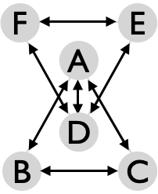 |  | Juggler |  |  |  |  |  | Standard right-handed start.  In the basic version, corners F, E, B, C do a 3-count outsides triangle. In both versions, A and D do an invigorating double 3-count, and in the full version all jugglers are on double 3-count (extra passes are indicated with grey font).  Tip: A and D keep your passes loopy!
 | Beat | A | B | C | D | E | F
 | 1 | B | C | A
 | 2 | D | C | B | A | F | E
 | 3 |  |  |  | E | F | D
 | 4 | C | A | B
 | 5 | D | C | B | A | F | E
 | 6 |  |  |  | F | D | E
Pattern by MAJ | 1-count base (both hands counting)
Metrics: J=6, CJ=3, pH=1, R=2, OJ=2.67, PBJ=⅔ (full), 4/9 (basic), motion=0. All jugglers swivel back and forth for spin= $2π/3$ rad = 120°.

Extra Club Stationary Six Person Patterns
Overlapping extra club 4-count triangles |  |  |  |  |  |  |  |  |  | 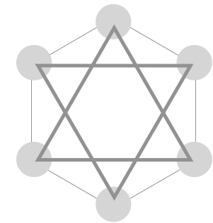
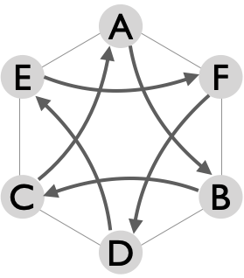  Start here! | Right  beat |  | Juggler |  |  |  |  |  | 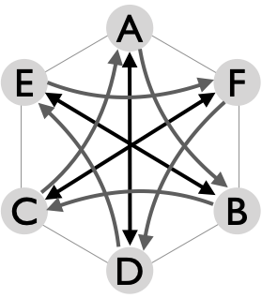  Bubbler of David
 | Right  beat |  | A | B | C | D | E | F
 | 1 | 0 | d-B |  |  | d-E
 | 1 | 1/3 |  | d-C |  |  | d-F
 | 1 | 2/3 |  |  | d-A |  |  | d-D
 | 2 | 0 | D |  |  | A
 | 2 | 1/3 |  | E |  |  | B
 | 2 | 2/3 |  |  | F |  |  | C
This fun pattern pairing starts with equilateral two triangles (A,B,C) and (D,E,F) that overlap in space like a Star of David, and that are synchronized in time, with both doing a 1-extra club 4 count insides triangle. Recall the 3-person 10-club 4 count pattern, which each trio is doing, involves jugglers offset by ⅓ of a full right-hand beat, and passing insides double throws to the next person in the sequence, as shown above. As you master the synchronized triangles you realize that counterparts between the triangles are available to pass on the 2nd right beat of the cycle, and these we do by a crispy single pass straight across the pattern (grey shaded passes in table). The result we call the Bubbler of David, a name that merges the shape descriptor with the Wisconsin-y effervescent image of a water fountain. (Thanks Kat for that name!) It’s a very doable pattern for good passers, but it requires good timing and patience!

Metrics: J=6, CJ=3 ⅓, R=1, pH=2 (overlapping), 1 ½ (full Bubbler), PBJ = ¼ (overlapping), ½ (full Bubbler), motion=0. To square up with both recipients in the full Bubbler, each juggler swivels 120°, i.e., pattern spin=$2π/3$ rad. By our convention spin=0 in the overlapping version. The full Bubbler is also tricky because on the triangle throws you’re not receiving from the person you pass to. OJ=1 in overlapping and 2 in full Bubbler. Pattern by MAJ.

**Variation** 7-Club 3-count Hex. For those seeking a challenge, try a Hex where each pair juggles a 3-count 7
club pattern in doubles. It works if the passes are precise. **I DOUBT IT!!**...maybe consider 21-club box in 2-count doubles or 4-count triples is more doable**

Trompe l’oeil  6-count version |  |  |  |  | Translated, “deceive the eye”.
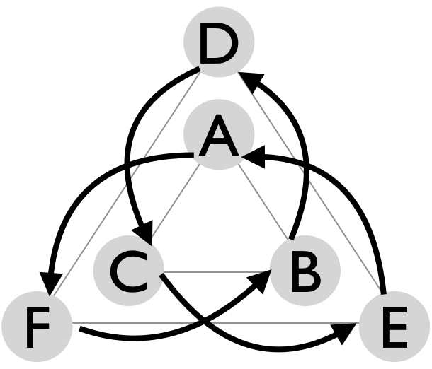  A starts with 4 clubs  All passes are doubles | 1-count  base |  | Juggler |  |  |  |  |  | A delightful 1-extra club pattern for six stationary jugglers. All jugglers do 6-count rights passing to one other. It’s helpful to vocalize your number as you pass. Inside positions are trickier owing to the bigger in-out angle and all the flying objects!
 |  |  | A | B | C | D | E | F
 | A, B, C  are out of phase from  D, E, F | 1 | F
 | A, B, C  are out of phase from  D, E, F | 2 |  |  |  |  |  | B
 | A, B, C  are out of phase from  D, E, F | 3 |  | D
 | A, B, C  are out of phase from  D, E, F | 4 |  |  |  | C
 | A, B, C  are out of phase from  D, E, F | 5 |  |  | E
 | A, B, C  are out of phase from  D, E, F | 6 |  |  |  |  | A
Metrics: J=6, CJ=3 ⅙, pH=2, R=1, cycle=6 on 1-count, PBJ=⅙, motion=0, spin=0 (recall our convention on spin refers to the angle swept out in passes over a cycle; since everyone has one recipient, we get spin=0 here, even though the inside jugglers have a big angle between their incoming and outgoing pass) . Pattern by Matt Mella. Matt learned a no-extra club version of the pattern with the same-to-from passing sequence, on any count of your choice. Noting the passing sequence, Peter Kaseman pointed out that this 1-extra club pattern is a stationary Extra Club Double Weave! **EXPLAIN THE 4-COUNT VERSION

Variation: 2-extra clubs. Same who-passes-to-whom, but now D and A start in phase with 4 each. Other jugglers are also in phase, passes are on 3-count, and are all right-right or left-left crossing throws. Then CJ=3 ⅓, PBJ=⅓, but other metrics are the same as above.

Theater-style Popcorn  A 3 extra club gem |  |  |  |  |  | A, B, and C, are each doing typewriter feeds of the same line, respectively in triples, doubles, and singles. Returns are popcorn: triple-double-single.
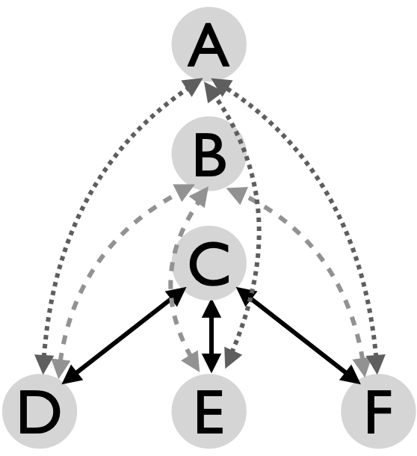 | Right  beat |  | Juggler |  |  |  |  |  | *check, I might guess that D starts with C?**  All throws are right handed singles, doubles, or triples. A, D, and F start with 4. B is out of sync, starting with a left release on beat 1; everyone else starts with a right release.
 | Right  beat |  | A | B | C | D | E | F
 | 1-count  base | 1 | t-D |  | E | t-A | C | d-B
 | 1-count  base | 2 |  | d-D
 | 1-count  base | 3 | t-E |  | F | d-B | t-A | C
 | 1-count  base | 4 |  | d-E
 | 1-count  base | 5 | t-F |  | D | C | d-B | t-A
 | 1-count  base | 6 |  | d-F
Metrics: J=6, CJ=3 ½, pH=2, OJ=3, PBJ=½, cycle=6 on 1-count, motion=0, spin=; R=4, with only C having a relatively easy role.
C needs to make crispy singles! Pattern by Peter Kaseman.

Moving Six Person Patterns

Ball Bearing |  |  |  |  |  |  |  |  | Here's a nifty extension of the 4-person Feast. | 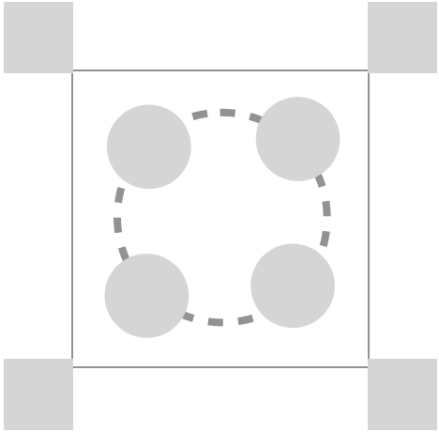
 | Beat, 3-count base |  |  |  |  |  |  |  | A, B, C, and D are doing a Feast (in 3 or 4-count), but the self throw is replaced  with a pass to one of the movers in the middle. E and F are passing 6 or 8-count. On the 3-count base it’s a bit easier to start lefts so that the long throws are right-handed.  Metrics: J=6, CJ=3, pH=1, R=2, OJ=2 ⅔ , PBJ=5/18=0.28 (3-count base), cycle=8 beats on base count (3 or 4 count work); motion $≃1$pu (assume the circle for E, F has diameter about 1 pu). spin $≃4π/3$ rad.
Juggler | 1 | 2 | 3 | 4 | 5 | 6 | 7 | 8
A | C | E | B | D | C | F | B | D
B | D | C | A | E | D | C | A | F
C | A | B | D | F | A | B | D | E
D | B | F | C | A | B | E | C | A
E |  | A |  | B |  | D |  | C
F |  | D |  | C |  | A |  | B
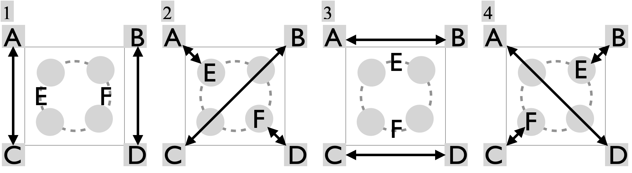 |  |  |  |  |  |  |  |  |  | An old pattern by Mike Newton

Benzene Ring (for 6) |  |  |  |  |  |  |  |  |  | An MAJ standard | 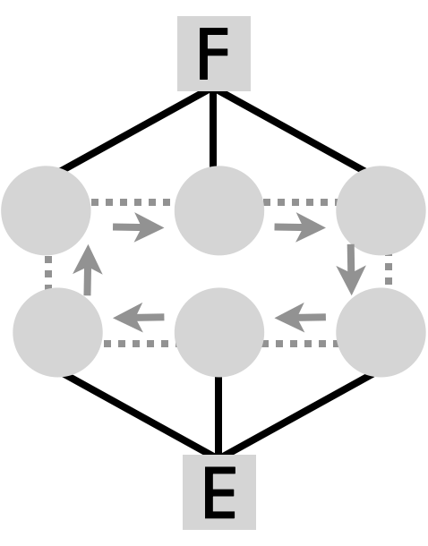
E and F each feed 3 positions: left, middle, right, left, middle, right, etc, while movers cycle through six positions.
 | Beat, 2-count base |  |  |  |  |  |  |  |  | 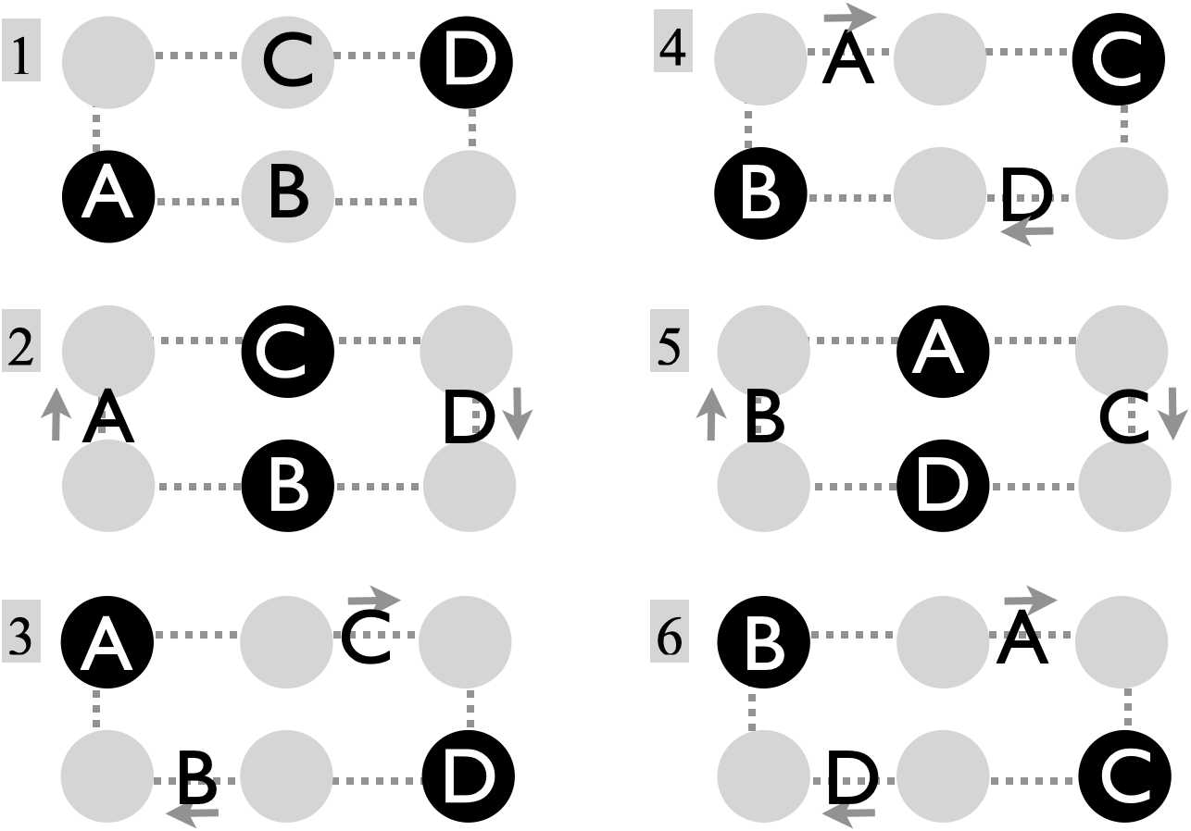  Feeders E and F pass simultaneous typewriter feeds with jugglers in the center, indicated with black circles. Movers shift to the next spot in the sequence after each pass. (½ cycle shown.)
Juggler | 1 | 2 | 3 | 4 | 5 | 6 | 7 | 8 | 9
A | E |  | F |  | F |  | F |  | E
B |  | E |  | E |  | F |  | F
C |  | F |  | F |  | E |  | E
D | F |  | E |  | E |  | E |  | F
E | A | B | D | B | D | C | D | C | A
F | D | C | A | C | A | B | A | B | D
Table shows ¾ of full cycle (12 2-counts)
Tip: Feeders pass deep throws to the position on the left, to help each mover switch sides.
Metrics: J=6, CJ=3, pH=1, R=2, OJ=, PBJ=, cycle=12 on 2-count base; motion $≃$2 pu and spin $≃2π$ rad (1 full turn per mover and about the same per cycle for feeders). An old pattern by Mike Newton.

Two-handled eggbeater  A good pattern for beginning movers |  |  |  |  |  |  |  |  |  | 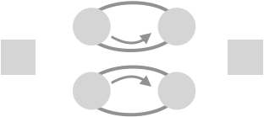
 | Beat, 4-count base |  |  |  |  |  |  |  | 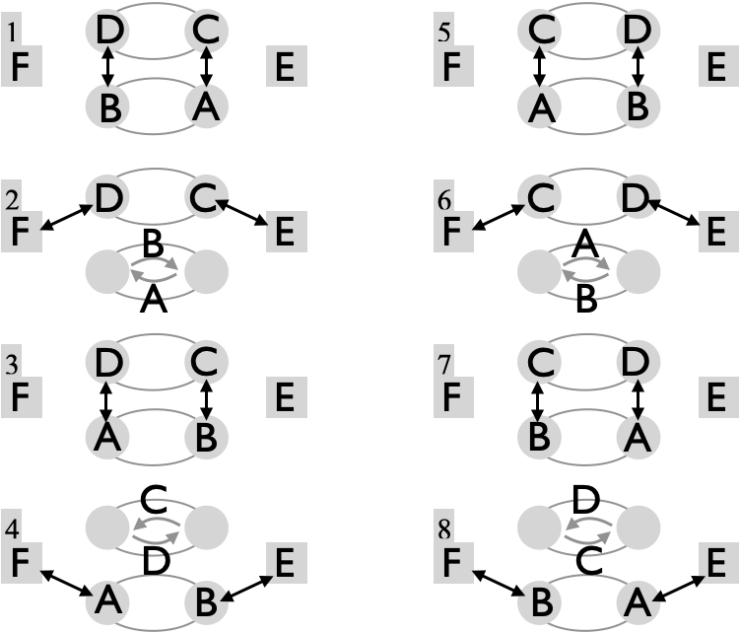
Juggler | 1 | 2 | 3 | 4 | 5 | 6 | 7 | 8
A | C |  | D | F | C |  | D | E
B | D |  | C | E | D |  | C | F
C | A | E | B |  | A | F | B
D | B | F | A |  | B | E | A
E |  | C |  | B |  | D |  | A
F |  | D |  | A |  | C |  | B
Feeders E and F are handles. (A,B) is one beater and (C,D) is another.
Derived by adding an extra juggler to the 5-person eggbeater, though it’s hard to imagine what a real 2-handled eggbeater would look like! There’s no reason why the pair switches can’t either go in the opposite direction, as long as jugglers agree. Pattern by Mike Newton.

Metrics: J=6, CJ=3, pH=1, R=2, cycle=8 beats on 4-count base, OJ=4, PBJ=⅙, motion = 1 ⅓ pu; considering the swiveling back and forth the average spin is $≃π$ rad per cycle.

Two-seated unicycle  Backdrops, spinning and both-hands passing! |  |  |  |  |  | 
Beat, 3 or 5-count base |  |  |  |  | 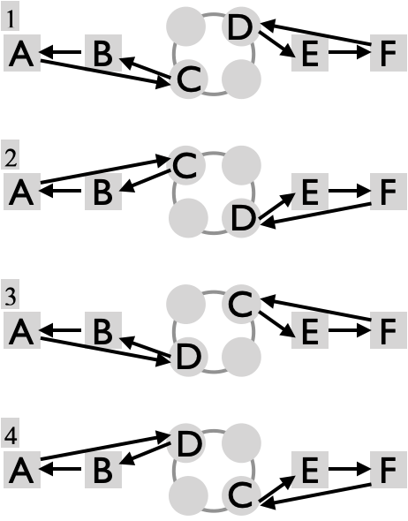 |  | B and E are posts facing in towards the wheel (C,D). They drop back to seats A and F, and receive passes from the wheel, which turns clockwise from above.  Metrics: J=6, CJ=3, pH=1, R=3, OJ=1 ⅔, cycle is 4 beats on 3 or 5 count base. PBJ = 1/base. Motion is 2 pu for the movers, giving a pattern average ⅔ pu. C and D have substantial spin (a full turn per cycle). Pattern spin $≃5π/6$rad. Get started with the 4-person unicycle. Pattern by MAJ.
Juggler | 1 | 2 | 3 | 4
A | C | C | D | D
B | A | A | A | A
C | B | B | E | E
D | E | E | B | B
E | F | F | F | F
F | D | D | C | C

Razor  1-2-2-1 |  |  |  |  | Fun with 4 good movers and 2 feeders. | 
 | Beat,  Base count |  |  |  | 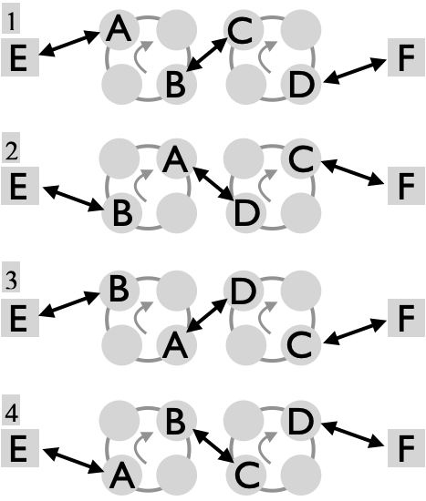 | The four movers A, B, C, and D are busy, spinning a ½ turn after every two throws and moving quickly to cover a full circle in 4 passing beats. The pairing has everyone passing twice in a row to the same partner.  Tip: Make the second throw of each pair deep enough to support the direction changes.  Pattern by Peter Kaseman.
Juggler | 1 | 2 | 3 | 4
A | E | D | D | E
B | C | E | E | C
C | B | F | F | B
D | F | A | A | F
E | A | B | B | A
F | D | C | C | D
Metrics: J=6, CJ=3, pH=1, R=2, OJ=2, cycle is 4 beats on the base count. 3-count is the high standard, but you’ll want to start on slower counts. Average motion = 1 ⅓ pu; spin is $2π$ rad per mover, and very slight per feeder, for an average in excess of $4π/3$ rad.

Electric Razor |  |  |  |  | An MAJ standard
 | Beat, 3-count base |  |  |  | 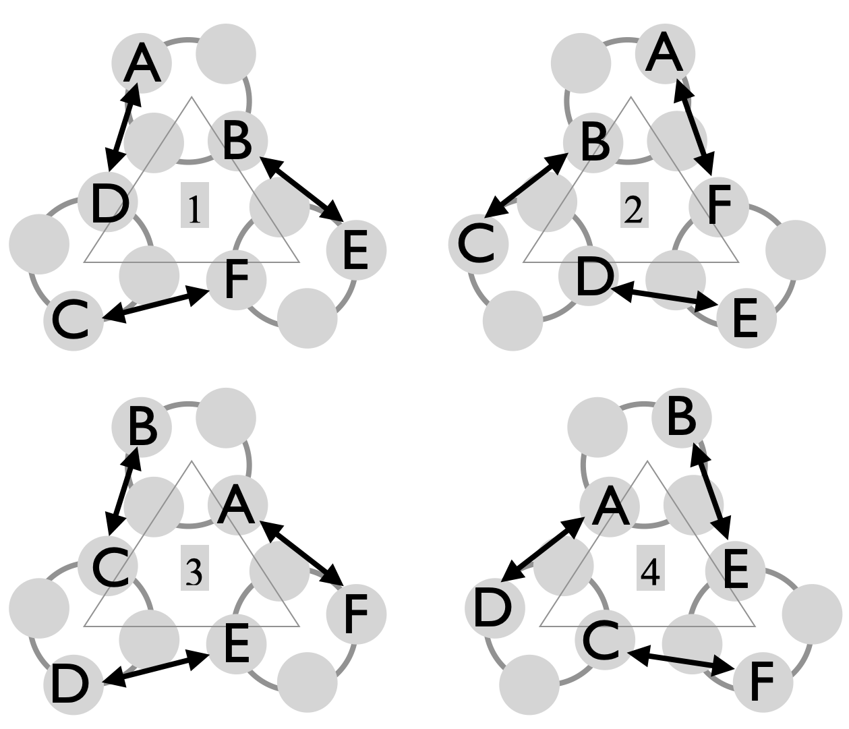 |  | Jugglers pair up. In each of the three pairs, jugglers cycle around each other while passing twice in a row to one member of each other loop, with all passes on 3-count.  Tip: Move quickly and juggle slowly.  Pattern by Peter Kaseman, summer 1998.
Juggler | 1 | 2 | 3 | 4
A | D | F | F | D
B | E | C | C | E
C | F | B | B | F
D | A | E | E | A
E | B | D | D | B
F | C | A | A | C
On December 1, 2022, we (Chan, Jeff, Mike, Mel, Nathan, and Nick) revisited the Electric Razor with colors, and on a comfortable 5-count base (rather than 3-count base). It takes 3 cycles to get back to the start. Good leads are important here, but they are deceptively tricky when you’re moving fast enough for the whole pattern to work.
Metrics: J=6, CJ=3, pH=1, R=1, OJ=2,PBJ=⅓, cycle=4 beats on 3-count, motion $≃2$ pu. Each juggler swivels approximately ½ turn through each cycle: spin $≃π$ rad.

Peter Feeds 5  Aka: 5-person weave; aka 24153  MAJ have been juggling this since 1998, though its origin is unknown! |  |  |  |  |  |  |  |  |  |  |  |  |  |  |  |  | 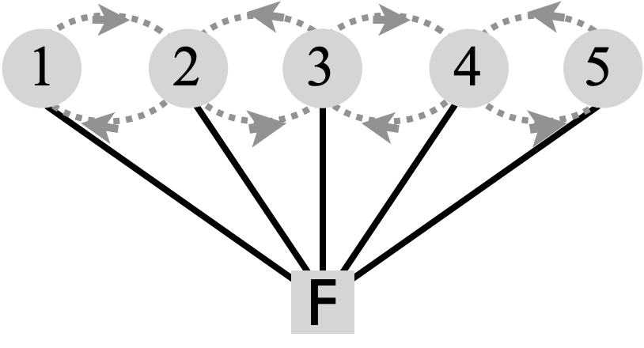
Juggler |  |  |  | Beat, 2-count base, ⅖ cycle |  |  |  |  |  |  |  |  |  |  |  |  | 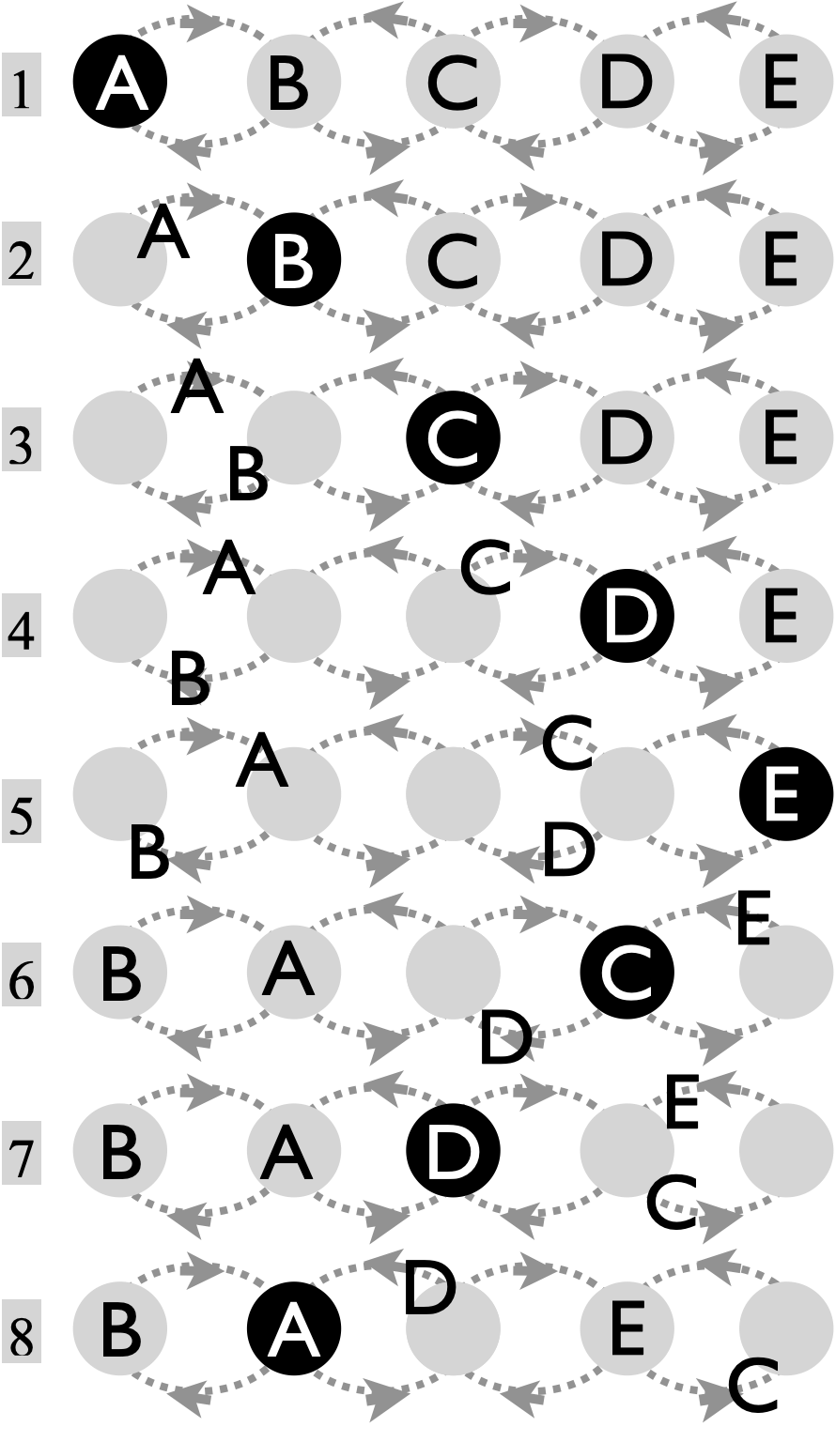  ⅕ full cycle
 | 1 | 2 | 3 | 4 | 5 | 6 | 7 | 8 | 9 | 10 | 11 | 12 | 13 | 14 | 15 | 16
A | F |  |  |  |  |  |  | F |  |  | F |  |  | F
B |  | F |  |  |  |  |  |  | F |  |  |  |  |  |  | F
C |  |  | F |  |  | F |  |  |  |  |  |  | F
D |  |  |  | F |  |  | F |  |  | F
E |  |  |  |  | F |  |  |  |  |  |  | F |  |  | F
F | A | B | C | D | E | C | D | A | B | D | A | E | C | A | E | B
This fun pattern requires straightforward movements but is mentally tough for beginners since the count changes as you move through the weave. The feeder (F) performs a windshield wiper 2-count feed of the 5 positions, vocalizing 1, 2, 3, 4, 5, 4, 3, 2, 1, etc. Movers advance through the spots.
The local rule for each mover (A-E) is: pass to Peter (F) then move to the next spot. If you're in an odd-numbered spot, then you move back away from Peter and with the grain (i.e. in the same direction as Peter's sweep); if you're in an even spot then you move forward and against the grain. You end up passing more frequently in the middle and less frequently on the ends. The shortest gap is 6-count; patience is a virtue as you move towards the ends! The figure above shows one full sweep back and forth by the feeder (8 2-counts). A full cycle takes 5 full back and forth sweeps (40 2-counts). It’s entertaining to recognize that the action of the pattern permutes the 5 movers, with the specific permutation $σ=$(24153) associated with one full back-and-forth sweep. Two states traversed by the action of this permutation as Peter feeds the pattern are highlighted in the table (bottom row, grey shading).
Metrics: J=6, CJ=3, pH=1, R=2, OJ=1 ⅔,, PBJ is 1/10 for each mover and ½ for F, giving a pattern average 1/6, cycle=40 on 2-count base, and average motion=16 pu. The feeder sweeps back and forth 5 times for a full cycle; the precise spin depends on how far F sets up from the line, but if (A,E,F) start as an equilateral triangle, then F spins $10π/3$ rad and each mover must spin about $2π/3$ rad, for a pattern average $≃π$ rad per cycle.

As you've seen, there is a mind boggling variety of possible weaves, which can be paired up in many ways to make a host of 6-person variations. Here are some we like.
Standard Double Weave  A building block for movers |  |  |  |  | 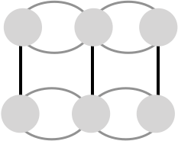 | Jugglers move in and out of passing points, the grey circles.
 | Beat, 2-count base |  |  | 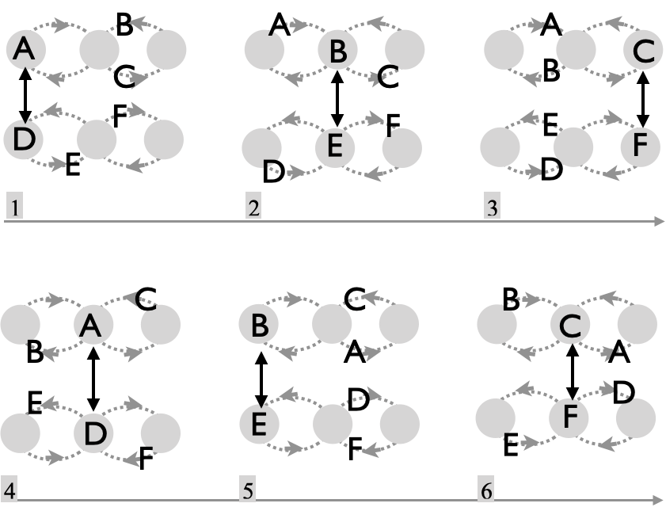
Juggler | 1 | 2 | 3
A | D
B |  | E
C |  |  | F
D | A
E |  | B
F |  |  | C
Two sets of three weavers each set up facing each other. ½ cycle shown right.
The Standard Double Weave has each juggler moving forward in the middle, and back on either end. Move to the next position after each pass. This extends the 4-person Standard Weave by replacing the 2-count feeder with three 6-count weavers. To compensate for the motion, end passes ought to be deep and middle passes ought to be short, while all aiming for the same height to keep proper time. As in the 4-person weave, there’s a tendency for beginner weavers to make a very shallow figure 8. Emphasize those back-on-the-end moves if that happens. And don’t forget: lead your partner, juggle slow, and move fast!
Coupling this pattern with two cycles of a Feast is a favorite club-passing-routine combo pattern, especially with a nice synchronized triple-up at the end (Double-Weave-Feast).
Metrics: J=6, CJ=3, pH=1, R=1, OJ=1, PBJ=⅙, cycle=12 on 2-count base; local passing cycle=3. Motion=4 pu and spin=0, since you’re always squared up with your passing partner.

Inverted and Dresser Drawer Double Weaves |  |  |  |  |  | Vary the motion.
Refer to Standard Double Weave for passing sequence. | 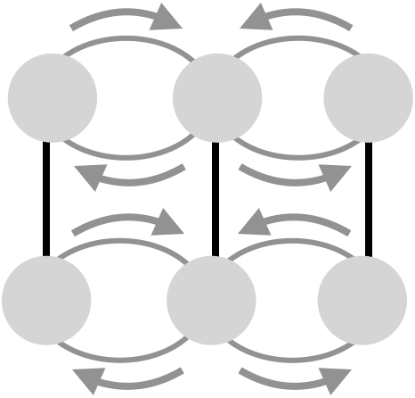 |  | 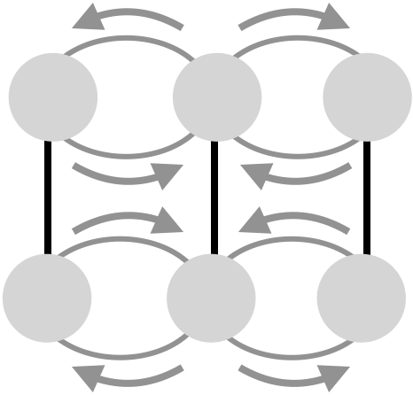 |  | 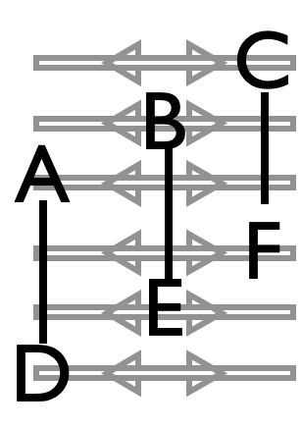
Refer to Standard Double Weave for passing sequence. | One weave inverted |  | Both weaves inverted |  | Weavers slide back and forth
Two notable variations of the Standard Double Weave, which share passing rules and metrics with the standard, have weavers on one (or both) sides moving differently than the standard back on the end, forward through the middle. An inverted weave has, back in the middle forward on the ends. This one can be a bit easier than the standard because passing pairs stay equidistant throughout the pattern when one weave is inverted and one is standard. But it requires the inverted weavers to take care coming off the ends so as not to move prematurely into the middle and get hit by a middle pass! It also seems to be trickier to accelerate backwards in the middle compared to an end, as there’s less room to work in. The other variation has the weavers actually sliding back and forth in the dresser-drawer format (see 4-person DresserDrawer Weave).
Metrics: J=6, CJ=3, pH=1, R=1, OJ=1, PBJ=⅙, cycle=12 on 2-count base, local passing cycle=3, motion=4pu, and about $2\sqrt{2}≃3.8$pu for the dresser drawers.

Cross Corner Double Weaves  Master the standard, then take it up a notch. |  |  |  |  | 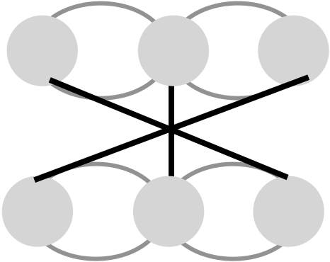 | Jugglers move in and out of passing points, the grey circles.
 | Beat, 2-count base |  |  | 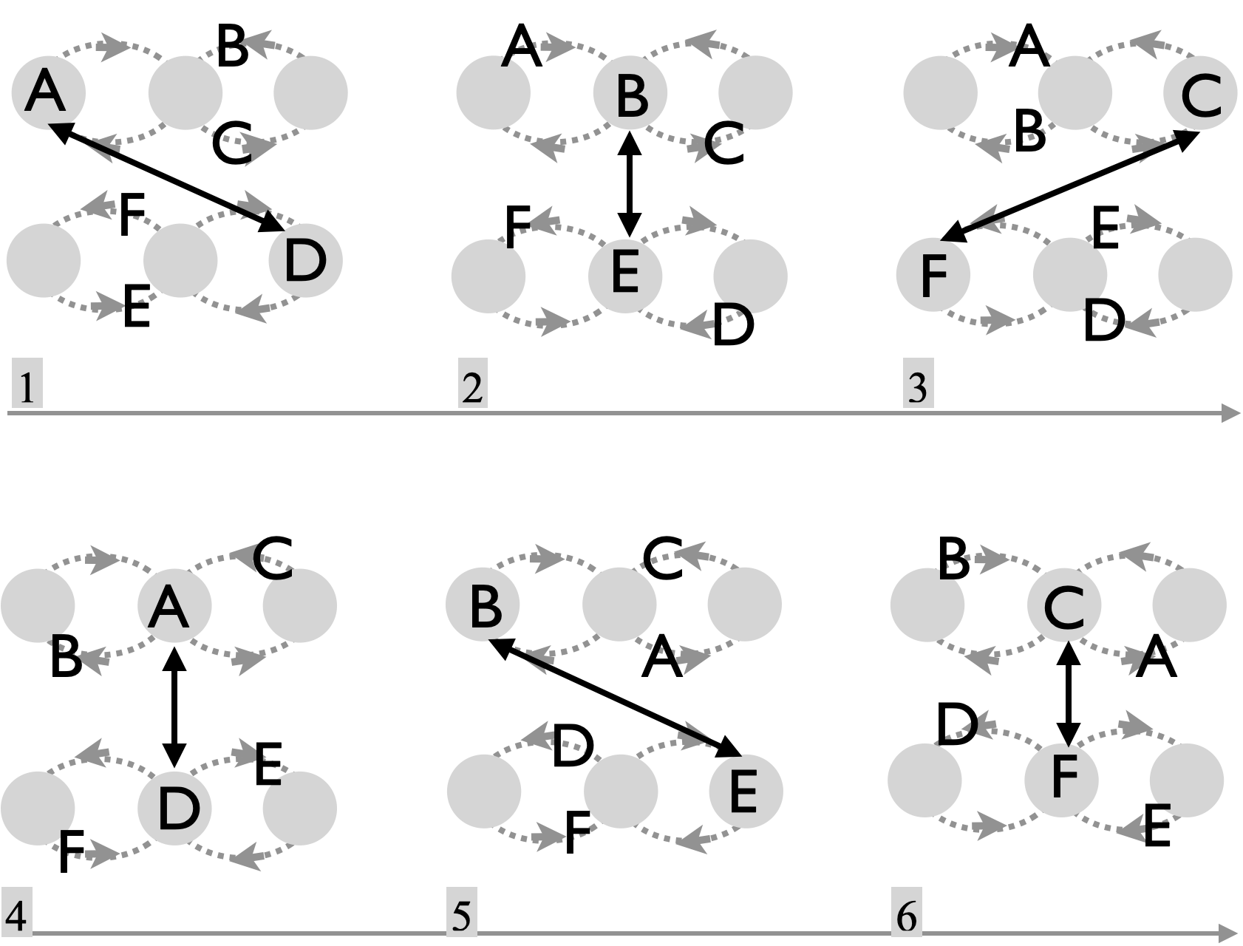
Juggler | 1 | 2 | 3
A | D
B |  | E
C |  |  | F
D | A
E |  | B
F |  |  | C
Two sets of three weavers as above. ½ cycle shown right.
The passing sequence here is identical to the Standard Double Weave, but instead of lining up opposite your partner, each end weaver lines up on the opposite side of the pattern from their passing partner. It’s as if one of the weaves (e.g., D, E, F) is a mirror image of what it was in the standard pattern. This one is a notch more difficult than the standard, in part owing to extra rotation (spin) as you square up to your passing partner, and also because those cross-corner passes are long and have to be quite precise to avoid hitting the movers heading through the middle! Also called the Kitty-Korner Weave
Metrics: J=6, CJ=3, pH=1, R=1, OJ=1, PBJ=⅙, cycle=12 on 2-count base, local passing cycle=3, motion=4pu and spin is about $π/2$ rad per cycle.

Unweave |  |  | 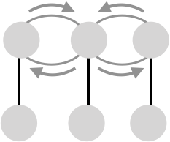 |  | One stale weave
Less notable double-weave variations amount to freezing three of the movers in place, and having just one set of three do the weaving. This is a great pattern when your group includes a few beginning passers who have not yet mastered moving and juggling. In the standard version, the weavers are on 6-count and the stationary line has a 4-counter in the middle and two 8-counters on the outsides. Other count variations are fun too.
Metrics: J=6, CJ=3, pH=1, OJ=3, R=3, PBJ=⅙ , cycle=12 on 2-count, motion=2pu, spin=0.

Stick on the End Double Weave  Synchronicity. |  |  |  |  |  | Move like other weaves, but pass twice on each end.
 | Beat, 6-count base |  |  | 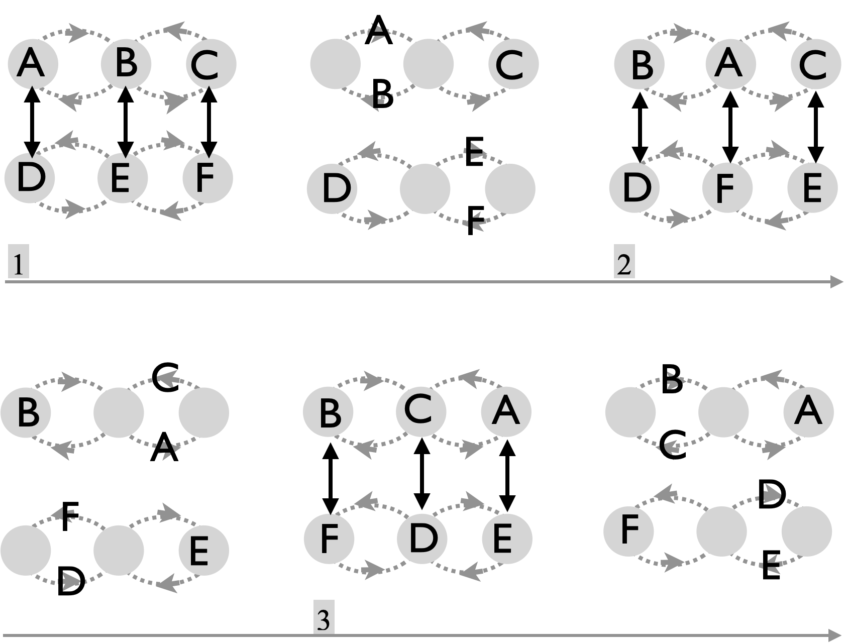
Juggler | 1 | 2 | 3
A | D | F | E
B | E | D | F
C | F | E | D
D | A | B | C
E | B | C | A
F | C | A | B
Two sets of three weavers. ½ cycle shown right, with intermediate moves.
Prof Mike remembers working on this pattern in the Tripp Commons with Matt Henry, Mark Hayward and other MAJ as early as 1993. It remains one of our favorite double weaves. You don’t have a single passing partner, as in other double weaves, but instead you pass to all others as you move the figure 8. Key to making it work is the stick-on-the-end feature, which has you pass twice at each end position. In the set up above, C and D start as stickers. Owing to the synchrony, there’s also no restriction to the typical 6-count passing rate. Try 5-count or even 4-count if you’re feeling your oats!
Metrics: J=6, CJ=3, pH=1, R=1, OJ=3, PBJ=⅙ (or ⅕, or ¼), cycle=6 on 6-count base; local passing cycle=3, motion=4pu and spin=0.
Note: If each side moves on the edges and middle of a rectangle, instead of weaving, we have the essence of Han's Delight. \[Euro '98'\].

Mondo Double Weave  A new member of the double-weave family. |  |  |  |  |  |  |  |  |  |  |  |  |  |  |  | Everyone passes on two 6-count gaps followed by a 3-count gap.  The pattern has a curious stick-on-the-end feature but also an asynchronous feature, in contrast to the ordinary stick-on-the-end double weave. Each weaver also has a single partner, like the standard double weave. So it’s a true hybrid, discovered just recently (Feb 2026) when visiting Mondo and extending their 4-person `6-count` weave to a double weave format. Thanks Tom!
 | Beat, 1-count base (1/2 cycle)
Juggler | 1 | 2 | 3 | 4/5 |  | 6 | 7 | 8 | 9/10 |  | 11 | 12 | 13 | 14/15
A | D |  |  |  |  |  | D |  |  |  |  |  | D
B |  | E |  |  |  |  |  | E |  |  | E
C |  |  | F |  |  | F |  |  |  |  |  | F
D | A |  |  |  |  |  | A |  |  |  |  |  | A
E |  | B |  |  |  |  |  | B |  |  | B
F |  |  | C |  |  | C |  |  |  |  |  | C
In the steady state, each pair passes three rights in a row on 6-count, followed by a 3-count stick on the end, followed by three lefts in a row on 6-count going back the other way.
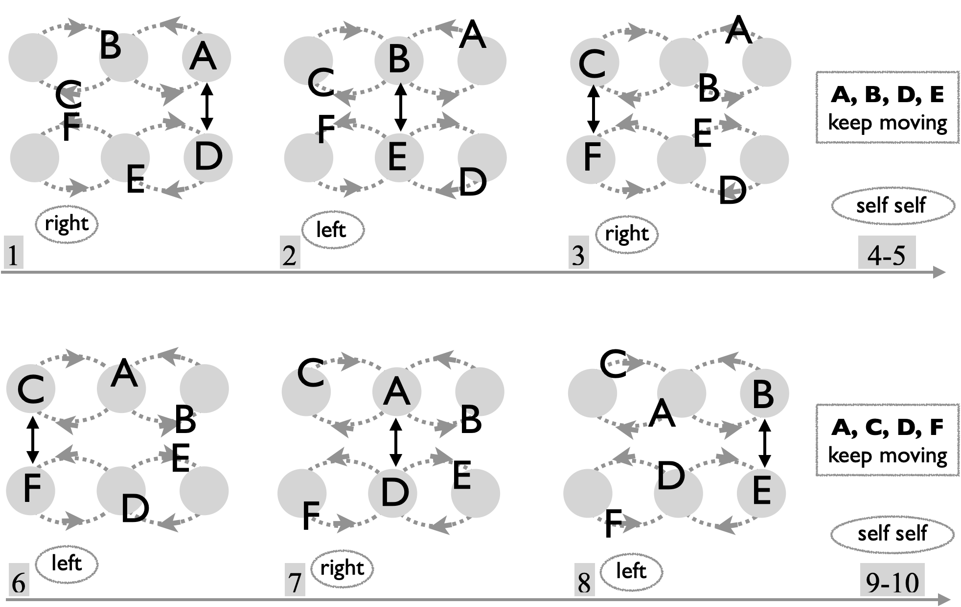
Metrics: J=6, CJ=3, pH=1, OJ=1, R=1, PBJ=⅕, cycle length=30 on 1-count base, motion=4, spin=0.

Combinatorial Double Weaves  Explore the multitude. |  |  |  |  | Here’s a fun game to play when you have six good movers. Try all 18 variations.
Even without cross-corners or switch-sides, we get 18 different double weaves by combining motion and pass variants. |  |  | Type of movement
 |  |  | standard  standard | invert  invert | standard  invert | standard  dresser | invert  dresser | dresser  dresser
 |  |  | 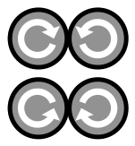 |  |  | 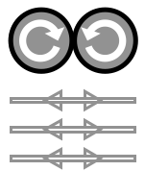 | 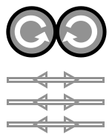 | 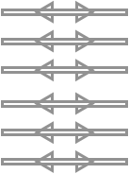
Type of 6-count passing |  | standard | ✓ |  | ✓ |  |  | ✓
 |  | stick | ✓ | Work through all 18 with 5 friends! |  |  |  | ⚠
 |  | mondo | ✓ |  | ✓ |  |  | ⚠
Each of the two weaves can be either standard (i.e., back on the end, forward through the middle), inverted (back in the middle, forward on the ends) or dresser drawer (side-to-side). That gives 6 possible movement types (columns). Independently, the pair of weaves can select one of three different passing types (rows). For instance, standard refers to the asynchronous 6-count deployed in the Standard Double Weave, stick refers to the synchronous passing in the Stick-on-the-End Double Weave, and mondo refers to the Minnesota 6-count. Check marks are ones we do regularly, but it’s worth the effort to try all of them. Warning signs indicate difficulty owing to passing lengths!
Metrics: Common to all are: J=6, CJ=3, pH=1, spin=0. OJ depends on the type of passing, with OJ=1 (standard), 3 (stick, mondo). Likewise, PBJ=⅙ for standard and stick, and ⅕ for mondo. Motion is 4 pu in the first three columns and a bit less for anything with dresser moves.

Add even more combinatorial complexity by including the inside-out weave as one of the movement types!!

## MORE FUN (from Aug 6, 2026)
Reconsider the Mondo-weave, and notice the weave spits out 3 passes every 5 beats. Two things we observe: (1) you can replace a single feeder with 3 stationary 5-count feeders, the middle one only passes to the middle, and each end feeder passes to the two sides of the weave. And (2), those 3 5-counters can start to move, in a 5-count standard weave…that’s fast, but it’s completely different from the opposite Mondo weave which sticks on the end. In other words, we can mix types (mondo, standard), as long as the standard is sped up to 5 count..very cool. More than that, the Mondo p-p-p-s-s base sequence can also be replaced by a p-p-s-p-s sequence, giving the same average! The movers end up doing 2-count stick on the end, followed by 6-count off the end and 7-count out of the middle!

### Switch Sides Double Weave
Switch sides at each end. For example, after A and D pass at the end, they switch positions so that A, E, and F are weaving, as are D, B, and C.

Double Gandini Weave  A double weave extension of the 4-person Gandini Weave |  |  |  |  |  |  |  | By Gandini Juggling Project and MAJ
 | Beat, 2-count base |  |  |  |  |  | 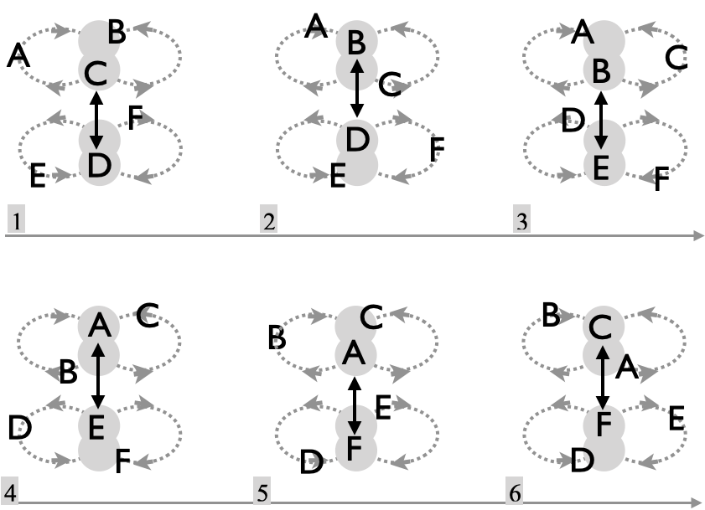
Juggler | 1 | 2 | 3 | 4 | 5 | 6
A |  |  |  | E | F
B |  | D | E
C | D |  |  |  |  | F
D | C | B
E |  |  | B | A
F |  |  |  |  | A | C
Standard version is right-handed 2-count. Passes only happen in the middle.
Each weaver passes twice in a row to two different jugglers, and then has 4 selves to move
out, around, and back and into the middle. The next move out goes into the opposite lobe. You’ll be surprised how fast the motion needs to be to meet the 2-count base, so try on a slower base at first. Don’t forget to leave the middle in the opposite direction from the last mover. To start, it works well to stack jugglers (C,B,A) in one line with C in front facing another stack (D,E,F) with D in front. Again, the basic rule is pass twice then phantom on 4 beats while you move out of the way for the others. Lot’s of timing variations fit that format, and the two sides may be in or out of sync in the directions they move out of the middle.
Metrics: J=6, CJ=3, pH=1, R=1, OJ=2, PBJ=⅙, cycle=12 on 2-count base, motion=4pu, spin=0.

Double Gandini Site-Swap Weave  3v3 |  |  |  |  | A surprisingly quick 9-count!
 | Beat, 3-count base |  |  | 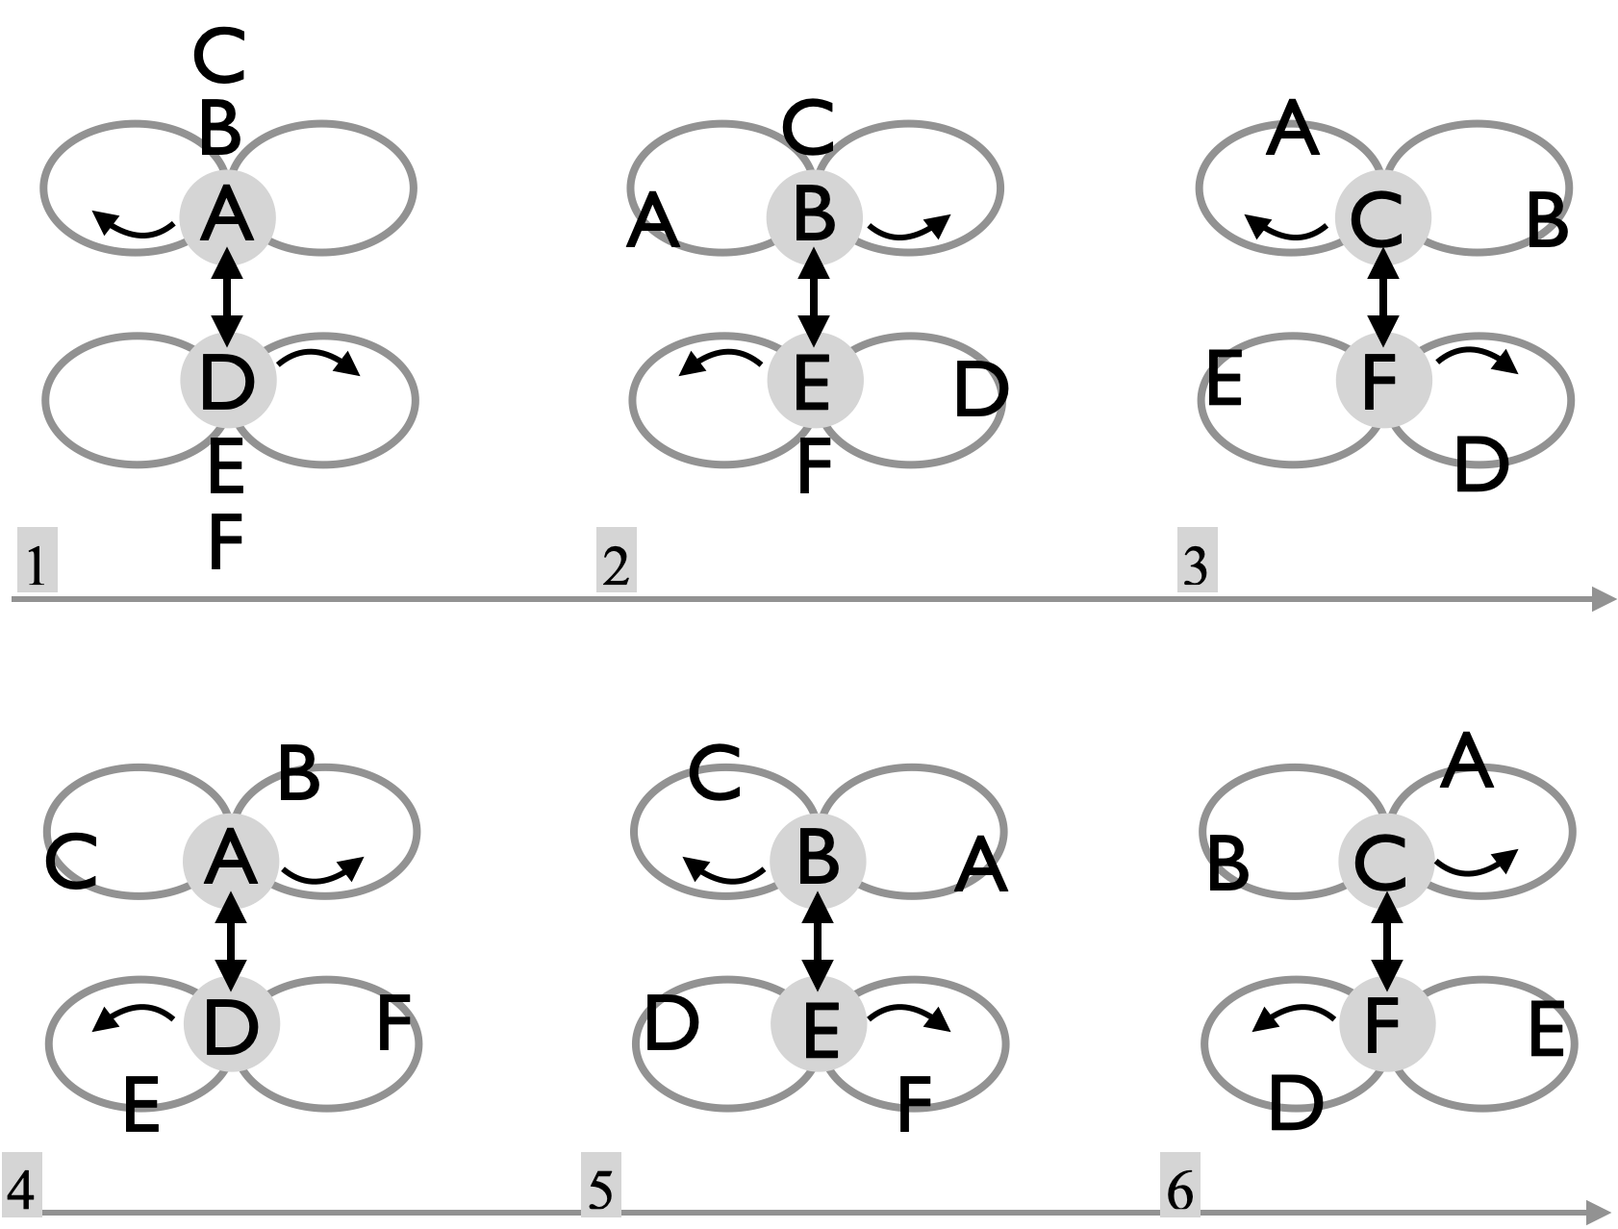
Juggler | 1 | 2 | 3
A | D
B |  | E
C |  |  | F
D | A
E |  | B
F |  |  | C
Move right after passing right; move left after passing left.
Metrics: J=6, CJ=3, pH=1, OJ=1, R=1, local cycle = 3; full cycle=6 on 3-count, PBJ=1/9 Motion through figure-8 as in standard weave, giving pattern motion=4pu per cycle. Since passes are always in the midline there’s no spin at all (spin=0).

Site-swap variants: As with other Gandini Site Swaps, imagine each set of jugglers, (A,B,C) and (D,E,F) separately as three objects being juggled. A pass event corresponds to imaginary jugglers throwing each passer; odd beats correspond to right hand throws, both for the passers and for the two imaginary jugglers, and likewise for even beats and left-hand throws. Shown is the simplest pattern, where the two imaginary jugglers are each doing site swap: 3. Any site swap should work, and they don’t need to be the same on the two sides! We’ve explored more of the site-swap patterns with 5 movers and one feeder who takes the role of the imaginary juggler, but the 3 versus 3

Twister 4 Weave |  |  |  |  |  |  |  |  | Twister weaves can be done with any number of jugglers. Here's a six person version.
 | Beat, 2-count base |  |  |  |  |  |  |  | 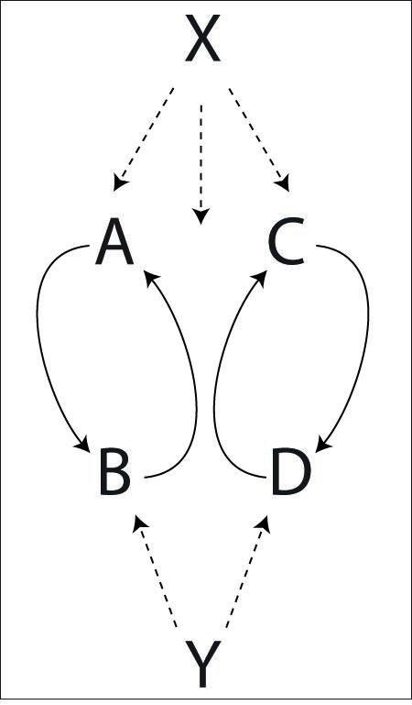 |  | Metrics: J=6, CJ=3, pH=1, R=3, OJ=2 ⅔ , PBJ=¼, cycle=8 on 2-count base, motion=1 ⅔ pu (assuming movers cover about 2pu each per cycle). Movers complete one full turn per cycle, and feeders perhaps a quarter turn, for a pattern average spin $3π/2$ rad.  Pattern by Luke Emery.
Juggler | 1 | 2 | 3 | 4 | 5 | 6 | 7 | 8
A | X |  |  | Y |  | X
B |  | X |  |  | X |  |  | Y
C |  |  | X |  |  | Y |  | X
D |  | Y |  | X |  |  | X
X | A | B | C | D | B | A | D | C
Y |  | D |  | A |  | C |  | B

5 Weaves |  |  |  |  |  | These weaves have 1 feeder and 5 moving feedees
Both versions |  |  |  |  |  | Standard 5-Weave |  | Gandini 5 Weave
 | Beat, 2-count base |  |  |  |  | 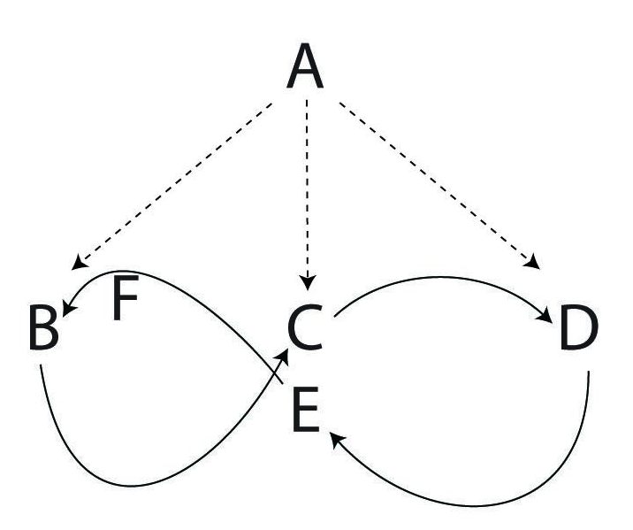 |  | 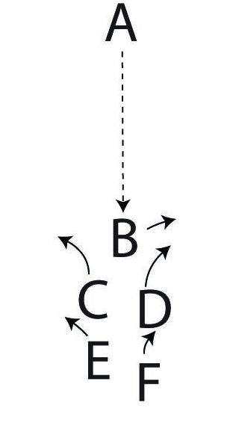
Juggler | 1 | 2 | 3 | 4 | 5
A | B | C | D | E | F
B | A
C |  | A
D |  |  | A
E |  |  |  | A |  | Passes happen in the middle and on both ends. |  | Passes happen in the middle.
F |  |  |  |  | A |  |  | Passes happen in the middle.
Standard: After passing, move back if on the end and forward if in the middle. The start can be confusing to sort out, but set up as in the figure, with the first weaver who passes in the middle (C) going away from the first outside pass. |  |  |  |  |  |  | Gandini: Start with the weavers stacked in a line all facing the feeder. Then each weaver passes once and moves in the opposite direction of the preceding weaver. We learned about this family of weaves from Sean Gandini and the Gandini Juggling Project in 2000. Thanks!!
Metrics: J=6, CJ=3, pH=1, R=3, OJ=5/3, PBJ=1/6, full cycle=10 beats on 2-count base (Gandini), local cycle is 5. Loops are bit bigger than standard weave to accommodate all the movers, who each each cover about 5pu per cycle, for a pattern average motion about 4 ⅙ pu. There’s no spin in the Gandini style version, but the standard version requires swiveling like in a standard weave, giving a pattern average spin **. How many sweeps per cycle?
Many of the timing and motion weave variations for 3 weavers carry over. We especially like the site-swap variations of the Gandini weave ***EXPLAIN*** prefer 3-count base

Spiral Weave  Peter and Luke have complained that this shouldn't be called a Spiral, but that's what we call it! It's sort of a weave, but there are three loops instead of two. And you pass at the faces of the loops instead of on the edges. |  |  |  |  |  |  |  |  |  |  | 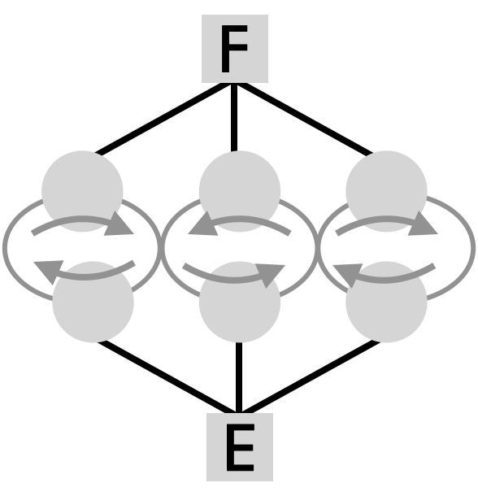
 | Beat, 3-count base (⅔ cycle) |  |  |  |  |  |  |  | 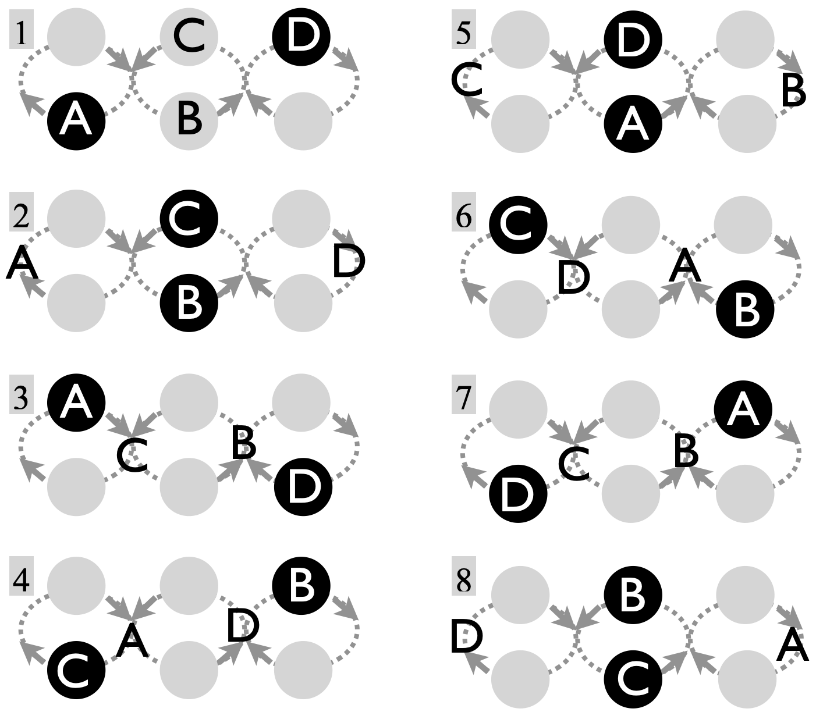
Juggler | 1 | 2 | 3 | 4 | 5 | 6 | 7 | 8
A | E |  | F |  | E |  | F
B |  | E |  | F |  | E |  | F
C |  | F |  | E |  | F |  | E
D | F |  | E |  | F |  | E
E | A | B | D | C | A | B | D | C
F | D | C | A | B | D | C | A | B
Passes to the spiraling movers are indicated as solid black circles.
The standard version has weavers in 6-count (A and D do 6-count rights and B and C do 6-count lefts) and feeders in 3-count carriage return. Beginners could try feeders in 4-count and movers in 8-count. The Fast Spiral, which has feeders on 2-count and movers on 4-count, is a high-level pattern; movers switch sides on 4-count and feeders need to send just-right leads to make it work! Pattern by Mike Newton and the MAJ. The Hyper Spiral has weavers in 3-count and feeders on 3/2 count; but it’s still a dream!
Metrics: J=6, CJ=3, pH=1, R=2, OJ= 2 ⅔ , PBJ=2/9 (3-count base), ⅓ (2-count base). Full cycle is 12 base beats. Movers cover about 6 pu per cycle, making the pattern average 4 pu. Movers also complete 4 full turns, and feeders swivel almost 2 full turns as they each perform 4 carriage returns per cycle, for a pattern average spin $≃$ $6π$ rad. (That’s a spinny one!)

Interlocking Turbos  A classic MAJ pattern. [Pre-requisite is 3-person Turbo] |  |  |  |  |  |  |  |  |  |  | Our favorite among several ways to conjoin two Turbos.
 | Beat, 2-count base, ½ cycle |  |  |  |  |  |  |  |  | 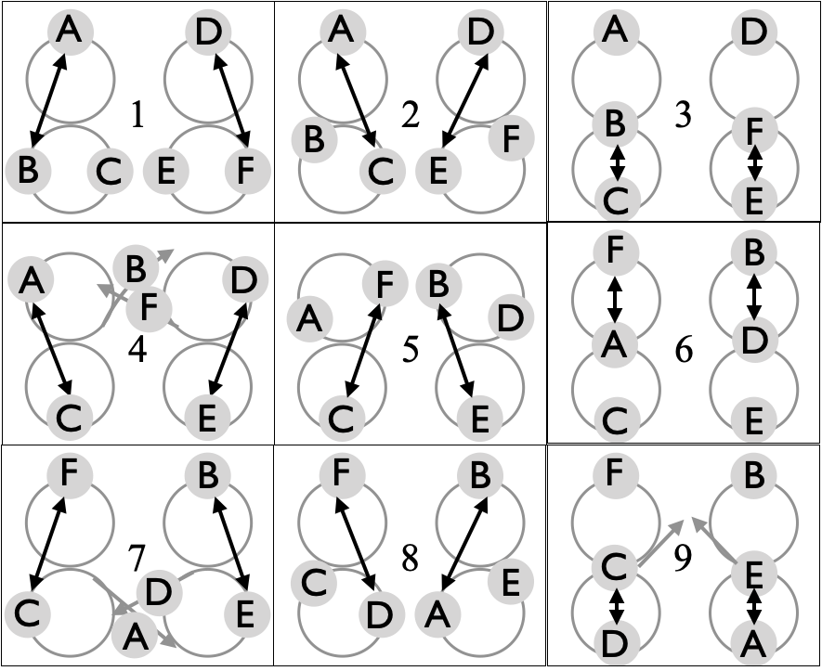
Juggler | 1 | 2 | 3 | 4 | 5 | 6 | 7 | 8 | 9
A | B | C |  | C | ⤻ | F | → | B | E
B | A | ↷ | C | → | E | B | E | A
C | ← | A | B | A | F |  | F | ↷ | D
D | F | E |  | E | ⤾ | B | ← | F | C
E | → | D | F | D | B |  | B | ⤻ | A
F | D | ↶ | E | ← | C | A | C | D
Standard version is right-handed 2-count. Switch sides ↷; slide →. Feeder positions are shaded in the table.
Jugglers set up as in panel 1, with both first-feeders (A,D) facing the others. It’s helpful to recognize a mirroring of positions (e.g., to simplify walkthrough). For instance B and F are mirrors and so are C and E. Mirrors have the same passing and motion sequence. The basic rule is to cross over into the other Turbo when it’s your turn to go through the middle. To avoid body blows, jugglers need to decide who goes in front during this transition and who goes behind! In spite of the symmetry, the two Turbos are not exactly the same, since jugglers (A,E,F) do inside turns (counter-clockwise from above) and jugglers (D,B,C) do outside turns (clockwise from above), which are usually a bit trickier with right-hand passing. Hand and count variations are fun; e.g. 3-count is good for beginners

Warm start: Have (A,B,C) and separately (D,E,F) initiate ordinary 3-person Turbos on either side of the room, running each for a full 18-beat cycle as they advance towards each other. When these separate patterns are side by side, they are then ready to interlock.
Disengage: This accompanies the warm start, and refers to separating the two Turbos, usually after ½ cycle interlocking or 3/2 of such a cycle. The whole business gives the impression of two 3-person patterns colliding, then moving through each other, and coming out the other side!
Metrics: J=6, CJ=3, pH=1, R=1, OJ=4, PBJ=⅓, cycle=18 on 2-count base, but passing sequence repeats after 9 beats. There’s some extra lateral motion compared to a single Turbo, so motion is about 6pu per cycle and spin = $2π$ rad. Pattern by Luke Emery. It has been juggled often, including by the Mad-5 at the 2001 IJA Cascade of Stars show in Madison, 1999.

**Back-to Back Turbos?**

Windy Two Holer |  |  |  |  |  |  | A classic MAJ pattern born on a windy day on the Library Mall. Mel and Mike were there! |  |  |  |  |  |  | 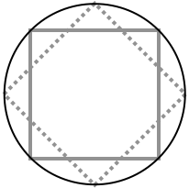
 | Juggler |  |  |  |  |  | 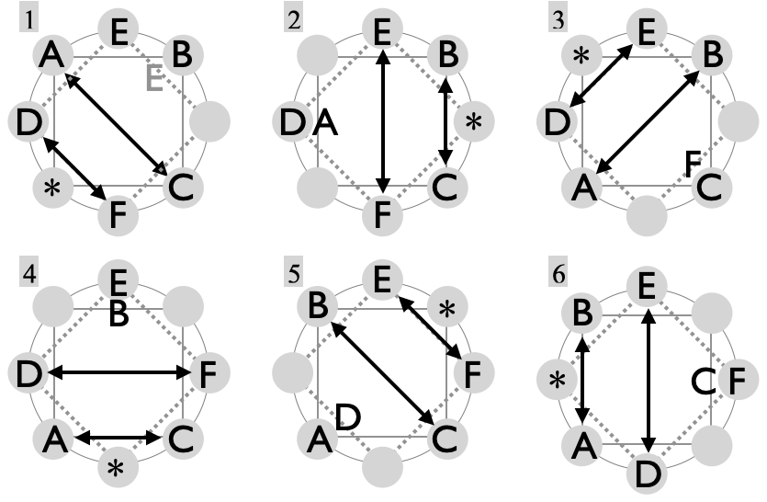
Beat | A | B | C | D | E | F
1 | C |  | A | F | ⇑ | D
2 | ⇑ | C | B |  | F | E
3 | B | A |  | E | D | ⇑
4 | C | ⇑ | A | F |  | D
5 |  | C | B | ⇑ | F | E
6 | B | A | ⇑ | E | D
7 | C |  | A | F | ⇑ | D
8 | ⇑ | C | B |  | F | E | Despite its full cycle being the rather lengthy 24 passing beats, the windy-two-holer is not so hard to remember, since each juggler's task repeats every 6 passing beats. This is fun in 4-count, 3-count, and even 2-count for those not faint of heart. Six jugglers set up around a circle inscribed with eight spots corresponding to the corners of two inscribed squares. The jugglers cover six of the eight spots, leaving two holes, known affectionately as the a-hole (*) and the number-2 hole. The a-hole floats around while jugglers in sequence move into that spot.
9 | B | A |  | E | D | ⇑
10 | C | ⇑ | A | F |  | D
11 |  | C | B | ⇑ | F | E
12 | B | A | ⇑ | E | D
⇑ indicates move
Jugglers A, B, and C move along one square while D, E, and F move along the other. The two sets of jugglers don’t interact (on purpose, anyway!). Each juggler only ever passes to the two others in his/her square, never to the other square. In the steady state, the local passing rule is, pass one - pass other - self - pass one - pass other - move/self, counting on the passing beats. At any passing beat one pair from each square is passing; collisions are avoided because the passing lanes are parallel. We start with E having already landed, but a steady-state start would have E on the move at the beginning (grey font, beat 1).
Metrics: J=6, CJ=3, pH=1, R=1, OJ=2 , PBJ= cycle=24 beats on base count (2, 3, or 4 count). Edges of each box are about 1pu (maybe a bit more), which makes motion per cycle 4 pu (same for all jugglers). Noting the swivelling back and forth per edge along 4 edges, the average spin per cycle is about $6π$ rad (3 full turns). (Note spiral weave has the same spin metric but over a pattern with ½ of the cycle of this one.)

Fast Forward  New-style non-weaving double weaves |  |  |  |  | 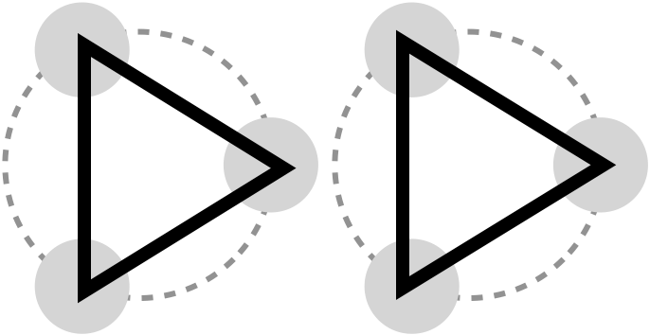
Version 1 | Beat, base count |  |  | 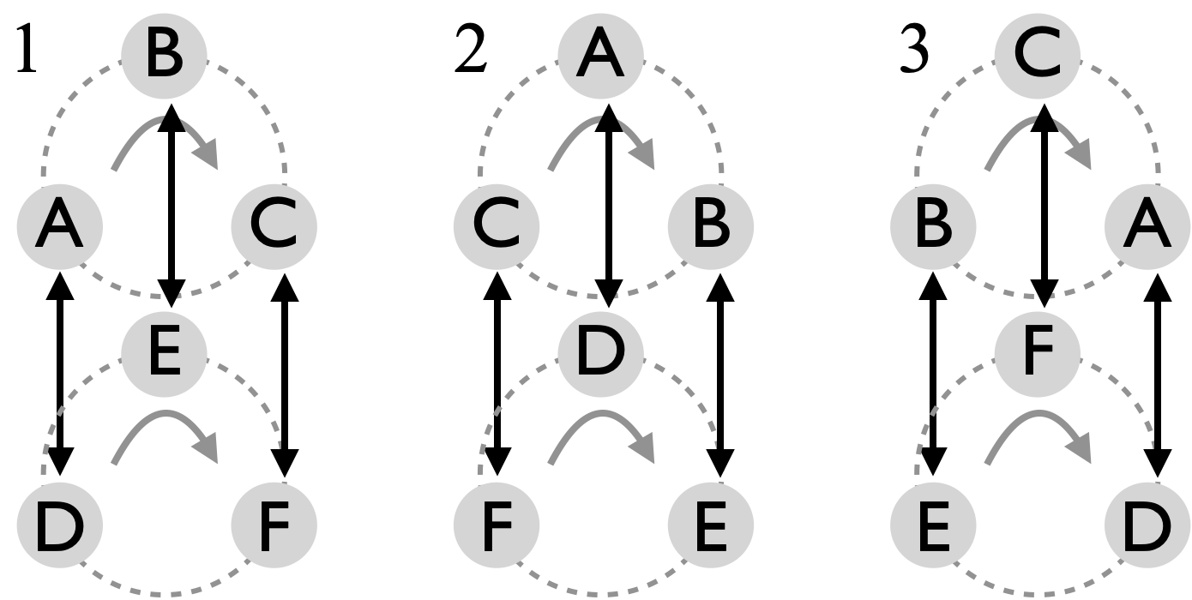 | Version 2 | Beat, base count
Juggler | 1 | 2 | 3 |  | Juggler | 1 | 2 | 3
A | D | D | D |  | A | D | E | F
B | E | E | E |  | B | E | F | D
C | F | F | F | 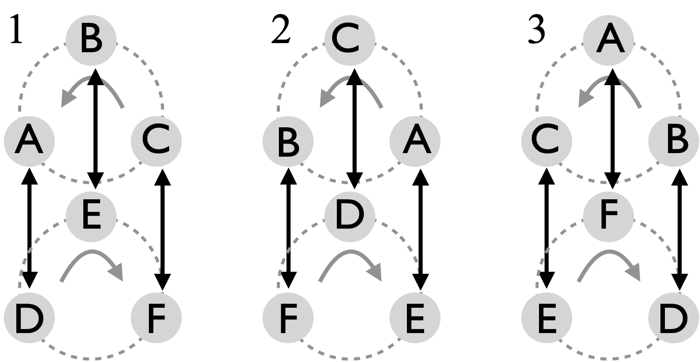 | C | F | D | E
D | A | A | A |  | D | A | C | B
E | B | B | B |  | E | B | A | C
F | C | C | C |  | F | C | B | A
Two sets of three movers as above. |  |  |  |  | The pattern version depends on whether circle rotations are aligned or opposite.
 |  |  |  | Passing is synced up, so any feasible count works (e.g., 6, 5, or 4).
Prof Mike thought of this as two circles, but then we tried it (first on March 29, 2026 at MCS), and two triangles stand out. Mark Hayward recognized the `fast forward` symbol! Beginners on this pattern benefit from the placement of advisory dots!
Metrics: J=6, CJ=3, pH=1, R=1, OJ=1 (v1) 3 (v2), PBJ=1/base, cycle=3 base count, motion =3.1 pu (if each circle has diameter 1 pu), and spin=0.

Foie Graham |  |  |  |  |  |  | This is an intense offset double-weave for six jugglers. Pattern by Graham Paasch.
 | Juggler |  |  |  |  |  | 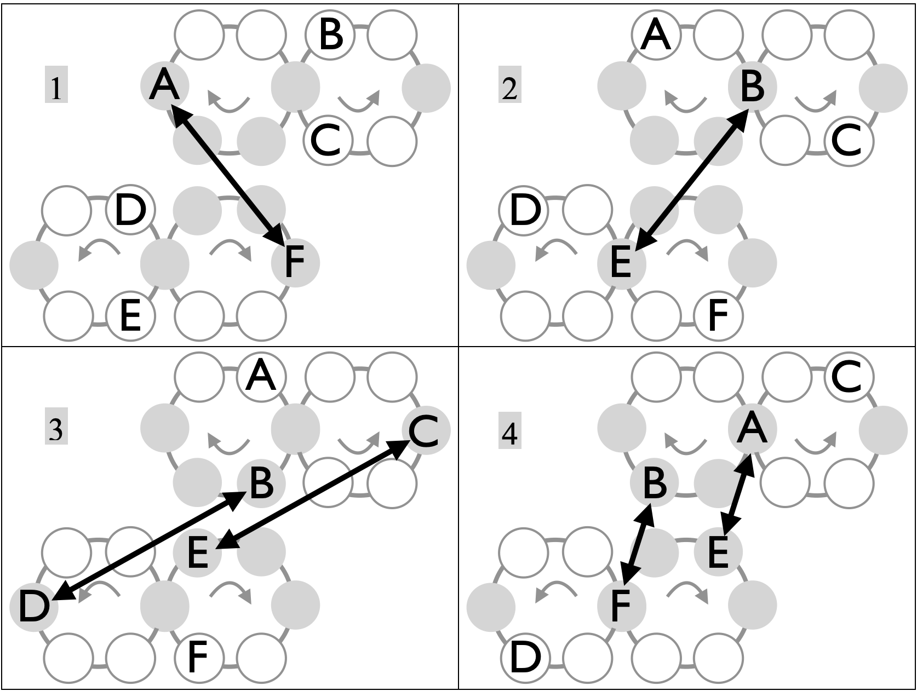  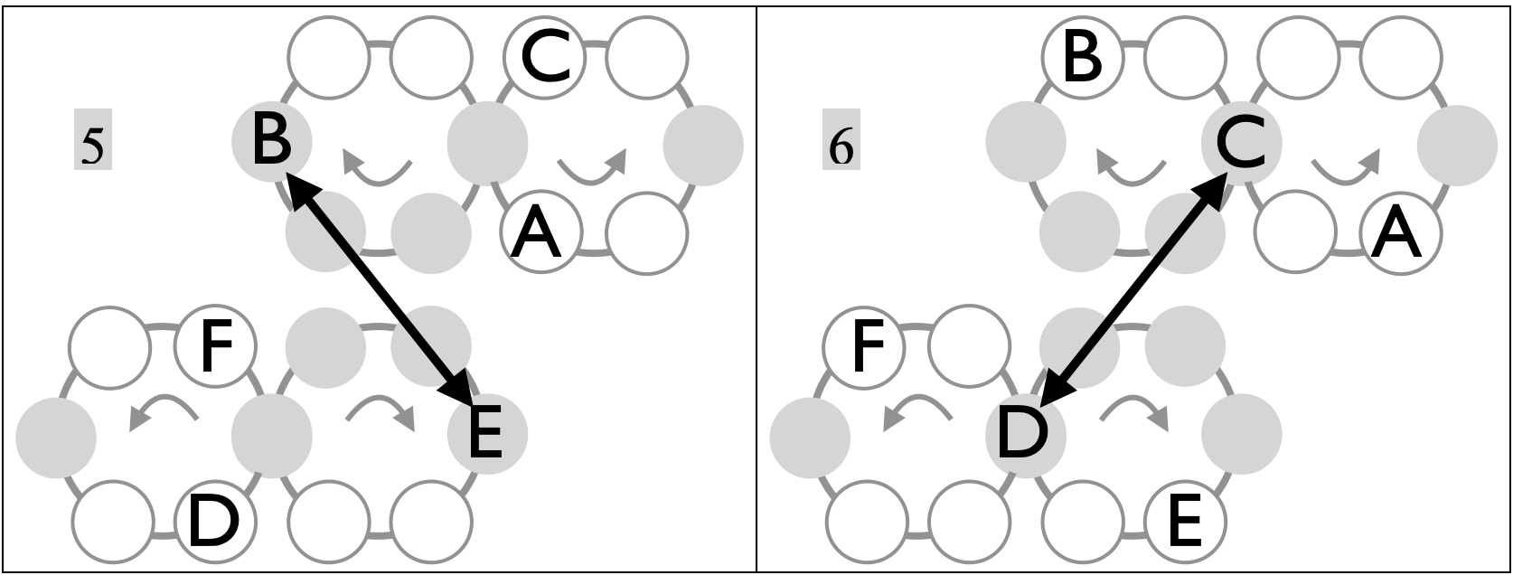
Beat | A | B | C | D | E | F
1 | F |  |  |  |  | A
2 |  | E |  |  | B
3 |  | D | E | B | C
4 | E | F |  |  | A | B
5 |  | E |  |  | B
6 |  |  | D | C
7 | D |  | F | A |  | C
8 |  | D | E | B | C
9 |  |  | D | C
10 | F |  |  |  |  | A
11 | E | F |  |  | A | B
12 | D |  | F | A |  | C
Right-hand 2-count. In figure, pass in grey spots, move through open spots.
Jugglers A, B, and C move along one figure 8 while D, E, and F move along the other.
As you enter an outer loop of your weave you do pass self self (right-hand counting) as usual for a weave. But as you enter the other loop, the inner loop, you make a series of 4 passes, starting and ending with the same person, and getting the other two in between. It takes advantage of the fact that coming out of the middle on a weave you are in front of
your other weavers, and so can get some extra passes in before going to the backside of the weave loop. Thanks Conner for the pattern name!
Metrics: J=6, CJ=3, pH=1, R=1, OJ=3 , cycle=12 on 2-count, PBJ=¼. Motion=4 pu, like other weaves. Considering the swivelling back and forth, spin $≃π$ rad per cycle.

Side-by-Side 2pi/3  Feels like a pattern we should have been doing for a long time! |  |  |  |  | 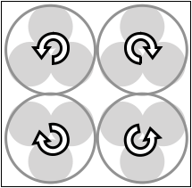 |  | Constantly moving and passing on count of choice (e.g. 4, 5, or 6 are nice!)
Beat, 1 local cycle |  |  |  | 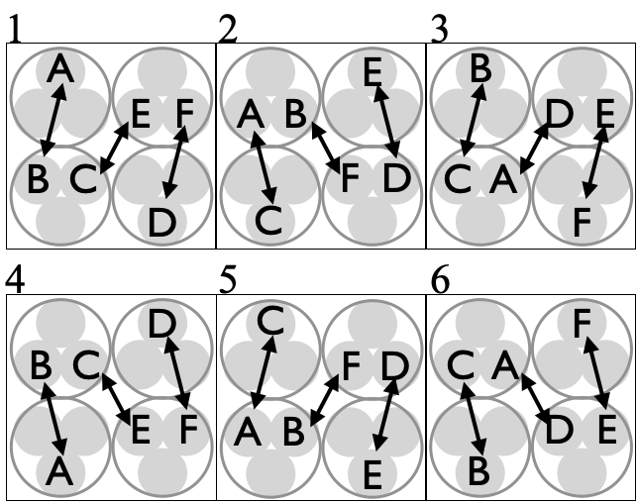 |  |  | Refer back to the 3-person 2pi/3 or the base pattern, and notice that 2 such patterns can have the phantom passes synced up.  Move smoothly, staying in your circle.
Juggler | 1 | 2 | 3
A | B | C | D
B | A | F | C
C | E | A | B
D | F | E | A
E | C | D | F
F | D | B | E
Pattern by Prof Mike
Metrics: J=6, CJ=3, pH=1, R=1, OJ=3, PBJ=1/base, cycle=6 on base count, but passing sequence repeats after 3 beats. Derived from the base pattern, motion=4pu and spin=$2π$ rad.

Interlocking 2pi/3  Big movement! |  |  |  |  | 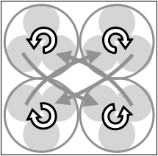 |  | Compare set up to side-by-side…a lot more moving…a bit less passing
Beat, 1 local cycle |  |  |  | 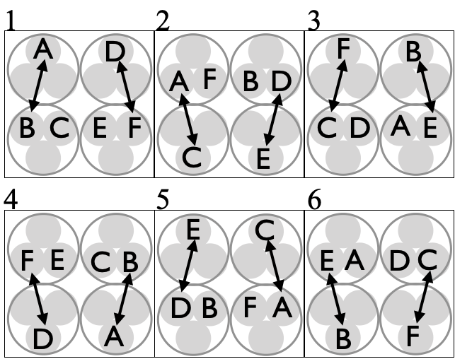 |  |  | Refer back to the 3-person 2pi/3 or the base pattern, and notice that 2 such patterns can have the phantom passes synced up. Rule: switch sides on every such sync up.  Born April 26, 2026 at MCS.
Juggler | 1 | 2 | 3
A | B | C
B | A |  | E
C |  | A | F
D | F | E
E |  | D | B
F | D |  | C
Pattern by Prof Mike
Metrics: J=6, CJ=3, pH=1, R=1, OJ=2, PBJ=2/(3*base), cycle=6 on base count, but passing sequence repeats after 3 beats. Spin inherits from the base pattern (spin = $2π$ rad), but motion is increased by the constant switching. Perhaps motion = 6pu per cycle.

Celtic Knot  A short cycle pattern with heavy-duty motion |  |  |  |  | 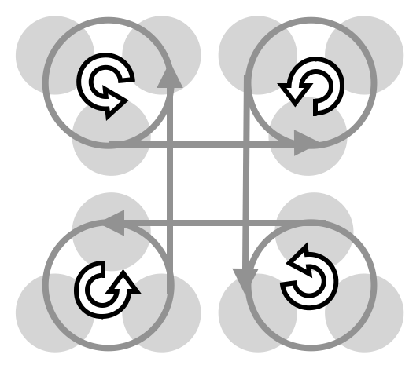
 | Beat, base count |  |  | 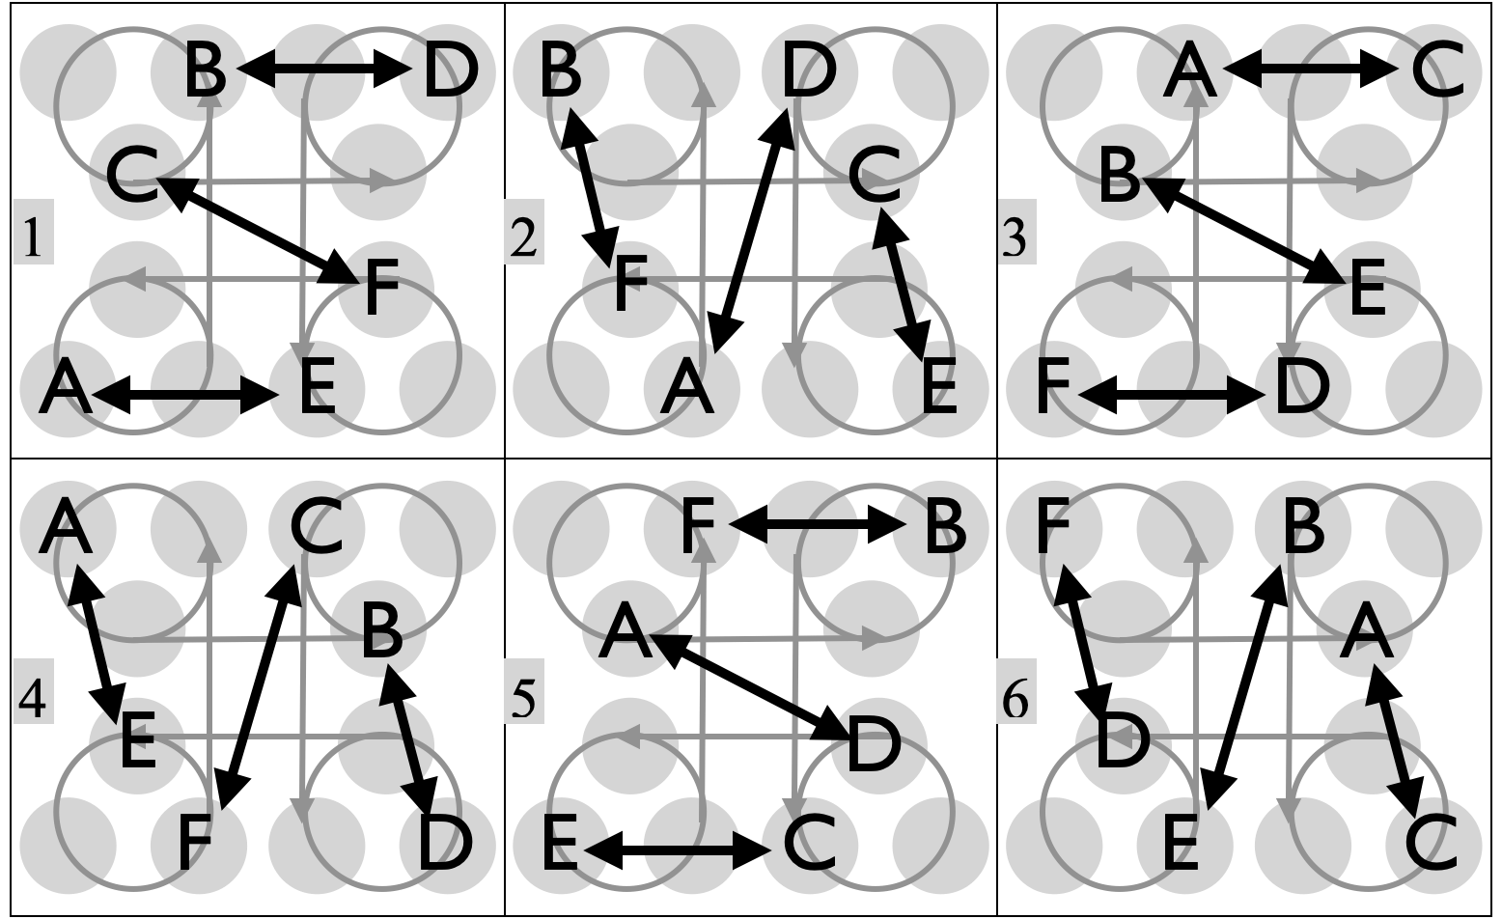
Juggler | 1 | 2 | 3
A | E | D | C
B | D | F | E
C | F | E | A
D | B | A | F
E | A | C | B
F | C | B | D
Notice a knot-like trajectory (upper right) that connects 12 grey spots, 3 on each of 4 corners of the knot. The basic pattern has 6 jugglers position themselves at every other spot along that trajectory; they make a specific pass, and then move to the next spot. Various pass rules work, but the one shown above has a nice vibe. One way to think about it is to have three jugglers (A,B,C) set up in a line facing three others (D,E,F); passes are exchanged between opposite pairs. Then the middle two (e.g., C and F on beat 1 above) change sides by moving quickly through the middle. On completing their fly by, they each face to their right while rotating and initiating a backwards move into their respective corner loops, and then pass again (e.g. C with E and F with B), leaving the last pair (D, A) to be the new middle (beat 2 above), who pass and change places as the pattern progresses. Remember the British driving rule when you move through the middle: keep your passing partner on your right as you walk past!
Metrics: J=6, CJ=3, pH=1, R=1, OJ=3, full cycle=12 on base count; local passing cycle is 3 beats. 6-count base is a good start, but 5-count is fun, and 4-count takes some smooth moves! PBJ = (⅓)(1/base). Assuming about 2pu per corner and 1pu in between corners, we get motion = 12pu per cycle. Likewise, there’s about a ¼ turn rotation on every beat, giving an overall pattern spin=$6π$ rad per cycle. Pattern by Prof. Mike; first attempted at the 2024 IJA festival in Green Bay. It takes some practice to control your own pattern well enough to move quickly through the middle without colliding with your counterpart and while prepping for the rotations needed to complete the cycle. Performed at 2025 Madfest show: Goose was there!

Slippery Knot  Take the knot up a notch! |  |  |  |  | 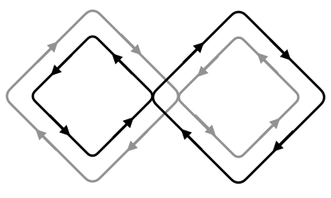
 | Beat, base count |  |  | 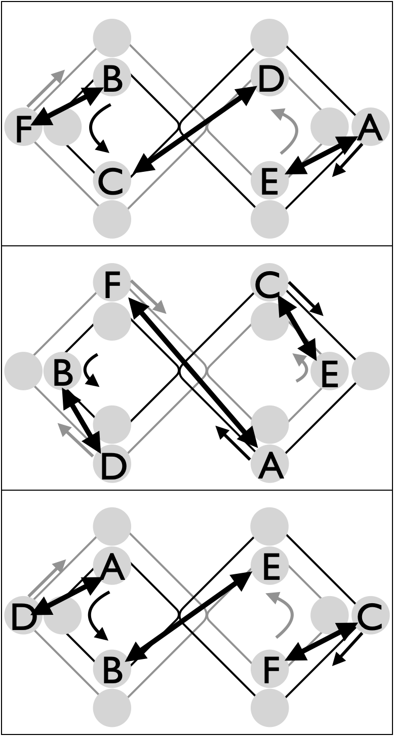
Juggler | 1 | 2 | 3 |  | From the Celtic Knot, we asked what happens if all three pairs would switch sides after passing, instead of just the middle pair doing so. We discovered this heavy-duty moving pattern. All jugglers move around two squares, with (A,B,C) following one path (black), and (D,E,F) the other, opposing path (grey). The rule is pass then move to the next spot. Perhaps the trickiest part is making the long pass and long move through the middle, all while avoiding the nearby jugglers. Notice too that there’s one small square and one bigger square, so some corners are sharper than others. Also, British driving rules apply!
A | E | F | D
B | F | D | E
C | D | E | F
D | C | B | A
E | A | C | B
F | B | A | C
The Slippery Knot is not for beginners. Be fleet of foot, juggle slow and move fast! It looks pretty cool! By Prof. Mike and Nathan Nard.
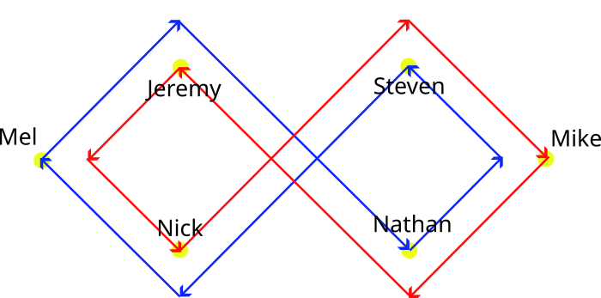  Nathan Nard’s set up from the 2026 Madfest show.  The all-pass all-move effect is impressive when it works! |  |  |  |  | Metrics: J=6, CJ=3, pH=1, R=1, OJ=3, full cycle=6 on base count; local passing cycle is 3 beats. 6-count base is a good start, but 5-count is fun, and 4-count takes some smooth moves! PBJ = (⅓)(1/base). Motion=8pu, assuming average edge is 1pu. Likewise, about 6 ¼ turns are needed, making, spin$≃3π$ rad per cycle. Performed by Nathan, Mike, Nick, Steve, Mel, and Jeremy in the 2026 Madfest show.

Disco Knot  Another constant motion pattern |  |  |  | 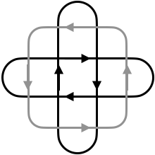
 | Beat, base count |  | The pass-move rule has everyone flying by everyone else, but only needing to track two passing partners each.
Juggler | 1 | 2 | 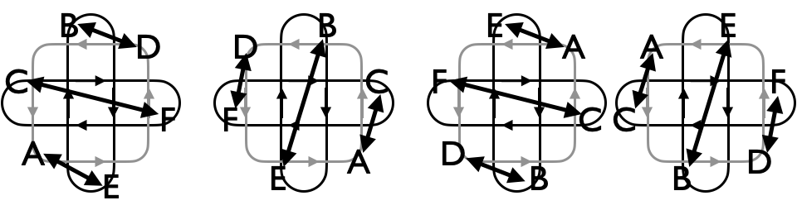  Though the figure doesn’t suggest it, the pattern comes from an always-switch-sides version of the Celtic Knot, while maintaining the turn rule. It helps to set it up with advisory dots!
A | E | C
B | D | E
C | F | A
D | B | F
E | A | B
F | C | D
Metrics: J=6, CJ=3, pH=1, R=2, OJ=2, full cycle=4 on base count; local passing cycle is 2 beats. 6-count base is a good start, but 7 and 5-count are fun. PBJ = (1/base). Assuming sides average to 1pu, pattern motion = 4pu. Four quarter turns makes the pattern spin=$2π$ rad. Conjured by Prof Mike on May 4, 2026, and first juggled a few days later on Library Mall by Mike, Mark, Nathan, Chan, and Nick. Mark noticed the shape’s relationship with disco rectangles! Movement on the two disco rectangles is in the opposite direction to movement on the square, creating a lot of chaos! Passes alternate north-south then east-west, which minimizes club-collision risk, though body-collision risk is high!

Meltic Knot + Orbiter  Best with a ripsticker! |  |  |  |  |  |  |  |  |  |  |  |  |  |  |  |  | 
Beat, base count (6-count is standard)
 | 1 | 2 | 3 | 4 | 5 | 6 | 7 | 8 | 9 | 10 | 11 | 12 | 13 | 14 | 15 | 16 | 17 | 18 | 19 | 20
A | C | E | B | D | F | 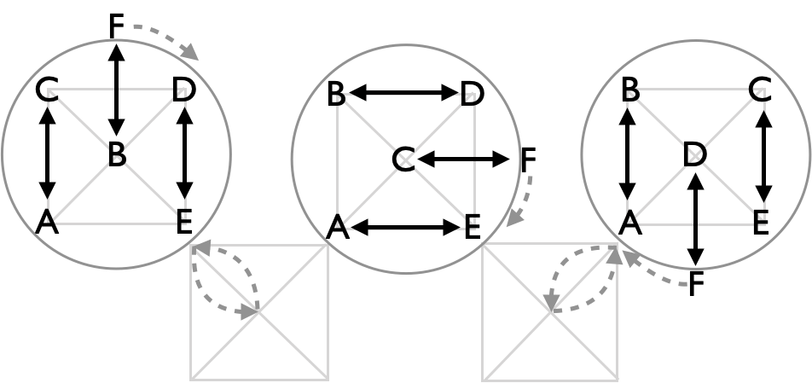  Three beats shown. B and C swap after 1, then C and D, etc.
B | F | D | A | C | E
C | A | F | E | B | D
D | E | B | F | A | C
E | D | A | C | F | B
F | B | C | D | E | A
Local cycle = 5 beats
Full cycle=20 beats
Refer back to the 5-person Meltic Knot for base pattern, which is extended here by adding one orbiter (F) who picks up all the phantom beats. Because those beats show up on the base count and give openings exterior to the 4 sides of the pattern, it takes a very fast juggler to do the orbiter role; we solve that by putting a ripsticker in as F. They lead the up-down to get us off to a proper start. Even forgetting the move in and out of the middle (shaded box and arrow), you are constantly swinging back and forth through a ¼ circle to pass to your neighboring corner. Making good leads for the ripsticker is important

Metrics: J=6, cycle=20, CJ=3, pH=1, R=2, OJ=5, PBJ=⅙, on 6-count, but generally 1/base. With sides about $\sqrt{2}$ pu on the box, the 5 central jugglers each covers about 8 pu to get back to the start. With F on a circle of radius $\sqrt{2}$ pu, the ripsticker completes 5 full turns per cycle, for distance $10\sqrt{2}π$ pu, and thus for a pattern average of about 14 pu per cycle! There’s also a lot of ¼ turns to alternate corners for passing, making total spin = $6π$ rad for internal jugglers, and $10π$ for F, making pattern average spin 3 ⅓ full turns (1200°; 20.9 rad) per cycle. Pattern by Mellonhead and Prof Mike. See video from Luke’s loft with Jeremy as the ripsticker!

El Turbo with 2 posts
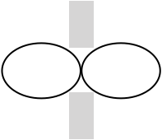 |  | Beat, base count: 2-count rights is standard; 3-count is pleasant!
 |  | 1 | 2 | 3 | 4 | 5 | 6 | 7 | 8 | 9 | 10 | 11 | 12 | 13 | 14 | 15 | 16
 | A | B | D | C | B | E | C |  | F | B |  | E | B |  | F | D
 | B | A |  | E | A |  | F | C |  | A | C | D | A | E | D |  | F
 | C |  | F | A |  | D | A | B | D | E | B |  | F | D |  | E | D
 | D | E | A |  | F | C |  | E | C |  | F | B |  | C | B | A | C
 | E | D |  | B |  | A |  | D |  | C |  | A |  | B |  | C
 | F |  | C |  | D |  | B |  | A |  | D |  | C |  | A |  | B
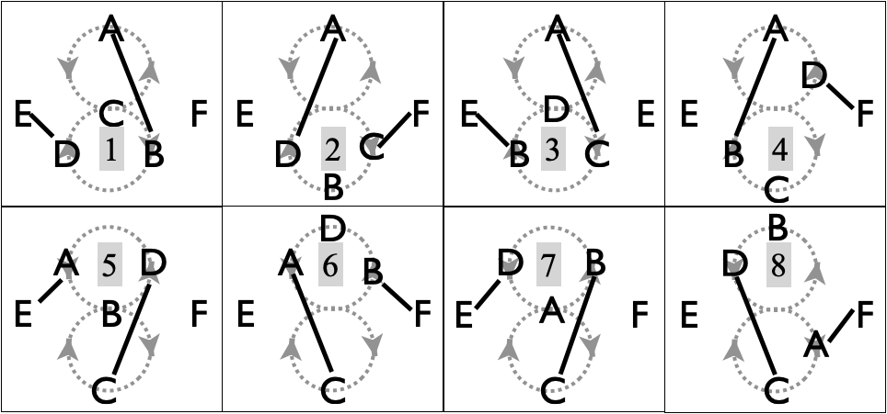 |  |  |  |  |  |  |  |  |  |  |  | Metrics: J=6, cycle=16, PBJ=(⅔)(1/base), CJ=3, OJ=4 ⅔ , pH=1, R=2. Movers each travel 5pu, for a pattern motion (⅔)5pu. Movers also rotate a full turn and the posts swivel a ½ turn per cycle, for a pattern spin of 1.7$π$ rad.
½ cycle shown. A, B, C, and D do the El Turbo, and E and F are the posts picking up some selves. But here there’s either an odd-beat post (E), or an even-beat post (F). Pattern by MAJ. See El Turbo (4-person) for more on the base pattern. As in El Turbo, each juggler feeds 4 spots (with #1 and #4 the same person), before moving on. Those feeds are highlighted (grey shading) in the passing table.

Ivy Pi Weave + Post  There are so many ways to move and juggle through a figure 8! | 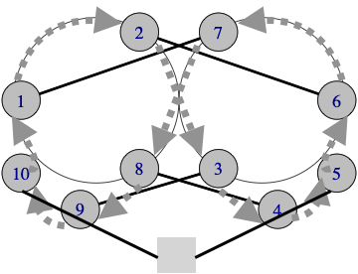
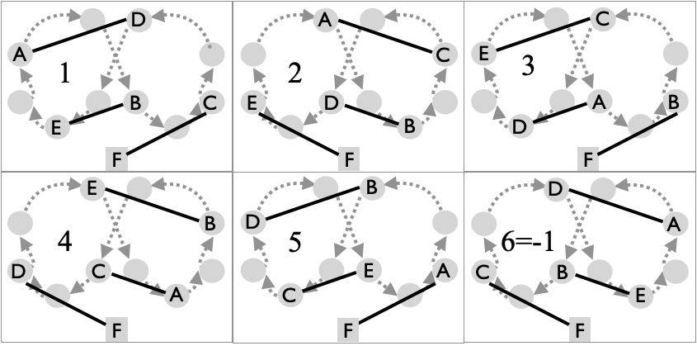  See 5-person Ivy Pi Weave for the base pattern. |  | Beat, base count (4-count standard)
 |  | 1 | 2 | 3 | 4 | 5
 | A | D | C | D | C | F
 | B | E | D | F | E | D
 | C | F | A | E | A | E
 | D | A | B | A | F | B
 | E | B | F | C | B | C
 | F | C | E | B | D | A
Metrics: Inherits mainly from Ivy Pi Weave. J=6, full cycle 10 beats, local cycle 5; PBJ=⅕ (on 4-count base), CJ=3, OJ=3, R=2. The base pattern has high spin, 5$π$ rad per mover, but a bit more rotation is required here to accommodate passes to F; likewise F swivels back and forth 5 times per cycle. Splitting the difference, the pattern average spin is close to 5$π$ rad. Motion about 6pu per cycle per mover, for a pattern motion = 5pu.

We usually juggle on a 4-count base to keep the moves doable. So, e.g., each juggler passes 4 in a row on that count, and then once to F. But each mover only passes to 2 other movers, while everyone passes to the post. Note the sharp turns going from positions 2-to-3 and 7-to-8.

Pollinator  aka, Three Leaf Clover with 2 Orbiters |  |  |  |  |  |  |  |  |  |  | 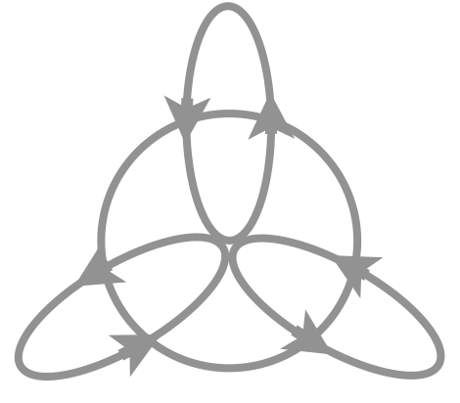
Revisit the 4-person 3-leaf clover, but add two jugglers (E and F) to absorb those pesky self throws! In this version, the orbiters aren't really ‘orbiting’ at all, they are smack in the middle of the pattern. As drawn, E and F move clockwise (from above) along the perimeter of an inner circle. Orbiter E passes to the person who has just finished their feed (initially D), then on ½ the count of the others, E passes to A, C, B, repeat. Orbiter F passes at the same pace as E, and passes to the person who is about to start their feed. Then the clover-movers do the standard 3-leaf clover, but there are two more jugglers packed into the space, increasing the pattern’s molecular weight! There are also fewer self throws per cycle, as the orbiters pick up 2 passes per other-mover per local cycle, making the rule a 1-in-1-out clover. 2-count is doable but 3-count is much more relaxing!
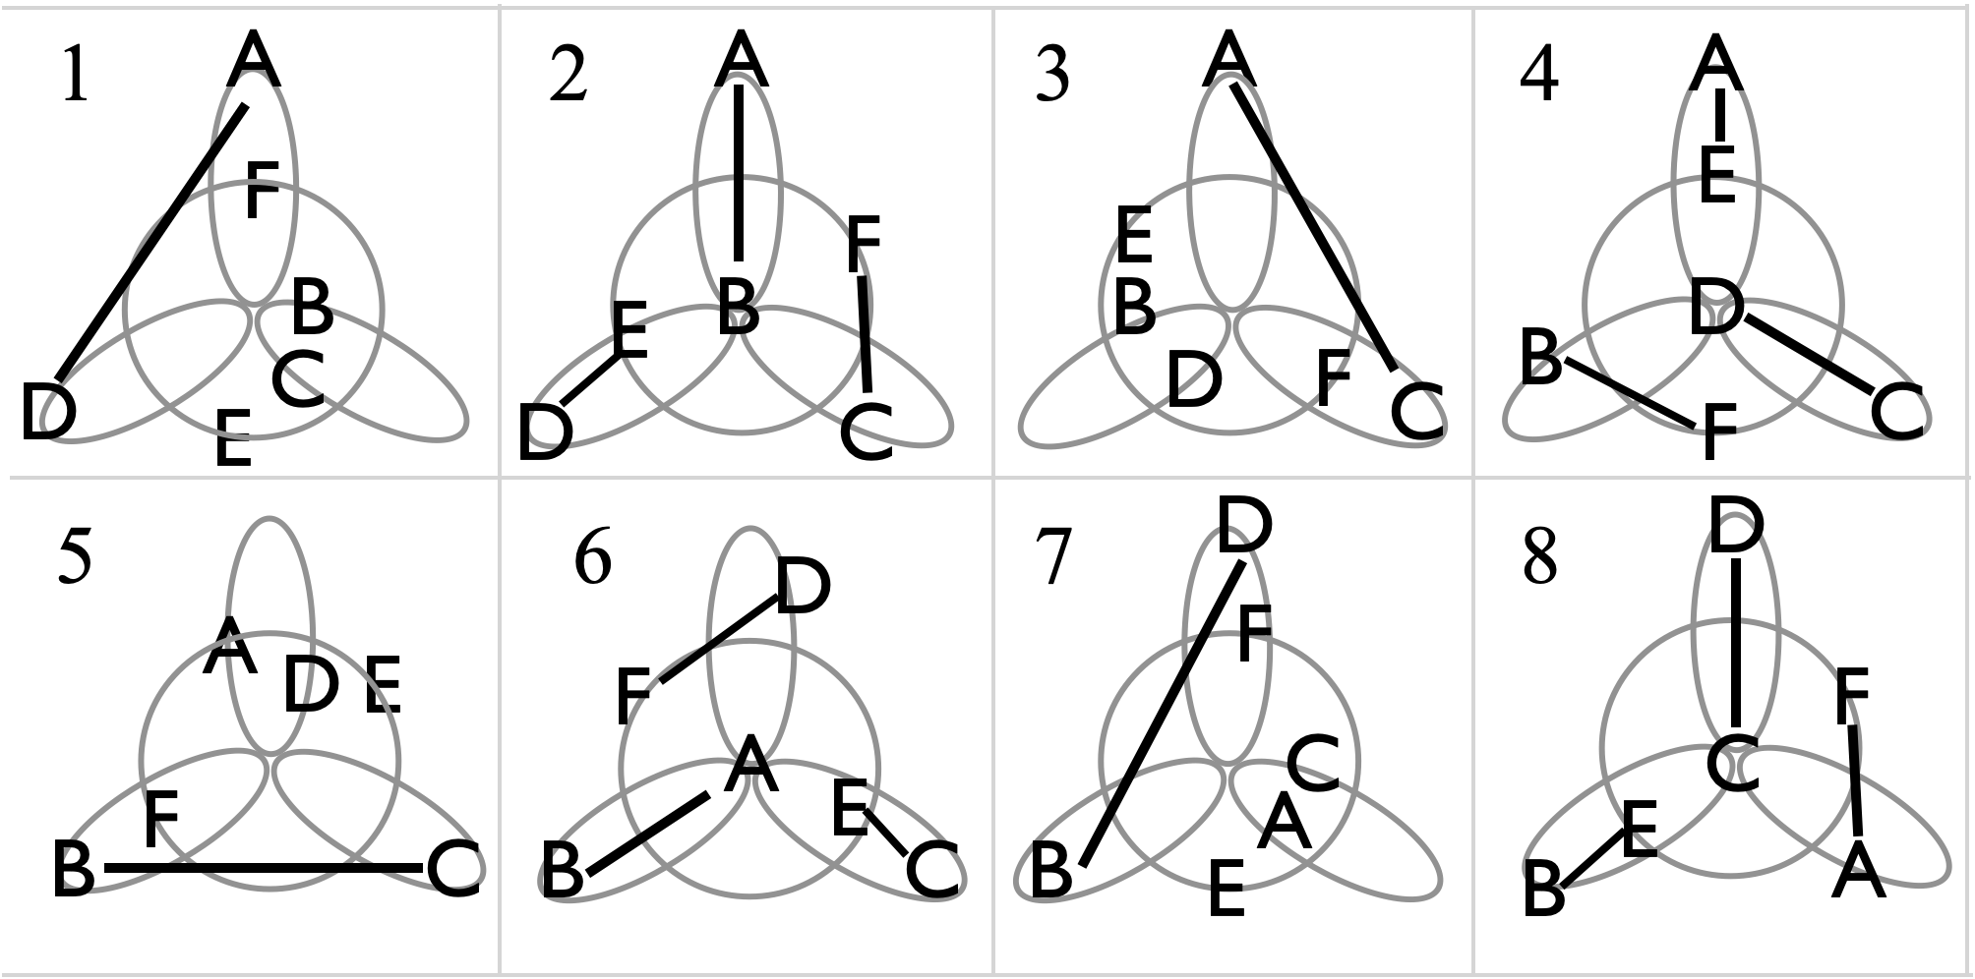
 | Beat, 3 count base is ideal. Feeder is grey. |  |  |  |  |  |  |  | Metrics: J=6, local cycle=8; full cycle=24 to get back to original spots;, base count = 3, OJ=5, CJ=3, pH=1, R=2, PBJ=2/9 (3-count base). Motion inherits from Three Leaf Clover (5 pu and 2.5$π$ rad per full cycle), then including the two orbiters gives pattern average motion at about 7pu. Likewise the average spin is about 4.3$π$ rad per cycle, considering the circle traversed an equivalent of 4 times by orbiters E and F over the full cycle.
 | 1 | 2 | 3 | 4 | 5 | 6 | 7 | 8
A | D | B | C | E |  | B |  | F
B |  | A |  | F | C | A | D | E
C |  | F | A | D | B | E |  | D
D | A | E |  | C |  | F | B | C
E |  | D |  | A |  | C |  | B
F |  | C |  | B |  | D |  | A

Four leaf clover with 1 orbiter |  |  |  |  |  |  |  |  |  |  |  | 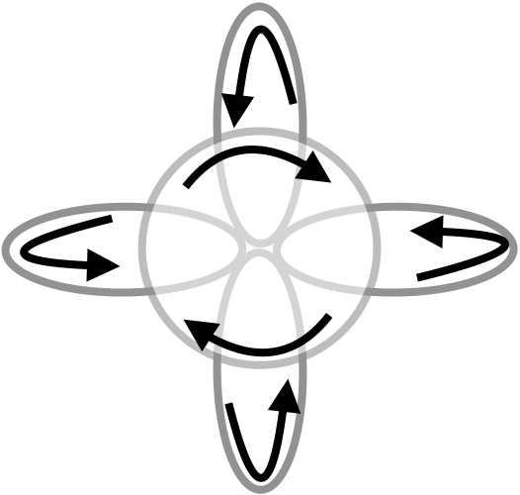
Add one juggler to the 5-person 4-leaf clover to absorb some of those pesky self throws! In this version, orbiter F moves clockwise (from above) along the perimeter of an inner circle.
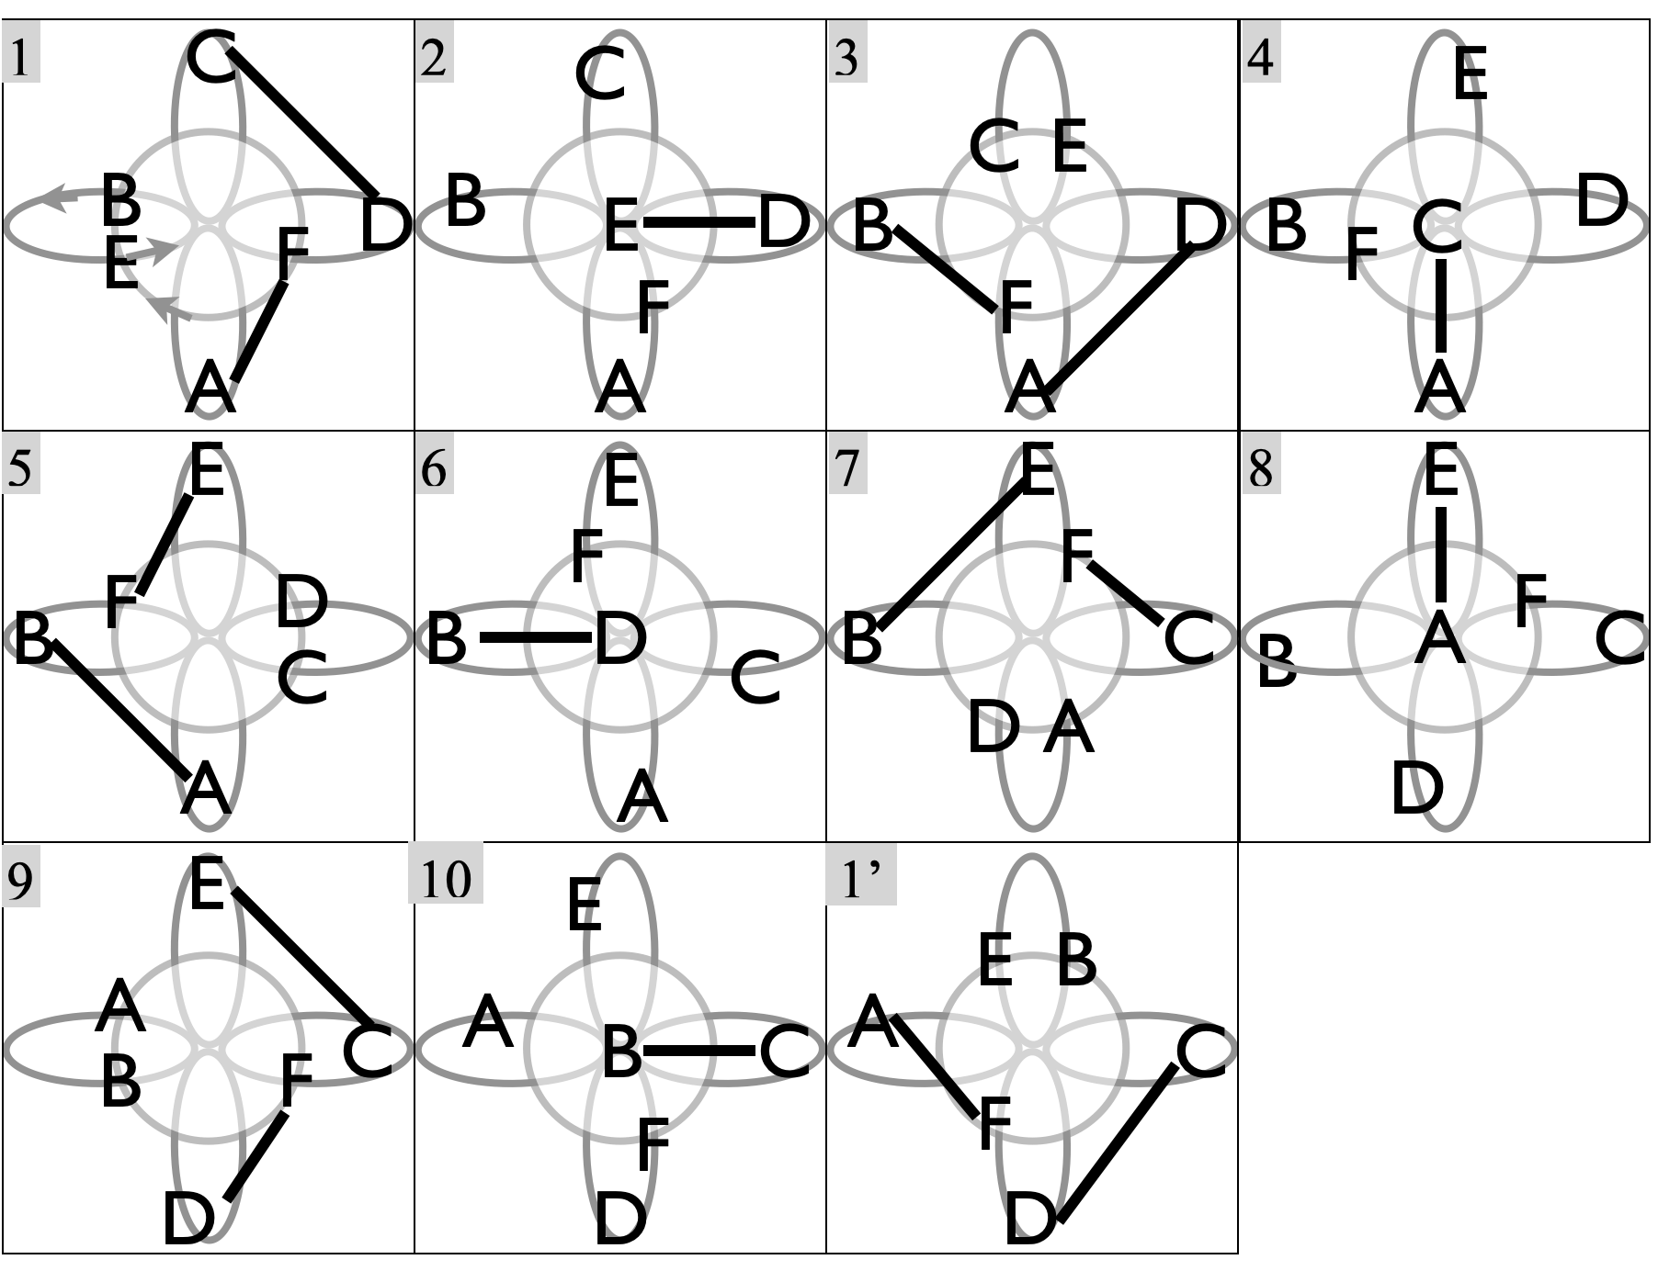 |  |  |  |  |  |  |  |  |  |  |  | Recall the 10 beats of a 4-leaf clover entail a feed of 3 positions, then 2 phantom beats to move into the middle, one pass, and 4 phantoms out to the leaf on your left. In this variation, orbiter F passes to the person who has just gone through the middle, and is on the 3rd self of their 4 phantom out beats. The clover-movers do the standard 4-leaf clover, but with one more juggler packed into the same space! In the table, grey indicates feeder.
 | Beat (base count; 2 or 3- count) |  |  |  |  |  |  |  |  |  | Metrics: J=6, local cycle=10, full cycle=40 to get back to original spots. Base count=2 or 3, OJ=5, CJ=3, pH=1, R=2, PBJ=¼ (2-count), ⅙ (3-count). For the clover, full cycle motion is 7pu and spin is $3π$ rad per cycle. The orbiter, meanwhile completes about 3pu per loop, and 4 loops per cycle, for 12pu, giving a pattern average motion near 8pu and a pattern average spin close to 8$π$ rad per full cycle.
 | 1 | 2 | 3 | 4 | 5 | 6 | 7 | 8 | 9 | 10
A | F |  | D | C | B |  |  | E
B |  |  | F |  | A | D | E |  |  | C
C | D |  |  | A |  |  | F |  | E | B
D | C | E | A |  |  | B |  |  | F
E |  | D |  |  | F |  | B | A | C
F | A |  | B |  | E |  | C |  | D
Variations arise by changing the orbit rule, such as by passing on the 2nd rather than 3rd beat out, or by picking up the tail or the head of each feed segment. The version shown seems to have more staying power!

Five leaf clover |  |  |  |  |  |  |  |  |  |  |  |  |  | 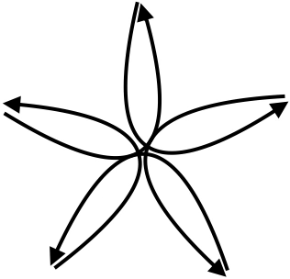
Among the multitude of options, this 2-in-6-out is the natural extension of lower-leaf clovers and one we like, especially when we add the extra pre-feed pass (grey in figure)!
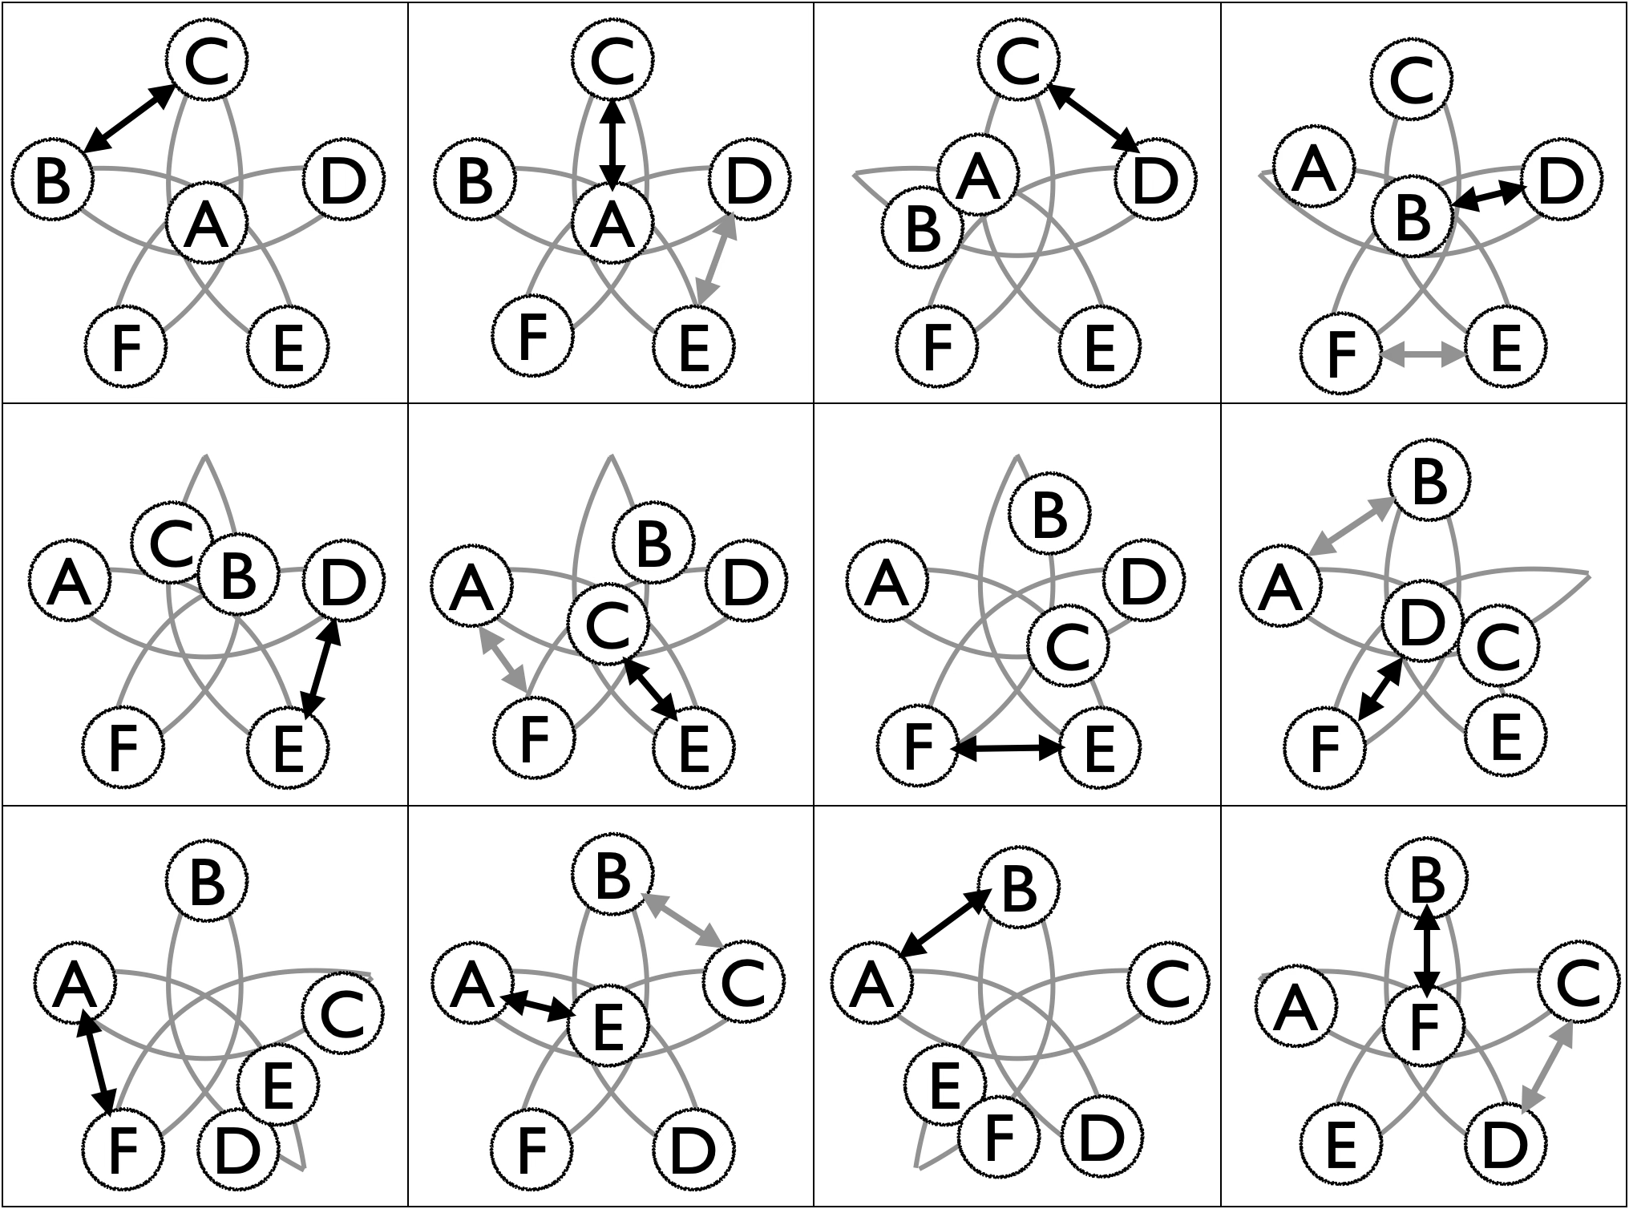
 | Beat, base count (2 or 3 count); feeder position in grey |  |  |  |  |  |  |  |  |  |  |  | Metrics: J=6, CJ=3, pH=1, R=1, OJ=4, PBJ=⅙ (2-count base) or 1/9 (3-count base). With the pre-feed pass, it’s ¼ and ⅙, respectively. We say the cycle is 12 beats, though 5 such cycles are needed to get back to the starting positions. Motion/spin ..high
 | 1 | 2 | 3 | 4 | 5 | 6 | 7 | 8 | 9 | 10 | 11 | 12
A |  | C |  |  |  | F |  | B | F | E | B
B | C |  |  | D |  |  |  | A |  | C | A | F
C | B | A | D |  |  | E |  |  |  | B |  | D
D |  | E | A | B | E |  |  | F |  |  |  | C
E |  | D |  | F | D | C | F |  |  | C
F |  |  |  | E |  | A | E | D | C |  |  | B
Comment on 2 in 6 out and also to 2 in (3-p-1-p)-out ; compare with Reddit posted video from July 2026…which is a non-cycleable 4-in-4-out variation, it seems!!

Extra Club Moving Six Person Patterns

Extra Club Double Weave

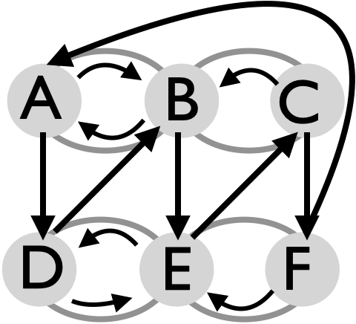 |  | 1-count  base |  | Juggler
 |  |  |  | A | B | C | D | E | F
 |  |  | 1 | D
 |  |  | 2 |  |  |  | B
 |  |  | 3 |  | E
 |  |  | 4 |  |  |  |  | C
 |  |  | 5 |  |  | F
 |  |  | 6 |  |  |  |  |  | A
(A,B,C) start right-handed; (D,E,F) start out of phase, each with 2 clubs in the left hand. All passes are doubles. Set up a standard double weave, but have one juggler (A) with an extra club. Passing beat stays at 6-count; moving stays the same (figure eight), but the passes are all doubles. Importantly, you receive from one juggler then pass to another, in order to retain the 7-club-style passing. Inspection shows that the passing sequence is the same (relabeled) as the stationary Trompe l’oeil. Leads are really critical in this pattern; lead deeply on the ends and short and lofty in the middle. The passing rate and moving rate are well within the skills of good movers/jugglers, but still the pattern eludes some perfectly capable groups.
Metrics: J=6, CJ=3 ⅙, pH=2, R=1, local passing cycle=6 on 1-count; full cycle 24 on 1-count base; PBJ=⅙, motion=4 (same as double weave), spin is low.

Variations: Start in Trompe l’oeil formation, then do 2 passes followed by a move into a circle; followed either by a move back or by an Oogle-boogie style move sequence. Tried on June 7, 2026 by Luke, Mike, Nathan, Chan, Gabe, and Keenan. Less common, but doable, is to weave via the dresser drawer style!
### Double Gandini Weave Plus
There is so much time at the back end of the Double Gandini Weave! Nine self throws! There must be something to do in all that time. Wait, I know! Let's add another club!This is the same as the previous pattern with a triple club passed back and forth over the top of the pattern. It's a spectacular pattern and not as hard as you might think (though certainly not easy).
| **Juggler/beat** | **1** | **2** | **3** | **4** | **5** | **6** |
|-------------|-------|-------|-------|-------|-------|-------|
| **A** | | T-F | | E | F | |
| **B** | | D | E | | | T-E |
| **C** | D | | | T-D | | F |
| **D** | C | B | | | T-B | |
| **E** | T-A | | B | A | | |
| **F** | | | T-C | | A | C |
> * Right-hand countingPattern by Luke Emery.
Seven Person Patterns

Stationary Seven Person Patterns
3 v 4 lines |  |  |  | Maybe the easiest entry-level passing pattern for 7.
Beat, 2 or 4 count base |  |  | 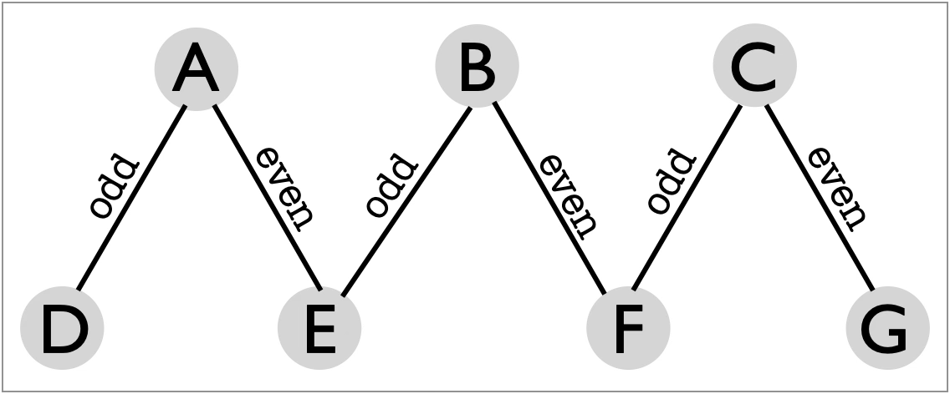
 | 1 | 2
A | D | E
B | E | F
C | F | G
D | A
E | B | A | We juggle this in Madison only when a bunch of newby club passers want to be in a biggish pattern. It’s certainly fun and good practice for timing; and it scales easily with more or fewer jugglers.  Magic club variation: Have the first club released by D to be of a different color than the other 20 clubs. Try to keep the pattern going as the magic club moves all the way from one side to the other. An engaging game!
F | C | B
G |  | C
Metrics: J=7, CJ=3, pH=1, OJ=12/7, R=2, cycle=2 beats on base count (usually 4-count for beginners), PBJ=3/14 (on 4-count base), motion=0, spin=;

1-2-4 Apollo |  |  |  |  |  | A nice and easy MAJ entry-level passing pattern.
 | Beat, 2-count base |  |  |  | 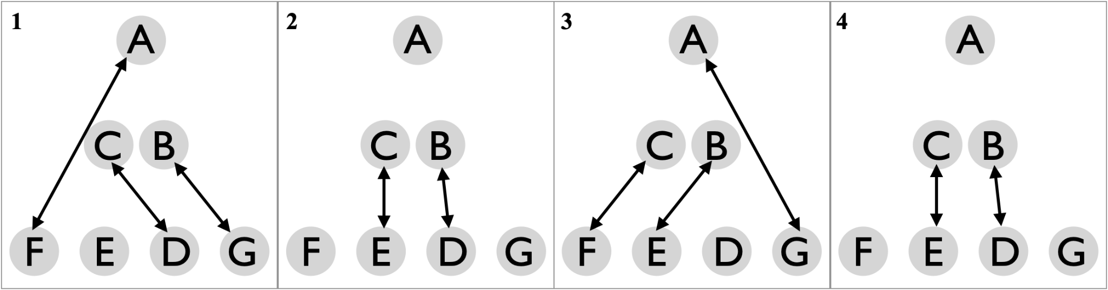
 | 1 | 2 | 3 | 4
A | F |  | G
B | G | D | E | D
C | D | E | F | E | Corners A, F, G, each pass on 4-count, alternating to two spots. Sweepers B and C each do standard sweep feed of three positions. Finally, E and D have interesting sweep-feed-like positions, each with a gap. We call that gap a phantom; it’s convenient to explain that someone is doing a sweep feed of 3 positions, with one of their feedees missing. To keep the pattern interesting, repeat tries to get a good run, then move everyone around and repeat. Try to get through all 7 positions!
D | C | B |  | B
E |  | C | B | C
F | A |  | C
G | B |  | A
Metrics: J=7, CJ=3, pH=1, OJ=16/7, R=4 (recognizing that A is different from F and G), PBJ=5/14, cycle=4 beats on 2-count base, motion=0, spin=; ?origin?

Hinge |  |  |  |  |  | Two simply connected feed lines make a nice and easy entry-level passing pattern for 7 jugglers.
 | Beat, 2-count base |  |  |  | 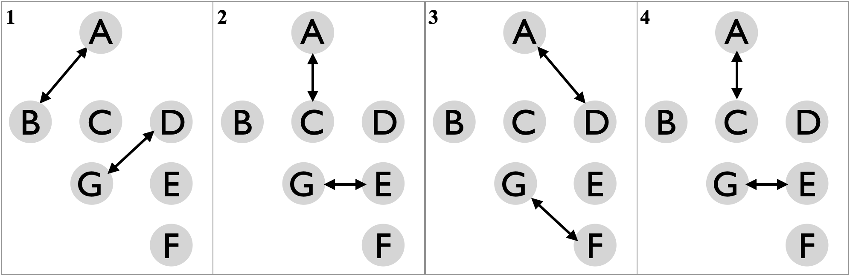
 | 1 | 2 | 3 | 4
A | B | C | D | C
B | A
C |  | A |  | A
D | G |  | A |  | Feeders A and G perform sweep feeds of respective lines of three jugglers (B,C,D) and (D,E,F). We call the overlapping position, D, the hinge, as they swivel back and forth on a 4-count between the two feeders.  Metrics: J=7, CJ=3, pH=1, OJ=12/7, R=4, PBJ=2/7, cycle=4 beats on 2-count base, motion=0, spin=; ?origin?
E |  | G |  | G
F | G
G | D | E | F | D

Feast for 7  A popular stationary pattern for 7 jugglers. |  | Everyone feeds everyone else in this classic pattern: go around the circle on any prespecified count, and be sure to include yourself in the count.
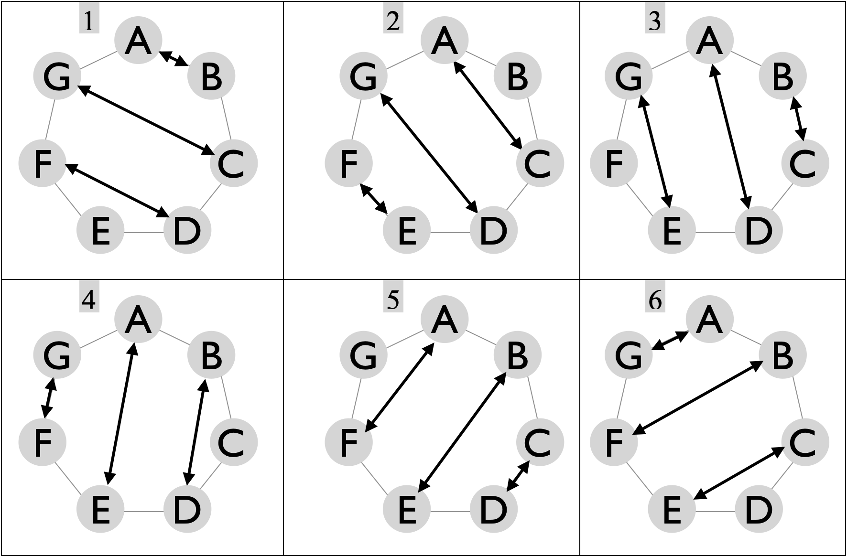 |  | Base count |  | Juggler
 |  |  |  | A | B | C | D | E | F | G
 |  |  | 1 | B | A | G | F |  | D | C
 |  |  | 2 | C |  | A | G | F | E | D
 |  |  | 3 | D | C | B | A | G |  | E
 |  |  | 4 | E | D |  | B | A | G | F
 |  |  | 5 | F | E | D | C | B | A
 |  |  | 6 | G | F | E |  | C | B | A
 |  |  | 7 |  | G | F | E | D | C | B
Full cycle is 7 beats on the base count (6 shown in figure). Self throws shaded in table (right).
While the pattern sets up as a stationary pattern, larger feasts like this Feast for 7 work well when jugglers slowly oscillate so as to shorten long passes and extend shorter passes. This leads to a pleasant amoeba effect! On counts, we often do 4 or 3-count for a friendly cycle, though 2-count rights is really more fun. When you’re comfortable with the 3-count version, try the Picnic variation in which each juggler completes a cycle of all crossing passes (e.g. right-right or left-to-left) followed by a cycle of all straights; the rule is to switch pass type as you move through your self beat. In a Picnic start, A, G, and F would start crossing and B, C, and D would start straight.
Metrics: J=7, CJ=3, OJ=6, pH=1, R=1, cycle=7 on any base count, PBJ=(6/7)(1/base) (e.g. 2/7 on 3-count base). motion=0, spin **.

7-point star |  |  |  |  | It’s about timing!
 | Beat |  | 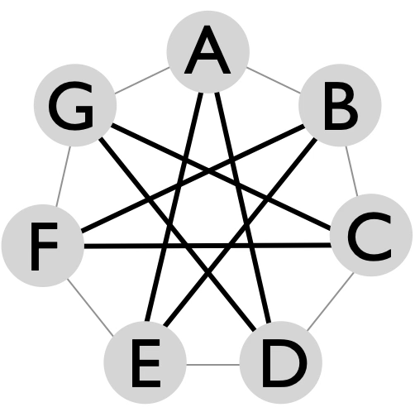 |  | This one is not for beginners, in spite of having no motion and essentially no spin! Jugglers set up in a circle, and depending on the chosen base count, they pass three spots to the right (on right throws) and three spots to the left on left throws. Collisions are avoided when everyone is well synced up: e.g. on a right-hand release, A’s pass to E goes just behind G’s pass to D and ahead of B’s pass to F and C’s pass to G! But it takes precision to stay synced!
 | odd | even
A | E | D
B | F | E
C | G | F
D | A | G
E | B | A | Metrics: J=7, CJ=3, pH=1, R=1, OJ=1 (even count) 2 (odd count), PBJ=1/base, cycle length=1 (even count) 2 (odd count). Best to try 2, 3, or 4 base count. Motion=0, spin=0 on even count and a very marginal $2π/7$ rad, or about 51°, noting the swiveling back and forth on odd base counts.
F | C | B
G | D | C

Overlapping Chocolate Bar 3-count feeds |  | A great stationary pattern for mixed skill levels, including one super challenging spot and lots of passing from both hands.
Recall the 5-person Chocolate Bar 3-count Feed, which has two chocolate-bar feeders and three 3-count feedees. This extension for seven overlaps two copies of the classic by merging two offset chocolate bars into one central juggler (B), and merging adjoining 3-counters into double-3-count spots (E,F). The passing itself requires typical MAJ precision, but the real challenge is remembering who you’re passing with! In fact, juggler B does a pretty special 1-count. A and C continue with chocolate bar; D and G do 3-count; and E and F do 3/2-count. |  | Base count |  | Juggler
 |  |  |  | A | B | C | D | E | F | G
 |  |  | 1 | D | E |  | A | B
 |  |  | 2 | E | F |  |  | A | B
 |  |  | 3 |  | F | G |  |  | B | C
 |  |  | 4 |  | D | E | B | C
 |  |  | 5 | E | F |  |  | A | B
 |  |  | 6 | F | G |  |  |  | A | B
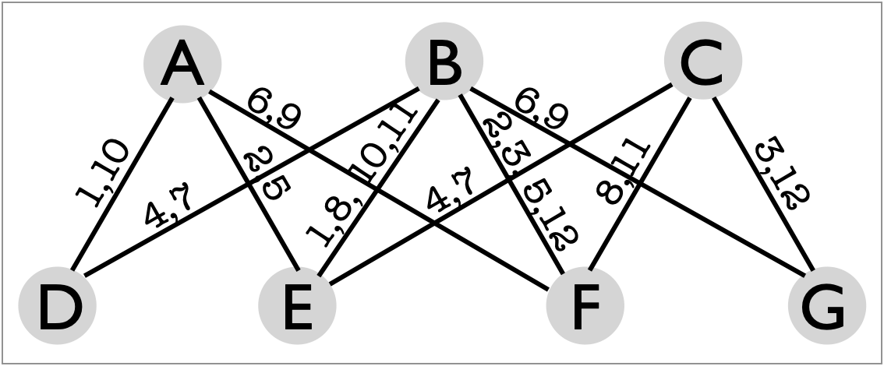  Passing beats are indicated on the edges |  |  | 7 |  | D | E | B | C
 |  |  | 8 |  | E | F |  | B | C
 |  |  | 9 | F | G |  |  |  | A | B
 |  |  | 10 | D | E |  | A | B
 |  |  | 11 |  | E | F |  | B | C
 |  |  | 12 |  | F | G |  |  | B | C
The passing sequence is pretty elaborate, but it follows nicely after you practice the separate 5-person sub-patterns. I.e., to start, ask C and G to sit out, and with the remaining 5 practice the chocolate-bar 3-count feed (passes indicated in gray in the table above). When you’re clear on the passes in that 12-beat cycle, then ask C and G to rejoin, and at the same time ask A and D to sit out; this creates a 2nd chocolate-bar 3-count feed in which, for example, B starts pass-pass, respectively to E and F (passes indicated by no shading in the table). With both sub-patterns ready, it’s time to put the patterns together.
Metrics: J=7, CJ=3, OJ=20/7, pH=1, R=4, cycle=12 on 1-count base, PBJ=4/7, motion=0, spin **.

Extra Club Stationary Seven Person Patterns

7-count 7-point Star |  | Serenity with 7.
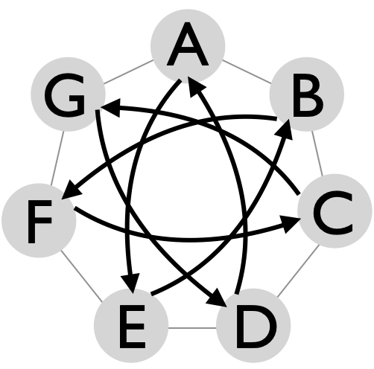 | Jugglers are in sync and in phase, with 1 extra club that triggers double crossing throws, one on each count from 1 to 7.  Surely not an MAJ origin, but a really good pattern! | 1-count  base |  | Juggler
 |  |  |  | A | B | C | D | E | F | G
 |  |  | 1 | E
 |  |  | 2 |  |  |  |  | B
 |  |  | 3 |  | F
 |  |  | 4 |  |  |  |  |  | C
Metrics: J=7, CJ=3 1/7, OJ=1, pH=2, R=1, PBJ=1/7, cycle=7 on 1-count, motion=0, spin=0. |  |  | 5 |  |  | G
 |  |  | 6 |  |  |  |  |  |  | D
 |  |  | 7 |  |  |  | A

Moving Seven Person Patterns

Open face sandwich with olive
3-3-1 Twister
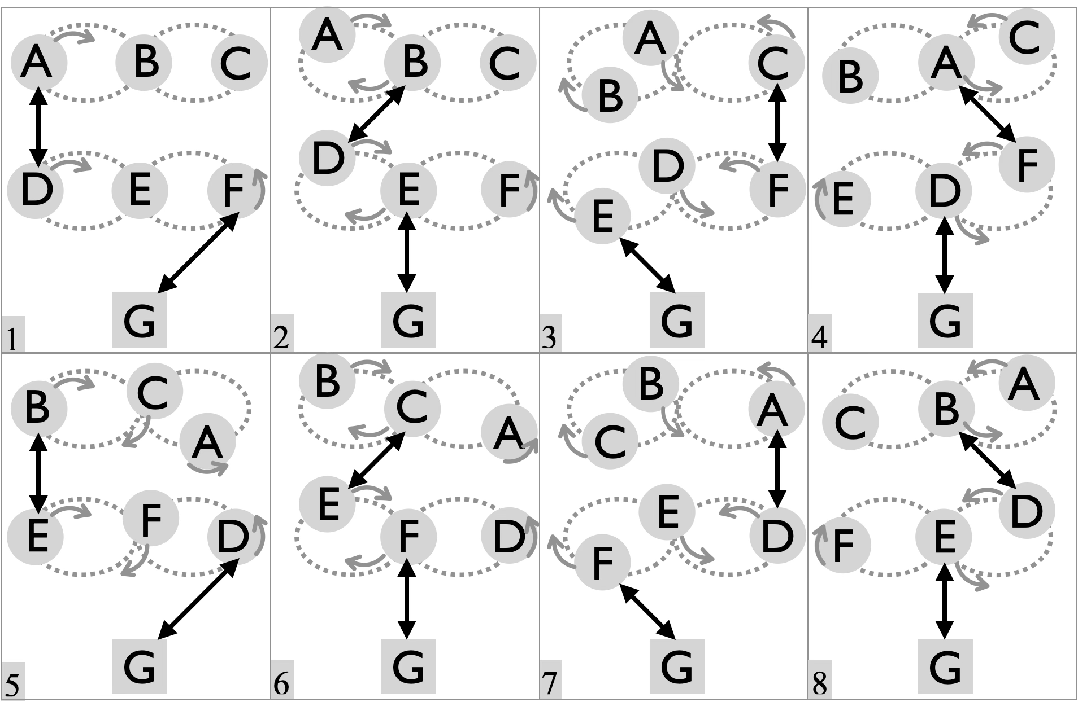 |  | Base count |  | Juggler
 |  |  |  | A | B | C | D | E | F | G
 |  |  | 1 | D |  |  | A |  | G | F
 |  |  | 2 |  | D |  | B | G |  | E
 |  |  | 3 |  |  | F |  | G | C | E
 |  |  | 4 | F |  |  | G |  | A | D
 |  |  | 5 |  | E |  | G | B |  | D
 |  |  | 6 |  |  | E |  | C | G | F
 |  |  | 7 | D |  |  | A |  | G | F
To appreciate the name, it’s good to look ahead to the 9-person Twister Sandwich, which organizes jugglers into three stacked weaves, the outer two like pieces of bread and the inner one the filling, or in code, a 3-3-3. This 3-3-1 replaces one slice of bread with a single stationary juggler, the olive, giving an open-face sandwich metaphor. Jugglers (A,B,C) perform a standard weave, each passing to two other twisters, among (D,E,F), who perform a double-time twister, moving swiftly through a figure 8 with a single right self on each direction change. |  |  | 8 |  | D |  | B | G |  | E
 |  |  | 9 |  |  | F |  | G | C | E
 |  |  | 10 | F |  |  | G |  | A | D
 |  |  | 11 |  | E |  | G | B |  | D
 |  |  | 12 |  |  | E |  | C | G | F
On the optional G in 4 count
Metrics: J=7, CJ=3, pH=1, cycle=12 on 2 count, R=3, OJ=18/7, PBJ=48/(7x12x2)=2/7, motion=**, spin=**

The Blast |  | 
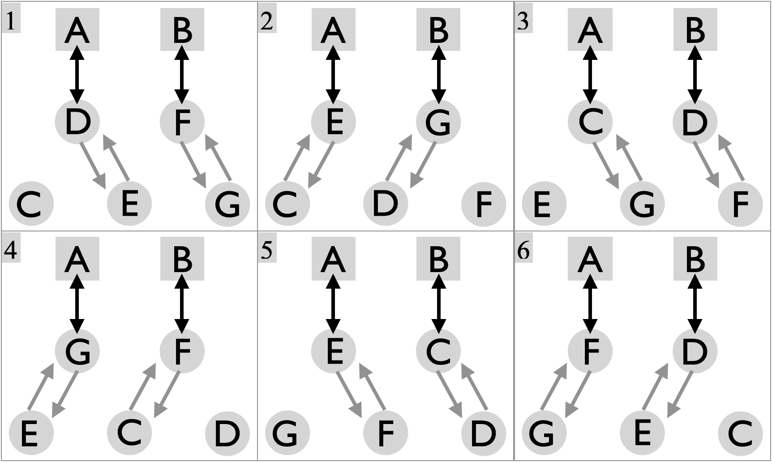 |  | Base count |  | Juggler
 |  |  |  | A | B | C | D | E | F | G
 |  |  | 1 | D | F |  | A |  | B
 |  |  | 2 | E | G |  |  | A |  | B
 |  |  | 3 | C | D | A | B
 |  |  | 4 | G | F |  |  |  | B | A
 |  |  | 5 | E | C | B |  | A
 |  |  | 6 | F | D |  | B |  | A
4-count is standard base…on Mel’s rule vs Mike’s rule for moving…for movers, think of it as 4-count with a bunch of phantoms! |  |  | 7 | G | E |  |  | B |  | A
 |  |  | 8 | D | C | B | A
 |  |  | 9 | F | G |  |  |  | A | B
 |  |  | 10 | C | E | A |  | B
Pattern by Peter Kasemen…while thinking about ball bouncing!
Metrics: J=7, CJ=3, pH=1, PBJ=2/7, cycle=10 beats on base (4 or 6 count), R=2, OJ=20/7, motion= ** , spin=0.

Broken Hearted Blast |  | 
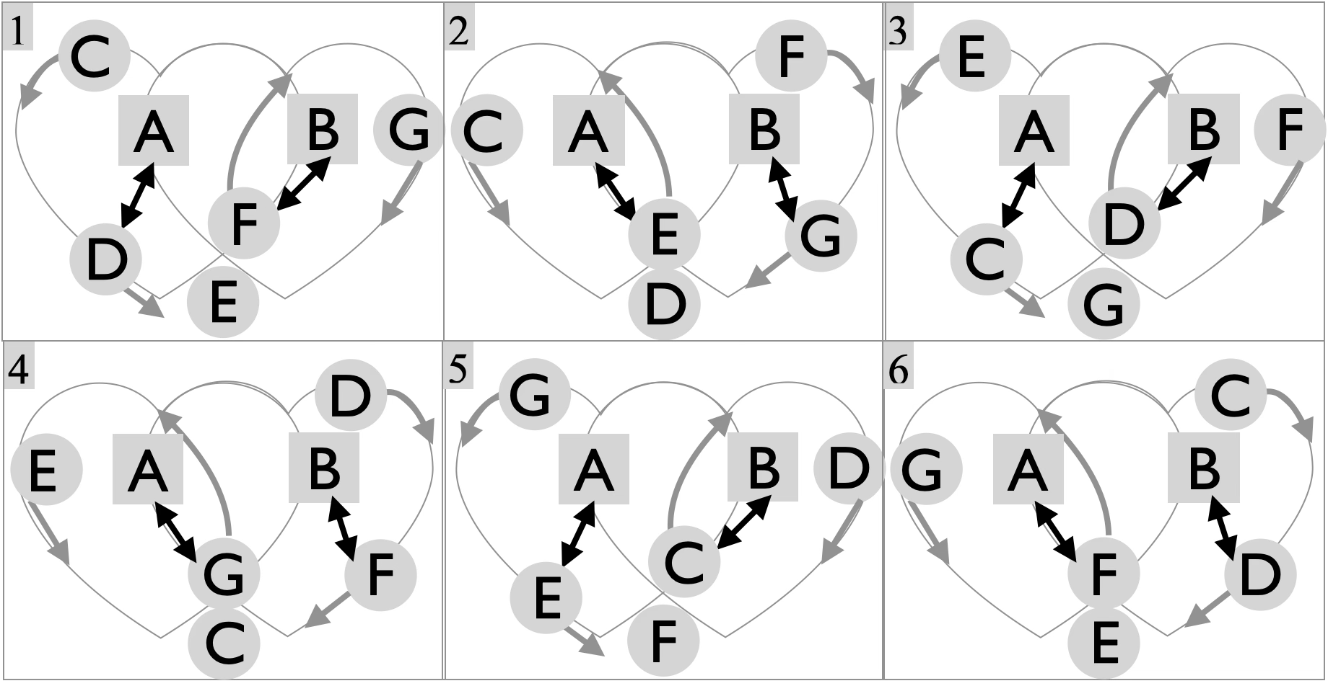 |  | Base count |  | Juggler
 |  |  |  | A | B | C | D | E | F | G
 |  |  | 1 | D | F |  | A |  | B
 |  |  | 2 | E | G |  |  | A |  | B
 |  |  | 3 | C | D | A | B
 |  |  | 4 | G | F |  |  |  | B | A
 |  |  | 5 | E | C | B |  | A
 |  |  | 6 | F | D |  | B |  | A
4-count is standard base…Same passing table as Blast, but much cooler motion! |  |  | 7 | G | E |  |  | B |  | A
 |  |  | 8 | D | C | B | A
 |  |  | 9 | F | G |  |  |  | A | B
 |  |  | 10 | C | E | A |  | B
Metrics: J=7, CJ=3, pH=1, PBJ=2/7, cycle=10 beats on base (4 or 6 count), R=2, OJ=20/7, motion= ** , spin=0.

Eye of the Needle  A Twister Weave with Obstacles |  | A popular extension of the twister weave when two brave stationary jugglers want to play. Big-time movement for the weavers!
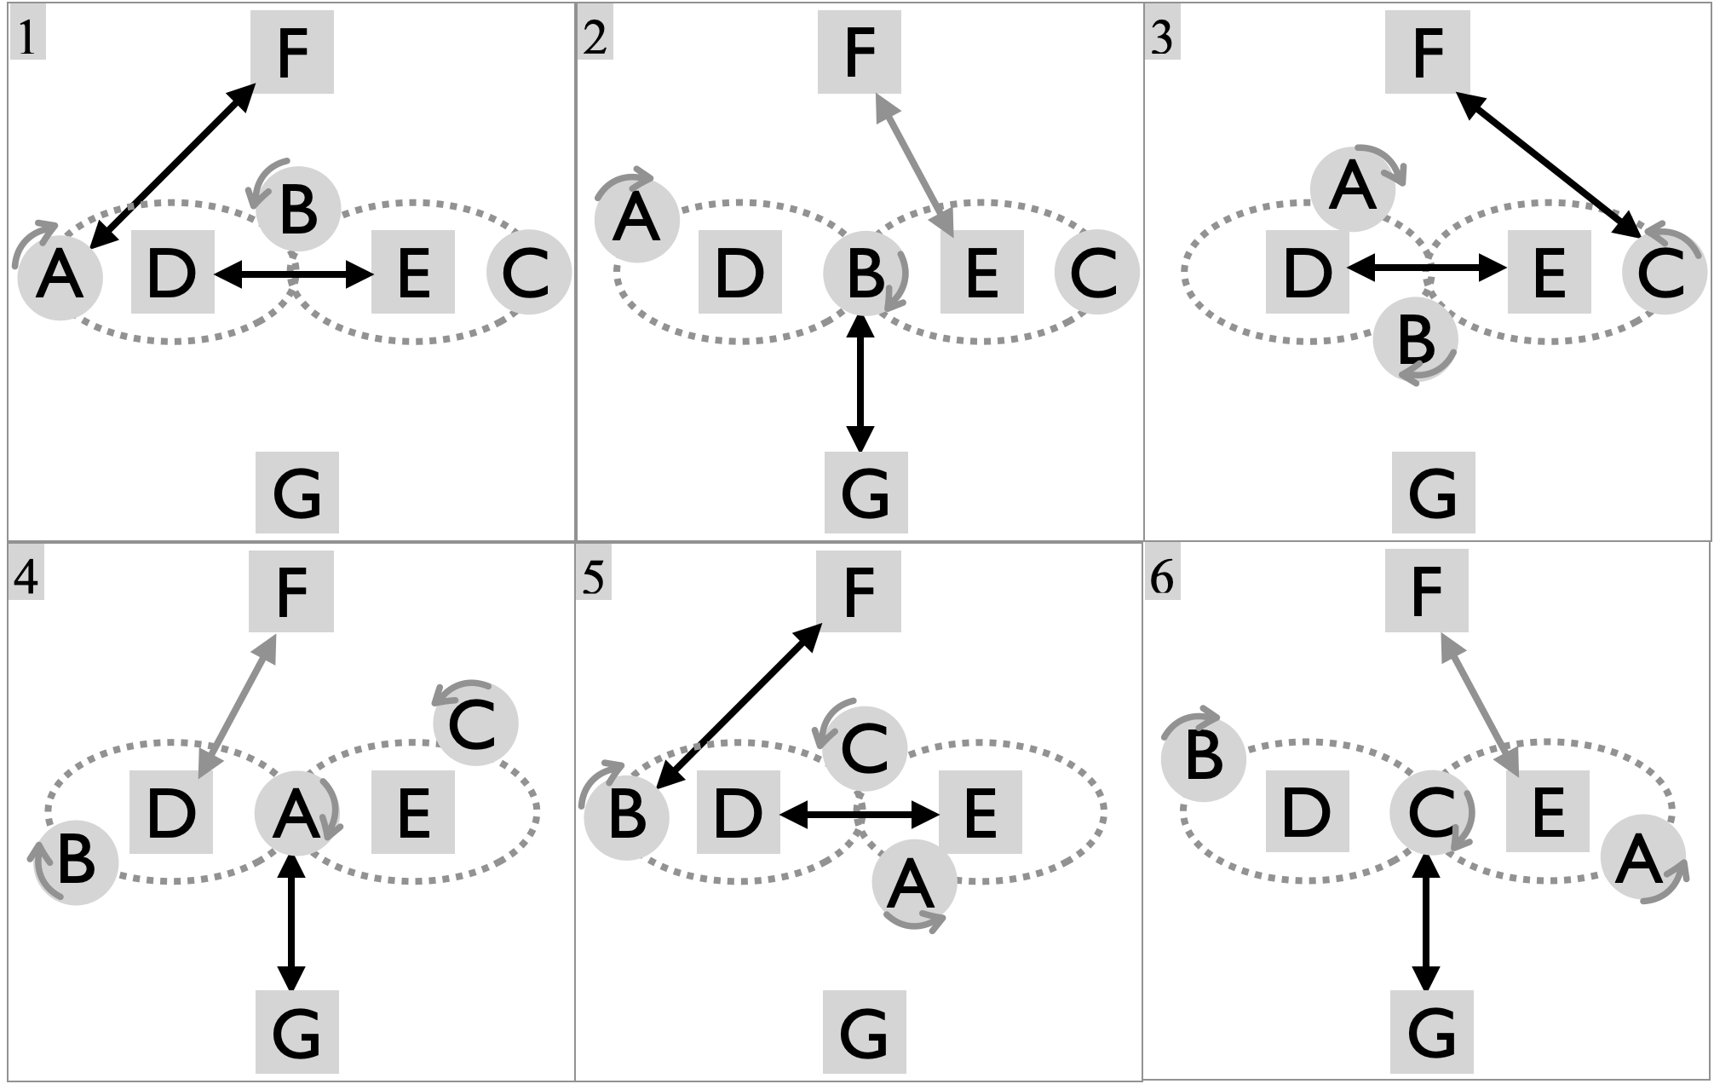 |  | Base count |  | Juggler
 |  |  |  | A | B | C | D | E | F | G
 |  |  | 1 | F |  |  | E | D | A
 |  |  | 2 |  | G |  |  | F | E | B
 |  |  | 3 |  |  | F | E | D | C
 |  |  | 4 | G |  |  | F |  | D | A
 |  |  | 5 |  | F |  | E | D | B
 |  |  | 6 |  |  | G |  | F | E | C
 |  |  | 7 | F |  |  | E | D | A
Set up with B facing Dr. Inside (G), but on Dr. F’s side of the two needles (D,E). Then G starts self as the needles pass and moves forward passing to G on beat 2, and so on for other weavers moving across the D-E passing lane. Traffic can get hectic, and there’s often interference between movers and the needles…all in good fun! The extra-pass version is pretty hard for non-expert needles! |  |  | 8 |  | G |  | F |  | D | B
 |  |  | 9 |  |  | F | E | D | C
 |  |  | 10 | G |  |  |  | F | E | A
 |  |  | 11 |  | F |  | E | D | B
 |  |  | 12 |  |  | G | F |  | D | G
Metrics: J=7, CJ=3, pH=1, cycle=12 on 2-count base, OJ=2, R=3 (standard), 4 (extra-throws), PBJ=3/14 (standard ), 2/7 (extra throws), motion=**, spin=**.

Twister 5 |  | A good pattern for new movers!
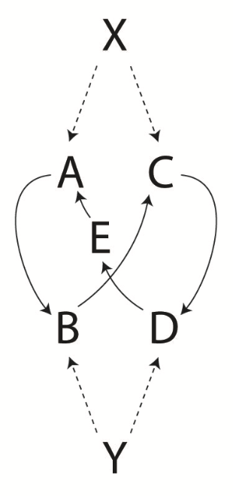 | This one comes by twister- izing the 6-person Gandini weave; that is, splitting the feed position into two (X,Y) and moving them to opposite sides of the weave. Thinking of the original feeder as juggling the 5 movers, this version defies gravity! The standard (black font) is a 2-count right-handed base. Once mastered, there’s plenty of time for even more passing by doubling up to each feeder as you move through (grey). | Base count |  | Juggler
 |  |  |  | A | B | C | D | E | X | Y
 |  |  | 1 | X |  |  |  | Y | A | E
 |  |  | 2 | X | Y |  |  |  | A | B
 |  |  | 3 |  | Y | X |  |  | C | B
 |  |  | 4 |  |  | X | Y |  | C | D
 |  |  | 5 |  |  |  | Y | X | E | D
 |  |  | 6 | Y |  |  |  | X | E | A
 |  |  | 7 | Y | X |  |  |  | B | A
 |  |  | 8 |  | X | Y |  |  | B | C
 |  |  | 9 |  |  | Y | X |  | D | C
 |  |  | 10 |  |  |  | X | Y | D | E
Metrics: J=7, CJ=3, pH=1, PBJ=1/7 (2/7 double time), cycle=10 beats on base (2 or 3 count), R=2, OJ=20/7, motion= ** , spin=**.
The standard set up has a 2 count base, so feeders X and Y are on 4-count (or 2-count in the double-time version). Ignoring the double-time, speeding the pattern up is possible by having X and Y on 3-count rather than 4-count. Since the table just shows events on passing beats, we recognize that the whole thing may be described as passing events happening on beats 1-and-2-on-a-3-count. For instance, X passes on every 1 and Y passes on every 2, and no passes on 3. This count is super nice for feeder balance and overall pace; for instance left-hand passes send the weaver off to the feeder’s left and vice versa. It also leads to movers alternating 7-count-8-count as they move through their cycle. **updated PBJ**

Iron Cross Weave  A weave with 4 doctors! |  | Weavers A, B, C move through figure 8 while passing to two twister-like doctors (D,E) and two new doctors F and G!
A good pattern for 3 busy movers and 4 happy feeders  Pattern by Luke Emery | 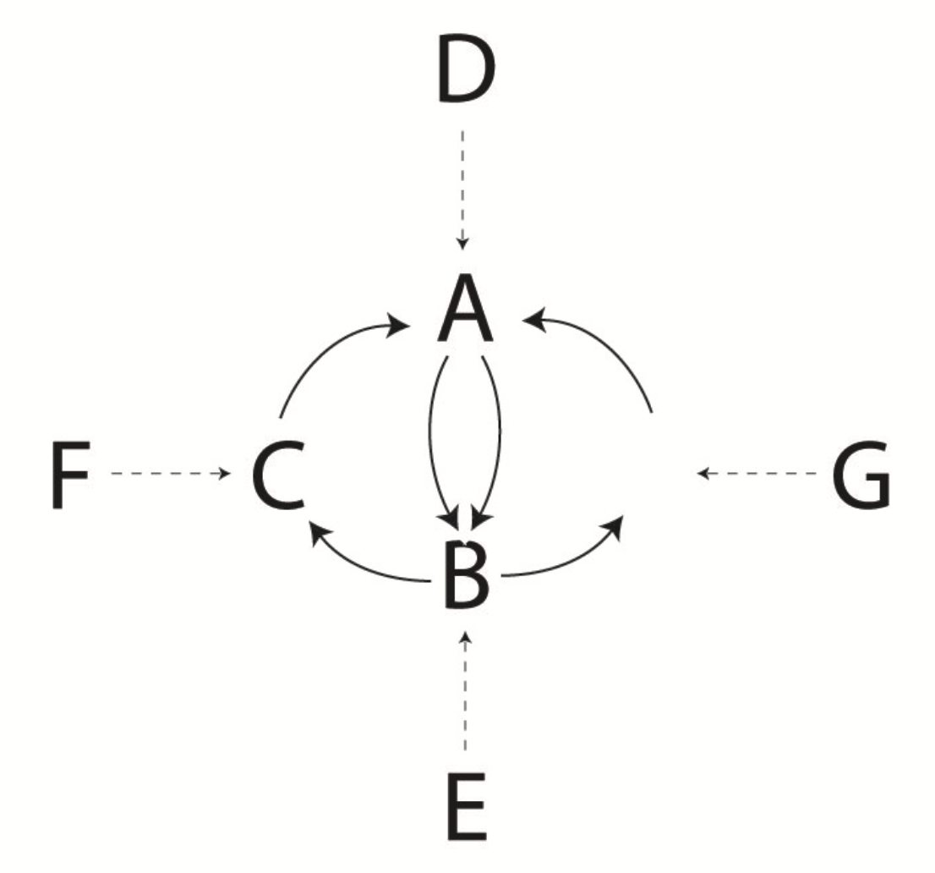 | 4 count base |  | Juggler
 |  |  |  | A | B | C | D | E | F | G
 |  |  | 1 | D | E | F | A | B | C
 |  |  | 2 | E | G | D | C | A |  | B
 |  |  | 3 | F | D | E | B | C | A
 |  |  | 4 | D | E | G | A | B |  | C
 |  |  | 5 | E | F | D | C | A | B
 |  |  | 6 | G | D | E | B | C |  | A
Variations: Luke recommends filling in the gaps in that 4-count base, for instance with 2 passes in a row to each doctor. Good luck!
Metrics: J=7, CJ=3, pH=1, OJ=24/7, cycle=6 on 4-count base, R=3, PBJ=36/(42x4)=3/14, motion=, spin=

Four-Loop Weaves

Intersecting Weaves
Aka 2-5 Foie Graham
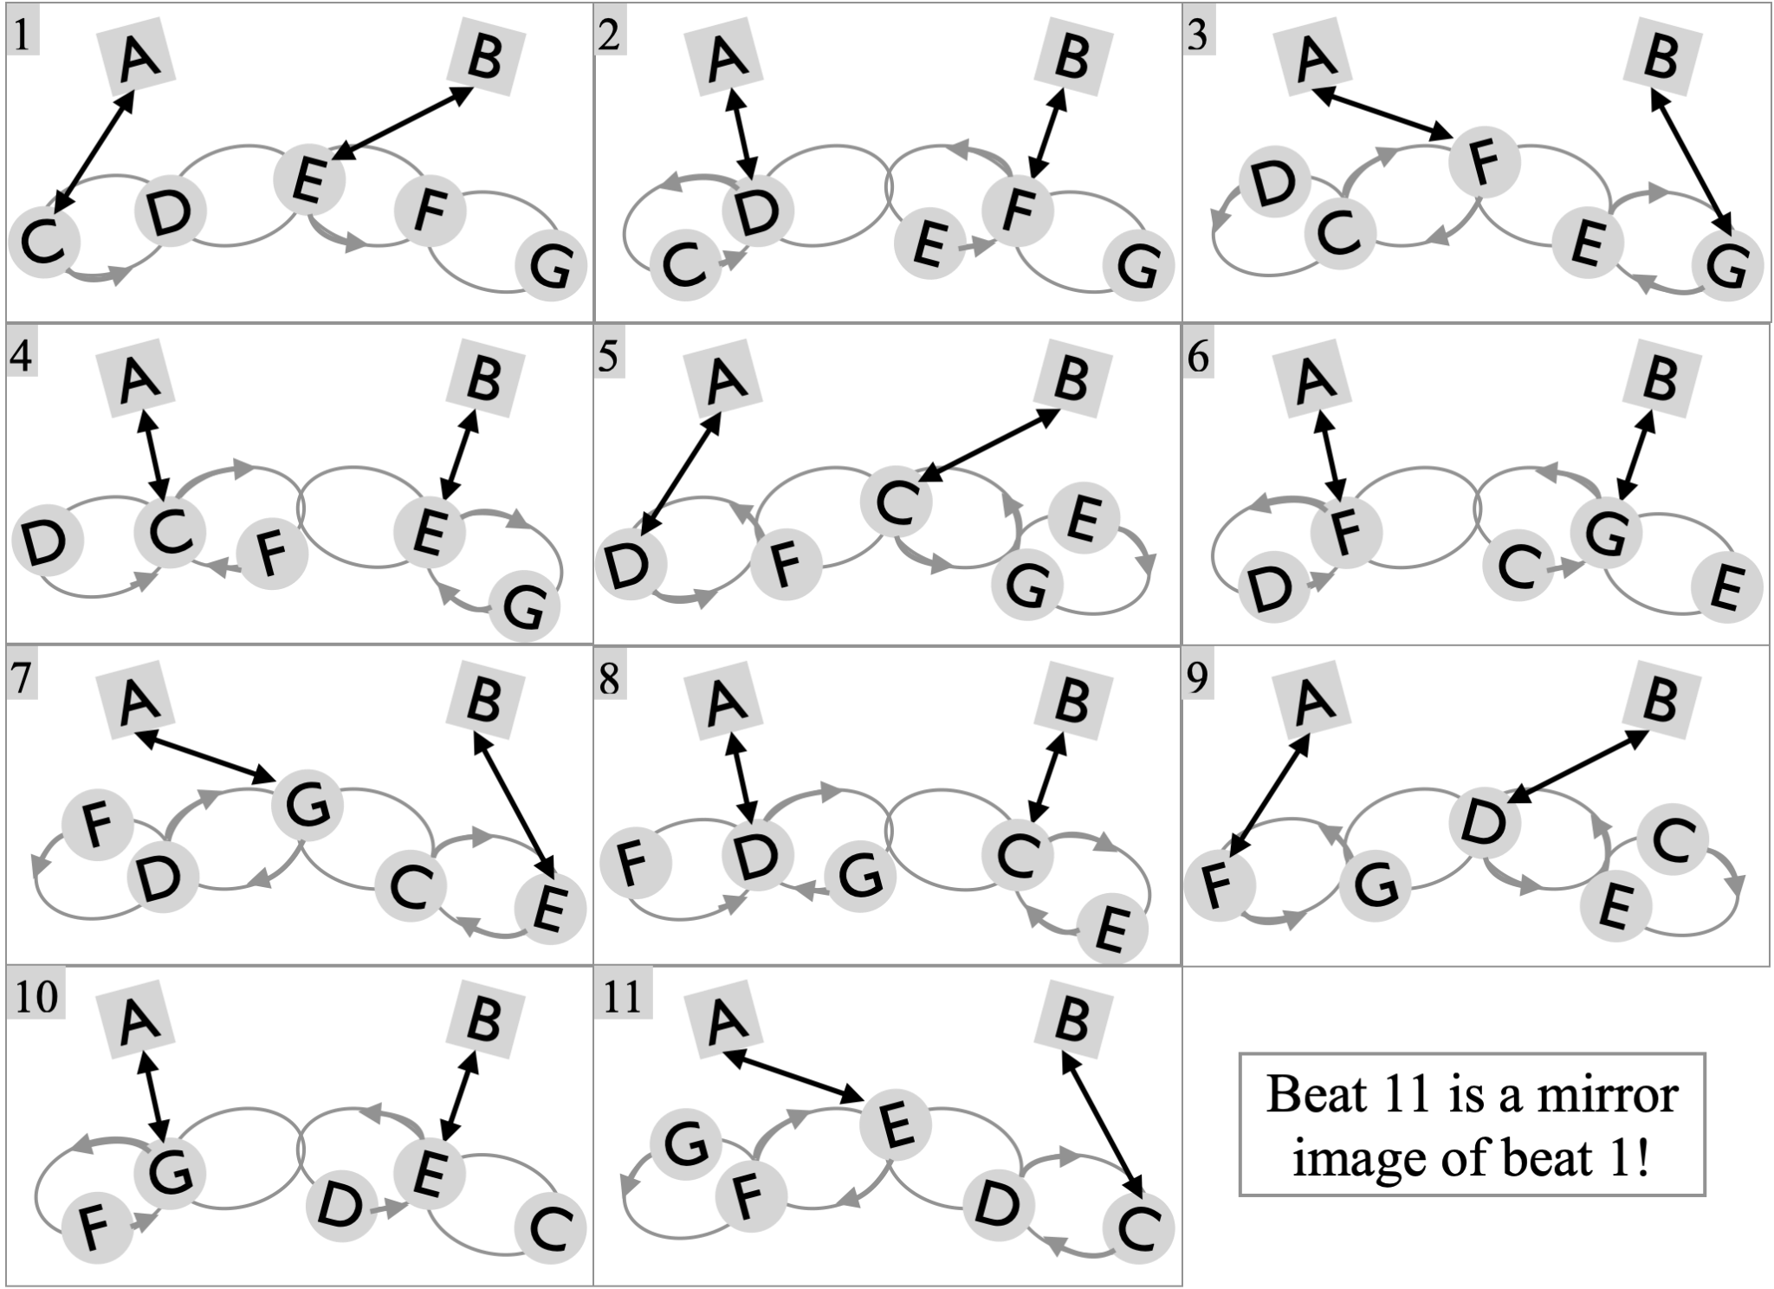 |  | two count base |  | Juggler
 |  |  |  | A | B | C | D | E | F | G
 |  |  | 1 | C | E | A |  | B
 |  |  | 2 | D | F |  | A |  | B
 |  |  | 3 | F | G |  |  |  | A | B
 |  |  | 4 | C | E | A |  | B
 |  |  | 5 | D | C | B | A
 |  |  | 6 | F | G |  |  |  | A | B
 |  |  | 7 | G | E |  |  | B |  | A
Two weaves set up side by side, sharing one juggler (E, at first). Weavers pass a regular 4 beats on 6-count to one weaver, and then they switch to the other feeder on a quick 2-count. |  |  | 8 | D | C | B | A
 |  |  | 9 | F | D |  | B |  | A
 |  |  | 10 | G | E |  |  | B |  | A
Metrics: J=7, CJ=3, pH=1, cycle=20 (on 2-count base), OJ=20/7, PBJ=2/7, R=2, motion= ** , spin=**.
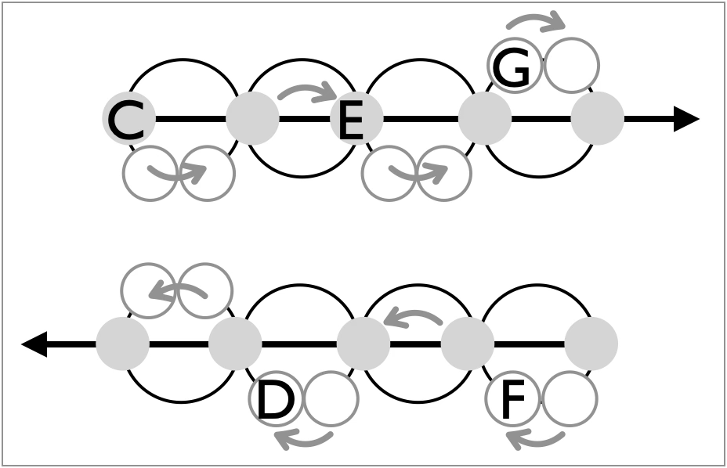 |  |  | In the steady state, weavers wobble left-to-right (top) and then right-to-left (bottom), passing at the grey spots on each line. The white circles are really phantom spots, where jugglers move through but don’t pass. The five weavers are marked here where they start, consistent with the more complete figure above. Notice the grey pass spots on either end are shared by top and bottom, and notice there’s a juggler at every 4th spot!
A concise description of the moving rule is to pass like in an ordinary weave (e.g., back on the end, forward through the middle, on six count), but when you are leaving a “middle” heading towards the other side of the pattern, then do two passes in a row (e.g., F on beats 2 and 3).
The Intersecting Weaves pattern is by Steve Otteson, dating perhaps to the mid-to-late 1990’s. It was “independently” rediscovered by Mellonhead as a variation of 8-person Mel Extension of the Foie Graham, which itself extended Graham Pasch’s 6-person Foie Graham. Steve’s Intersecting Weaves appeared in earlier versions of the Pattern Book, but we realized quite late (while preparing Version 4.0, September, 2026) that it is exactly the same as what we had later introduced and named the 2-5 Foie Graham. What is in a name?

1-5-1 Foie Graham

Wonky Benzene Ring |  | A “pattern” in Version 3 that actually doesn’t work!!
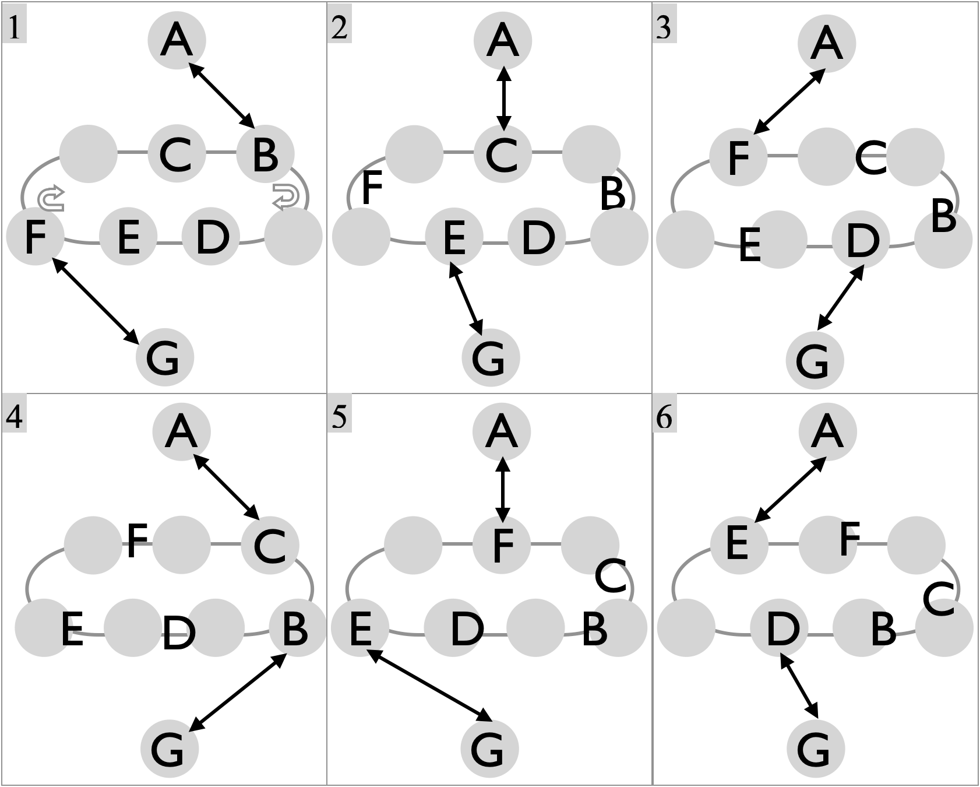 |  | Base count |  | Juggler
 |  |  |  | A | B | C | D | E | F | G
 |  |  | 1 | B | A |  |  |  |  | F
 |  |  | 2 | C |  | A |  |  |  | E
 |  |  | 3 | F |  |  |  |  |  | D
 |  |  | 4 | C | G | A |  |  |  | B
 |  |  | 5 | F |  |  |  |  |  | E
 |  |  | 6 | E |  |  |  |  |  | D
 |  |  | 7 | F | G |  |  |  |  | B
 |  |  | 8 | E |  | G |  |  |  | C
 |  |  | 9 | D |  |  |  |  |  | D
This set up doesn’t work!! |  |  | 10 | E | G |  |  |  |  | B
 |  |  | 11 | D |  | G |  |  |  | C
 |  |  | 12 | B |  |  |  |  |  | F
 |  |  | 13 | D | G |  |  |  |  | B
 |  |  | 14 | B |  | G |  |  |  | C
 |  |  | 15 | C |  |  |  |  |  | F
 |  |  | 16 | B |  |  |  |  |  | E
 |  |  | 17 | C |  | G | ?? |  |  | C
 |  |  | 18 | F |  |  | ?? |  |  | F
Metrics: J=7,

Extra Club Moving Seven Person Patterns

Big Mangled Squirrel

Eight Person Patterns

Stationary 8

Double-vision box

Extra-Club Stationary 8

Moving 8

Benzene Rink
1-3-3-1 Twister

Mating 3-leaf clovers

Extra Club Moving 8

Extra Club Inverted Benzene Ring

Patterns for an indefinite number of jugglers!
…an idea whose time has come…like

Pattern Statistics

Pattern | N  Jugglers | N  clubs /  J | PBJ | N moves /  cycle / Jug | N  rotations /  Cycle / jug | SD ?

