The Big Lemniscate Juggling Pattern
Michael Newton
Version 02.18.2026.
On Sunday, January 18, 2026, 40 jugglers performed a big lemniscate at the O’Keefe Middle School in Madison, as part of the 34th 47th annual Madfest juggling festival. Lemniscate is a funny math word referring to a figure-8 shape (Figure 1), and the big lemniscate is a fun club-passing pattern involving a whole bunch of jugglers moving steadily through this shape while passing to others along the way. Counting jugglers and props, the version we did on January 18 was a trick involving 160 moving objects (40 jugglers and 120 clubs)! The video evidence
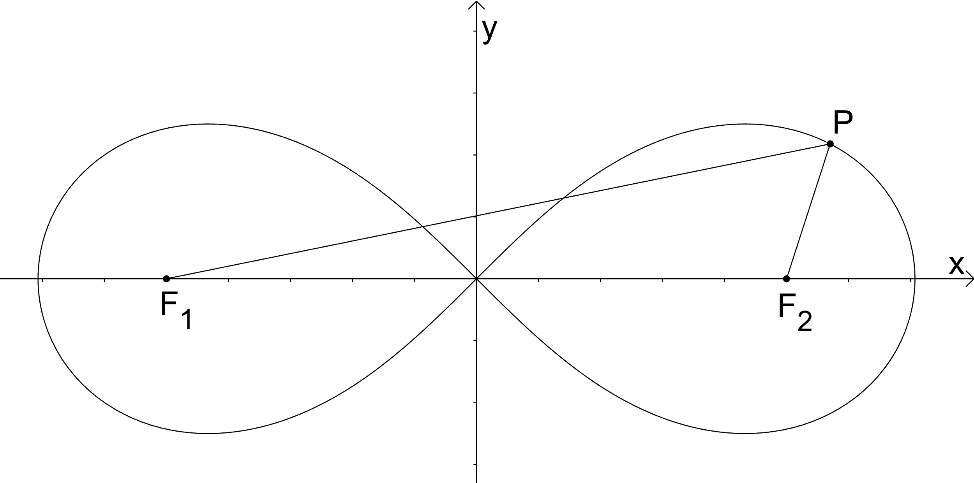
Figure 1. Lemniscate of Bernoulli. All points on the curve have the same product of distances to the two foci F1 and F2 (It’s also a familiar juggling shape!)
confirms some drops (ha!), however in spite of those we got the pattern rolling and it was a blast.
I’ve organized big patterns at Madfest for years, and also once at the IJA festival, and I have come to realize that while being a challenge to set up efficiently, big patterns can be a lot of fun for avid club passers. One key in that statement is efficiently. Nothing saps the enthusiasm of a group of jugglers like delays, confusion, and long discussions about where people are supposed to be and what they’re supposed to do to make a pattern happen. The pattern itself also needs to be sufficiently interesting to capture the imagination of good club passers. It is relatively easy to set up relatively boring patterns! The trick is to set up interesting patterns, where jugglers can move amongst their friends and pass to lots of other participants, while not requiring excessive skill that would further limit participation. I’m not aiming for a pattern for beginning passers; participants need to be able to keep time with other jugglers, pass on some regular beat, and engage in basic juggler movements (like walking and turning a bit). No extra-club passing skill is needed; no fancy movements are needed; but I do require one of the rarest of things -- the ability to juggle in time with others. In southern Wisconsin, that means about 65 right-hand releases per minute. The present article provides some details on how I set up the big lemniscate pattern to maximize fun for all!
Coming into the Madfest weekend, I wanted to be prepared for a variable number of jugglers, and had a sign-up sheet from the first night to encourage participation. It’s easier to sort out a pattern’s dimensions when you know the number of jugglers well in advance, but realistically it is pot luck in terms of who will show, so it’s good to be flexible and to be ready to adjust the size quickly. On Saturday night I settled on the number (40 jugglers), hoping we’d have enough folks turning up for the 11am start, which we did! I needed some time to sort out the dimensions in advance. I had tried a 26-person version at the 2025 Madfest, but that did not go so well as I had the dimensions screwed up. I workshopped a size-corrected 26-person version at the IJA festival in Evansville, Indiana in summer 2025, which worked well, though the room size in that case limited the overall pattern size. In setting up for 2026 Madfest, I wanted to be flexible with the final number, since we had room and a lot of potential passers, and so I needed a fast set up simpler than the geometric method I used previously.
The Set Up.
You need a fair bit of space to set up this pattern. Our 40-person big lemniscate fits on a rectangular floor at least 76 feet by 30 feet, which fills most of a regular basketball court [see math insert]. That makes it far too big to eyeball approximate positions for the jugglers or to provide informal instructions on passing/moving rules. My solution is to mark out essential instructions on the gym floor in advance. Figure 2 shows some tools of the trade.
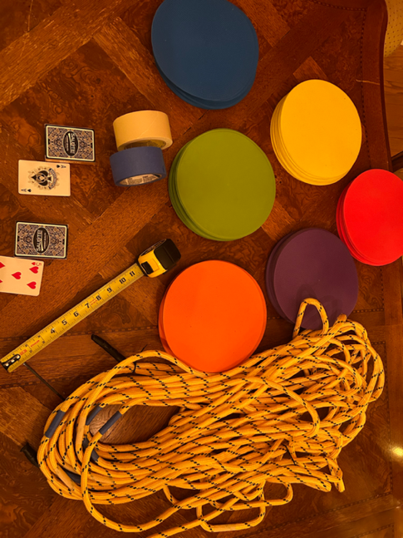
Figure 2. Tools you need to set up the big lemniscate: floor markers (various colors), tape measure, masking tape, playing cards (2 decks), 100 feet of rope.
Every juggling pattern has its own special features. The big lemniscate gets its fun elements by having so many movers and by having a cool way to cross paths in center of the pattern. It may help to visualize the thin curve of Figure 1 as more of thick ribbon, with the ribbon’s two edges (teel and grey, Figure 3) defining paths of two groups of jugglers who move in opposite directions through the lemniscate.

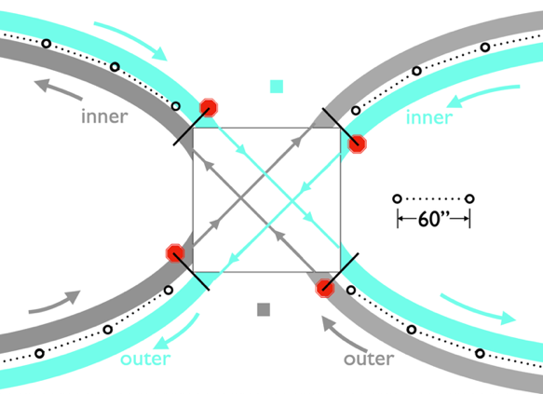
Figure 3. Teel-colored path moves counter-clockwise (from above) on the inner edge of the right loop, and then clockwise on the outer edge of the left loop; the grey path goes in the opposite direction. 19 jugglers move along the teel path; another 19 move along the grey path. Small circles mark passing points. Red octagons are stop signs.
The crossing rules at the center make the lemniscate an especially fun pattern. That center is the first thing I mark on the gym floor, starting with a square with edges about 7 ½ ft (90 inches) and thus a diagonal about 10 ½ ft (Figure 4). By the way, the dimensions of this central square ought to be the same no matter how big you make big lemniscate (The juggling is easier for bigger numbers. Communication is easier for smaller numbers.) The pattern’s crossing and moving rules work only if you have the same odd number of jugglers moving along each of the two opposite paths. As noted, we had 19 movers on each path in the 2026 Madfest attempt, which corresponds to a 40-person pattern. It would be fun to go even bigger. I think the smallest you can do is 5 jugglers per path (12 jugglers total), which we found out at practice on February 1, 2026. After setting the central square with masking tape, I mark out the backbone of each lemniscate loop using a long rope, on which I’ve pre-set alternating-color tape marks every 5 feet (60 inches); see the dashed lines with open-circle ends in Figure 3.
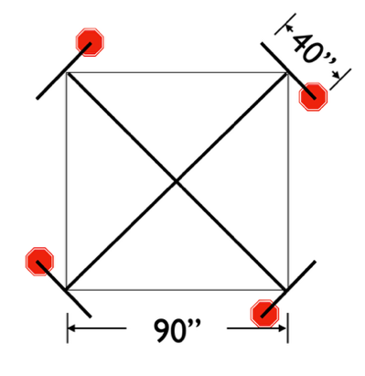
Figure 4. Setting up the center. Stop signs mark each path’s entry into the crossing square.
The alternating-color tape marks tell me where to place colored plastic floor markers indicating the passing points along each path. It’s worth to make a few comments about the marked rope before I explain the moving rule. I use enough rope for one full loop, setting up one side and then separately the second side. For each side of the pattern, the looping rope connects two adjacent corners of the central square. I need 17 5-foot segments of rope in one loop for the 40-person pattern (see math insert at the end); by having at least that many segments pre-set on the rope, you have the ability to adjust the size of each loop and thus the overall size the pattern. Fortunately I had marked a 100 ft rope, so 85 ft was available for the 17 segments. Several Madfest volunteers helped to shape out by eye the rope into a lemniscate-loop. To give a bit of necessary extra room near the central square, I start and end the rope loop 1-2 fit away from each connecting corner (see Figure 3). Next, my volunteers help me drop the colored plastic floor markers all the way around each loop (Figure 4). The use of four colors turns out to be convenient, with two-colors marking passing points on each of the opposing paths.
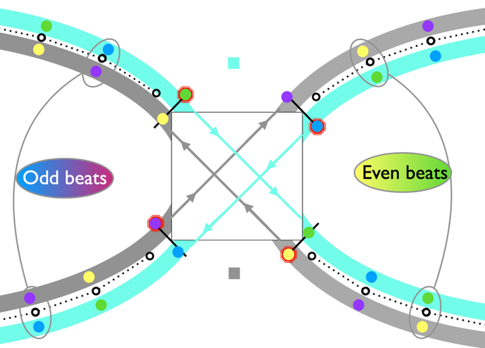
Figure 5. Floor markers for even (yellow/green) and odd (purple blue) passing beats on the grey path (yellow/purple) and the teel path (green/blue).
For instance, I used green and blue markers on the teel path and yellow and purple markers on the grey path. Colors alternate on both paths in such a way that jugglers are at blue or purple spots on odd passing beats and they’re at green or yellow spots on even passing beats. Aside from the interesting crossing rule, the passing/moving rule entails simply passing at a passing point and then moving forward along your path to the next passing point. Your pass goes to whomever is in front of you on the opposite path; they will be facing you about 10 ft away. Moves follow passes, and so each passer ends up moving along their path so that they are side-by-side of the person they just passed with as they set up for their next pass to the next person along that path.
All that passing and moving along the loops is super fun, but the most exciting part of the pattern is crossing through the middle square. You’ll have noticed already in Figures 3 and 4 the presence of four stop-sign positions, which show up on a path as that path enters the square. The rule is simple: when you land at a stop sign, you neither pass on the next passing beat nor move after that passing beat. In other words, when you arrive at a stop sign you stop, skip a passing beat, and stay put after that beat while two jugglers cross through from opposite corners. Then you take your turn, passing and moving fully across the diagonal to pick up the pattern on the other loop. To make up for skipped passes, each juggler at the passing point just prior to a stop sign needs someone to pass with, and we add two extra jugglers for that purpose. I call them jokers, considering the playing-card associations I describe shortly. Their centers of gravity don’t move; jokers are set up on either the top or bottom side of the central square. There’s one for the teel path and one for the grey path, and they end up swiveling back and forth on passing beats to pass alternatively to movers who are getting close to their respective stop signs. In summary, all but two jugglers pass at passing points, move along their respective paths one 5-foot segment after each pass. As they approach the stop sign, they pass once to a joker, then they get to the stop sign, wait, and then proceed after skipping one beat.
I often use two decks of playing cards as a simple device to sort out where all the jugglers have to be at the beginning of big pattern. Cards from one deck go on the floor at respective starting spots; matching cards from second deck are in my possession when we congregate to start the pattern, and we ritualistically have jugglers select cards at random to get their coordinates. The path structure of the big lemniscate is conducive to using cards of all four suits, running ace,
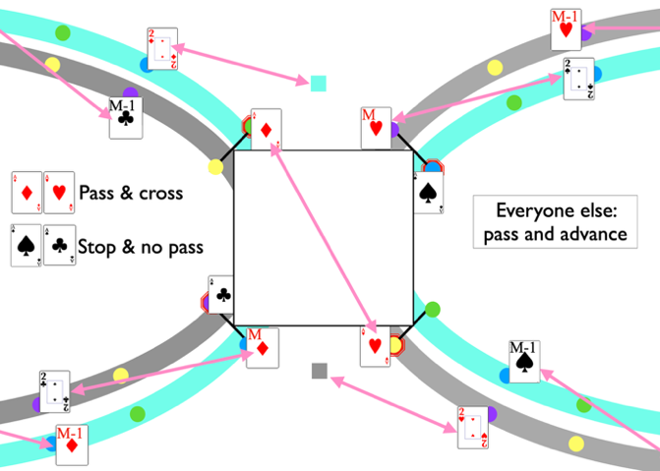 | 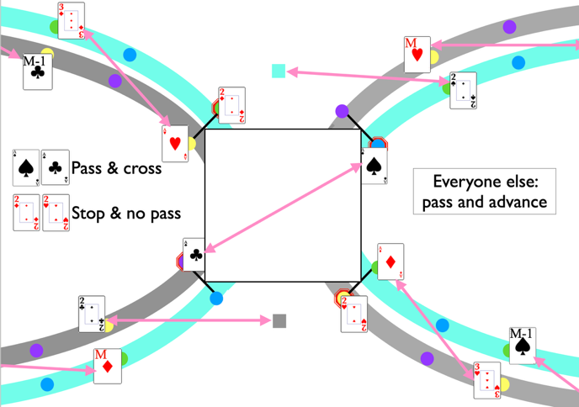
Figure 6. First two passing beats. For example, aces of hearts and diamonds pass and cross the square on beat 1. The other aces don’t pass and don’t move on beat one, though everyone else does. M=10 here for the 40-person version, but could be some other even number. There are 2M-1 movers per path, 4M jugglers total considering the 2 jokers (small squares). Forty passing beats completes one full cycle.
two, three, etc, of a given suit along passing positions emanating from corners of the central square. I used hearts for the outer edge of the grey path (right loop) and clubs on the inner edge of the grey path (left loop); likewise, diamonds and spades live on the teel path. Figure 6 shows the first two passing beats. As it happens the odd number comes from the fact that there’s one more person occupying an outer edge than an inner edge on either loop when the pattern starts. With our 40-person pattern, 10 jugglers are on each outer loop and 9 are on each inner loop. So, the cards I need are ace to 10 of hearts, ace to ten of diamonds, ace to 9 of
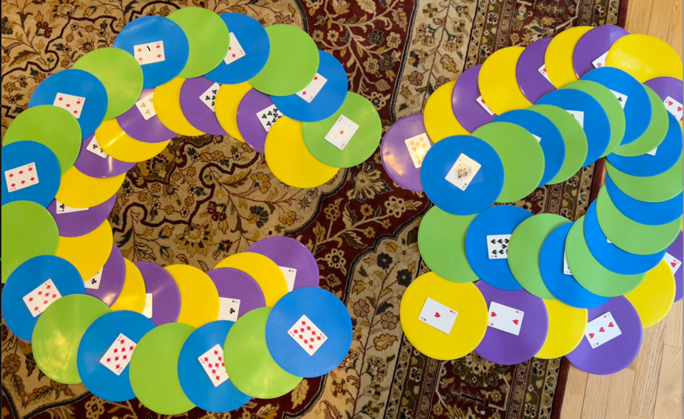
Figure 7. Living room simulation on the morning before the big pattern. The yellow/purple path is on the inner on the left and the outer on the right; the blue/green path is the opposite, being on the inner on the right and the outer on the left.
both clubs and spades. And since there are marks for odd and even passing beats, only half of the passing points receive cards as starting positions. To speed the set up, I tape the floor-bound cards to their respective plastic markers in advance. Figure 7 shows the simulation on my living room floor just before heading to the gym!

Let’s Juggle!
Enough about setting up the pattern. How do we actually juggle it? After welcoming participants and giving out cards for the starting positions, I explain basic rules and we “walk it through” enough times to get ourselves all on the same page. To help with timing, I broadcast a metronome set for 130 bpm (thanks Nathan Nard); someone aside from me needs to call out the up-down-start and tick off the passing beats. A million thanks to Dan Howard for taking that job, calling out the 8-count passing rhythm with the metronome back beat. We keep trying until our 1-hour allotted time is up, by which time at Madfest we had completed a full cycle of 40 passing beats without complete disintegration of the pattern (Figure 8). Three cheers!
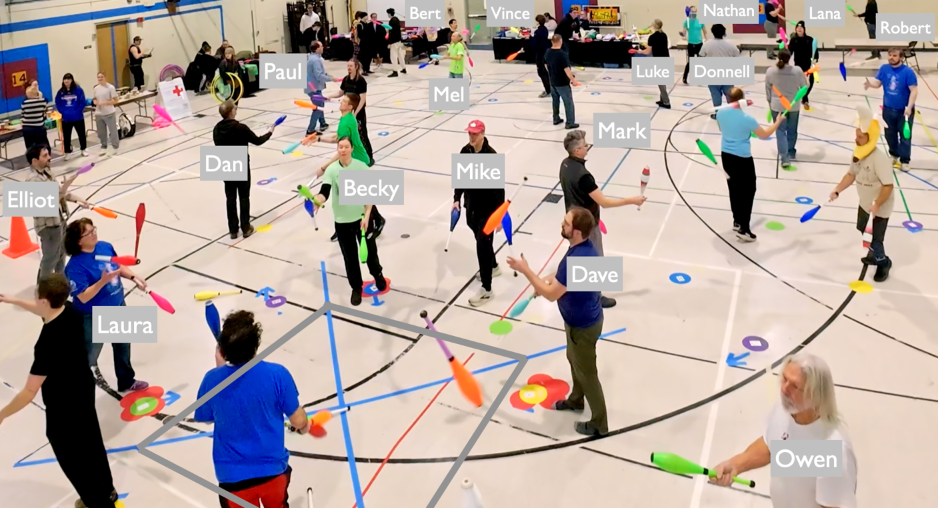
Figure 8. A drone’s view of the big lemniscate in action, showing center cross (blue tape) and one of the two loops. The central square is marked with grey lines, and some of the floor markings are evident. For example, Dave and Laura have just arrived at stop signs (overlapping red markers), and stay put without passing as Becky and the man in a blue shirt exchange clubs from their stop signs and begin to cross the square. Mike (that’s me) acts as non-juggling crossing guard trying to direct traffic. Owen and Elliot are two jokers passing to those who are one spot shy of a stop sign (Elliot is passing to the man in the green t-shirt on the path behind Becky; Owen is passing to someone on the inner edge of the loop that’s out of view.) On the previous passing beat Dave was on the purple marker behind his current spot, and must have passed to Owen. This pic is evidently on the time of an even passing beat, as movers are at green/yellow passing point markers. Mark got a little bit ahead of his green passing point (which is by my left shoe); he had just moments before crossed through the middle and his momentum probably carried him just past the green marker (I may also have been encouraging him to hurry up!); he’s now passing with the man in the banana hat. But no harm no foul. It takes 40 passing beats to complete one cycle, curiously matching the number of jugglers in the pattern. This run had us passing on 8-count (i.e., every 4th right hand), while following a 130 bpm metronome and the cadence of our silky-smooth caller Dan Howard (out of view). Thanks to Freddy Astrada, Sky Bound Productions, for the drone coverage. See https://www.instagram.com/p/DUGhfODCAq5/ for a video clip.

Tips: A couple of things are worth to mention. It was very helpful having me stand near the center and be a crossing guard to provide real-time confirmations to each mover as they prepared to cross the central square. It’s also good to recognize that the pass-move rules have each juggler moving about 5 ft to the next passing position, except in the case where they cross the central square. In that case the move is double (10 ft). Jugglers need to be alert, and not delay after their passes, else they will clog up the center for the next pair. Also, in case of drops, it’s better to stay along your path and pick up at the next opportunity, rather than chasing a club off the lemniscate. Finally, I can’t stress enough the importance to stay on the counter’s beat.

Math Insert:
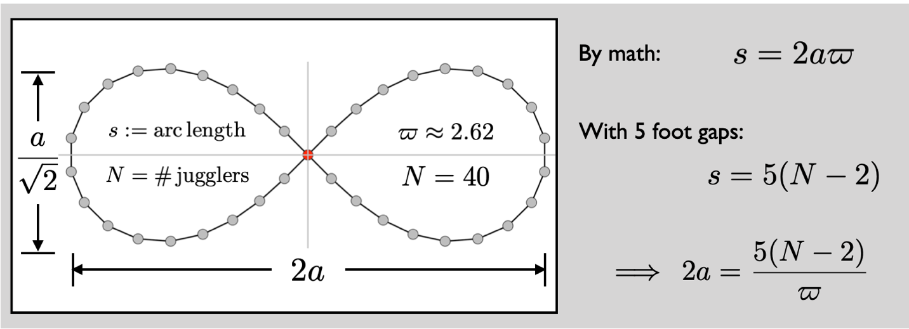
To figure out dimensions, I use the lemniscate constant ϖ, which is to this shape what π is to a circle, and I divide up the arc length s of the whole lemniscate into 5-foot chunks for all N-2 (e.g. 38) movers. This gives 2a just over 72 feet for N=40. Allowing for the width of the ribbon-like pattern, a rectangle containing the 40-person pattern must be at least 76 x 30. The smallest (i.e. 12-person) pattern gets 2a = 19.1. There’s good reason to think we can do a N=52 person version, which would need 2a = 95.3, and thus a room at least 100 x 37.

Pattern Metrics: Version 4.0 of the Madison Area Jugglers Pattern Book (in preparation) tags juggling patterns with a variety of metrics, which I report here for completeness:
Number of jugglers: 40
Clubs per juggler (CJ): 3
Pass heights per throw (pH): 1 (i.e., singles)
Cycle length: 40 on an 8-count base
Passes per beat per juggler (PBJ): 1/8
Other jugglers passed to per juggler (OJ): 19
Motion (i.e., average distance travelled per juggler per cycle): (38s)/40, where s = lemniscate arc length; 190 ft or about 23 JU (juggler units, the comfortable distance between two passers).
Spin (i.e., average rotation per juggler per cycle): One full circle for each path mover, and a half circle per half of the path movers for each joker, which is about $3π$ radians on the average.
Pattern Snapshot:
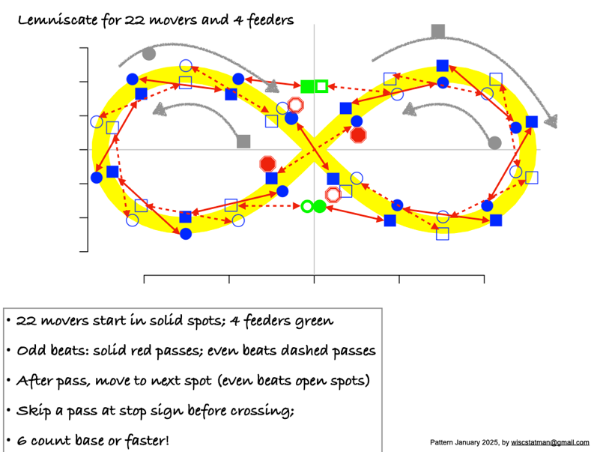
Figure 9. 26-person lemniscate description from the 2025 Madfest/IJA fest [I split the jokers in two, otherwise it would have been 24 jugglers]

Author Bio: Michael Newton is a longtime member of the Madison Area Jugglers, club passer, and pattern builder. When not juggling or hanging out with his awesome family, he’s a professor and department chair at the University of Wisconsin, Madison: instagram.com/wiscstatman/

Correctly pronounced with an accent on the second syllable and an ending that sounds a bit like ‘biscuit’
Figure by Kmhkmh - Own work, CC BY 4.0, https://commons.wikimedia.org/w/index.php?curid=50728078
Thanks to Freddy Astrada, Sky Bound Productions, for the drone coverage. https://www.instagram.com/p/DUGhfODCAq5/
I miscalculated in preparations for the first big lemniscate attempt (in Jan 2025), which meant everything was too small by a factor of about square root of 2. Jugglers were patient but the crossing lanes were very crowded!

