Kill-Screen clubs

**Nathan's proof that colliding clubs at beat 37 in KS 6-7-6/5 are the same as the clubs in the original first position (Feb 25, 2024).**

If we want to color coordinate the clubs that collide with each other, there's actually little work involved.  The first club that each juggler throws (pass or self) will be a club that collides at the end.

Here's a determination/proof:

When juggling we're all permuting our clubs through the same 6 permutations:  a-b-c --> b-a-c --> b-c-a --> c-b-a --> c-a-b --> a-c-b --> a-b-c ....      Call  these the "juggling permutations".

For a pattern involving multiple jugglers, we can use a matrix to represent each juggler's "juggling permutations":

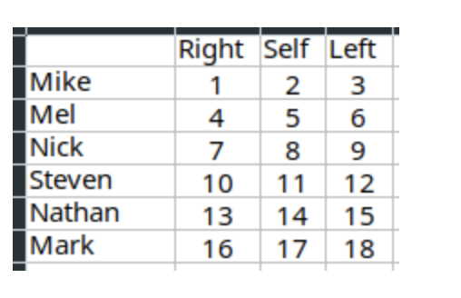

If we juggle for one throw (all selves, no passes), each juggler permutes their Right club with the Self club (assuming the self club is mid air and traveling towards the right hand), so then the matrix becomes:

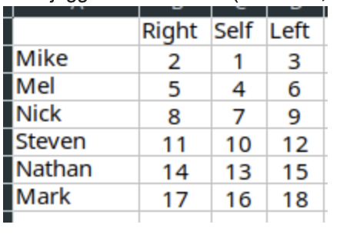

Notice that clubs 1,4,7,10,13,16 are all still in the same column, but shifted over (likewise for clubs 2,5,8,11,14,17).

This model would represent passes by permuting clubs across rows.  Let's say the second throw Nick and Mark pass (clubs 9 and 18, a left handed pass), while everyone else throws selves.  We would permute the Self and Left columns, and then swap clubs 9 and 18:

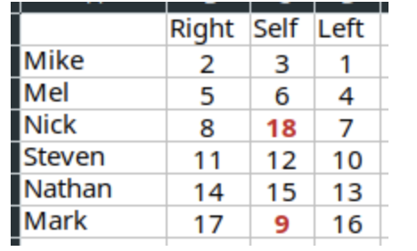

Notice that the columnar sets are still constant.  Even though clubs 9 and 18 swapped, clubs 3,6,9,12,15,18 are all still together in a column.

So then to determine which clubs will collide, we just need to determine which of the 6 different "juggling permutations" our jugglers will be in at throw number 37.  This can be easily modeled/determined using modulo.  37 mod 6 = 1, which means that the juggling permutation on throw  37 is the same as throw number 1, the first throw.  In other words, whichever clubs all started in the Right hand at throw 1 will be what will collide on throw number 37. □