# **Introducing the Pattern Book**

## **Welcome Jugglers and Friends**

Welcome to the *Madison Area Jugglers' Pattern Book*, a collection of club-passing patterns for intermediate to advanced passers. These patterns are part of our juggling repertoire. Many we learned or adapted from other jugglers; we include them because

it's fun trying to juggle them. But very many of the patterns in this book were born in Madison, Wisconsin, conjured up at Thursday/Sunday juggling sessions or at 47th Annual Madfests, annual events since 1992. The book offers some record of the evolution of club passing in Madison.

All jugglers are welcome to play with, use, distribute, extend, and otherwise enjoy all the club-passing patterns described in *Madison Area Jugglers' Pattern Book, Version 4,* which is licensed by its creators, the Madison Area Jugglers, under the [Creative Commons Attribution 3.0 Unported License](http://creativecommons.org/licenses/by/3.0/deed.en_US) . You may access the book [online](http://madjugglers.com), or check the latest updates at our [GitHub repository](https://github.com/wiscstatman/pattern-book). 

If you have questions, comments or suggestions relating to this book, please contact the Madison Area Jugglers. Where possible we have given credit to the creators of the patterns described here, though for many these origins were unknown to us. If we have erred in our attributions, please let us know.

This collection is a living document. New contributions are welcome for the next version, so please join the team and provide some pattern descriptions. *give an easy instruction on how to add*

## **About the Project**

Originally we wrote down the patterns just to save time arguing over exactly how we did the pattern last time. (Don't worry...there's still plenty of arguing, even with the book.) We were pleasantly surprised to find other people found our book helpful too! The pattern book can be used as a club passing guide or just a library of the patterns that we originated or find interesting. If you're from Madison, then it's a handbook to what we do twice a week, on Thursdays and Sundays, and if you don't know the patterns already then you probably will. This book is not intended to be an encyclopedia of all possible passing patterns (that would be a big book)! In fact, we don't include patterns just because they are *theoretically* possible; we include them if we have done them!

The Madison Area Jugglers (MAJ) have been attempting, inventing, and recording juggling patterns for longer than most of us can remember. In 1997, when our memories were already getting strained by the variations, Michael Newton (aka Prof Mike) compiled our first *Pattern Catalogue* to record the patterns for four or more jugglers. This morphed into the first *Pattern Book* by him in January 1999, but the hand-written collection (*Version 0.1*) was in a pretty limiting format. By October of that year, Steve Otteson created the first computerized collection by reformatting and expanding Mike's hand-written notes. Melonhead still carries around a tattered printout of *Version 1.0*. Steve made a few version updates, for example adding a bunch of extra-club patterns by Peter Kaseman and Luke Emery; the unusual computer format of Steve's version and his departure from Madison slowed down subsequent updates, even though the MAJ continued to create new patterns at a steady rate. The next big contribution was Luke Emery's version (*Version 2.0*, 2012). Though it was not widely distributed, Luke's version contained all kinds of new additions: more patterns for all numbers of jugglers, more on site-swap, more on specialized extra-club patterns, and tips for creating and doing patterns.

In 2015 Matt Hemke and Evan Driscol created a Github repository for the project, converted Luke's version into a repo, and updated the collection further. Chan Wilson, Jeff Adamus, and Melonhead began tracking the patterns we do at Thursday and Sunday MAJ practices. It's an amazing collection, and for those who remember the code words, like *1-5-1 Foie Graham* or *4-5 Twister*, it's enough to figure out what we really did. But most of us forget the code words after a while, except for the frequently juggled ones, and this was an impetus for the *Version 3.0* update by Prof Mike in 2018. Since then, we've suffered through two years of COVID restrictions and two lost Madfests (only 1 lost if you count spring ‘22). But we kept juggling and discovered some cool new patterns that work well with face masks! Nathan Nard's rejuvenating and inventive contributions helped to launch *Version 3.1* in 2023.

All along the editors have had substantial input from the Madison Area Jugglers and friends, and we are indebted to them for helping enhance this collection. Club passing

is a social pastime that needs a group of similarly inclined jugglers. Many of these patterns are inspired by other jugglers and patterns or created in collaboration with other jugglers. We hope that these patterns will help inspire new club passing ideas and help more jugglers all over the world enjoy club passing!

## **The Madison Area Jugglers**

*\*Mark, please write an intro paragraph or two on the MAJ\**

## **Version History**

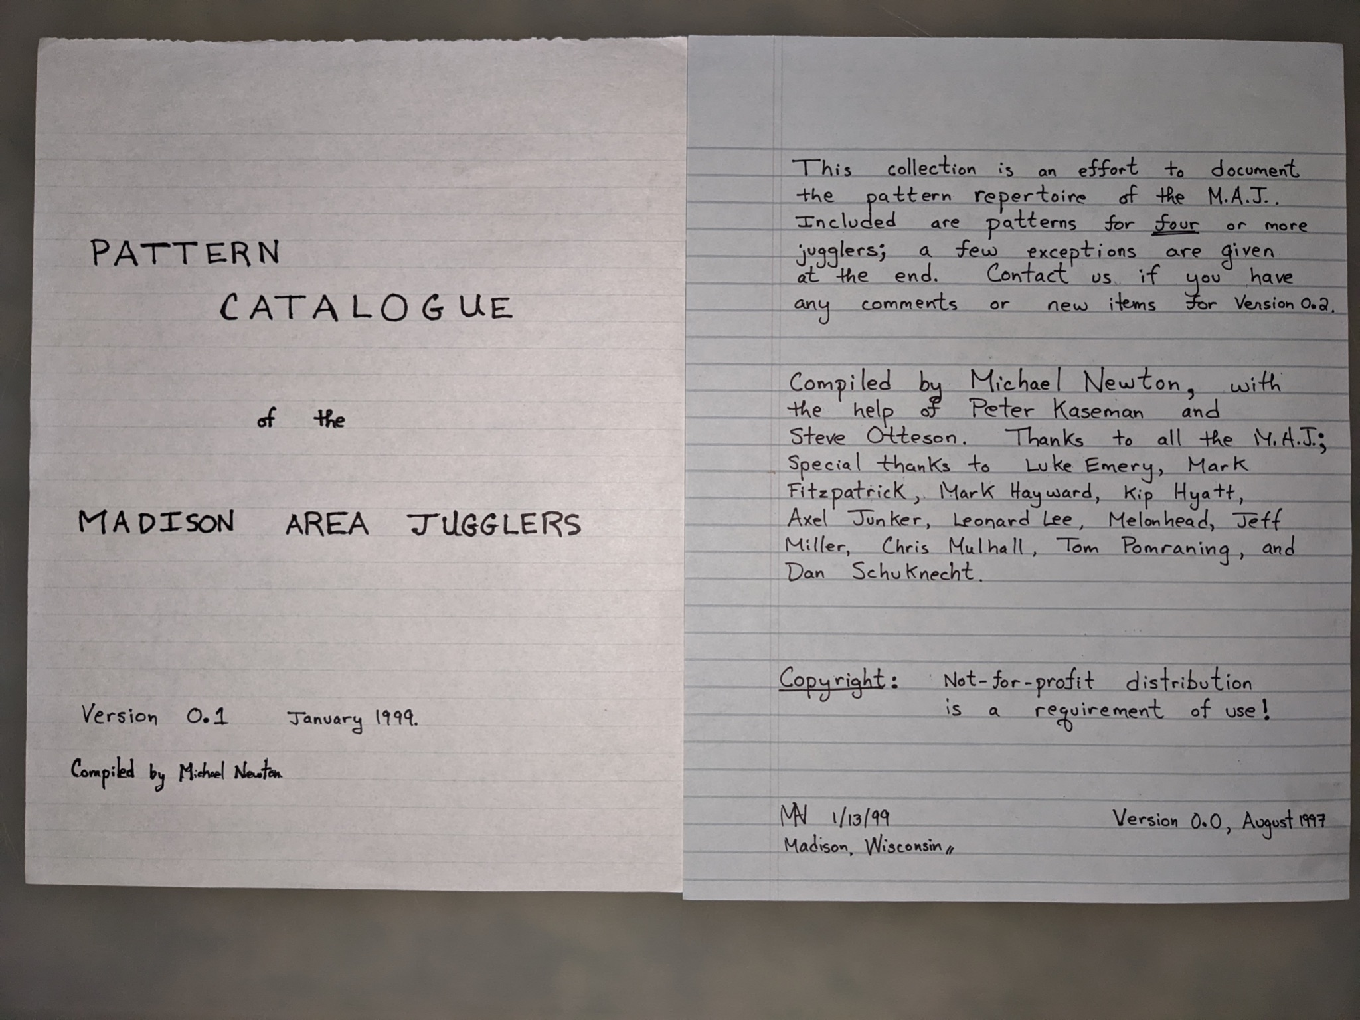

* Madison, Wisconsin, August 1997 Version 0.0

* Madison, Wisconsin, January 1999 Version 0.1

* Madison, Wisconsin, October 1999 Version 1.0

* Madison, Wisconsin, January 2001 Version 1.1

* Madison, Wisconsin, March 2001 Version 1.2

* Madison, Wisconsin, January 2012 Version 2.0

* Madison, Wisconsin, January 2018 Version 3.0

* Madison, Wisconsin, January 2023 Version 3.1

### **Updates in *Version 3.1****:*

We added a bunch of new patterns (e.g., *laxatives, the pollinator, the zigzag, sneaky-snake, that's-a-really-good-one, fully-loaded-blast, Mel's-dream*, and more). We added more on big patterns, including on the super-fun 24-person *hex-of-clovers*. At recent practices we've experimented a lot with colors, in which jugglers each start with a distinct set of clubs, and we see how long it takes to move the colors around. This version has some details on the substructure of a few of our cool patterns.

Thanks to Jeff Adamus for posting YouTube recordings of a bunch of our patterns; we've added links *where* (Thanks to Jeremy, Jessie, and ? others for great camera work!) . *other animations?*

Like all earlier versions, the current version contains mistakes and unfortunate omissions, which we have yet to discover and for which the Editors take responsibility. We hope that future versions will correct these shortcomings.

### **Updates in *Version 4.0*:**

**google doc version..prep for real book…new patterns …more uniform pics/tabular descriptions** [lead by MAN]

## **The Editors**

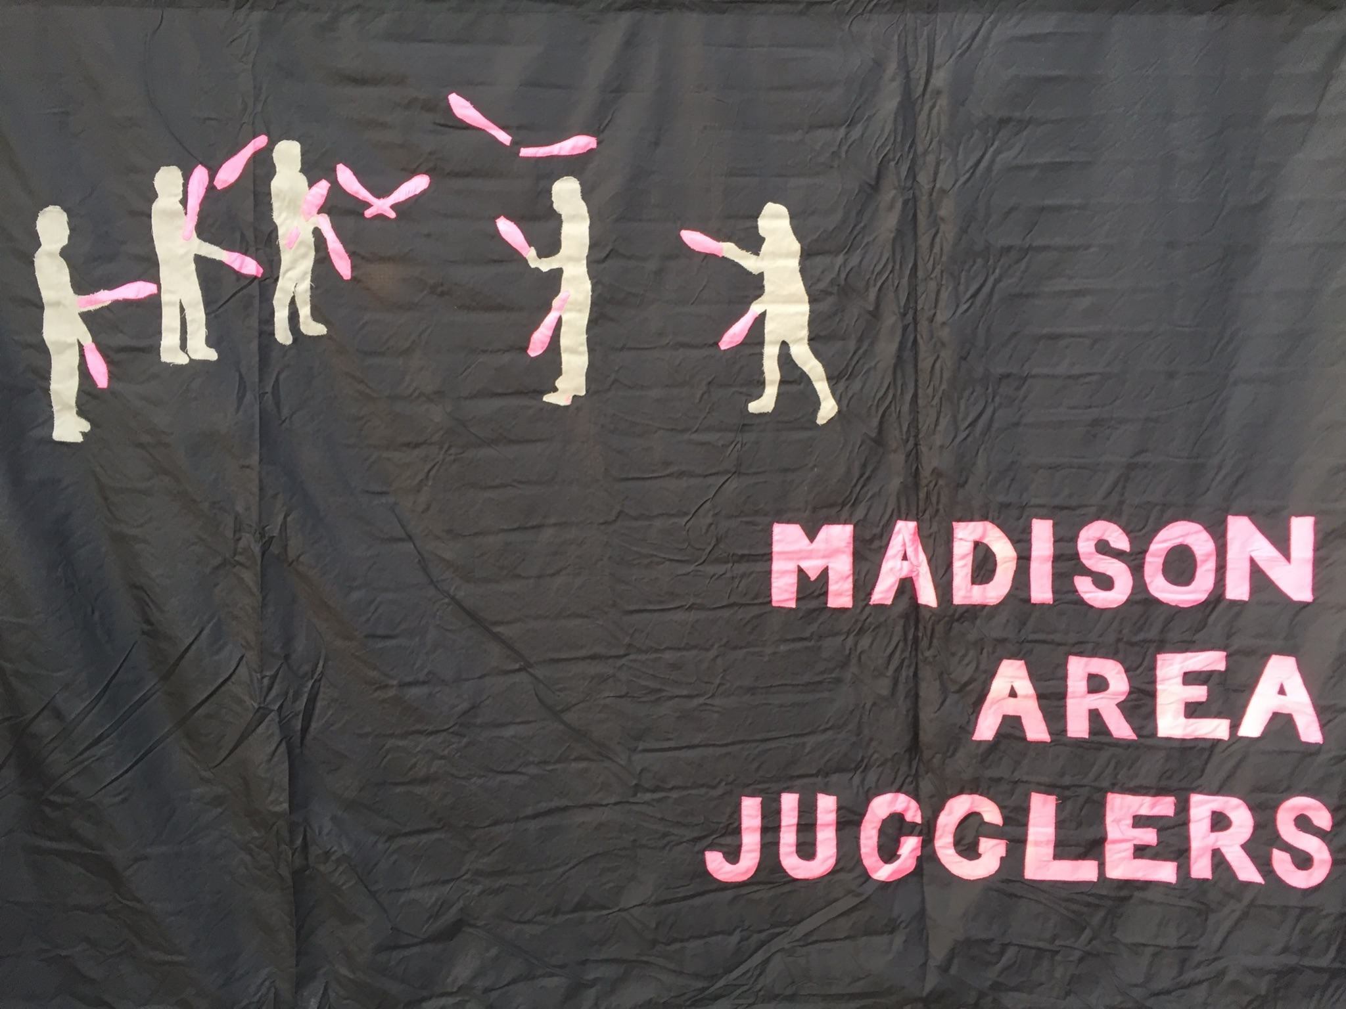

Michael Newton (aka Prof Mike) and the Madison Area Jugglers, especially (in alphabetical order): Jeff Adamus, Nick Aikens, Josh Casey, Steve Clipson, Evan Driscol, Luke Emery, Mark Hayward, Matt Hemke, Peter Kaseman, Melonhead, Nathan Nard, Graham Paasch, Steve Otteson, and Chan Wilson. You can be an editor too by working on the next version!

# **Preliminaries**

## **How To Read Patterns**

There seems to be an indefinite number of ways a single juggler can juggle, so it's not

surprising that a juggling *pattern*, which combines the efforts of multiple jugglers, can

also take many many forms. There are many exceptions -- and we cover a lot of them – but to develop our intuition it's convenient to start with standard formulations. Say

each juggler is throwing three clubs, alternating hands *right-left-right-left* etc, and juggling in sync with the others (all doing *right-left-right-left*...). In this standard formulation, passes are single-spin exchanges between jugglers, either right-to-left

or left-to-right throws. Even without adding extra clubs or unusual throws (heff's, zips, simuls, etc), there is an incredible variety of fun patterns found by varying where jugglers are and who passes to whom when.

## **Counts/Cycles**

A basic passing descriptor is the *count*, which tells the juggler how frequently to make a pass. In simple patterns each juggler's count is constant, but even simple patterns can be very difficult on a fast count. We say you are passing on an *m/n-*count if you make *n* passes in a cycle of *m* beats, counting on both hands. For example, 2/1-count means, *pass-self*, then repeat. When the denominator *n* is 1 we just say *m*-count, as in the familiar 1-count, 2-count, 3-count, and so on. Double-three count is a popular count, which in this notation is 3/2-count. Stating the count does not necessarily imply what hands are doing what, how many clubs are being juggled, or the starting configuration. E.g., left-hand 2-count is different from right-hand 2-count. Odd counts (i.e., odd *m*) are nicely balanced for the hands; then the only issue is the start, which we usually do out of the right.

Mortal jugglers, like us, can only do patterns that repeat. That repeatable unit is called a *cycle,* and it takes some total number of beats to complete on whatever is the base count of the pattern. Patterns with longer cycles are usually harder to remember and therefore harder to do, but not always. In many patterns each juggler does something relatively simple (i.e., a shorter *local* cycle) even if the whole pattern takes a long time to complete. Those are cool!

**on the recent kill screen and the unending pattern**

Throw timing, throw destination, and juggler position over time have to be recorded to describe a juggling pattern. We use tables and figures to express this information. For

example, the table below (right) describes a standard feed, with jugglers (letters) on the rows and passing beat (numbers) on the columns. We sometimes reverse row and column for complicated (longer-cycle) patterns. We often accompany the table with a simple figure showing how the jugglers are positioned (left). In moving patterns (later) we also indicate positions and transitions with a nodes-edges graph.

## **Tables**

### **Name of Pattern**

| LAYOUT  *where the jugglers are in space* |  | **Beat, base count** | | | | | |  |
| --- | --- | --- | --- | --- | --- | --- | --- | --- |
| **Juggler** | **1** | **2** |  | **…** |  | **N-1** | **N=Length of cycle** |
| **A** |  |  |  |  |  |  |  |
| **B** |  |  |  |  |  |  |  |
| **…** |  |  | *Who passes to whom* | | **wh** | | --- | |  |  |  |
|  |  |  |  |  |  |  |  |
| **Last juggler** |  |  |  |  |  |  |  |

The patterns we describe require jugglers to sync up. Commonly, this has everyone releasing a club from the right hand at the same time, and likewise everyone releasing a left at the next time step. For some patterns with extra clubs, there is still a syncing of releases, but with a subset of jugglers releasing from the left hand while others are releasing from the right. In either case, these patterns have a **base count** which refers to a way of counting the time steps of these releases (see notes previous section). For instance, right-handed 2-count is a common base, or right-handed 4-count, or a variety of more interesting counts (e.g., 1-3 on a 5 count). Typically passes happen on the named count, though not every juggler may be passing. And we may have time steps (beats) on that named count where no-one is passing. Patterns can be described in different base counts; often when learning a more complicated pattern we start with a slow base (e.g. 6 or 8 count), and then speed it up to a faster count as we learn. For convenience, we usually describe a pattern in base count that squeezes away the most all-self beats.

Other pattern descriptors can be more detailed and informative, and these are good for elaborate passing between 2 or 3 jugglers with extra clubs. But most of what we describe in this collection does not aim to record, for example, the state of every club at every time. Primarily, we are content with knowing who throws to whom when, and where everybody is. (But see Chapter ** with Nathan’s piano rolls to see a neat variation where all the clubs are tracked in elaborate patterns; we use these rolls to figure out the full cycle of a pattern; i.e. the number of beats to get back to the beginning.)

**Examples**

### **Standard feed (aka windshield wiper)**

|  |  | **Beat, right hand counting** | | | |
| --- | --- | --- | --- | --- | --- |
| **Juggler** | **1** | **2** | **3** | **4** |
| **A** | **B** | **C** | **D** | **C** |
| **B** | **A** |  |  |  |
| **C** |  | **A** |  | **A** |
| **D** |  |  | **A** |  |

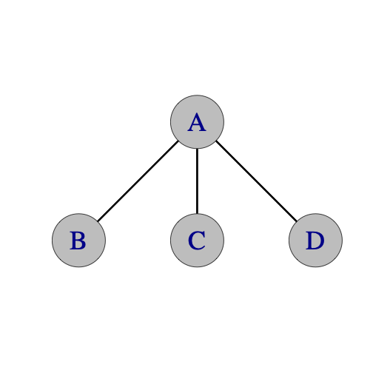

*Right hand counting* refers to a 2-count base count, starting with rights. Only the right hand throws are tabulated in columns. The column under each number indicates the jugglers that pass at that time. More specifically, an entry in a row/column is the juggler who receives a pass from the row juggler at that time beat. Since left hand passes are not made in the standard feed, they are not tabulated; self throws are indicated with a blank entry.

For example, if I was juggler **C** in the above pattern, I would read along the 3rd row to see where to pass. On the first pass (column 1), I have a self throw (the empty box represents a self throw). For the next right-hand throw (column 2), I pass to **A**. For the next two right-hand throws, I do a self throw followed by a pass to **A**. The table rolls over, so that the fifth pass is the same as the first; i.e. the pattern has a 4-beat cycle.

We can tabulate the same pattern in different ways; ignoring the layout, the following two tables describe the same pattern:

### 

|  | **Beat, right hand counting** | | | |
| --- | --- | --- | --- | --- |
| **Juggler** | **1** | **2** | **3** | **4** |
| **A** | **B** | **C** | **D** | **C** |
| **B** | **A** |  |  |  |
| **C** |  | **A** |  | **A** |
| **D** |  |  | **A** |  |

|  | **Beat, both hands counting** | | | | | | | |
| --- | --- | --- | --- | --- | --- | --- | --- | --- |
| **Juggler** | **1** | **2** | **3** | **4** | **5** | **6** | **7** | **8** |
| **A** | **B** |  | **C** |  | **D** |  | **C** |  |
| **B** | **A** |  |  |  |  |  |  |  |
| **C** |  |  | **A** |  |  |  | **A** |  |
| **D** |  |  |  |  | **A** |  |  |  |

Unless otherwise specified, all passes are single spins and do not cross. (We often say so in the extra notes!) Doubles and triples to juggler **A** are indicated by d-**A** and t-**A** respectively and are also straight unless noted. Special instructions like different counts, double selves, crossing passes or starting instructions may be noted in or below the table.

### **Typewriter Extra Club Feed (13 clubs)**

|  | **Beat, both hands counting** | | | | | | |
| --- | --- | --- | --- | --- | --- | --- | --- |
| **Juggler** | **1** | **2** | **3** | **4** | **5** | **6** |
| **A** | d-**D** |  | d-**C** |  | d-**B** |  |
| **B** |  | d-**A** |  |  |  |  |
| **C** |  |  |  | d-**A** |  |  |
| **D** |  |  |  |  |  | d-**A** |

* All jugglers make right hand double (d) passes.
* **A** starts with 4 and right hand
* **B**, **C** and **D** start with left hand

Here's an example with double straight passes and special instructions. In this case all the passes are right-handed passes, but we count both left and right-hand throws. A throws right Double pass to D, then left self, then right Double pass to C, then left self, then right Double pass to B.

*How to tip: Jugglers C and D should throw a little higher and deeper so A has*

*room to pass underneath to C and B.*

### **A Funny Left/Right Box**

|  | **Beat, both hands counting** | | | | | | |
| --- | --- | --- | --- | --- | --- | --- | --- |
| **Juggler** | **1** | **2** | **3** | **4** | **5** | **6** |
| **A** | **B** | **C** | **B** |  | **D** |  |
| **B** | **A** | **D** | **A** |  | **C** |  |
| **C** |  | **A** |  | **D** | **B** | **D** |
| **D** |  | **B** |  | **C** | **A** | **C** |

The above pattern has both hands counting, so the column under 1 is a right hand pass, the column under 2 is a left hand pass, etc. If I was juggler **D**, I will read the fourth row to see that I start with a right hand self (column under 1), followed by a left hand pass to **B** (column under 2). The next 4 throws are: right hand self, left hand pass to **C**, right hand pass to **A**, and a left hand pass to **C**. Then the pattern repeats.

**Site Swaps**

Occasionally we tap the wonderful world of site-swap notation https://en.wikipedia.org/wiki/Siteswap to describe patterns. For example, 7 club 2-count is 4p 3 | 3 4p (2<sup>nd</sup> juggler starts with left hand). There are a number of different site swap notations out there for passing. We use whatever seems to make sense to us at the moment and make no guarantee of consistency!

## **Glossary: Secret Juggling Code Words and Phrases**

**baby position**. The least challenging task in a juggling pattern, if there is one.

**Bernardos**. Unnecessary solo juggling tricks performed while other jugglers are trying to start a pattern. Named after Paul Bernardo, an expert of the craft.

**Canadian catch**. An impressive catch that would have been difficult for most mortal jugglers.

**carriage return.** A style of feeding where the feeder returns to the first feedee in the line after passing in sequence to all feedees. (also called typewriter)

**chalant.** To drop a perfectly fine pass due to lack of focus. The opposite of nonchalant.

**chocolate bar.** *pass--pass--self--self*; a 4/2-count. By convention, this starts with the right-hand pass.

**colors.** The restriction that each juggler starts the pattern with a visually distinct (usually by color) set of clubs.

**cross.**  A left-to-left or right-to-right pass.

**cycle.** The amount of juggling after which the pattern repeats.

**Doc Blanchard/Glenn Davis.** Mr. Inside/Mr. Outside.

**double 3-count.**  pass-pass-self: Academics insist that this is a 3/2-count not 2/3-count.

**encroachment**. Premature lane-crossing between two passing jugglers in a moving pattern. Usually entails a 5-yard penalty.

**everies.** 2-count

**every-others.** 4-count

**exclusion principle.** No two jugglers can occupy the same place at the same time.

**extra clubs.** When the number of clubs for the pattern exceeds three times the number of jugglers.

**feast**. A pattern having only feeders, usually arranged in a circle.

**feed.** A passing configuration where one juggler passes to multiple others.

**feedee**. One who passes with a feeder.

**feeder.** One who feeds. Usually this juggler is stationary.

**hup**. The vocalization that signals the end of the pattern.

**immaculate assumption.** When you think that a juggler is about to move or pass...maybe they even give you the look...you know, the **look**...but then they don't!

**Inverted**. A non-standard moving convention in a weave: move forward on the end and back through the middle. The standard convention is back on the end forward through the middle.

**I blame society**. An excuse for some juggling failure (usually by Mel).

**last jugglers' try.** The last attempt at a pattern, but only if it goes well enough.

**leader.** One who calls out, *jugglers ready: up, down, ...* at the beginning of a pattern.

**Mel catch**. The act of catching the fat end after a 2.5 triple up.

**Mr. Inside/Mr. Outside**. The two feeding positions of a doubly-fed weave. Gender!

**mustard**. Energy, power, spice, velocity or chi added to throws. As in, "Your corner

passes need more mustard." Also, crispy. The opposite of mustard is mayonnaise.

**NFP.** Nice Pass.

**No, this is a club**. Said while pointing to a juggling club and talking to a curious

passer-by who asks about the group, "Is this a club?".

**olive**. In a stacked, sandwich-style pattern, a single feeder on one side of the pattern.

**orbiter.** A juggler who orbits a standard moving pattern and passes to others on some of their would-be self throws.

**phantom**. A feedee placeholder who isn't really there. A feeder, for example, may feed 2 real feeders and a phantom in a sweep feed: *pass-pass-self-pass* and repeat.

**plus**. A suffix added to indicate an extra club added to the base pattern.

**post.** A stationary orbiter.

**run it.**  Continue juggling for an indefinite number of cycles.

**scheisse**. An utterance of frustration, possibly by Dan Schuchnect.

**Someone passed me a bad self**. An excuse for dropping.

**southern Wisconsin convention**. When changing sides from a feedee position in a standard count, do so on an outside-throw/inside-catch; e.g. on a right-hand throw/left-hand reception when on the right side of the feedee line.

**straight.** A right-to-left or left-to-right pass.

**sweenish**. A fancy final move in a pattern, preferably clean.

**three-count.** In Madison, the default passing count between two jugglers. Sometimes called the *waltz*.

**tomify.** Replace a pass-self or a pass-self-self with pass-pass-pass to the same recipient. (thanks Tom Pomraning)

**triple up**. The showy last action in a pattern, after the hup, in which each juggler lofts a triple self.

**ultimate**. 1-count

**walk it through**. To perform a slow-motion instance of a pattern, with juggling replaced by the holding of clubs, with passes replaced by pointing to where you would pass, and following a slow, deliberate count by the leader. Done while setting up a pattern in order for jugglers to figure out what they are supposed to do.

**weave.** A most popular moving pattern with three feedees and a feeder, which is the basis of many multi-person patterns. The 3 feedees move in a figure 8 while juggling.

**windshield wiper.** The more common style of feeding where the feeder first feeds the line in sequence, and then returns in reverse order. Windshield wiper and carriage return are the same with two feedees, but differ for three or more feedees.

**wuss.** The amount of gentleness, tenderness and love added to a juggling throw. Compare to mayonnaise. Also, the quality of passes you would make to your favorite

grandmother. As in, "Please add some wuss to your middle passes. You're hurting my catching hand!"

**You herniated my ZOC**. Said if a pass forced extension and excessive effort in the catching.

**ZOC.** Zone of Catchability. The volume near a juggler in which successful catches are probable, as in, “Peter Kaseman has the largest ZOC in Madison.”

**ZOOS**. (sounds like the Greek god Zeus) Zone of occupied space. Space occupied by a moving juggler.

## **Random Tips on Passing Patterns**

*Better never than late.*

If you miss a passing beat, don't pass on the next throw! Instead, wait for the pass opportunity to come around again in the regular cycle of the pattern.

*Always keep your eye on Mel*.

Don't pick up the clubs until you're sure the pattern is over, unless you know you can pick up and keep juggling. Even when you're not juggling, it's wise to keep an eye on Mel.

*Juggle slow, move fast*.

You get it. There's a tendency to speed up your juggling when you move. Don't.

*Lift your selves.*

So you slow down!

*Juggling means never having to say you're sorry.*

No, really. Don't say you're sorry unless you draw blood. However, if you draw blood then you do have to say you're sorry.

lots of passing! If people want to do a hard pattern that is too advanced

for beginners then they will, and you'll be left out of that one. Just do a

pattern with somebody else. If we're juggling with you it's because we want

to, not because we have to. Most patterns have positions of varying skill

requirements, so if you're a beginner in a bigger or more advanced pattern,

we'll try to put you in the best spot for your level. Just try to do the

best you can, and if you drop, try to keep the timing anyway.

*Mike's the leader*.

Unless he's not.

*Throw global, catch local*.

A prescription for happy passing.

*The wind is our friend.*

Remember this when juggling outside.

## **Mastering the craft**

### **Timing**

It may already be obvious, but good timing is critical to group passing

patterns. One of the best tools to keep timing is your ears. For most patterns,

all the catches should happen at the same time. When the timing is perfectly

synchronized the sound of catching clubs is a metronome for the pattern.

Otherwise, find a juggler in your field of vision and make sure you throw at

exactly the same time as they do (either passes or selves).

Make sure all the passes of the same spin go to the same height.

For many patterns, selecting a juggler to count out loud as a metronome can be

very helpful.

And follow the leader!

*MAJ timing*: We estimate 0.9 seconds per right hand beat for no-extra-club passing.

This is a little slower than at most North American sites and a little faster than at some European sites!

### **Leads**

The second most important skill is for the passer to lead the catcher in the

direction they are moving. The amount of lead varies based on the height of the

throw, the tempo of the juggling, and how fast the weaver is moving.

Outside leads are the easiest, because they are thrown away from the catcher's

pattern.

Inside leads are trickier, because they are thrown towards the catcher's

pattern, and if the passer is exchanging clubs with the catcher, the two passes

are prone to collision. (For some patterns, such as the *Cyclone*, the weavers are

moving so fast that the inside leads go all the way on the other side of the

incoming pass.)

One key to throwing good leads is to be able to see where your passes land.

That's a difficult skill at first, and especially hard for some patterns with

high throws, but your target will certainly appreciate the effort. Otherwise,

good communication (especially for dropbacks or other blind passes) helps fine

tune lead throws.

Remember that in a feed, the feedee on the same side as the feeder's pass must

throw an inside and/or deep pass to give the feeder room to throw underneath to

the next feedee.

### **Turning**

Twister weaves and other fun patterns are all about turning. In general you can classify how hard a moving pattern is by how many selves are allocated to turn 180 degrees. For example, the *Standard Twister Weave* has 5 selves (weaving in 6-count). The *Fast*

*Spiral* has 3 selves (weaving in 4-count). The *Chocolate Swirl* has 1 self (crossing sides in double 3 count).

In most of these patterns you can turn either to the outside or the inside. One turn is usually easier than the other, but I recommend jugglers learn both turns whenever possible. Learn turning in easy patterns like the *Twister Weave* and then you can apply those to *Clovers* or *Strange Attractors* and other more advanced weaves.

It is also helpful to practice turning while juggling solo. How many selves does it take for you to turn 180 degrees while spinning continuously?

### **Learning**

Take advantage of opportunities to pass with jugglers better than you. That's how you'll learn timing.

Take advantage of opportunities to pass with jugglers less skilled than you. That's how you'll learn catching.

Be sure to pass with jugglers at the same level as you. That's how you know how good you really are. :)

Lots of passing patterns benefit from solo skills too. You'll need to be able to juggle 4 clubs comfortably in triple singles, double singles and the fountain to do a lot of the 7 and 8 club based passing patterns.

## **Passing Pattern Philosophy**

We're occasionally asked at juggling conventions, where do you come up with all these patterns? Actually, they sort of make themselves once you invite the opportunity. Here are some tips on how to make new passing patterns and have fun doing it. We discuss some other pattern generation techniques in Chapter 12.

### **Mutate**

* Start with a classic juggling pattern or any geometric figure (box, triangle,

star, Y, W, line, etc.).

* Think about everybody juggling 3 or 4 clubs.
* Replace any selves with a pass to another juggler doing a self.
* Switch the positions of jugglers, but retain the passing sequence.
* Try the same movement in a different count, or left handed.
* Try the same passing sequence in a different movement.

### **Complicate**

Why not make things harder? You get better at basic patterns if you try harder variations; plus they can be interesting if they're not too hard. (We estimate that a success rate of 1/3 is optimal for making progress and retaining interest!)

* Replace any 3-count with a double 3-count.
* Replace any feed with an extra club feed.
* Replace any extra club feed with a 2 extra club feed.
* Make stationary jugglers move (circles, clovers, figure eights, or any juggling siteswap just to name a few).
* The clubs can be passed in any juggling pattern or siteswap (admittedly, patterns get challenging quickly once you get past the easier siteswaps).

### **Combine patterns** (*Mating*)

Replace any position with a set of jugglers that spits out that same count. E.g. replace one person doing a 4-count with one side of a *Twister Weave*; or replace a 2-count person with a *Weave* (assuming there is room!). This is the source of many fun big patterns, such as the *Egg-Beater-Twister*.

### **Stacking**

Weaves-of-three and spinning-pairs are pattern components that emit passes on either side of a line. They are naturally combined into multi-layer patterns by stacking them up against each other in parallel. Then feeders (sometimes called *olives*) or same-facing movers anchor either end of the stack. We get simple descriptors for quite elaborate patterns, such as 1-2-3-2-1, or 1-2-2-2-2-2-1. (See later chapters for more details.)

### **Starting**

There's nothing that saps mojo more than a long discussion about how to start or progress through a pattern. Keep instructions simple, informative, and clear. Warm up by doing parts of a pattern in isolation. Walk it through and minimize the Bernardos.

For very big patterns, we use two decks of playing cards: one is used to mark starting positions by taping cards to the floor; a matched set from the second deck is handed out to the participants. The leader just instructs jugglers to find their positions, and they usually self-organize! We also use tape on the floor to mark movements or passing lanes to keep it clear.

### **Make it interesting**

* Many of our favorite patterns are group collaborations where lots of people gave ideas for new ways to move or pass.
* Share your favorite club passing patterns with other jugglers and listen to their ideas too.
* Recognize the skill level of your participants and do patterns in which everyone can be challenged while also having fun.

Antonio Vivaldi, in 1725, titled his Opus 8, 12 Concerti for chamber orchestra and

violin,  *Il cimento dell'armonia e dell'inventione*, or, *The contest between harmony and invention*. There's no evidence he was juggling, but there is a connection to our endeavor. To be worked on, a juggling pattern has to be sufficiently novel that it is interesting for the participants to engage in, but also sufficiently regular that it can be mastered with reasonable effort. The fact that the Pattern Book has grown is testament to the fact that jugglers regularly pass clubs in Madison; for this activity to persist there must be invention of new things; and as well there must be consistent elements -- count signatures or motion elements -- that we master and then recombine in interesting and enjoyable ways.

## **Internet Passing Resources**

The world of juggling has many contributors and contributions that we have failed to identify in this collection. Some important ones we know about are:

* [Flying Karamozov Brothers](http://www.fkb.com/)
* [Gandini Juggling Project](http://www.gandinijuggling.com/)
* [Martin Frost's Youtube channel](https://www.youtube.com/user/elgra2)
* [JiBe's passingDB site](https://www.passingdb.com/)
* [International Juggling Association site](http://www.juggle.org)
* [Will Murray's site](http://www.csulb.edu/~wmurray/)
* [Mark Weston's passing collection](http://www.varietyartsdirectory.com/resources/PassingPatternsAug06.pdf)

# 

# **Three Person Patterns**

Big patterns come from little patterns, so we start small! Arrangements for three stationary jugglers are limited, with the most popular arrangement being the *feed* (one feeder **A** exchanges with two feedees **B, C**). Polls indicate that triangles and lines are fun but less popular! Exchanges happen between any pair of jugglers in triangles, and lines – well lines usually require some brave person in the middle who doesn’t mind risking injury from an errant pass! Even without any moving among positions, there’s an impressive variety of feeds, triangles, and lines to delight any juggling trio. We provide details of some of our favorites below.

| Feed | Triangle | Line |
| --- | --- | --- |

* Edges in each graph indicate possible exchanges between the jugglers.

## **Stationary Three Person Patterns**

### **Basic Feed**

The feed for 3 jugglers is the simplest 3 person pattern and maybe the first one you try. It’s a great building block for all kinds of other patterns.

|  | **Beat,**  **right hand counting** | | |  |
| --- | --- | --- | --- | --- |
| **Juggler** | **1** | **2** |  |
| **A** | **B** | **C** | **feeder** |
| **B** | **A** |  | **feedees** |
| **C** |  | **A** |

**Many variations, e.g.:**  left handed, chocolate bar, feeder in double 3-count (and feedees in 3-count), or Tom's (which is 3 passes in a row to each feedee with no selves for the feeder). Here’s a variation that’s been popular in Madison since Version 3.0.

### **Ryan's Feed**

|  |  | **Beat, both hands counting** | | | | | | | |
| --- | --- | --- | --- | --- | --- | --- | --- | --- | --- |
| **Juggler** | **1** | **2** | **3** | **4** | **5** | **6** | **7** | **8** |
| **A** | **B** |  | **C** |  | **B** | **C** | **C** | **B** |
| **B** | **A** |  |  |  | **A** |  |  | **A** |
| **C** |  |  | **A** |  |  | **A** | **A** |  |

* <https://jugglingfan.org/pmwiki/pmwiki.php?n=Patterns.RyansFeed>
* Think 1-5-8 and 3-6-7 for the two feedees.
* Variation: Inverted version has **B** and **C** swap
* Variation: Change side and turbo variants [see ahead]

### **Rotating Feed (i.e. Feast for 3)**

|  | **Beat,**  **right hand counting** | | | |
| --- | --- | --- | --- | --- |
| **Juggler** | **1** | **2** | **3** |
| **A** | **B** |  | **C** |
| **B** | **A** | **C** |  |
| **C** |  | **B** | **A** |

### 

* I.e. Everyone feeds everyone else, hence the name
* This feast is clockwise from above
* **Variations:** change count (e.g. 4 count easier; odd counts fun); go counterclockwise

### 

### **Basic Triangle**

|  | **Beat,**  **Any odd count** | | |
| --- | --- | --- | --- |
| **Juggler** | **1 (R)** | **2 (L)** |
| **A** | **C** | **B** |
| **B** | **A** | **C** |
| **C** | **B** | **A** |

### 

* When on 3-count base, this is a default pattern for 3 jugglers in Madison (almost as popular as basic feed!)
* **Variations:** changing the count, making it odd, maintains the pattern but slows it down; as written the throws are the preferable inside triangle throughs; switching **B** and **C** gives outside throws, which seem harder for most jugglers owing to wide angles
* **More variations:** Stay on even count, restrict to rights only (or lefts only) and just do **A**->**B**->**C**, (i.e. take one column; cycle of length

### **Pulsar [MAYBE TIME TO RETIRE…DOES THIS WORK??]**

| **Juggler/beat** | **1** | **2** | **3** | **4** | **5** | **6** | **7** | **8** | **9** | **10** | **11** | **12** |

|-------------|-------|-------|-------|-------|-------|-------|-------|-------|-------|--------|--------|--------|

| **A** | B | C | | C | | B | C | B | C | | B | |

| **B** | A | | C | | C | A | | A | | C | A | C |

| **C** | | A | B | A | B | | A | | A | B | | B |

> * Right hand counting

> * Rules:

> * Jugglers take turns as feeders: A is first, then C, then B (repeat).

> * Each feeder feeds the other 2 jugglers.

> * The next feeder feeds in the opposite order of the previous feeder.

A starts as the feeder and feeds right-left. C is the next feeder and feeds opposite of A, so C feeds left-right. B, the next feeder, feeds opposite of C, namely, right-left. A then feeds left-right, followed by C with right-left, and B finishes the pattern with left-right.

I recommend that feeders call out what they are doing (right-left or left-right) so that the next feeder will know what to do. This will also help every juggler know what is going on.

With the rules and the recommendation, you won't have to memorize all of the passes in the stinking table.

Try this with 1-count, so that both hands pass when you are the feeder.

Pulsar dates to 1993 by Steve Otteson and MAJ.

### **Puzzle Feeder**

|  |  | **Beat, both hands counting** | | | | | | | | | | | |
| --- | --- | --- | --- | --- | --- | --- | --- | --- | --- | --- | --- | --- | --- |
| **Juggler** | **1** | **2** | **3** | **4** | **5** | **6** | **7** | **8** | **9** | **10** | **11** | **12** |
| **A** | **C** |  | **C** | **B** |  | **C** | **B** |  | **B** | **C** |  | **B** |
| **B** |  |  |  | **A** |  |  | **A** |  | **A** |  |  | **A** |
| **C** | **A** |  | **A** |  |  | **A** |  |  |  | **A** |  |  |

* Right hand starts
* **A** is the feeder, and **B** and **C** are doing the 2-person *Three Piece Puzzle* pattern six throws out of phase.
* *Three-Piece Puzzle* and *Puzzle Feeder* patterns are by Jim Brennen
* Steve Otteson in the mid-90’s promoted this pattern; but it’s not juggled frequently

#### 

### **Puzzle Feast**

|  |  | **Beat, both hands counting** | | | | | | | | | | | |
| --- | --- | --- | --- | --- | --- | --- | --- | --- | --- | --- | --- | --- | --- |
| **Juggler** | **1** | **2** | **3** | **4** | **5** | **6** | **7** | **8** | **9** | **10** | **11** | **12** |
| **A** | **C** | **B** |  | **C** | **B** |  | **B** | **C** |  | **B** | **C** |  |
| **B** | **A** | **C** |  | **A** | **C** |  | **C** | **A** |  | **C** | **A** |  |
| **C** | **B** | **A** |  | **B** | **A** |  | **A** | **B** |  | **A** | **B** |  |

* Both hands counting, right hand starts
* All 3 jugglers are doing what the feeder did in *Puzzle Feeder*.
* *Puzzle Feast* is by Steve Otteson

### **Mel in the Middle**

|  |  | **Beat, both hands counting** | | | | | |
| --- | --- | --- | --- | --- | --- | --- | --- |
| **Juggler** | **1** | **2** | **3** | **4** | **5** | **6** |
| **A** | **C** | **B** |  | **C** |  |  |
| **B (Mel)** |  | **A** |  |  | **C** |  |
| **C** | **A** |  |  | **A** | **B** |  |

#### 

#### 

#### 

* A double 3 count pass feed with a moving juggler in the middle spinning around.
* If Mel is B (Mel is always **B)**, and starts facing **A**, then it is as above.
* **Variation:** slow it down or don’t spin every time

### **Peter’s Backcrosses**

|  |  | **Beat,**  **3-count base** | |
| --- | --- | --- | --- |
| **Juggler** | **1 (R)** | **2 (L)** |
| **A** | **B** | **C** |
| **B (Peter)** | **C** | **A** |
| **C** | **A** | **B** |

#### 

#### 

#### 

* All jugglers are in 3-count (or a slower odd count, like 5 count)
* Notice that **A**’s rights have to be lofty over **B**’s selfs: ditto for **C**’s lefts
* **A’**s lefts (likewise **C**’s rights) go behind Peter, who is facing down [relative to layout above]
* **Variation:** 1-count…only a dream

### **Siteswap Feeds**

It’s a can of many worms, but here are a couple!

|  | **Beat,**  **Both hands counting** | | | |
| --- | --- | --- | --- | --- |
| **Juggler** | **1** | **2** | **3** |
| **A** | d-**B** | d-**C** | **1** (zap**)** |
| **B** |  | **A** |  |
| **C** |  |  | **A** |

### 

* Right hand starts
* **A** does 441 (i.e. double pass, double pass, shuffle=zap)
* Variations: **A** can throw cross double passes and **B** and **C** can throw cross passes too (starting on opposite hands).

| **Juggler/beat** | **1** | **2** | **3** |

|-------------|-------|-------|-------|

| **A** | T-C | B | 1 |

| **B** | | A | |

| **C** | | | A |

> * Both hands counting, right hand starts

> * A does 5px3px1 (i.e. triple pass, single pass, shuffle)

Alternatively, A can throw straight passes and B and C can throw cross passes (starting on opposite hands).

**Q: Luke, is this correct?**

### **Hovey's Nightmares ?**

## **Three Person Patterns with Extra Clubs**

The most popular extra-club feed in Madison has been the 10 club right-handed two-count feed in doubles. The only tip is for the feedee on the feeder’s right (**B**) to send slightly loopy doubles in order to avoid collisions with the feeders pass to the feedee (**C**) on their left. Adding clubs without modifying the structure requires throwing higher, faster, and with more spins!

The likes of Peter, Nick, and Steve can routinely juggle more elaborate extra club variations, such as the following. There are 4-count feeds in triples and popcorn feeds in 5-count, 6-count and 7-count. And 7 club double 3-count feeds in pass, pass, pause. And extra club chocolate bar feeds. Here are some more.

### **4 Count Popcorn Feed**

|  |  | **Beat,**  **right hand counting** | |
| --- | --- | --- | --- |
| **Juggler** | **1** | **2** |
| **A** | **C** | **B** |
| **B** | **A** | t-self |
| **C** | t-self | **A** |

* B starts with 4
* t-self means triple to self

### **6 Count Popcorn Feed**

|  |  | **Beat,**  **right hand counting** | | |
| --- | --- | --- | --- | --- |
| **Juggler** | **1** | **2** | **3** |
| **A** | **C** | t-self | **B** |
| **B** | **A** |  | t-self |
| **C** | t-self | **A** |  |

* **B** starts with 4
* This variation makes a nice triangle too.
* **Variations:** you can replace any triple self, self, single pass with a triple pass, single self to make things more interesting, or with double straight self, double straight self, pass (533p, 5p33, 443p, 44px3 all work).

### **5 Count Popcorn Feed** (one variation)

|  |  | **Beat,**  **both hands counting** | | | | |
| --- | --- | --- | --- | --- | --- | --- |
| **Juggler** | **1** | **2** | **3** | **4** | **5** |
| **A** | d**-B** |  | d**-C** |  |  |
| **B** |  | t-self |  | d-**A** |  |
| **C** |  | d**-A** |  |  | t-self |

* **A** and **C** start with 4
* The timing is a bit wonky, **B** and **C** should delay slightly at the start.
* 4.5p:B 3 4.5p:C 3 3 | 3 5 3 4.5p:A 3 | 3 4.5p:A 3 5 3

### **Why Not + 5 count** **add the variation where feeder is doing WHY NOT**

### **Extra clubs chocolate bar feed** (one variation)

|  |  | **Beat,**  **both hands counting** | | | |
| --- | --- | --- | --- | --- | --- |
| **Juggler** | **1** | **2** | **3** | **4** |
| **A** | dx**-B** | dx-**B** | dx**-C** | dx**-C** |
| **B** | **A** | **A** | d-self | d-self |
| **C** | d-self | d**-**self | **A** | **A** |

### 

### 

### 

* **A** and **C** start with 4 clubs
* **A** throws all crossing doubles (dx)
* **B** and **C** throw chocolate bar, then double self, double self
* The double selves are straight

Other feeds: Fast/Slow Feeds, Gorilla Feeds, Site-Swap Feeds...we’ve done them all in Madison, but they haven’t made it of the Pattern Book!

### **Extra Club Rotating Feed (for 3 jugglers)**

|  |  | **Beat, both hands counting** | | | | | | | | |
| --- | --- | --- | --- | --- | --- | --- | --- | --- | --- | --- |
| **Juggler** | **1** | **2** | **3** | **4** | **5** | **6** | **7** | **8** | **9** |
| **A** | d-**B** |  | d-**C** |  | d-**C** |  | d-**A** | pause |  |
| **B** |  | d-**A** |  | d-**B** | pause |  | d-**C** |  | d-**C** |
| **C** | d-**C** | pause |  | d-**A** |  | d-**B** |  | d-**B** |  |

* Both hands counting, right hand starts for **A** and **C**
* **B** starts with left hand; notice each juggler does a double self at some point
* **Variations:** Once you're comfortable with this pattern, try pirouetting under the double self, or instead of throwing the double self, do two single selves and an early triple straight pass instead (followed by a pause), or both! Pattern by Luke Emery, 1999.

There are a lot of nice extra-club triangle variations. Here are a few examples to play with.

### **10 Club 3 Count Triangle**

|  |  | **Beat, both hands counting** | | |
| --- | --- | --- | --- | --- |
| **Juggler** | **1** | **2** | **3** |
| **A** | dx-**C** |  |  |
| **B** |  |  | dx-**A** |
| **C** |  | dx-**B** |  |

* Jugglers start in sync with right hands; **A has 4**
* All passes double spin crossing passes

If that isn't challenging enough. Add more clubs and passes. A and C start with 4.

### **11 Club 2 of 3 Count Triangle**

|  |  | **Beat, both hands counting** | | |
| --- | --- | --- | --- | --- |
| **Juggler** | **1** | **2** | **3** |
| **A** | dx-**C** | dx-**C** |  |
| **B** | dx**-A** |  | dx-**A** |
| **C** |  | dx-**B** | dx**-B** |

* Jugglers start in sync with right hands; **A, B have 4**
* All passes double spin crossing passes**CONFIRM WITH LUKE…**

### **12 Club 1-Count Triangle**

|  |  | **Beat, both hands counting** | |
| --- | --- | --- | --- |
| **Juggler** | **1(R)** | **2(L)** |
| **A** | dx-**C** | dx-**C** |
| **B** | dx**-A** | dx-**A** |
| **C** | dx-**B** | dx-**B** |

**\***A-level pattern!

The 10 club version has been around for some time. We learned it from some fellow club passers at a convention, but I don't remember from whom. 11 Club and 12 Club variations are by Luke Emery, 2005, although it seems likely that other jugglers have also tried them.

There are corresponding extensions to a 5 person star in the chapter on 5 Person Patterns.

### **10 Club Triangle with Triple-Single-Single**

|  |  | **Right hand counting** | | |
| --- | --- | --- | --- | --- |
| **Juggler** | **1** | **2** | **3** |
| **A** | t-**C** | **B** | **C** |
| **B** | **C** | **A** | t-**A** |
| **C** | **B** | t-**B** | **A** |

* **A** starts with 4
* You can skip all the single passes until the triple passes are reliable.

### **6-Count Popcorn Triangle**

|  |  | **Right hand counting** | | |
| --- | --- | --- | --- | --- |
| **Juggler** | **1** | **2** | **3** |
| **A** | **C** |  | t**-self** |
| **B** |  | t**-self** | **A** |
| **C** | t**-self** | **B** |  |

* **A** starts with 4
* You can skip all the single passes until the triple passes are reliable.

### **5-Count Popcorn Triangle**

|  |  | **Both hands counting** | | | | |
| --- | --- | --- | --- | --- | --- | --- |
| **Juggler** | **1** | **2** | **3** | **4** | **5** |
| **A** | **C** |  |  | t**-self** |  |
| **B** |  |  | t**-self** |  | **A** |
| **C** | t**-self** |  | **B** |  |  |

* **A** starts with 4 and right throw
* **C** starts with left
* **B** starts with right
* All passes are crossing and alternate hands
* Timing is wonky (hands really aren't all synced up, so the table is a little misleading!!)
* **C** should wait a bit before the first triple, throw high lofty single crossing passes): 3.3px3 3 5 3.
* Another 5-Count triangle is to throw crossing triples to the left in 5-count. This timing is also wonky 1 2/3 count or some such difference between each juggler.
* The pattern should be possible in 5-count with triple crossing passes too...Hmmm... But fast...

### **10 Club 4-Count Triangle**

This is probably the simplest extra club triangle, but jugglers are out of sync so it doesn’t fit neatly into the tabular format. The juggler with 4 clubs starts with a right hand double to the left and then repeats in 4-count. Each juggler passes a right handed double to the left as the incoming double pass approaches. The timing on this pattern is not symmetric. Each juggler is 1/3 beat out of time with the juggler before. This pattern can be extended to a number of interesting variations, such as the *Bubbler of David*.

#### Swiftly Tilting Popcorn ??NOT SURE A AND C NOT SYMMETRIC..??

Extra club version of Mel in the Middle, except in 4-count instead of 3-count. Inside person whirls with half pirouettes under doubles while outsides do popcorn. All passes are right handed.

\footnotesize

| **Juggler/beat** | **1** | **2** | **3** | **4** | **5** | **6** | **7** | **8** | **9** | **10** | **11** | **12** | **13** | **14** |

|-------------|-------|--------|-------|-------|--------|-------|--------|-------|-------|--------|--------|--------|--------|--------|

| **A** | D-C | | B | | D-C | | T-self | | D-C | | D-C | | B | |

| **B** | | | A | | D-self | ½ P | | C | | D-self | ½ P | | A | |

| **C** | | T-self | | D-A | | D-A | | B | | D-A | | D-A | | T-self |

\normalsize

> * Both hands counting

> * A starts with 4 clubs, right hand

> * B starts facing A, right hand

> * C starts with left hand

> * ½ P marks half pirouette underneath the double

> * 1 is the same as 11. This is just one possible variation of spinning underneath popcorn.

### **Swiftly Tilting Popcorn **CHECKING TO MATCH ABOVE BUt OUt OF SYNC**

|  |  | **Beat, both hands counting** | | | | | |  |  |
| --- | --- | --- | --- | --- | --- | --- | --- | --- | --- |
| **Juggler** | **1** | **2** | **3** | **4** | **5** | **6** |  |  |
| **A** | **C** | **B** |  | **C** |  |  |  |  |
| **B (Mel)** |  | **A** |  |  | **C** |  |  |  |
| **C** | **A** |  |  | **A** | **B** |  |  |  |

#### 

* **A** starts with 4 clubs, and right hand
* B starts facing A, and right hand
* C starts with left hand
* ½ P marks the half pirouette underneath the double
* 1 is the same as 11??

### 

### **Line Variations**

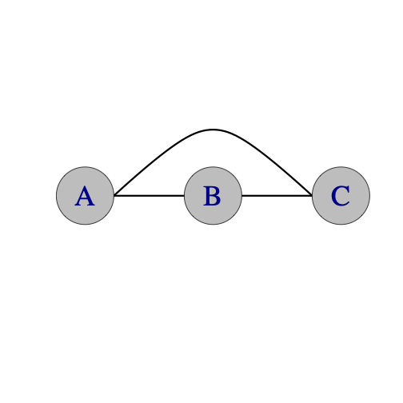

* **Dropback Line: A** passes to **B**. **B** drops back to **C**. **C** passes to **A**. You can do a dropback line in any count: 2-count, 4-count, 3-count, chocolate bar. It's a nice pattern to add clubs to as well. Try one two, or 3 extra clubs with doubles or one extra club in 3-count (**A** and **B** cross, **C** throws straight).
* **Line Feeds:** You can do any of the feed variations in a line layout instead of a V. Some will be useful for more complex patterns. Also see 4 person Lines.

### 

| **An Extra Club Line** | | | | | |
| --- | --- | --- | --- | --- | --- |
|  |  | **Beat, both hands counting** | | | |
| **Juggler** | **1** | **2** | **3** | **4** |
| **A** | d-**C** |  | **B** |  |
| **B** |  |  | **A** |  |
| **C** |  | t**-self** |  | d-**A** |

#### 

## 

## 

* **A** starts with 4 clubs; **B** faces **A**
* **A** alternates right hand doubles to **C** and singles to **B**. **B** does right hand 4-count to **A**. **C** alternates right triple selves and doubles to **A** (fast popcorn)
* What do you do if there are 3 club passers and one is more advanced, one is intermediate and the third is a beginner. This is a nice pattern to accommodate everyone!

## 

### **Up-Up-Over**

Here's a curious pattern that exercises your 4-club columns skill. Jugglers **A** and **B** start with 4 clubs each. Juggler **C** starts with 2 clubs. The vertical arrow in the table means **up**, i.e., throw two clubs up as double selves. Feeder **A** is doing a slow two-hand doubles feed, starting with **C**. Juggler **B** starts in sync with **A** and does **up-up-over**. Juggler **C** waits to receive the two incoming from **A** and then responds with **up-up-over.**.

| **Up Up Over** | | | | | | | |
| --- | --- | --- | --- | --- | --- | --- | --- |
|  |  | **Beat (synced hands)** | | | | | |
| **Juggler** | **1** | **2** | **3** | **4** | **5** | **6** |
| **A** | **C** |  |  | **B** |  |  |
| **B** | **↑** |  | **A** |  | **↑** |  |
| **C** |  | **↑** |  | **↑** |  | **A** |

* Simultaneous double throws (all jugglers)
* **A** and **B** both start with 4
* **C** starts with 2
* Vertical arrow indicates synced double self

Prof Mike and Steve Otteson did this first in the early 90's, when Madfest was still in the Memorial Union. See an animation of (a variation of!!) this pattern at [Juggloid](*http://juggloid.com/editor/?s=yhIKp1*)

## **Moving Three Person Patterns**

Now for some moving patterns.

-change side feeds **discuss this is the first moving pattern, but we don’t describe it super carefully**

## 

## **Turbo**

After you’ve mastered change-side feeds, you’re ready for the Turbo, one of the Madison favorites. A *Turbo* is a group of 3 weaving jugglers who feed themselves. It is also a *Two-leaf Clove*r or a continuous change-sides feed through the middle. In the standard version, you pass every right hand throw when you are feeding, and every other when you are moving.

| ***Turbo*** | | | | | | | | | | |
| --- | --- | --- | --- | --- | --- | --- | --- | --- | --- | --- |
|  |  | **Beat, base count (usually right-handed 2-count)** | | | | | | | | |
| **Juggler** | **1** | **2** | **3** | **4** | **5** | **6** | **7** | **8** | **9** |
| **A** | **B** | **C** | **B** |  | **B** |  | **C** |  | **C** |
| **B** | **A** |  | **A** | **C** | **A** | **C** |  | **C** |  |
| **C** |  | **A** |  | **B** |  | **B** | **A** | **B** | **A** |

* A cool animation (thanks Nick)

[https://www.passingdb.com/patterns.php?id=49 2](https://www.passingdb.com/patterns.php?id=49%202%20http://juggloid.com/editor/?s=npRW7l) <http://juggloid.com/editor/?s=npRW7l>

* The standard turbo is right-handed 2-count base
* It's 18 right-hand beats for a full cycle; 9 beats to repeat the passing sequence, but flipped in orientation. When a juggler moves to the other side, he or she cuts across in front of the old feeder, and turns around to pass to the new feeder
* **Left Handed** – Same as standard, but mirror image.
* **3-count** – Feeder does 3 count, feedees do 6 count.
* **Chocolate Bar** – Fun! (pass-pass-self-self replaces pass-self)
* **Double 3 count** – Tricky. There are 2 different ways to do the transitions. Usually we have the movers stay in 3-count and move on the inside hand throw. You can also do this pattern where the movers transition in 4 count and move on the outside hand throw. Feels a little like the El Nino.
* **Tom's Turbo** – Feeder is in 1-count and does 3 passes in a row to each feeder. Have each juggler start with a different set of clubs. (Created by Tom Pomraning.)
* **10-Club Turbo** – See below.
* Also see Interlocking Turbos in 6 person patterns and Strange Attractor in 5 person patterns.
* **Timing variations:** Recent innovations, like pass only on beats 1-3 on a 5-count cycle or 1-4 on a 7 count cycle

*Jazzing it up:* When changing sides the mover has the option of clockwise or counter-clockwise turns. Try both. One is harder and cooler. The standard (inside) turn is usually easier for right-handers off the right side of the feed and harder for right-handers off the left side. Try double or triple earlies before entering the middle. Try a behind-the-back pass when moving off the right side.

| **Turbo:** passes and positions | | | | |
| --- | --- | --- | --- | --- |
| **Jugglers** | | | | **locations/passes** |
| **Beat** | **A** | **B** | **C** |
| **1** | **B** | **A** |  |  |
| **2** | **C** |  | **A** |  |
| **3** | **B** | **A** |  |  |
| **4** |  | **C** | **B** |  |
| **5** | **B** | **A** |  |  |
| **6** |  | **C** | **B** |  |
| **7** | **C** |  | **A** |  |
| **8** |  | **C** | **B** |  |
| **9** | **C** |  | **A** |  |
| **Repeat 9 more beats for full cycle** | | | | |

*History:* We’re not sure. Turbo may have developed inadvertently when in the early 90’s we tried, unsuccessfully, to recreate Bruno’s Nightmare from faulty memory. The main difference between Bruno’s Nightmare and Turbo is when you turn. In Turbo you turn before entering the middle. In Bruno’s Nightmare you turn after exiting the middle, which lengthens the cycle and makes the pattern easier by some measures. There are also variations of Bruno’s Nightmare that we’ve heard about but we don’t juggle.

As presented in the table above, the starting beat is really where juggler **B** is just going through the middle, as in beats 4 and 7 for the other two; it’s been more typical to start feedees side-by-side (as shown). Also, the more modern convention has the first feedee to receive a pass be the one who goes through the middle first (e.g., as if we really start on beat 2 in the table); we call that Peter’s start!

### **Bruno's nightmare**

We haven't juggled this much in Madison, but we mention it for reference. It used to be popular in Europe! See [PassingDB](<https://www.passingdb.com/patterns.php?id=49>)

### 

### **10-Club Turbo**

The 10 Club Turbo has the same positions and movement as the Turbo but with an extra club. Usually we throw the passes as doubles (same as in 7 club 2-count). In order to keep the timing the mover must add an extra beat into the pattern. That can be done by throwing a double self (either right or left) to the opposite hand or by throwing an early triple pass and pausing for one beat. The diagram below shows the early triple, but experiment with whatever works best for you (some people think a right to left double is easier). Beats below are on the right hand of the person on the left side of the pattern (in this view; e.g. juggler A at the beginning); B and C could start in sync with A but with two clubs in the left, but we usually start them on the delay. In the table, **move** refers to the beat when the juggler initiates his/her switch of sides; to be fair, jugglers are constantly moving in this A-level pattern! Also, **pause** happens after the juggler sends his/her triple and they are waiting ½ a beat to get synced up with the opposite side, where they are headed.

| **10-club Turbo** | | | | |
| --- | --- | --- | --- | --- |
| **Jugglers** | | | | **locations** |
| **Beat** | **A** | **B** | **C** |
| **1** | d**-B** |  |  |  |
|  |  | d**-A** |  |
| **2** | d-**C** | **move** |  |  |
|  |  |  | d-**A** |
| **3** | d-**C** |  |  |  |
|  |  | t-**C** | d-**B** |
| **4** |  | **pause** |  |  |
|  |  |  | d-**A** |
| **5** | d-**C** |  |  |  |
|  | **move** |  | d-**B** |
| **6** |  | d-**C** |  |  |
|  |  |  | d-**B** |
| **7** | t-**B** | d-**A** |  |  |
|  | **pause** |  |  |
| **8** |  | d-**C** |  |  |
|  |  |  | d-**B** |
| **9** |  | d-**A** | **move** |  |
|  | d-**B** |  |  |
| **10** |  |  |  |  |
|  | d-**C** |  | t-**A** |
| **Continue…** | | | |  |

#### 

The table shows 2 transitions. Note that the old feeder (**A)** passes twice in a row to the new feeder (**C**). The mover (**B**) throws a triple to the new feeder at the SAME time as the new feeder throws a double to the mover and then pauses for one beat. The feeder and the 2 feedees are always on opposite timings (the feeder's right is synchronized with the feedees' lefts). The easiest way to learn is by practicing the change sides feed with transitions on the outside and getting comfortable with the triple or the self double timing transition. Then learn the inside transition and finally rev it up to true turbo speed. Excelsior!

By Luke Emery, 1999.

**Even more variations:**

Try with single passes instead of double passes in 7 club 2 count singles speed.

We worked out an 11-Club Turbo variation with triple selves on the transitions, but it's too hard for us to run more than a couple transitions at a time. Maybe we'll get it in a future version of the book.

### **Another 10-Club Turbo**

The pattern above will always be **the** 10-Club Turbo, but here is another version that makes a nice diversion. It's based on an extra club feed too, but the transitions in the middle are made by a half pirouette underneath a right to left double.

The feedee who is moving first steps into the middle of the pattern directly between the feeder and the non-moving feedee. After one pass the moving feedee does a half pirouette underneath a double right to left self throw, Then steps back to complete a single turbo transition. The table below has one complete transition.

\footnotesize

| **Juggler/beat** | **1** | **2** | **3** | **4** | **5** | **6** | **7** | **8** | **9** | **10** | **11** |

|-------------|-------|-------|-------|-------|-------|-------|-------|--------|-------|--------|--------|

| **A** | D-B | | D-C | | D-B | | D-C | | D-C | | |

| **B** | | D-A | | | | D-A | | D-self | | | D-C |

| **C** | | | | D-A | | | | D-A | | D-B | |

\normalsize

> * Both hands counting

> * A starts with R

> * B and C start with L

> * D-self is a half pirouette

![](./media/image3.jpeg)

When you do the half pirouette, make sure to throw the double more inside than usual and have the outside passers pass a little on the wide side to reduce collision. By Luke Emery, 2002.

### **GDP**

Luke's GDP is a sort of extra-club continuous change-sides feed. Peter, Mike and Luke like to practice it after doing the extra-club turbo; it's a fine pairing! By Luke Emery, 1999.

| **GDP:** passes and positions | | | | |
| --- | --- | --- | --- | --- |
| **Jugglers** | | | | **locations/passes** |
| **Beat** | **A** | **B** | **C** |
| **1** | t-**C** |  |  |  |
| **2** | **B** | **A** | t-**A** |  |
| **3** | t-**C** | move |  |  |
| **4** | move |  | t**-B** |  |
| **5** | **C** | t-**C** | **A** |  |
| **6** | move |  | t-**B** |  |
| **7** |  | t-**A** | move |  |
| **8** | t-**B** | C | **B** |  |
| **9,**  **then 10=1** |  | t-**A** | move |  |

* **Beat:** Right hand counting
* **Start: A** starts with 4 clubs and passes triple to **C**, then a single to **B**. **B** faces **A**, starts with a self, as if passing every others to **A**. **C** starts with a self, then triple o **A**. [Note, if three jugglers repeat beats 1 and 2 they are doing a stationary extra-club feed.]
* **Movement:** The first two beats above describe a base pattern without movement. In GDP, all three jugglers do the same sequence, but shifted in time. From **B’**s perspective: self, single to **A,** self, self (while replacing **A**), triple to **C**, self (**A** replaces **C**), triple to **A**, single to **C,** triple to **A**, self, (as **B** moves to the middle). Repeat. Be careful to keep your triples from hitting the non-recipient by pushing them toward the new mover!
* **Variations:** Doubles – Throw doubles instead of triples (this has the 7-club 4-count cadence for two). Also, a whole bunch of tricks can be done while moving into the center (such as an early triple followed by a pirouette when entering the middle). See also a variation we call Cathedral in the 5 Person Patterns.

## 

## 

## **Laura's Weave**

Peter came up with this pattern as a birthday present for Laura in 2010. Three jugglers move in a figure eight, as in a standard weave, but with no feeder. There's one extra club. On right-hand counting, it's triple self, triple pass, then four single selves as you move over to the other side. This same sequence can be done with straight-up passes in the middle of the weave. The six beats shown get us half way towards a full cycle (12 beats)

| **Laura’s Weave:** passes and positions | | | | |
| --- | --- | --- | --- | --- |
| **Jugglers** | | | | **locations/passes** |
| **Beat (**right hands**)** | **A** | **B** | **C** |
| **1** | t-**self** |  |  |  |
| **2 (start)** | t-**B** |  |  |  |
| **3** |  | t-**self** |  |  |
| **4** |  | t-**C** |  |  |
| **5** |  |  | t-**self** |  |
| **6** |  |  | t-**A** |  |

## 

## 

## 

## 

## 

## 

## 

## 

## 

## 

## 

## 2/3

Read this *two pi on three*. This one is a late bloomer, considering how simple it is and how long people have been juggling and moving in groups of three. There are three moving jugglers, **A**, **B**, and **C**, and six passing beats for a full cycle: (on count of choice; rows of tables). Everyone moves through the figure eight; in contrast to a Turbo or Bruno’s nightmare, there is not a feeder being swapped here; all folks are moving all the time. Four count is fun; three count is more fun; recent variations alternate the count, such as 1-4 on a 7 for a 3-count/4-count alternation. In any count, it’s pass-one, pass-the other, self (i.e. phantom). Whatever is the base count the pattern has a gap (in this layout, positions 2 and 5) where you can plug in any other juggler or pattern that matches that count (including three other jugglers doing a 2/3). Looks like two pies when viewed from above, and it’s 3 jugglers. Plus, each circle in the layout is divided into 3, hence the name. Prof Mike invented 2/3 in summer 2017.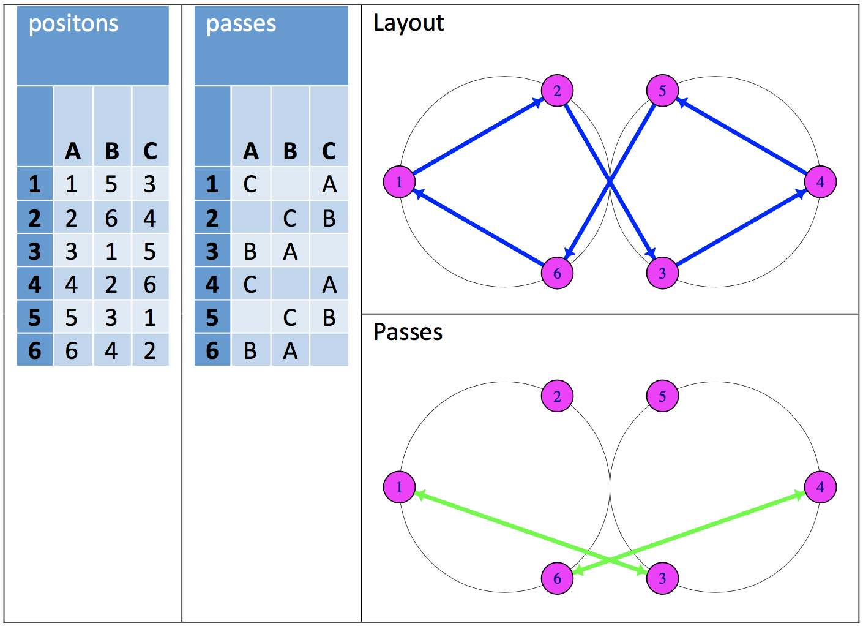

**Chiral variants:**  In the original version (as described above), the juggler in the back position (either 1 or 4) passes to a front position on the opposite side (either 3 or 6), after which the front-position juggler moves toward the back of their respective pie. Likewise, the juggler who’s on their phantom at the start (e.g., **B** above) moves across and turns into the opposite pie. Alternatively (i.e., if we would make passing arrows between positions 1 and 5 and also 4 and 2 instead), the receiver on the side with two-jugglers to start would receive and move through. This alternative version has become the standard start [i.e., pass and move across, when you’re starting on the side with two]. They’re similar but slightly different patterns! Here’s the popular, chiral version, in the same format as for the *turbo.*

| **2pi on 3 (chiral version)**  passes and positions (another view) | | | | |
| --- | --- | --- | --- | --- |
| **Jugglers** | | | | **locations/passes** |
| **Beat** | **A** | **B** | **C** |
| **1** | **B** | **A** |  |  |
| **2** | **C** |  | **A** |  |
| **3** |  | **C** | **B** |  |
| **4** | **B** | **A** |  |  |
| **5** | **C** |  | **A** |  |
| **6** |  | **C** | **B** |  |
| **7=1; 6 beats is full cycle** | | | | |

## 

## 

## 

## 

## 

## 

## 

## 

## 

## 

## 

## 

## 

## 

## **Laxative**

This one makes you *go go go*, hence the name. It's dynamic, simply-structured 3-person moving pattern, in which everyone is synced up and passing on the same odd count. Because of the constant movement, the to-from passes never change. Referring to the figure, red (a) always passes to green (c), who always passes to blue (b), who always passes to red. The movement and the odd-count allows that all these passes are inside-triangle passes. We usually do this on 7-count, which allows plenty of time to move; 5-count also works well; 3-count is still a dream! Notice there are 6 total passing beats, during which each juggler traverses the 6 positions, though the local cycle is three beats. Those movements entail crossing between the other two jugglers (which goes in turn *a* then *b* then *c*), and then moving along the edges of the hexagon (either twice to left or twice to the right), in order to make space for the next mover.

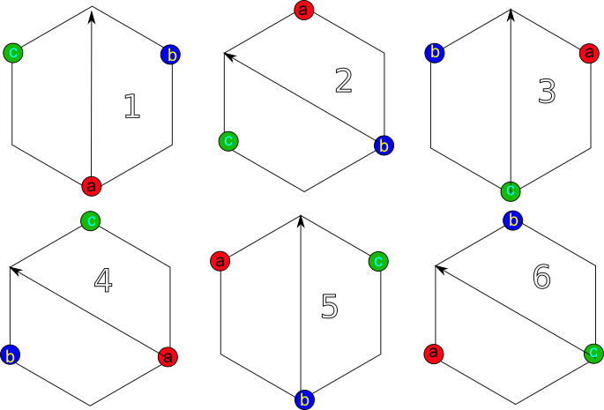

*./media/laxative/3j.png*

Pattern by Prof Mike, sometime after 2018. Frequently juggled by Mike (c), Mel (b), Conor (a) or Mike (c), Mel (b), Nathan (a) [who performed it at Madfest 2025]

## 

## **Graham's 3 stuff**

Here are some challenging patterns for 3 jugglers by Graham Paasch.

### **Change Sides Double-3 Count Feed Plus**

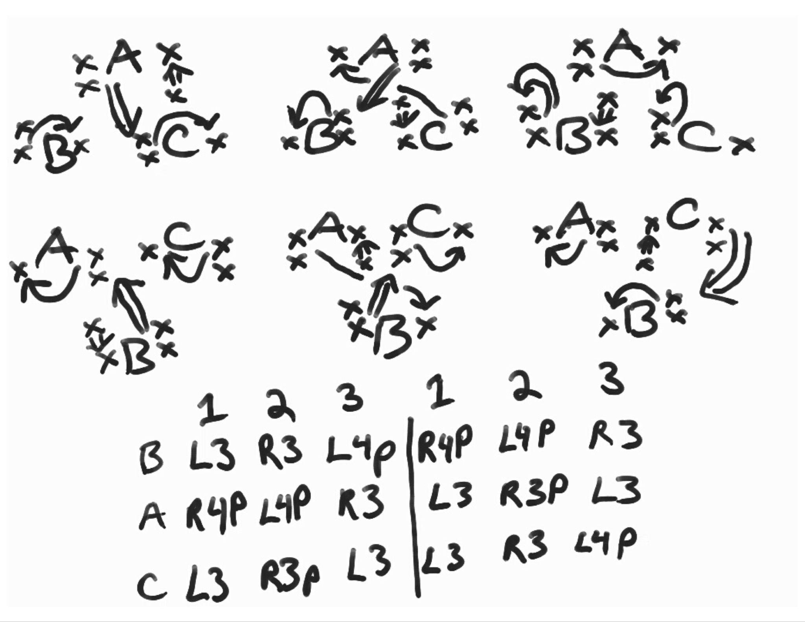

*./media/ChangeSidesDouble3FeedPlus.jpg*

### **Change Sides RRLRLRLLRLRL**

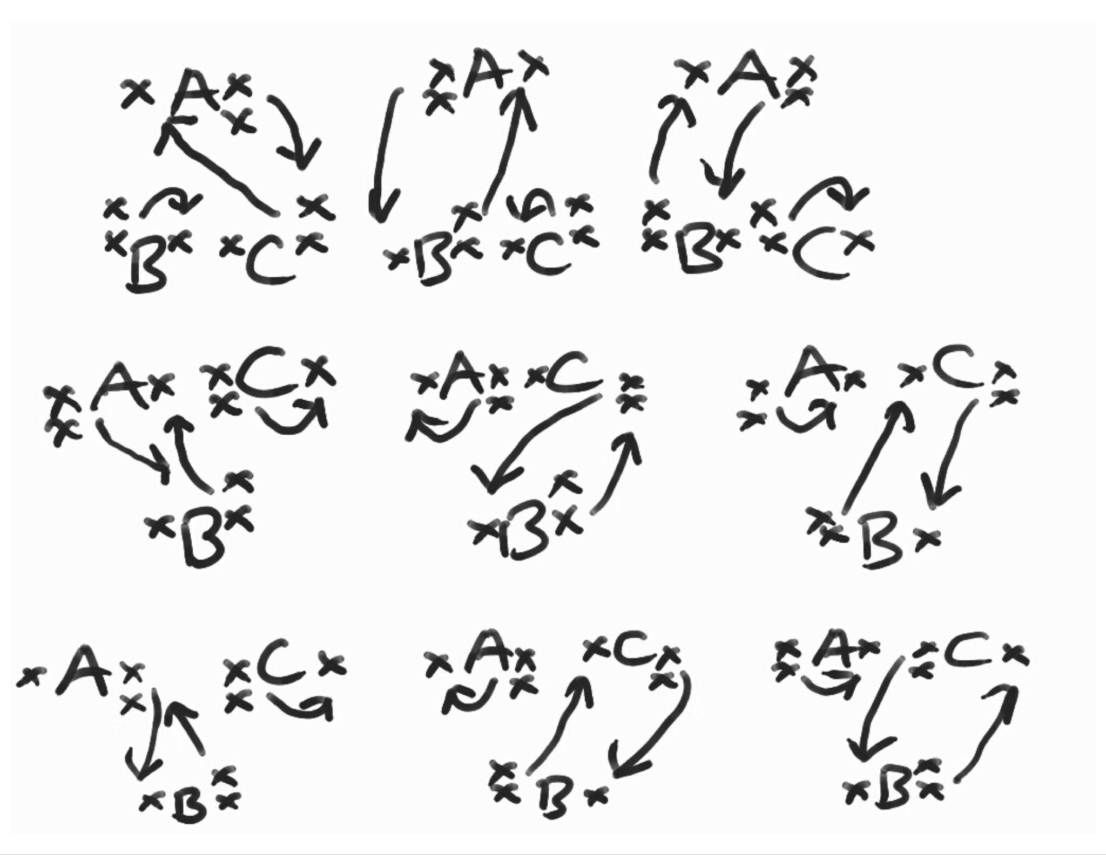

*./media/ChangeSidesRRLRLRLLRLRL.jpg*

### **Safe Beast of Arg**

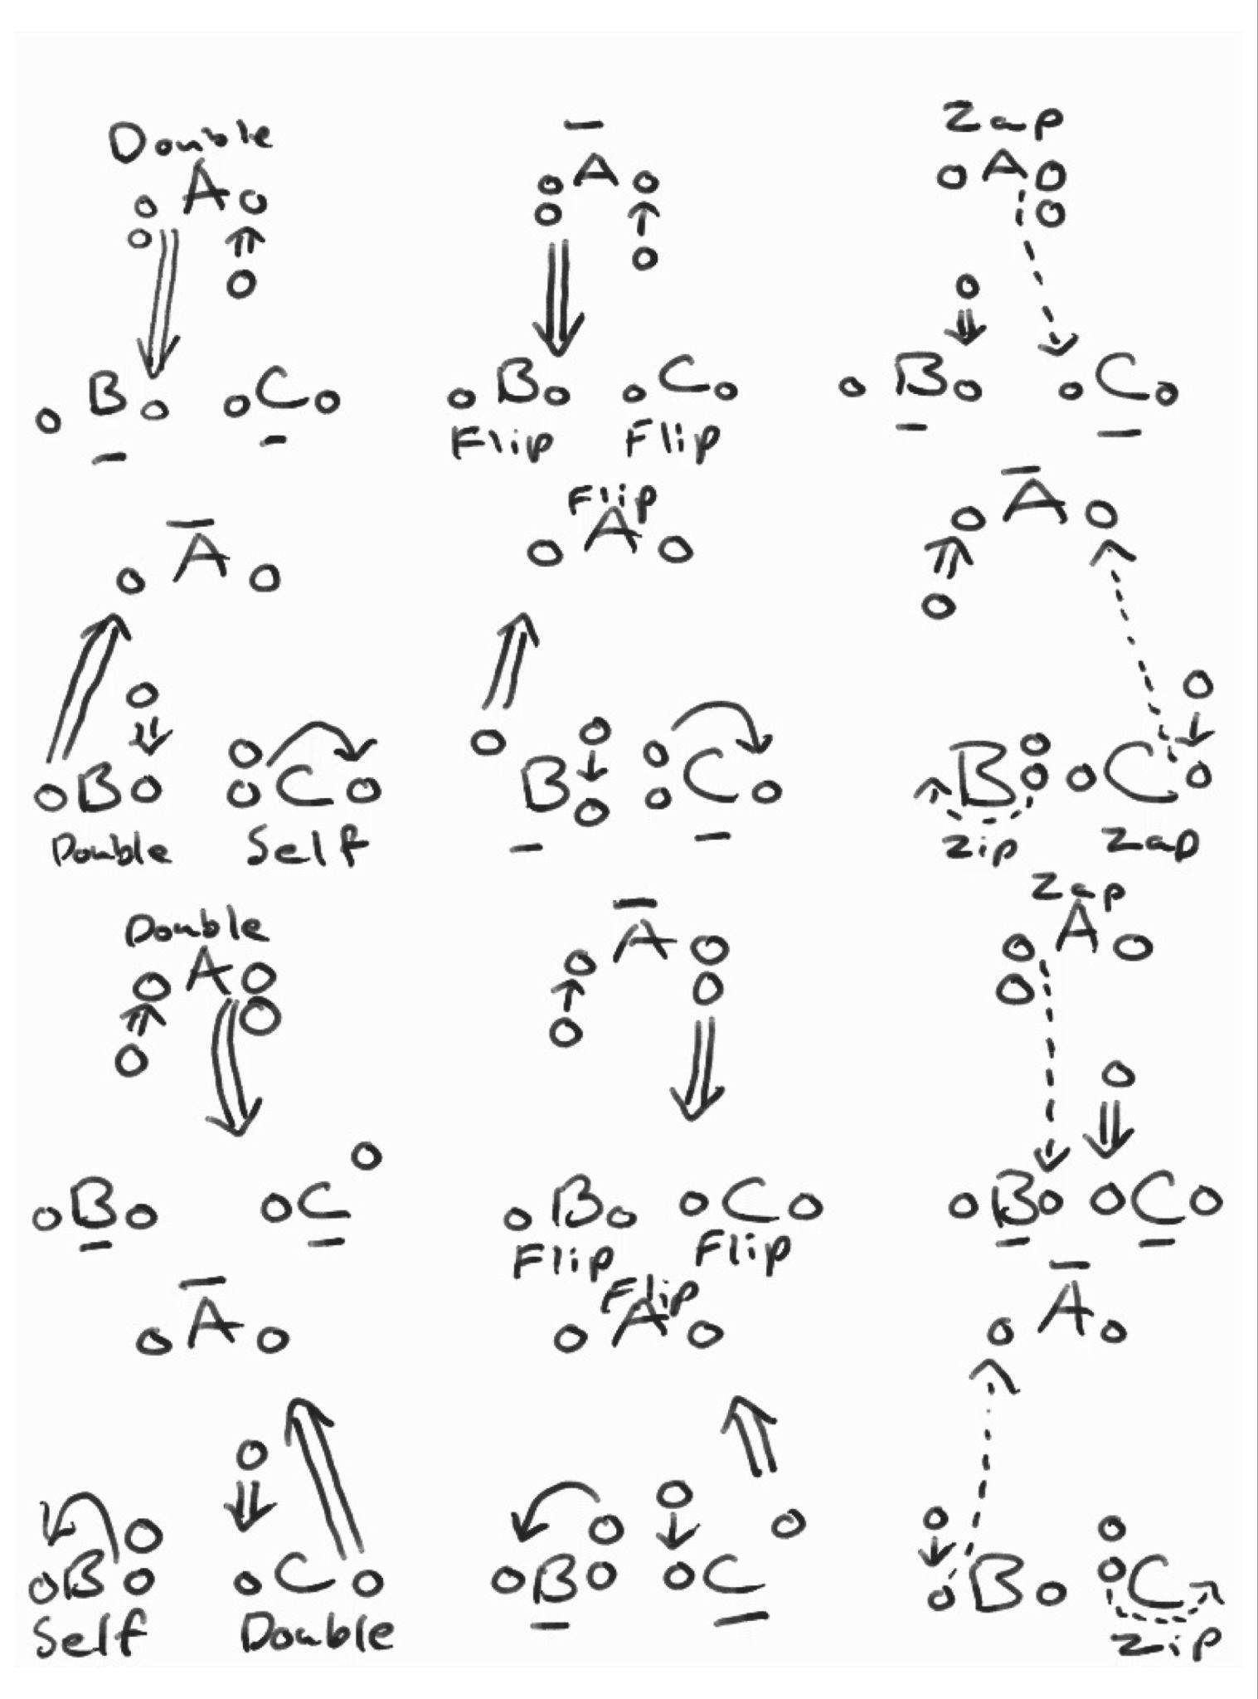

*./media/SafeBeastofArg.jpg*

### **Change Sides Variant (Ryan’s feed)**

In this variant, the feedees take turns moving across like in the traditional change sides feed. However with each transition the pattern will be flip flopping between the original Ryan's Feed and the inverted variant. All 3 juggler's will need to pay attention to what variant they are transitioning to. As to when the feedees should make their transition, we found there are multiple times when the feedees can take turns moving across. The easiest time to transition is after the feedee does their two 1-count throws (EG, Juggler C's 6 and 7 throws in the original pattern).

### **Turbo Variant**

It is theoretically possible to turbo the change sides variant by having the feedees transition through the middle. However in practice we found it difficult, but the nice thing is the pattern doesn't invert itself after each transition like in the change sides variant.

# **Four Person Patterns**

## **Stationary Four Person Patterns**

Here are some classic arrangements for four stationary jugglers

| Box | Feed |
| --- | --- |
| 2 on 2 | Y |
| Locked lines | |
| Canoe | |

* Edges in each graph indicate possible exchanges between the jugglers.
* Think upside down to see the Y shape among the juggler positions!
* *\* comment on A-B pass in some Y’s [Y2K*
* *Add anklet shape*

### **Boxes**

#### 

| **Standard Asynchronous Box** | | | |  |
| --- | --- | --- | --- | --- |
|  | **Beat**  **(asynchronous)** | | |  |
| **Juggler** | **1** | **2** |  |
| **A** | **B** |  |  |
| **B** | **A** |  |  |
| **C** |  | **D** |
| **D** |  | **C** |  |

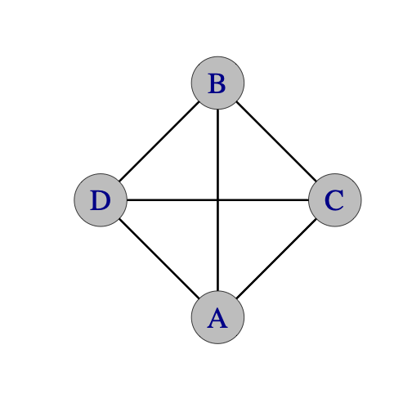

* A box is characterized by having jugglers face and pass to each other if they reside on opposite ends of a diagonal, such as jugglers **A** and **B** or jugglers **C** and **D**. Later we talk about box-like patterns where passes go along the perimeter, but they are less boxy!
* In the standard 2-count asynchronous box, the **A-B** are offset (i.e., are asynchronous) from the **D-C** pair [i.e. one pair is on lefts while the other is on rights]. Purists like to have **A-B** starting each with 2 in the right hand and passing, while **D-C** start with two in the left at the same time and selfing, but it’s easier for **D-C** just to watch and throw from right on queue (i.e. when **A-B** are on their first left self).
* Try left-handed!
* Any regular count slower than 1-count involves gaps, and so the pairs may be offset for a successful box; e.g. 2-count lefts, 3-count work nicely. But the gaps need to balance out; e.g., 3/2 count doesn’t work for both pairs because if **A-B** do 3/2 then there’s only 1 gap in 3 beats for **D-C** [but **D-C** can do 3-count in that case]
* The 4-count box is a great place to start, and it’s also a popular box when you have audience volunteers. You put the volunteer right in the middle and pass around on all sides! Remember when Mel dinged one of the Channel 15 news anchors in the head! (Was it Mike Mickiney?)
* *Pistons* and the *Minuet* are moving patterns derived from the asynchronous box.

#### 

| **Standard Synchronous Box** | | |  |
| --- | --- | --- | --- |
|  | **Beat** | |  |
| **Juggler** | **1** |  |
| **A** | **B** |  |
| **B** | **A** |  |
| **C** | **D** |
| **D** | **C** |  |



* Now the **A-B** pair is doing exactly the same thing as the **D-C** pair, and at the same time. The jugglers can pass on any standard timing (1-count, 2-count, 3-count are most common). Owing to the synchrony, collisions are much more likely. Synchronous boxes are great for working on your timing!
* Wide throws make collisions less likely.
* A good technique to regulate the timing is to focus on the pass release by the person to your right (at least at right-handed throw beats). Your release should be synced with theirs, and then your club will pass just **behind** their club, owing to the configuration.

#### **Extra Club Boxes**

* **14 club box (standard):**  A classic pattern for four. *Set up is basically like the Standard Asynchronous Box*, but jugglers **A** and **D** start each with 4 clubs. To find the best gaps and avoid collisions, each juggler keeps an eye on the juggler to their right (in the right-handed version!), and releases their double straight pass just after that next-spot juggler so that the clubs cross passing lines in an orderly fashion. With the right-handed version, **A** starts and passes a double to **B;** then at about a ¼ beat**, D** passes a double to **C;** by then **B** is ready to respond to **A** while also being behind **C,** so **B** passes next back to **A;** finally **B** chases **C** and passes back to **A** to complete the cycle**.** Simply, chase the person on your right. Collisions happen when someone misses a gap, so make sure you keep an eye on each release on the right side (rather than on the mess of clubs in the middle). Timing can get screwed up too if one pair juggles higher than another, but when it works it’s a beautiful pattern. The Mad-5 did a version where after 10 rights, one of each pair would collect all 7 clubs, and spin to show the collected clubs for a rousing applause!
* **14 club box (4-count):**  The 4-count means it’s *easy;*  there are big gaps for each pair to use (more juggling with oneself, and less opportunity for exciting collisions!). But the timing and extra clubs make this challenging; usually it’s done with triples, but doubles are possible for passers with better hand speed! The two pairs are 1 beat away from each other (**A** and **B**'s rights are synchronized with **C** and **D**'s lefts).
* **16 club box (standard):**  A thing of beauty! There are variations for the talented numbers jugglers, but the one we like is set up like the *14 club box*, but with **A** and **D** doing triples and **C** and **B** responding with singles. Nice steady triples are key; chasing your neighbor on the right is the same rule as before, but it’s harder to keep triples steady. All jugglers tend to stare at the triples, and it’s easy for the single passers (**B** and **C**) to over charge their singles. Triplers start, with **D** chasing **A**; singlers should wait as long as possible to release on the start.
* **Really hard boxes!** You can also do a 16 club box pattern with all the jugglers synchronized in 8 club 2-count singles, doubles or triples. Nice! Pass either straight across, or to the juggler on the left. With 9 club triples 2 count and each juggler offset ½ beat, you get an 18-club box! If the timing is perfect, it is possible to do a 14 club box in 1-count, with right hand doubles across the box and left hand singles along the edges of the box (BUT THEN YOU PASS TO TWO PEOPLE, SO NOT WE DESCRIBE LATER)

### **Less Boxy Boxes**

In these patterns jugglers set up like in a box, but passes include those along the perimeter as well as across the diagonal.

#### 

| **Rotating feed (4 person)** | | | | | |  |
| --- | --- | --- | --- | --- | --- | --- |
|  |  | **Juggler** | | | |  |
| **Beat** | **A** | **B** | **C** | **D** |  |
| **1** | **D** |  |  | **A** |  |
| **2** | **B** | **A** |  |  |  |
| **3** | **C** |  | **A** |  |
| **4** |  |  | **D** | **C** |  |
| **5** |  | **C** | **B** |  |  |
| **6** | **B** | **A** |  |  |  |
| **7** |  | **D** |  | **B** |  |
| **8** |  |  | **D** | **C** |  |
| **9=1** | **D** |  |  | **A** |  |
| * Rotating feed (both directions work; left-right from feeders perspective is shown) * Beat is preferred count (often a right-hand 2-count base) * **A** starts the feed * Rule: last feedee becomes next feeder * With this version, the feeder position quietly circulates counter clockwise, even though each feeder is sending passes clockwise * An ancient pattern! | | | | | |  |

#### 

#### 

#### 

#### 

#### 

| **Feast (4 person)** | | | | | |  |
| --- | --- | --- | --- | --- | --- | --- |
|  |  | **Beat** | | | |  |
| **Juggler** | **1** | **2** | **3** | **4** |  |
| **A** | **D** | **B** | **C** |  |  |
| **B** | **C** | **A** | **D** |  |  |
| **C** | **B** |  | **A** | **D** |
| **D** | **A** |  | **B** | **C** |  |
| * Everyone feeds everyone else (hence the name!) * Include yourself in the count * This version is clockwise (from above); counterclockwise works too. * Any agreeable count works. * 4-count is nice for rookies * This pattern is a notch harder than the asynchronous box because you have to swivel through 90 degrees during each cycle. * *Picnic* is a nice 3-count variation where **A** and **C** start passing crosses (right-right or left-left) and **B** and **D** start with straight passes. When you complete your cycle and restart after your self beat, you switch from whatever you were doing (e.g. crosses then straights, or straights then crosses). | | | | | |  |

#### 

| **Bermuda Quadrangle** | | | | | |  |
| --- | --- | --- | --- | --- | --- | --- |
|  |  | **Beat (both hands counting)** | | | |  |
| **Juggler** | **1** | **2** | **3** | **4** |  |
| **A** | **B** | **C** | **D** |  |  |
| **B** | **C** |  | **A** | **D** |  |
| **C** | **A** | **D** |  | **B** |
| **D** |  | **A** | **B** | **C** |  |
| * Jugglers start with 2 clubs in the right hand. * Pattern by Laura and Becky Provance, Barry Friedman, and Steve Otteson. | | | | | |  |

#### 

| **Maya** | | | | | | | |  |
| --- | --- | --- | --- | --- | --- | --- | --- | --- |
|  |  | **Beat (both hands counting)** | | | | | |  |
| **Juggler** | **1** | **2** | **3** | **4** | **5** | **6** |  |
| **A** | **D** |  | **B** | **C** |  | **B** |  |
| **B** | **C** |  | **A** | **D** |  | **A** |  |
| **C** | **B** | **D** |  | **A** | **D** |  |
| **D** | **A** | **C** |  | **B** | **C** |  |  |
| * Jugglers start with 2 clubs in the right hand. * This pattern by Tom Pomraning (`Coach`) was published in Jugglers World [**date**]. Tom was an incredible chocolatier and juggler! | | | | | | | |  |



#### 

| **Interlocking Triangles** | | | |  |
| --- | --- | --- | --- | --- |
|  |  | **Beat (right hand counting)** | |  |
| **Juggler** | **1** | **2** |  |
| **A** | **B** | **B** |  |
| **B** | **D** | **C** |  |
| **C** |  | **A** |
| **D** | **A** |  |  |

### 

### 

### **Extra club less boxy boxes!**

| **Spider Web** | | | | | |  |
| --- | --- | --- | --- | --- | --- | --- |
|  |  | **Beat (both hands counting)** | | | |  |
| **Juggler** | **1** | **2** | **3** | **4** |  |
| **A** | t-**C** |  | d-**B** |  |  |
| **B** |  | t-**D** |  | d-**C** |  |
| **C** | d-**D** |  | t-**A** |  |
| **D** |  | d-**A** |  | t-**B** |  |
| * 3 extra clubs * Both hands counting, passes with rights * **A** and **C** start with right; **B** and **D** start with left * **A**, **B**, and **C** start with 4 clubs * Check with Luke on origin and start for B; is this coded correctly? Seems like triples should cross and doubles should go right… | | | | | |  |

#### 

|

And more [include Luke’s 14-club 1-count box from V3.0 ****CHECK WITH LUKE on Version 3.0 book entry*

Throw a little wide on the double passes and make sure that everyone has

metronome perfect timing and it actually works! Pattern by Luke Emery, 2007. **Q. Luke. C is not on A's left; should C-D swap?**

#### 

| **Extra club rotating feed (for 4 jugglers)** | | | | | |  |
| --- | --- | --- | --- | --- | --- | --- |
|  |  | **Juggler** | | | |  |
| **Beat** | **A** | **B** | **C** | **D** |  |
| **1** | **D** | d-**self** |  |  |  |
| **2** |  | **pause** | **A** | **d-self** |  |
| **3** | **B** |  |  | **pause** |
| **4** |  | **D** | d-**self** |  |  |
|  | **5** | d-**self** |  | **pause** | **B** |  |
| **6** | **pause** | **C** |  |  |  |
| **7** |  |  | **A** | **d-self** |  |
| **8** | **C** | d-**self** |  | **pause** |  |
| **9** |  | **pause** | **D** |  |  |
| **10** | d-**self** |  |  | **B** |  |
| **11** | **pause** | **D** | d-**self** |  |  |
| **12** |  |  | **pause** | **A** |  |
| * 1 extra club rotating feed (both directions work) * Beat in table is both hands counting * All throws are right hand doubles (unless you do the opposite version with all throws being lefts) * **A** starts with 4 clubs * **A** and **B** start with right hand * **C** and **D** start with left hand * The steady state right hand sequence is pass across, pass left, self, pass across, self. * Right-hand selves are all double selves[Luke please check this.] * Pattern by Luke Emery, 1999. | | | | | |  |

| **Gustav **LUKE, PLEASE CHECK\*\*** | | | | | | | |  |
| --- | --- | --- | --- | --- | --- | --- | --- | --- |
|  |  | **Beat (both hands counting)** | | | | | |  |
| **Juggler** | **1** | **2** | **3** | **4** | **5** | **6** |  |
| **A** | t-**D** |  | C | **t-D** |  | **C** |  |
| **B** | **D** |  | **D** |  |  |  |  |
| **C** |  |  | **A** |  | **A** |  |
| **D** | **B** | t-**A** |  | **B** | t-**A** |  |  |
| * This is a double 3 count extra club3 extra clubs?check * Both hands counting * **A** starts with 4 clubs, and throws triple crosses * **B** throws triple straights * **C** and **D** start slightly after **A** and **B** – timing is a bit wonky **Are they doing singles or triples?** * Pattern by Luke Emery, 2008, and named after the hurricane | | | | | | | |  |

#### 

| **Two on Two Double Three Count** | | | | |  |
| --- | --- | --- | --- | --- | --- |
|  |  | **Beat (both hands counting)** | | |  |
| **Juggler** | **1** | **2** | **3** |  |
| **A** | **C** |  | **D** |  |
| **B** | **D** | **C** |  |  |
| **C** | **A** | **B** |  |
| **D** | **B** |  | **A** |  |
| * Both hands counting; right hand starts * This is the left-to-right feed version; other versions ok too * This is a prerequisite for *El Nino* or *La Nina* * Dates to July 1997 in MAJ, but maybe earlier by others | | | | |  |

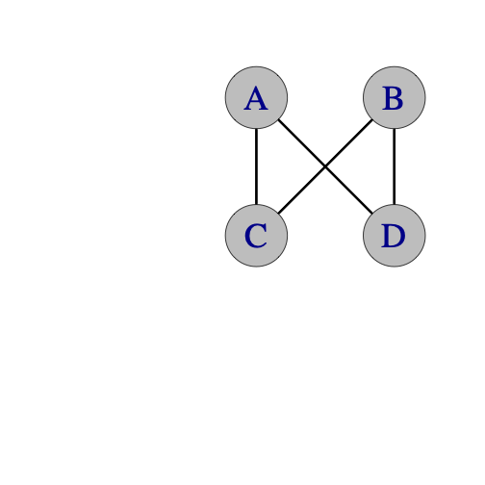

#### 

| **Y (oogle)** | | | |  |
| --- | --- | --- | --- | --- |
|  |  | **Beat** | |  |
| **Juggler** | **Right** | **Left** |  |
| **A** | **C** | **D** |  |
| **B** | **D** | **C** |  |
| **C** | **B** | **A** |
| **D** | **A** | **B** |  |
| * On whatever count you like, proceed as above * Eg, 4 count rights would use only column 1, but 3-count would use both * **B** has to relax as they receive crossing throws from the opposite person than they pass to. * **C** and **D** have to take care with long passes to **A** and carefully lofty passes to **B**. * This stationary Y is the basic building block for the *Oogle Boogie* moving patterns | | | |  |

## 

## 

## 

## 

## 

## 

#### 

| **Y2K** | | | | | |  |
| --- | --- | --- | --- | --- | --- | --- |
|  |  | **Juggler** | | | |  |
| **Beat** | **A** | **B** | **C** | **D** |  |
| **1** |  |  | **B** | **B** |  |
| **1.5** | **C,D** | **A** |  |  |
| * One of the most difficult non-extra-club patterns that we’ve done (doable if Peter Kaseman is **B**) * Version 1   + **A** and **B** both face same direction, towards **C** and **D**   + Synchronous 1-count passes from **A** to **C** and **D**   + Synchronous 1-count dropbacks from **B** to **A**   + **C** and **D** are on crossing 2-count   + **C** on 2-count rights to **B’s** right hand   + **D** on 2-count lefts to **B’s** left hand * Version 2   + **B, C,** and **D** all face **A**   + **A** passes synchronous 1-count to **C** and **D** as before   + **B** passes synchronous 1-count to **A**   + **C** and **D** drop forward over **B’s** shoulders to **B!** * At **B’s** discretion**, B** rotates so as to alternate between version 1 and version 2! The passer-receiver pairs are all the same in the two versions, but **B** is turned around! * Y2K generalizes the synchronous 1-count feed, so it’s a call-response pattern (i.e. passer/receiver’s are ½ beat off). * Switch positions so that everyone can experience the challenge! * Pattern by Prof Mike, December 31, 1999 | | | | | |  |

## 

## 

## 

#### 

| **Canoe** | | |  |
| --- | --- | --- | --- |
|  |  | **Beat** |  |
| **Juggler** | **1** |  |
| **A** | **B** |  |
| **B** | **C** |  |
| **C** | **D** |
| **D** | **A** |  |
| * **A** is facing **B, C, and D,** who are all facing **A** * On whatever count you like, proceed as above * **B** and **C** are passing backdrops * We don't know who invented this pattern, but we have been doing it since 1993. * You can add extra clubs or people and use a variety of passing counts. | | |  |

### 

### 

### 

### **Feeds**

#### 

| **Windshield Wiper Feed** | | | | | |  |
| --- | --- | --- | --- | --- | --- | --- |
|  |  | **Beat (2-count base)** | | | |  |
| **Juggler** | **1** | **2** | **3** | **4** |  |
| **A** | **B** | **C** | **D** | **C** |  |
| **B** | **A** |  |  |  |  |
| **C** |  | **A** |  | **A** |
| **D** |  |  | **A** |  |  |
| * **A** (the feeder) faces **B, C,** and **D** (the feedees). Usual start is right-handed. * This pattern probably predates all the other 4-person patterns in this chapter! We don’t know its origin story, but it’s a great go-to for 4 and a pre-requisite for all kinds of other patterns. * 2-count lefts is good practice also on the ! * Other count bases are possible but rarely done except for the 1-count, *ultimate feed;* where **C** does 2-count lefts and **B** and **D** do 4 count. | | | | | |  |

#### 

| **Typewriter Feed** | | | | |  |
| --- | --- | --- | --- | --- | --- |
|  |  | **Beat (2-count base)** | | |  |
| **Juggler** | **1** | **2** | **3** |  |
| **A** | **B** | **C** | **D** |  |
| **B** | **A** |  |  |  |
| **C** |  | **A** |  |
| **D** |  |  | **A** |  |
| * Also called the *carriage return feed;* both names make sense if you ever used an old-fashioned typewriter! (Though, as presented above, it’s opposite direction of return from the standard, non-Yiddish typewriter!) * **A** (the feeder) faces **B, C,** and **D** (the feedees) * The 1-count base version has the feedees doing 3-count, which is nice; such a 1-count base is also called an *ultimate feed,* and is a pre-requisite for *El Nino* and other cool moving patterns. | | | | |  |

### **Extra Club Feeds**

#### **Ultimate Feed Plus**

*\*\*Luke, are these good for both windshield wiper and typewriter?\*\**

Add one extra club to the *Ultimate Feed* by having all the feedees throw crosses. Alternatively (the feeder can throw crosses while the feedees throw straight). The extra club feed can be done with many different spins.

* All passes in singles. (Timing is a bit wonky. Throw a little outside, especially on the middle throws.)
* Feeder and feedees all in double passes. (Feeder rights synchronized with feedee lefts.) Feels like 7 club 3-count.
* Feeder in triples ultimates, feedees in singles. (Feeder rights synchronized with feedee rights.)
* Feeder in single ultimates, feedees in triples. (Feeder rights synchronized with feedee rights.)

#### **Ultimate Feed Plus Plus**

* To add another club (14 total), throw all passes as doubles and all passes are straight from both feeder and feedees.
* Theoretically you could keep adding more clubs and higher throws, and just switching back and forth from straight to cross feedee passes with each extra club, but it gets challenging quickly.

| **Popcorn Feed** | | | | | | | |  |
| --- | --- | --- | --- | --- | --- | --- | --- | --- |
|  |  | **Beat (both hands counting)** | | | | | |  |
| **Juggler** | **1** | **2** | **3** | **4** | **5** | **6** |  |
| **A** | d-**B** |  | d-**C** |  | d-**D** |  |  |
| **B** |  | t-**Self** |  | d-**A** |  |  |  |
| **C** |  |  |  | t-**Self** |  | d-**A** |
| **D** |  | d-**A** |  |  |  | **t-Self** |  |
| * Recall that a (6-count) popcorn pattern between 2 jugglers is a 7 club pattern where the jugglers are passing a beat out of sync. With the right hand, each juggler passes a double spin to partner, a single spin to self, and a triple spin to self. Think **3-2-1** out of the right; the left hand throws are all single spin self throws. The triple self gets released in response to the incoming double from the feeder. (As usual, empty cells indicate single self throws.) * The *Popcorn Feed* is a 14 club pattern where **A** is out of sync with **B, C,** and **D**. **A** and **D** start with 4 clubs each, and **B** and **C** start with 3 each. **A** does a typewriter feed in doubles. **B, C**, and **D** all do a standard 6-count popcorn. Note that at any right beat, either all feedees are on left selfs, or the feedees distribute the three popcorn throws 3-2-1 among themselves. * **A** starts with right throw and 4 clubs * **B, C** start with left self * **D** starts with 4 clubs and a pause, then right throw on beat 2 * This is a spectacular pattern, and could be a basis for an *El Nino* (future work!) | | | | | | | |  |

### Low Popcorn Feed

This feed can be done with single passes and double selves instead of doubles

and triples.

## Gorilla for Four

This is one variation on gorilla passing with 4 passers.

There are 13 clubs. X starts with 4. A, B and C start with 3.

X throws synchronous ultimates. B throws right handed 2 count. A and C throw

right handed 4 count. Here is the pattern.

X starts by throwing synchronous ultimates to B's left hand and C's left hand.

Then X throws synchronous ultimates to A's left hand and B's left hand. And

repeat.

B starts a little after X's first throws, with a right hand throw to X's right

hand, then the next right hand throw is to X's left hand. In the steady state, B

alternates feeding X's right hand and X's left hand with 2 count right hand

throws.

C starts a little after X's first throw (in time with B) and throws to X's right

hand. After that, C is always doing 4 count with X's right hand.

A starts a little after X's first throw with a right hand self. After that, A

does 4 count with X's left hand.

Pattern by MAJ.

## Anklet (for 4 jugglers)

Argyle sock minus 2 jugglers.

| **Juggler/beat** | **1** | **2** | **3** | **4** | **5** | **6** |

|-------------|-------|-------|-------|-------|-------|-------|

| **A** | B | D | | C | D | |

| **B** | C | C | | A | C | |

| **C** | A | B | | B | B | |

| **D** | | A | | | A | |

> * Both hands counting

**Variation**: Try making D spin.

Pattern by MAJ.

### 

### **Extra club Y’s (Slingshots) *[NEEDS CHECKING BY LUKE OR PETER!]***

| **Slingshot** | | | |  |
| --- | --- | --- | --- | --- |
|  |  | **Beat (2-count base)** | |  |
| **Juggler** | **1** | **2** |  |
| **A** | t-**C** | t-**D** |  |
| **B** | **C** | **D** |  |
| **C** | **B** | t-**A** |
| **D** | t-**A** | **B** |  |
| * 14 club variation of the *Y* (i.e. the *Ooogle*) * Usually right-hand counting (could be left!) * All jugglers are synced up, with **A** and **B** facing **C** and **D** * **A** starts with 4 clubs and does a triple feed to **C** and **D** * **D** starts with 4 and feeds triples to **A,** singles to **B** * **C** has a similar job to **D,** but starts with single to **B** * **B** feeds **C** and **D** in singles * By Peter Kaseman, 1999 | | | |  |

| **Slingshot Minus** | | | | | |  |
| --- | --- | --- | --- | --- | --- | --- |
|  |  | **Beat (2-count base)** | | | |  |
| **Juggler** | **1** | **2** | **3** | **4** |  |
| **A** |  | t-**C** |  | t-**D** |  |
| **B** | **C** |  | **D** |  |  |
| **C** | **B** |  | t**-A** |  |
| **D** | t-**A** |  | **B** |  |  |
| * 13 club variation of *Slingshot;* should be easier! * Usually right-hand counting (could be left!) * **D** starts with 4 clubs; all jugglers on 4-count | | | | | |  |

| **Slingshot Plus** | | | | | |  |
| --- | --- | --- | --- | --- | --- | --- |
|  |  | **Beat (1-count base)** | | | |  |
| **Juggler** | **1** | **2** | **3** | **4** |  |
| **A** | t-**C** |  | t**-D** |  |  |
| **B** |  | d-**C** |  | d-**D** |  |
| **C** | d-**B** |  | t-**A** |  |
| **D** | t-**A** |  | d-**B** |  |  |
| * 14 club variation of *Slingshot Minus;* should be easier! * Both hands counting; all jugglers in 2-count * Usually right-hand counting (could be left!) * **B** starts left handed, and then proceeds in 2-count doubles rights to **C** and **D** | | | | | |  |

| **Slingshot Plus Plus** | | | |  |
| --- | --- | --- | --- | --- |
|  |  | **Beat (2-count base)** | |  |
| **Juggler** | **1** | **2** |  |
| **A** | t-**C** | t-**D** |  |
| **B** | t-**D** | t-**C** |  |
| **C** | t-**B** | t-**A** |
| **D** | t-**A** | t-**B** |  |
| * Ok, while we're at it, you can add another club (so that all right hands are triple passes) * 16 club variation of the *Y* (i.e. the *Ooogle*)!! * Usually right-hand counting (could be left!) * All jugglers are synced up, with **A** and **B** facing **C** and **D** * All juggler start with 4 clubs and do 2-count rights * **A** does a triple feed to **C** and **D** (as before) * Prerequisite: 8-clubs triple passing with partner * Created June, 1999 by MAJ. | | | |  |

### 

### **Extra Club Lines**

#### 

| **Death from Above** | | | |  |
| --- | --- | --- | --- | --- |
|  |  | **Beat (right hand counting)** | |  |
| **Juggler** | **1** | **2** |  |
| **A** | t**-D** | **B** |  |
| **B** | t-**C** | **A** |  |
| **C** | **D** | t-**B** |
| **D** | **C** | t-**A** |  |
| * This is a fun but challenging pattern with 2 extra clubs. It requires two jugglers that are comfortable with 7 clubs 4-count back to back passing and who aren't pansies like some Madison Area Jugglers I could mention! * **A** faces **B; B** and **C** are back-to-back; **C** faces **D.** * **A** and **B** start with 4 clubs each and start passing at the same time. **C** and **D** each start with 3 clubs. * **A** passes triple to **D**, then single to **B**. * **B** passes triple back-to-back to **C**, single to **A**. * **C** passes single to **D**, triple back-to-back to **B**. * **D** passes single to **C**, triple to **A**. * Pattern by Luke Emery, 1999. | | | |  |

## 14 Club Lines (for 4 jugglers)

Here are some of the many 4 juggler line variations we do in Madison. A and B

are both facing C and D.

### Locked Lines

| **Juggler/beat** | **1** | **2** | **3** | **4** |

|-------------|---------|---------|---------|---------|

| **A** | D-C | | D-C | |

| **B** | D-D | | D-D | |

| **C** | | D-A | | D-A |

| **D** | | D-B | | D-B |

> * Both hands counting, right hand passes only

> * A and B start with 4 and right hand

> * C and D start with 3 and left hand

To avoid dangerous collisions, A and B should throw at exactly the same time,

and C and D should throw at exactly the same time. A and D can control the

timing the best since they have the best visibility.

### Popcorn Lines

| **Juggler/beat** | **1** | **2** | **3** | **4** |

|-------------|---------|----------|---------|---------|

| **A** | | T-self | | D-C |

| **B** | D-D | | C | |

| **C** | D-A | | B | |

| **D** | | T-self | | D-B |

> * Both hands counting, right hand passes only

> * B and C start with 4 and right hand

> * A and D start with 3 and left hand

### Popcorn Lines 2

| **Juggler/beat** | **1** | **2** | **3** | **4** |

|-------------|---------|---------|---------|---------|

| **A** | | T-D | | D-C |

| **B** | D-D | | C | |

| **C** | D-A | | B | |

| **D** | | T-D | | D-B |

> * Both hands counting, right hand passes only

> * B and C start with 4 and right hand

> * A and D start with 3 and left hand

You can switch back and forth between the Popcorn Line variations.

### Popcorn Dropback Line

The popcorn dropback variations work better if B and C move a little to the side

in more of a diamond formation than a line.

| **Juggler/beat** | **1** | **2** | **3** | **4** | **5** | **6** |

|-------------|---------|----------|---------|---------|----------|---------|

| **A** | D-C | | | | T-self | |

| **B** | | T-self | | D-A | | |

| **C** | | T-self | | D-D | | |

| **D** | D-B | | | | T-self | |

> * Both hands counting, right hand passes only

> * A and D start with 4 and right hand

> * B and C start with 3 and left hand and throw all dropbacks as doubles

### Popcorn Dropback Line 2

Now add triple passes over the top!

| **Juggler/beat** | **1** | **2** | **3** | **4** | **5** | **6** |

|-------------|---------|---------|---------|---------|---------|---------|

| **A** | D-C | | | | T-D | |

| **B** | | T-C | | D-A | | |

| **C** | | T-B | | D-D | | |

| **D** | D-B | | | | T-A | |

> * Both hands counting, right hand passes only

> * A and D start with 4 and right hand

> * B and C start with 3 and left hand and throw all dropbacks as doubles

To start, add one set of triple passes at a time.

### Popcorn Dropback Line 3

Ok, add in some more extra passes. Why not?

| **Juggler/beat** | **1** | **2** | **3** | **4** | **5** | **6** |

|-------------|---------|---------|---------|---------|---------|---------|

| **A** | D-C | | | | T-D | |

| **B** | | T-C | | D-A | | C |

| **C** | | T-B | | D-D | | B |

| **D** | D-B | | | | T-A | |

> * Both hands counting, right hand passes only

> * A and D start with 4 and right hand

> * B and C start with 3 and left hand and throw all dropbacks as doubles

### **Other oddities**

#### **Martin's Madness/Mildness**

After we learned Martin's Madness, we put 4 jugglers in the positions shown and

tried to figure out if all 4 jugglers could be the feeder as in Martin's Madness

at the same time. The pattern below is what we ended up with.

\footnotesize

| **Juggler/beat** | **1** | **2** | **3** | **4** | **5** | **6** | **7** | **8** | **9** | **10** | **11** | **12** |

|-------------------|-----------------|-----------------|-----------------|-----------------|-----------------|-----------------|-----------------|-----------------|-----------------|-----------------|-----------------|-----------------|

| **A<sub>l</sub>** | \* | C<sub>r</sub> | | s | | D<sub>r</sub> | s | | D<sub>r</sub> | | C<sub>r</sub> | |

| **A<sub>r</sub>** | s | | D<sub>l</sub> | | C<sub>l</sub> | | \* | C<sub>l</sub> | | s | | D<sub>l</sub> |

| **B<sub>l</sub>** | | D<sub>r</sub> | s | | D<sub>r</sub> | | C<sub>r</sub> | | \* | C<sub>r</sub> | | s |

| **B<sub>r</sub>** | C<sub>l</sub> | | \* | C<sub>l</sub> | | s | | D<sub>l</sub> | s | | D<sub>l</sub> | |

| **C<sub>l</sub>** | | A<sub>l</sub> | | B<sub>l</sub> | | \* | B<sub>l</sub> | | s | | A<sub>l</sub> | s |

| **C<sub>r</sub>** | B<sub>r</sub> | | s | | A<sub>r</sub> | s | | A<sub>r</sub> | | B<sub>r</sub> | | \* |

| **D<sub>l</sub>** | | B<sub>l</sub> | | \* | B<sub>l</sub> | | s | | A<sub>l</sub> | s | | A<sub>l</sub> |

| **D<sub>r</sub>** | s | | A<sub>r</sub> | s | | A<sub>r</sub> | | B<sub>r</sub> | | \* | B<sub>r</sub> | |

\normalsize

> * Legend: A<sub>l</sub> = left hand of A

> * C<sub>r</sub> = right hand of C

> * \* = handoff

> * s = self pass

Notes:

* A and B are doing Martin's Mildness, out of sync. (straights)

* C and D are doing Martin's Madness, out of sync. (crosses)

* A and D are in sync, as are B and C.

Martin Frost created Martin's Madness and the variation on this page dates to

4/98 by MAJ. Martin has innovated many interesting feeds and other patterns,

often with hurries and zips. Look them up, or best of all, find a Stanford

juggler to help out.

Also see the 3 person Siteswap Feeds.

## Rush and Rest

This is a four-person pattern using right and left hand passing where each

juggler passes four out of six throws.

### Classic Rush and Rest

| **Juggler/beat** | **1** | **2** | **3** | **4** | **5** | **6** |

|-------------|---------|---------|---------|---------|---------|---------|

| **A** | B | C | B | | D | |

| **B** | A | D | A | | C | |

| **C** | | A | | D | B | D |

| **D** | | B | | C | A | C |

> * Both hands counting

### First Variation

This is a Feast pattern with an extra pass across and an extra pass to self.

| **Juggler/beat** | **1** | **2** | **3** | **4** | **5** | **6** |

|-------------|---------|---------|---------|---------|---------|---------|

| **A** | B | B | C | | | D |

| **B** | A | A | D | | | C |

| **C** | | | A | D | D | B |

| **D** | | | B | C | C | A |

> * Both hands counting

### Second Variation

A and B repeat the passing rhythm in the classic Rush and Rest. C and D pass for

two beats, rest for one beat.

| **Juggler/beat** | **1** | **2** | **3** | **4** | **5** | **6** |

|-------------|---------|---------|---------|---------|---------|---------|

| **A** | D | D | B | | C | |

| **B** | C | C | A | | D | |

| **C** | B | B | | D | A | |

| **D** | A | A | | C | B | |

> * Both hands counting

Rush and Rest is by Steve Otteson and MAJ from 1998.

## **Moving Four Person Patterns**

## Switch Sides Feed

The standard Switch Sides Feed is an easy introduction to moving while passing.

The extra club version is a fun and spectacular pattern. The basic idea is that a feeder feeds three feedees, but the feedees on the end

move straight across after every pass so that the middle feedee becomes the new

feeder after each sweep.

### Windshield Wiper Switch Sides Feed

| **Juggler/beat** | **1** | **2** | **3** | **4** | **5** | **6** | **7** | **8** |

|-------------|-------|-------|-------|-------|-------|-------|-------|-------|

| **A** | B | C | D | C | | C | | C |

| **B** | A | | | | C | | | |

| **C** | | A | | A | B | A | D | A |

| **D** | | | A | | | | C | |

> * Right hands counting

> * Start with right hand

In this version, movers go back and forth, passing 8-count.

### Typewriter Switch Sides Feed

| **Juggler/beat** | **1** | **2** | **3** | **4** | **5** | **6** |

|-------------|-------|-------|-------|-------|-------|-------|

| **A** | B | C | D | | C | |

| **B** | A | | | C | | |

| **C** | | A | | B | A | D |

| **D** | | | A | | | C |

> * Right hands counting

> * Start with right hand

### Extra Club Switch Sides Feed

In this version, weavers move back and forth in an 6-count. This is a fun one.

\footnotesize

| | | | | | | | | | | | | | | |

|-------------|--------|-------|-------|--------|-------|-------|-------|--------|-------|--------|--------|--------|--------|--------|

| **Juggler/beat** | **1** | **2** | **3** | **4** | **5** | **6** | **7** | **8** | **9** | **10** | **11** | **12** | **13** | **14** |

| **A** | D-B | | D-C | | D-D | | D-C | | | | D-C | | | |

| **B** | | D-A | | D-self | ½ P | | | | D-C | | D-self | ½ P | | |

| **C** | | | | D-A | | | | D-B | | D-A | | D-D | | D-A |

| **D** | D-self | ½ P | | | | D-A | | D-self | ½ P | | | | D-C | |

\normalsize

> * Both hands counting, all passes are right handed

> * A starts with right hand and 4 clubs

> * B, C and D start with left hand

> * ½ P marks a half pirouette underneath the Right to Left double self throw

Pattern by Luke Emery.

### Popcorn Weave

Like most feeds, this can be turned into a weave. The feeder throws windshield

wiper feed instead of typewriter feed. The feedees throw a triple self, then a

double pass, then move to the next weave position on their self. This is a

challenging weave. Also see the Popcorn Twister and Popcorn Twister Weave.

This pattern dates to September, 1999 by Luke Emery and the MAJ.

## Simple Egg Beater, No Handle

This is like a 4-person version of a synchronous double weave.

| | |

|------------|------------|

| ![](./media/image20.png){width=25%} | ![](./media/simpleeggbeatertable.png){width=45%} |

| positions | Right hand counting |

After the 4th beat, the jugglers are inverted, but the passing sequence repeats.

This pattern dates to 1997 by Mike Newton and MAJ, but it took us a while to recognize it is an egg-beater without a handle!

## Unicycle

The unicycle is a nice moving pattern in 3-count.

### 12 club

| | |

|------|--------|

| ![](./media/image25.png){width=30%} | ![](./media/unicycletable.png){width=40%} |

| | * Both hands counting |

| | * Start with right hand |

| | * A is the seat, B is the stem, and C and D are the wheel. |

| | * A and B face C and D. C and D move around the circle in |

| | a counter-clockwise direction |

| | * Passes are done on 3-count. |

| | * All passes from B to A are drop-backs. |

Unicycle dates to 1996 by MAJ. Performed by Mad-5+1 at Madfest 1999.

### Unicycle Plus

![](./media/image26.png){width=30%}

This is a fun moving pattern in 4-count with triple passes,

double passes and dropbacks.

A feeds the left and right positions with 4-count triples.

B always throws dropbacks to A in 4-count.

C and D each throw 2 double passes to B in 4-count from the left position and

then the right position, and then have 4 right hand counts to move around the

back of the circle to the start.

\footnotesize

| | | | | | | | | | | | | | | | | |

|-------------|-------|-------|-------|-------|-------|-------|-------|-------|-------|--------|--------|--------|--------|--------|--------|--------|

| **Juggler/beat** | **1** | **2** | **3** | **4** | **5** | **6** | **7** | **8** | **9** | **10** | **11** | **12** | **13** | **14** | **15** | **16** |

| **A** | | | T-C | | | | T-D | | | | T-D | | | | T-C | |

| **B** | | D-A | | | | D-A | | | | D-A | | | | D-A | | |

| **C** | D-B | | | | D-B | | | | | | | | | | | |

| **D** | | | | | | | | | D-B | | | | D-B | | | |

\normalsize

> * Both hands counting – all passes with right-hand

> * C starts with 4 clubs and right-hand

> * B starts with left-hand

> * A and D start with right-hand selves

## Weaves

### Standard Weave

Here's where the fun really begins! This is a great pattern to master because it

leads to many other exciting patterns.

| | |

|------|--------|

| ![](./media/image4.jpeg){width=40%} | ![](./media/weaveTable.png){width=37%} |

| | Right-hand counting |

The feeder, A, throws to the end, middle, end, middle and then repeats, passing in 2-count.

That's called a wind-shield wiper feed (as opposed to a typewriter feed that only goes in one direction). Each weaver, (B,C,D), passes in their current position and then moves to the next

position. For the standard weave, the three movers pass in a 6-count, moving back on the ends and forward in the middle in a figure eight pattern. Beginners have a tendency to move well side-to-side but not so

well backwards and forwards; think of the pattern more like a bowtie than a figure 8 if that's a problem. Notice

also that it's a 12-beat cycle for everyone to get back to the same positions,

but the passing cycle takes on 3 beats, as the table above shows.

![](./media/image5.png){width=60%}

Note on starting: The middle weaver moves towards the end that passes to the feeder first.

Here's another look at the details of the standard weave; the feeder exchanges with jugglers in positions 1, 4, 7,

and 10 (which is 4, going the other way). Weavers move regularly through the 12 positions. This detail is

helpful when we start thinking about Fois-Graham and other complicated double weaves.

![](./media/weavedetail.png){width=40%}

The weave is an old pattern. For sure the Flying Karamazov Brothers were doing it the 1980's, and maybe earlier.

(Prof. Mike saw them at a show in Seattle in the late 80's, and became hooked on club juggling after that!).

**Variations:**

Oh, there are so many variations of the weave! The mind boggles. To start, try

with left handed throws in 2-count feeding. Try moving forward on the ends and

back in the middle (an inverted weave). Now try with chocolate bar (feeder

throws ultimates, Right, and then Left to each feeder.)

You can do this pattern with an extra club, all passes as doubles, or all throws

as singles, or feeder throwing singles and weavers throwing triples, or feeder

throwing all triples and weavers throwing singles.

Do this pattern with 2 extra clubs and all the passes are triples.

Slow it down and pass twice in a row from the feeder to each weaver.

In general, the weavers can move in many different counts, and the feeder can

choose a pattern that makes the weave work as long as two weavers aren't passing

at the same time. You can slow the weave down if you want, or speed it up. Here

are some examples (all of these in both hands counting):

### 5-Count Weave: Feeder PSPSP=5/3-Count, Feedees 5-Count

| **Juggler/beat** | **1** | **2** | **3** | **4** | **5** | **6** | **7** | **8** | **9** | **10** |

|-------------|---------|---------|---------|---------|---------|---------|---------|---------|---------|----------|

| **A** | B | | C | | D | B | | C | | D |

| **B** | A | | | | | A | | | | |

| **C** | | | A | | | | | A | | |

| **D** | | | | | A | | | | | A |

There are other variations that also work out as a 5-count Weave (like the

feeder throwing PPPSS instead of PSPSP).

### Double 3-Count Weave: Feeder 3/2-Count, Feedees 4-then-5-Count

| **Juggler/beat** | **1** | **2** | **3** | **4** | **5** | **6** | **7** | **8** | **9** |

|-------------|---------|---------|---------|---------|---------|---------|---------|---------|---------|

| **A** | B | | C | D | | B | C | | D |

| **B** | A | | | | | A | | | |

| **C** | | | A | | | | A | | |

| **D** | | | | A | | | | | A |

In this variation, the weavers move in a 5 count to the middle and a 4 count to

the outsides. We also call this the 4-count-5-count weave. Notice the 3/2 feeder starts pass-self-pass-pass. The inverse works too, but is a bit harder.

The variations with a 4-count or 3 of 4-count for the feeders don't work with

the standard feed, but see the Iron Cross Weave, Spiral Weave or Twister Weave

for more 4-count weave variations.

### Hyper-Weave: Feeder 1-Count, Feedees 3-Count

| **Juggler/beat** | **1** | **2** | **3** | **4** | **5** | **6** |

|-------------|---------|---------|---------|---------|---------|---------|

| **A** | B | C | D | B | C | D |

| **B** | A | | | A | | |

| **C** | | A | | | A | |

| **D** | | | A | | | A |

Ok, this is about as fast as a weave can get. It's really fast and really hard.

Throw really high lofty slow passes, move fast and hope for the best. If you can

do this weave, make sure you stop by Madison some time and do some fun juggling

with us!

Also see Mr. Inside Mr. Outside Weaves, Inside Out Weaves, Twister Weaves, etc.

There are a number of variations floating around where the weavers trade place

with the feeder (typically on one end only). Work it out.

### Dresser-Drawer Weave

| | |

|------|--------|

| ![](./media/image6.png){width=30%} | ![](./media/weaveTable.png){width=35%} |

| | Right-hand counting |

This weave variation has the same passes as the standard weave, but the weavers

move side-to-side like dresser drawers instead of through a figure eight. Usually we debate whether

B is the socks or underwear drawer. Each juggler has its own slot (i.e. *drawer*) to move on. Each slot has three positions: left,

middle, and right. Weavers move back and forth on their slots. Moves are made to

the next position after the pass is made from the current position.

![](./media/image7.png){width=70%}

The weave predates the MAJ. Seems like the Flying Karamozov's must have done it.

We've been weaving since 1992.

### Inside-Out Weave

![](./media/image8.jpeg){width=40%}

Take the path of a standard weave -- a figure eight -- and

imagine warping space so that one of the loops shrinks a bit and is folded back inside the

other. That's the Inside-Out Weave.

The count and the passes are exactly the same as the standard weave, but the

jugglers move in a small loop from the new center (which is in the middle, but

has the count and movement for an end) to the “middle” (which is now on the

outside), and then in a large loop back (the other end) . In the loops always

move forwards for the “middle” (where C starts) and backwards from the “ends”

(where B and D are).

The passing lanes can be somewhat narrow, so be careful, or you might bruise

your ZOC.

Pattern by Mike Newton.

### El Turmeric Weave

![](./media/elturmeric.png){width=105%}

### That's a Good One

For a count challenge with no extra clubs, but in the standard weave formation,

the Feeder (A) passes 2 count, twice in a row to each feedee on each side. Feedees

(B,C, D) throw: 2 throws of 2-count, 3-count transition, left-handed 4-count, 3-count transition, and repeat on other side. Set up with A facing B, C, D, with C in the middle,

moving forward and to the left. (Also called, *It's a good one*)

![](./media/goodone.png){width=70%}

### That's a Really Good One

This is a challenging, no-extra-club moving pattern. It starts in the same set up as *That's a Good One*, but the feeder also gets to move. In the favored version, every weaver coming into the middle from the right (i.e., weaver's right; feeder's left) passes to the feeder and then moves into the feeder position to become the (temporary) feeder, completing a 1/2 turn in order to face the weavers. Meanwhile,

the former feeder vacates the feeding position and continues to the (weaver) left, the destinaton of the person

who he/she just exchanged with, had they not swapped spots. You find in running this that the maneuver into and out of the feed entails a series of 6 2-count passes in a row while moving in a tight circle. It's pretty fun! (sorted out by MIke, Steve C, Mel, and Conor on Dec 13, 2018). (btw, the pattern degenerates if you try to swap from both

sides of the weave).

### Gandini Weave

The Gandini Juggling Project has explored a lot of interesting weaves (see

Chapter 12 for more examples). We call any weave a Gandini Weave if the weavers

always pass in the middle of the figure 8 loop, although the Gandini's have

innovated many other interesting weaves besides just these variations. We don't

know if that is what the Gandini's call them! This is a simple Gandini Weave

that is a great foundation for other patterns.

In this weave all the weavers move in a figure 8, but they always pass from the

middle instead of the end. To make the weave slow enough to be under control the

feeder will pass twice in a row to each mover.

The feeder is in 2-count (every right hand pass), the feedees throw 2 right hand

passes in a row, and then 4 right hand selves (PPSSSS).

| **Juggler/beat** | **1** | **2** | **3** | **4** | **5** | **6** |

|-------------|---------|---------|---------|---------|---------|---------|

| **A** | B | B | C | C | D | D |

| **B** | A | A | | | | |

| **C** | | | A | A | | |

| **D** | | | | | A | A |

It's easiest to start with the weavers stacked in a line all facing the feeder.

* The feeder (A) passes twice to the first weaver (B), then that weaver goes to

the right.

* The feeder passes twice to the second weaver (C), then that weaver goes to the

left.

* The feeder passes twice to the third weaver (D), then that weaver goes right.

* Now repeat where each weaver passes to the feeder and then moves in the

opposite direction of the previous weaver.

This weave can be done in many interesting variations.

* Try adding an extra club and making all the passes as doubles, or passing

chocolate bar.

* You can also invert the weave (reverse cascade).

* Try this weave in 6-count with only a single pass to each weaver if you want a

challenge that will really make you break a sweat.

We learned about this family of weave variations from juggling with Sean Gandini

and the Gandini Juggling Project in 2000.

## Three Leaf Clovers

The clover leaf patterns have a juggler on each *leaf*, and one

in the middle, all moving. As the pattern progresses, the juggler in the middle trades places with a juggler on

a leaf, *pushing* that juggler out of his/her leaf and back into the middle towards the next leaf in

the sequence, and passing along the way. There are a different ways to make this work, but the following has become our default.

### Standard Clover

| | |

|------|--------|

| ![](./media/image9.jpeg){width=40%} | ![](./media/standardCloverTable.png){width=50%} |

| | Right-hand counting |

In the standard version, there is a feeder who passes 3 times in a row (once to each

of the other jugglers; from right to left). Then the former feeder has 2 right hand selves to move

to the middle, one pass in the middle, and 2 right hand selves to move out of

the middle. Then the pattern repeats. We say it's *2-in-2-out*, as that counts the right selves on

the way through the middle.

To start, ignore the fact that there is a clover. Just concentrate on the feed,

and then moving into the middle of a feed and then moving out and repeating the

feed. After the feed, as you start your *2-in*, it's helpful to move forward and slightly to the right while

simultaneously rotating to the right (clockwise, from above); this helps you open up to be ready to be the

middle pass in the next person's feed.

Just remember, feed, 2 selves-in-pass-2-selves-out. In the diagram above, A is the first

feeder. In 8 passes, the clover has completed a cycle where every juggler has

moved from their leaf to the next leaf. A full cycle is 24 right-hand beats (3 leaves

times 8 beats per leaf).

![](./media/image10.jpeg)

There's a beautiful symmetry to the pattern once it gets going. I hope you

enjoy it as much as we do!

Mike Newton created this pattern in 2000.

**Variations:**

Try it in 3-count or chocolate bar. There are extensions that add clubs, people,

and variations that change the passing sequence.

The 8 beat cycle (in passing table above) resets the jugglers into their original *relative* positions, but it takes 24 beats for the pattern to get back to its original state. It's helpful to recognize that on the non-passing beats a juggler must be moving through regular spots on the three-leaf clover, and considering this there are 18 such positions. The position table below shows exactly where all jugglers are throughout the pattern. Check out Nathan's piano roll **WHERE** to see also the trajectory of all 12 clubs, and how long it takes to get them back in order.

![](./media/3clovertable.pdf){width=99%}

### Run Over Clover

The Run Over Clover is the same pattern (as the standard clover) with some of the selves (before and after each feed) replaced with passes.

| | |

|------|--------|

| ![](./media/image11.jpeg){width=40%} | ![](./media/runoverclovertable.png){width=50%} |

| | Right-hand counting |

![](./media/image12.jpeg)

Notice that the movers now do *1-in-1-out* in this clover, compared to the *2-in-2-out* in the standard 3-leaf

clover. We conceived this as a 2-count pattern, but we find it's great to learn on a slower 3 or 4 count.

> * [Watch the 3-count run-over-clover with colors](https://www.youtube.com/watch?v=bJLnODIlHMI)

Created in 2001 by Mike Newton and the MAJ.

### Zero in Zero Out (ZIZO) Clover

As above, but now just get rid of that one self, which takes some contortion to manage! We've done it most-successfully on a 5-count, in which case all your lefts go to the same person, and your rights alternate. We sometimes call this the *zigzag*

> * [link the ZIZO video]

> * [See the piano role]

### Extra-Club Three Leaf Clover

This is the standard three leaf clover with an extra club added and all passes

as doubles. As usual, there are a number of ways to add a club. Here is a slower

version that is a little easier. The feeder passes twice to the 2<sup>nd</sup>

and 3<sup>rd</sup> feedees. The Hyper Clover is a faster and more elegant (but

much harder) relation.

All passes are right hand straight doubles. A right to left double self is

required to keep the timing.

\footnotesize

| **Juggler/beat** | **1** | **2** | **3** | **4** | **5** | **6** | **7** | **8** | **9** | **10** | **11** | **12** |

|-------------|----------|---------|----------|----------|---------|----------|---------|----------|---------|----------|----------|----------|

| **A** | D-D | | D-B | | D-B | | D-C | | D-C | | D-self | Pause |

| **B** | | | | D-A | | D-A | | D-self | Pause | | | |

| **C** | D-self | Pause | | | | | | D-A | | D-D | | D-D |

| **D** | | D-A | | D-self | Pause | | | | | | D-C | |

| Juggler | 13 | 14 | 15 | 16 | 17 | 18 | 19 | 20 | 21 | 22 | 23 | 24 |

| **A** | | | | | | D-B | | D-B | | D-self | Pause | |

| **B** | | | D-C | | D-A | | D-A | | D-D | | D-D | |

| **C** | | D-B | | D-B | | D-self | Pause | | | | | |

| **D** | D-C | | D-self | Pause | | | | | | D-B | | D-C |

| Juggler | 25 | 26 | 27 | 28 | | | | | | | | |

| **A** | | | | | | | | | | | | |

| **B** | D-self | Pause | | | | | | | | | | |

| **C** | D-D | | D-D | | | | | | | | | |

| **D** | | D-C | | D-A | | | | | | | | |

\normalsize

> * Both hands counting, right hand passes only

> * A and C start with R

> * B and D start with L

Hmmm...this is the first time that pattern has been written down. It isn't

really as complicated as it looks. Let's walk one juggler through it.

1. Feed from right to left in doubles. Pass once to the end, twice to the

middle, twice to the other end.

2. Self double, pause.

3. Two right selves to move into the middle, then pass twice

4. Self double, pause

5. Two right selves to move out of the middle

6. Repeat!

It's good fun if you're comfortable weaving while throwing doubles. Make sure

your double selves are high enough to maintain the timing of the pattern.

Pattern by Luke Emery, 2001.

### Hyper-Clover

\footnotesize

| **Juggler/beat** | **1** | **2** | **3** | **4** | **5** | **6** | **7** | **8** | **9** | **10** | **11** | **12** |

|-------------|-------|--------|--------|-------|--------|--------|-------|--------|--------|--------|--------|--------|

| **A** | | D-B | | D-C | | D-self | Pause | | D-B | | D-self | Pause |

| **B** | Pause | | D-A | | D-self | Pause | | D-A | | D-D | | D-self |

| **C** | | D-self | Pause | | D-D | | D-B | | D-self | Pause | | D-D |

| **D** | D-A | | D-self | Pause | | D-C | | D-self | Pause | | D-C | |

\normalsize

> * Both hands counting, all right hands are double passes or double selves

> * A starts with left hand

> * B starts with pause, then left hand (for start, B can just start with right

self)

> * C starts with left hand

> * D starts with right hand and 4 clubs

It's a great pattern but quite challenging.

This was one of the first extra club clover variations we tried. (The first

attempt was me, Peter and Luke and Ilka from Luka Luka at a juggling

convention.) Peter, Luke and Ilka are all fantastic club passers, but we

discovered that this pattern was actually quite hard to do. That was the

motivation to create the slower version described previously. However, after

practicing and performing the Extra Club Clover for a few years, we were finally

able to learn the original variation too, now renamed to the Hyper-Clover.

Pattern by Luke Emery, 2001.

### Mike's Original Clover

Here's another version of the 4 person clover. However, we juggle the Standard

Clover more often (which used to be called the New Clover) because it is easier

to remember and has a nicer flow to it. Local cycle is 8 beats and full cycle is 24.

| **Juggler/beat** | **1** | **2** | **3** | **4** | **5** | **6** | **7** | **8** |

|-------------|---------|---------|---------|---------|---------|---------|---------|---------|

| **A** | B | | D | | C | | D | |

| **B** | A | | C | | D | | C | |

| **C** | D | | B | | A | | B | |

| **D** | C | | A | | B | | A | |

> * Right hand counting

Every juggler is a feeder passing a standard 4-count feed to the other 3

jugglers. Performed by Mad-5 at 1998 Madfest.

![](./media/image31.png){width=50%}

### Peter's Clover

The MAJ juggles the Standard Clover more often than this version. This is a nice

pattern, if you can remember the passing sequence.

| **Juggler/beat** | **1** | **2** | **3** | **4** | **5** | **6** | **7** | **8** | **9** | **10** | **11** | **12** |

|---------------|---------|---------|---------|---------|---------|---------|---------|---------|---------|----------|----------|----------|

| **A** | B | C | D | B | D | C | B | C | D | B | D | C |

| **B** | A | D | C | A | C | D | A | D | C | A | C | D |

| **C** | D | A | B | D | B | A | D | A | B | D | B | A |

| **D** | C | B | A | C | A | B | C | B | A | C | A | B |

> * Right handed 4-count

In the graph below, lines indicate passes, and arrows indicate the movement of

jugglers after the pass.

![](./media/image33.jpeg){width=50%}

Notice that the movement around the leaves in Peter's version is reversed from

Mike's original and Steve's version. (The starting positions are also different). It

takes 12 passes for everyone to move to the next leaf.

Every juggler is a feeder in a modified typewriter feed.

### Steve's Clovers

Here's another way to configure clover passes, though it hasn't garnered the adoraton

of the standard clover.

**Inside Passing Triangles**

| **Juggler/beat** | **1** | **2** | **3** | **4** | **5** | **6** | **7** | **8** |

|---------------|---------|---------|---------|---------|---------|---------|---------|---------|

| **A** | B | | D | | C | | D | |

| **B** | A | | C | | D | | C | |

| **C** | D | | B | | A | | B | |

| **D** | C | | A | | B | | A | |

> * Right hand passing 4-count

**Outside Passing Triangles**

| **Juggler/beat** | **1** | **2** | **3** | **4** | **5** | **6** | **7** | **8** |

|---------------|---------|---------|---------|---------|---------|---------|---------|---------|

| **A** | B | | D | | C | | D | |

| **B** | A | | C | | D | | C | |

| **C** | D | | B | | A | | B | |

| **D** | C | | A | | B | | A | |

> * Right hand passing 4-count

**Alternate Inside/Outside Passing Triangles**

| **Juggler/beat** | **1** | **2** | **3** | **4** | **5** | **6** | **7** | **8** |

|---------------|---------|---------|---------|---------|---------|---------|---------|---------|

| **A** | B | | D | | C | | D | |

| **B** | A | | C | | D | | C | |

| **C** | D | | B | | A | | B | |

| **D** | C | | A | | B | | A | |

> * Right hand passing 4-count

The movement graph below applies to the three versions above. Lines indicate

passes. Arrows indicate movement of jugglers after the pass.

![](./media/image35.jpeg){width=50%}

The passing rate and movement along the leaves is the same as in Mike's original version.

In Steve's version, for the odd numbered passes, A and D always pass to each

other, and B and C always pass to each other. For the even numbered passes,

three jugglers pass to each other in a triangle. The juggler not in the triangle

will be bumped off its leaf. You get three variations based on inside-only, outside-only,

or alternating passes.

## Shooting Star

In a Star pattern five jugglers stand in a circle and pass to the second

juggler to the right. A Shooting Star is a star with one juggler missing. When

each juggler runs out of clubs, they move to the empty space.

![](./media/image28.png){width=30%}

1. A, C, and D start with 3 clubs and pass according to diagram one. When C

runs out of clubs, C moves to the empty spot.

1. A will run out of clubs next and then move to the empty spot. The pattern

continues so that each juggler will run out of clubs and move to the empty spot.

**Tip:** Move to the center as you throw your last club after a club whizzes by

the front of your head. Turn around. Move out as the next pass whizzes by the

back of your head.

There are many variations on the shooting star. Add multiple clubs and up the

passes to doubles and/or triples. Pirouette through the middle

Shooting Star was created by Bryan Olson in 1993 (not in Madison!!).

## Spinny patterns

### Benzene Ring (Four Juggler Version)

There is a whole family of benzene ring patterns, where movers juggle in a

circle between two feeders. The Benzene Ring for Six and for Eight are

easier patterns to learn, but Benzene Ring for Four is more fun.

This version is in 3-count. Now we usually call this Spinning 3-count.

| | |

|------|--------|

| ![](./media/image14.png){width=27%} | ![](./media/4benzenetable.png){width=45%} |

| | Both hands counting |

| | Starting with right hand |

| | Only passing beats shown |

After the first pass (throw \#1 in the graph, made with the right hand), A and B

have 2 self throws to turn around. If C and D make their right hand passes deep,

A and B will have an easier time turning.

After the second pass (throw \#4 in the graph, made with the left hand), A and

B have 2 self throws to switch places. They switch places by moving around each

other in a counter clockwise direction.

After the 3rd pass (throw \#7 in the graph, made with the right hand), A and B

have 2 self throws to turn around.

After the 4th pass (throw \#10 in the graph, made with the left hand), A and B

have 2 self throws to switch places. The jugglers are at their original

positions. At this point, the pattern repeats.

This pattern is fast for the movers A and B because they are passing 3-count

while spinning around each other.

This pattern could be considered a 2-seated unicycle without the seats, going

backwards. It is a precursor for the Razor juggling pattern.

Pattern created July, 1997 by MAJ. Performed by Peter, Mel, Mike and Dan at Madfest 1998.

### Chocolate Stir

A chocolate bar variation of the 4 person Benzene Ring starts in the same

positions as the Benzene Ring. Each juggler is in chocolate bar. The inner

jugglers throw right pass, left pass, then right to left single and do a half

pirouette underneath, followed by a left self and then repeat.

| | |

|------|--------|

| ![](./media/image15.png){width=27%} | ![](./media/chocolatestirtable.png){width=55%} |

| | Both hands counting |

| | Starting with right hand |

| | Only passing beats shown |

> * The ½ P marks a half pirouette under a single spin right to left self.

> A and B spin in place.

Pattern by Luke Emery

## $2\pi/3$ With Post

Take the 3-person $2\pi/3$ pattern, but add a stationary *post* who feeds the same count as

everyone else, but alternating to positions 2 and 5.

## El Nino

El Nino is a rotating 1 count feed and is one of the crown jewels of the MAJ

pattern book.

It is a challenging pattern, but quite doable once passers master the 1-count

feed and the 2 on 2 double 3-count box. And once you can juggle it, you can join

the Madison elite group of Jugglers Who Can Do The El Nino.

\footnotesize

| | | | | | | | | | | | | | | | | |

|-------------|---------|---------|---------|---------|---------|---------|---------|---------|---------|----------|----------|----------|----------|----------|----------|----------|

| **Juggler/beat** | **1** | **2** | **3** | **4** | **5** | **6** | **7** | **8** | **9** | **10** | **11** | **12** | **13** | **14** | **15** | **16** |

| **A** | C | D | B | C | | B | | | C | | | C | | | D | |

| **B** | | | A | | D | A | C | D | | C | | | D | | | D |

| **C** | A | | | A | | | B | | A | B | D | A | | D | | |

| **D** | | A | | | B | | | B | | | C | | B | C | A | B |

\normalsize

> * Both hands counting

> * All jugglers start with left hands

![](./media/image17.jpeg){width=80%}

Positions: Lines indicate passes, arrows indicate movement of juggler after the

pass.

El Nino is the combination of 2 patterns: Two on Two Double 3-Count, and

Ultimate feed. Starting in the positions of the Ultimate Feed pattern, one of

the feedees moves across and stands next to the feeder. Now the jugglers are

doing Two on Two Double 3-Count.

Then another of the original feedees moves across, following the first mover,

and the pattern becomes the Ultimate Feed again.

Now have 2 jugglers move back (one at a time) to join the feeder. See the

diagrams above to see how the jugglers move.

The pattern in the graphs above is the fastest version. While learning, it's a

good idea to wait a while, until the next juggler is ready, before the next

move. Remember to move on a right hand pass.

The mirror image (1-count feeding left to right) is called La Nina. Move on left

throws instead of rights and start with a right pass in the middle.

There are other fun ways to rotate a 1-count feed. Tarim demonstrated a pattern

similar to 1-count El Nino where the mover transitions in 4-count instead of

3-count (leaving on a left hand throw in the above picture instead of a right,

and joining the double three count box on the opposite count. He also goes the

wrong direction like La Nina! :)

El Nino dates to August, 1997 by Peter Kaseman and MAJ, during the famous

[meteorological event](https://en.wikipedia.org/wiki/1997%E2%80%9398_El_Ni%C3%B1o_event) .

## El Nino Plus

### Slow Version

![](./media/ElNinoPlusSlow.jpg){width=75%}

### Fast Version

![](./media/ElNinoPlusFast.jpg){width=75%}

El Nino patterns by Graham Paasch. **Q. Graham, where are the transitions?**

## El Turbo

A four-person turbo-fied version of El Nino. The idea is to cross through the

center of the pattern when you make your change-side, as in the Turbo. It might

not be theoretically possible in 1-count (the rate for El-Nino), so we usually

do it in 2 count (right-handed). The pattern has 16 passing beats, and we

usually count it 1-2-3-4 four times; each set corresponds to one person being

the feeder. For example, in the figure below, the red juggler starts as the feeder. Notice, that beats 1 and 4 of each feed go to the same feedee. You'll also notice that the pattern is *chiral*, as we say, which means that it has a specific orientation; a backwards version would be different. In the figure, for example, movement through the middle always goes left to right.

![](./media/el-turbo.jpg){width=70%}

> * [Watch the 3-count El Turbo with colors](https://www.youtube.com/watch?v=5ORfAzSpCcU)

**Variations:**

There are opportunities in El Turbo for

extra passes (compared to El Nino) that have become available owing to the crossing of jugglers. These extra passes are noted with dashed grey lines in the figure above. Of course they're not required, but they're cool. There are also opportunities to pass to stationary jugglers on the left or right side of the pattern, making it a 5 or 6 person variant. These extra jugglers pass 4 count; we set the one on the right doing even beats: pass to pink on beat 2, green on beat 4, blue on 6, and red on 8 [i.e. after they come through the middle]. Then the passer on the left picks up the odd extra beats (e.g. green on 1, blue on 3, red on 5). Notice the left passer does two passes to one side of the El Turbo and then two to the other side, all on 4 count. Since the two stationary extra players are on alternating 4 counts they can add an extra club triple over the top to each other. We tried this extra-club once but it didn't really work!!

## Tomahawk

This is an El Turbo variation. Slow down the 2-count El Turbo base count to 3-count; then tomify

by replacing each *pass-self-self* with a *pass-pass-pass*. It has nice club color coordination like

Tom's Turbo. It's pretty heavy duty; e.g. as you cycle into your feeder position you end up

doing 1-count for 12 passes!

## Oogle Boogies

Oogle Boogies are rotating Y patterns, with four jugglers passing multiple times then switching positions.

### Original Oogle Boogie

**Positions and passing directions**

![](./media/image18.jpeg){width=75%}

For each box, the jugglers will throw 3 right hand passes (two count) followed

by a right hand self throw so they can move to the positions in the next box.

The arrows are the directions of the passes. For example, in box 1, A passes to

C, C passes to B, B passes to D, and D passes to A.

For the **Left Hand Version of Oogle Boogie**, use the same positions but

reverse the direction of all of the arrows and rearrange the order of the boxes

as 1,8,7,6,5,4,3, and 2.

For **Three Count Oogle Boogie**, use the positions in the diagram above.

Instead of the arrows, use the table below to determine where to pass. Notice

that the table below does not show beats 2,3,5,6,8,9, .... Assume that all beats

not in the table are self throws.

The first 3 passes, i.e. on beats 1, 4, and 7, are done in the positions in box

one above. The next 3 passes, i.e. on beats 13, 16, and 19, are done in the

positions in box two. Continue assigning 3 passes to each box. After the 4th

box, you will be at the end of the table below. For the boxes 5 through 8, start

again at the beginning of the table below.

\footnotesize

| | | | | | | | | | | | | | | | | |

|-------------|---------|---------|---------|----------|----------|----------|----------|----------|----------|----------|----------|----------|----------|----------|----------|----------|

| **Juggler/beat** | **1** | **4** | **7** | **10** | **13** | **16** | **19** | **22** | **25** | **28** | **31** | **34** | **37** | **40** | **43** | **46** |

| **A** | C | D | C | | C | C | C | | C | D | C | | D | D | D | |

| **B** | D | C | D | | D | D | D | | D | C | D | | C | C | C | |

| **C** | B | A | B | | A | A | A | | B | A | B | | B | B | B | |

| **D** | A | B | A | | B | B | B | | A | B | A | | A | A | A | |

\normalsize

Try the above in a 'pass, pass, self' pattern. Each box in the position table

will have 6 passes before changing positions for the next box. This is a

difficult pattern.

### Fast Oogle Boogie

Use only the position boxes 1, 3, 5, and 7, and follow

the passing directions indicated by the arrows. Remember to pass 3 times with

the right hand, using the 4th right hand self to switch positions. This is the

version we usually do.

Notice that the passes are always from A to C, B to D, C to B, and D to A.

When was this pattern created? We have been doing it since 1991; the Mad-5 performed it

at Madfest 1997.

### 14 Club Oogle Boogie

This has the same movement sequence as the standard Oogle Boogie, but with 2

extra clubs so all the passes are doubles (like 7 2-count).

![](./media/image19.jpeg){width=75%}

Position 1: C, D start with 4 clubs each, do 3 passes, then triple self. A, B

start (1/2 beat after C and D) with 3 clubs each, do 3 passes, then move to

position 2.

Position 2: A, B do 3 passes , then triple self. C, D do 4 passes, then move to

position 3.

Position 3: A, B do 3 passes, then triple self. C, D do 3 passes, then move to

position 4.

Position 4: A, B do 4 passes, then move to position 5. C, D do 3 passes, then

triple self.

All passes are double spin passes. Four passes are needed to transfer the extra

clubs to the team that is not moving.

It's probably helpful to be comfortable with 7 club popcorn variations before

learning this pattern.

It's possible to do a regular fast Oogle Boogie instead of the slow version if

you have jugglers that are comfortable moving while throwing self triples.

Pattern by Luke Emery, 2000.

### Luke's Oogle

This is a Y in 3-count. Odd numbers are right hand passes and even numbers are

left passes.

| **Juggler/beat** | **1** | **2** | **3** | **4** |

|-------------|---------|---------|---------|---------|

| **A** | C | D | C | D |

| **B** | D | C | A | A |

| **C** | B | A | D | B |

| **D** | A | B | B | C |

> * 3-Count

> * Start with R

> * B does drop backs to A

If you have 4 jugglers that can do every position, then you can try the

following:

Four position graphs are depicted below. Starting with the first position,

perform 4 passes (one cycle) and use your 2-self throws to move to the positions

in the next graph. Four passes are made in every position.

The kind of rotation that the jugglers are doing in the variation above is the

same as in the fast Oogle Boogie pattern, also known as the rotating-Y.

Pattern created in 1998 by Luke Emery.

# **Five Person Patterns**

## **Death Beater.**

|  | **Positions: shaded=pass** | | | | |
| --- | --- | --- | --- | --- | --- |
| Beat\Juggler | A | B | C | D | E |
| 1 | 1 | 3 | 5 | 2- | 5-- |
| 2 | 1+ | 3 | 1- | 2 | 5- |
| 3 | 4- | 3 | 1 | 3-- | 5 |
| 4 | 4 | 1- | 1+ | 3- | 5 |
| 5 | 5-- | 1 | 2- | 3 | 5 |
| 6 | 5- | 1+ | 2 | 3 | 1- |
| 7 | 5 | 4- | 3-- | 3 | 1 |
| 8 | 5 | 4 | 3- | 1- | 1+ |
| 9 | 5 | 5-- | 3 | 1 | 2- |
| 10 | 1- | 5- | 3 | 1+ | 2 |
| 11 | 1 | 5 | 3 | 4- | 3-- |
| 12 | 1+ | 5 | 1- | 4 | 3- |
| 13 | 2- | 5 | 1 | 5-- | 3 |
| 14 | 2 | 1- | 1+ | 5- | 3 |
| 15 | 3-- | 1 | 4- | 5 | 3 |
| 16 | 3- | 1+ | 4 | 5 | 1- |
| 17 | 3 | 2- | 5-- | 5 | 1 |
| 18 | 3 | 2 | 5- | 1- | 1+ |
| 19 | 3 | 3-- | 5 | 1 | 4- |
| 20 | 1- | 3- | 5 | 1+ | 4 |

## Make sure you have mastered the regular **egg-beater** before you attempt this riskier version! In this variation all jugglers do the same sequence, shifted in time, and they move through all the positions, completing a full cycle in 20 passing beats. What used to be the stationary handle is now being constantly replaced by jugglers shifting into that position; a juggler moves into the handle after completing the two crossing (odd-beat) passes (positions **3** and **5**). The handle position (**1**) passes to receivers in positions **2** or **4,** and on their turn they pass and move out immediately in order to clear the next pass that occurs between positions **3** and **5.** That special pass/move role is indicated in the table with **1+.** All jugglers do the same 5-beat sequence, but out of phase: **pass-phantom-pass-phantom-phantom,** and each juggler passes to two of the other four. The pattern has the same pass-twice then move as the egg-beater, but movement is completely different. (We could say **self** instead of **phantom**, but we’re referring to the base passing beat, so **phantom** seems more appropriate.) In the inaugural running of this pattern (by Mike, Mel, Mark, Carly, and Chan, March 20, 2025), we started on a 4-count base. It’s amusing to watch people hesitate in the 1-spot and miss their opportunity to move down to **2** and **4.** In the position diagram, the shaded numbers are where passes happen; the negative superscripts indicate one or two passing beats preceding the pass at the numbered spot. For instance, juggler **E** starts in **5–**, two `steps` before position **5** where he/she will pass on the third beat.