# Barossa Grazing Group - Grazing Weatherstation Web App Proposal.

**Detailed below are ideas for utilisation of weather and soil data from automatic systems. While some drawings are provided along with ideas and costings, actual implementation would be adjusted to meet user needs in negotiation with the group.**

## Data Inputs Overview

The table below summarises potential inputs for models and subsequent outputs – more details on data inputs and outputs and be determined over time.

|  |  |
| --- | --- |
| **Inputs** | **Details** |
| **Adcon**  **adVANTAGE**  **pro data** | * Generalised Weather Data * Daily Evapotranspiration Figures * Forecast Eto for next 7 Days * Other Details required to calculate growth co-efficient. |
| **User Inputs** | * Paddock and Property Names * Starting DM estimates for Annual and Perennial Pastures. * Stock Numbers and stock type * Weather station applicable to paddock location |
| **Administrator Inputs** | * Adding users and passwords (users can reset their own passwords). * Linking users with specific properties * Changing System variables below. |
| **System Variables** | * Stock types and their DSE equivalents   + Estimate of nitrogen production   + Estimate of Dry matter intake * Monthly growth rate factor for both annuals and perennials. |

## Design of web app – Overview Principles

Design and layout of the Web App would follow the following principles, with the details to be worked out and defined in conjunction with the group before project starts.

### Paddock Layouts Are self-contained in a tile.

Layout of the website will be based around “tiles” which contain all the information for the paddock. This has similarities to the layout of other modern sites, would allow the user to work on each paddock as a unit. The design would group different types of information relating to the paddock together as shown below.

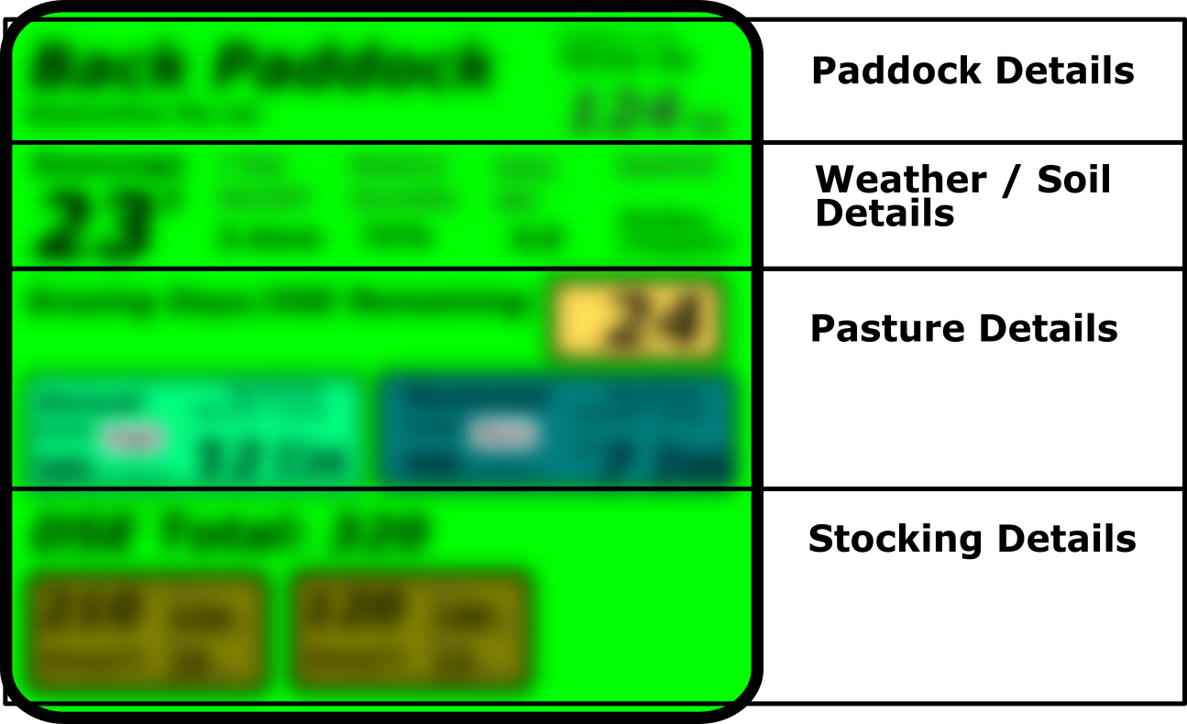

Figure 1: Paddock information grouped into major categories.

These tiles are currently shown as all one size; however, it would be simple to have them resizing to fit different information depending on the view.

### Overall Classification for grazing status based on stoplight colours:

To allow the farmer to easily see what the DM (dry matter) status of each paddock is at a glance, the background colour of the tile would change based on how far away the current DM /ha level is from the specified minimum DM/ ha level for the paddock.

- **Red:** cover levels are about to fall below acceptable limits (or have already done so)

- **Orange:** less than a week’s grazing left in paddock before cover limits are below recommended.

- **Green:** more than a week’s grazing is available.

### Each paddock will have three views:

**- Instant or default view:** Provides “right now” status data for the paddock, along with relevant details. This is the default view and the view that is first available when the page is accessed. Data cannot be edited from this view, but the user can refresh to check for updated weather or soil data.

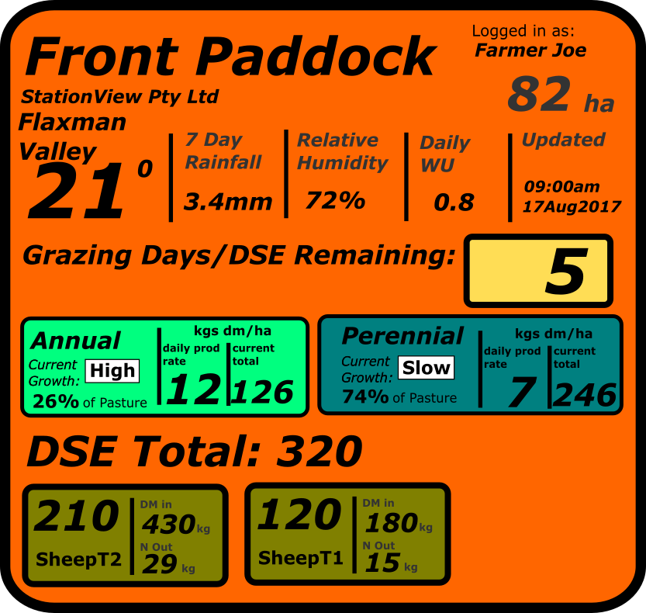

Figure 2: Default view shown in Orange (DM getting low) colour. Details shown here are indicative of how view may look only.

**- Timeline view:** Provides status over time for the data, with graphs and possibly tables showing trends over time. This is accessible via right click (desktop) or equivalent on mobile, with a tick icon to return to default main view.

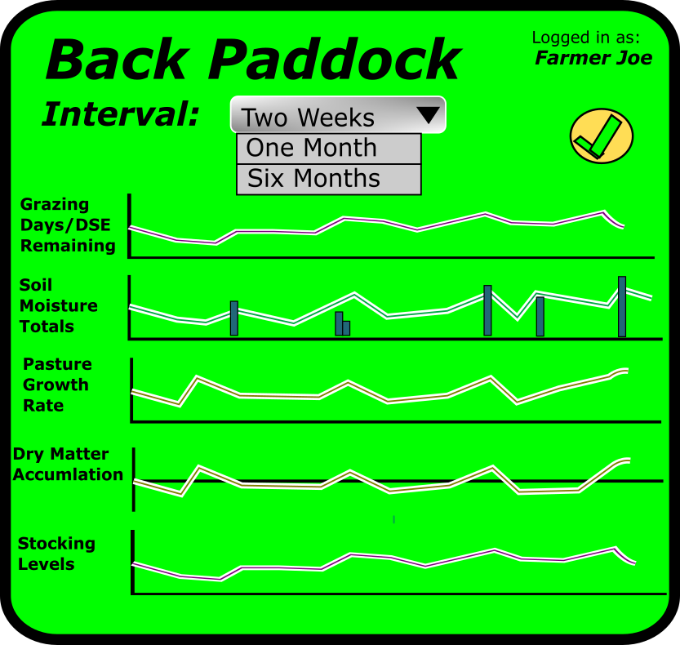

Figure 3: Timeline view shown in green (DM levels ok) colour. Details of data shown here are indicative of how view may look only.

**- Edit view** – Provides a way to edit variables for the paddock such as vegetation type and cover, and actual stocking rates. White boxes, buttons and the dropdown box are all editable features.

This view is accessible via double click on the desktop and double tap on mobile.

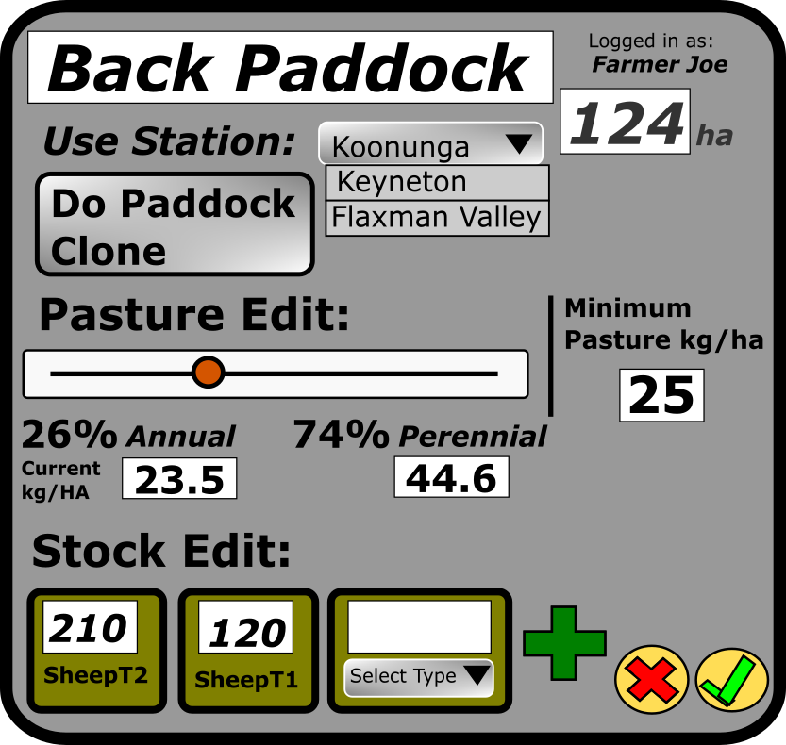

Figure 4: Editing view, which is not coloured as status is changing. Details of functions shown here are suggestions of how they may look and work only.

### Viewing, editing and management of paddock data will work equally well on Desktop and Mobile Devices

Using a tile layout where each paddock is self-contained, the web app can easily be used on desktop, tablet or mobile phone. Apart from the tiles other settings would be accessed by a simple menu in the top toolbar which would allow changes to user settings and allow new properties to be added.

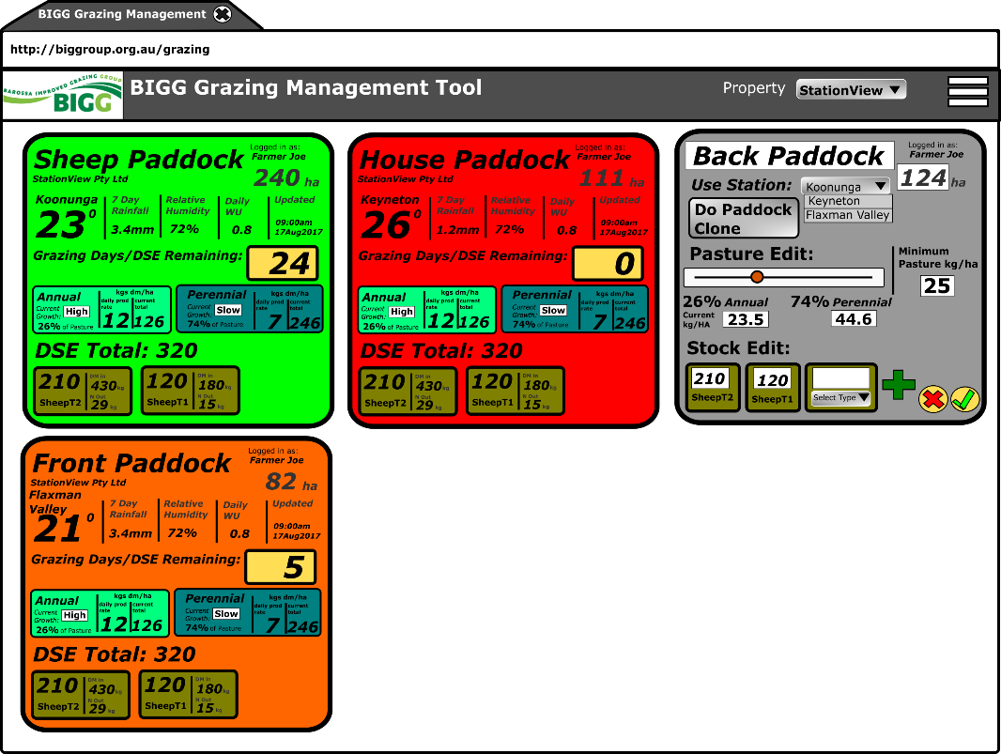

Figure 5: User view of web app when working from the desktop.

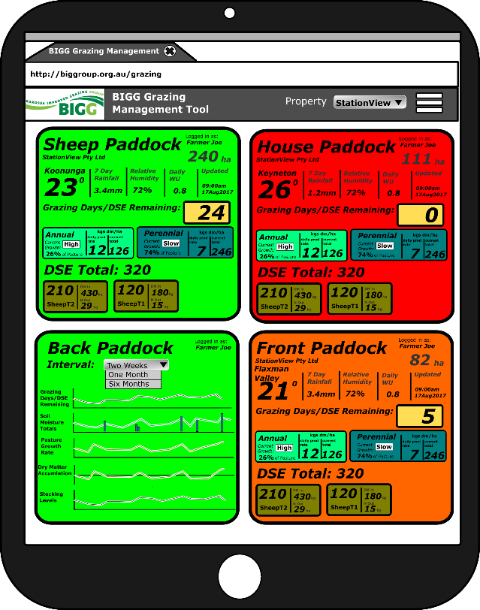

Figure 6: User view of web app when working from a tablet pc.

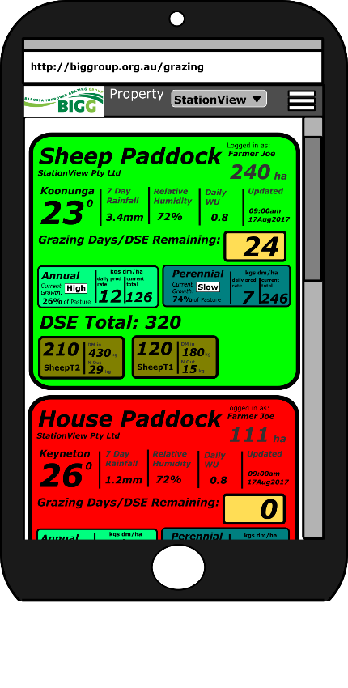

Figure 7: User view of web app when working from a mobile phone.

## Data and Model Notes

Except where noted below, all data structures would be created as specified in the initial information document. Created data would be available to export from the server if required. The suggestions below have been made with the view that simplifying data inputs and outputs for farmers is more likely to see wide utilisation of the tool. While I am unsure of the exact budget scope, these suggested optimisations will simplify the project and reduce costs. As with this whole proposal WDM is happy to work through any changes required.

|  |  |
| --- | --- |
| Data Type | Notes / Suggested Configuration. |
| Pasture Details | Rather than specifying multiple types of pasture, maybe the user could specify the percentage of annual and perennial pasture for each paddock. The starting DM /kg for annuals and perennials would be specified, and be able to be manually updated at any time. This would simplify entering pasture details and avoid the need to check to see the user has entered 100% of the area as pasture cover. See figure 4 (Edit View) for possible implementation layout.  Annual and perennials would each have a growth coefficient for each month of the year to allow for changes in growth patterns by seasons |
| Stock Details | Calculations would be carried out for the derived DSE equivalent based on stock types rather than separately for each stock type. |

## Costing and Timelines

|  |  |
| --- | --- |
| Task | Estimated Costing |
| **Initial Setup:**   * Work with BIGG to refine proposed layout to match perceived group needs * Estimate at least 4 iterations of design before finalisation. * Get raw initial import of data from Adcon server and build working static model in MS Excel to check / verify formulas (Maybe this has already been done?) | **$3000** |
| **Initial Software Building:**   * Create site based on updated layout drawings from task 1. * Create data models and check functionality to ensure calculations are correct. * Get site to initial working level (still with errors but most functionality working). * Provide details for group to carry out initial user testing | **$4750** |
| **Refinement and Testing:**   * Fix errors / make superficial changes based on initial feedback from users. * Make small adjustments to data models * Follow-up issues identified in testing and resolve identified errors. | **$3750** |
| **GST**  **Total** | **$ 1150**  **$12650** |

**Exclusions:**

* Extensive changes to model or layout when in “Refinement and Testing” stage.
* Hosting of site beyond initial project build.