FF Aegis Max
1. Version Statement
1.1 Legal Statement
Before using this product, users must carefully read the user manual and operate the product strictly in accordance with its contents. The company shall not be held liable for any property damage or personal injury resulting from the use of the product in violation of the instructions in this manual. This product consists of multiple components. Please ensure that children cannot access the product to avoid accidents. This product is only for use by persons aged 18 and above. To extend the product's service life, do not use it in high-temperature or high-pressure environments. This manual aims to include functional descriptions and usage instructions for the product as comprehensively as possible. However, due to continuous improvements in functionality and design changes, there may be discrepancies between the actual product and the manual content. If there are differences between the actual product and this manual in terms of colour, appearance, etc., please refer to the actual product.
1.2 Precautions
This manual applies to the Aegis Max version (Model: [FF model code to be assigned]).
A. Application of the Robot
- Terrain: Please try to avoid walking on smooth surfaces such as glass or ice; if walking is necessary, reduce the robot's walking speed to prevent slipping and falling.
- Climate / Weather: Please avoid deploying the robot in severe weather conditions such as heavy fog, thunderstorms, sandstorms or strong winds whenever possible.
- Communication Interference: Do not operate the robot in any environment with severe communication signal interference from sources such as WiFi or RF; if necessary, turn off the interference sources or reduce their interference.
- Electromagnetic Interference: Do not operate the robot in environments with strong electromagnetic interference, such as near high-voltage power lines, high-voltage substations, communication base stations or signal towers. If necessary, consult after-sales service first.
- IP Protection: The robot has a protection rating of IP67, allowing it to walk 1 m underwater for 30 min. Before use, keep the robot in proper condition — exterior undamaged, expansion port cover securely closed, battery and its compartment dry and free of moisture. After completing 30 min of underwater walking, promptly remove the robot from the water, thoroughly wipe and dry its body, and perform any required maintenance before the next underwater operation. Any malfunction caused by prolonged water immersion may void the warranty.
- Maximum Speed: The robot can reach a maximum speed of 6 m/s, with significant impact force. At any high speed, keep the robot away from crowds.
- Mode of Motion: The modes of motion are Stationary Mode, Sport Mode, Navigation Mode and Stair Climbing Mode. Switch between modes according to the environmental scenario.
- Recovery from a Fall: The robot requires space to regain its standing posture after a fall. To avoid collisions, ensure no persons or objects within 2 m around the robot. Do not drag a fallen robot when its hard emergency stop has not been triggered.
B. Battery Application
- If the battery emits a noticeable odour, shows signs of overheating or exhibits corrosion before initial use, contact the battery supplier.
- Before allowing children to use the equipment, adults must clearly explain how to use the equipment and the battery, and periodically follow up to confirm proper use.
- Do not use or place the battery in an extremely high temperature environment (e.g. over 60℃, such as under intense direct sunlight or inside an extremely hot vehicle). The battery may overheat or catch fire, its performance may degrade and its service life may be shortened.
- Do not use the battery in any environment with electrostatic discharge over 1,000 V, as this may damage the protection circuit and create a safety hazard.
- The battery can only be charged within the temperature range of 0 to 50℃. Charging outside this temperature range may cause the battery to leak liquid, overheat or suffer severe damage, and may degrade its performance and lifespan.
- Do not charge or discharge the battery near anything flammable, as this may create a fire hazard.
- The battery will automatically enter storage mode when a single-cell undervoltage condition is detected. In this mode the battery does not respond to the power switch and the battery indicator remains off. The battery exits storage mode after being charged.
- Once powered off via the battery button, the battery enters sleep mode and can be woken by communication, by pressing the button, or by charging.
- If the battery circuit terminal becomes dirty, wipe it clean with a dry cloth before use; otherwise poor contact may lead to performance failure.
- The battery should be stored at room temperature and charged to 30%–60% of its capacity. To prevent over-discharge, charge the battery to 50% with the standard charging method once every 3 months. If the battery has been stored for over one year, perform one full charge–discharge cycle annually with the standard method to activate the battery.
- A battery left unused for an extended period may become over-discharged through self-discharge, and the cell may even discharge to 0 V. Continued use of such a battery carries risk. Charge the battery regularly to maintain its voltage between 30% and 60% of capacity.
- The plug cord has limited tension resistance and excessive pulling force may damage the battery. Once the battery is installed, do not swing the battery or the plug cord freely.
- Do not use or store the battery near fire or a heater, or in a high-temperature environment (>80℃).
- The use of any unauthorised charger is prohibited. Any damage to the battery caused thereby is not covered under warranty.
- Do not connect the battery with reversed polarity, and do not short-circuit the battery by connecting the positive and negative terminals with wires or any other metal objects.
- Do not incinerate or heat the battery, and do not subject it to excessive mechanical shock such as striking, throwing or stomping. Do not pierce the battery with nails or other sharp objects.
- Do not disassemble the battery — disassembly will void the warranty.
C. Other Precautions
- If the robot shows signs of water ingress, immediately turn off its power, remove the battery and allow it to dry thoroughly.
- If the robot smokes or catches fire, use a carbon dioxide or dry powder extinguisher. Do not use foam extinguishers.
- If the robot exhibits uncontrolled motion such as leg swinging, first trigger the soft or hard emergency stop and ensure the safety of personnel, then power off and remove the battery before troubleshooting. Report difficult problems to technical support for troubleshooting, repair or replacement.
- Unauthorised disassembly of the robot is prohibited. The warranty will be voided if the robot is disassembled.
- Moving parts — keep body parts away from moving parts.
Regulatory statements — omitted deliberately
The source manual carries FCC, ISED/IC, Thai NBTC and French-language regulatory statements at this point. They are tied to the original certification holder and its FCC ID and are therefore not reproduced.
FF's own compliance statements must be inserted here once certification is in place. See Section 0.2, item 2.

D. Open Network Ports
The following ports are open on the device.
No. | Port | Open? | Function
1 | 21 | Yes | Network log download service, for retrieving system logs remotely.
2 | 22 | Yes | SSH development and debugging entry, for remote access and diagnostics.
3 | 5555 | Yes | ADB debugging entry point. Port remains open; password authentication is enforced.
4 | 7447 | Yes | ROS topic routing entry, for inter-module message passing.
5 | 8081 | Yes | App control port, for the application-layer command and control interface.
6 | 8554 | Yes | RTSP video streaming port, real-time video data transmission (stream 1).
7 | 8555 | Yes | RTSP video streaming port, real-time video data transmission (stream 2).
8 | 5760 | Yes | TCP connection port, remote controller communication link.
9 | 50000 | Yes | Dedicated port for gimbal control and cloud platform integration.

2. Product Introduction
2.1 Product Overview
Aegis Max is a wheel-legged quadruped robot featuring lightweight design, high load capacity, long endurance, strong protection, and flexible, stable movement. Each leg is equipped with three joint motors and one hub motor, forming a wheeled leg. It is equipped with sensors including LiDAR, optical cameras, ultrasonic radar, IMU, fill lights and RTK modules. Internally it incorporates a high-performance main platform for motion control, autonomous navigation and positioning, and environmental detection, and it provides a rich set of power supply and communication interfaces supporting the expansion of multiple categories of mission payload.
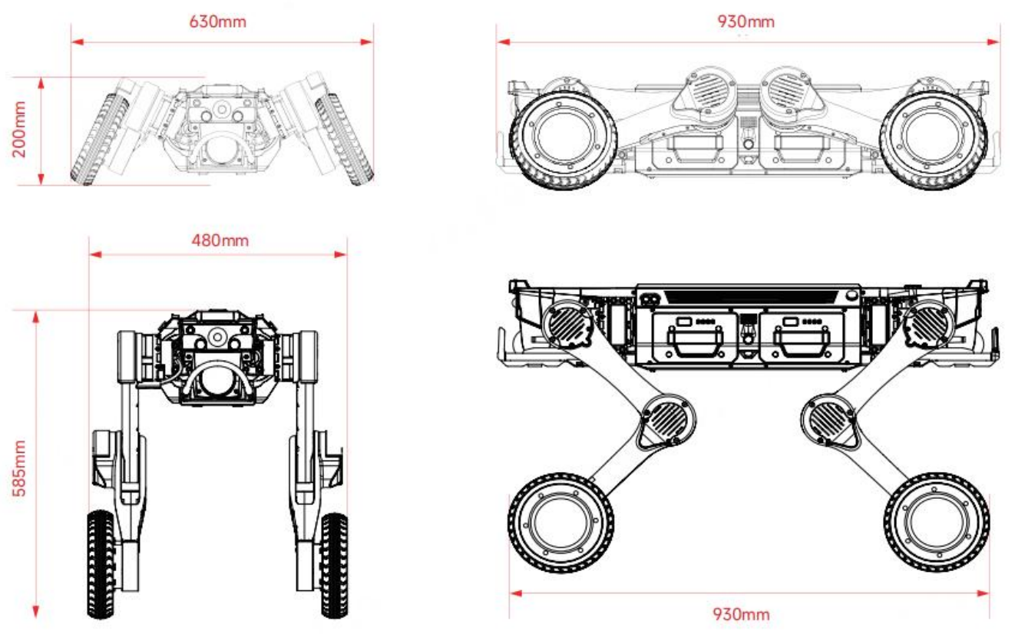
Source figure — reference only; FF artwork required before publication.
2.2 Component Name
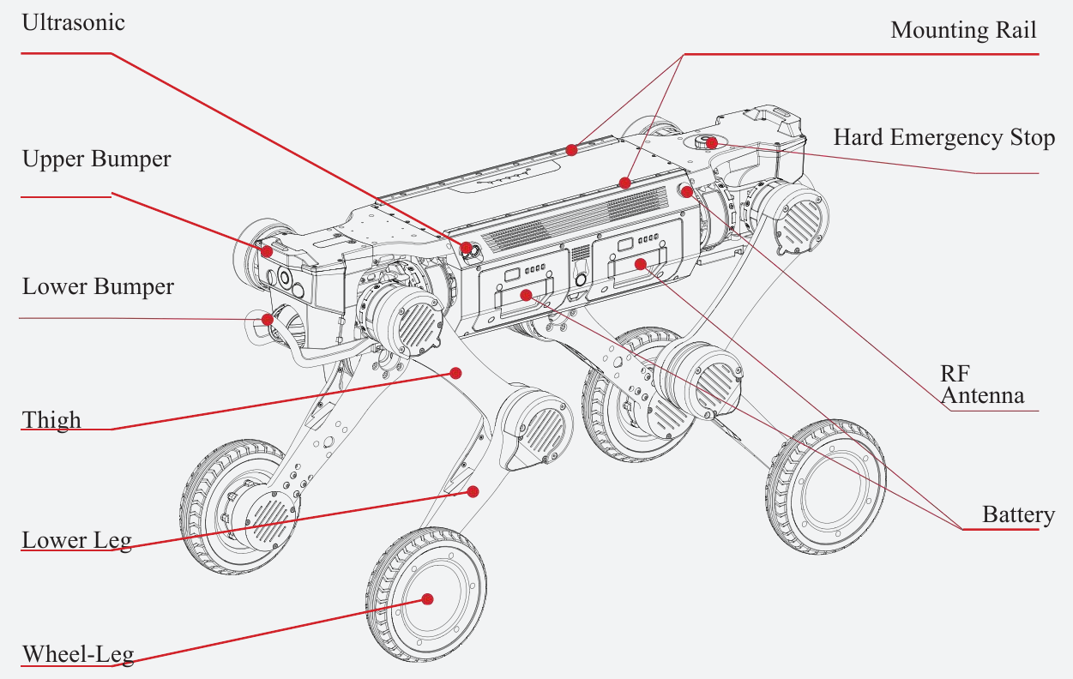
Source figure — reference only; FF artwork required before publication.
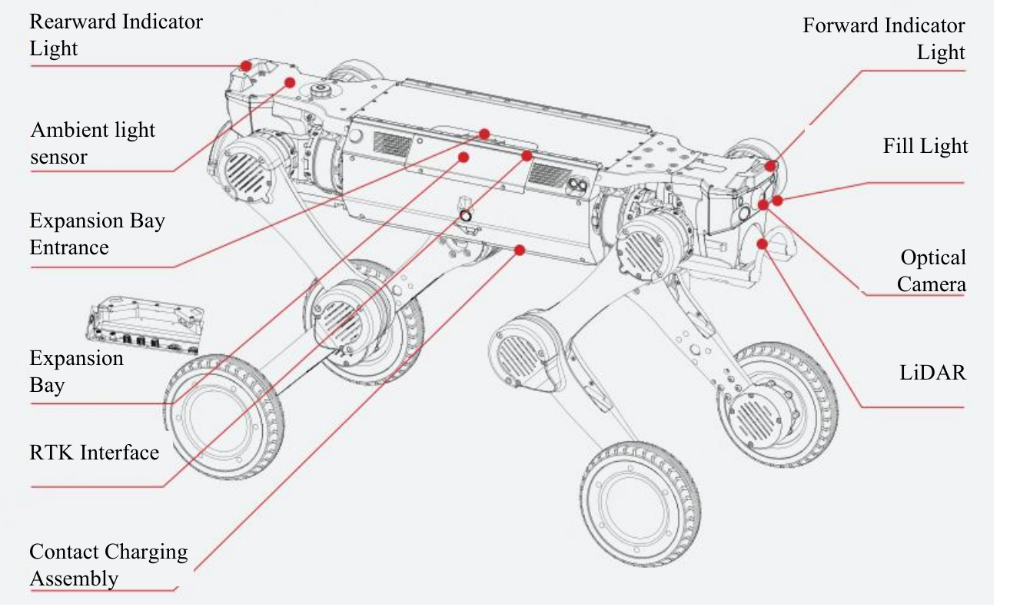
Source figure — reference only; FF artwork required before publication.
Callouts: Ultrasonic Mounting Rail · Hard Emergency Stop · Upper Bumper · Lower Bumper · RF Antenna · Thigh · Battery · Lower Leg · Wheel-Leg · Rearward Indicator Light · Forward Indicator Light · Ambient Light Sensor · Fill Light · Expansion Bay Entrance · Optical Camera · Expansion Bay · LiDAR · RTK Interface · Contact Charging Assembly.
2.3 Core Specification
Category | Specification | Description
Basic Information | Product Model | [FF model code to be assigned]
 | Material | Aluminium alloy + high-strength engineering plastic
 | Size (standing) | 930 mm × 480 mm × 585 mm
 | Size (lying prone) | 930 mm × 630 mm × 200 mm
 | Machine weight (with battery) | 41 kg
 | Battery weight | 3.3 kg per unit
 | Wheel size | 8 inches
 | Ingress protection | IP67
 | Operating temperature | -20℃ ~ 55℃
Motion Performance | Degrees of freedom | 12+4 DOF
 | Max speed | 6 m/s
 | Effective payload | 25 kg ← see Section 0.2 item 1
 | Max climb angle | 45°
 | Continuous climbable step height | 25 cm
 | Vertical obstacle crossing height | 80 cm
 | Load-bearing span | 50 cm
 | Minimum turning radius | Supports turning around in place and switching between forward and reverse directions
 | Crawling height | 34 ± 0.5 cm
Battery Parameters | Battery capacity | 504.9 Wh × 2; dual batteries supporting quick replacement with hot-swap capability
 | No-load runtime | 5 ± 0.5 h
 | Full-load runtime | 3.5 ± 0.5 h
 | No-load range | 29 ± 1 km
 | Full-load range | 18 ± 1 km
 | Charging dock input voltage | AC 100–240 V
 | Charging dock output voltage / current | DC 63 V, max charging current 10 A
 | Charging time | < 1.5 h

Notes:
(1) For instructions on using the functional expansion interface, refer to the expansion manual.
(2) For detailed warranty terms, refer to the product warranty manual.
(3) The above parameters are laboratory test data. Actual performance may vary due to usage environment, operation methods and other factors. Refer to actual product performance.
2.4 Description of Light Effect
Status Indicator
Colour | Effect | Robot Status
White | Slow flash | Startup in progress
White | Normally on | Manual control / working state
White | Breathing | Standby
Green | Slow flash | Locating / auto return in progress
Green | Normally on | Auto task execution in progress
Yellow | Quick flash | Alarm state
Yellow | Normally on | Low battery
Red | Quick flash | Fault state
Red | Normally on | Soft emergency stop
Blue | Normally on | Upgrading
— | Breathing | Charging (optional charging pile)

- Hard emergency stop: the red status indicator is normally on and the red light of the hard emergency stop button is normally on.
- Forward / reverse direction switch: when the robot switches between forward and reverse directions, the status light on the corresponding direction illuminates, followed by the lighting effect above.
- Except when switching between forward and reverse main direction states, where the front and rear lights differ, the lights are consistent in all other situations.
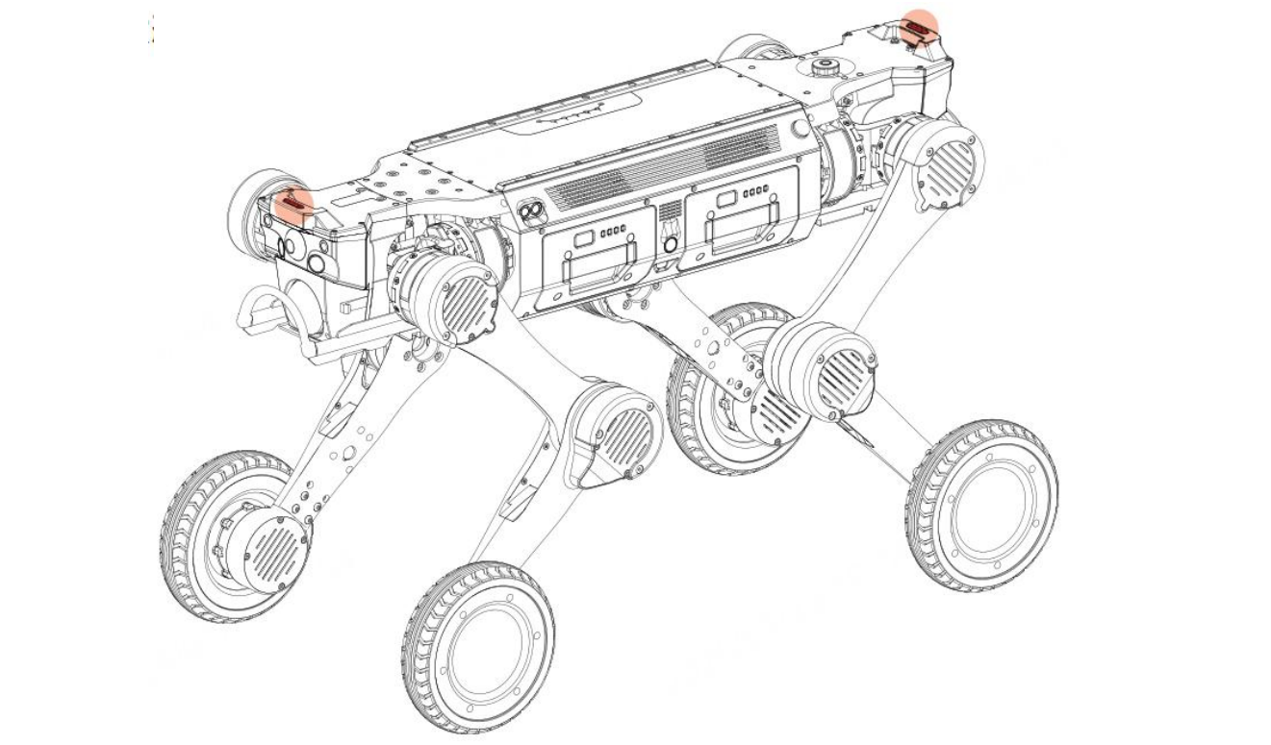
Source figure — reference only; FF artwork required before publication.
Battery Indicator
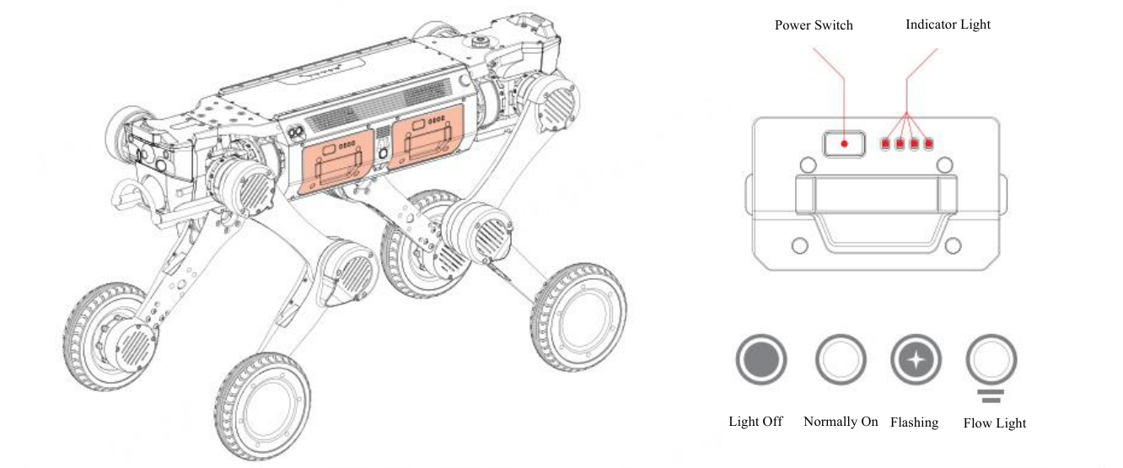
Source figure — reference only; FF artwork required before publication.
Indicator Effect | Battery Level
4 LEDs normally on | 75%–100%
First 3 LEDs normally on | 50%–75%
First 2 LEDs normally on | 25%–50%
First LED normally on | 0%–25%
First LED flashing | 0%
4 LEDs illuminated in sequence | Charging; all 4 stay lit when fully charged

Emergency Stop Indicator
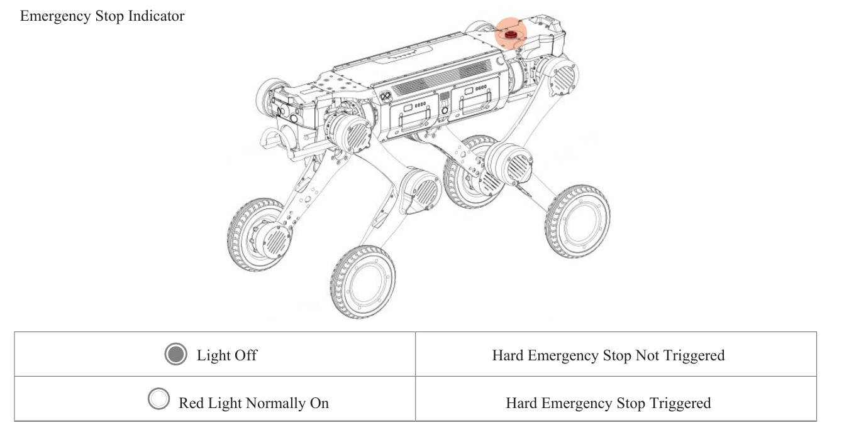
Source figure — reference only; FF artwork required before publication.
Indicator | State
Off | Hard emergency stop not triggered
Red, normally on | Hard emergency stop triggered

2.5 Expansion Interface
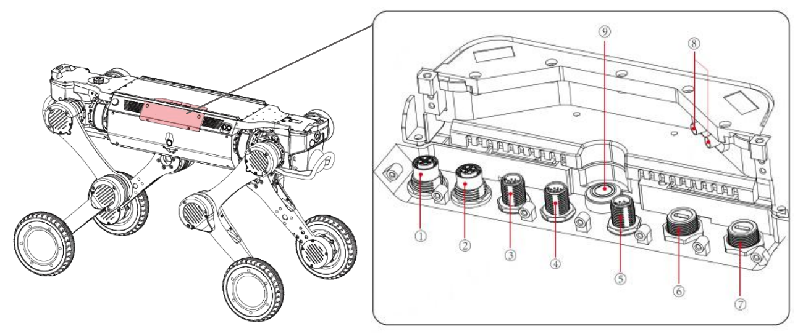
Source figure — reference only; FF artwork required before publication.
No. | Interface
① | 48 V (10 A) × 1
② | 24 V (20 A) × 1
③ | 24 V (3 A) + 1 × Ethernet port
④ | 12 V (5 A) + 1 × Ethernet port
⑤ | Serial port (RS232 × 1, RS485 × 1, SBUS × 2, PPS × 1)
⑥, ⑦ | 2 × USB 3.0 (5 V, 1 A)
⑧ | RTK interface
⑨ | Expansion bay button

Warning
- When installing additional equipment on the back of the robot, consult after-sales service staff regarding the planning and design of centre of gravity, position, interface and wiring before formal installation.
- The total power supplied by all power interfaces is ≤ 480 W.
- If an aviation plug is used, a protective cap shall be fitted to ensure the IP67 rating. The protective cap shall be secured when the aviation plug is not in use.
- The expansion bay button controls the power supply to the expansion interface. When connecting assemblies, power off the expansion bay first.
2.6 Mode of Motion
The robot comes standard with a reinforcement learning locomotion model, featuring Stationary Mode, Sport Mode, Navigation Mode and Stair Climbing Mode.
Mode | Description
Stationary Mode | The robot remains stationary while its torso performs various actions including rotation, pitch and height adjustment.
Sport Mode | The robot automatically adapts to flat ground, slopes, stairs and complex terrain such as mountains, forests and rubble. It supports forward and backward movement and in-place rotation, and can perform standing, crawling, prone and locked postures, as well as advanced manoeuvres such as climbing elevated platforms and twisting motions.
Navigation Mode | Maps can be created in this mode. Once the map is generated, the fixed-point cruise function can be enabled based on the map to achieve automated inspection and fixed-point operations.
Stair Climbing Mode | The robot autonomously plans its gait to traverse multi-level staircases with stability, suitable for multi-storey operations.

Warning
- When performing high-platform climbing manoeuvres, ensure the robot has ≥ 2 battery bars and is unloaded, keep it in sight, and maintain a safety distance of ≥ 2 m from bystanders.
- When navigating stairs, slopes or similar surfaces, ensure no one is directly above, below or within the robot's path.
- In Sport Mode the robot has standard low, medium and high speed settings. To ensure safe task execution, lateral movement and in-place rotation are restricted at medium and high speeds.

3. Instructions for Use
3.1 Environment Requirement
- Before powering on, the operator shall thoroughly read this manual to become familiar with all functional states, operational details and precautions.
- During initial operation, avoid the robot moving out of sight and ensure no person or obstacle is within 2 m around it, to prevent collision.
- Temperature: use the robot within an ambient temperature range of -20℃ to 55℃.
- Weather: do not power on and use the robot in severe weather such as heavy fog, thunderstorms, sandstorms or tornadoes.
- Electromagnetic environment: avoid using the robot in environments with strong electromagnetic interference (high-voltage power lines, transmission substations, communication signal towers) to prevent magnetic breakdown.
- Communication environment: do not power on and remotely operate the robot in environments with communication signal interference, to avoid communication disruption and loss of connection.
3.2 Unpacking
The robot is packed in a flight case. Place the case on a flat surface with the correct orientation upward, open and remove the lid, then sequentially remove the robot, battery, remote control and charger cradle, and place them on a hard, flat surface.
Warning
- When moving the robot out, hold the designated lifting points as instructed, and pay attention to the location and content of warning labels to avoid pinching or scratching hands.
- Handle the robot, battery, remote control and charger cradle gently during transport.
- After transport, check that the Aegis Max emergency stop button and battery power button have not been triggered.
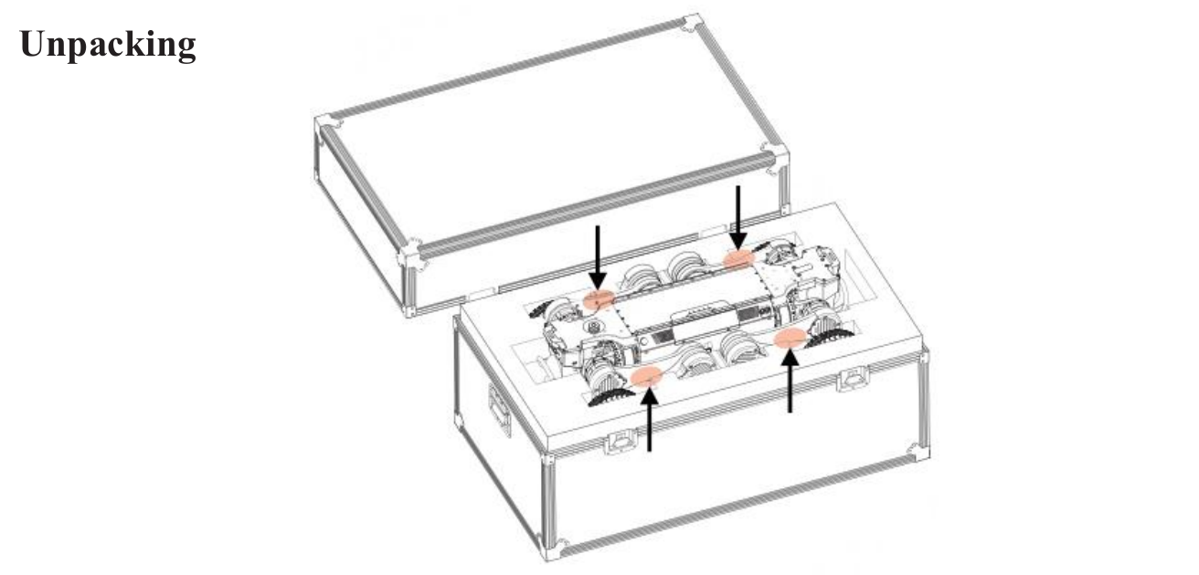
Source figure — reference only; FF artwork required before publication.
3.3 Pre-start Inspection
A. Appearance and Mechanical Structure
- Overall exterior integrity: check the body shell for cracking, deformation or detachment, focusing on vulnerable parts such as joint connections and sensor protective covers. Check for obvious stains, liquid residue or foreign matter on the body surface, especially around radiator holes and interfaces.
- Joint and moving parts: check each leg joint and wheel leg to confirm that joint motion is smooth, without sticking, abnormal noise or looseness. For wheel-legs, confirm the anti-slip tread is clear, without cracking or peeling. Confirm that fasteners such as screws and clips at the joints are not missing or loose.
B. Battery Status
- Battery appearance: check whether the battery pack shell is bulging, leaking or damaged. Bulging may indicate the battery is aged or overcharged — do not use it; replace it immediately to avoid fire or explosion risk.
- Battery connection: check that the interface between the battery and the body is clean and free from oxidation, corrosion or foreign matter. Ensure the latch is fastened securely when inserting, to avoid power interruption due to poor contact.
- Battery level: before power-on, judge the battery level via the indicator — at least one battery should have more than 2 bars of charge. Click the battery power button to display the exact charge level. In a low-battery state, charge first to avoid mid-operation shutdown.
C. Environmental Perception Sensors
- Optical sensors: check that camera and LiDAR lenses are clean and free from stains, scratches or obstructions.
- Distance / obstacle avoidance sensors: check that the probes of obstacle avoidance components such as ultrasonic sensors are intact and unobstructed.
D. Remote Control
- Check that the remote control buttons are responsive without sticking, and that the battery has sufficient charge, to ensure normal operation once the robot is powered on.
- Check the display screen, indicator lights and speakers. Confirm the display is undamaged and free of distortion, and that indicators illuminate normally, so that operating status (battery level, fault warning) can be read once powered on.
3.4 Pre-start Preparation
A. Install the Battery
The robot is equipped with dual battery compartments, supporting both single-battery and dual-battery power supply. Align the battery with the compartment interface (which has a foolproof design to prevent incorrect insertion), pull up the battery hand strap, push the battery in until it bottoms out, then release the strap. A click indicates the latch is locked. Once installed, check the battery installation status — the outer surface of the battery should be flush with the surface of the robot body.
B. Place the Robot
Adopt a horizontal prone posture: abdomen fully flush with the ground, legs naturally positioned on either side of the body, lower legs in a minimally retracted stance, with all four knee joints and wheel feet flat on the ground, and no thigh or lower leg compressed by the torso.
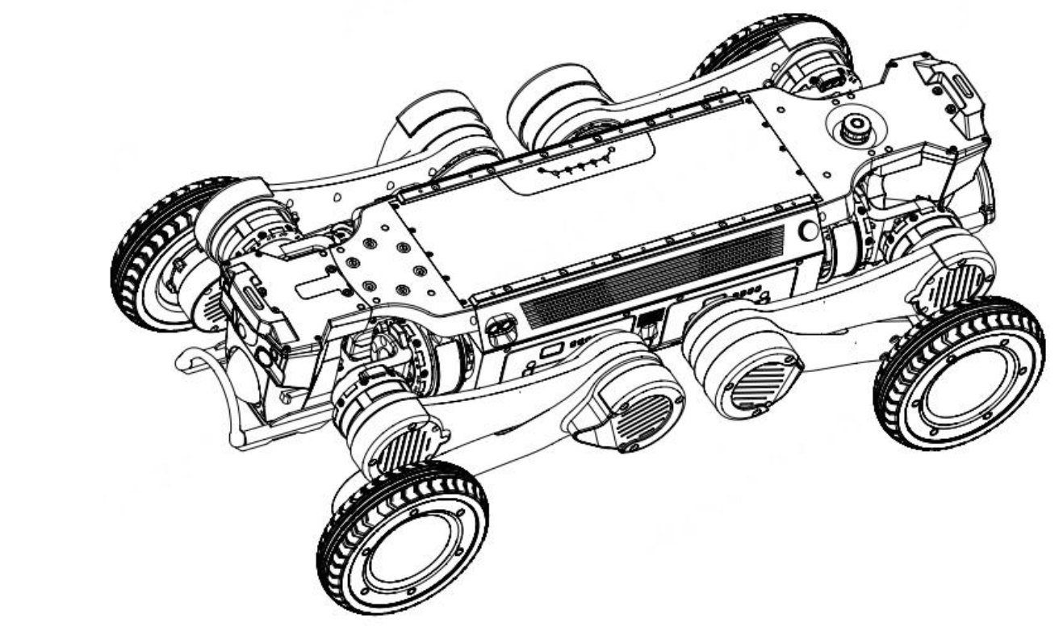
Source figure — reference only; FF artwork required before publication.
3.5 Startup and Operation
A. Power-On Process
Power-on is initiated through the battery. Briefly press the battery button to activate the battery — its indicator will be normally on and display the current charge level. Then press and hold the battery button for 3 s to turn on the battery and boot the robot. A white blinking status indicator signifies startup in progress; a steady white light indicates startup is complete and the robot has entered universal motion mode.
Battery Status | Power-On Process
Robot powered off, no battery inserted | Insert only one battery: either insert a battery that is already powered on, or first insert a powered-off battery and then power on the battery to start the robot.
Robot powered off, one powered-off battery inserted | Insert another powered-on battery to start the robot. An inserted powered-off battery will start automatically 1 min after insertion. Alternatively, insert another powered-off battery, then power on either battery.
Robot powered off, two powered-off batteries inserted | Either battery can be powered on to start the robot as a whole. The other battery will be engaged automatically without manual activation.

Warning
- The dual batteries feature mutual wake-up. In dual-battery mode, only both-on or both-off states are supported; one battery on and one off is not supported.
- When Aegis Max is powered on with a single battery, inserting another battery — powered on or off — will automatically activate and connect it.
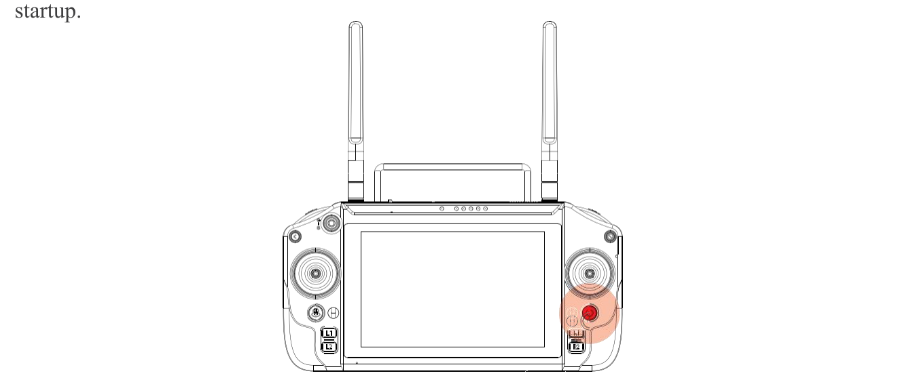
Source figure — reference only; FF artwork required before publication.
B. Power On the Remote Control
Press and hold the remote control power button; the screen and power indicator will illuminate. The remote control is paired one-to-one with the robot before delivery and will connect automatically on startup. Once the remote control is on, tap the app icon on the screen to enter the control interface. Once the app health status is confirmed, you can control the robot.
C. Operation Guide
For remote control operation, refer to the [FF remote controller user manual — title to be assigned].
D. First Power-On Verification
- Basic motion test: use the app to command the robot to stand, go prone, move forward, backward, left and right, and turn. Confirm joints move freely. In case of jerking, abnormal noise or inability to stand, power off immediately and check for joint jamming or incorrect posture.
- Sensor status test: confirm all vision, laser, ultrasonic and inertial navigation sensors function normally and data displays properly in the app.
- Status feedback: observe the equipment status shown by the LEDs, display and app to confirm normal battery level, connection signal and firmware version. If a fault prompt appears, troubleshoot according to this manual.
- Initial password setup for a new device: (1) after first boot, a mandatory password-change prompt appears on SSH remote login, and debug interface access is denied until the password is changed; (2) the Wi-Fi hotspot password can be changed directly in the app; (3) the app supports a 6-digit numeric lock-screen PIN, verification is required to re-enter the app after a 14-minute timeout, and repeated wrong entries trigger a temporary lockout.
3.6 Battery Swapping and Power-Off
A. Change the Battery
The robot features dual batteries with hot-swap capability. When powered by both batteries, you can unplug one powered-on battery and replace it with a battery in either an on or off state. The robot continues operating normally during battery changing.
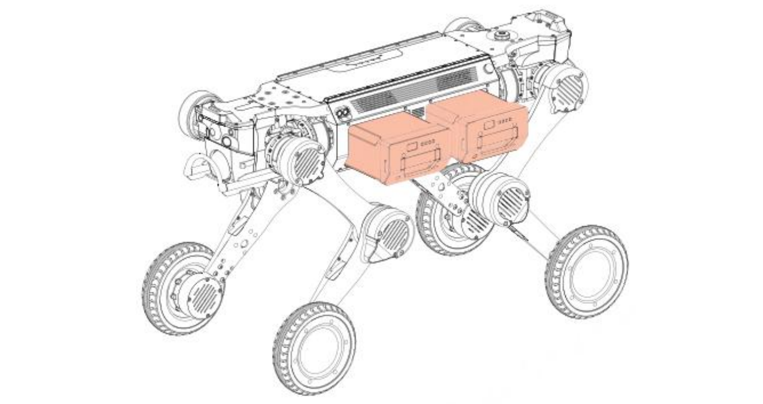
Source figure — reference only; FF artwork required before publication.
B. Power Off
In single-battery or dual-battery mode, turn off any battery. The battery indicator will go out, the robot status indicator will go out, and the robot will power off. To power off the remote control, press and hold its power button.
Warning
- Whenever possible, first place the robot in a horizontal prone posture before powering off. Avoid powering off directly while the robot is standing.
- When the robot has only one powered-on battery, it is prohibited to shut down by pulling out that battery.
3.7 Emergency Stop and Protection
A. Hard Emergency Stop
- Trigger: when the robot is out of control or malfunctioning, in either autonomous or remote-control mode, press the red hard emergency stop button on the robot's back. The hard emergency stop red light will be normally on, the robot will slowly lie down and remain motionless, and a real-time alert will appear in the app.
- Release: turn the hard emergency stop button clockwise to release it.
B. Soft Emergency Stop
- Trigger: when the robot is out of control or malfunctioning, press the soft emergency stop button on the remote control. The robot will cease its current action and remain stationary in a standing posture, and a real-time alert will appear in the app.
- Release: once the robot and its surroundings are confirmed safe, release the soft emergency stop via the app, restoring both app and robot to normal status.
C. Overheat Protection
The robot has comprehensive temperature detection. If a joint, the main control or the battery overheats, the robot enters overheat protection, ceasing all motion, going prone and remaining still. The overheat location and temperature can be viewed in the app. Once the temperature drops to normal, operation can continue.
D. Low Battery Protection
When the charge level of both batteries falls below 20%, the robot enters a low battery warning state and should be charged immediately. Below 10%, low battery protection triggers: the robot goes prone automatically and no longer responds to remote control commands. Replace the batteries before continuing use.
E. Fall Protection
The robot attempts to recover to a standing position after a fall, under the control of a reinforcement learning motion control model. Where the surrounding environment does not permit recovery, the robot maintains a fixed posture and raises an alarm.
F. Expansion Bay Power Supply Protection
The expansion bay has a separate power button allowing independent control of its power state. When the machine is powered on as a whole and the mounted payload must be replaced, the expansion bay button can power off all interfaces in the bay without powering down the machine. The button is located inside the compartment to avoid accidental external contact powering down the upper assembly.
3.8 Payload Expansion
The space on the robot's back is flat, with a load of 30 kg. It is equipped with dual rails on the back to facilitate installation of mounted payload.
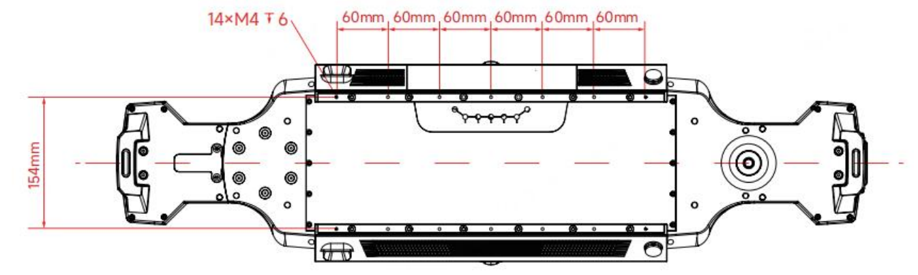
Source figure — reference only; FF artwork required before publication.
The back of the robot has an expansion bay entrance. The power and communication cables of the mounted payload enter the expansion bay and connect to the aviation plug, enabling power supply and communication between the robot and the payload.
Payload figure — unresolved in the source
This section states 30 kg while the Core Specification table states an effective payload of 25 kg. Both figures appear as such in the Chinese source and are reproduced unchanged. Resolve before publication — see Section 0.2, item 1.

Warning
- Once fitted with a payload, the robot supports basic motion modes only. Do not use elevated-platform manoeuvres after adding a payload.
- Adding a payload to the back may affect motion performance. Consult after-sales service staff before installation.
- When using an external power interface to supply a load, the total power provided must not exceed 480 W.
- To ensure the IP67 rating, all interfaces shall use IP67 aviation plugs with protective caps. Cover any unused aviation plug interfaces with caps.
- When installing a top-mounted payload and connecting the power interface, ensure the robot or the expansion bay is powered off.
3.9 Charging
A. Unplug the Battery
- Place the robot in a horizontal prone posture, with the abdomen completely against the ground, legs naturally placed on both sides of the body, lower legs fully retracted, and all four knee joints and wheel-legs flat on the ground. Lift the front and rear legs on the battery side in sequence to leave space for unplugging the battery.
- Alternatively, before turning off the robot, execute the battery swapping posture — the robot automatically assumes a horizontal prone posture and lifts the front and rear legs on the battery side.
- Gently pull the battery hand strap to unlock the battery latch, then pull the battery out.
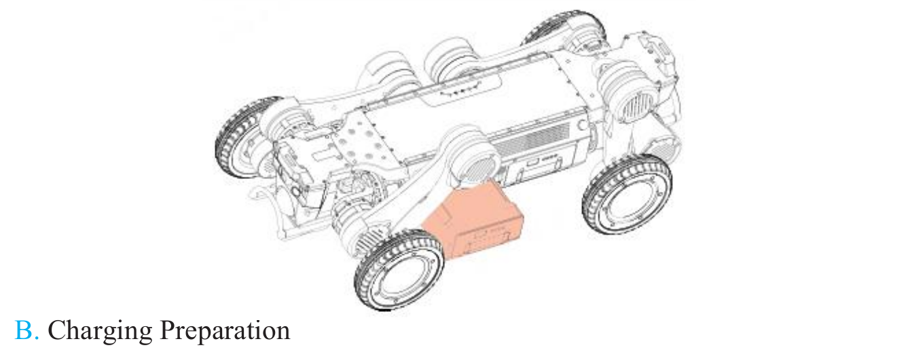
Source figure — reference only; FF artwork required before publication.
B. Charging Preparation
- Check the battery exterior for integrity and confirm no bulging, leakage or other damage.
- Place the charger cradle on a hard, flat surface to ensure stable placement and prevent tipping during charging.
- Connect the charger to AC mains. Turn on the charger cradle's rocker switch — a steady red light means the cradle is connected and powered on.
- The charging environment should be dry and cool, away from anything flammable or explosive, with the ambient temperature around the charger cradle between 0 and 50℃.
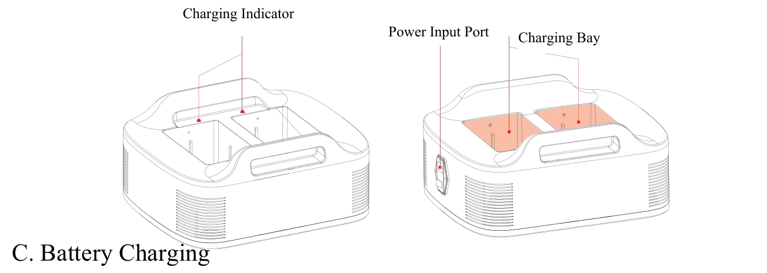
Source figure — reference only; FF artwork required before publication.
C. Battery Charging
- Align the battery with the charging interface on the cradle and insert it into the battery holder. Single-battery and dual-battery charging are both supported.
- A steady green indicator on the cradle corresponding to the battery indicates stable charging.
- The battery indicator illuminates in sequence to display charging progress. A steady LED denotes that its corresponding battery segment is fully charged; a rapidly flashing LED denotes the segment currently charging.
- When the battery is fully charged, all four indicators remain on. Promptly disconnect the battery or the cradle power source. Charging time should not exceed 6 hours.
- Once a fully charged battery is removed, promptly turn off the charger cradle to avoid the plug remaining live and posing a risk of electric shock.
It is prohibited to charge the battery using third-party chargers or charger cradles.
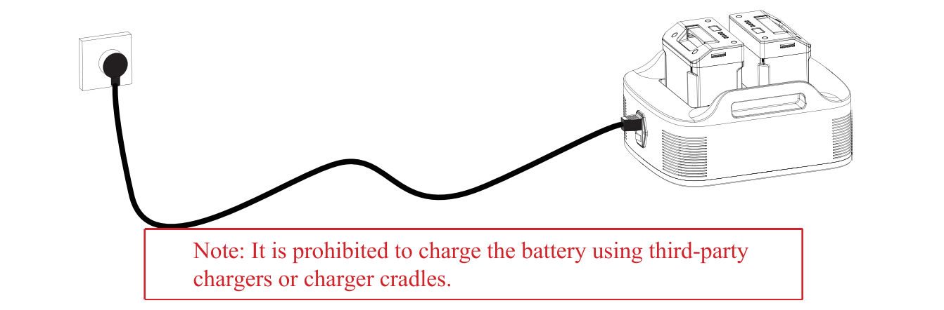
Source figure — reference only; FF artwork required before publication.
D. Remote Control Charging
- Charge the remote control with the original USB charger (AC 100–240 V, USB Type-C).
- During charging, the battery indicator illuminates in sequence to display progress. A steady LED denotes a fully charged segment; a rapidly flashing LED denotes the segment currently charging.
- To maintain the remote control battery in optimal condition, fully charge it once a month.
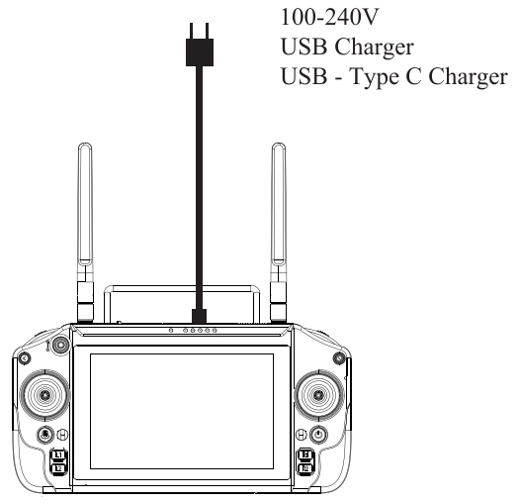
Source figure — reference only; FF artwork required before publication.
3.10 Transporting
Two modes of transport are supported: transporting while powered off, and transporting while powered on.
A. Powered-Off Transport
- Place the robot in a horizontal prone posture, abdomen completely flush against the ground, legs naturally placed on either side of the body, lower legs fully retracted, and four knee joints and wheel-legs flat on the ground.
- Two persons shall stand at the head and tail of the robot respectively and use both hands to hold the designated lifting points (the position of the lower leg near the knee joint), lifting the thigh and lower leg upward to the joint limit to prevent the legs from swinging.
- Once at the destination, place the robot on the ground, still in a horizontal prone posture.
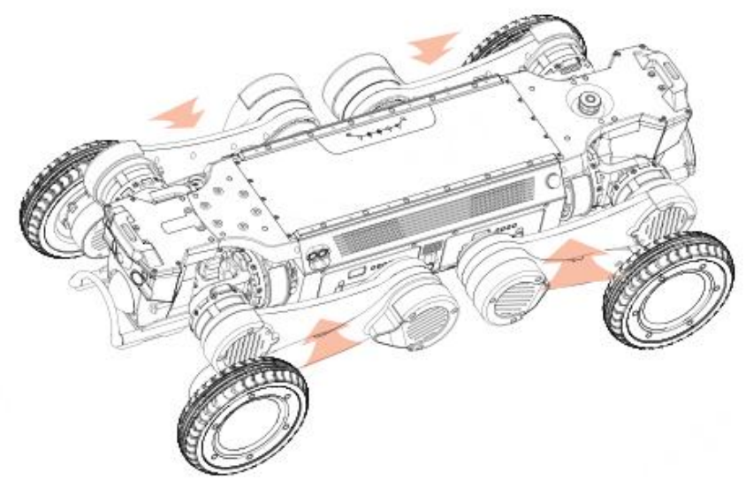
Source figure — reference only; FF artwork required before publication.
B. Powered-On Transport
The robot features a locked posture. While powered on, its limbs can be locked, allowing a single worker to carry the robot by gripping the bumper with both hands.
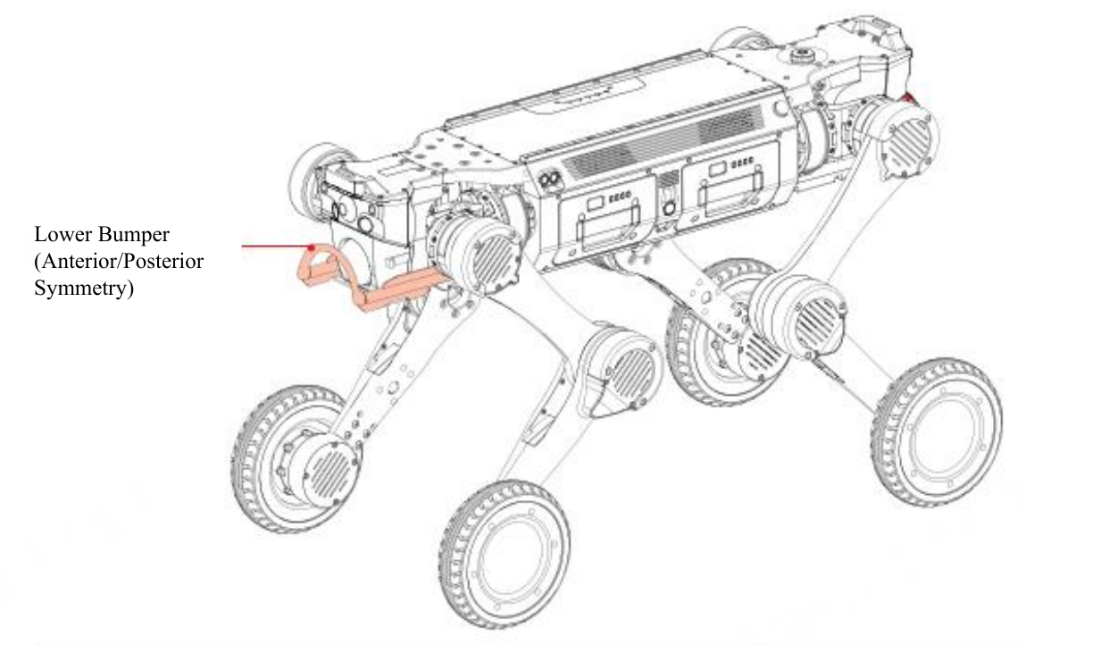
Source figure — reference only; FF artwork required before publication.
Warning
- Pay close attention to the warning labels on the robot during transport, to avoid pinching hands with the legs.
- When transporting the robot while powered on, or immediately after powering off, grasp it as far from the joints and battery as possible to avoid burns from heat generated by the battery or joints.
3.11 Storage
A. Preparation before Storage
- Environment: the storage environment shall be at a temperature of -20℃ to 60℃, kept dry and ventilated, and away from strong magnetic fields (high-power transformers, electromagnets) and strong vibration sources (generators, crushers).
- Cleaning: remove dust, stains and other impurities from the surfaces of the robot body, remote control, battery and charger cradle. Avoid liquids entering interfaces and radiator holes, to prevent moisture damage to internal components.
- Status check: check the robot, remote control, battery and charger cradle to ensure no physical damage and good functional condition.
- Battery charge regulation: charge the battery to 50%–60%. This range prevents damage from excessive discharge while avoiding capacity degradation from long-term storage at full charge.
B. Storage Method for Each Component
- Robot: power off a cleaned robot, remove its batteries and place it stably inside the dedicated packing case.
- Battery: place the two removed batteries in the packing case, each stored separately to avoid mutual compression or collision. Prevent the positive and negative poles from contacting metal objects, to avoid short circuits.
- Remote control: power it off, place it in the dedicated protective sheath and store both in the packing case. Avoid severe impact or compression that could crack the shell, damage buttons or break the display.
- Charger: place the charger in the dedicated storage bag or the charger storage space inside the packing case. Keep it isolated from other metal components to prevent wear or damage to the charger interface. Check that the plug is intact; if damage or rust is found, replace it before storage.
- Packing case: fold the case neatly and place it in a dry, ventilated environment. Avoid moisture, mould, or deformation from heavy objects. If the case is damaged or its load-bearing capacity is reduced, replace it with a new dedicated case.
C. Maintenance and Inspection during Storage
Short-term storage (1–3 months)
- Conduct a monthly visual inspection of the robot, batteries, remote control and charger to confirm no damage, deformation, rust or other defects.
- Check the battery charge level once; if below 40%, charge to 50%–60% before continuing storage.
- Check whether the temperature and humidity of the storage environment are satisfactory, and promptly replace any desiccant that has become ineffective.
Long-term storage (over 3 months)
- Conduct a power-on test once every 2 months: connect the robot to a power source or install batteries, power it on and run it for 5–10 min, checking that all functions are normal and joints move freely.
- Perform charge–discharge maintenance on the batteries once a month (discharge to 30%, then recharge to 60%) to prevent memory effect and preserve capacity.
- Perform a functional check on the remote control and charger once every 3 months, testing button sensitivity and charging function. If abnormalities are found, contact after-sales service for repair.
D. Precautions for Storage
- Do not store the robot or its accessories upside down or tilted. Upside-down storage may cause internal components to shift or become damaged.
- During storage, do not place heavy objects on the equipment or its packing case, to prevent deformation or component damage.
- If the equipment is taken out of storage for use, first let it rest at room temperature for 1–2 hours where there is a significant temperature difference between storage and usage environments. Wait until the device temperature matches ambient temperature before starting up, to prevent internal condensation and damage to electronic components.
- Do not let any non-professional disassemble the robot, battery, remote control or charger during storage. If malfunctions or abnormalities are detected, contact after-sales service for professional inspection and repair.
- Keep detailed storage records (time of storage, inspection dates, maintenance status) to facilitate subsequent tracing and timely identification of potential problems.

4. Remote Control
4.1 Controls
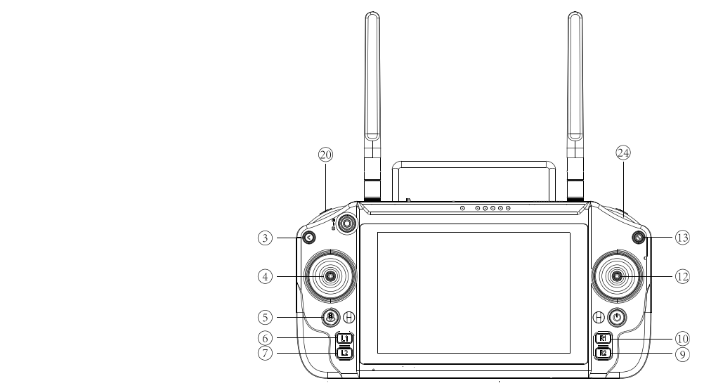
Source figure — reference only; FF artwork required before publication.
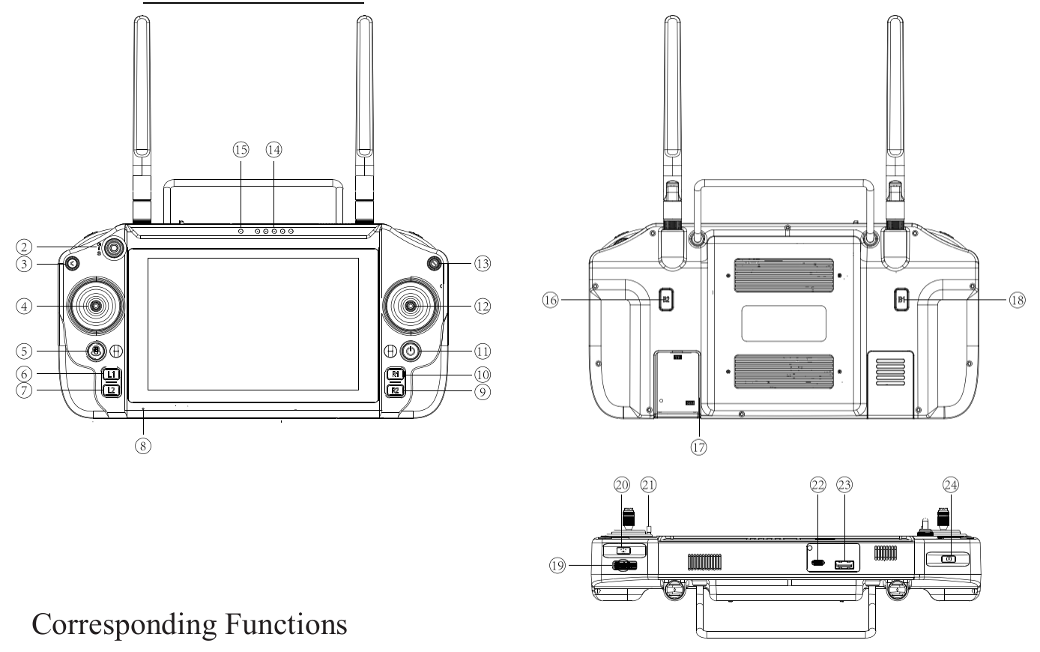
Source figure — reference only; FF artwork required before publication.
No. | Control | No. | Control
① | 2.4G / 5.8G antenna | ⑬ | Soft emergency stop
② | — | ⑭ | Remote control battery level indicator
③ | Back | ⑮ | Pairing indicator light
④ | Left joystick | ⑯ | B2
⑤ | H | ⑰ | SIM card slot
⑥ | L1 | ⑱ | B1
⑦ | L2 | ⑲ | Pulsator
⑧ | Microphone | ⑳ | Fill light
⑨ | R2 | ㉑ | Lanyard hole
⑩ | R1 | ㉒ | Type-C interface
⑪ | Power on/off | ㉓ | USB interface
⑫ | Right joystick | ㉔ | Shooting / video recording

4.2 Function Details
Function | Operation | Definition
Back to previous | Click Back (③) | Returns to the previous page.
Forward / backward / left / right motion | Push left joystick (④) | Speed increases gradually with joystick pressure; pushed fully, it reaches the upper limit set for each gear.
In-place turning | Push right joystick (⑫) | Controls in-place turning.
Turn while moving | Left joystick + right joystick (④+⑫) | The left joystick controls movement and the right joystick controls direction.
Horizontal turn left / right | Stationary Mode + right joystick pushed left/right (⑫) | In stationary mode, performs the lean-left / lean-right action.
High / low posture | Stationary Mode + right joystick pushed up/down (⑫) | In stationary mode, performs the pitch-up / pitch-down action.
Lean left / right | H + right joystick pushed left/right (⑤+⑫) | Performs a horizontal left / right turning action.
Pitch posture | H + right joystick pushed up/down (⑤+⑫) | Toggles between high and low postures.
Forward / rearward switching | Press L1 + R1 simultaneously (⑥+⑩) | Switches the machine directional angle.
Knee joint mode switching | Press L2 + R2 simultaneously (⑦+⑨) | Switches between in-phase knee mode and internal opposing knee mode.
Soft emergency stop | Press the soft emergency stop button (⑬) | Stops machine motion.
Photograph | Click the shoot key (㉔) | Takes a photograph.
Video recording | Press and hold the shoot key for 3 s (㉔) | Starts recording; click again to stop.
Fill light on/off | Click the fill light key (⑳) | Cycles through: both on — front on, rear off — rear on, front off — both off.

4.3 App
Connecting to the Robot
- Keep the robot near the remote control before connecting.
- Once the robot is powered on, press and hold the remote control power button to start up.
- Open the [FF app name to be assigned] app and wait for the remote control and robot to connect automatically.
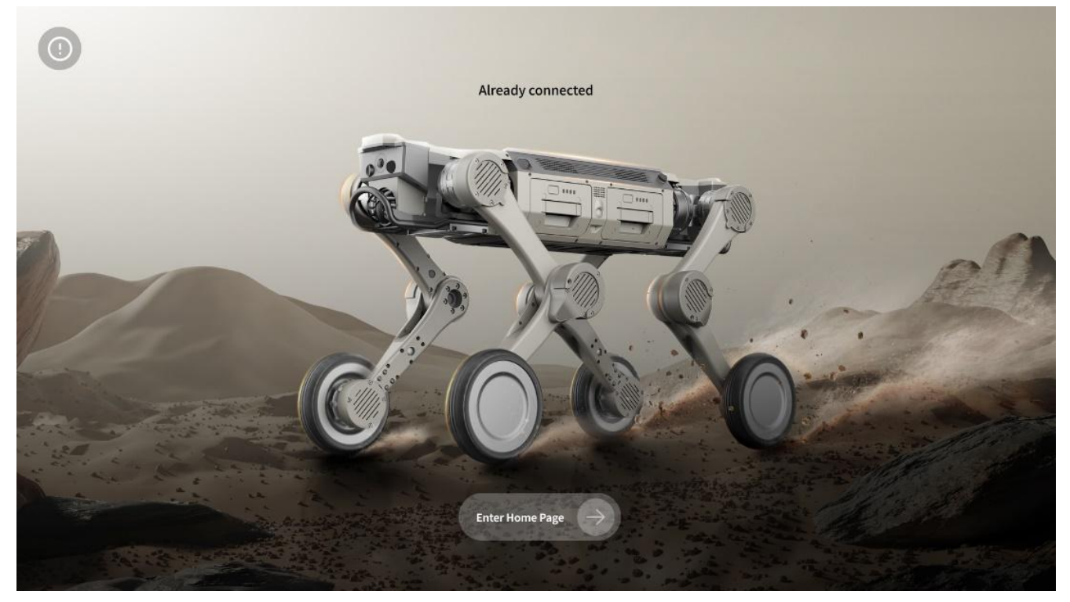
Source figure — reference only; FF artwork required before publication.
Mode Switching
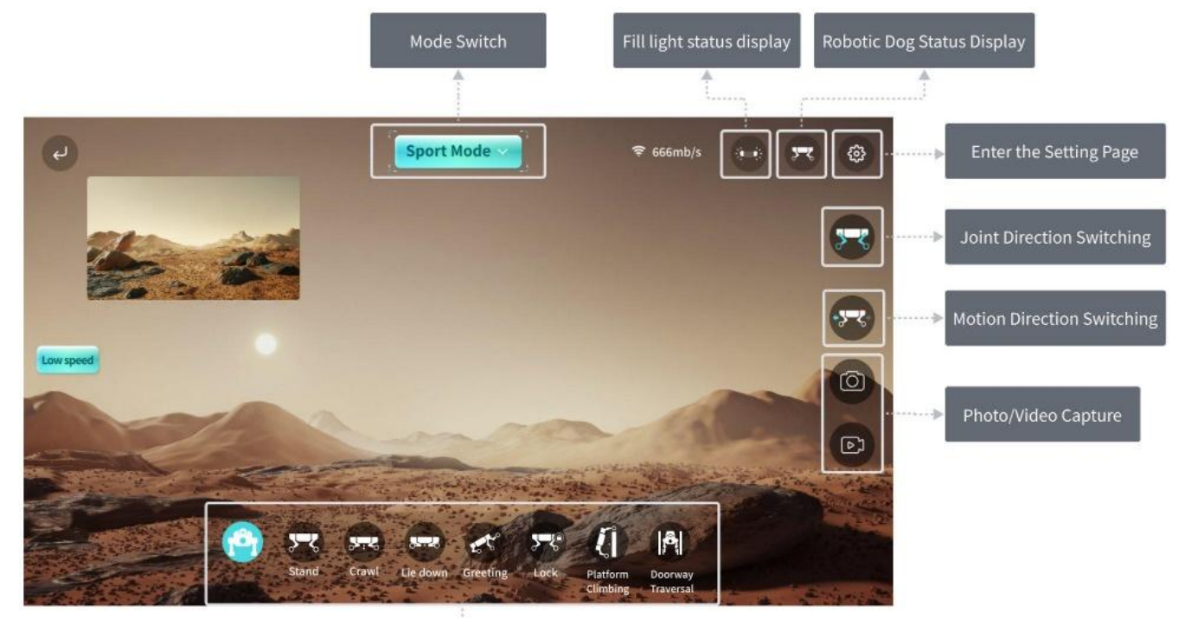
Source figure — reference only; FF artwork required before publication.
Mode | Function | Purpose | Scenarios
Stationary Mode | The robot locks its mobility and maintains a stable standing posture in place. | Performing manoeuvres, precise calibration or equipment inspection. | Power-on self-test, debugging and calibration.
Sport Mode (default) | Unlocks all mobility, allowing precise manual control of omnidirectional movement, turning and basic actions. | Flexible, precise manual control in a complex environment. | Complex terrain traversal, narrow space exploration, close observation of specific targets.
Navigation Mode | Guide the robot to build an environmental map; after mapping, set fixed-point tasks to initiate automated cruising and operation. | Autonomous, repeatable inspection and operational tasks. | Automated inspection, preset route patrol.
Stair Climbing Mode | The robot autonomously plans its gait to steadily traverse multi-level stairs. | Efficient execution of cross-floor tasks. | Multi-storey building inspections.

Settings
- Auto activation of fill light: automatically activates or deactivates the front fill light based on ambient light intensity, to ensure clear video capture in low light.
- Automatic obstacle stop: when enabled, the robot automatically stops moving forward if an obstacle is detected during manual operation. Designed for collision avoidance during manual control in complex environments.
- Auxiliary posture — battery swapping posture: triggered when battery replacement is required; the robot assumes a specific posture to facilitate battery insertion and removal.
- Equipment information: view the robot's core information, including equipment serial number and the software version of each subsystem (main control, motion, vision).
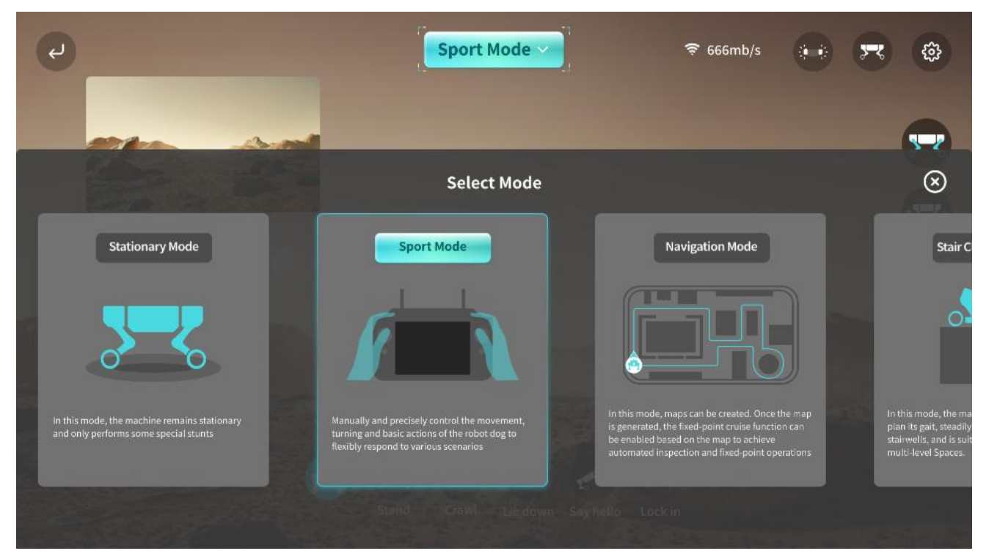
Source figure — reference only; FF artwork required before publication.
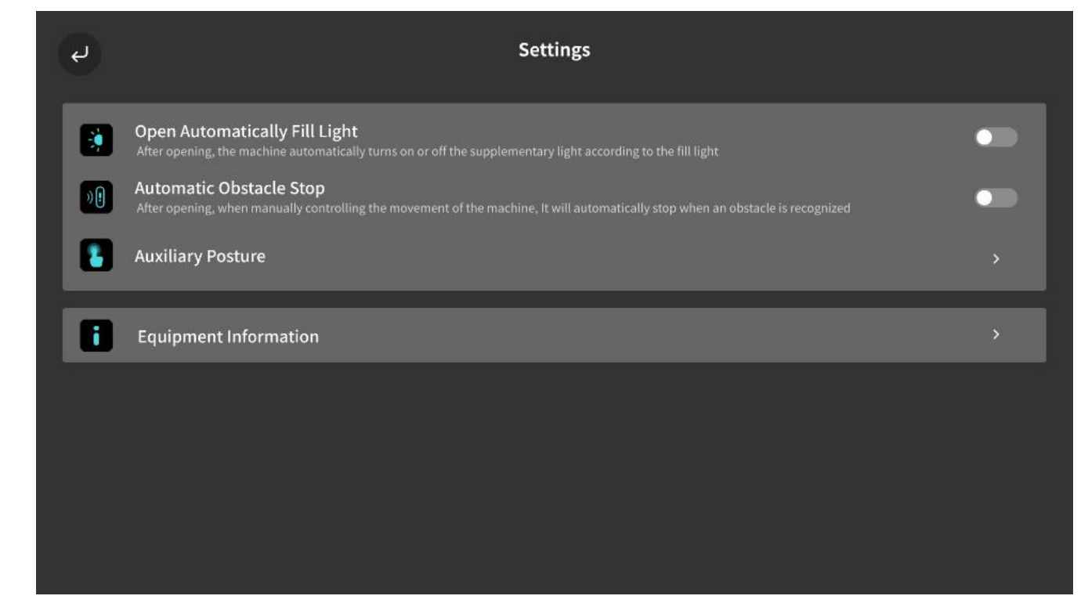
Source figure — reference only; FF artwork required before publication.
Software continuous upgrade statement
The app accompanying this product undergoes regular iteration and feature updates. Descriptions in this manual may therefore differ from the latest version. Specific functions are subject to what is actually presented within the app.

5. Anomalies and Solutions
Anomaly | Solution
Power dead and startup failed | Gently press the battery switch to check the battery level. Reinstall the battery, keeping it aligned with the body interface until a click is heard. Clean the interfaces: wipe the metal contacts of the battery and body with a dry cloth or eraser to remove oxidation.
Remote control connection is abnormal | First confirm the robot is powered on normally. If so, check whether the emergency stop is deactivated; if not, troubleshoot first, then deactivate it. If the emergency stop is deactivated and the robot still cannot be controlled, restart the robot. If the abnormality persists, contact after-sales service.
Standing posture is abnormal on power-on — can it still be used? | Do not control the robot's movement. Immediately press the soft emergency stop to make the robot go prone, then power off and restart before attempting to make it stand again. If the abnormality persists, contact after-sales service.
Blurry or no signal in the image transmission screen | Gently wipe the camera surface with a lens cloth to remove dust and stains. Optimise the signal environment by avoiding strong interference sources such as Wi-Fi and Bluetooth, and shorten the distance between the control terminal and the robot to ≤ 10 m. Turn off the robot and control terminal, then restart and test again. If there is still no signal, contact after-sales service.
What terrains can the robot adapt to? | The robot is suitable for relatively flat terrain such as plains and grassland, and can navigate complex terrain such as stairs and slopes. Avoid operating on extreme terrain — overly smooth surfaces such as ice, sharp or highly uneven ground, and edges at height.
Problems that remain unsolved after consulting this manual | Save the data and promptly contact after-sales service.

6. Daily Maintenance
6.1 Routine Cleaning
After use, if there are stains on the surface, clean them promptly. Before wiping the body, first turn off the power, then use a dry, clean, soft cloth. Pay particular attention to cleaning the camera and radar thoroughly, and avoid scratching the lenses with hard objects. Do not use corrosive liquids such as alcohol or disinfectants for cleaning.
6.2 Regular Inspection and Maintenance
Cycle | Module | Items
Daily check  (approx. 5 min before each use) | Appearance and structure | Check the body and leg links for deformation or cracks. Check whether joint and foot fastening screws are loose. Check the foot tires for detachment or severe wear (tread worn smooth); replace promptly if present.
 | Battery and power supply | Check whether the battery shell shows bulging or leakage. Ensure the battery is securely installed to prevent loosening during operation. Check the battery level via the screen or app (charge if below 20%).
 | Functional test | Start the equipment and operate the joystick to test whether all joints move freely and whether there is stuttering or abnormal clicking. Check that camera and sensor lenses are unobstructed and the image transmission screen is clear. Test whether the remote control signal is stable within 10 m without delay.
Weekly maintenance  (once a week, approx. 20 min) | Overall machine | Wipe the body shell with a dry, soft cloth (for oily stains, dampen lightly with clean water and wipe gently). Gently wipe dust off the camera and LiDAR surfaces with a lens cloth. Use a brush to clean debris from gaps around sensors. Use tweezers to clean weeds or threads entangled in the tires to prevent jamming.
 | Joints and drive system | Wipe all joint surfaces and crevices with a dry, soft cloth to remove mud and dust; after wading, dry the bearing area with a hairdryer on a low-temperature setting. Manually articulate each joint to confirm no jamming, abnormal noise, loose screws or tangled/worn cables.
 | Battery | Fully charge the battery before use (avoid storing below 80% charge for extended periods). Perform one full charge–discharge cycle every 3 weeks: fully charge, then use until below 20% before recharging.
Monthly maintenance  (once a month, approx. 30 min) | Software update | Check for firmware updates via the app or official website. Download and install as prompted, keeping the battery level ≥ 50% during upgrade and not cutting power.
 | Component status | Check joint connectors (robotic arm shafts, leg bearings) monthly; if loose, tighten with a specialised wrench. Check tire wear monthly and replace promptly if damaged. Check battery health every 3 months (view cycle count in the app); replacement is recommended above 500 cycles.

Precautions
- Power off the equipment during maintenance to avoid damage from accidental operation.
- When replacing spare parts such as tires and batteries, use genuine parts. Non-genuine parts may compromise equipment safety.
- In case of complex malfunctions such as joint jamming or sensor failure, do not disassemble the robot. Contact after-sales technical support.
7. Warranty Policy
Placeholder — FF policy required
This chapter is reproduced from the source manual and is a PLACEHOLDER ONLY. The terms below create binding obligations for whoever is named on the manual. FF must confirm these are the terms it is actually offering, or replace this chapter with FF's own warranty policy, before publication. See Section 0.2, item 3.

A. Warranty Periods
Component | Warranty Period
Overall unit | 1 year
Mainboard | 12 months
Joint module | 7 months
Battery | 6 months / 200 cycles

Note: vulnerable parts such as the outer shell and foot tires, and accessories such as the transport case, are not covered under warranty. Consult after-sales support if needed. Different warranty periods apply to different components, and mileage limits are set. If either the mileage of the product or the warranty period for specific components exceeds the limits stated above, the warranty automatically converts to paid repair service.
The warranty period commences from the date you sign for receipt. To protect your interest, check and confirm on the spot that the product and its attached articles and documentation are in good condition upon signing for receipt; otherwise, contact Party B immediately. In accordance with the logistics company's claim settlement requirements, for any damage caused by logistics transportation you shall contact the after-sales department within 24 hours of discovering the damage; otherwise your request cannot be processed.
B. Exceptions to Free After-Sales Service
Under any of the following circumstances, the entitlement to free after-sales service for a product under warranty is void. Paid repair services may still be available.
- Damage from collisions, drops or burns not caused by the product's own quality defects (e.g. human factors).
- Any secondary development of the product (with or without prior authorisation), hardware modification or disassembly.
- Damage caused by unauthorised repair of components, circuit modification, battery pack alteration or improper use of chargers.
- Damage caused by immersion in liquid, debris ingress, chemical contact or scratches.
- Damage caused by use beyond the safe load limit of the product.
- Damage caused by prolonged inactivity of the product.
- Damage caused by failure to activate, install or use the product as required by the user manual.
- Malfunction or damage caused by the use of non-genuine accessories, including replacement and retrofitting.
- Damage caused by operational error or intentional action leading to impact against hard objects or drops, or evident signs of impact, collision or scratching on the product surface.
- Damage caused by force majeure or extreme adverse conditions, including strong magnetism, strong interference, high or low temperature, and natural disasters.
- Damage caused by operation on sharp terrain, significantly undulating ground or smooth surfaces.
C. How to Send for Repair
- When contacting after-sales service, describe all defects of the product in detail. We will first attempt to diagnose and solve the problem by phone, email or remote assistance.
- If those methods do not resolve the problem, you may send the product to Party B for further testing, upon which corresponding arrangements will be made. If, upon inspection, the product does not comply with the free warranty policy, you may choose paid after-sales service — Party B will confirm the relevant services and charges with you — or have the original machine returned.
- You are responsible for advance payment of mailing fees when sending the product to Party B.
- Upon receipt of the returned product, Party B will conduct fault detection to determine liability. If the fault is confirmed to be the product's own quality defect and falls within the warranty period, all related costs and return courier fees will be borne by Party B.
- If the product is not eligible for free repair, you may opt for paid repair or have the faulty product returned. Party B will confirm the repair programme with you; if accepted, Party A will pay all fees according to the confirmed programme; if not accepted, the equipment will be returned to Party A, and all related inspection fees, labour costs and freight will be borne by Party A.
- Water ingress to the main body, charger or remote control severely affects performance and renders the product irreparable. Party B cannot provide repair services in that case but may offer paid replacement, as circumstances allow.

End of content draft. Sections 0.2 items 1–6 must be resolved before this document is published.

