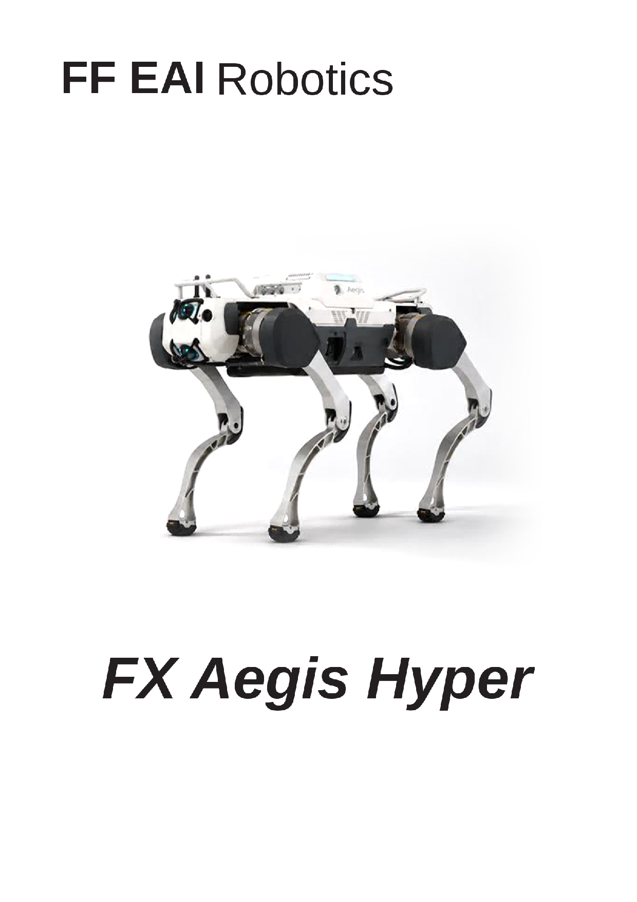
User Manual

Statement
• This manual is the information asset owned by FF EAI Robotics
(hereafter referred to as “FF EAI Robotics”) and any reprinting of part or all
of this manual is strictly prohibited without the permission of FF EAI Robotics.
• This manual explains the basic components, transport and storage, specific
operations, exception handling, and technical specifications of the quadruped
robot “FX Aegis Hyper”. Be sure to read and fully understand this manual before
operating the robot.
• Basic information on safe use is described in detail in the "Reading Tips", so be
sure to read this part thoroughly to ensure proper use.
• The diagrams and photographs in this manual are representative examples and
may differ in detail from the product purchased.
• This manual may be modified as appropriate for product improvements,
specification changes, etc.
• The contents of this manual do not rule out the possibility of error or omission. If
this manual is damaged or lost or if you have questions about the contents of this
manual, please contact us promptly.
• Failure caused by unauthorized disassembly or modification of the product by the
customer is not covered by our warranty. See "Service and Warranty" for details.
Reading Tips
Description of Symbols
Before use (installation, transportation, maintenance, inspection), please be sure to read
and master this manual, and familiarize yourself with the equipment and safety matters
before you start using it. The safety matters in this manual are divided into "Caution",
"Mandatory" and "Prohibition". Even the contents of "Caution" may cause serious
consequences depending on the situation, so any of these safety matters are extremely
important and should be strictly observed.
Usage tips or operational recommendations. Improper using or
Caution
operating the robot may cause damage to it.
Mandatory
Matters that must be observed.
Prohibition Matters prohibited. Misoperation is dangerous and may cause injury to
operators or damage to the robot.
Help Acquiring
For more resources to assist you in using FX Aegis Hyper proficiently, you can also visit
FF EAI Robotics’ corporate website: https://www.ff.com/

Content
1 Introduction
1
2.6 Power Off
17
2.7 Payload and Development
18
1.1 Overview
1
3 Precautions
19
1.2 Product List
1
1.3 Main Specifications
2
3.1 Work Environment
19
1.4 Power and STOP
4
3.2 Other Precautions
19
1.5 Intelligent Controller
5
4 FAQs
20
1.6 Mode and Gait
6
5 Transport and Storage
21
2 Operation
9
5.1 Transportation
21
2.1 Preparation
9
5.2 Storage
21
2.1.1 Environment
9
2.1.2 Checking
9
5.3 Carrying
21
2.2 Charging
9
6 Service and Warranty
22
2.2.1 Charging the Robot
9
2.2.2 Changing Battery
10
6.1 After-Sales Service
22
2.3 Start
11
6.2 Warranty Policy
22
2.3.1 Preparation
11
6.3 Warranty Coverage
22
2.3.2 Power on
11
6.4 Repair Instructions
23
2.3.3 Connection
11
2.4 Motion Control
12
7 Disposal
25
2.4.1 Controller Operation
12
2.4.2 Settings
15
2.5 Emergency Operation
16
2.5.1 Soft Emergency Stop
16
2.5.2 Hard Emergency Stop
16
2.5.3 Overtemperature
16
2.5.4 Falling Down
17
2.5.5 Low Battery
17
2.5.6 Other Circumstances
17
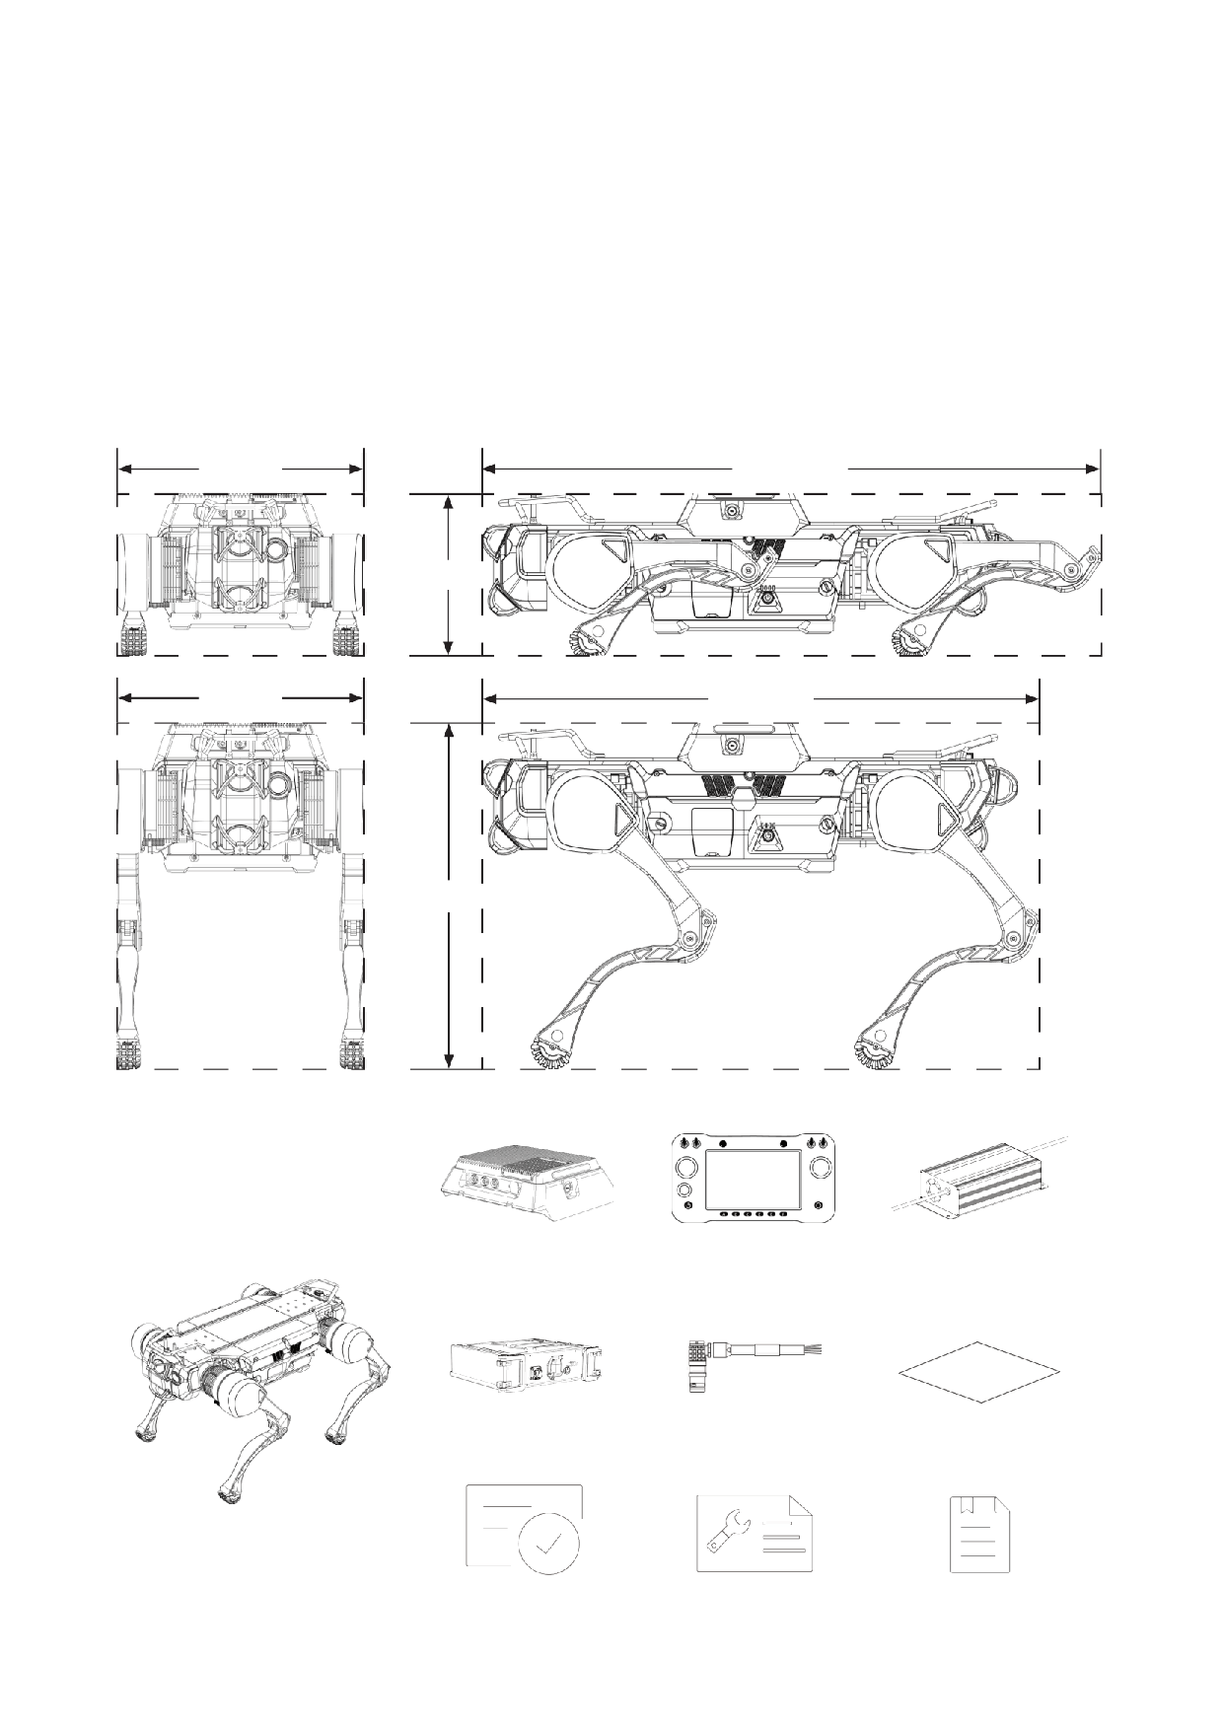
FX Aegis Hyper User Manual
1 Introduction
1.1 Overview
FX Aegis Hyper is an intelligent quadruped robot designed to meet core industry needs,
with a total of 12 degrees of freedom (DOF), capable of walking, going up and down the
stairs. The robot is equipped with a wide-angle camera, four laser radars, and two internal
hosts respectively for motion control and environmental perception calculation. An
additional host inside Intelligent Controller is used for navigation and inspections.
470mm
1130mm
285mm
470mm
1000mm
715mm
1.2 Product List
Intelligent Controller ×1
Controller ×1
Charger ×1
Repalceable Battery ×1
Aviation Plug ×8
Antistatic Cloth ×1
Robot ×1
(without battery)
Certificate ×1
User Manual ×1
Warranty Card ×1
1
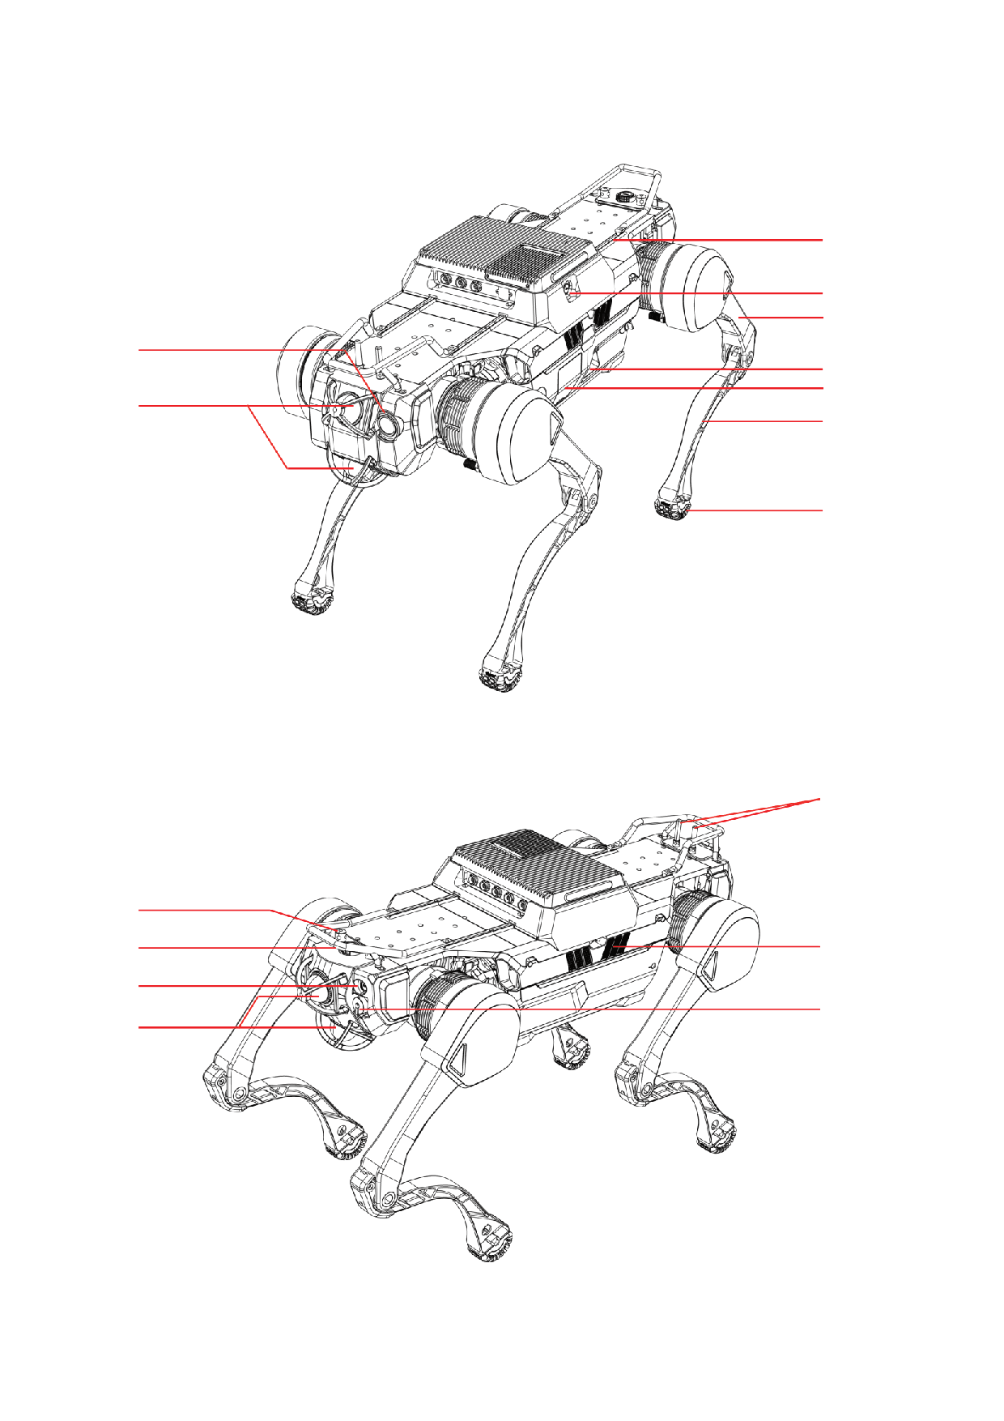
1.3 Main Specifications
3
4
5
1
6
7
2
8
9
1 Wide Angle Camera
2 Laser Radar
3 Mounting Rails
4 Intelligent Controller Power Button
5 Upper Leg
6 Power Button
7 Charging Port Cover
8 Lower Leg
9 Antislip Foot
10
11
12
13
14
15
16
10 Controller's Antenna
11 WiFi Antenna
12 Cooling Fan
13 Soft Emergency STOP
14 Hard Emergency STOP
15 Debugging Ethernet Port
16 Laser Radar
2

FX Aegis Hyper User Manual
Robot Dimensions
Sitting Size (Length × Width × Height)
1130mm×470mm×285mm
Standing Size (Length × Width × Height)
1000mm×470mm×715mm
Weight
59kg
Electric Parameters
22.4Ah(Ideal data in an environment at 25℃)
Battery Capacity
Nominal Battery Voltage
72V
Charger Input Voltage
200V~240V
Charger Output
84V/8A
Charging Time
2.5h~3h
Power Supply
12V; 24V; 5V(USB)
Communication Interface
Ethernet; WiFi; USB2.0; USB3.0
Autonomous Charging
Supported
Locomotion Parameters
Maximum Speed
4.95m/s (Data from extreme test)
Maximum Walking Speed
1.2m/s
Maximum Running Speed
2.5m/s
Maximum Slope
±30°
Maximum Step Height
20cm
Maximum Slope of Staircase
±45°
No-load Runtime
4h
Payload Runtime
2.5h
Payload
20kg (Intelligent Controller Weight Included)
Maximum Load
85kg (Data from extreme test)
3
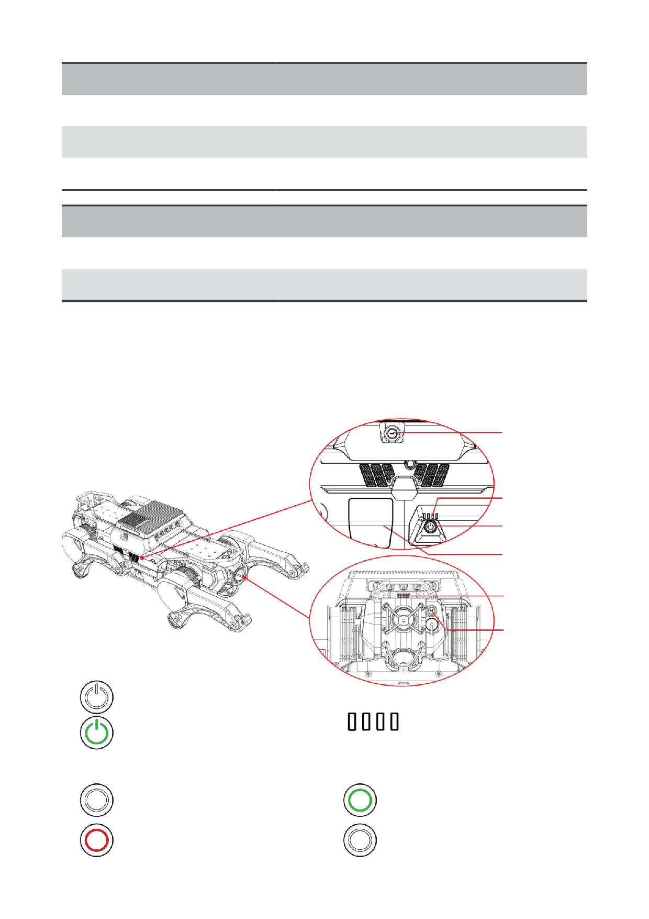
Sensor Parameters
Laser Radar
×4
Wide-angle Camera
×1
Other Optional Modules
Bi-spectrum PTZ Camera
Environment Parameters
Ingress Protection
IP67
-20℃~55℃
Operating Temperature
※Data above is measured under ideal conditions, and the actual results may be biased.
1.4 Power and STOP
Power Button
of Intelligent
Controller
Power LED
Power Button of
Robot
Charging Port
Cover
Soft Emergency
STOP Button
Hard Emergency
STOP Button
Light OFF
Power OFF
Power LED
Light ON
Percentage & Voltage
Power ON
Light ON
Light OFF
Hard Emergency Stop OFF
Soft Emergency Stop OFF
Light ON
Light OFF
Soft Emergency Stop Triggered
Hard Emergency Stop Triggered
4
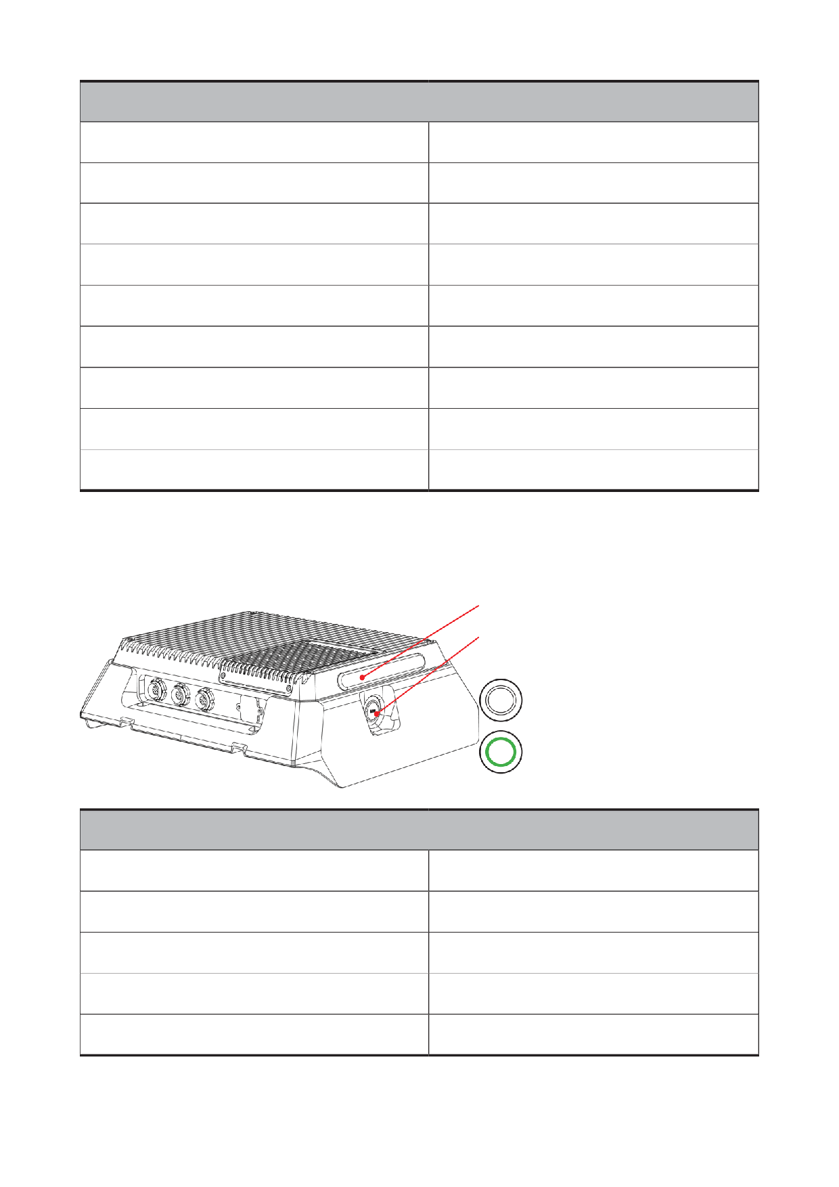
FX Aegis Hyper User Manual
Power LED
4 lights are always on
75% < Current Battery Level ≤ 100%
1 light is off, 3 lights are always on
50% < Current Battery Level ≤ 75%
2 light are off, 2 lights are always on
25% < Current Battery Level ≤ 50%
3 lights are off, 1 light is flashing
5% < Current Battery Level ≤ 25%
4 lights are off
Current Battery Level ≤ 5%
4 lights cycle on
Charging: Current Battery Level ≤ 25%
1 light is always on, 3 lights cycle on
Charging: 25% < Current Battery Level ≤ 50%
2 lights are always on, 2 lights cycle on
Charging: 50% < Current Battery Level ≤ 75%
3 lights are always on, 1 light flashes
Charging: 75% < Current Battery Level ≤ 100%
1.5 Intelligent Controller
Indicator light
Intelligent Controller's
Power Button
Light OFF
Intelligent Controller OFF
Light ON
Intelligent Controller ON
Intelligent Controller Indicator Light
Intelligent Controller is working normally.
Always on and green light
Green flashing light
Robot is charging.
Yellow flashing light
Robot is avoiding obstances when in navigation.
Red flashing light
Robot battery is not enough.
Light off
Intelligent Controller is not powered on.
5
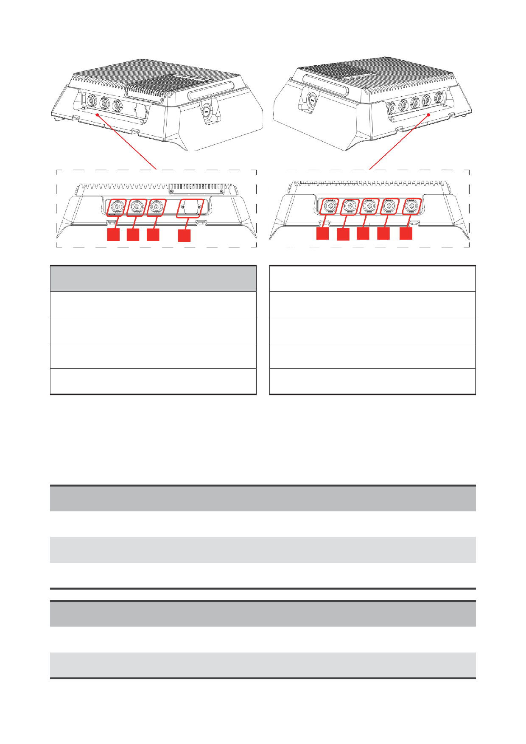
5
7
8
9
6
1
2
3
4
⑤USB2.0×2
Interface
①LAN1+12V
⑥ LAN3+12V
②LAN2
⑦ LAN4+12V
③24V
⑧ LAN5+24V
④USB3.0x2
⑨ LAN6+24V
※When the USB 3.0 interface is not in use, the intelligent controller maintains an IP67 protection rating.
If the dust- and water-proof cap is removed to use the USB 3.0 intelligent, additional protective measures
are required to preserve dust and water resistance.
1.6 Mode and Gait
Control Mode
Manual
Robot is completely controlled by the user through the controller
The perception host will monitor the surrounding environment and
Assist
assist the user in controlling the robot
Navigation
Robot moves autonomously and can not be controlled with the controller
Body Height
Normal
Robot stands normally
Crawling
Suitable for passing through the terrain with smaller longitudinal height
6

FX Aegis Hyper User Manual
Gait
Walking
Suitable for flat surfaces such as concrete (limited max speed: 1.2m/s)
Running
Suitable for flat surfaces such as concrete (limited max speed: 2.5m/s)
Slope
Suitable for slopes less than 30° or other gentle irregular terrain
Suitable for complex terrain through irregular obstacles such as stone
Off-Road
piles and ruins
It can perceive the shape of the staircase and calculate the foothold on
Stair
its own, which is suitable for stairs with a slope under 45°
It can perceive the shape of the staircase and calculate the foothold
45° Stairs
on its own, which is suitable for stairs with a slope of 45°, and is only
supported in multi-frame mode
Utilizes AI algorithms, suitable for surfaces with slight undulations
L-Walk
under normal conditions
Utilizes AI algorithms, suitable for complex terrain with height
Mountain
differences, slopes and stairs
Utilizes AI algorithms, suitable for scenarios requiring reduced robotic
Silent
motion noise.
※L-Walk is suitable for surfaces with little undulations, including but not limited to flat surfaces, muddy
surfaces, flooded surfaces, undulating surfaces with small differences in height, stairs with a single step of
15cm, slopes of 18° , etc.
※Mountain is suitable for surfaces with large undulations under normal conditions, including but not
limited to rubble surfaces, bumpy surfaces with large differences in elevation, stairs with a single step of
25cm, and slopes of 30° .
※Silent is suitable for noise cancellation demand scenarios, the gait noise when standing still
≤ 50dB,
walking noise ≤ 60dB, does not support walking up and down stairs, walking on slopes.
• When the robot passes through stairs or slopes, do not stand on the
stairways, platforms or slopes below the robot, to avoid possible
personal injury if the robot falls.
• The robot can only climb stairs when its front faces the upward
direction of the staircase.
Using mountain gait generates a lot of heat, and the continuous use
of this gait to cross obstacles within a short period of time will easily
cause the robot to overheat, so it is recommended not to use this gait to
climb stairs for more than 8 minutes continuously.
7

Elevation Map Mode
Suitable for scenarios where the robot's landing plane
Solid ground mode
is solid, such as a normal solid concrete flat floor or
concrete stairs.
Suitable for scenarios where the robot's landing plane
is a grid-like pattern with gaps in between, such as an
Grid ground mode
industrial platform or staircase made of steel grating
panels.
A special condition of solid ground, which refers to a
Stair without risers mode
staircase where the robot places its feet on a solid surface
without risers.
Suitable for scenarios including multiple types of ground
Multi-frame mode
surfaces or 45° stairs. For example, if the robot moves
from solid ground to grid ground.
8
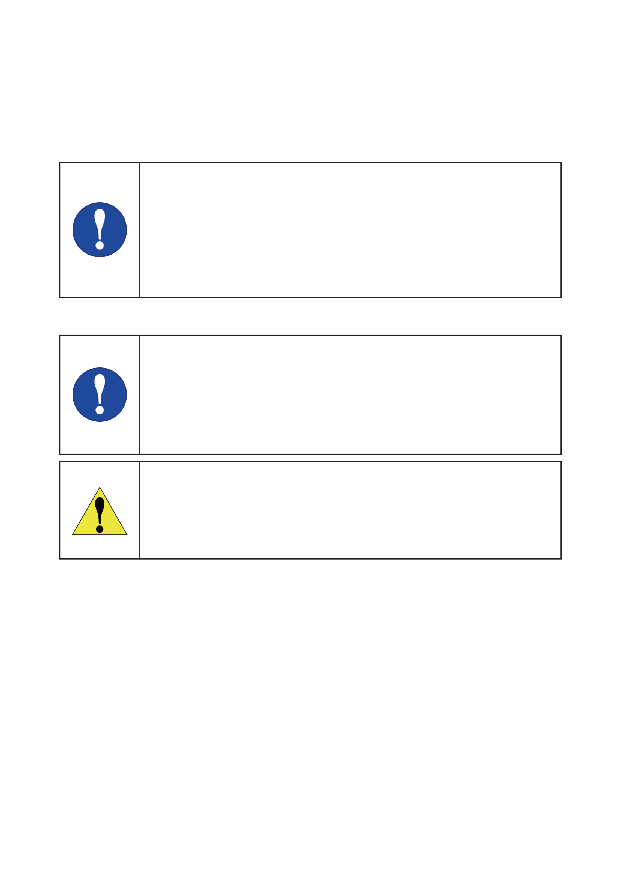
FX Aegis Hyper User Manual
2 Operation
2.1 Preparation
2.1.1 Environment
• Please ensure that operators and non-operators present have
read the manual carefully and understand the basic operating
instructions and safety precautions.
• Before start FX Aegis Hyper, ensure that all people or objects
present are more than 2 meters away from the robot to avoid
collisions.
• Please use FX Aegis Hyper in an environment of -20℃~55℃.
2.1.2 Checking
• Check the battery indicator. It is suggested to use the robot when
the battery is at least 75%.
• Make sure that the emergency stop buttons stay off.
• Make sure there is no visible damage to the exterior of the robot.
• Make sure the joystick used for remote control is fully charged.
If the robot parts are aging or damaged, please do not start the robot
and contact the after-sales staff in time.
2.2 Charging
2.2.1 Charging the Robot
FX Aegis Hyper is powered by a ternary lithium battery.
You can connect the robot with 220V AC power supply through the charger, and the charging
port is located on the left side.
1. First make sure the robot is turned off. Open the charging port cover and connect the
charger to the charging port and tighten it (charger has an anti-reverse plug-in port), then
connect it to 220V AC power.
2. During charging, the charging indicator on the charger is red.
3. When charging is complete, the charging indicator on the charger turns green.
9
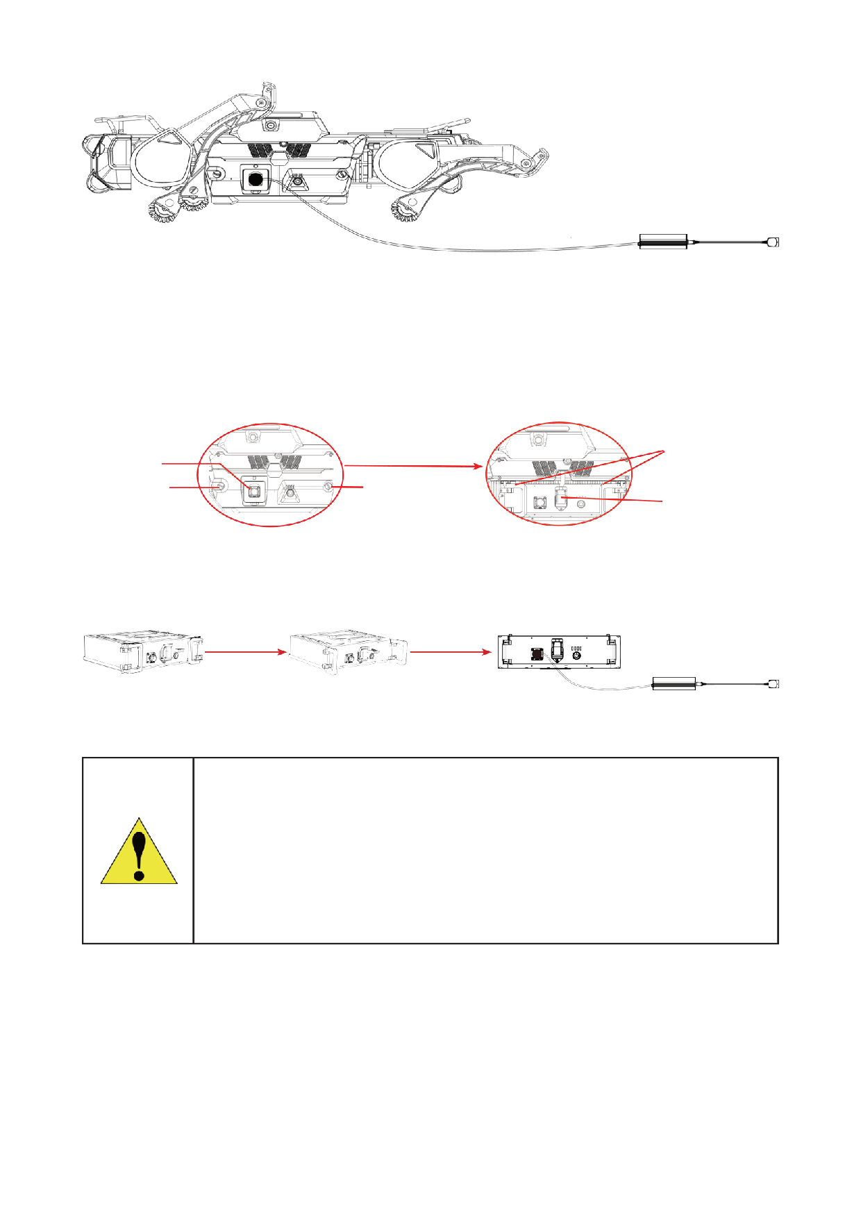
2.2.2 Changing Battery
The battery of FX Aegis Hyper is replaceable, so users can take out the battery and replace
it with other batteries, and charge the removed battery separately.
1. Unscrew the two hand-screws, remove the cover plate, and unplug the connector:
Battery Handle
Remove
Charging Port
hand-screw
hand-screw
Battery Connector
2. Straighten the battery handle outward and take out the battery, then connect the charger
for charging:
Straighten the
Remove the battery
handle
and charge it
3. When charging normally, the charging indicator light on the charger is red; when
charging is complete, the charging light on the charger turns green.
• It is recommended to charge in an environment of 0 ℃ to 45℃.
• During charging, please do not power on the robot and always
pay attention to the state of the charger during charging to avoid
accidents. Disconnect the charging power supply in time after
charging.
• When the robot is not charging, the charging port cover must be
closed to prevent water.
10
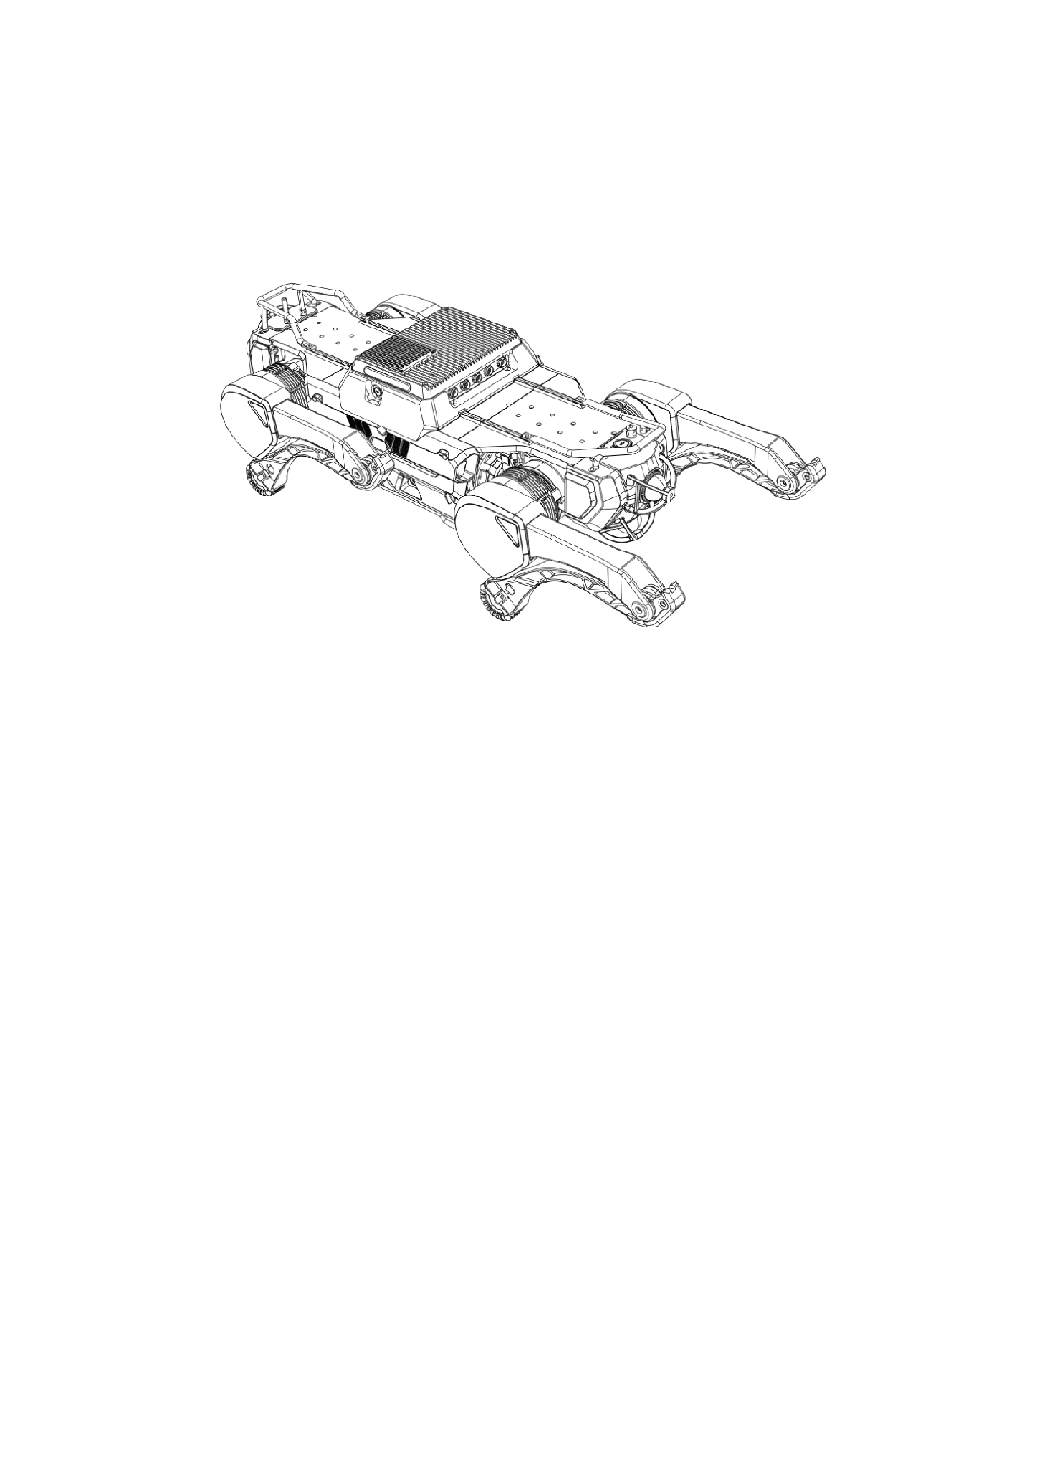
FX Aegis Hyper User Manual
2.3 Start
2.3.1 Preparation
1. Take the robot from the transport case and place it on a flat surface, as described in the
section "Transport and Storage".
2. Adjust the robot pose as required (as shown in the picture above): knee joints retracted,
hip front swing joints swung back, side swing joints vertical, and the bottom of the body
touching the ground.
2.3.2 Power on
Press the power button to turn on the robot. At this time, the power button is always on. At
the same time, it is necessary to ensure that the light of soft emergency stop is off and the
light of hard emergency stop is on. If not, press the hard emergency stop button or rotate
the soft emergency stop button in the direction indicated by the arrow to turn it off. If the
hard emergency stop is triggered, it is necessary to restart the robot after turning off the
hard emergency stop.
2.3.3 Connection
Long press the power button to turn on the controller (please ensure that the controller is
fully charged). The robot and controller have been paired and bound. After opening the app,
the controller will automatically connect to the robot it is bound to.
11
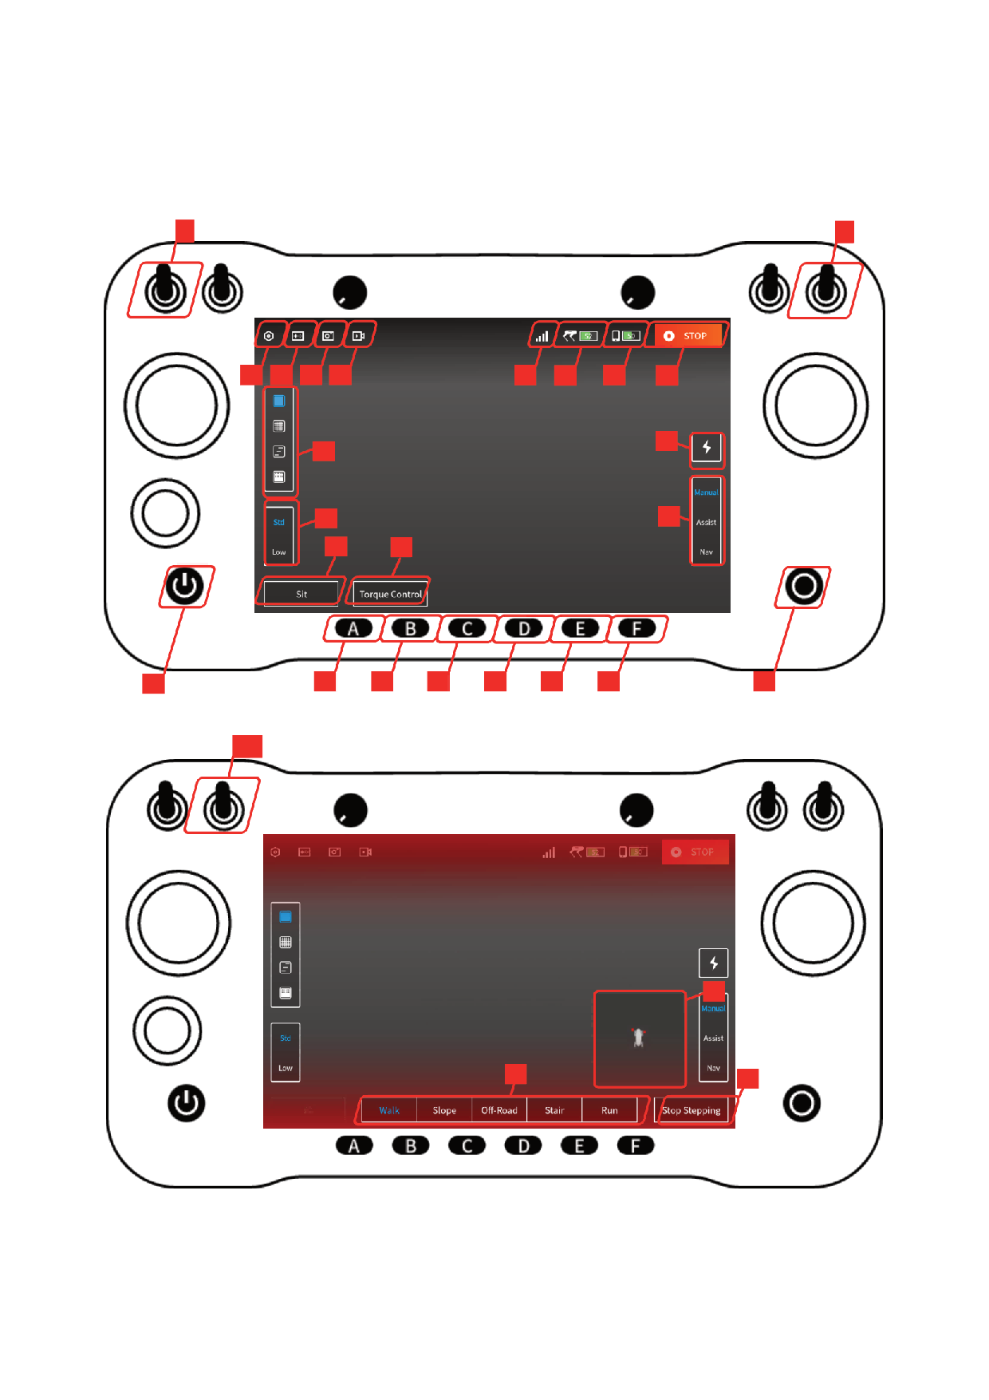
2.4 Motion Control
2.4.1 Controller Operation
2
3
12 13 14
11
15
17
16
18
24
19
23
20
21
22
5
6
7
8
9
10
4
1
25
28
26
27
12

Flip to the center simultaneously
Cancel Soft Emergency Stop
FX Aegis Hyper User Manual
Button
①Controller Power
Press and hold to power on/off, and press once to wake
Flip up simultaneously
Trigger Soft Emergency Stop
②SW1
③SW4
④Start/Stop Moving
Start or stop moving, that is, to start or stop stepping
Stand up or sit down
⑤A
Switch to Torque Control Mode to unlock each joint
⑥B
Switch to Walk gait
⑦C
Switch to Run gait
⑧D
Switch to Slope gait
⑨E
Switch to Off-Road gait
⑩F
View APP version/Set language/Jueying Lab/User Protocal/Save
⑪Settings
data
⑫Buttons Introduction Show the introduction to physical buttons
⑬Screenshot
Save images for the video streaming
⑭Record
Record a video of the video streaming
Displays the connection status：
connected
/connecting
/
⑮Robot Signal
disconnected
⑯Robot Battery
Real-time display of robot signal strength
⑰Controller Battery
Real-time display of the controller's remaining battery
Soft emergency stop:Forcing the robot to lie down, which is
⑱STOP
generally used when the robot dog is out of control or in an
emergency
Select the elevation map mode, from top to bottom: Solid
⑲Elevation Map Mode
Ground/Grid Ground/Stair without Risers/Multi-Frame
Select body height: Normal/Crawling,and the button displays the
⑳Body height
current status
㉑Stand/Sit
Stand up or sit down and the button displays the current status
㉒Torque Control
Switch to Torque Control Mode to unlock each joint
㉓Control Mode
Select the control mode:Manual Mode/Asist Mode/Nav Mode
13

Button
To enable the robot dog to perform autonomous charging, please
㉔Auto Charging
refer to the autonomous charging manual for specific use
Show the real-time video
Flip to the center
from the robot
㉕SW2
Close the real-time video
Flip up or down
from the robot
㉖Gait
Select gait, which can be switched only in the stepping status
㉗Start/Stop Moving
Start or stop moving, that is, to start or stop stepping
㉘2D obstacle point
Open the Jueying Lab to show a top-down 2D obstacle point
clouds
cloud
• After connecting the robot, ⑮will display as connected, at which point you can start
controlling the robot.
• After standing up, each joint of the robot is in a protective locking state, and in this state,
it can switch between lying down and standing by ⑤ or ㉑, or switch to force control
mode by ⑥or ㉒, and the locking state of each joint can be lifted, so that it can move in
steps.
• To make the robot walk, first make the robot stand up, then press ⑥or ㉒ to switch to
torque control mode, and then press ④or ㉗ to make the robot start moving, and the
robot will start stepping. At this time, the left joystick can control the robot to move
forward, backward, left and right, the robot will adjust the movement speed according to
the amplitude of the joystick, and after releasing the joystick, the robot will slow down to
zero and step in place; The right joystick controls the robot to turn left and right. Press
④or ㉗ again to end walking, and if the robot is walking forward, it will take a certain
amount of time to slow down and stop.
• Soft emergency stop on Controller: Triggered by flip ② and ③up simultaneously or
clicking ⑱.
• Through ⑲, the stair gait can be assisted to carry out foothold planning in manual
mode, and the correct elevation map mode needs to be selected according to the type of
staircase ground when used; In the assist mode, it can assist the user to avoid obstacles,
and it is necessary to select the correct elevation map mode according to the ground in
the actual environment to make the obstacle avoidance function work normally.
• Multi-frame mode can only be enabled when the robot is standing still.
14
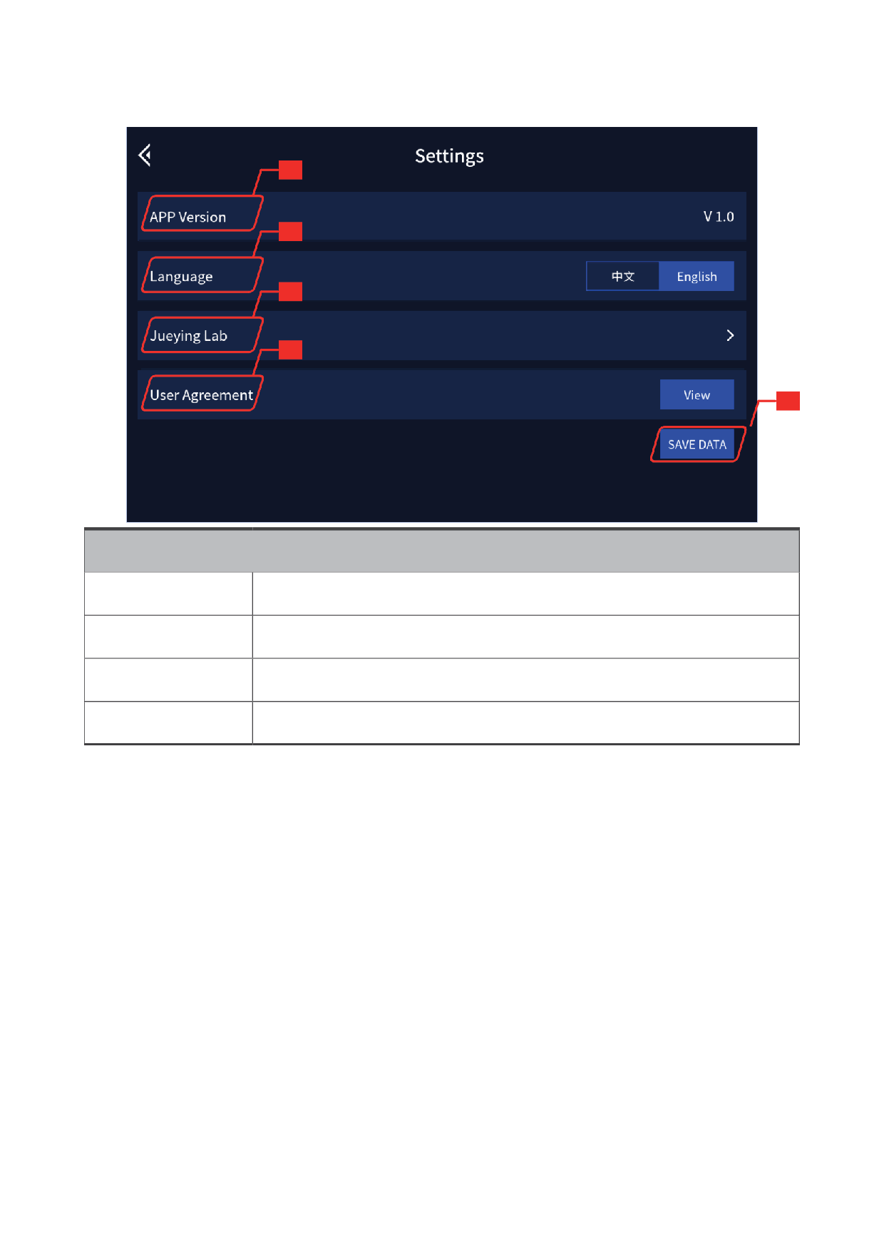
FX Aegis Hyper User Manual
2.4.2 Settings
29
30
31
32
33
Button
㉙APP Version
View the current APP version
㉚Language
Select language: 中文 /English
㉜User Agreement
Click "View" to view the user agreement
㉝SAVE DATA
Save the data of robot operation
When the robot is abnormal, you can use the ㉝SAVE DATA to record the abnormal data
for troubleshooting. Please ensure that the robot dog is in the state of getting down or
emergency stop before using it.
15
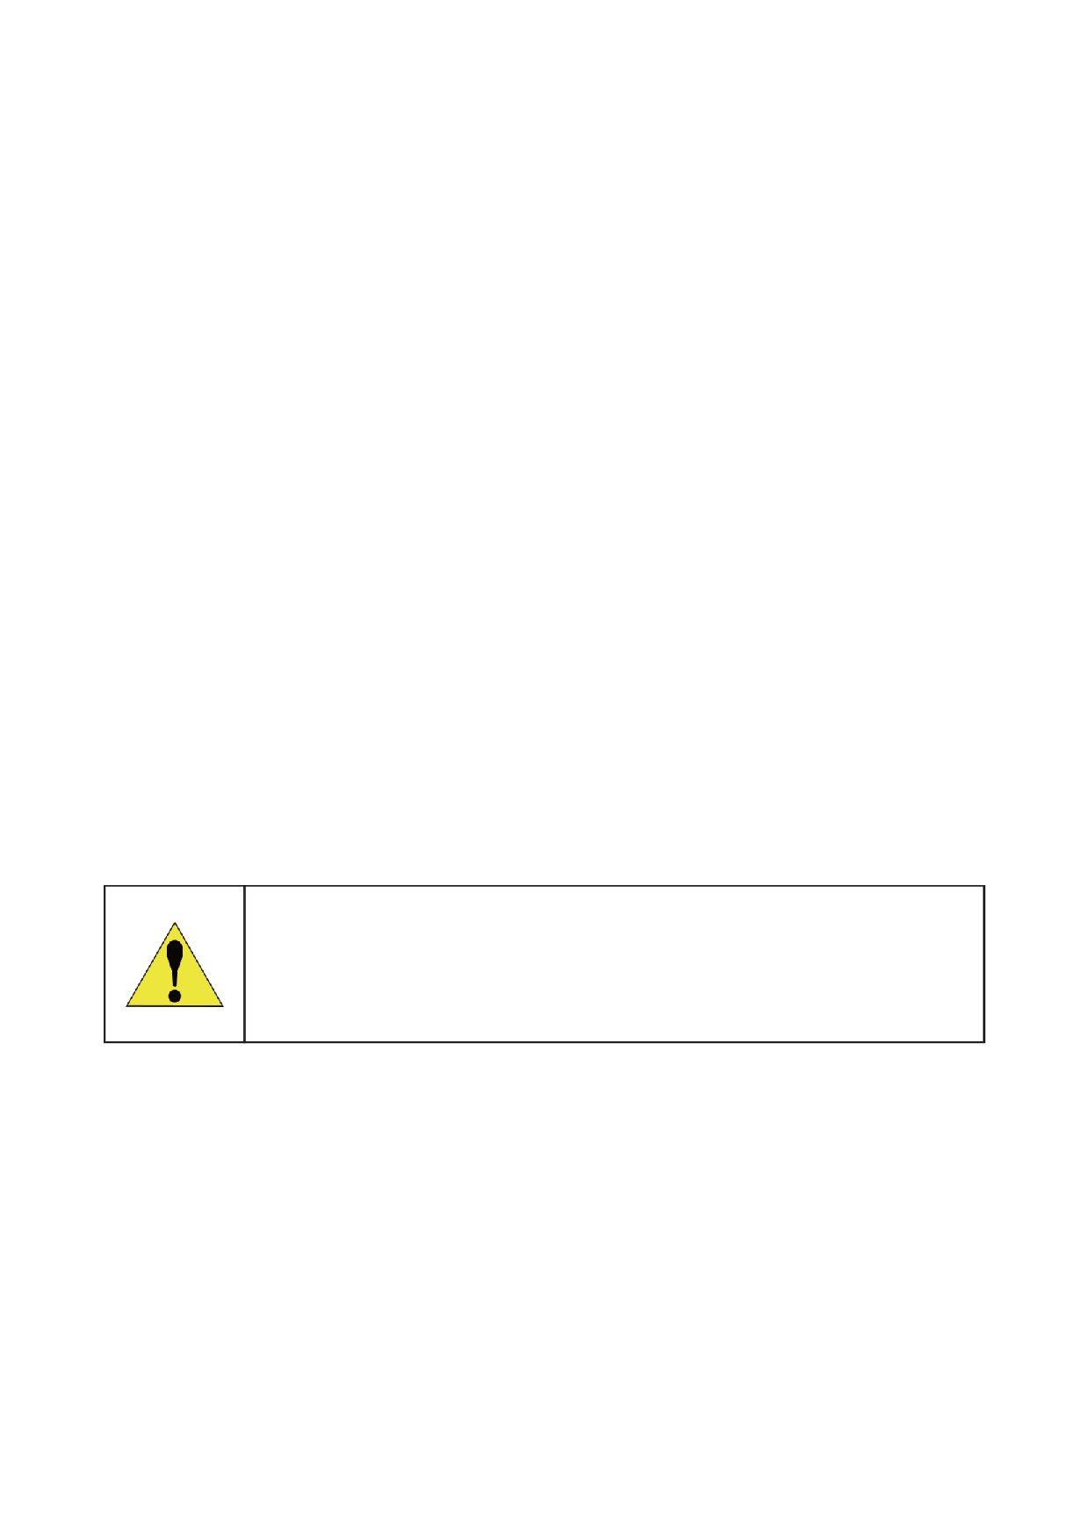
FX Aegis Hyper User Manual
2.5 Emergency Operation
2.5.1 Soft Emergency Stop
If the robot's legs swing or shake violently and other abnormal phenomena occur during
use, please start the soft emergency stop function on Controller (flip ②and ③up at the
same time or click the button ⑱) or push the soft emergency stop button at the tail of
the robot to make the robot lie down and enter the self-locking protection state. If the
soft emergency stop is triggered by ②and ③ , please flip them back to release the soft
emergency stop. If the rear soft emergency stop button is pressed, you need to rotate
the button in the direction of the arrow on the button to release it. After releasing the
soft emergency stop, please release the force in time (press ⑤or ㉑) to release the self-
locking protection. After troubleshooting, press the stand button again to operate the robot
normally.
2.5.2 Hard Emergency Stop
Hard emergency stop, that is, hardware emergency shutdown, press the hard emergency
stop button at the tail of the robot, and the indicator light is off to indicate that the hard
emergency stop has been triggered, which can ensure that the robot joints are locked in
the boot state and avoid the robot from getting out of control. At this time, press the hard
emergency stop button again, and the indicator light will be on to indicate that the hard
emergency stop has been lifted, and the robot needs to be restarted to restore the normal
use state after the hard emergency stop is lifted.
Once the hard emergency stop is triggered, it will cause the robot to lose
all kinetic energy and thus fall to the ground. There is a risk of damaging
the ground or the robot, so it is strictly forbidden to press the hard stop
emergency button during normal movement!
2.5.3 Overtemperature
The system comes with temperature sensing. Once the robot runs for a long time causing
the motor or drive to overheat, it will automatically start the overtemperature protection
and the robot will automatically stop moving and get down in place.
16
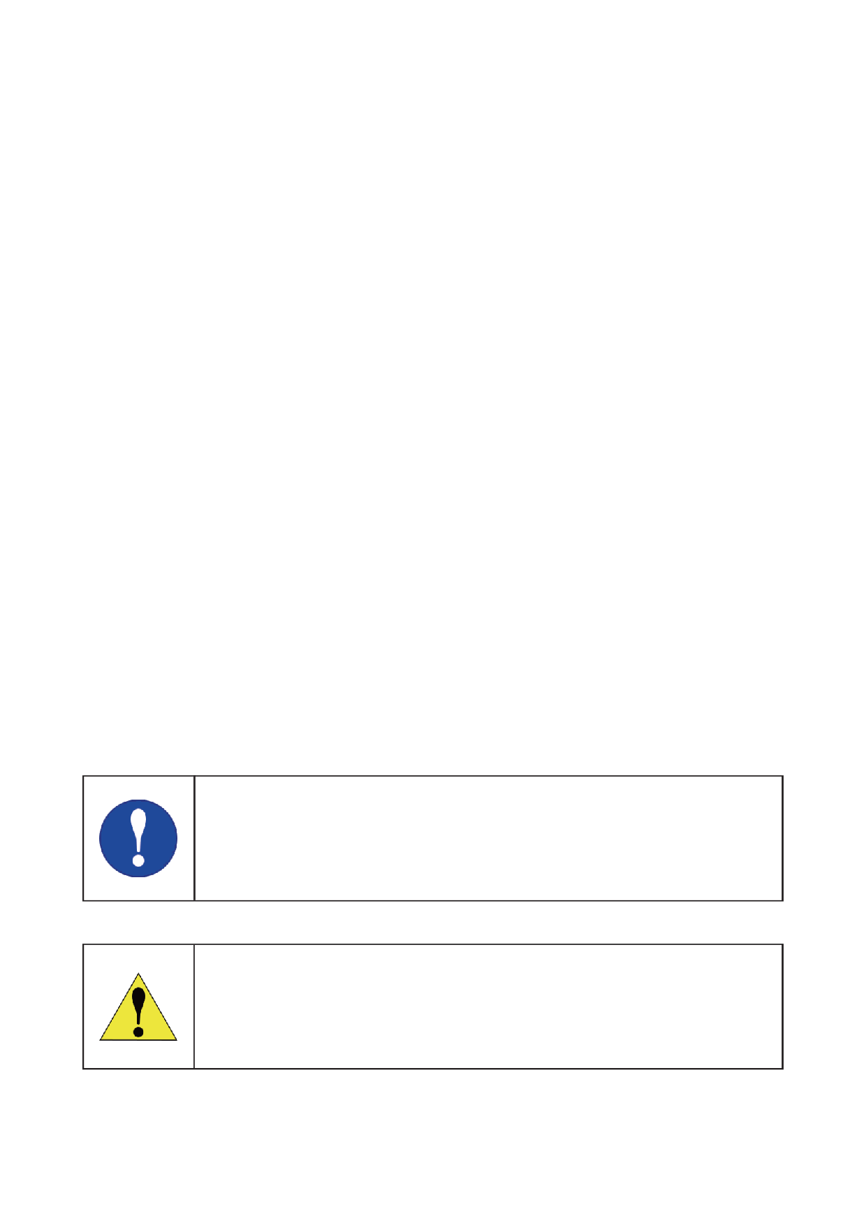
2.5.4 Falling Down
If the robot falls down suddenly, the joints will be automatically locked. Please try to click
[Stand] button in the app after making sure there is no obstacle around. If the robot still
can't get up, press the emergency stop button at the rear of robot, then click [Save Data] at
the Settings page of the APP and power off the robot.
2.5.5 Low Battery
When the robot's battery is below 10%, it will enter a low battery warning state, and it
should be charged immediately. When the battery level drops below 3%, the robot will
trigger a low battery protection mode, where it will automatically lie down and will no
longer respond to commands from the remote controller.
2.5.6 Other Circumstances
• If the joints are not locked or are still swinging after the robot falls down suddenly, wait
30 seconds after the robot joints have completely stopped moving before pressing the
hard emergency stop button at the rear of the body.
• In case of a fire, do not use water to extinguish it. Please use foam fire extinguisher, dry
powder fire extinguisher or carbon dioxide fire extinguisher nearby.
• If the soft emergency stop button fails or smoke from or water in robot or other
unexpected situations, please immediately power off the robot and wait until it's
safe to identify the problem. Then please contact FF EAI Robotics, and we will help to
troubleshoot the problem and repair or change your robot. Pay attention to safety in use!
• If the robot falls, do not drag, push or flip it before triggering the hard emergency stop.
2.6 Power Off
Make sure that the robot is sitting before the following operations.
Press the power button to power off the robot.
After powering off, please cover the robot with the antistatic cloth to
avoid dust contamination of laser radar and other devices.
17
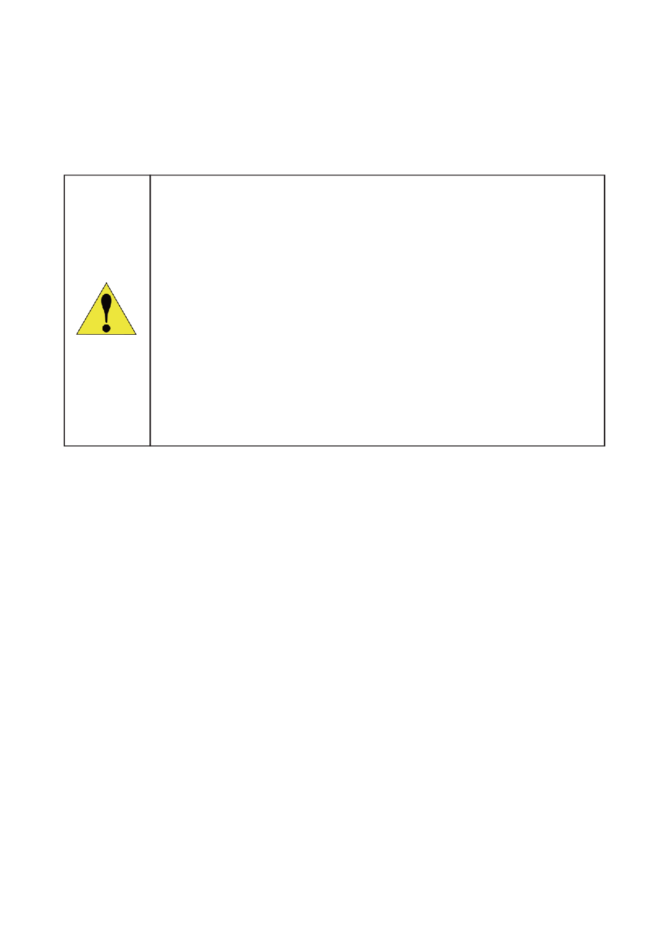
FX Aegis Hyper User Manual
2.7 Payload and Development
Users can attach payloads to the back of the robot or develop new functions based
on software interfaces. To learn more about payload development, usage of software
interfaces and packages, refer to Application Manual and API Documentation.
• After attaching payloads to the back of the robot, please modify
the parameters of payload. To learn more about how to modify the
parameters, refer to the chapter "2.2 Paramters Configuration" in
Application Manual, or contact after-sales staff.
• The maximum power supplied by the robot to the payload is 600W.
For details about the maximum power provided by each power port,
read the chapter "5.2 Hardware interface and wiring definition" in
Application Manual.
• Please cover the aviation plug with its cover.
18
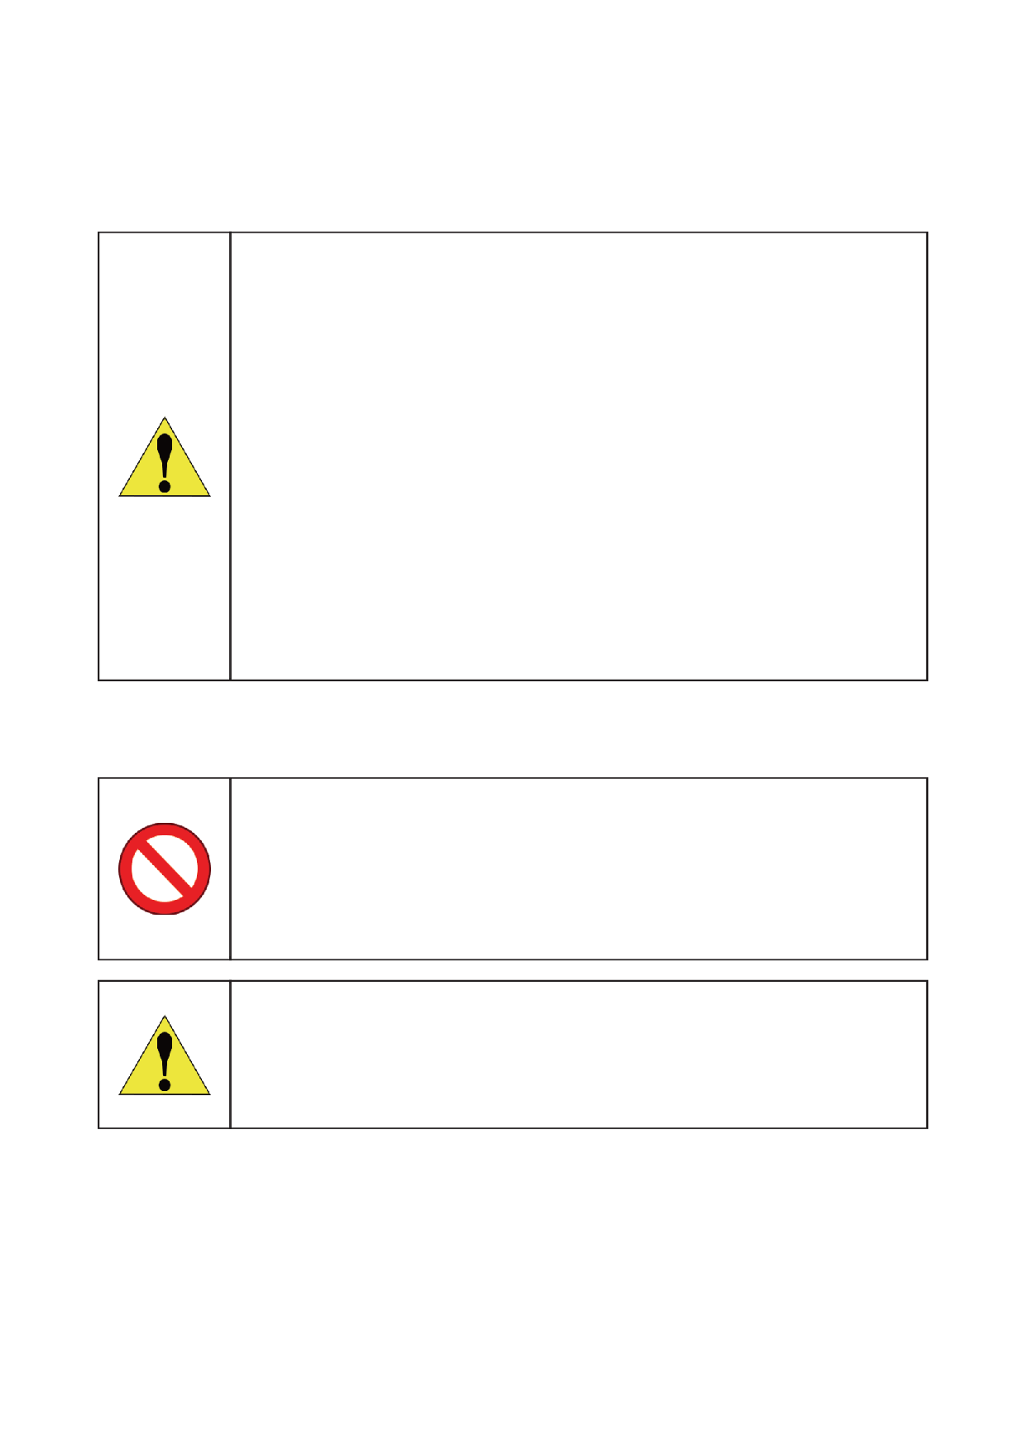
3 Precautions
3.1 Work Environment
• Please do not operate the robot in environments with strong WiFi
signal interference. Be sure to turn off part or all other WiFi signal
sources, and then use the joystick to operate the robot.
• Do not operate the robot in such bad weather as fog, snowing,
lightning, sandstorms, windstorms, tornadoes, etc.
• Keep the robot in sight and always keep it at least 2 meters away from
people, water, open flames, etc.
• When using the robot on smooth surfaces such as glass and tiles,
avoid violent movements and apply Stair or Slope gait to prevent the
robot from slipping and falling down.
• Do not operate the robot on the edge of a high place to prevent it from
falling and causing damage.
• Please consult the after-sales staff first before operating the robot in
environments with strong electromagnetic interference.
3.2 Other Precautions
• When carrying the robot, pay attention to the anti-pinch label on the
robot and do not put your hands into the position where the anti-pinch
label is attached!
• Do not lift the robot while it is moving to avoid unintended movements
that could cause damage to robot or injury to people!
• Please do not download other unrelated APPs in the controller.
• Pay attention to the sealing label on the robot. It is strictly forbidden
to disassemble the robot personally. Once disassembled, the warranty
will be invalid!
19
of the APP to save the abnormal motion data, and then restart the robot. If it does not
FX Aegis Hyper User Manual
4 FAQs
Q1: Is it normal for a robot to stop moving on its own?
A: The motor or driver may be overtemperature protected. Please wait 10 minutes and
try again. If you still can't control the robot to move, please check if the battery is fully
charged, if the hard emergency stop button is turned off (the button lights green).
Q2: What if there is no response to the commands from APP after connected?
A: First confirm if the hard emergency stop is off (the button lights green). If the APP is still
unable to control the robot, please restart the robot.
Q3: Can the robot continue to be used when its body or legs are askew after standing up?
A: At this time, do not continue to click [Torque Control]. Please immediately trigger soft
emergency stop to make the robot lie down. Then shut down and restart to try to control
the robot to stand up again. If still abnormal, please contact the after-sales staff.
Q4: What terrain can the robot adapt to?
A: The robot can be applied to gently uneven ground such as flat land and grass, and can
also climb complex terrain such as stairs and slopes, but please avoid operating and using
the robot in extreme terrain (such as too smooth surfaces such as ice, sharp or undulating
terrain, near high edges, etc.).
Q5: What should I do if the robot suddenly falls, stumbles, or has an abnormal gait
without being disturbed by external forces?
A: Please press the soft emergency stop in time, and click [Save Data] at the Settings page
return to normal after restarting, please contact after-sales service for help.
Q6: What if encountering a problem that cannot be solved even after consulting this
manual?
A: Click [Save Data] at the Settings page of the APP and contact the after-sales staff in
time.
20
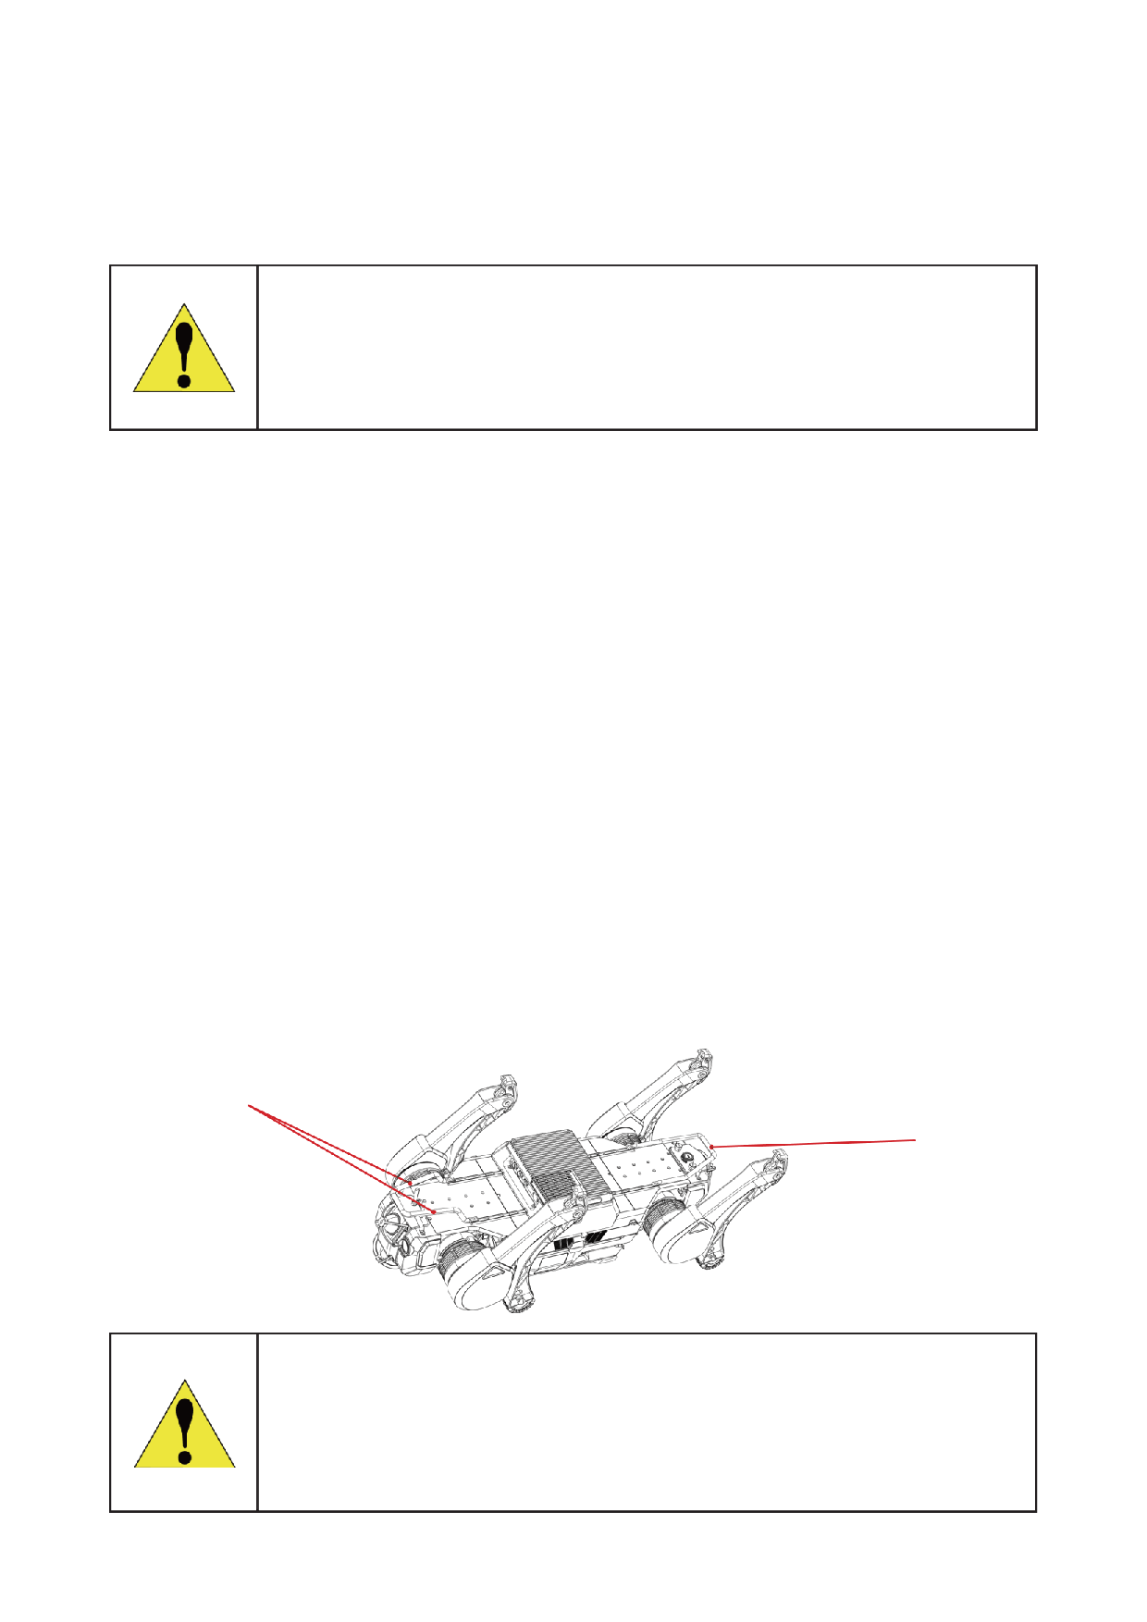
5 Transport and Storage
5.1 Transportation
The transport case is 1.09m×0.55m×0.57m.
• Before the transport case is being transported on the truck, make
sure to step on the two diagonal brake wheels on the transport box.
• During shipping the robot with transport case, make sure the front of
the transport case is facing up.
5.2 Storage
• FX Aegis Hyper shall be stored in a clean and dry place at -20℃~55℃.
• Robot must be powered off.
• Do not pour water or other liquids on the robot.
• Do not place other objects within the joint rotation range.
• Cover the robot completely with a clean antistatic cloth after use.
• It is recommended to store FX Aegis Hyper in the specifically designed transport case
to protect it from shock and vibration.
• FX Aegis Hyper must be placed in the transport case with its back facing up.
• If the robot is not used for a long time, charge it every three months to keep the battery
active.
5.3 Carrying
FX Aegis Hyper weights approximately 59 kg and it is recommended that two people carry
it: one person lifts the anterior carrying point of the robot, while the other lifts the rear
carrying point of the robot.
Carrying Point
Carrying Point
• Power off FX Aegis Hyper and carry it gently.
• Do not hold joints to prevent pinching or even scratching when carrying.
• The metal components of the robot's legs that have just finished running
are hot, so please wait until it cools down to suitable temperature before
carrying.
21

FX Aegis Hyper User Manual
6 Service and Warranty
6.1 After-Sales Service
• After the delivery of the equipment, FF EAI Robotics will send the specialized staff to
check the equipment and install the system as agreed.
• Provide free user training to guide users to operate the equipment, and arrange
technical support staff to provide timely after-sales service to ensure the smooth
operation of the system.
6.2 Warranty Policy
The warranty period for the major components of FX Aegis Hyper is as below.
Component
Warranty Period
Joint Module, Upper Legs, Lower Legs
6 months
Battery, Laser Radar, Wide-angle Cameras, Hosts
12 months
Tip: Shell, foot, other wear components, transport case and other accessories are not covered by warranty.
If necessary, please consult the after-sales staff.
The warranty period starts from the acceptance date. Products or components that are in
the warranty period and covered by warranty acquire free warranty service. If the product
you purchased is beyond the warranty period, you can also be helped by us through
purchasing the separate service.
6.3 Warranty Coverage
Depending on the specific situations, we will repair or replace components for the product
you purchased. However, the following situations will not be covered by the free warranty,
but you can still choose the paid warranty service. Please consult the after-sales staff for
details:
• Damage caused by man-made non-product quality problems.
• Unauthorized modification, disassembly, shell opening, etc.
• Out of warranty.
• Damage caused by improper installation, use and operation (such as dropping, crushing,
immersion, violent use, etc.) as required by the manual.
• Damage caused by secondary development.
• Damage caused by use in excess of the safe weight capacity.
• Damage caused by self-repair or replacement of parts without official instructions.
• Damage caused by installing third-party products by yourself.
• Damage caused by the use of a non-original battery pack for power supply.
22
• Failure or damage due to force majeure factors such as typhoon, earthquake, fire,
lightning strike, abnormal voltage.
• Damage caused by operating the robot dog in an environment with severe signal
interference.
• Damage caused by improper handling of the robot on slippery surfaces such as glass
and ice.
• Fallen damage caused by the use of a robot near a high edge.
• Fallen damage other than operate the robot on flat terrain.
• Damage caused by operation in environments such as sharp terrain and large
undulations.
• Damage caused by forced operation of parts in the event of aging or damage.
• Damage caused by not keeping a safe distance when used in complex environments.
• There are obvious traces of dust, grit, water, and metal powder intrusion inside the
robot.
• Damage caused by improper handling operations.
• Damage caused by violent or non-violent means applied to the robot when it exceeds its
anti-interference limit.
• Due to operation errors, there are obvious marks of collision and scratches on the
surface of the robot.
6.4 Repair Instructions
• Before acquiring after-sales service, please make sure to back up all data and delete
important data to prevent data loss or leakage. FF EAI Robotics is not responsible for any
data loss or leakage in the product.
• When you acquire after-sales service from FF EAI Robotics, you authorize FF EAI Robotics
to make any modification, delete data or restore factory settings for the purpose of after-
sales service.
• Before sending it for repair, please contact the after-sales staff and FF EAI Robotics will
try to diagnose and solve your problem remotely.
• If the above methods cannot solve your problem, you can send the robot for repair after
verifying with the after-sales staff. You need to pay for the postage when you send the
product to FF EAI Robotics. After FF EAI Robotics receives the problematic product in
need of repair, the product will be tested to determine the problem and responsibility.
• If the problem is caused by defects in quality of the product itself, FF EAI Robotics will be
responsible for the testing fee, material fee, labor fee and your postage.
• If the product does not meet the conditions of free repair after testing, you can choose
to pay for repair, and the testing fee, material fee, labor fee as well as the postage for
sending back shall be paid by you. You can also choose not to repair and to send product
back to you, and the postage and insurance fee shall be paid by you.
• Considering environmental protection and safety, please do not send seriously damaged
23
FX Aegis Hyper User Manual
batteries. If you have sent, FF EAI Robotics will scrap such batteries and will not return
them back to you.
• If you provide an incorrect delivery address which results in non-delivery or rejection by
the recipient, the adverse consequences and losses shall be borne by you.
• To ensure your rights and interests, when you sign for the after-sale product sent by
FF EAI Robotics, please check carefully whether the product is intact. If there is any
abnormality, please immediately take video or photos on the spot and contact FF EAI Robotics
to get the solutions. If there are unresolved after-sale problems, please also
contact FF EAI Robotics immediately, otherwise it is deemed as the end of this after-sale
service without dispute.
※FF EAI Robotics reserves the right of final explanation of the after-sales terms.

24
Thank you for choosing FX Aegis Hyper.
If a non-user-induced quality issue arises during the applicable warranty period, please contact FF after-sales support with your proof of purchase and product serial number. We will assist with remote diagnostics and, based on the assessment results, provide repair or replacement support in accordance with the FF AI Robotics General After-Sales Service Policy.
Returns and exchanges are handled through the original point of purchase and in accordance with applicable local consumer protection laws. Complete terms are governed by the FF AI Robotics General After-Sales Service Policy.
After-sales support: support.ff.com
After-sales email: support@ff.com
7 Disposal
• The disposal of waste robots and components shall be carried out in accordance with
the corresponding national laws and regulations on the recycling of wasted electric
appliance and electronic products.
• Especially the use or disposal of lithium batteries contained in robots shall be subject to
national laws and regulations regarding the disposal of batteries.
25

