FX Aegis EDU user manual_EN

FF EAI Robotics

FX Aegis EDU

QUADRUPED ROBOT

User Manual
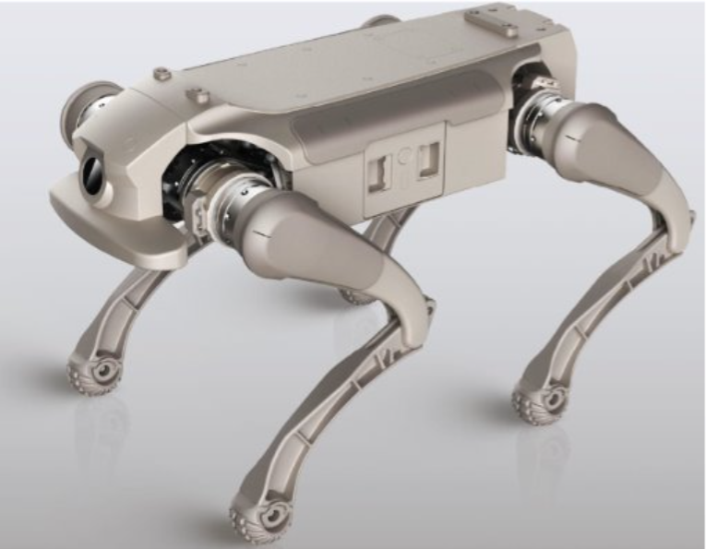

Professional, embodied-AI quadruped robot designed for security and companionship

Version Statement
- Legal Statement
- Notes
- Battery and Charging Precausions
Product Description
- Product Overview
- Component Introduction
- Tail Light Introduction
- Power Supply Introduction
Product Usage
- Preparation before First Use
- Remote Control User Guide
- APP User Guide
- Product OTA Upgrade
Product Parameters
Troubleshooting
Transportation and storage
- Product Transportation
- Storage Environment
- Battery Precautions
- Handle with Care
Hazardous Substances Information
Warranty Information
- After-sales Service
- Warranty Policy
- Warranty Exclusion
- Repair Instructions

Legal Statement
Before using this product, users must carefully read the D1 Product User Manual (hereinafter referred to as "this manual") and strictly follow its instructions when operating the product. The company shall not be liable for any property damage or personal injury resulting from use contrary to this manual. This product consists of multiple components; ensure children cannot access it to prevent accidents. This product is intended for use by individuals aged 18 years or older. To prolong the product's lifespan, avoid using it in high-temperature or high-pressure environments. While this manual strives to provide comprehensive functional descriptions and usage instructions, actual product features may differ from the manual due to ongoing improvements and design changes. ln cases where the physical product differs from the manual in color, appearance, or other aspects, the physical product shall prevail.

Notes to be Observed
This manual is applicable to the Dl Edu versions (Product Model ZYXG02).
This product should not be used by people with physical, sensory or intellectual disabilities, or by those without relevant experience and knowledge (including children), unless under the supervision or guidance of a guardian to ensure its safe use.
Do not let children treat the robot as a toy. Please supervise children and pets to keep them away from the main unit when it is working.
If the power cord is damaged, it must be replaced with a special power cord or a special component purchased from its manufacturer or service department.
Do not use in suspended environments without guard rails.
When the robot dog shows abnormal behaviors such as random leg movements or violent shaking during use, please press the Emergency Stop button to activate the soft emergency stop function, which will put the moving robot dog into a protective state. The robot dog will automatically lie down. After troubleshooting, it can be operated normally.
Do not place the robot dog upside down. Do not carry it by its legs. Do not use in an environment above 40°C or below 0°C.
Do not operate the robot in an environment with electromagnetic interference.
Do not operate the robot in an environment with Wi-Fi or 2.4G signal interference.
Before starting the robot dog, please ensure there is more than I meter of space around it to avoid collisions with people or objects.
When the robot dog is going up or down stairs or slopes, do not stand on the stairs, platforms or slopes below the robot dog to avoid possible personal injury if the robot dog falls.
Do not place children, pets or any items on the stationary or running main unit.
When handling, do not insert your hands into the range of motion of the joint to prevent pinching or even cutting injuries.
Before cleaning and maintaining the main unit and the charging dock, please turn off the power and unplug the power cord.
Do not wipe the main unit or the charging dock with a damp cloth or rinse them with any liquid.
Do not use any third-party batteries, power cords, or charging docks. Only use the standard charging dock provided.
Do not disassemble, repair or modify the main unit, battery, or charging dock by yourself. No warranty service will be provided after disassembly, repair or modification.
Do not place the charging dock near a heat source.
Do not discard used batteries at will. They should be handed over to professional recycling agencies for disposal.
If the product is not used for a long time, please fully charge it, turn off the main unit and store it in a cool and dry place. Charge it at least once every three months to avoid over-discharge of the battery.
If you need to transport the product, please ensure that the main unit is turned off, and it is recommended to use the original packaging box for packaging.
Please use this product in accordance with the instructions in the manual. Any loss or damage caused by improper use shall be borne by the user.
Joint and wiring harness inspection
Please check if there are any foreign objects affecting the joints, if the wiring harness is damaged, and ensure that the foot pads are intact.
Battery power and camera cleaning
Check the battery level to ensure it is fully charged to prevent sudden drops or falls. At the same time, keep the camera surface on the head and the underside of the body clean to avoid scratching the lens with hard objects. If there is any dirt, wipe it off promptly with a dry soft cloth.
Precautions for Cleaning Products
Do not use liquids containing alcohol or other solvents or corrosive components to clean this product.
Reasonable placement and ground environment
When placing it, please ensure that the legs are in a natural and weight-free state to avoid damage to the legjoints caused by the weight of the machine. Do not let the product lie flat on a hard, sharp or overly bumpy surface to prevent scratches on the bottom lens of the machine.
Foot pads and wear and tear
The foot pads are consumable. Please pay attention to their wear and tears during use. If you notice any wear, damage, or an increase in the noise of the robot's impact with the ground, replace the footpads promptly to prevent damage to the robot's movement.
Safe use and terrain adaptability
When in use, keep it within your line of sight and maintain a sufficient safety distance. Stay away from obstacles and potential collision hazards. Although the product has good terrain adaptability, it is still necessary to ensure that the terrain meets the requirements.
Speed, turns and complex terrain
Sharp turns are prone to loss of control, especially on steep slopes, uneven or unknown terrain. Avoid risky maneuvers and reduce speed.
Steep slopes and climbing angles
Keep within the rated forward climbing angle and avoid making direct turns at large climbing angles to prevent the robot from losing stability. Please handle operations on steep slopes and terrain with significant inclines properly.
Maximum speed and prohibited usage scenarios

The maximum open speed on a flat terrain can reach 3.5 m/s. Do not use this product on complex, slippery, debris-covered, overly steep slopes or in areas with sharp objects nearby.
Joint and battery status check
If you notice loose joints, inability to stand normally, or excessive noise during operation, please stop using it immediately, turn it off and seek professional maintenance.
Low battery warning
When the battery level is low, the product may not have enough power to perform actions. Please charge it in time to avoid danger
Safety Precautions
Avoid touching the moving parts of the robot with your hands or body to prevent pinching or bumping injuries. At the same time, do not touch the metal parts on the surface of the joint motors to avoid burns.
Product heat dissipation and cleaning
Continuous use for a long time may cause the motor to overheat. Please take regular breaks. lfthe product is contaminated, please clean it in time.
Power connection specifications
Please connect this product with a fast-charging cable that meets the specifications.
Shut-down Precautions
Please shut down the machine immediately after use.

Battery and Charging Precautions
Battery Usage Restrictions
Do not disassemble the battery or use the battery plates in any way by exposing them.
Adapters and Cleaning
Do not use alcohol or other flammable agents to clean the power adapter to avoid potential safety risks.
Dealing with Battery Leakage
If the battery leaks and the electrolyte gets into your eyes, do not rub them. Immediately rinse your eyes with clean water and then seek medical treatment.
Exception handling
If the battery emits an unusual smell, smokes, deforms or shows other abnormal conditions during charging, please immediately unplug the power adapter and check it.
Safe temperature
The power adapter may generate a relatively high temperature during charging. Please avoid touching it for a long time to prevent bums.
Power adapter
Do not use a damaged power adapter. Only use the official power adapter. Nonofficial power adapters may cause lithium battery leakage, overheating, fire or explosion.
Charging time
The battery charging time should not exceed 24 hours. Overcharging may shorten the battery life

Warning
CAUTION of Battery
Risk of explosion if the battery is replaced by an incorrect type.
Disposal of a battery into a fire or hot oven, or mechanically crushing or cutting of a battery, that can result in an explosion.
Leaving a battery in an extremely high temperature surrounding environment can result in an explosion or the leakage of flammable liquid or gas.
A battery subjected to extremely low air pressure that may result in an explosion or the leakage of flammable liquid or gas.
FCCSAR
FCC Radiation Exposure Statement This equipment complies with FCC radiation exposure limits set forth for an uncontrolled environment. This transmitter must not be co-located or operated in conjunction with any other antenna or transmitter. This equipment should be installed and operated at a minimum distance 20cm between the radiator & your body.
IC Warning
This device contains license-exempt transmitter(s)/receiver(s) that comply with Innovation, Science and Economic Development Canada's license-exempt RSS(s). Operation is subject to the following two conditions: (1) This device may not cause interference. (2) This device must accept any interference, including interference that may cause undesired operation of the device.
Any changes or modifications not expressly approved by the party responsible for compliance could void the user's authority to operate the equipment.
IC SAR
ISEDC Radiation Exposure Statement: This equipment complies with ISEDC RF radiation exposure limits set forth for an controlled environment. This transmitter must not be co-located or operated in conjunction with any other antenna or transmitter. This equipment should be installed and operated at a minimum distance of 20cm between the radiator& your body.
Warning
The device for operation in the band 5150-5250 MHz is only for indoor use to reduce the potential for harmful interference to co-channel mobile satellite systems.

Product Overview
Aegis EDU is a universal intelligent bionic quadruped robot with 12 degrees of freedom, featuring multiple motion gaits and movements. Meanwhile, the Edu version opens up the motion control algorithm development SDK and communication protocol, allowing users to conduct secondary development as needed.
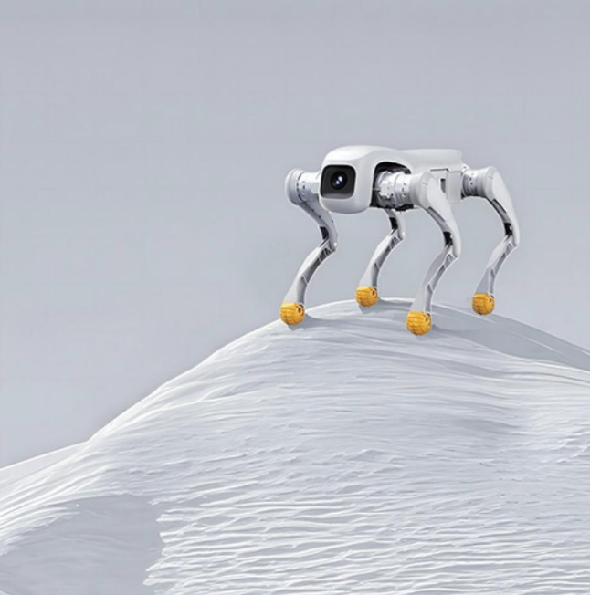

Component Introduction
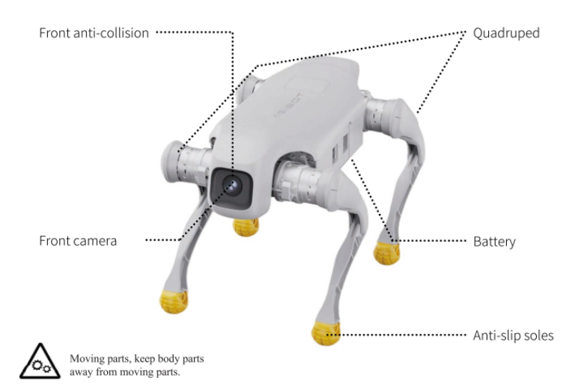

Expansion Interface (Applicable to Edu Version)
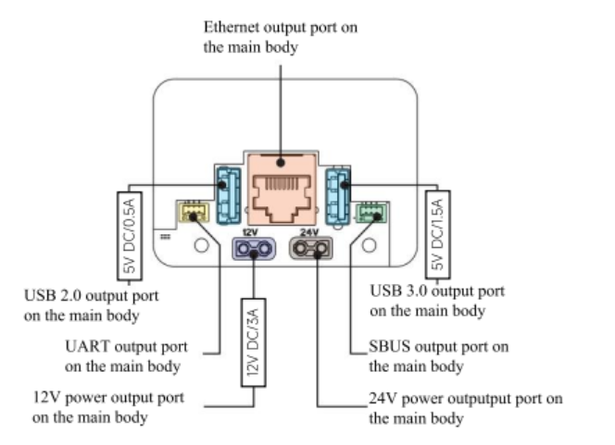

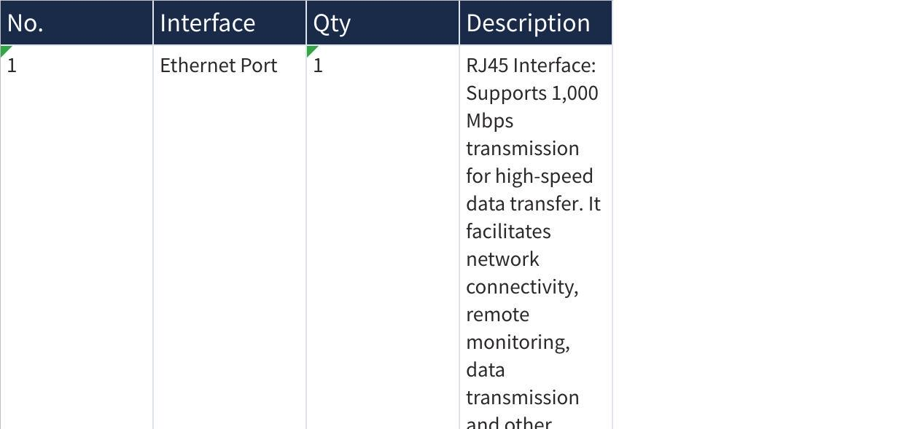
点击图片可查看完整电子表格

Introduction to Tail Lights

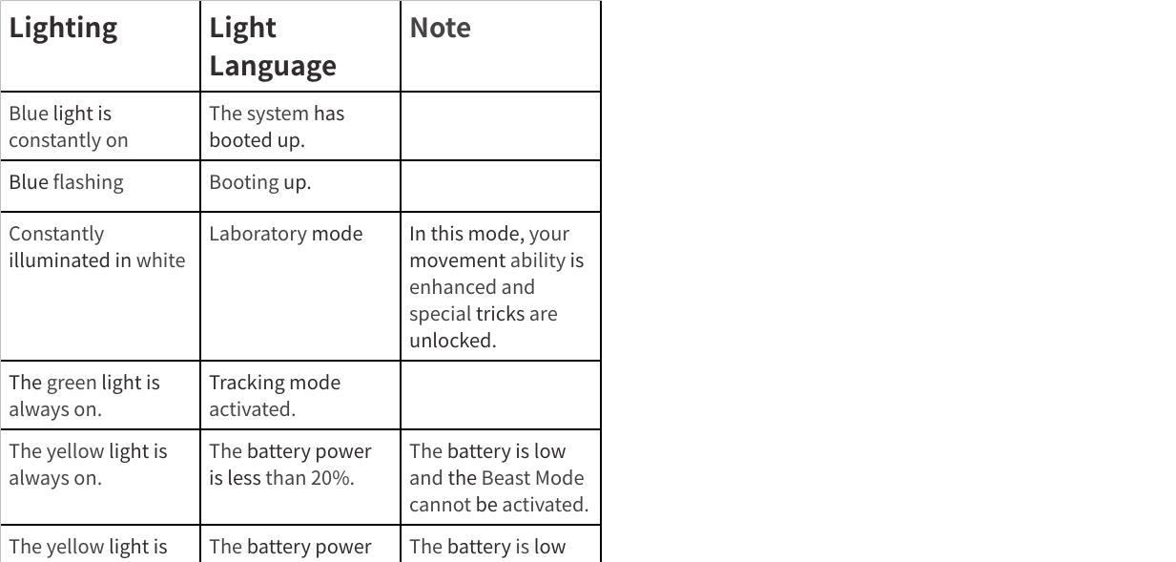
点击图片可查看完整电子表格

Power Supply Introduction
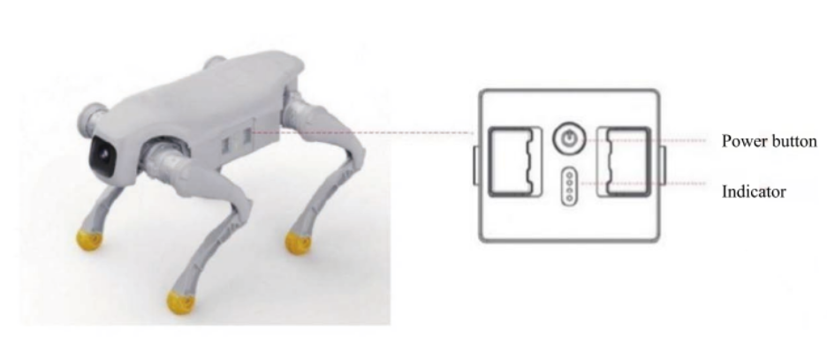

Battery display when the device is powered on
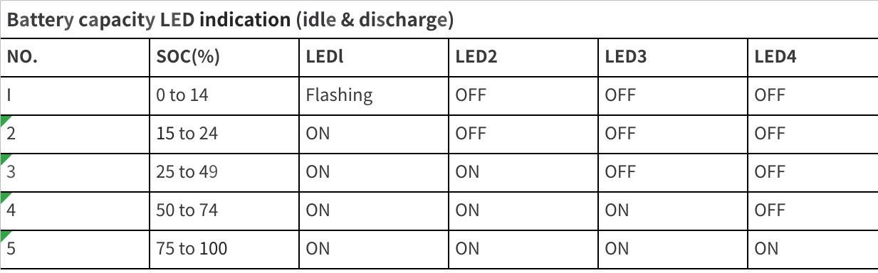
点击图片可查看完整电子表格

Battery Display in charge state
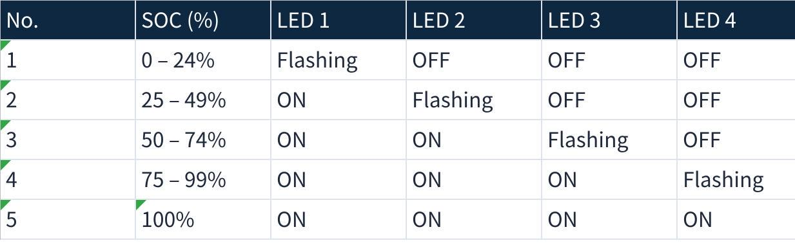
点击图片可查看完整电子表格

Power Adapter
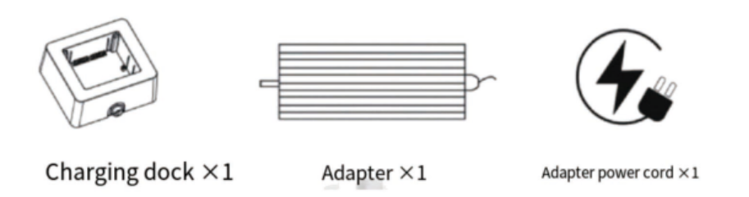

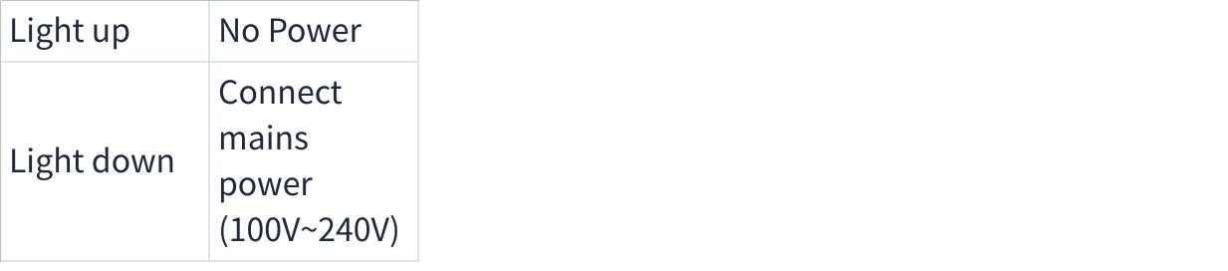
点击图片可查看完整电子表格

Charging Instructions
Please ensure that both operators and non-operators present have carefully read this manual and are familiar with the basic operating procedures and safety precautions.

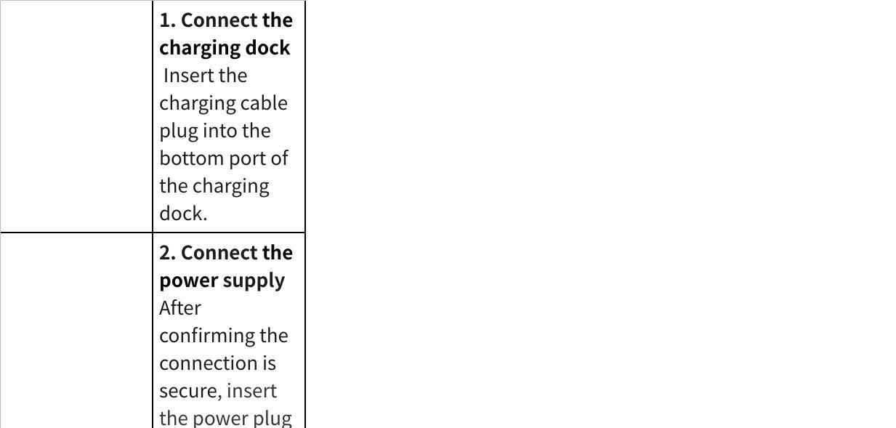
点击图片可查看完整电子表格

To ensure electrical safety:
1 Please follow the steps in the above order and avoid connecting the power supply before the charging dock.
2.Do not plug or unplug the charging dock port while it is powered.

Preparation Before First Use
Power On
Remove the robot dog from its packaging box and place it on a flat surface. Take out the battery and insert it into the robot dog’s battery compartment. Briefly press the power button once, then bold it down for at least 3 seconds. The robot dog will power on successfully once the LED light on its head stops flashing.
Power Off
Ensure the robot dog is in a lying-down position. Briefly press the power button once, then hold it down for at least 3 seconds. Once all LEDs on the battery have turned off, the device will enter the shutdown state.

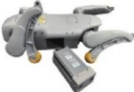

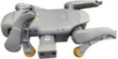

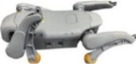

Remote Control User Manual
Product Use Statement: Due to the continuous upgrading of the product’s software version, some functions, operation methods, or interface displays may differ from the descriptions in this manual.
The same. If you have any questions or operational confusion, please contact the official customer service at any time for technical support.

Remote Control Introduction
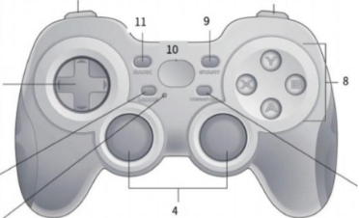

Operation Instructions
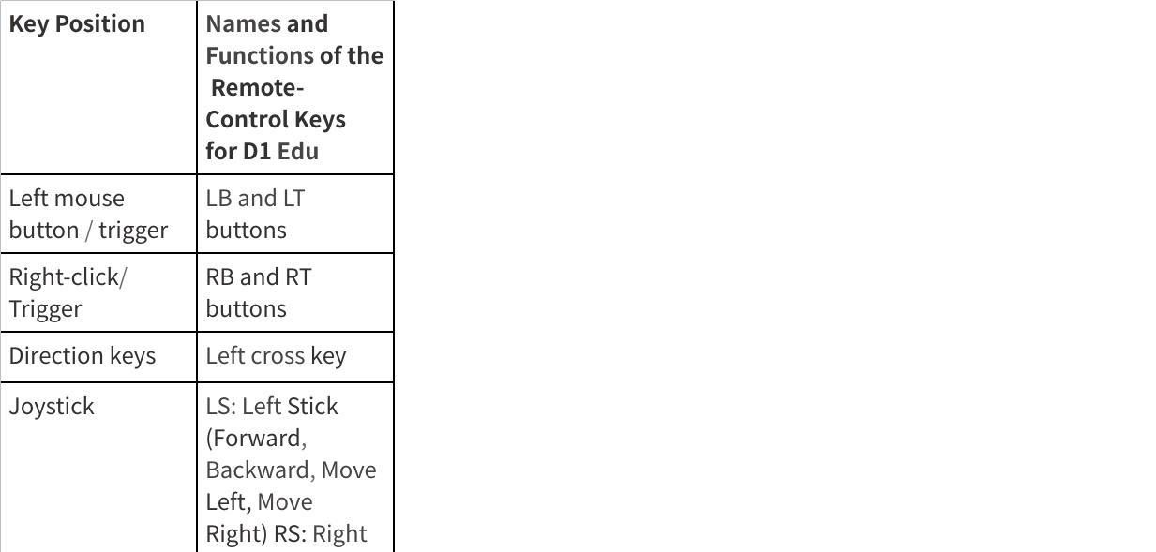
点击图片可查看完整电子表格

Connection method
- Remove the battery and insert it into the battery compartment of the robot dog. Press briefly.
Press the battery power button once, then hold it down for 5 seconds. Release it and wait for 20 seconds. The startup is now complete. At this point, the battery indicator light shows the remaining battery power of the robot dog.
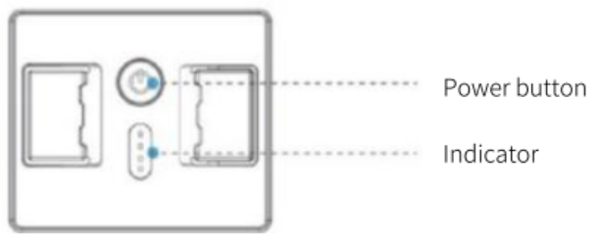

- Check above the remote control to ensure it is in the X position.
- Press LB+Y to make the robot dog stand up and gently push the left joystick forward to try to control it. If the robot dog does not respond when you move it forward, press the MODE key and then gently push the left joystick forward.

Operations Instructions
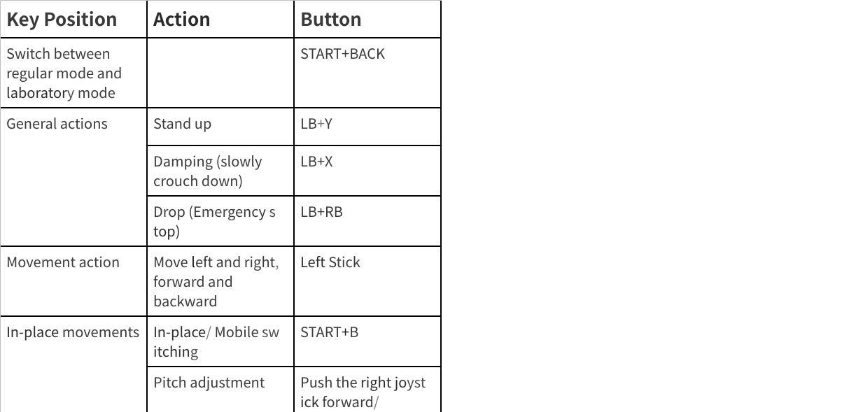
点击图片可查看完整电子表格

Warning: Stunt actions may affect the lifespan of the device.
- Regular mode: Features stable regular movement capabilities and standard actions, suitable for daily use.
- Laboratory Mode: Enhance athletic performance and unlock more stunts.

Stunt actions in Lab Mode put a lot of strain on the joints. Using it for too long can cause faster wear and cause faster wear and shorten the device's life. Use with care and keep sessions short to maintain the device's health.

APP User Guide
- APP Download
Click the link http://www.zhiyuan-robot.com/DOCS/SW/Dl/app to download the AgibotGO APP. Link需要改

- Account Registration and Login
Register and log in to the APP using your mobile phone number or email address.
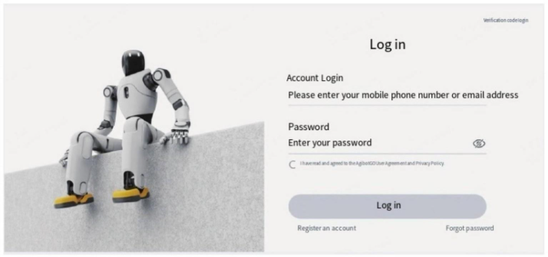

- Equipment Connection
- Click the "Add Robot" button
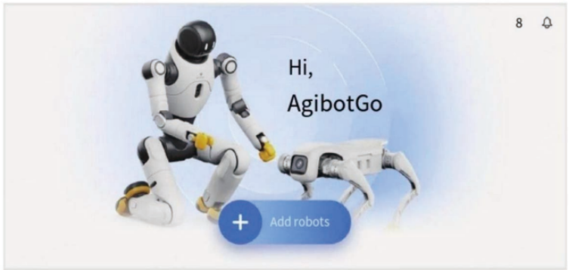

- Select to add a robot
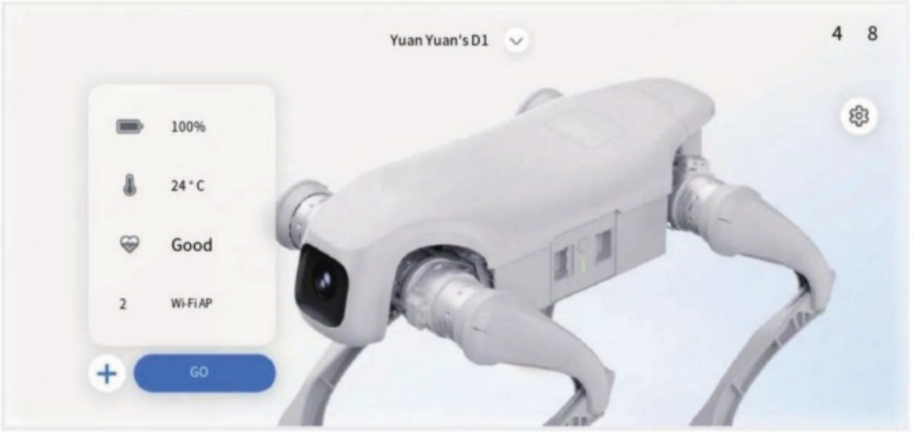

- Select the network connection mode. Two modes are supported: WiFi and direct connection to AP.
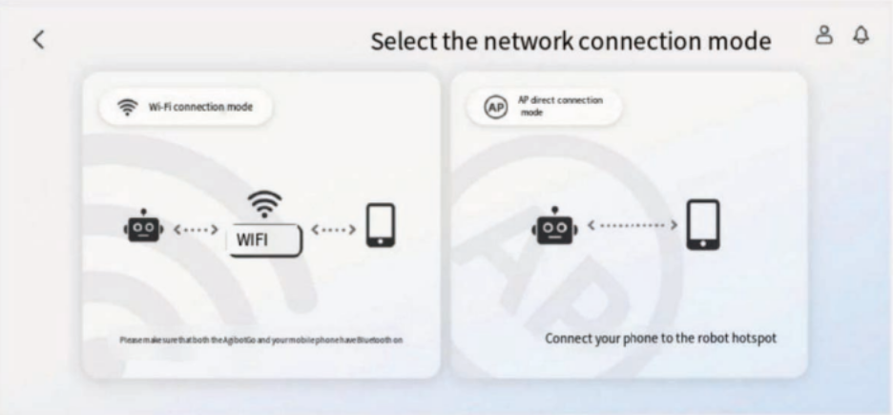

- Select WiFi connection mode Automatically read the current Wifi network connected to the mobile phone.

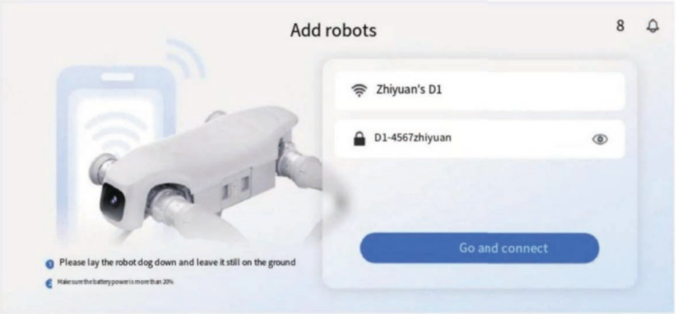

Connecting
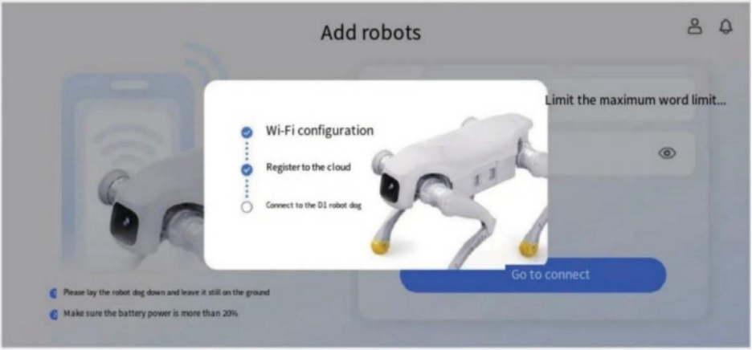

Connection successful. Return to the APP home page.
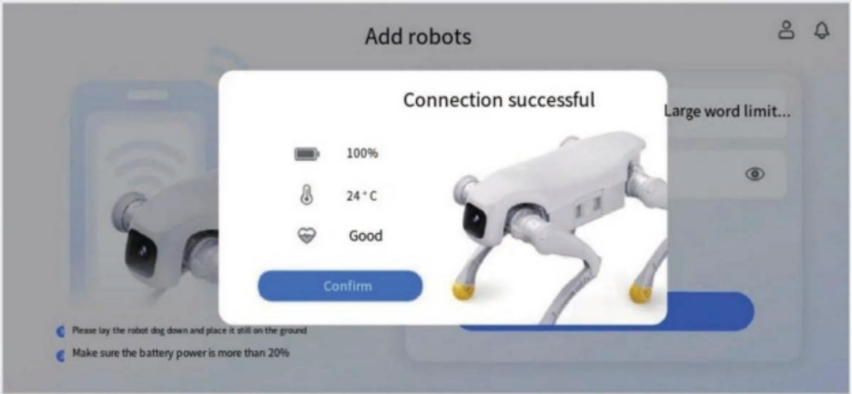

- Select AP connection mode
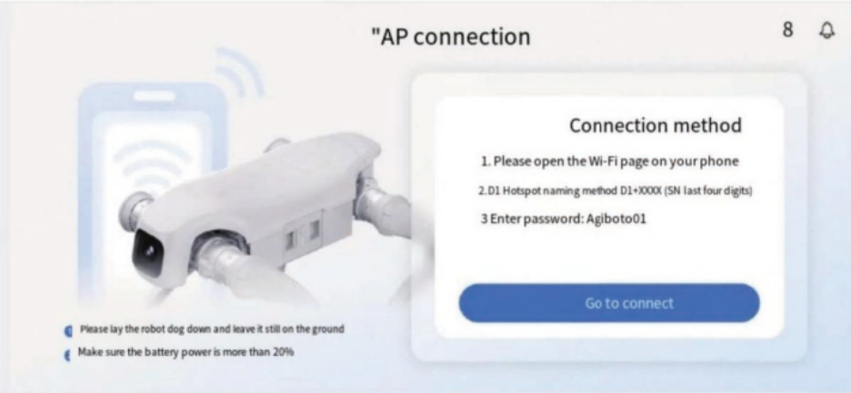

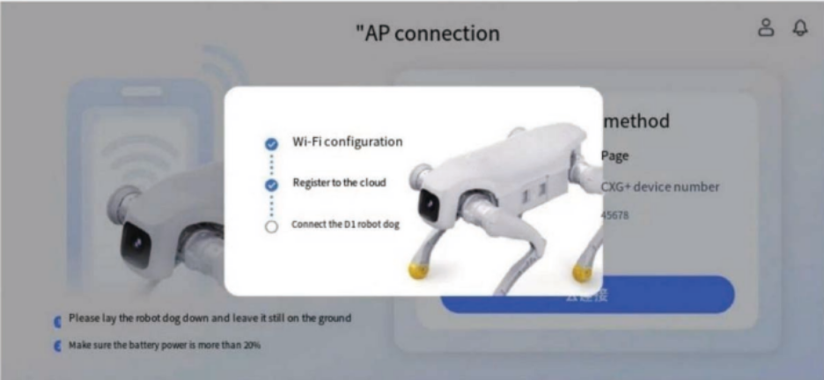

- After a successful connection, return to the device's home page.
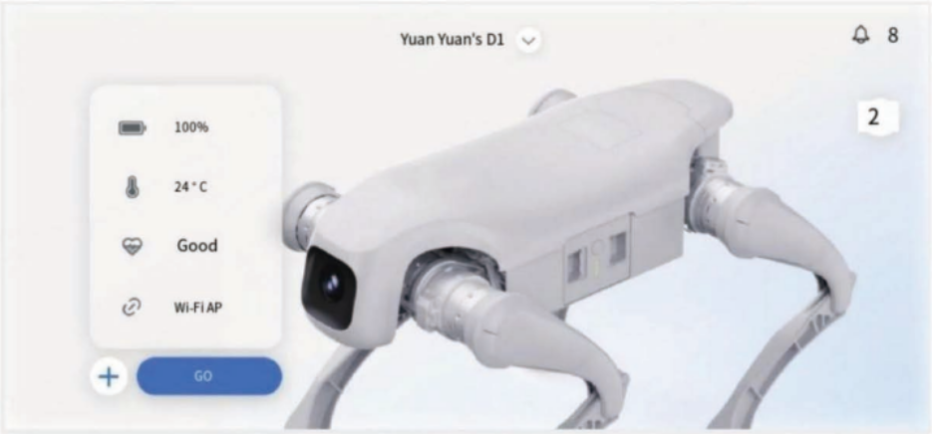

Operation page
- The upper left corner can be used to switch between mobile mode and stationary mode;
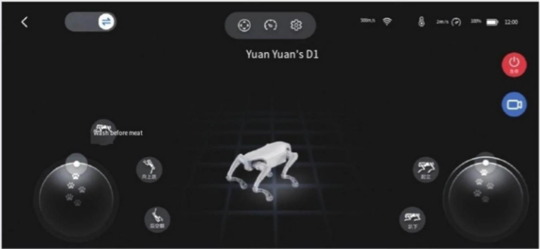

- In mobile mode, the left joystick controls the robot's walking direction, and the right joystick controls the robot's rotation direction.
- In place mode, the joystick operation is switched to left and right head movement and pitch. The robot cannot walk in place mode.
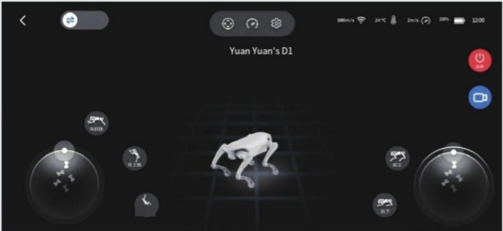

- Press the red emergency stop button to trigger the emergency stop operation.
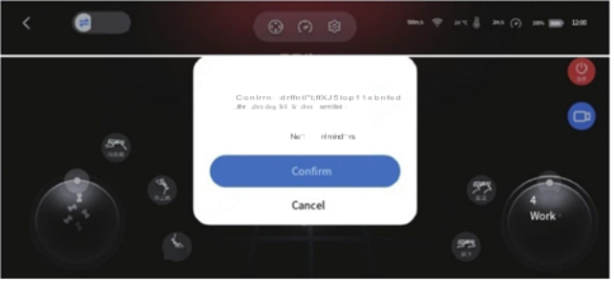

- Click on the left to perform a forward jump, an upward jump, or a backflip. The prompts indicate these are stunt moves.
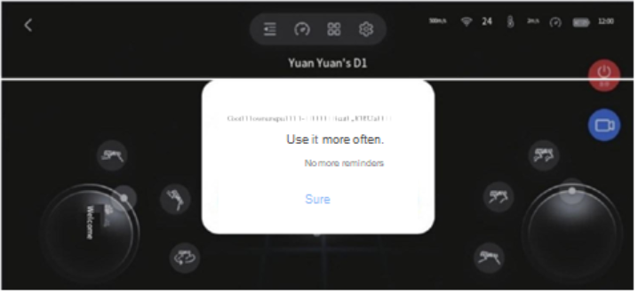

- Robot speed setting
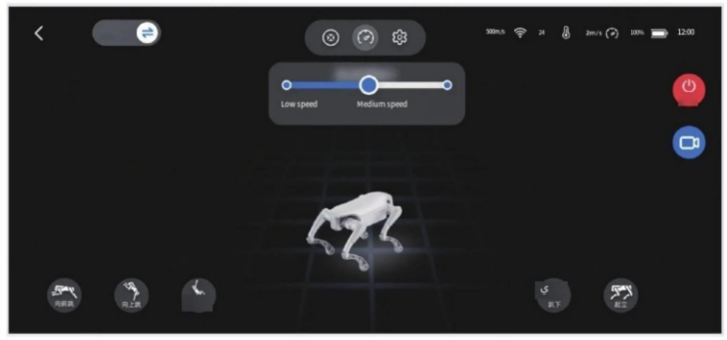

Warning: Stunt actions may affect the lifespan of the device.
Performing stunt actions will impose a significant load on the joint modules of the equipment. Prolonged operation may lead to accelerated wear of the joints, seriously affecting their service life.
Life. Please open it carefully and control the usage time reasonably to ensure the long-term stability of the device.

Product OTA upgrade

OTA Upgrade Procedure Preliminary Preparation

Operating System
- Windows

Get the flashing package
- OTA official website link: https://www.zhiyuan-robot.com/DOCS/SW/Dl/OTA 改连接

Python installation
The firmware update package relies on Python. Before using it, Python needs to be installed. Just enter the link below in your browser to install.
When installing https://www.python.org/ftp/python/3.l 2.0/python-3.12.0rc3-amd64.exe, please make sure to check the boxes as shown in the following figure:
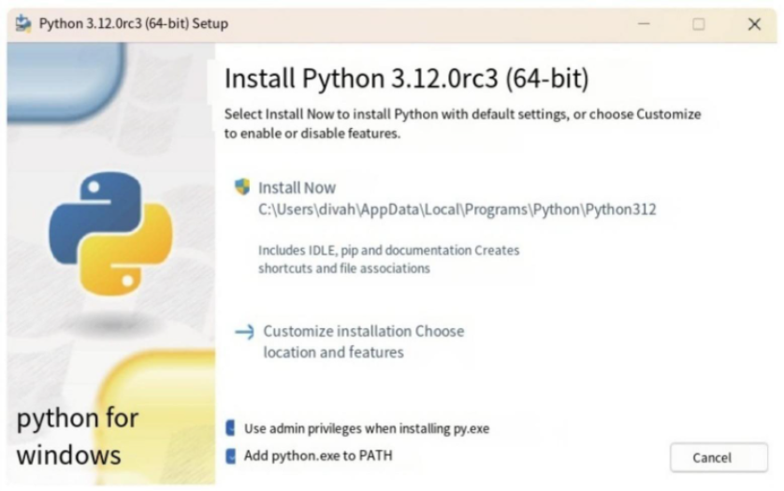

2.4.2 Windows operation process
Please ensure that the robot is fully charged before the upgrade begins. Upgrade using the OTA flashing tool
Download the OTA flashing tool package agibotDl_update_pkg_<version number>.zip and extract it.
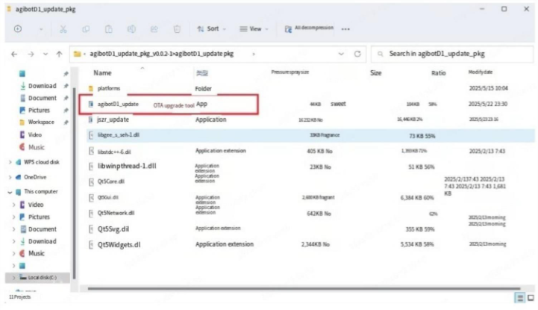

- Connect to the robot's WIFI.
- After filling in the robot's Wi-Fi name, click the "Get Current Version Information" button to obtain the current version information of the robot.
- Select the upgrade package to be used (the file suffix is tar.gz).
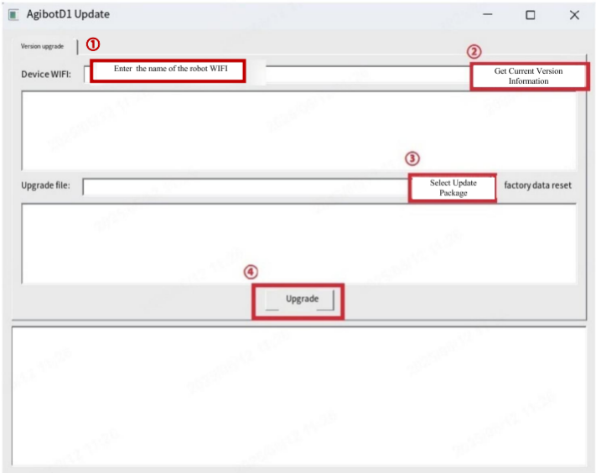

- After confirming that the upgrade package information is correct, click the upgrade button to upgrade the version. During this process, the robot will restart.
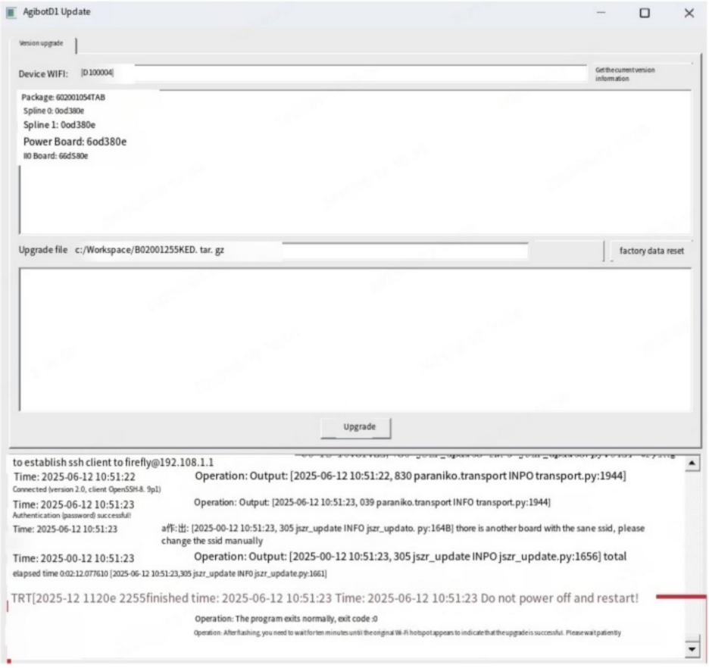

Product Parameters
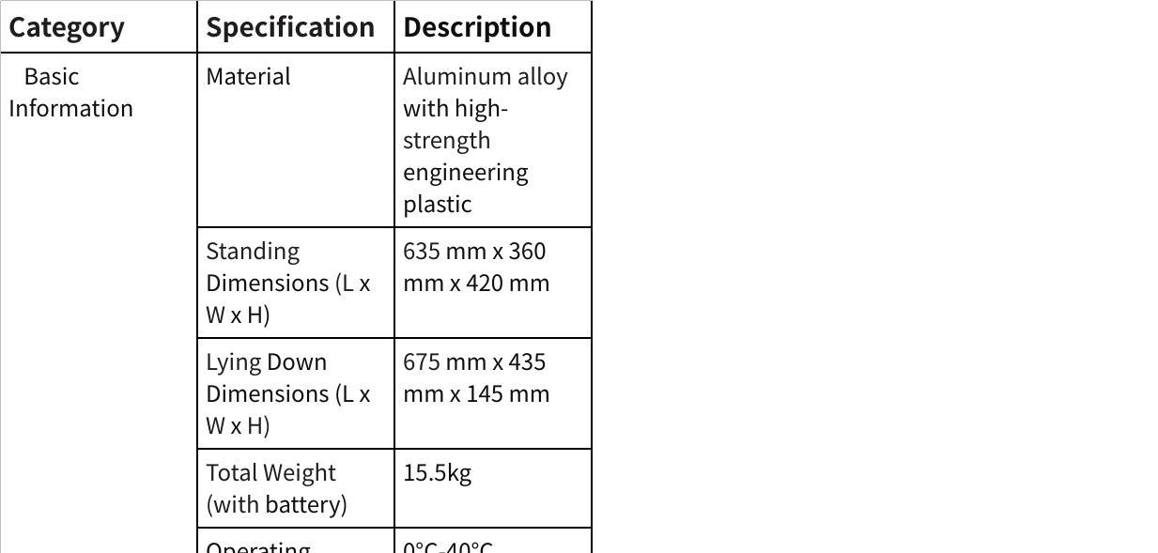
点击图片可查看完整电子表格

Notes:
- Charging time is measured at a standard ambient temperature of 25°C
- Operating range is measured at 1m/s speed under no-load conditions.
- For details on the expansion of interface usage, refer to the Expansion Interface Manual.
- For warranty terms, please refer to the Product Warranty Manual;
- All parameters are based on laboratory test data. Actually performance may vary depending on environment and operating conditions.

Troubleshooting
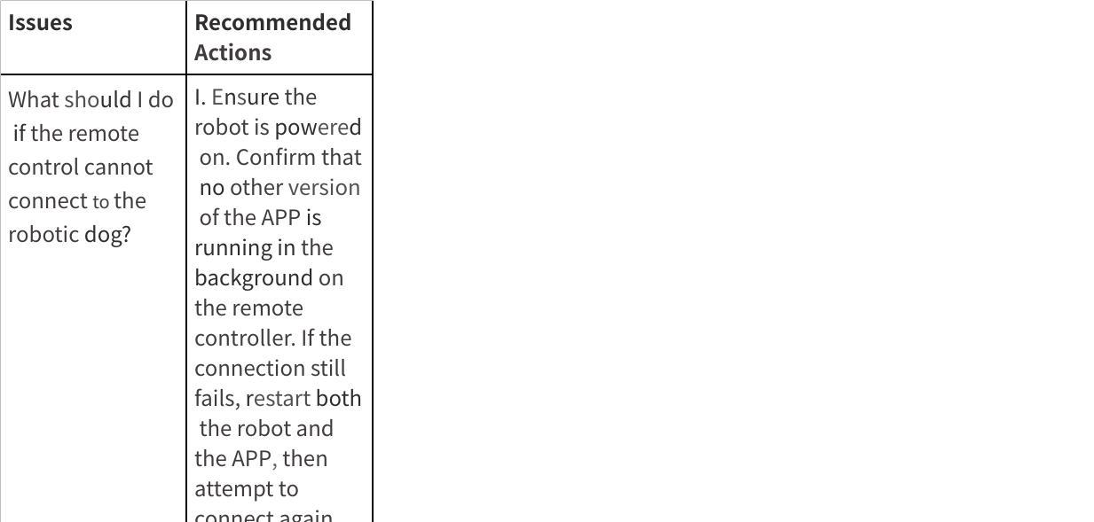
点击图片可查看完整电子表格

Product Transportation
The dimensions of the box are 64cm * 46cm * 41.5cm. Please remove the battery from the robot dog before transporting it with the box. During transportation, make sure the front of the box is facing upwards.

Storage Environment
When storing the power adapter and the entire machine, place them in a dry and cool environment, away from direct sunlight, fire sources and strong electromagnetic fields. The temperature should be maintained between 20°C and 25°C . Do not store the product in an environment where the temperature exceeds 60°C or drops below -10°C . For long-term storage, it is recommended to keep the temperature at 20°C - 25°C, the relative humidity at 0 - 60% RH, and the battery charge below 50%.

Battery Precautions
Prolonged inactivity may affect battery performance. Avoid deep discharges to maintain battery health.
While the battery will automatically stop charging once fully charged, it is recommended to disconnect it to preserve battery condition.
Regularly check the battery charge level and perform a charge-discharge cycle approximately every three months to maintain battery activity. If the charge level falls below 20%, recharge it to 40%-60% before storage to prevent battery damage.

Handle with care.
After turning on the machine, please avoid lifting or moving this product. Before moving it, make sure to tum it off. When moving, handle it gently to avoid mechanical shock that may cause damage to the components.

Hazardous Substances Description

Hazardous Substances Information
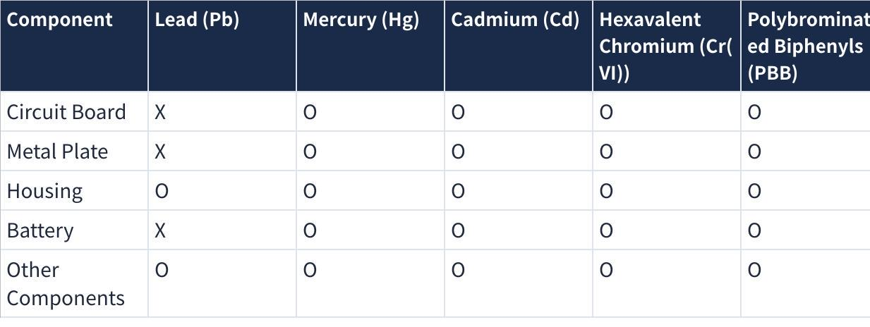
点击图片可查看完整电子表格
This inspection is based on the provisions of SJ/T 11364.
O = Indicates that the content of the hazardous substance in all homogeneous materials of the component is below the limit requirement specified in GB/T 26572.
X = Indicates that the content of the hazardous substance in at least one homogeneous material of the component exceeds the limit requirement specified in GB/T 26572.

This product contains a rechargeable lithium battery pack. It is harmful to the environment when discarded. Please remove the battery from the main unit before disposal and handle it properly:
- Before removing the battery, please power off the device and deplete the battery charge as much as possible.
- Do not damage the battery casing to prevent potential hazards.
- The removed battery must be handed over to a professional recycling agency for proper disposal.

Caution
Risk of explosion if the battery is replaced by an incorrect type;
Disposal of a battery into fire or a hot oven, or mechanically crushing or cutting of a battery that can result in an explosion;
Leaving a battery in an extremely high temperature surrounding environment that can result in an explosion or the leakage of flammable liquid or gas
A battery subjected to extremely low air pressure that may result in an explosion or the leakage of flammable liquid or gas.

Warranty Instructions
After-sales service
This product is not eligible for return. Warranty service is provided, please refer to the warranty policy.

Warranty Policy
After you purchase this product, the warranty period starts from the day you receive the goods. Please keep your warranty certificate safe. If the product meets the warranty period and the warranty conditions,
Products or components will be entitled to free after-sales service. Ifthe product you purchased is beyond the warranty period, you can also obtain our assistance by purchasing the service separately.

Warranty Exclusions
We will provide corresponding repairs or component replacements for your purchased product based on the specific circumstances. However, the following situations are not covered under free warranty, but you may still opt for paid after-sales service. Please consult after-sales support for specific details:
- Damage caused by human error not related to product quality.
- Unauthorized modifications, disassembly, or opening of the casing.
- Damage resulting from incorrect installation, use, or operation not in accordance with the user manual.
- Damage caused by usage exceeding the specified safe load capacity.
- Damage resulting from the installation of third-party products.
- Damage caused by internal exposure to water, debris, or other chemical substances.
- Malfunctions or damage caused by force majeure events such as typhoons, earthquakes, fires, lightning strikes, or abnormal voltage.
- Malfunctions or damage resulting from operation under harsh conditions, including strong magnetic fields, severe interference, or extreme temperatures.
- The product is not a genuine FF EAI product or valid proof of purchase cannot be provided.
- Malfunctions or damage caused by unauthorized repairs through non-official channels.

Repair Instruction
Before seeking after sales service, be sure to back up all data and delete sensitive information to prevent data loss or leakage. FF is not responsible for the loss or leakage of any data contained within the product.
- Requesting after-sales service constitutes your authorization for us to perform any necessary modifications, data deletion, or factory resets for the purpose of servicing the product.
- Before sending the product for repair, please contact F after-sales support. We will attempt to diagnose and resolve your issue remotely.
- If the above methods cannot resolve your issue, you will be responsible for the initial shipping costs when sending the product to FF. Upon receipt, the product will be inspected to determine the issue and liability.
- If the issue is determined to be a manufacturing defect, FF will cover the costs of inspection, parts, and labor.
- If the product does not qualify for free repair, you may choose paid repair. The corresponding costs for inspection, parts, labor, and return shipping will be your responsibility. If you decline repair, the procudt will be returned to you at your expense.
- For environmental and safety reasons, please do not return severely damaged batteries. If such batteries are received, they will be safely disposed of and not returned.
- You are responsible for any adverse consequences or losses resulting from an incorrect shipping address you provide or refusal of delivery by the recipient.
- To protect your rights, please inspect the product carefully upon receipt after service. If any abnormalities are found, immediately take photos or videos and contact FF for a solution. If unresolved issues remain, contact us immediately; otherwise, the service request will be considered resolved and closed.

