FF Futurist Ultra Edition Instruction Manual

FF Futurist Ultra Edition Instruction Manual v1.0

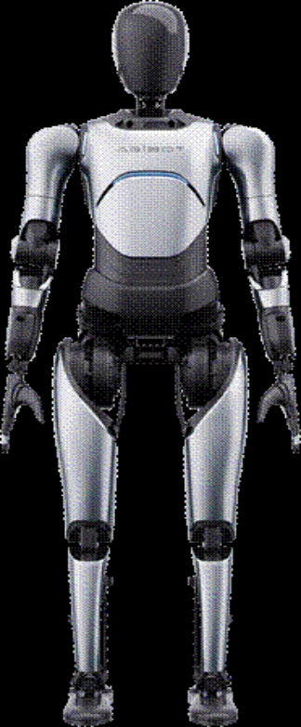

This manual is for reference only.
FF AI-Robotics Inc. reserves all rights to interpret this document.

FF Futurist Product Manual
Foreword
- Safety Protection Measures
1.1 Safety Guide
1.1.1 WARNING: Do not operate the robot
1.1.2 Before turning on the robot:
1.1.3 Precautions during manual operation of the robot:
1.1.4 When the task is complete:
1.1.5 WARNING: Ensure the power is completely turned off when doing maintenance
1.1.6 When transferring the robot:
1.1.7 When the robot is not been used for a long time:
1.2 Precautions for Use
1.3 Maintenance and Management Guidelines
- Product Overview
2.1 Product Introduction
- Quick Start Guide
I. Startup
Step 1: Open Client FF Robotics App
Step 2: Lift the robot
Step 3: Install the battery and turn on the robot
Step 4: Wireless emergency stop
Step 5: Connect the robot
Step 6: Switch standing posture
Step 7: Lower the robot
Step 8: Switch to Standing Mode
II. Shutdown
Step 1: Safely stop the robot
Step 2: Lift the robot
Step 3: Shut down
III. Motion control
III.I Preparation for walking
III.II Remote walking
III.III Action display
IV. Charging & battery swapping
IV.1 Charging
Step 2: Machine in hoisting-ready mode
Step 3: Open the maintenance compartment
Step 4: Connect the charger
IV.2 Battery swapping:
Step 1: Shut down
Step 2: Machine in hoisting-ready mode
Step 3: Remove the battery
Step 4: Install the battery
- Maintenance and Suggestion
4.1 Routine Maintenance
4.2 Battery Maintenance
- Product Specifications
5.1 Product Composition
5.2 Basic Parameters
5.3 Workspace
- Product label description
7.Specifications

Foreword
IMPORTANT SAFETY INSTRUCTIONS
READ ALL INSTRUCTIONS BEFORE USING FF Futurist
Thank you for purchasing the general-purpose robot FF Futurist (hereinafter referred to as Futurist, the product, the robot or equipment). This product is developed by FF AI-Robotics Inc. (hereinafter referred to as our company) for general-purpose applications.
Before operation and maintenance of the equipment, please read the instructions in this manual carefully, and strictly follow the instructions. If you have any comments and suggestions, please contact us in time. We will provide you with warm and efficient service!
The specific operation in different versions may be different; this manual is only for end-user’s reference. Our company reserves the right to modify and interpret this manual.

CAUTION Read the instructions before using the machine.

WARNING: Read all safety warnings and instructions. Failure to follow the warnings and instructions may result in electric shock, fire and/or serious injury.

FF AI Robotics Inc.

1. Safety Protection Measures

1.1 Safety Guide
To ensure safety, please comply with the following regulations when operating and maintaining the FF Futurist:

1.1.1 WARNING: Do not operate the robot
- Unless you have received professional training or been authorized by the manufacturer/distributor.
- Unless you have read and fully understood the user manual.
- Unless you are physically and mentally able to operate the machine properly according to the user manual.
- If the machine doesn’t meet the working conditions, such as charging or changing battery.
- If the machine is installed with unauthorized accessories, it may cause the machine to work abnormally.
- Do not use the machine in an unsuitable environment, on the floor with unsuitable material, or where there is a risk of falling objects. If you have any questions, please contact after-sales technician.
- Operators shall be adequately instructed on the use of these machines.
- The operation of this machine is strictly reserved to trained and qualified operators.
- This machine is not intended for use by persons (including children) with reduced physical, sensory or mental capabilities, or lack of experience and knowledge.
- This machine is only used in a confined zone. The zone is intended to prevent access of persons. Physical fences must be used.
- WARNING Risk of personal injury. Sensors and controls shall only be serviced by a skilled person.

1.1.2 Before turning on the robot:
- Check there is enough battery to complete the task.
- Check the work area is free of people or other obstacles, especially near its moving parts.
- Check the components of the machine are in good condition.
- Check whether the emergency button is working properly.

1.1.3 Precautions during manual operation of the robot:
- Maintain a safe distance 4 to 6 feet (≥1.5m~2m) from the robot's working range to avoid accidental collisions. Especially when the robot performs high-speed actions, do not stand near the movement path.
- Strictly adhere to the robot's designed load limits to avoid overloading.
- When using the robot's actuators, grippers, or other components, ensure they match the objects to be operated to avoid unnecessary pressure and stress.
- During robot operation, direct intervention in its actions is prohibited. If adjustments or manual intervention are needed, ensure the robot is completely stopped and powered off.
- If using the robot's remote operation function, ensure a secure network environment to prevent control errors due to network failure or external intrusion.
- During remote control, the operator should monitor the equipment in real-time to ensure full awareness of the robot and surrounding environment.
- Ensure the robot is not used in any improper, dangerous, or legally prohibited scenarios.
- In emergencies, use the remote emergency-stop to stop the robot. Ensure the remote emergency-stop is always within reach. Note that after using the emergency stop, the robot's joints will enter a damped collapse state. Do not use it in non-emergency situations or when the robot is not protected.
- Report for repair in time when the machine malfunctions.

1.1.4 When the task is complete:
- Make sure to power off except for charging.
- Please store the machine in the designated location and be careful not to put the machine on the slope.

1.1.5 WARNING: Ensure the power is completely turned off when doing maintenance
- Use the spare parts specified by the manufacturer for replacement.
- Do not disassemble the machine on your own and contact the professional repair personnel designated by the manufacturer if repairs are required.
- Please do not modify the machine by changing its original design or configuration. Any modification to the machine requires manufacturer authorization.

1.1.6 When transferring the robot:
- Power off when transferring the machine. Do not touch the laser and other sensors directly, otherwise it will affect performance.
- If you want to transport the machine by vehicle, please use packing belts, boxes, wooden plates, foam, etc., to pack and protect the machine, so as to avoid unnecessary damage.
- Caution: risk of crushing the body.
- Caution: protective equipment is necessary when transferring the robot.

1.1.7 When the robot is not used for a long time:
- Store the machine at a temperature of -4 -20~70°C.
- The machine needs to be fully charged at least once every 60 days, otherwise the battery life will directly be affected.
- If the user does not use the machine for more than one week, please ensure that the machine's power is not less than 60% before shutdown, and turn off the main power switch.

1.2 Precautions for Use
- Ensure the robot is used in a flat surface (slope ≤2%), avoiding extreme temperatures, humidity, steep slopes, uneven surfaces, fragile planes, and vibrating areas.
- Ensure the robot has sufficient operating space, avoiding narrow or crowded environments to reduce the risk of collisions and crushing.
- The robot operating area must be physically separated from spectator areas by safety barriers.
- Strictly adhere to the robot's designed load limits to avoid overloading.
- When using the robot's actuators, grippers, or other components, ensure they match the objects to be operated to avoid unnecessary pressure and stress.
- During robot operation, direct intervention in its actions is prohibited. If adjustments or manual intervention are needed, ensure the robot is completely stopped and powered off.
- If using the robot's remote operation function, ensure a secure network environment to prevent control errors due to network failure or external intrusion.
- During remote control, the operator should monitor the equipment in real-time to ensure full awareness of the robot and surrounding environment.
- Ensure the robot is not used in any improper, dangerous, or legally prohibited scenarios.
- Do not charge the battery if the battery is removed from this machine.
- In emergencies, use the remote emergency-stop to stop the robot. Ensure the remote emergency-stop is always within reach. Note that after using the emergency stop, the robot's joints will enter a damped collapse state. Do not use it in non-emergency situations or when the robot is not protected.
- Report for repair in time when the machine malfunctions.
- CAUTION: this machine is for indoor use only.
- WARNING: to reduce the risk of fire, electric shock, or injury, do not use this machine in outdoor environments.
- CAUTION: this machine shall be stored indoors only.
- Using this machine as a toy is strictly prohibited. Extra attention is required when used by or near children.
- Use only as described in this manual. Use only attachments recommended by the manufacturer.
- Please note that changes or modifications not expressly approved by the party responsible for compliance could void the user’s authority to operate the equipment.

1.3 Maintenance and Management Guidelines
Robot
- Perform regular maintenance as recommended by FF AI-Robotics Inc. to ensure the robot is always in optimal working condition.
- If the robot malfunctions during operation, stop immediately and notify professional technicians for inspection and repair.
- Do not disassemble or repair the robot while it is running.
- If the robot uses a battery, ensure it is charged in a safe, dry environment.
- Avoid connecting the robot to power for extended periods to prevent overcharging or overheating.
- Software Updates: Ensure the robot's operating system and control software are regularly updated to prevent vulnerabilities and security risks.
- This appliance contains batteries that are only replaceable by skilled persons.
- A charger that is suitable for one type of battery pack may create a risk of fire when used with another battery pack.
- WARNING: For the purposes of recharging the battery, only use the detachable supply unit UY600L-W546080 provided with this appliance.
- Before do maintenance, the emergency stop must be initiated firstly, then the robot must be hoisted by the equipped lifting device.
- Do not charge the battery pack or appliance outside of the temperature range specified in the instructions. Charging improperly or at temperatures outside of the specified range may damage the battery and increase the risk of fire.
- The battery shall be removed from the appliance before it is scrapped; the battery shall be disposed of safely.
- If you want to restore factory settings, please go to “Settings” - “Restore” in FF Robotics App.

2. Product Overview

2.1 Product Introduction
FF Futurist is an intelligent general-purpose robot designed for various of tasks. FF Futurist has a variety of abilities such as navigation, operation, identification and interaction. The robot is equipped with multiple sensors. Employing LiDAR-based simultaneous localization and mapping (SLAM), which allows the robot to operate in polymorphic indoor environments. The model naming rules for this robot can be found in the “Settings” section of FF Robotics App.
This machine complies with part 15 of the FCC Rules. Operation is subject to the following two conditions: (1) This device may not cause harmful interference, and (2) this device must accept any interference received, including interference that may cause undesired operation.

3. Quick Start Guide

I. Startup
Step 1: Open Client FF Robotics App
Open the official controller, the power button of the controller is located at the top. Long press the power button until the white light next to the power button lights up. After the controller is turned on, it will automatically open FF Robotics App and enter the robot startup wizard.
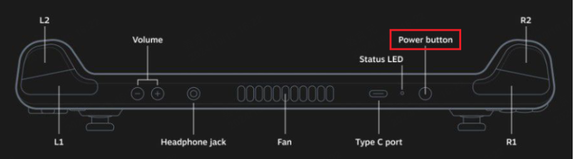

Controller power button
Select "FF Futurist" in the robot type selection interface, enter the "FF Futurist" boot wizard, and gradually complete the robot boot operation according to the prompts of the boot wizard.
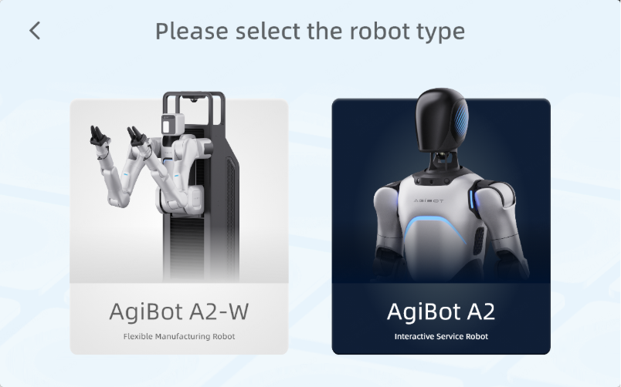

Startup wizard
Step 2: Lift the robot
Before starting the robot, it needs to be lifted. The robot is connected to the hook on the top of the electric shifter through the lifting ring and cable on the shoulder. Manually operate the electric shifter to lift the robot to the position shown in the figure, ensuring that the robot's feet are completely off the ground .
Note:
- The lifting rings installed on the robot's shoulders must be securely fastened to prevent the robot from falling due to loosening of the rings.
- Both shoulder lifting rings must be connected before lifting the robot to prevent swaying during hoisting operations.
- During the process of moving and lifting robots, please be careful not to squeeze or hit dexterous hands.
- The lifting bracket is only for lifting the FF Futurist robot and cannot be used for other purposes.
- The lifting capacity is designed solely for hoisting the robot; do not use it for other purposes to avoid hazards.
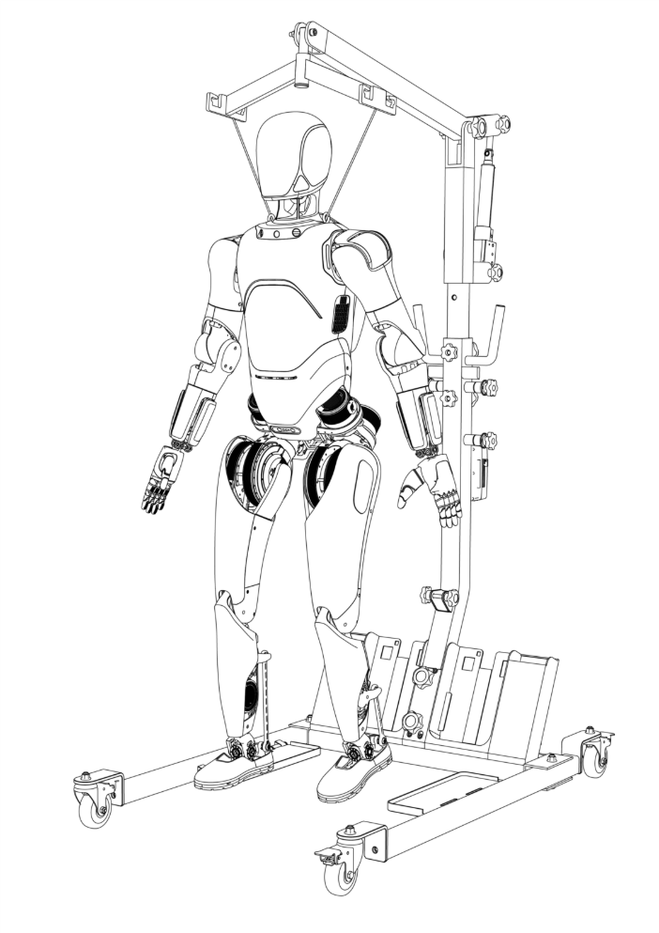

Lift the robot
After lifting the robot, click "Next" on the FF Robotics App interface.
Step 3: Install the battery and turn on the robot
The battery of the robot is installed on the back of the robot. Confirm that the battery is fully charged and slide the battery from top to bottom into the battery slot on the back of the robot for installation. When the battery slides to the bottom, a "click" sound will be heard to indicate that the battery is installed in place.
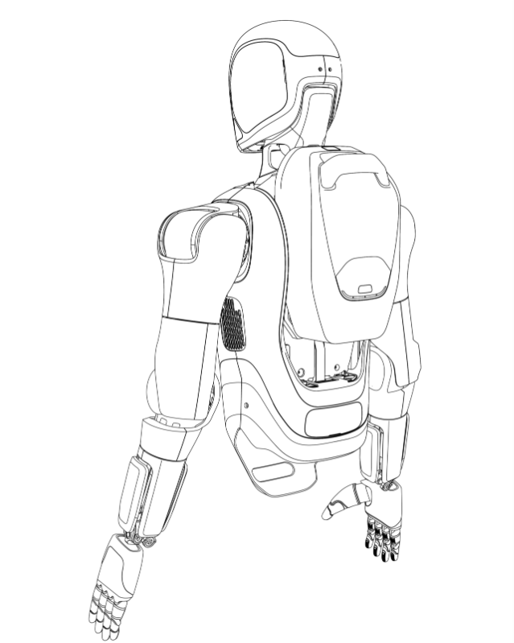

Install the battery
Press the power button on the back of the robot waist to turn it on. When the robot power is connected, the power button will light up.
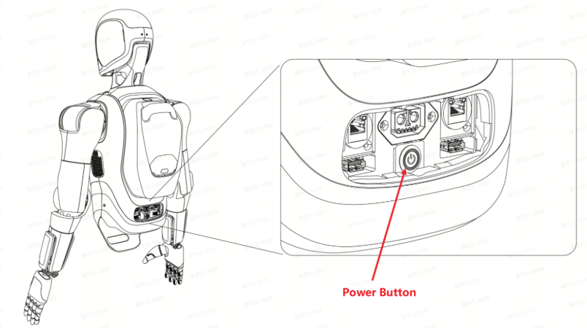

Power button
After the robot is turned on, click "Next" on the FF Robotics App interface.
Step 4: Wireless emergency stop
Upon receiving the emergency stop remote control, it defaults to the released state, with the motor powered and operating normally.
In case of a machine abnormality, pressing the remote's button immediately cuts off the motor's power, halting the machine for safety. After resolving the issue, rotating the button back to the released state restores power to the motor, allowing it to resume operation.
Note：
- The emergency stop remote is pre-paired at the factory and ready to use out of the box. It defaults to the released state, allowing the motor to receive power.
- The remote features a dual-channel design, typically using channel 1 to control the motor's power on and off. If channel 1 fails, it automatically switches to channel 2, which can only cut power, not restore it.
- When the emergency stop remote control is beyond the 10-meter operating range, the emergency stop function may fail, and the machine may not receive the emergency stop signal, potentially resulting in an inability to power off during abnormal conditions. Ensure the emergency stop remote control is operated within the normal range (within 10 meters) to guarantee safety.
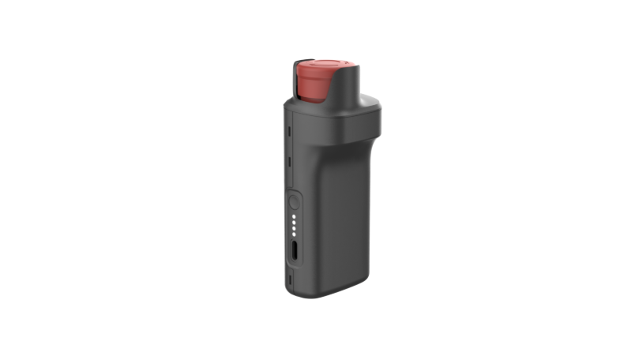

During the robot joint self-inspection process, the robot's neck will rotate in a small area, and the wrists and fingers will swing to zero. After zero correction is completed, the robot's wrists will return to a vertical state and make fists with both hands.
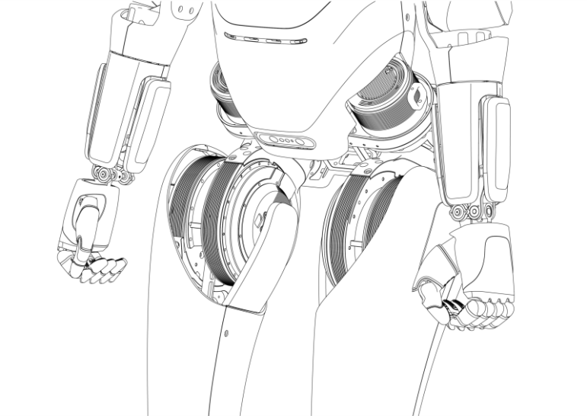

Self-inspection complete
After the robot joint self-inspection is completed, click "Next" on the FF Robotics App interface.
Step 5: Connect the robot
Click the "One-click Connect to Robot" button to establish a connection between the wireless controller and the robot. Before Use: For enhanced security, we recommend changing the default password (02270227) upon first use to prevent unauthorized device connections.
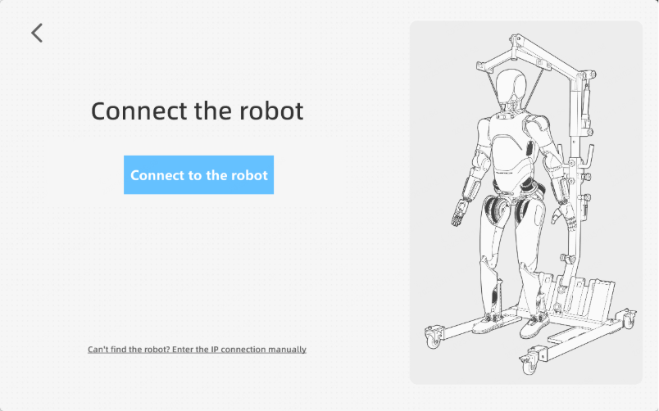

Connect to the robot
After the robot is successfully connected, the FF Robotics App interface will display the words "Connection Successful", click "Next".
Step 6: Switch standing posture
Before the robot stands, it needs to be switched to the ready standing posture in the suspended state. Click the "Switch Standing Posture" button, and the robot will automatically adjust the position of the head, arms, and legs to the ready standing posture.
Preparing to stand, the robot bends its arms slightly, wrists parallel to the forearms, legs slightly bent, and soles roughly parallel to the ground.
Note:
During the process of switching positions, the robot joints will move. Please stay away from the robot and ensure that there is sufficient space around the robot.
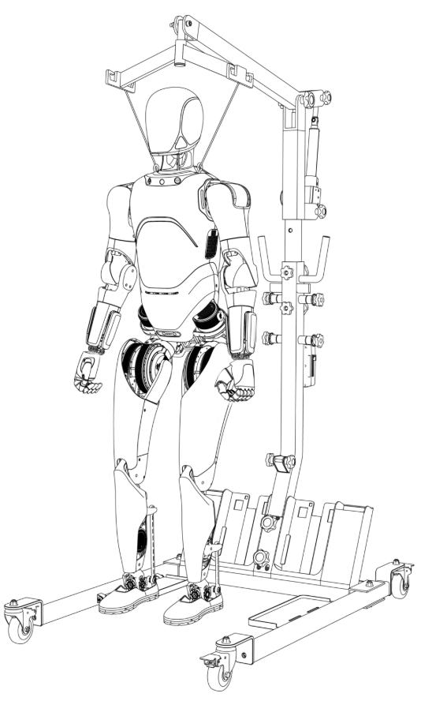

Preparing to stand
After completing the standing posture switch, click "Next" on the FF Robotics App interface.
Step 7: Lower the robot
Control the electric shifter to lower the robot until the robot's feet fully touch the ground, the suspension rope is completely relaxed, and there is some margin.
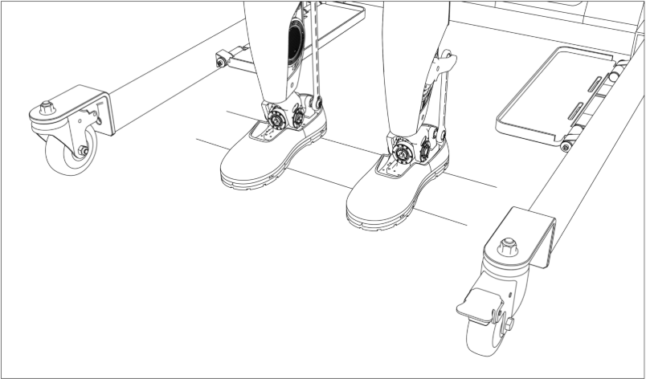

Robot's feet fully touch the ground
After completing the robot lowering operation, click "Next" on the FF Robotics App interface.
Step 8: Switch to Standing Mode
Click the "Enable Standing Mode" button and the robot will enter standing mode. When you see the words "Standing Successful!", it means that the robot has completed standing. At this time, you can remove the hanging rope from the robot's shoulder, and the robot will maintain autonomous balance standing.
Note:
Before switching to standing mode, make sure the robot has descended to the ground and its feet are fully in contact with the ground.
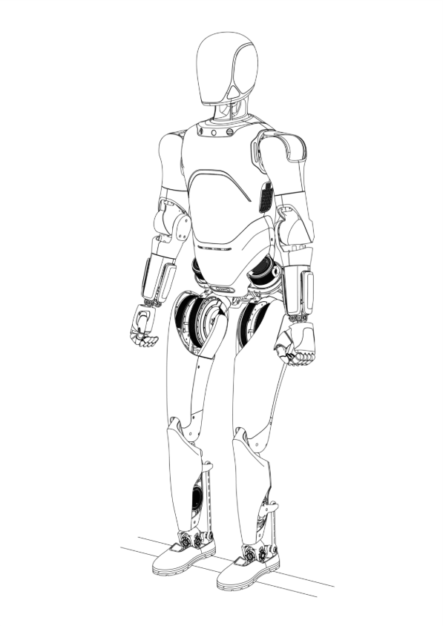

Self-standing
Click "Finish" to exit the Foot Boot Wizard, and FF Robotics App will enter the Workplace page.

II. Shutdown
Step 1: Safely stop the robot
Click the red "Stop" button at the bottom of the FF Robotics App sidebar to safely stop the robot, and the robot will enter the joint-freeze state.
Step 2: Lift the robot
Install a lifting ring on the robot's shoulder and lift the robot using an electric shifter until the robot's feet are completely off the ground.
Step 3: Shut down
Press the power button in the maintenance compartment at the back of the robot waist to power off the robot and turn off the robot.

III. Motion control

III.I Preparation for walking
Before remotely controlling the "FF Futurist" robot to walk, it is necessary to ensure that the robot has completed standing. The robot standing process can refer to Chapter 2.1.
After the robot stands up, click the "Time and Battery Area" in the upper right corner of the FF Robotics App main interface to bring up the Toolbox panel and view the corresponding RC_Actions bar.
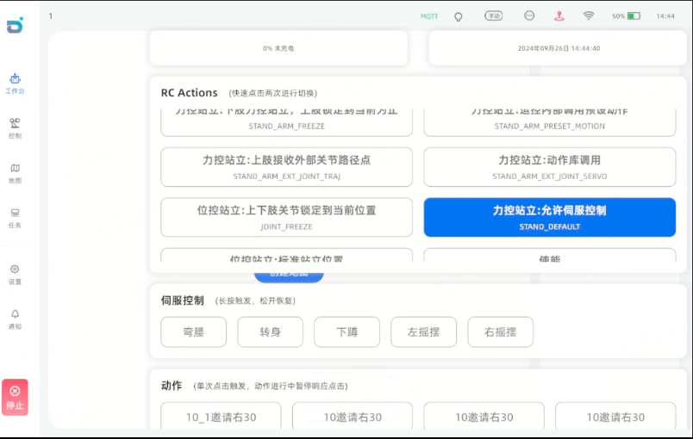

RC_Action
Double-click to switch to "walking" mode, and the robot starts to move in place.
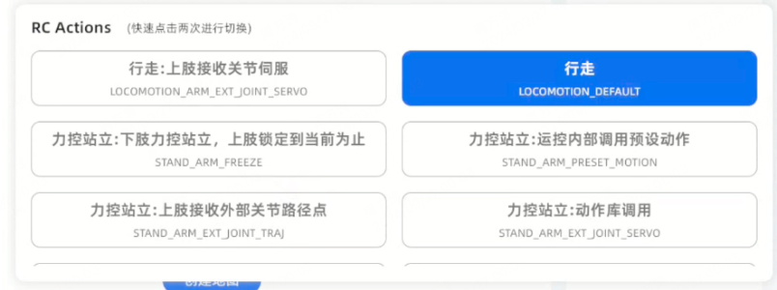

Switch to "walking" mode

III.II Remote walking
Click the "Control" button on the software sidebar to enter the "Remote Walking" page.
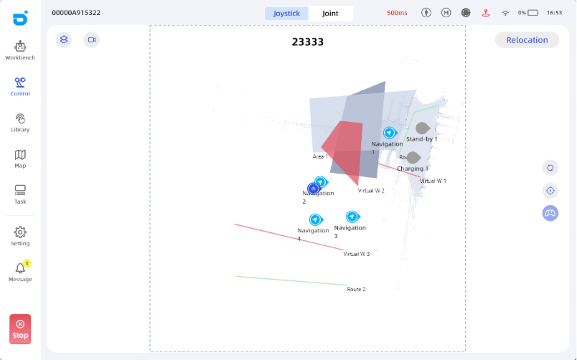

Remote walking
Press and hold the Options button in the upper right corner of the controller for 3 seconds to activate the remote control mode. After the controller remote control mode is activated, you can use the physical buttons of the controller to remotely control the robot.
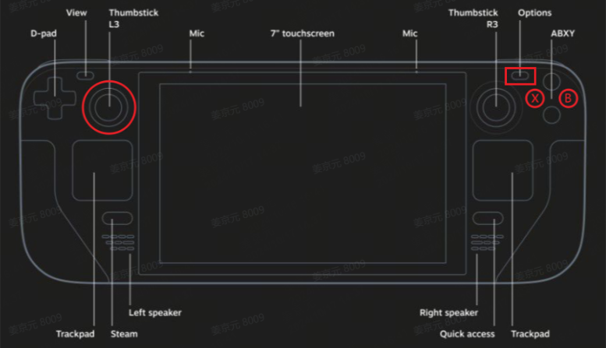

Controller buttons
Controller button function description:
- On the left joystick: walk forward
- Left joystick down: backwards
- Left joystick left: move horizontally to the left
- Left joystick right: move horizontally to the right
- Left joystick oblique: oblique shift
- X "key: Turn left in place
- B "key: Turn right in place
- [Key combination] Left joystick + X/B keys: turn and walk

III.III Action display
Double-click the robot status in the RC_Actions bar to switch to "Force Control Standing: Action Library Call".
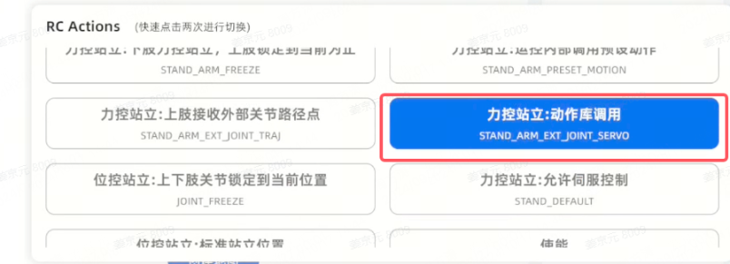

Action Library Call
Click "Interaction" in the sidebar to switch to the interaction page. Click "Action List" at the top of the screen to enter the action list page. Swipe up and down to view the preset robot actions on the machine, click the play button in the upper left corner of the card to play the action, and the robot will start performing the action.
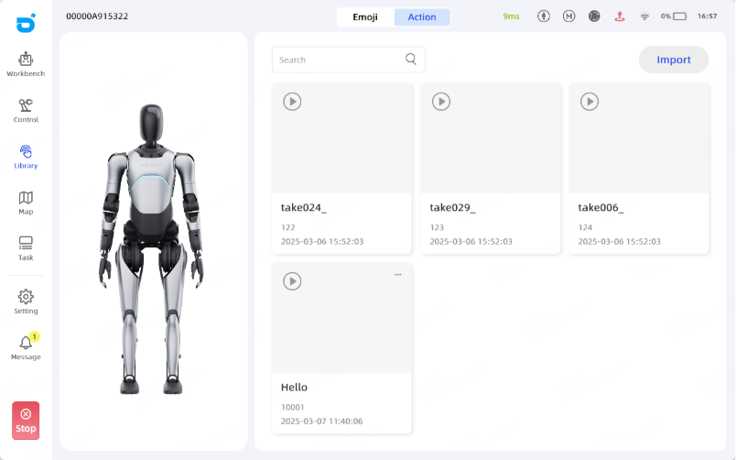

Action List

IV. Charging & battery swapping

IV.1 Charging
Step 1: Turn off the machine
Turn off the robot by pressing the power button in the maintenance compartment on the back side of the robot's waist to de-energize the robot.
Step 2: Machine in hoisting-ready mode
Before powering up the robot, you need to switch the robot to hoisting-ready mode.
Step 3: Open the maintenance compartment
Open the maintenance compartment cover behind the robot.
Step 4: Connect the charger
The charging port is located below the rear cover of the robot body waist. Connect the charging head of the power adapter to the charging port.
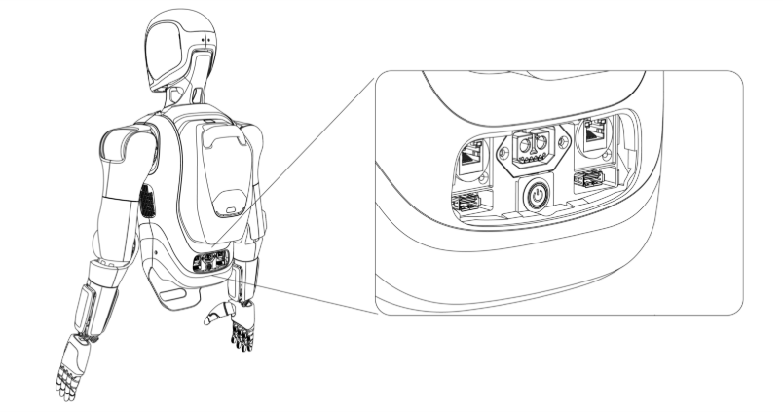

Charging port

IV.2 Battery swapping:
Step 1: Shut down
Refer to the shutdown process in 2.3.
Step 2: Machine in hoisting-ready mode
Before powering up the robot, you need to switch the robot to hoisting-ready mode.
Step 3: Remove the battery
Press the square mechanical button on the top of the battery to unlock, and lift the battery up to remove it.
Step 4: Install the battery
Refer to step 3.1 for battery installation process
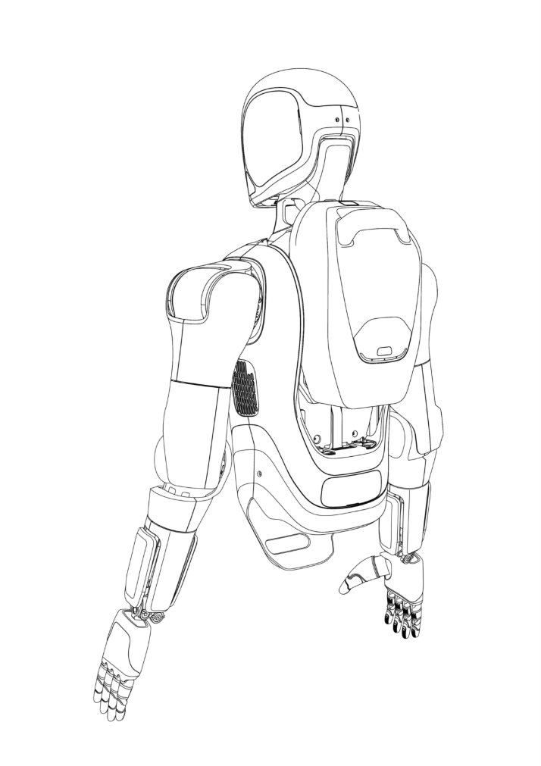

Remove battrey
Note:
Always maintain robot operation within the operator's direct line of sight.

4. Maintenance and Suggestion
The operator needs to carry out simple maintenance before and after use of the robot every time, periodically carry out the necessary inspection of the robot.

4.1 Routine Maintenance
We need to carry out necessary maintenance of the robot in order to increase the life of the robot, so that the robot is in good condition for a long time and creates more value for customers.
- Before maintenance, the power must be turned off to prevent accidental electric shock or parts damage.
- The machine should be placed in a dry and ventilated place to prevent humid environment from affecting electronic and electrical components and shortening their lifespan.

4.2 Battery Maintenance
- The battery is not allowed to be disassembled or replaced without permission in order to avoid unnecessary loss.
- Keep batteries away from heat sources, high pressure places, and prolonged sunlight exposure.
- Do not put the battery in water or fire.
- Short-circuiting the positive and negative battery terminals with metal is prohibited.
- Avoid excessive physical shock and impact on the battery. Do not hit, drop, or step on the battery.
- Without the permission and guidance of the manufacturer, it is strictly prohibited to disassemble or assemble the battery.
- Do not mix batteries of different manufacturers, types and models.
- Do not use or store in a high temperature (> 36℃) environment, otherwise it will cause heat, fire or reduce the service life of the battery.
- Do not use it in a low temperature (< -10℃) environment, otherwise it will cause machine malfunction and reduce battery life.
- Normally, the battery needs to be fully charged every 20 charges.
- If the machine is stored for more than 2 months, please keep the battery at least 60% and charge the battery every 60 days.
- WARNING: when charging the battery, only use the UY600L-W546080 provided with this appliance.
- Please stop using the battery when it has abnormal odor, discoloration, noise, leakage, serious deformation, etc. Please contact qualified after-sales service personnel for further handling.
- If the electrolyte leaks into the skin or eyes, rinse with water and seek medical attention immediately.
- Keep batteries out of reach of pets and children.
- When loading and unloading batteries during transportation, please be careful not to drop them. Do not stack more than 3 layers or turn them over. Please ensure the front side is up.
- Do not use a battery pack or appliance that is damaged or batteries may exhibit unpredictable behaviour resulting in fire explosion or risk of injury.

5. Product Specifications

5.1 Product Composition
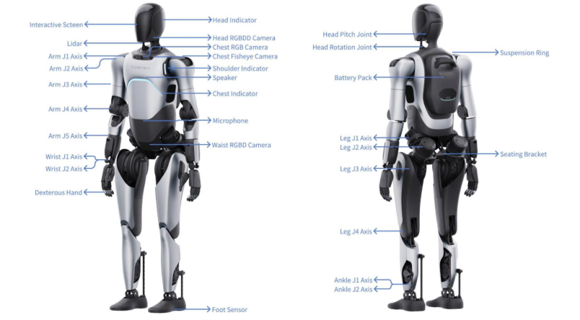

5.2 Basic Parameters

The machine includes WIFI, 4G, Bluetooth, hotspot and Lora wireless modules. The machine communicates with the outside world through the above-mentioned wireless modules.
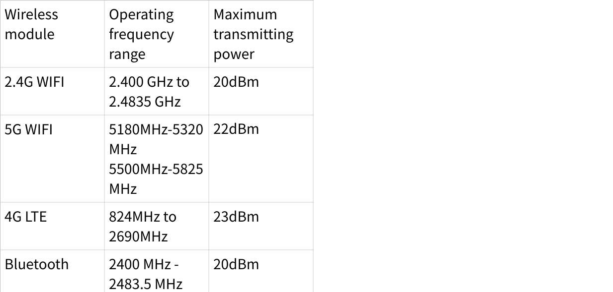
点击图片可查看完整电子表格

Radiation Exposure Statement:
This equipment complies with radiation exposure limits set forth for an uncontrolled environment.
This equipment should be installed and operated with a minimum distance of 20 cm between the radiator and your body.

Note:
The WLAN function for this device is restricted to indoor or vehicle use only in the 5.15 to 5.230 GHz frequency range.
According to 10(10) of Directive 2014/53/EU, the packaging shows that this radio equipment will be subject to some restrictions when placed on the market in Belgium (BE), Bulgaria (BG), Czech Republic (CZ), Denmark (DK), Germany (DE), Estonia (EE), Ireland (IE), Greece (EL), Spain (ES), France (FR), Croatia (HR), Italy (IT), Cyprus (CY), Latvia (LV), Lithuania (LT), Luxembourg (LU), Hungary (HU), Malta (MT), Netherlands (NL), Austria (AT), Poland (PL), Portugal (PT), Romania (RO), Slovenia (SI), Slovakia (SK), Finland (FI), Sweden (SE), Norway (NO), the United Kingdom in respect of Northern Ireland (UK(NI)) ,Iceland (IS), Liechtenstein (LI), Switzerland (CH) and Turkiye (TR).

5.3 Workspace

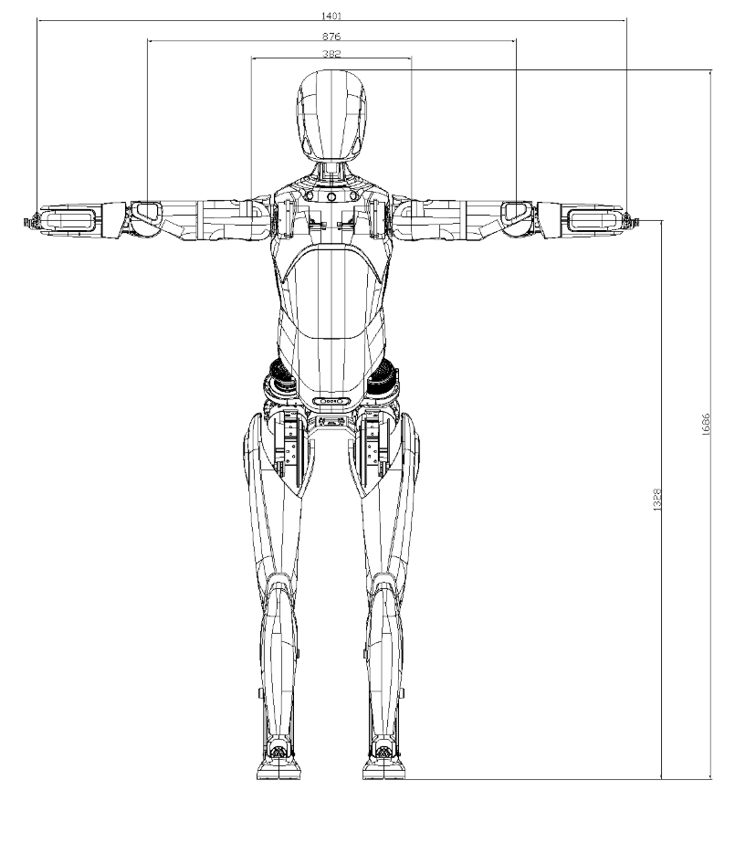

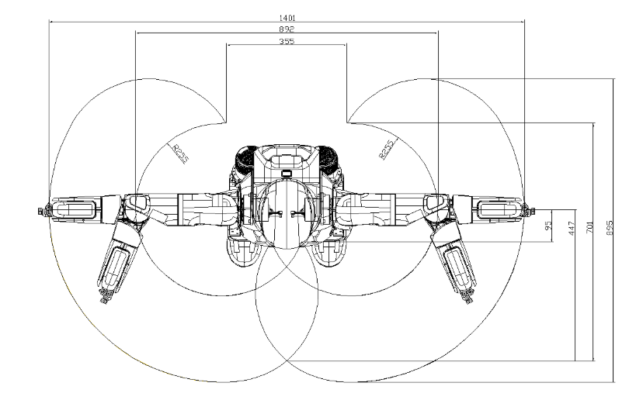

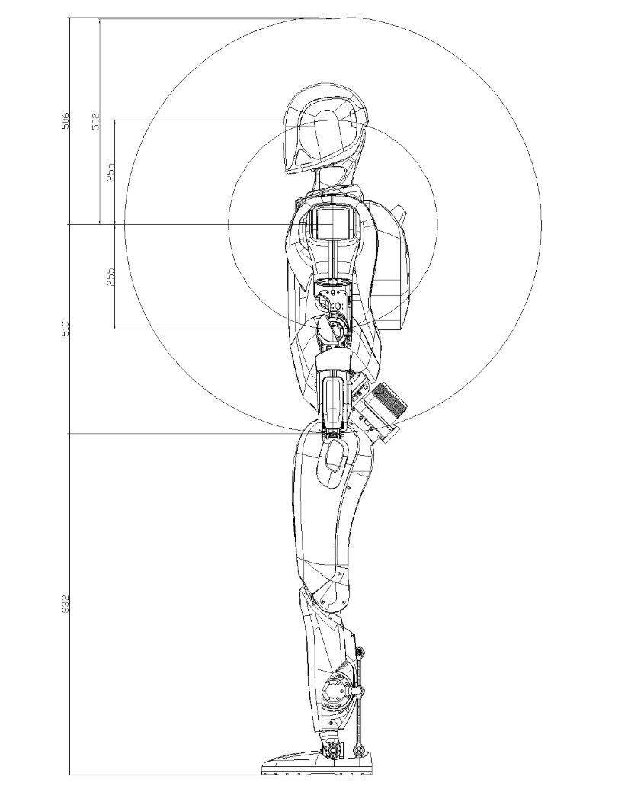

6. Product label description
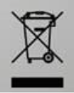

The symbol with the crossed-out wheeled bin means that electrical and electronic equipment must not be disposed of with household waste. Consumers are legally obliged to collect electrical and electronic equipment separately from unsorted municipal waste at the end of their useful life. In this way, an environmentally friendly and resource-saving recycling is ensured. Batteries and accumulators that are not firmly enclosed by the electrical or electronic device and can be removed without being destroyed must be separated from the device before it is handed over to a collection point and taken to a designated disposal facility. The same applies to lamps that can be removed from the device without destroying them. Owners of electrical and electronic devices from private households can hand them in at the collection points of the public waste disposal authorities or at the collection points set up by the manufacturers or distributors. The disposal of old devices is free of charge. Dealers with a sales area of at least 400m² are obliged to take back electrical and electronic equipment. The same applies to grocers with a total sales area of at least 800 m², provided they offer electrical and electronic equipment permanently or at least several times a year. Distance sellers with a storage area of at least 400 m² for electrical and electronic equipment or a total storage area of at least 800 m² are also obliged to take them back. In general, distributors are obliged to ensure that old devices are taken back free of charge by providing suitable return options within a reasonable distance. Consumers have the option of handing in an old device free of charge to a distributor who is obliged to take it back if they purchase a new device of the same value with essentially the same function. This possibility also exists for deliveries to a private household. In distance selling, the possibility of free collection when purchasing a new device is limited to heat exchangers, display devices and large devices that have at least one outer edge with a length of more than 50 cm. The distributor must ask the consumer when concluding the purchase contract whether they intend to return the goods. Apart from that, consumers can hand in up to three old devices of a device type to a distributor's collection point free of charge, without this being linked to the purchase of a new device. However, the edge lengths of the respective devices must not exceed 25 cm.


The CE mark indicates that the product meets the requirements of the European Union's health, safety and environmental protection regulations and can be sold and distributed within the member states of the European Union.
Disclaimer: this product complies with relevant CE marking directives, including:
Directive 2006/42/EC - Machinery directive(MD).
Directive 2014/53/EU - Radio equipment directive(RED).
Directive 2011/65/EU - Restriction on the use of certain hazardous substances in electrical and electronic equipment(RoHS) Annex II and its amendment.



This equipment has been tested and found to comply with the limits for a Class B digital device, pursuant to part 15 of the FCC Rules. These limits are designed to provide reasonable protection against harmful interference in a residential installation. This equipment generates, uses and can radiate radio frequency energy and, if not installed and used in accordance with the instructions, may cause harmful interference to radio communications. However, there is no guarantee that interference will not occur in a particular installation. If this equipment does cause harmful interference to radio or television reception, which can be determined by turning the equipment off and on, the user is encouraged to try to correct the interference by one or more of the following measures:
- Reorient or relocate the receiving antenna.
- Increase the separation between the equipment and receiver.
- Connect the equipment into an outlet on a circuit different from that to which the receiver is connected.
- Consult the dealer or an experienced radio/TV technician for help.
Note:
This device complies with part 15 of the FCC Rules. Operation is subject to the following two conditions:
(1) This device may not cause harmful interference, and
(2) this device must accept any interference received, including interference that may cause undesired operation.



Before using FF Futurist, please read the product manual carefully to avoid insufficient knowledge to operate this product and other potential risks.

SAVE THESE INSTRUCTIONS.

7.Specifications
2.4GHz Wi-Fi: 20dBm (EIRP)
Bluetooth: 20dBm (EIRP)
5GHz Wi-Fi:
5150-5250MHz: 23dBm (EIRP)
5725-5850MHz: 14dBm (EIRP)
SRD(868-868.6MHz, 863-865 MHz, 865.0-868.0 MHz): 14dBm (ERP)
GNSS Receiver: 1559-1610 MHz, 1164 -1215 MHz
Wi-Fi 5150-5250MHz frequency range is limited to indoor use in all EU/EFTA member states and Turkey.
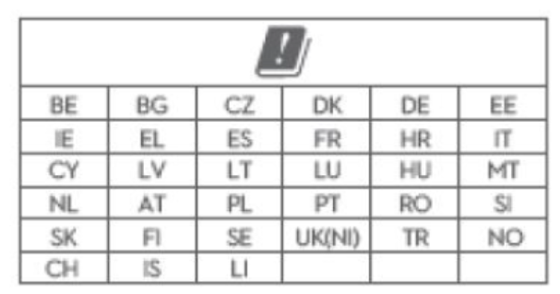

Cellular bands:
LTE Band 1: Uplink: 1920-1980MHz, Downlink: 2110-2170MHz
LTE Band 3: Uplink: 1710-1785MHz, Downlink: 1805-1880MHz
LTE Band 7: Uplink: 2500-2570MHz, Downlink: 2620-2690MHz
LTE Band 8: Uplink: 880-915MHz, Downlink: 925-960MHz
LTE Band 20: Uplink: 832-862MHz, Downlink: 791-821MHz
LTE Band 28: Uplink: 703-748 MHz, Downlink: 758-803MHz
LTE Band 34: Uplink & Downlink : 2010-2025MHz
LTE Band 38: Uplink & Downlink : 2570-2620MHz
LTE Band 40: Uplink & Downlink : 2300-2400MHz
LTE Band 42: Uplink & Downlink : 3400-3600MHz
5G NR:
NR n1: Uplink 1920-1980MHz, Downlink 2110-2170MHz
NR n3: Uplink 1710-1785MHz, Downlink 1805-1880MHz
NR n7: Uplink 2500-2570 MHz, Downlink 2620-2690 MHz
NR n8: Uplink 880-915 MHz,925-960 MHz Downlink
NR n20: Uplink 832-862 MHz,791-821 MHz Downlink
NR n28: Uplink 703-748 MHz,758-803 MHz Downlink
NR n38: Uplink & Downlink: 2570-2620MHz
NR n40: Uplink & Downlink: 2300-2400MHz
NR n41: Uplink & Downlink: 2496-2690MHz
NR n77: Uplink & Downlink: 3300-4200 MHz
NR n78: Uplink & Downlink: 3300-3800 MHz
LTE bands: 23dBm+2.0dB/-2.0dB (Power class 3, LTE band 1/3/7/8/20/28/34/38/40/42)
5G NR:23dBm +2.0dB/-2.0dB (Power class 3, NR band n1/3/7/8/20/28/38/40)
26dBm +3dB/-4dB (Power class 2, NR band n41/77/78)

RF exposure:
The equipment complies with radiation exposure limits set for an uncontrolled
environment. To avoid the possibility of exceeding radio frequency exposure
limits, human proximity to the antenna shall not be less than 20 cm during normal
operation. This transmitter must not be co-located or operated in conjunction with any
other antenna or transmitter.

