Overview

Master Mini is a humanoid robot development platform for competitions, education, entertainment, and related scenarios. It is affordable, lightweight, and durable.

1.1 Product Composition
The MASTER MINI robot consists of the head, torso, arms, and legs. It has 22 degrees of freedom across the whole body, enabling flexible motion and posture control.
- The head has 2 degrees of freedom, including the head yaw joint and head pitch joint. The depth camera and microphone array are located in the head.
- Each arm has 4 degrees of freedom, including the shoulder pitch joint, shoulder roll joint, shoulder yaw joint, and elbow joint.
- Each leg has 6 degrees of freedom, including the hip pitch joint, hip roll joint, hip yaw joint, knee joint, upper ankle joint, and lower ankle joint.
- The torso contains the controller, speaker, and battery.
See details in Specifications

1.2 What Can It Do?
Motion Capabilities. MASTER MINI supports omnidirectional walking and compound gaits, including forward/backward, lateral, and rotational movement. It can walk on uneven ground, has strong disturbance resistance, and actively recovers balance when subjected to a certain external force.
Built-in Agents. MASTER MINI includes 6 official Agents, which work like ready-to-use "apps" covering entertainment, conversation, teaching, competition, and other scenarios. Developers can also create their own Agents and share them with other users.
Agent | Scenario | Core Capability
Master Mini | Getting Started | A general-purpose basic Agent that supports daily actions such as waving, handshaking, and bowing with folded hands. It can also perform several fun dances for everyday interaction scenarios.
Soccer | Football Competition | Designed for soccer scenarios. It can autonomously track, chase, kick, and shoot the ball, and can accurately reproduce signature celebration moves from soccer stars such as Cristiano Ronaldo and Messi.
Hi Chat | Voice Interaction | An intelligent conversational Agent that can switch flexibly among fun personas such as a cute child, tutor, or pet, meeting needs for casual chat and entertaining companionship.  See details in Voice Interaction
Teach | Teaching | A hands-on learning Agent. Users physically guide the robot through a motion, and the device quickly recognizes and accurately reproduces it, making custom actions easy to create.
Dance | Entertainment | Specialized in a wide range of Chinese and Western dances, including folk, trendy, and classic dance moves, while also mastering advanced actions such as roundhouse kicks.
Lion Dance | Festival Performance | Focused on traditional folk performance, skillfully performing authentic Southern-style lion dance and showcasing the charm of traditional Chinese culture.
Safety Protection. When the robot enters an uncontrollable state, it automatically switches to DAMP mode to prevent damage. In dangerous situations, the joystick, App, and back-panel buttons can all trigger a soft emergency stop.

2. Specifications

2.1 Product Specifications
Type | Specification Parameters | Master Mini | Master Mini Pro | Master Mini Ultra
Basic Parameters | Height (when standing upright) | 0.95m | 0.95m | 0.95m
Basic Parameters | Weight | About 19.5kg | About 19.5kg | About 19.5kg
DoFs | Total DoFs | 22 | 22 | 22
DoFs | Single Leg DoFs | 6 | 6 | 6
DoFs | Single Arm DoFs | 4 | 4 | 4
DoFs | Head DoFs | 2 | 2 | 2
Operational Parameters | Walking Speed | 1.1m/s | 1.1m/s | 1.1m/s
Operational Parameters | Turning Speed | 1.5rad/s | 1.5rad/s | 1.5rad/s
Battery Parameters | Battery Capacity | 2Ah | 5Ah | 5Ah
Battery Parameters | Battery Life | 20min（1.1m/s） | 1h10min（1.1m/s） | 1h10min（1.1m/s）
Battery Parameters | Charging Time | ≤2h | ≤2h | ≤2h
Battery Parameters | Cycle Life | ≥500 times | ≥500 times | ≥500 times
Computing Platform | Computing | 48 TOPS (Dense) AI performance | 117 TOPS AI performance | 200 TOPS AI performance
Sensors | Camera | Depth Camera | Depth Camera | Depth Camera
Sensors | Microphone | Microphone Array | Microphone Array | Microphone Array
Sensors | Speaker | 1 | 1 | 1
Interaction interface | Buttons | Power×1, Interaction*3 | Power×1, Interaction*3 | Power×1, Interaction*3
Interaction interface | Indicator Light | RGB LED*1 | RGB LED*1 | RGB LED*1
Safety Fuction | Auditory Alerts | Low Battery Alert, Joint Overheat Alert | Low Battery Alert, Joint Overheat Alert | Low Battery Alert, Joint Overheat Alert
Communication Methods | Wired connection | Gigabit Ethernet | Gigabit Ethernet | Gigabit Ethernet
Communication Methods | Wireless Connection | WIFI 6 | WIFI 6 | WIFI 6
Communication Methods | Bluetooth | Bluetooth 5.2 | Bluetooth 5.2 | Bluetooth 5.2
Communication Methods | Certification Standards | CE/FCC | CE/FCC | CE/FCC
Noise | Walking Noise | ≤70dB | ≤70dB | ≤70dB
Environmental Adaptability | Environmental Adaptability | -10℃~45℃ | -10℃~45℃ | -10℃~45℃
Environmental Adaptability | Operating Humidity | 5%~90%，without condensation | 5%~90%，without condensation | 5%~90%，without condensation

2. 2 Main Components

2.2.1 Joint Motors

2.2.1.1Joint IDs and Limits
Joint ID | Joint Name | Limit (Degrees)
Joint ID | Joint Name | Max | Min
0 | Head Yaw Joint | 59 | -59
1 | Head Pitch Joint | 49 | -19
2 | Left Shoulder Pitch Joint | 69 | -169
3 | Left Shoulder Roll Joint | 94 | -94
4 | Left Shoulder Yaw Joint | 109 | -109
5 | Left Elbow Joint | 39 | -129
6 | Right Shoulder Pitch Joint | 69 | -169
7 | Right Shoulder Roll Joint | 94 | -94
8 | Right Shoulder Yaw Joint | 109 | -109
9 | Right Elbow Joint | 129 | -39
10 | Left Hip Pitch Joint | 128 | -170
11 | Left Hip Roll Joint | 89 | -22
12 | Left Hip Yaw Joint | 59 | -59
13 | Left Knee Joint | 133 | 0
14 | Left Ankle Up Joint | 38 | -17
15 | Left Ankle Down Joint | 41 | -16
16 | Right Hip Pitch Joint | 128 | -170
17 | Right Hip Roll Joint | 22 | -89
18 | Right Hip Yaw Joint | 59 | -59
19 | Right Knee Joint | 133 | 0
20 | Right Ankle Up Joint | 38 | -17
21 | Right Ankle Down Joint | 41 | -16
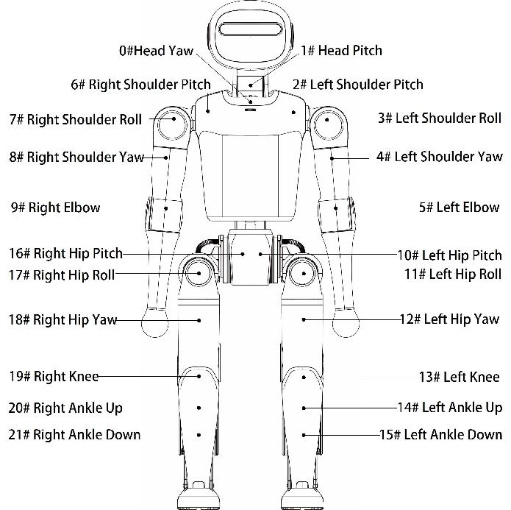

2.2.1.2 Coordinate Systems
When all joints are at zero degrees, the coordinate systems of the joints are shown below.
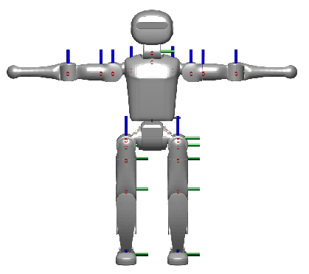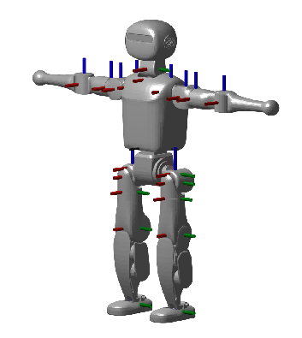

2.2.2 Controller
 | Master Mini | Master Mini Pro | Master Mini Ultra
Processor | High-performance ARM Processor | Jetson Orin NX 8GB | Jetson AGX Orin 32GB
Computing performance | 1×GoldP@3.2GHz  4×Gold@2.8GHz  3×Silver@2.0GHz  48 TOPS (Dense) | 6-core Cortex-A78AE CPU@2GHz  AI performance: 117 TOPS | 8-core Cortex-A78AE CPU@2.2GHz  AI performance: 200 TOPS
Memory | 8GB | 8GB | 32GB
Storage | 128GB | 512GB | 512GB
Wired Network | 1000M*1 | 1000M*1 | 1000M*1
Wireless Network | Wi-Fi 6*1 | WIFI6*1 | Wi-Fi 6*1
Audio | Microphone, speaker | Microphone, speaker | Microphone, speaker

Safety and Warnings
Whenever the robot moves, stands up, or performs actions, there is a risk of falling, collision, or personal injury. The following items are the most common real-world risk points. Read them before operating the robot for the first time.
❗Read Before Operation
- Before entering WALK mode, always enter PREP mode first and make sure the robot is standing securely on the ground.
- Do not lift the robot while it is moving.
- During motion, make sure there are no people or obstacles within the robot's operating range to avoid injury or collision.
- During motion, do not touch any part of the robot with your body except the handle.

3.1 Venue and Actions
Large full-body actions such as full-body dances should be performed on hard surfaces such as rubber, cement, or tile. Carpet has high resistance and can increase the risk of falling. Keep people away from the robot throughout the action. For detailed venue and environment requirements, see "Overview".

3.2 During Upgrade
When installing new software, the robot's motion-control program is stopped and the joints no longer output torque. Before upgrading, make sure the robot is well supported, for example lying flat on the ground, and then switch it to DAMP mode to prevent it from falling during the upgrade.

3.3 Additional Notes for Secondary Development
After entering CUSTOM mode, all joints, including the legs, are controlled by your code, and the robot can easily lose balance and fall. Use a hoist to protect the robot throughout the process, and validate algorithms in Webots / Isaac simulation before running them on the physical robot. Be especially careful with changes involving biped control. CUSTOM mode can only be entered from PREP mode or DAMP mode, and can only switch back to those two modes. For the full mode description, see "Modes"。

3.4 FCC Compliance Statement
Product Name: Master Mini
Model: Master Mini
This device complies with Part 15 of the FCC Rules. Operation is subject to the following two conditions:
- this device may not cause harmful interference, and
- this device must accept any interference received, including interference that may cause undesired operation.
Responsible Party: AlphaBeta Tech LLC
Address: 3080 OLCOTT ST UNIT B108 SANTA CLARA, CA 95054
Contact: alphabetallc@outlook.com

Modes
- The robot has multiple mode
- Different mode determines which action are available
- Different mode can switch between one another, but with certain constraints. For example, DAMP mode cannot switch directly to WALK mode; it must first enter PREP mode

4.1 State map
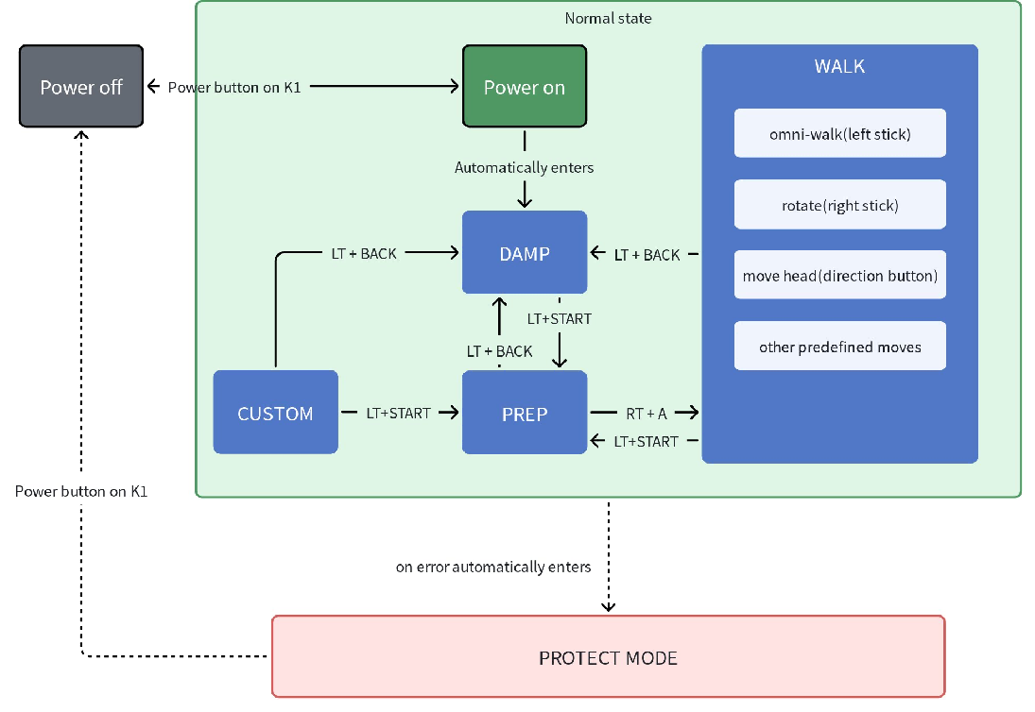

4.2 DAMP Mode (DAMP)
- The robot is powered on and the main controller is running normally.
- All joints enter a damped state. That is, when their positions are changed, there is resistance resistance; the joints do not actively change position and do not try to hold position.
- In DAMP mode, the robot cannot stand and needs effective support.
- DAMP mode is a safe mode and is less likely to cause accidental injury.
- DAMP mode can switch to PREP mode , but cannot switch directly to WALK mode

4.3 PREP Mode (PREP)
- The robot is powered on and the main controller is running normally.
- The robot enters and maintains a standing posture. That is, the robot assumes and holds a standing pose. If you try to change a joint position at this time, there is very strong resistance , and after displacement the joint will actively recover to return to the standing posture.
- In PREP mode, the robot can stand steadily and remain balanced on the ground. However, it cannot withstand large disturbances in this state because it only holds its posture and does not try to recover balance.
- PREP mode can switch to any other mode, including DAMP Mode、WALK mode

4.4 WALK Mode
- The robot is powered on and the main controller is running normally.
- The joints can execute corresponding preset action , including omnidirectional walking, turning, stepping, standing still, and head turning.
- Compared with PREP mode, WALK mode has stronger disturbance resistance and actively tries to recover balance after external forces within a certain range.
- WALK mode can switch to any other mode, including DAMP mode and PREP mode
- Before entering this mode, make sure the robot is already in PREP mode and standing on flat ground.

4.5 CUSTOM Mode
- The robot is powered on and the main controller is running normally.
- At this time, all robot joint control is fully handed over to user-defined joint commands, including both legs. Use caution in this mode to prevent the robot from losing balance and falling.
- CUSTOM mode can only be entered from PREP mode or DAMP mode.
- CUSTOM mode can only switch to DAMP mode or PREP mode.
💡During secondary development, especially in CUSTOM mode, it is recommended to use a hoist to protect the robot throughout the process.

4.6 PROTECT Mode
- The robot automatically enters PROTECT mode when runtime issues occur, such as exceeding limits or falling.
- In PROTECT mode, the joint state is the same as DAMP Mode the same.
- PROTECT mode is a safe mode and is less likely to cause accidental injury.

Body Operations
There are four buttons on the MASTER MINI back panel:
- Power button
  - Press and hold for 3 seconds to power on; press and hold again for 3 seconds to power off.
  - After powering off, wait 6 seconds before powering on again.
- WLAK： Tap to enter WALK mode.
💡 Make sure the robot has switched to PREP mode and is standing steadily on the ground before switching to WALK mode.
- STAND： Tap to enter PREP mode; the robot will fully straighten.
- F1： customized botton
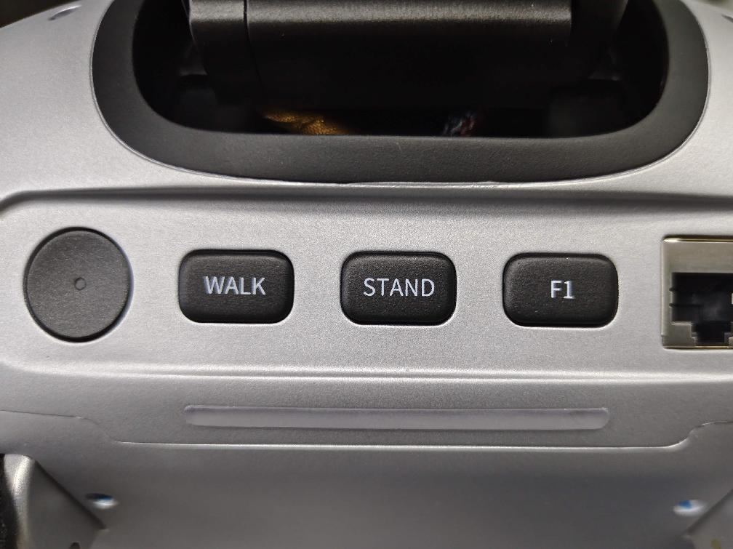

Joystick Control
💡 Note that joystick button mappings vary by software version. Please confirm the current robot software version in the "Check Version" section.

6.1Master Mini Joystick

6.1.1 Power on & off
- Power On: Press and hold the Home button for 5 seconds to power on. LED1, LED2, LED3 and LED4 all light up instantly upon startup. LED1 stays on steadily after boot completion.
- Power Off: Press and hold the Home button for 5 seconds to power off. LED1, LED2, LED3 and LED4 flash synchronously during shutdown. All indicator lights turn off after shutdown.

6.1.2 Charging
- Low battery: LED2 flashes as an alert.
- Charging in progress: LED2 keeps flashing.
- Fully charged: LED2 changes to steady on.

6.1.3 Basic Capabilities
Actions/Functions | Buttons | Prerequisites
Enter Master Mini Agent | L2 + R2 + A
Enter Soccer Agent | L2 + R2 + B
Enter Hi Chat Agent | L2 + R2 + X | This feature requires an internet connection
Enter Dance Agent | L2 + R2 + Y
Enter Lion Dance Agent | L2 + R2 + UP
Enter DAMP mode | L2 + Back
Enter PREP mode | L2 + Start
Enter WALK mode | R2 + A | Under PREP mode
locomotion control | Left stick | Under WALK mode
rotation control | Right stick | Under WALK mode
head rotation | Direction buttons | Under WALK mode

6.1.4 Agent Capabilities
Agent | Actions/Functions | Buttons | Prerequisites
Master Mini | Shake Hand | A | Under WALK mode
Master Mini | Wave | B | Under WALK mode
Master Mini | Ultraman | X | Under WALK mode
Master Mini | Respect | Y | Under WALK mode
Master Mini | Lucky Cat | R + A | Under WALK mode
Master Mini | Dabbing | R + B | Under WALK mode
Master Mini | Cheer | R + X | Under WALK mode
Master Mini | Carry | R + Y | Under WALK mode
Master Mini | CNY Dance | L + UP | Under WALK mode
Master Mini | Rock Dance | L + LEFT | Under WALK mode
Master Mini | Future Dance | L + RIGHT | Under WALK mode
Master Mini | Get Up | L2 + UP | Under DAMP/PREP mode
Soccer | Shake Hand | A | Under WALK mode
Soccer | Wave | B | Under WALK mode
Soccer | Get Up | L2 + UP | Under DAMP/PREP mode
Soccer | Track Ball | L2 + A | Under WALK mode
Soccer | Chase Ball | L2 + B | Under WALK mode
Soccer | Kick Ball | L2 + X | Under WALK mode
Soccer | Power Kick | L2 + Y | Under WALK mode
Soccer | Siuuu | L + Y | Under WALK mode
Soccer | Arms Crossed | L + B | Under WALK mode
Soccer | Point to Sky | L + UP | Under WALK mode
Soccer | Cradle Dance | L + DOWN | Under WALK mode
Dance | Rock Dance | L+A | Under WALK mode
Dance | CNY Dance | L+B | Under WALK mode
Dance | Future Dance | L+X | Under WALK mode
Dance | MJ Dance | L+Y | Under WALK mode
Dance | Arabic Dance | L+DOWN | Under WALK mode
Dance | Boxing Style Kick | L+LEFT | Under WALK mode
Dance | Roundhouse Kick | L+RIGHT | Under WALK mode
Dance | Mounts & Pals | L+R+A | Under WALK mode
Dance | Reform Breeze | L+R+B | Under WALK mode
Hi Chat | Default | L2+A | Under WALK mode
Hi Chat | XiaoBao | L2+B | Under WALK mode
Hi Chat | Gentle Ella | L2+X | Under WALK mode
Hi Chat | Grumpy Jax | L2+Y | Under WALK mode
Hi Chat | English Tutor | L2+UP | Under WALK mode
Hi Chat | Cute Pet | L2+DOWN | Under WALK mode
Hi Chat | Alien Weirdo | L2+LEFT | Under WALK mode
Hi Chat | Say Hello | R2 + Y | Enable chat
Lion Dance | Dance Prepare | L+A | Under DAMP/PREP mode
Lion Dance | Dance Walk | L+B | Under WALK mode
Lion Dance | Lion Dance 1 | L+X | Under WALK mode
Lion Dance | Lion Dance 2 | L+Y | Under WALK mode

6.1.5 Xbox Joystick
Use a standard Xbox joystick.Before use, confirm that the joystick control mode is receiver mode and that the operating mode shows three lights steadily on.

6.1.6 Basic Capabilities
Actions/Functions | Buttons | Prerequisites
Enter Master Mini Agent | LT + RT + A
Enter Soccer Agent | LT + RT + B
Enter Hi Chat Agent | LT + RT + X
Enter Dance Agent | LT + RT + Y
Enter Lion Dance Agent | LT + RT + UP
Enter DAMP mode | LT + Back
Enter PREP mode | LT + Start
Enter WALK mode | RT + A | Under PREP mode
locomotion control | Left stick | Under WALK mode
rotation control | Right stick | Under WALK mode
head rotation | Direction buttons | Under WALK mode

6.1.7 Agent Capabilities
Agent | Actions/Functions | Buttons | Prerequisites
Master Mini | Shake Hand | A | Under WALK mode
Master Mini | Wave | B | Under WALK mode
Master Mini | Ultraman | X | Under WALK mode
Master Mini | Respect | Y | Under WALK mode
Master Mini | Lucky Cat | RB + A | Under WALK mode
Master Mini | Dabbing | RB + B | Under WALK mode
Master Mini | Cheer | RB + X | Under WALK mode
Master Mini | Carry | RB + Y | Under WALK mode
Master Mini | CNY Dance | LB + UP | Under WALK mode
Master Mini | Rock Dance | LB + LEFT | Under WALK mode
Master Mini | Future Dance | LB + RIGHT | Under WALK mode
Master Mini | Get Up | LT + UP | Under DAMP/PREP mode
Soccer | Shake Hand | A | Under WALK mode
Soccer | Wave | B | Under WALK mode
Soccer | Get Up | LT + UP | Under DAMP/PREP mode
Soccer | Track Ball | LT + A | Under WALK mode
Soccer | Chase Ball | LT + B | Under WALK mode
Soccer | Kick Ball | LT + X | Under WALK mode
Soccer | Power Kick | LT + Y | Under WALK mode
Soccer | Siuuu | LB + Y | Under WALK mode
Soccer | Arms Crossed | LB + B | Under WALK mode
Soccer | Point to Sky | LB + UP | Under WALK mode
Soccer | Cradle Dance | LB + DOWN | Under WALK mode
Dance | Rock Dance | LB+A | Under WALK mode
Dance | CNY Dance | LB+B | Under WALK mode
Dance | Future Dance | LB+X | Under WALK mode
Dance | MJ Dance | LB+Y | Under WALK mode
Dance | Arabic Dance | LB+DOWN | Under WALK mode
Dance | Boxing Style Kick | LB+LEFT | Under WALK mode
Dance | Roundhouse Kick | LB+RIGHT | Under WALK mode
Dance | Mounts & Pals | LB+RB+A | Under WALK mode
Dance | Reform Breeze | LB+RB+B | Under WALK mode
Hi Chat | Default | LT+A | Under WALK mode
Hi Chat | XiaoBao | LT+B | Under WALK mode
Hi Chat | Gentle Ella | LT+X | Under WALK mode
Hi Chat | Grumpy Jax | LT+Y | Under WALK mode
Hi Chat | English Tutor | LT+UP | Under WALK mode
Hi Chat | Cute Pet | LT+DOWN | Under WALK mode
Hi Chat | Alien Weirdo | LT+LEFT | Under WALK mode
Hi Chat | Say Hello | RT + Y | Enable chat
Lion Dance | Dance Prepare | LB+A | Under DAMP/PREP mode
Lion Dance | Dance Walk | LB+B | Under WALK mode
Lion Dance | Lion Dance 1 | LB+X | Under WALK mode
Lion Dance | Lion Dance 2 | LB+Y | Under WALK mode
Lion Dance | Lion Dance 3 | LB+UP | Under WALK mode

Connect to Robot

Use Agents

8.1 What Is an Agent?
An Agent is a "skill pack" installed in the robot's brain. It can also be understood as an application running on the robot. Like switching apps on a phone, switching Agents lets the robot enter the corresponding capability scenario and use different interaction methods and task capabilities.

8.2 How to Switch Agents
- Switch via the mobile App
  - Tap the Agent name in the top-left corner to switch to another Agent. Each Agent has different capabilities — for example, Soccer Master can play soccer with you, Hi Chat can talk with you using different personas, and Dance Master can perform a variety of dances from around the world.
- Switch via the Joystick
Switch Agents | Master Mini joystick buttons | Xbox joystick buttons
Enter Master Mini Agent | L2 + R2 + A | LT + RT + A
Enter Soccer Agent | L2 + R2 + B | LT + RT + B
Enter Hi Chat Agent | L2 + R2 + X | LT + RT + X
Enter Dance Agent | L2 + R2 + Y | LT + RT + Y
Enter Lion Dance Agent | L2 + R2 + UP | LT + RT + UP

8.3 Official Agents
Master Mini includes 6 official Agents covering entertainment, conversation, teaching, competition, and other scenarios.

8.3.1 Master Mini
A general-purpose basic Agent that supports daily actions such as waving, handshaking, and bowing with folded hands. It can also perform several fun dances for everyday interaction scenarios.
Video1, local

Functions list
Functions | Master Mini joystick buttons | Xbox joystick buttons | Prerequisites
Shake Hand | A | A | Under WALK mode
Wave | B | B | Under WALK mode
Ultraman | X | X | Under WALK mode
Respect | Y | Y | Under WALK mode
Lucky Cat | R + A | RB + A | Under WALK mode
Dabbing | R + B | RB + B | Under WALK mode
Cheer | R + X | RB + X | Under WALK mode
Carry | R + Y | RB + Y | Under WALK mode
CNY Dance | L + UP | LB + UP | Under WALK mode
Rock Dance | L + LEFT | LB + LEFT | Under WALK mode
Future Dance | L + RIGHT | LB + RIGHT | Under WALK mode
Get Up | L2 + UP | LT + UP | Under DAMP/PREP mode

8.3.2 Soccer
Designed for soccer scenarios. It can autonomously track, chase, kick, and shoot the ball, and can accurately reproduce signature celebration moves from soccer stars such as Cristiano Ronaldo and Messi.
Video2, local
Functions list
Functions | Master Mini joystick buttons | Xbox joystick buttons | Prerequisites
Shake Hand | A | A | Under WALK mode
Wave | B | B | Under WALK mode
Get Up | L2 + UP | LT + UP | Under DAMP/PREP mode
Track Ball | L2 + A | LT + A | Under WALK mode
Chase Ball | L2 + B | LT + B | Under WALK mode
Kick Ball | L2 + X | LT + X | Under WALK mode
Power Kick | L2 + Y | LT + Y | Under WALK mode
Siuuu | L + Y | LB + Y | Under WALK mode
Arms Crossed | L + B | LB + B | Under WALK mode
Point to Sky | L + UP | LB + UP | Under WALK mode
Cradle Dance | L + DOWN | LB + DOWN | Under WALK mode

8.3.3 Hi Chat
An intelligent conversational Agent that can switch flexibly among fun personas such as a cute child, tutor, or pet, meeting needs for casual chat and entertaining companionship.
See details in Voice Interaction。
Video 3, local
Functions list
Functions | Master Mini joystick buttons | Xbox joystick buttons | Prerequisites
Default | L2 + A | LT + A | Under WALK mode
XiaoBao | L2 + B | LT + B | Under WALK mode
Gentle Ella | L2 + X | LT + X | Under WALK mode
Grumpy Jax | L2 + Y | LT + Y | Under WALK mode
English Tutor | L2 + UP | LT + UP | Under WALK mode
Cute Pet | L2 + DOWN | LT + DOWN | Under WALK mode
Alien Weirdo | L2 + LEFT | LT + LEFT | Under WALK mode
Say Hello | R2 + Y | RT + Y | Enable chat

8.3.4 Teach
A hands-on learning Agent. Users physically guide the robot through a motion, and the device quickly recognizes and accurately reproduces it, making custom actions easy to create.
Video 4, local

8.3.5 Dance
Specialized in a wide range of Chinese and Western dances, including folk, trendy, and classic dance moves, while also mastering advanced actions such as roundhouse kicks.
💡 Full-body dances require a dedicated venue. Rubber, cement, or tile floors are recommended; high-resistance surfaces such as carpet increase the risk of falling.
Video 5, local
Functions list
Functions | Master Mini joystick buttons | Xbox joystick buttons | Prerequisites
Rock Dance | L + A | LB + A | Under WALK mode
CNY Dance | L + B | LB + B | Under WALK mode
Future Dance | L + X | LB + X | Under WALK mode
MJ Dance | L + Y | LB + Y | Under WALK mode
Arabic Dance | L + DOWN | LB + DOWN | Under WALK mode
Boxing Style Kick | L + LEFT | LB + LEFT | Under WALK mode
Roundhouse Kick | L + RIGHT | LB + RIGHT | Under WALK mode
Mounts & Pals | L + R + A | LB + RB + A | Under WALK mode
Reform Breeze | L + R + B | LB + RB + B | Under WALK mode

8.3.6 Lion Dance
Focused on traditional folk performance, skillfully performing authentic Southern-style lion dance and showcasing the charm of traditional Chinese culture.
Functions list
Functions | Master Mini joystick buttons | Xbox joystick buttons | Prerequisites
Dance Prepare | L + A | LB + A | Under DAMP/PREP mode
Dance Walk | L + B | LB + B | Under WALK mode
Lion Dance 1 | L + X | LB + X | Under WALK mode
Lion Dance 2 | L + Y | LB + Y | Under WALK mode

Service Start/Stop

9.1 Use the App
- On the control page, tap "Settings" to enter the settings page.
- On the settings page, tap "Restart Robot" to restart the robot.

9.2 Use a Terminal
- Use another device toconnect to the robot through a terminal
- Run the following commands in any directory on the robot:
💡 Note: restarting the robot service fully restarts the robot firmware. Make sure the robot is properly supported on a stand or lying flat on the ground before doing this.

Charging

10.1 5Ah Battery Charging
- Insert the charging plug according to the indicated direction.
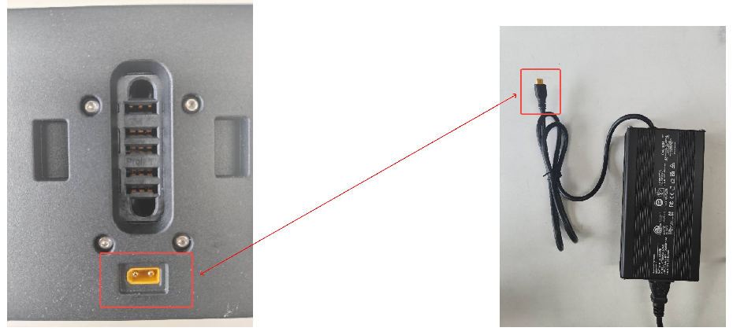
- The charging status is shown as follows: the green light indicates a full charge, and the red light indicates charging in progress.
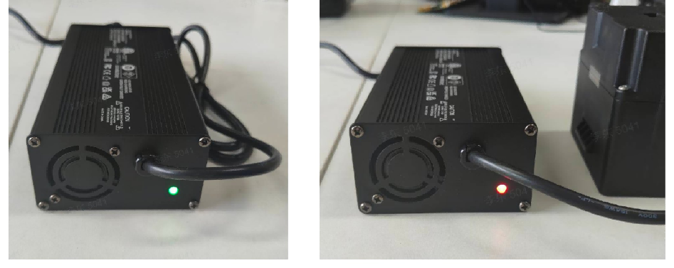

10.2 2Ah Battery Charging
- Insert the charging plug according to the indicated direction.
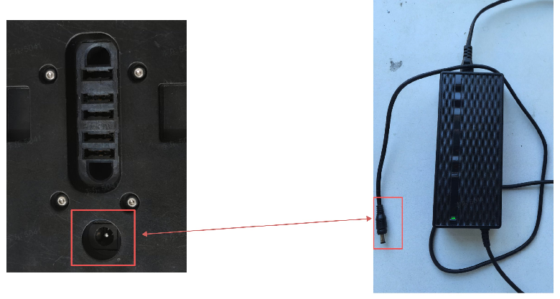
- The charging status is shown as follows: the green light indicates a full charge, and the red light indicates charging in progress.
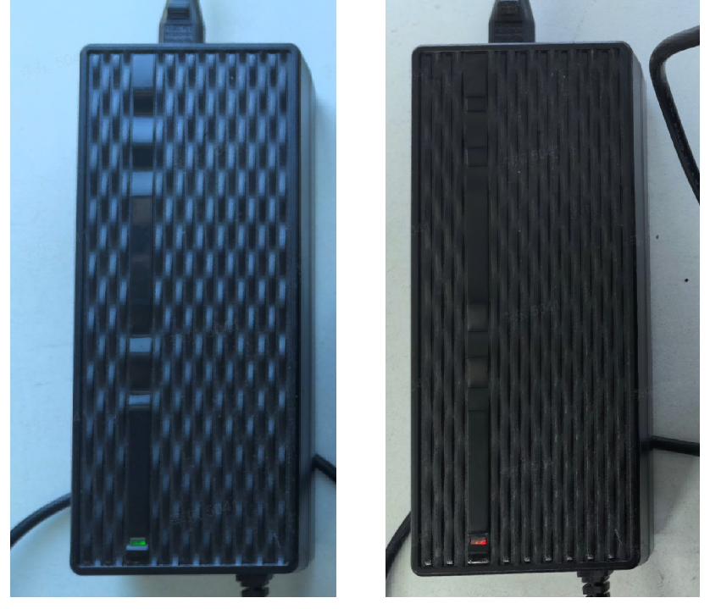

Voice Interaction

12.1 Introduction

12.1.1 Hi Chat Agent
For v1.3.1.1 and above, the Master Mini robot is equipped with AI real-time voice dialogue. This feature can be enabled or disabled via the “Hi Chat” Agent in the mobile app.

12.1.1.1 Usage Instructions
- Open the “Hi Chat” entry in the mobile app, tap and select a persona. When you hear a voice prompt similar to “Hello, I am the Master Mini robot. How can I assist you?”, the real-time voice dialogue function is activated, and you can start talking to the robot.
- Once real-time voice dialogue is enabled, the robot will automatically turn its head to face the nearest person in front of it.
- AI voice interaction requires an internet connection.

12.1.1.2 Voice Commands
Note: When using a custom persona, conflicting system prompts may cause voice commands to fail.
Master Mini robots currently support voice commands that make the robot perform corresponding actions. The large model may also autonomously trigger the following actions based on the current conversation context. The action set includes:
Action Category | Command Name | Trigger Condition
Basic Movement | Turn Left | Triggered when explicit commands such as "turn left" or "turn to the left" are received.
Basic Movement | Turn Right | Triggered when explicit commands such as "turn right" or "turn to the right" are received.
Basic Movement | Turn Left One Full Circle | Triggered when commands such as "turn left one full circle" or "turn counterclockwise one full circle" are received.
Basic Movement | Turn Right One Full Circle | Triggered when commands such as "turn right one full circle" or "turn clockwise one full circle" are received.
Basic Movement | Walk Forward | Triggered when commands such as "walk forward" or "go forward" are received.
Basic Movement | Walk Backward | Triggered when commands such as "walk backward" or "move back" are received.
Basic Movement | Move Left | Triggered when commands such as "move left" or "move to the left" are received.
Basic Movement | Move Right | Triggered when commands such as "move right" or "move to the right" are received.
Interaction Actions | Wave | Triggered when commands such as "wave" or "wave your hand" are received, or when expressing goodbye.
Interaction Actions | Handshake | Triggered when explicit social commands such as "shake hands" or "let's shake hands" are received.
Interaction Actions | Greet | Triggered only when the user explicitly greets the robot, such as "hello" or "Hi MASTER MINI"; the reply should include a greeting.
Interaction Actions | Nod | Triggered when the robot needs to express agreement or approval, such as responding to "the weather is nice today" or "did I do it right?"; the reply may use an affirmative tone.
Interaction Actions | Shake Head | Triggered when the user asks about unknown content, such as "what does this word mean?"; execute this action if the knowledge base has no answer.

13. Firmware Version

13.1 Check Version

13.1.1 Check via App
After connecting to the robot, tap "Settings - About" to view the robot's current version.

13.1.2 Check via Terminal
After connecting to the robot's board, run the following command to view the current system version of the robot.

13.2 Version Upgrade

13.2.1 Before Upgrading
❗ When installing a new version of software, the robot's motion control program will be stopped, and the robot's joints will not exert force. Before upgrading, ensure the robot is in damping mode or motion control is stopped and has good support (e.g., placing it flat on the ground or using a stand to support the robot). Do not cut off power or interrupt the process during the upgrade.
- Make sure the installation package matches the current MASTER MINI model and the target version.
- Make sure the robot's battery level, network, and terminal connection are stable.
- If you have modified any configuration files, back up important configurations and logs first.

13.2.2 Upgrade via App
In the robot settings, tap "Firmware Update".
- Before installing the firmware, make sure the robot has entered damping or ready mode, and the battery level is above 50%.

13.2.3 FAQ

13.2.3.1 Slow pip Downloads
The perception process depends on some Python libraries installed via pip. If downloads are slow, you can switch the pip download source and run the upgrade again.
sudo su
pip config set global.index-url https://pypi.mirrors.ustc.edu.cn/simple
./v1.1.1.0-release-aarch64.run

13.2.3.2 apt update Fails
If the upgrade log indicates that apt update failed, you can use the fishros tool to switch sources and try the upgrade again.
# Recommended: use fishros and select in order:
# [5] One-click source change
# [1] Change system source only
# [1] Add ROS/ROS2 source
wget http://fishros.com/install -O fishros && . fishros

Troubleshooting and Support

14.1 Restore Factory Settings
When MASTER MINI cannot return to a usable state due to configuration changes, software errors, or environment changes, you can restore factory settings to reinstall the factory software.

14.1.1 When to Use
- Abnormal behavior after modifying the robot's configuration, which cannot be recovered through normal configuration rollback.
- Technical support recommends reinstalling the factory software to rule out environment issues.
- You need to restore the robot to a software state close to its initial delivery.

14.1.2 Before You Begin
💡
Restoring factory settings may erase existing configurations and local changes. Before proceeding, back up important configurations, logs, and custom files, and make sure the robot is in a stable, well-supported state.
- Confirm that the current robot model and the recovery package are compatible with MASTER MINI.
- Make sure the power, network, and terminal connection are stable, and do not cut off power during the recovery process.
- If you are not sure whether a recovery is needed, contact technical support first.

14.1.3 Perform the Recovery
After logging in to the robot's board, navigate to the recovery directory and run the recovery program. The following command uses the installation package name in the current recovery directory; if there are multiple packages in the directory, use the file that matches your device version.

14.1.4 After the Recovery
- Wait for the recovery program to finish, and restart the robot as prompted.
- Confirm that the robot starts normally and that basic services and network connection are restored.
- Reconfigure the network, App, voice, or custom parameters that you want to keep.
- If the robot still behaves abnormally after recovery, record the symptoms and provide logs to technical support as described on the "Log Retrieval" page.

14.2 Log Retrieval
When MASTER MINI has issues, follow the steps on this page to retrieve logs and send them to technical support. Logs help locate when the issue occurred, the running state, and related error information.

14.2.1 Privacy and Purpose
Our company will, without violating any applicable laws and regulations or involving any personal privacy information, collect only data related to the operation of the robots for the purposes of fault detection, problem localization, and statistical analysis.

14.2.2 Upload Logs via App
- After connecting to the robot via the App, go to "Settings".
- Tap "Log Upload".
- Select the time range to upload, making sure it covers the time when the issue occurred.
- The upload takes about 5-10 minutes. During this process, keep the robot powered on and connected to the network. Both the App logs and the robot logs will be uploaded together.
- After the upload is complete, contact customer service to report the issue. Our technical staff will retrieve your uploaded log files through the management console.

14.2.3 Retrieve Logs via Terminal
Before you start, record the time the issue occurred, the symptoms, and the operation you were performing at the time as accurately as possible. The robot uses the UTC+8 time zone by default; if you are in a different time zone, convert the time before filling in the log time range.
- Log in to the robot via terminal.
- Confirm the time the issue occurred and prepare the start and end times for the logs. The time format is YYYYMMDD-HHMMSS.
- Run the log export command.
- Select a range that covers the time before and after the issue. For example, if the issue occurred around 20200808-120810, you can export logs about 10 seconds before and after:
- Send the log package to technical support, along with the symptoms, the time of occurrence, and the reproduction steps.

14.3 Remote Support

14.3.1 Introduction
When the robot has issues and you need remote assistance, follow these steps to get remote support from our staff.

14.3.2 Information to Send to Technical Support
- Device ID and one-time password.
- The robot's current status: whether it can power on, whether it can connect to the network, and its current mode.
- Symptoms: for example, unable to walk, abnormal App connection, upgrade failure, etc.
- The time the issue occurred and the operation you were performing at the time.
- Whether logs have been uploaded, or exported by yourself via terminal.

14.3.3 Remote Assistance Procedure
💡
You can choose from the following two remote assistance methods:
- Connect your personal computer to the robot via SSH; technical support can then connect to your computer via remote desktop and subsequently to the robot via SSH.
- Install remote desktop software on the robot; you can use a display and keyboard/mouse to open the remote desktop software, allowing support personnel to connect directly to the robot.

