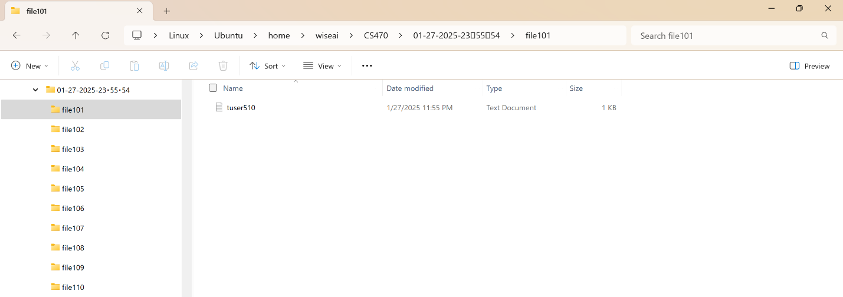

# Linux Command Explanations

Cp: cp will copy one file or directory into another one.

Example: cp file101 file110

This will make a copy of file101 in file110

Ps: ps will display information about the current running processes

Example: ps -a

This will show all information

Ls: ls will show all the file or subdirectories in the current directory

Example: ls

Mv: mv will move the current directory into another directory

Example: mv file101 file102

This will move everything in the directory file101 into file102. Can also be used to rename the directory.

Rm: rm is used to delete a directory

Example: rm -r file102

This will delete the directory file102 and all subdirectories under it.

Mkdir: mkdir is used to create a directory.

Example: mkdir file111

This will create a new directory named file111

Rmdir: rmdir is used to delete an empty directory

Example: rmdir file111

This will delete the empty directory called file111

Echo: echo is used to display a line of text

Example: echo “Hello world”

This will display the message “Hello world to the terminal”

Date: date is used to get the current date information

Example: $(date "+%m-%d-%Y-%H:%M:%S")

This will get the month-day-year-hour:minute:second

Kill: kill is used to terminate the current process

Example: pkill linux

This will end the current process

History: history is used to get a list of recent commands

Example: history 5

This will display the last 5 used commands

Chmod: changes the mode or permissions of a file for the user

Example: chmod +x create_files_with_subdirs.sh

This allows the file to be executed

Chown: chown changes the owner of the directory or file

Example: chown bwise file101

This cnages the owner of the file to the said user

# Script Execution

My script first gets the current date and time for the parent directory name. This inside a for loop, the parent directory is created and all subdirectories are created under the parent directory. Then i use an array to list the names of different programming languages. Then I write the name of each programming language to a tuser510.txt file in each subdirectory.

This script can be used to create a directory based on what I need. If I need multiple subdirectories then I can edit the number it makes. I could also edit it to make grandchild directories based on my needs. This makes it easier for me so that I don’t have to create a directory one by one, but rather create them all at once.