CS 543 MP3 Report

In this machine problem, an image-stitching algorithm is implemented with the following techniques:

1. Use corner detection and find the descriptor about each feature.
2. Find the least distant pairs of features based on the descriptor.
3. Use RANSAC to find the transformation matrix from a number of pairs of features (at least 3 for affine and 4 for homography).
4. Choose the transformation matrix that results the least outlier ratio.
5. Warp image together with the transformation matrix.

**T:** (higher resolution images are in the data folder)

Set 1:

Feature matches:

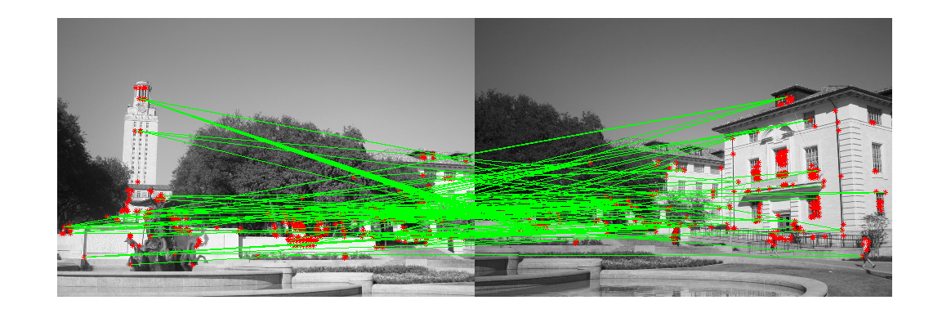

Affine transformation:

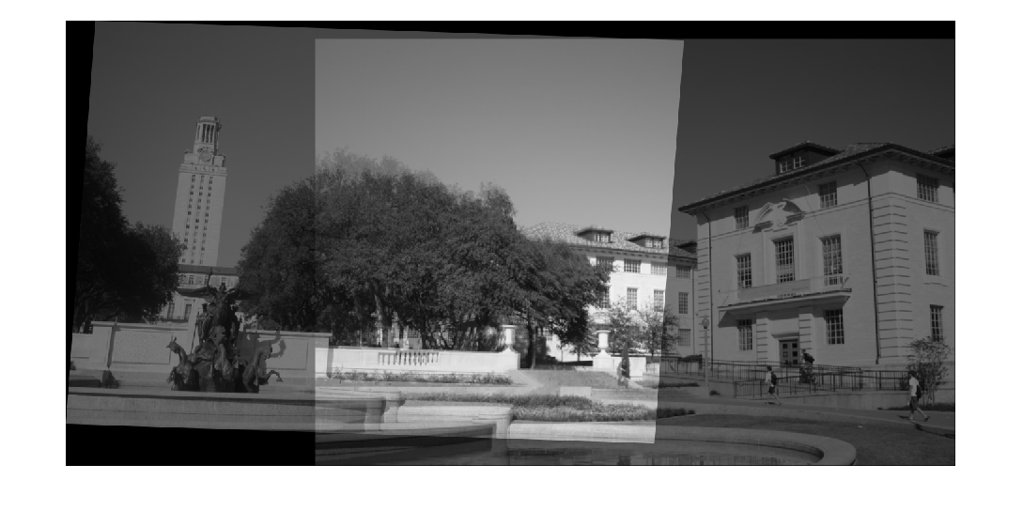

Homography:

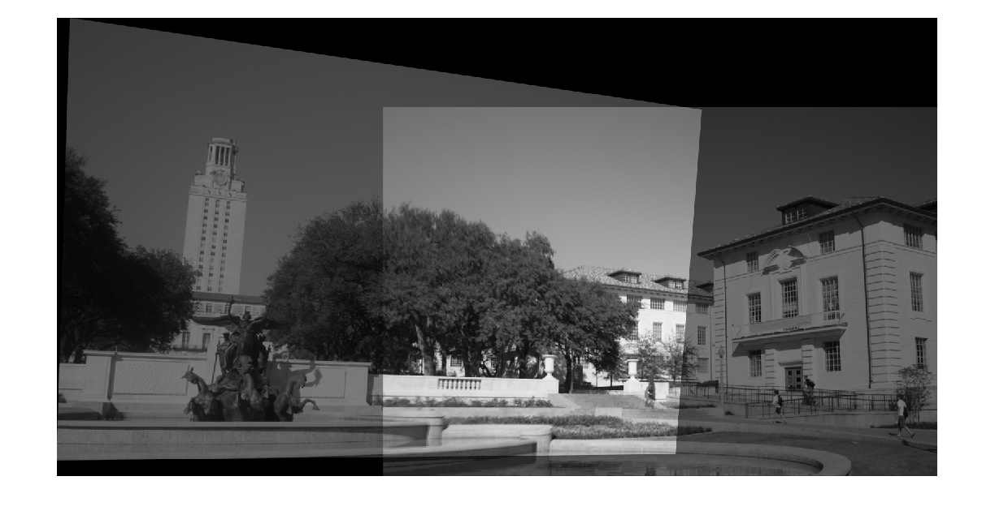

Set 2:

Feature matches:

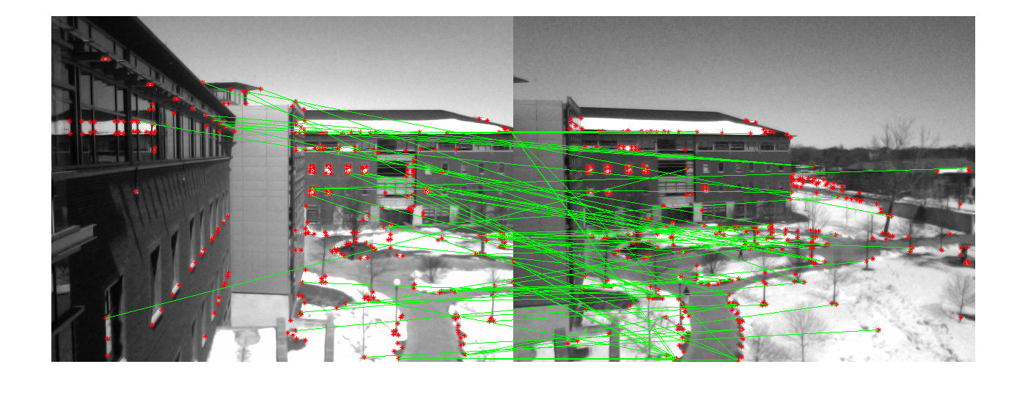

Affine transformation:

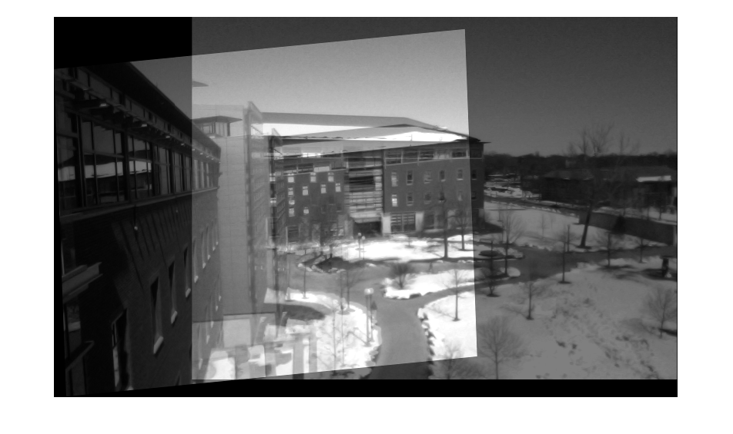

Homography:

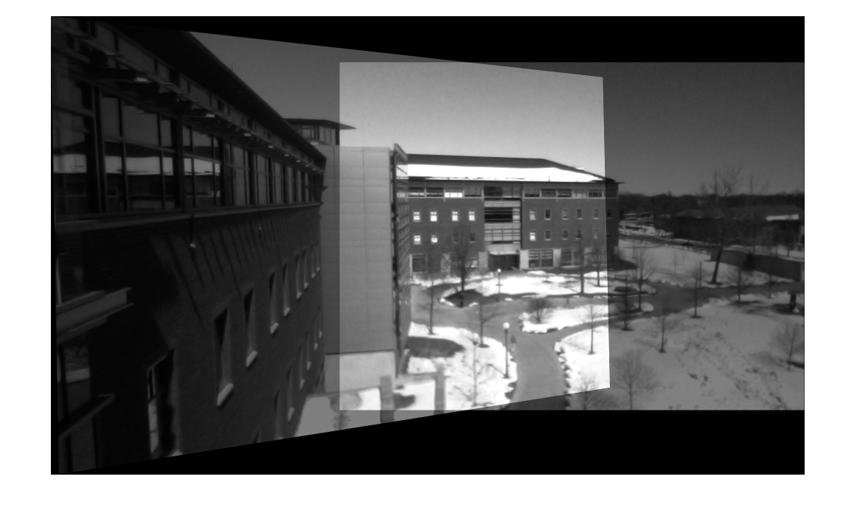

Set 3:

Feature matches:

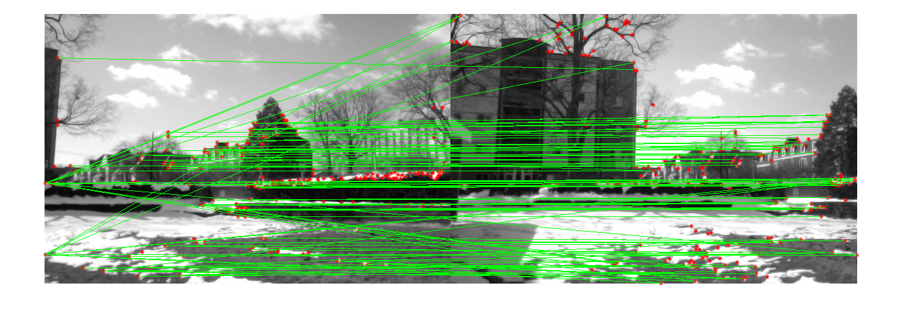

Affine transformation:

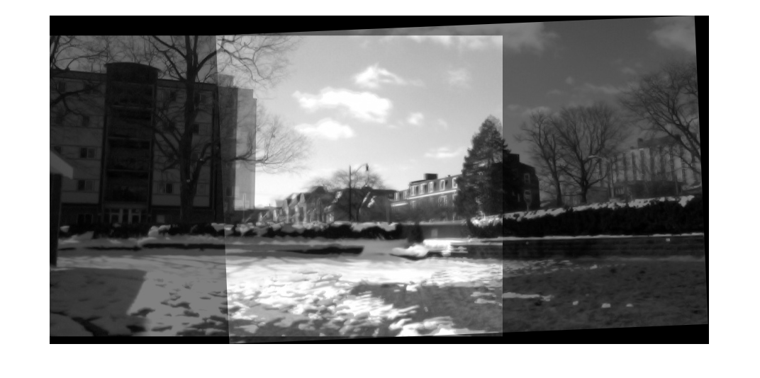

Homography:

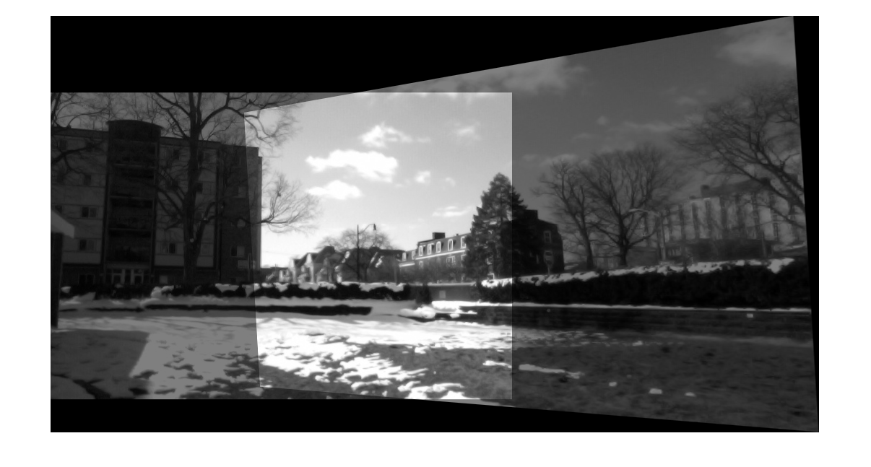

**Observations**:

In general, homography always has better results than affine transformation, as affine transformation is a subset of the homography. For example, the affine model of Siebel center has better alignment along the road than the rest of the image, while homography aligns everything perfectly.

**Interestingness:**

Trade off on the two types of feature descriptors:

The current descriptor is a matrix holding the pixel values around a feature, and it is used later to calculate the sum of squared distance. Previously, a histogram type of descriptor was used which has counts for different pixel value ranges, but it was not as good because it does not factor in the location of the pixels but only the values. However, the histogram type may be more useful when the images undergo significant rotations, because in that case histogram will stay the same while the matrix SSD will not give the close results any more.

**Parameters:**

FEATURENUM=200

# of corners to extract out of an image. which results an 200x200 feature check.

PATCHSIZE=5-10

# of pixels around the feature to get the descriptor by using sum of squared distance

PairNum=100-200

# of pairs of top(least distant) features for RANSAC pool.

RANSAC_ITERATION=2000-15000

# of sampling iterations for RANSAC, depending on the quality of feature extraction.

Threshold = 5

Threshold to differentiate between an inlier and an outlier.

SAMPLESIZE=6

# of pairs of features used to solve the transformation matrix, at least 3 for affine and 4 for homography. Over determined matrix may give a better results by giving the least square solution, but it requires more RANSAC iterations.

**Extra credit:**

Stitching more than one pair of images is implemented by iteratively applying the same algorithm. Proper scaling is necessary in order to preserve the validity of descriptor. Only homography is used here since affine transformation will always give inferior results. The following shows an example of stitching a 3rd image on set 3.

In order the preserve the intensity, only the region two intersects have the pixel values averaged, and elsewhere has the original value.

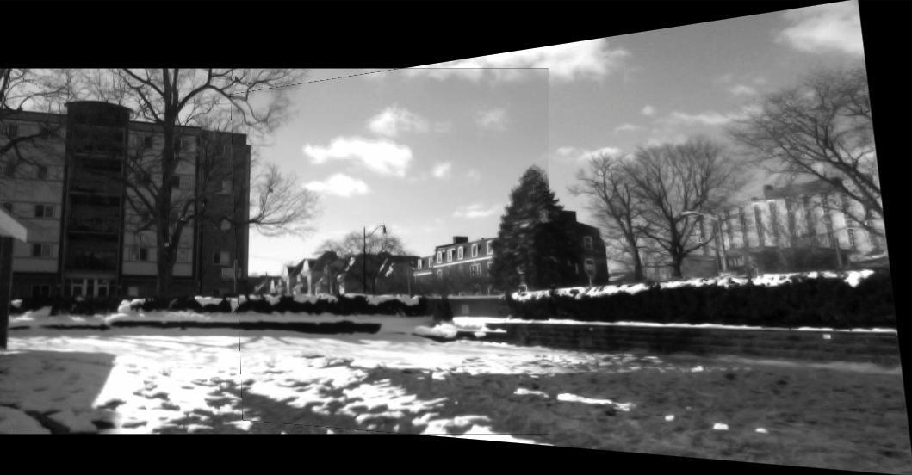

By applying the algorithm to the image above again, 3 images are then stitched:

