Team Assignment 1 – Project Management and Requirements Specifications

“Zed”

GSP410 – Summer Session A

Christopher Campshure

Christopher Cone

Joshua Cripe

Brian Goodspeed

Aaron Fuller

Kao Vang

**Contents**

**Cover Page_______________________________________________________________________Pg. 1**

**Table of Content___________________________________________________________________Pg. 2**

**Summary Evaluation - Requirements__________________________________________________Pg. 4**

What would you do better or different? **__________________________________________Pg.4**

Quality of tools and techniques? **_______________________________________________Pg. 4**

Are the requirements clear? **___________________________________________________Pg. 4**

What are the strengths and weaknesses? **________________________________________Pg. 4**

**Introduction____________________________________________________________________Pg. 6**

1.1 Purpose**_________________________________________________________________Pg. 6**

1.2 Scope**__________________________________________________________________Pg. 6**

1.3 Definitions, acronyms, and abbreviations**_____________________________________Pg. 7**

1.4 References**____________________________________________________________Pg. 8**

1.5 Overview**_______________________________________________________________Pg. 8**

**Overall description______________________________________________________________Pg. 8**

2.1 Product perspective**______________________________________________________Pg. 8**

2.2 Product functions**________________________________________________________Pg. 9**

2.3 User characteristics**_______________________________________________________Pg. 9**

2.4 Constraints**___________________________________________________________Pg. 9**

2.5 Assumptions and dependencies**_____________________________________________Pg. 9**

**Specific requirements___________________________________________________________ Pg. 10**

3.1 External interface requirements**__________________________________________ Pg. 10**

3.1.1 User interfaces**_________________________________________________ Pg. 10**

3.1.2 Hardware interfaces**___________________________________________ Pg. 10**

3.1.3 Software interfaces**______________________________________________ Pg. 10**

3.1.4 Communications interfaces**_______________________________________ Pg. 10**

3.2 Functional requirements**________________________________________________ Pg. 11**

3.3 Performance requirements**________________________________________________ Pg. 11**

3.3.1 Standards**______________________________________________________ Pg. 11**

3.3.2 Hardware limitations**_____________________________________________ Pg. 12**

3.4 Design Constraints**____________________________________________________ Pg. 12**

3.4.1 Availability**_____________________________________________________ Pg. 12**

3.4.2 Security**_______________________________________________________ Pg. 12**

3.4.3 Maintainability**_________________________________________________ Pg. 12**

3.5 Other requirements**______________________________________________________ Pg. 13**

**Figure 1. ________________________________________________________________________ Pg. 14**

**Figure 2. ________________________________________________________________________ Pg. 15**

**Summary Evaluation – Requirements**

**What would you do better or different?**

* More precise job responsibilities established
* More frequent communication, either on team discussion board or email
* Better task scheduling so as to avoid the ‘crunch time’ on Sunday
* Scheduled weekly meeting for collaboration purposes

**Quality of tools and techniques?**

Primary Tools: Microsoft Word, Excel, Project, Visio, Google Chrome, E-mail, School Discussion Board

Our primary tools included the Microsoft Office Suite 2010 including Word, Excel, Project & Visio for project documentation and planning. Coordination and communication were primarily conducted through the School Blackboard system, but were also supplemented by Private email accounts and a basic WordPress page. Team communication and work ethic maintained high levels throughout the week and I was very impressed by my class mate’s responsiveness and cooperation.

**Are the requirements clear?**

The requirements are clear, but could perhaps have gone into additional detail. As this is a technical document, additional details are always better. Future revisions may include a project UML, Specific IDE Version, Versioning System Description, Available Resources and Estimated Costs.

**What are the strengths and weaknesses?**

Strengths:

* High level of cooperation and personal creativity
* Willingness by the team to jump in to help with various sections of the assignment
* Solid data dictionary referencing common terms associated with the game

Weaknesses:

* Failure to establish explicit responsibilities early in week lead to time crunch to achieve deadline.
* More work in general could’ve been accomplished earlier in the week—procrastination led to less time being devoted to the assignment
* More detail could be added to functional requirements section, describing the ‘systems’

**Introduction**

* 1. **Purpose**

The purpose of *Zed* is to develop a 2D platformer video game. Because it will be created in Java, this game will be cross-platform compatible. This game will be single-player, and will feature multiple levels with unique and challenging enemies. All assets will be developed by WiseEyes Enterprise. Upon completion, this game will be made available for free on WiseEyes Enterprise’s website (<http://games.wiseeyesent.com/>). This game is being developed for project experience and enjoyment purposes only.

* 1. **Scope**

This is a single-player platformer game where the user will try to outwit or outmaneuver the AI-controlled enemies. This game is built using Java.

* 1. **Definitions, acronyms, and abbreviations**

Data Dictionary

**AI (Artificial Intelligence)** – a set of programmed actions and reactions to control NPC movements within the game, creating the illusion of ‘intelligence’

**Alpha** – the first phase of testing where the game is fully tested in-house to work out any major issues before Beta

**Animation** – using multiple images or frames of a model to simulate movement for characters within the game

**Attack** – any action from a character that can cause damage to another character or object

**Beta** – the second and final phase of testing where players from outside the company play-test the game prior to its release

**BGM (Background Music)** – music that is typically looped over a level to increase immersion and a player’s enjoyment of the game

**Character** – any living (or undead) creature within the game

**Checkpoint** – a position in a level that, when reached, sets the PC’s spawn point to the checkpoint’s location, letting the player respawn there if they die later in the level

**Cutscene** – a brief scene in the game where the player does not control their character and watches a predetermined set of events

**Damage** – any decrease in current HP of an NPC, PC, or object.

**Developer** – a member of the WiseEyes Enterprise team heading the development of this game

**Entity** – any character, object, or item

**Event** – a condition that, when activated, causes other game-related actions, such as spawning items and NPCs, changing a spawn point, or changing some terrain

**HP (Hit Points)** – measure the life force or durability of an NPC, PC, or object. If this reaches zero, the entity is killed or destroyed

**Item** – any entity in the game that can be picked up by a PC or NPC to increase their character’s effectiveness

**Level** – a region of gameplay that maintains a consistent theme and difficulty. This region is occupied by the PC, NPCs, objects, and terrain.

**Level Start** – an event that is automatically run upon loading of the level, which places the PC and all the initial NPCs, objects, and items

**Loop** – when a BGM or SFX is played repeatedly

**Model** – a graphical representation of a character, object, or item

**NPC (Non-Player Character)** – any character in the game that is not controlled by the player—this includes all enemies, critters, and any helpful characters in the game

**Object** – any entity in the game that is not a character, but may be destroyed by the PC or NPCs

**PC (Player Character)** – the character Zed, whom the player controls for the entirety of this game

**Platformer** – a style of video game where the player is affected by gravity and must jump to cross platforms and complete levels

**Player** – see PC.

**Respawn** – when an entity reappears at its spawn point, usually after being killed, destroyed, or picked up

**SFX (Sound Effects)** – sounds used to complement graphical effects on-screen to add realism and believability

**Spawn** – the initial placement of an entity into a level, which may be triggered by events other than level start

**Spawn Point** – the location where an entity will reappear at when killed, destroyed, or picked up, if respawning is allowed for that entity. There is an initial spawn point for every entity in a level, but a player’s spawn point can change if they hit a checkpoint

**Terrain** – non-living, non-destructible parts of a level that are used to enhance visual quality of the game or to modify the level’s difficulty. Mountains, water, floating platforms, and ladders are all examples of terrain.

**Texture** – any picture used on a model or terrain to enhance its visual quality

**Trigger** – a condition that, when fulfilled, causes an event to occur

**UI (User Interface)** – the screen viewed by the user to interact with the game and monitor critical game-related information, such as the player’s HP.

**Weapons** – items that are used for new or more powerful attack options

* 1. **References**

Any and all references can be found at <http://news.wiseeyesent.com/z/>

* 1. **Overview**

The player will control “Zed”, just your slightly smarter than average undead ghoul, as he traverses 2-d levels and attempts to outwit, out-maneuver and otherwise catch the humans unawares. Humans are capable of quickly killing the player, both at a range and in close proximity. Attacking humans takes time, and leaves the player vulnerable. Infecting human's, may or may not, result in zombie allies.

**2.1 Product perspective**

This game is a single-player platformer game. In the game, the player controls Zed, a zombie, and must kill, incapacitate, infect, or avoid all the enemies within each level. Enemies will be quicker, more powerful, and have more range than Zed, so timing and strategy are key points the player will need to focus on to complete the game. A list of key features is as follows:

* Cross-platform capability
* Multiple level designs
* Unique, challenging enemies
* Numerous player options to apply different strategies
* Powerup items that boost Zed’s abilities
* Intuitive UI
* Simple controls

**2.2 Product functions**

Functional components of the game must include the following:

* Many AI scripts based on level design
* Game physics
* Multiple enemy types
* Numerous items
* Destructible objects
* Player input control
* Multiple possible screen resolutions
* Suiting BGM and SFX for each level
* Appropriate animations and models for all entities
* Cross-platform capability
* Updating UI Objects

**2.3 User characteristics**

As this is a zombie-based game, there will be some blood and gore present within the gameplay. As such, this game will be focused on a Teen-rating.

**2.4 Constraints**

This game serves primarily as a project to gain experience and skills necessary to obtain employment within the gaming industry. As such, it is not intended to be marketed or to provide the developers with a profit. Effort will be placed on making the game functional--not optimal.

**2.5 Assumptions and dependencies**

This game can be downloaded or directly played from <http://games.wiseeyesent.com/>. Installation will not be required to play. The game page will be updated as new versions of the game are released for public play and/or play testing. To play this game, the user must have a PC or mobile device that meets the following system requirements (Section 3.1).

**Specific requirements**

**3.1 External interface requirements**

This section of the document relates to the user and system requirements that affect the processes of the game within the system in use.

**3.1.1 User interfaces**

The game has the capability to run on a computer or mobile platforms such as smartphones and tablets. The user interface will vary depending on the platform. Interface will be via keyboard input on a PC and touch input on mobile platforms. The game is compatible with various screen resolutions ranging from 800x640 to 1920x1080.

**3.1.2 Hardware interfaces**

*Zed* will run on a touchscreen smartphone or tablet with a capacitive or resistive touchscreen.

*Zed* will run on a computer equipped with the following hardware interface requirements:

* Keyboard
* Mouse
* Display
* Broadband Internet Connection

**3.1.3 Software interfaces**

*Zed* can run on any PC equipped with the following software requirements:

* Functional operating system
* Internet Browser with Java Plugin
* Support for Java version 1.6 or higher

Mobile device requirements:

* Android: Android 2.1 or higher
* iOS: iOS version 4 or higher

**3.1.4 Communications interfaces**

*Zed* can played online via a PC with a broadband internet connection. Mobile platform users can access online play through 3G/4G or WiFi connection.

**3.2 Functional Requirements**

* Control: WASD interface or arrow key, space bar, ctrl, alt, etc requirements to allow players to move about in game.
* Abilities:
  + Walk
  + Crawl
  + Feign death
  + Burrow
  + Scratch
  + Bite
  + Devour
* Characters:
  + Zed (Player Character)
  + Child
  + Civilian: Unarmed, Melee, Pistol
  + Hunter: Shotgun, Rifle, Bow, Camouflage
  + Police: Club, Pistol, Shotgun, Rifle, Assault Rifle, Armor, Shield, Barricades
  + Soldier: Camouflage, Armor, Pistol, Rifle, Assault Rifle, Machine Gun, Explosives, Barricades
* Minimum of two levels (3 optimally)
  + Cemetery
  + Suburbs
  + City
* Death/heath system
* Point system with rewards (extra lives)
* Cross platform capability
* Level Editor for future release
* Story Line

**3.3 Performance requirements**

**3.3.1 Standards**

Zed will be a Java based embeddable browser game, giving it maximum compatibility with any system capable of supporting Java as well as making distribution and reselling to other gaming web sites easier. A downloadable app will be developed primarily for mobile devices to maximize functionality in these environments. The level editor will also be released as a downloadable app with upload abilities connecting the editor to an online level database. Player scores can also be logged or discarded, at the player’s discretion. Custom levels may be selected from the database to be run live or downloaded for future use.

**3.3.2 Hardware limitations**

Zed will be primarily developed in Java and, as such, will require Java capabilities on the user’s device. Browser based play is available for all internet capable computers with Java support. Downloadable apps are available for mobile devices, primarily the Android series, which runs entirely on Java. An Objective-C port may be developed for Apple mobile devices.

**3.4 Design Constraints**

**3.4.1 Availability**

Single Player: Player is in full control of character functions and abilities. Character will interact with object in the game to obtain winning condition.

Multiplayer: There is no multiplayer base right now. If new content is released, updates will be provided to show multiplayer functionality and winning conditions.

Level Editor: Plans are in place for a separate level developer app to allow the players to expand the playability and world of Zed.

**3.4.2 Security**

There will be no Security issue in this game since it is not a genre will outside threat will profit from. Unlike online base game like MMO, the condition of the game will not likely be hit by outside threat to user.

**3.4.3 Maintainability**

To maintain version, the system will use a version number base naming system. For example, the beta version will be 1.0.0. Depending on how big the change will be it will be modify into the numbering system. If it is a big change it will change to 1.1.0. If it is a minor change it will change to 1.0.1. Major changes, such as an engine rewrite or sequel, will result in the version 2.0.0

Code will be grouped into its focus point. For example, we have art, physic, sound, and input. Each of those can be a focus point and coding that match those examples can be grouped respectively.

**3.5 Other Requirements**

This game’s development will require the following:

1. Personnel: Designers, Programmers, Artists, Sound Artists/Musicians, Writers
2. Software:
   1. Programming: Eclipse Java IDE & Mac OS X Development Tools
   2. Graphics Software: Paint, Gimp, Adobe Illustrator
   3. Sound Software: Sound Recorder, Sound Editor (e.g. Audacity), Music Software (e.g. Garage Band)
   4. Office Productivity Software: MS Office Word, Excel, Project, Visio, Outlook
3. Hardware
   1. Testing Devices, Android 2.0, iPhone 3GS or iPod Touch running iOS 4.0, Windows, Linux & Mac OSX Personal Computers
   2. Development Devices: Windows, Linux or Mac OSX Work Stations
   3. Recording Devices: Microphone, Studio, Mixing Devices
4. Production & Publishing:
   1. Public Website for development news & game release
   2. Internal Website for ongoing development & communication
   3. Versioning system for tracking & storing game assets

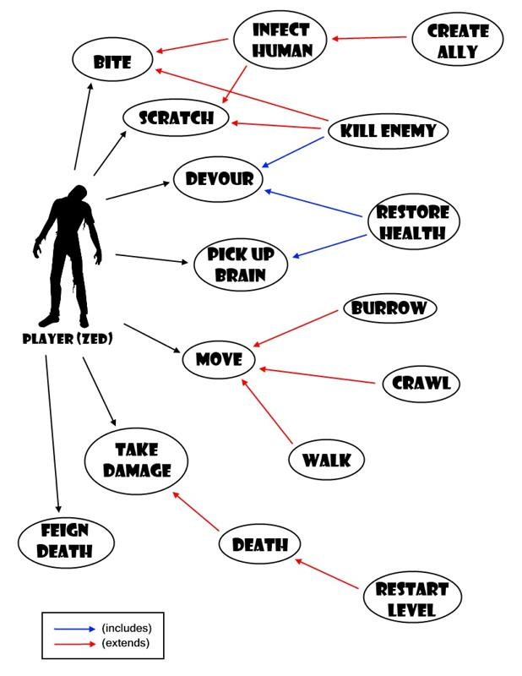

Figure 1. Player Character (Zed) Use Case Diagram

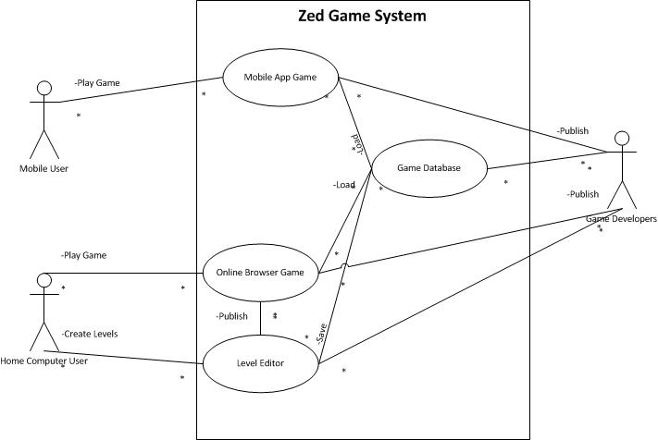

Figure 2. End user & developer Use Case Diagram