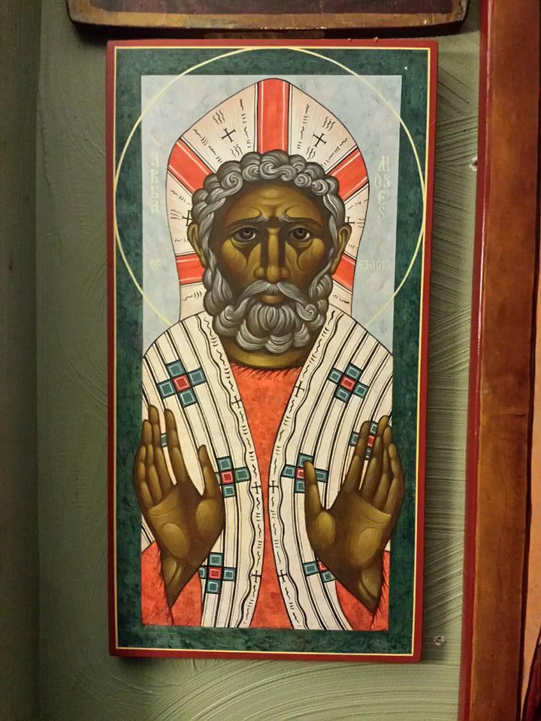**St. Moses the Black Orthodox Church**

**Rev. Paul Abernathy, Pastor**

**412.254.6281** [**www.stmosesonthehill.com**](http://www.stmosesonthehill.com)

[**stmosestheblackpgh@gmail.com**](mailto:stmosestheblackpgh@gmail.com)

**Sunday, May 7, 2017 – Sunday of the Paralytic**

*Appearance of the Sign of the Precious Cross in the heavens above Jerusalem (351 A.D.);   
Martyr Akakios the centurion at Byzantium; John of Beverly, Bishop of York;  
 Priest Alexis Toth of Wilkes-Barre, confessor and defender of Orthodoxy in America*

*The Priest begins Divine Liturgy with “Blessed is the Kingdom” and the choir responds “Amen.” Bearing the Paschal Candle, the Priest then leads the singing of the Paschal Apolytikion and censes the west side of the Altar Table.*

**Priest: Christ is risen from the dead, trampling down Death by death; and upon those in the tombs bestowing life!**

*The Choir then sings this twice, and the Liturgy continues with the Great Litany.*

**THE FIRST ANTIPHON**

Verse: Shout with joy to God, all the earth; sing to His Name, give glory to His praises.

**Refrain: Through the intercessions of the Theotokos, O Savior, save us.**

Verse: Say to God: How awesome are Thy works; let all the earth worship Thee, and sing to Thee. Let it sing a song to Thy Name, O Most High. **(Refrain)**

Glory… Both now… **(Refrain)**

**THE SECOND ANTIPHON**

Verse: May God have mercy upon us, and bless us, and may He cause His face to shine upon us, and have mercy upon us. **Refrain: Save us, O Son of God, Who art risen from the dead; who sing to Thee. Alleluia.**

Verse: That Thy way may be known upon earth, Thy salvation among all nations; let the people give thanks to Thee, O God, let all the people give thanks to Thee. **(Refrain)**

Verse: May God bless us, and may all the ends of the earth fear Him. **(Refrain)**

Glory… Both now… O, only begotten Son and Word of God…

**THE THIRD ANTIPHON**

Verse: Let God arise, and let His enemies be scattered, and let those who hate Him flee from before His face.

**Refrain: Christ is risen from the dead, trampling down death by death; and upon those in the tombs, bestowing life!**

Verse: As smoke vanishes, so let them vanish, as wax melts before the fire. **(Refrain)**

Verse: So let sinners perish before the face of God, and let the righteous be glad. **(Refrain)**

Verse: This is the day which the Lord hath made; let us rejoice and be glad in it. **(Refrain)**

**THE EISODIKON (ENTRANCE HYMN) OF PASCHA** - In the gathering places bless ye God the Lord, from the springs of Israel. Save us, O Son of God, Who art risen from the dead, who sing to Thee: Alleluia.

• Now sing these apolytikia in the following order.

**RESURRECTIONAL APOLYTIKION IN TONE THREE** - Let the heavens rejoice and the earth be glad, for the Lord hath done a mighty act with His own arm. He hath trampled down death by death, and became the first-born from the dead. He hath delivered us from the depths of Hades, granting the world the Great Mercy.

• Now sing the apolytikion of the patron saint or feast of the temple.

**KONTAKION OF PASCHA IN TONE EIGHT -** O Immortal One, when Thou didst descend into the tomb, Thou didst destroy the power of Hades; and Thou didst rise victorious, O Christ God. Thou hast said to the ointment-bearing women: Rejoice! And Thou gavest peace to Thy Disciples, O Bestower of Resurrection to those Who had fallen.

**THE EPISTLE**

**Sing praises to our God, sing praises. Clap your hands, all you nations.**

**The Reading from the Acts of the Saintly and Pure Apostles. (9:32-42)**

*In those days, as Peter went here and there among them all, he came down also to the saints that lived at Lydda. There he found a man named Aeneas, who had been bedridden for eight years and was paralyzed. And Peter said to him, “Aeneas, Jesus Christ heals you; rise and make your bed.” And immediately he rose. And all the residents of Lydda and Sharon saw him, and they turned to the Lord. Now there was at Joppa a disciple named Tabitha, which means Dorcas. She was full of good works and acts of charity. In those days she fell sick and died; and when they had washed her, they laid her in an upper room. Since Lydda was near Joppa, the disciples, hearing that Peter was there, sent two men to him entreating him, “Please come to us without delay.” So Peter rose and went with them. And when he had come, they took him to the upper room. All the widows stood beside him weeping, and showing tunics and other garments, which Dorcas made while she was with them. But Peter put them all outside and knelt down and prayed; then turning to the body he said, “Tabitha, rise.” And she opened her eyes, and when she saw Peter she sat up. And he gave her his hand and lifted her up. Then calling the saints and widows he presented her alive. And it became known throughout all Joppa, and many believed in the Lord.*

**THE GOSPEL**

**The Reading from the Holy Gospel according to St. John. (5:1-15)**

At that time, Jesus went up to Jerusalem. Now there is in Jerusalem by the Sheep Gate a pool, in Hebrew called Bethsaida, which has five porticoes. In these lay a multitude of invalids, blind, lame, paralyzed, waiting for the moving of the water. For an angel of the Lord went down at certain seasons into the pool and troubled the water; whoever stepped in first, after the troubling of the water was healed of whatever disease he had. One man was there, who had been ill for 38 years. When Jesus saw him and knew that he had been lying there a long time, He said to him, “Do you want to be healed?” The sick man answered Him, “Sir, I have no man to put me into the pool when the water is troubled, and while I am going another steps down before me.” Jesus said to him, “Rise, take up your pallet, and walk.” And at once the man was healed, and he took up his pallet and walked. Now that day was the Sabbath. So the Jews said to the man who was cured, “It is the Sabbath, it is not lawful for you to carry your pallet.” But he answered them, “The man who healed me said to me, ‘Take up your pallet, and walk.’” They asked him, “Who is the man who said to you, ‘Take up your pallet, and walk’?” Now the man who had been healed did not know who it was, for Jesus had withdrawn, as there was a crowd in the place. Afterward, Jesus found him in the temple, and said to him, “See, you are well! Sin no more, that nothing worse befalls you.” The man went away and told the Jews that it was Jesus Who had healed him.

**MEGALYNARION FOR PARALYTIC SUNDAY IN TONE ONE** *The angel spake to her that is full of grace, saying, O pure Virgin, rejoice; and I say also, Rejoice; for thy Son is risen from the tomb on the third day. We believers in unison bless thee, O Virgin, crying: Rejoice, O gate of the Lord. Rejoice, O living city. Rejoice, O thou from whom didst rise upon us from the dead the Light of Resurrection, He Who was born of thee.*

**KOINONIKON (COMMUNION HYMN) OF PASCHA IN TONE EIGHT** Receive ye the body of Christ; taste ye the Fountain of immortality.

• Instead of “We have seen the true light,” sing “Christ is Risen” once.

**SPECIAL THANKS – to all the parishioners who donated to support our brother Joseph Clark and the funeral costs for his mother – Lillian. In total the parish was able to provide him with $2,225!! Thank God.   
May Lillian rest in the place of the rest where all the saints repose and May her memory be eternal.**

**SERVICE SCHEDULE**

**May 13th – 5:00 PM** – GREAT VESPERS

**May 14th – 9:30 AM** – Matins and Divine Liturgy – Mother’s Day

**May 20th –** NO GREAT VESPERS

**May 21st – 9:30 AM** – Matins and Divine Liturgy

**May 27th – 1:00 PM – 3:00 PM** FAMILY Day & **5:00 PM** – GREAT VESPERS

**May 28th – 9:30 AM** – Matins and Divine Liturgy

**PRAYER LIST -** Please contact Pres. Kristina Abernathy via email at [Kristina.nicole@me.com](mailto:Kristina.nicole@me.com) or via text or call at 724.493.7213 to add living or departed names to the prayer list.

**LIVING–** *Patriarch John, Metropolitan Boulous, Archbishop Johana, Archpriest Elias, Archpriest Jason & Family, Archpriest James, Kh. Linda, Archpriest Patrick, Kh. Vanessa, Archpriest Joseph, Priest Joseph, Kh. Arleen, Hiromonk Michael, The Sisterhood of St. Nina Monastery, The Sisterhood of Pandanassa Monastery, Gregory, Justin, Christopher, Joseph, Rodger, Sister Janice, John, Aksana, Nicholas, The Painter Family, The Boozer Family, The Wells Family, The Horne Family, The Focus Family, Pearl, Brandon, Isabella, Ashley, Carmen, Timothy, Marcella, Cassie, Cami, George, Eva, The Elderkin Family, Decoda, Ainsley, Destiny, Zachary, Billy, Michael, Sophie, Mary, Larry, Daniel, Leisa, Kane, Beverly*

**DEPARTED –** *Archpriest John, Kh. Joanne,**Monica, Andre, Joey, Lillian*

**CONFESSIONS and HOUSE BLESSINGS By Appointment -** Please contact Rev. Paul Abernathy via calling at 412.254.6281 to schedule confession or a meeting.

**DONATIONS**

Please make your offerings to St. Moses the Black as follows: Checks made payable to St. George Orthodox Church with St. Moses the Black in the memo line. Checks or cash can be either given to Pres. Kristina or mailed to the following address: St. George Orthodox Church, Attn: St. Moses the Black, 610 Dewey Avenue, Bridgeville, PA 15017.

**PARISH OFFICERS**

**Sacred Music** – David Anderson & Susan Rice

**Youth Ministry** – Brandon Bailey & Katrina Bitar

**Pastoral Care** – George Langan

**Congregational Care** – Holly Lassila

**Communications** – Chris Vacarello

**Secretary** – Pres. Kristina

**Hospitality Director** – Katherine Miller