**FCS - User Guide**

Revision 4

6/2/2021

**Introduction**

The Flow Controller System is a Human-Machine Interface (HMI) designed to be used with Sonotec Clamp-On Flow Sensors. Features of this product include:

* Over-The-Air Software Updates
* Flow Data Logging to a USB Drive in CSV Format
* Flow Averaging Calculations
* Sensor Zeroing
* Flow Data Graphing
* Flow Calibration
* PID Pump Control (4-20mA)
* Automatic fluid dispensing

This User’s Guide gives a brief overview of how to use the Flow Controller System and a summary of how it’s features are integrated.

*Note: Images in this guide are for reference only, and were captured using an emulator running on a PC to get screenshots. No sensor or pump was connected during the time of capture.*

**Table Of Contents:**

**Page**

**I. Quick Start Setup**3

**II. Using the GUI**4

Graphing Sensor Data 4

Calibrating/Setting Flow Offset 5

Logging Data 6

Stopping/Starting Data Reading 10

Sensor Tare/Zero 12

**Configuring PID Loop Settings**13

Setting Desired Flow Rate (Setpoint) 14

Dispensing A Set Volume of Liquid 15

**III. Connecting To WiFi**17

## I. Quick Start Setup

The steps to quickly get started with the Flow Controller System are as follows:

1. Plug in the unit with the provided DC power brick.
2. Plug in the Sonotec Sensor to the unit through the 8-pin M12 Connector
3. Connect the pump to be controlled (if one is to be controlled) to the 5-pin M12 Connector.
4. Press the power button to turn on the unit. The button should light up if power is connected.
5. The unit will now go through it’s initial boot sequence, and a FCS Logo will shortly appear on the screen.
6. If Wi-Fi is available in the area, connect the device to the internet (detailed instructions follow in the “Connecting to Wi-Fi” Section on page 11)
7. Press start on the User Interface to begin controlling the pump.

## II. Using the GUI

### Graphing Sensor Data

By default when the device starts up, it will attempt to find and connect to a Sonotec sensor. If none is attached, it will continue to look for a sensor until one is plugged into the M12 connector. Once the sensor is connected, the HMI will begin to graph the sensor’s read flow rate (blue), along with the flow set point (red).

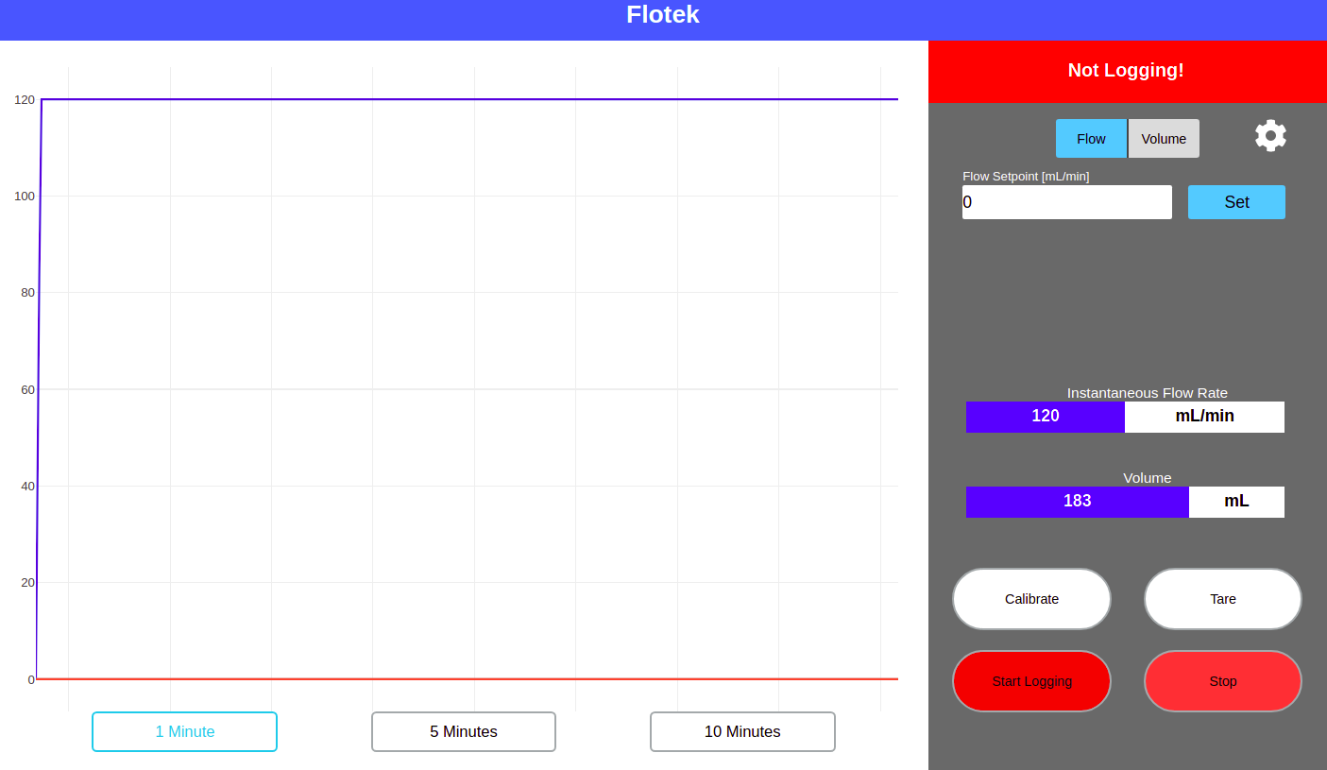

*Figure 1: Sensor Data Graph*

Data can be viewed in the graphing section from either the last 1, 5, or 10 minutes. Data is still being stored from before that timeframe (so long as the device has been powered on and running).

### Calibrating/Setting Flow Offset

The Sensor can be calibrated with the “Calibrate” button. This allows the user to set an offset between the wanted and currently read flow rate. This calibration persists between power cycles of the device.

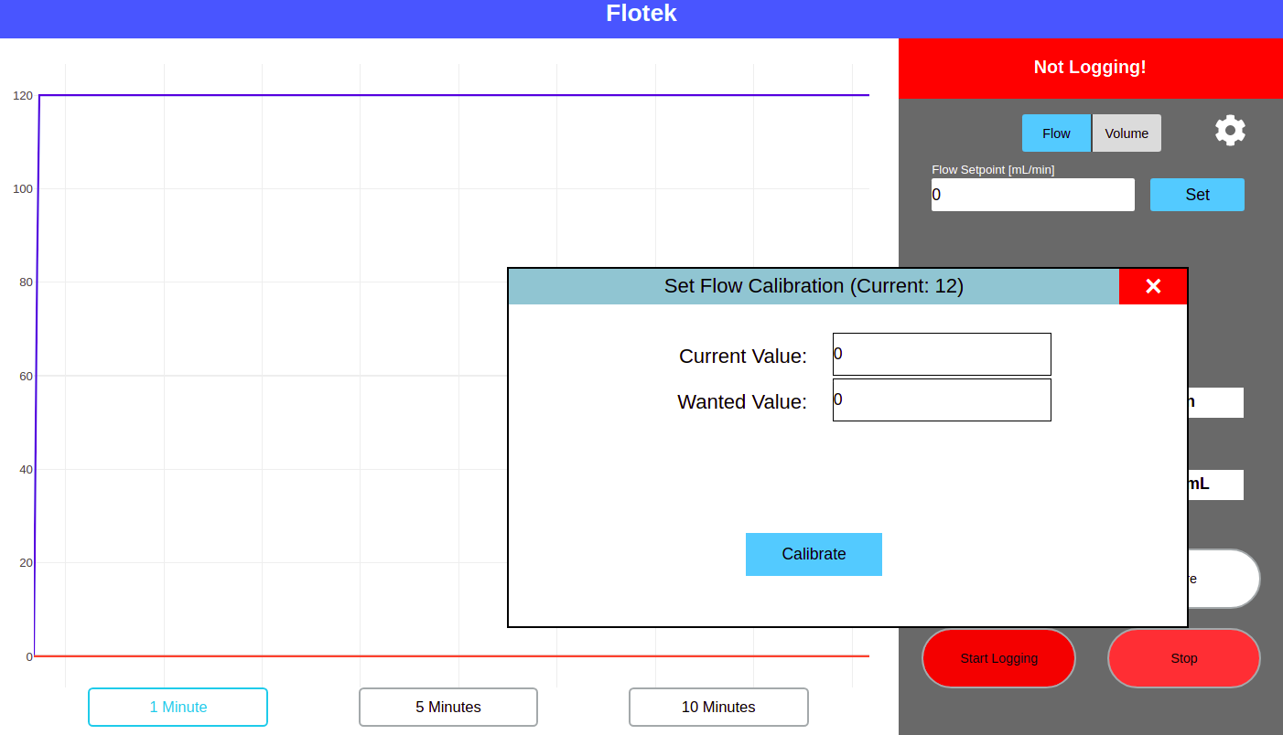

*Figure 2: Flow Calibration Pop-up*

### Logging Data

The FDC allows for logging of flow data in a CSV format to a USB drive. To accomplish this, the “Start Logging” button must first be pressed. This sets the start point for data logging to a CSV file. Once pressed, the button will change to a “Stop Logging” button, and the warning banner will disappear.

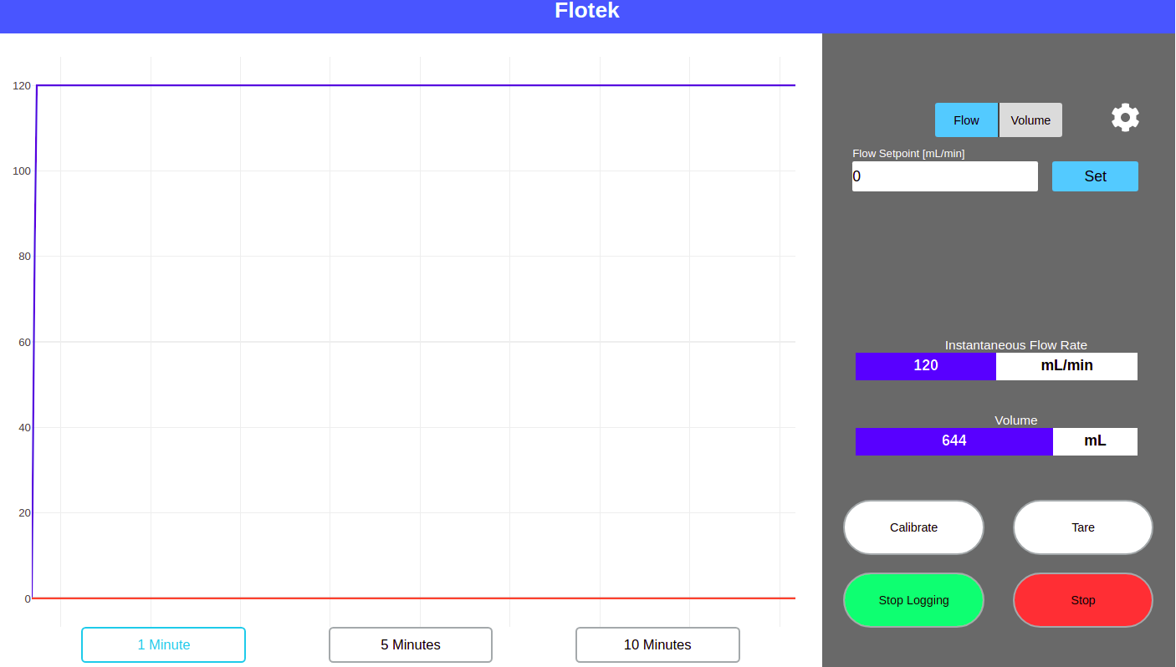

*Figure 3: Controller In Logging Mode.*

*Note the “Stop Logging” State of the logging button and the green color*

Then, at a later point in time, the “Stop Logging” button can be pressed. This will indicate to the device the point in time that logging is stopped. The CSV file can now be downloaded to a USB drive, and is indicated by the button changing color and state to a “Save Log” button.

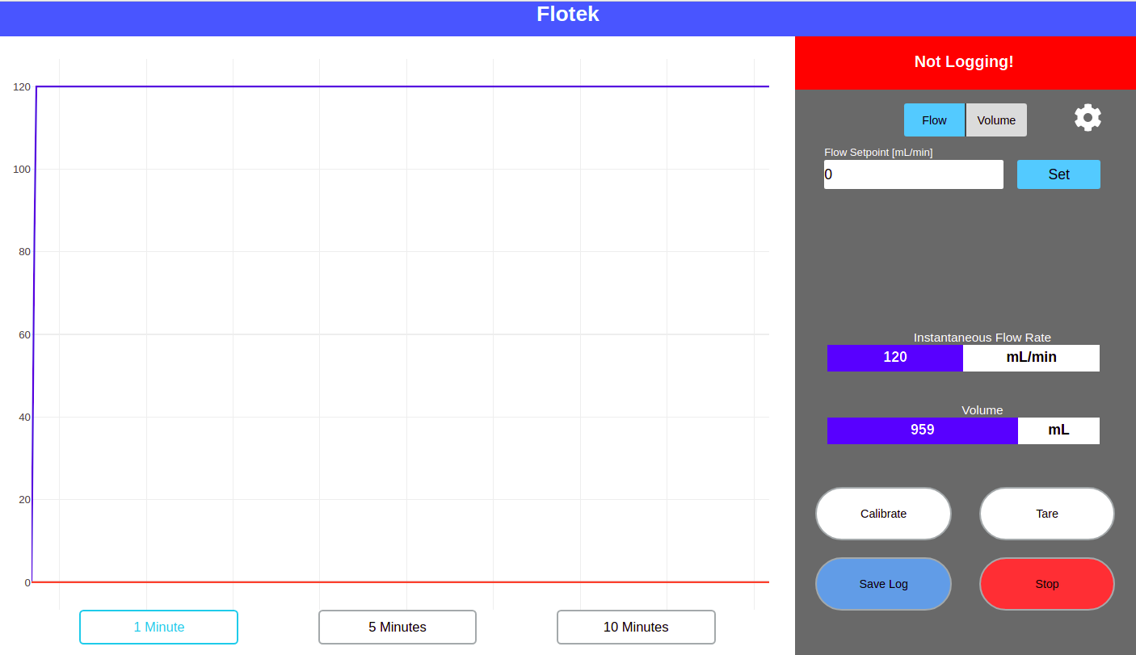

*Figure 4: FDC Ready to save logged data to a CSV File*

When the “Save Log” button is pressed, a window will appear with a USB status bar, a file name, and a save button.

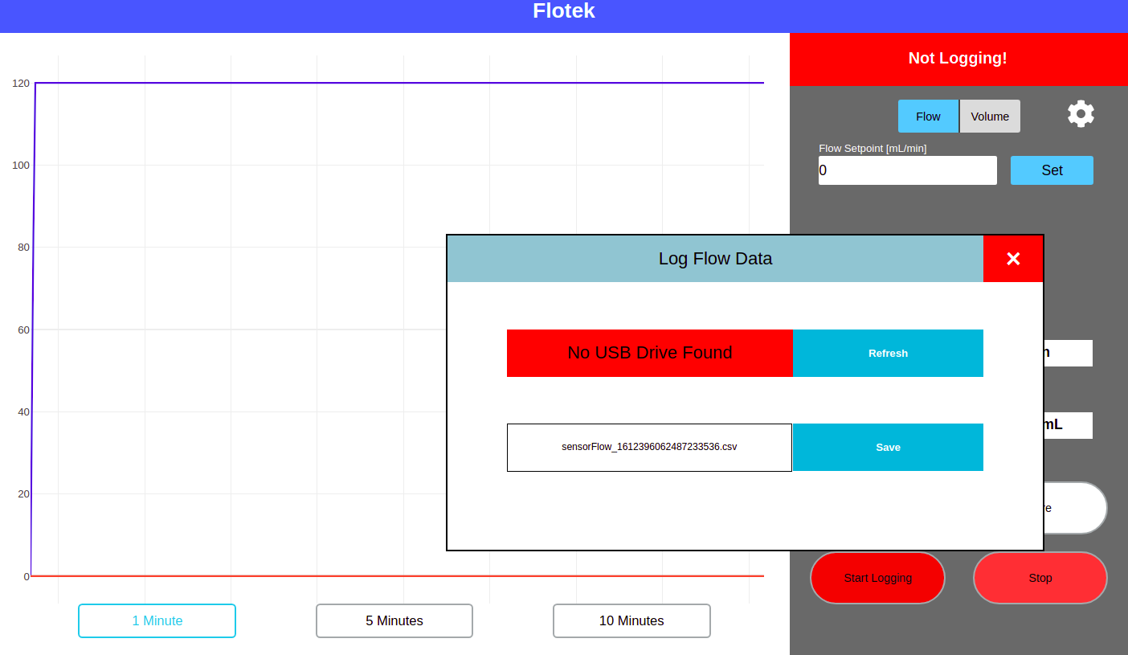

*Figure 5: Save Log Pop-up with no USB drive connected*

If a USB drive is inserted, and the “Refresh” button is pressed, the USB status bar will turn green and say “USB Drive Connected”, indicating that data can be saved to the USB drive.

When the “Save” Button is pressed, the HMI will begin downloading data to the USB drive in CSV format. The time this takes is dependent on the length of time being saved. Once data is done being downloaded, the save button will change to “Saved” indicating that the window can be closed and the USB drive can be removed.

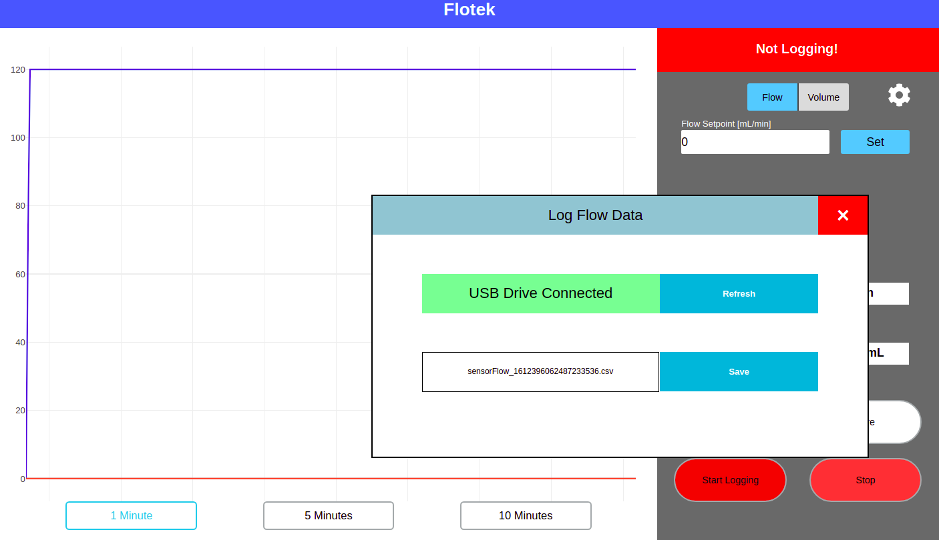

*Figure 6: Logging Pop-up with USB Drive Connection and File Available to be saved*

Upon pressing the “Save” button on this popup, the button will display “Saving” as it copies data onto the USB drive. It will change to “Saved” once data transfer is complete.

### 

### 

### Stopping/Starting Data Reading

The button on the bottom right of the GUI simply Starts and Stops reading of data from the sensor. The default state of the device is Stopped after boot.

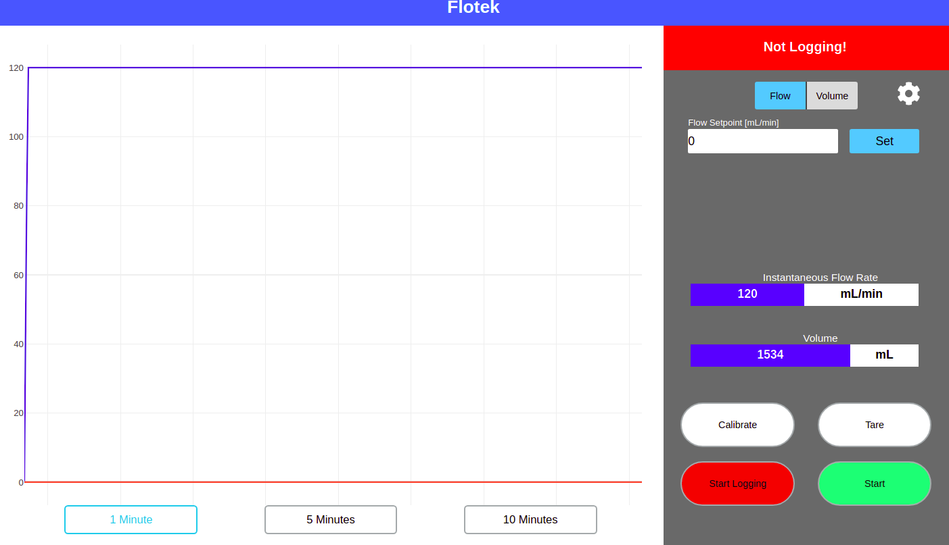

*Figure 7: Shortly after pressing the Stop button. Note the Color and State of the Start/Stop Button This is the state present at boot*

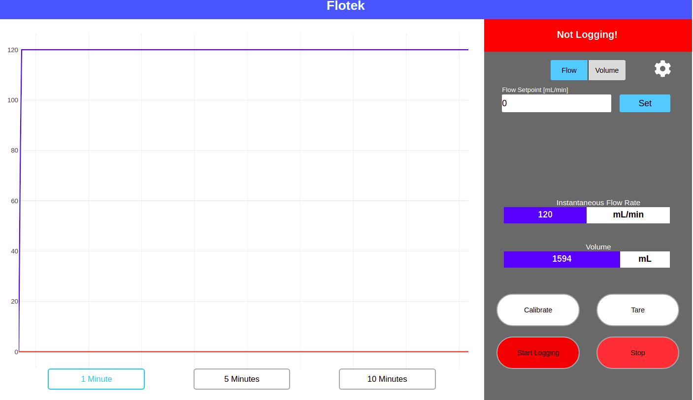

*Figure 8: Controller In Running mode with user prompt to stop graphing.*

### 

### 

### 

### 

### 

### 

### 

### 

### Sensor Tare/Zero

The Controller’s Tare button is used to set the zero point of the sensor, which it accomplishes by sending a zero command over the RS485 bus. The Tare button also sets the average flow rate to zero. During the Tare procedure, the button will indicate that the sensor is currently being Tared, and the graph will stop, as the RS485 bus is being used to zero the sensor.

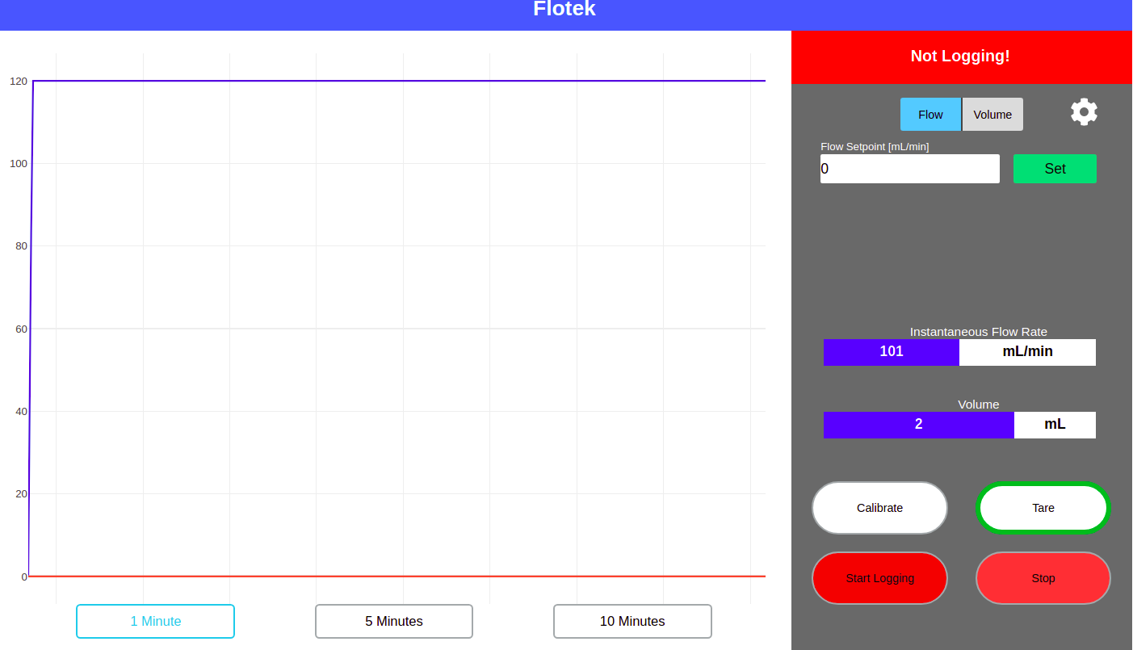

*Figure 8: Controller GUI Shortly after pressing the Tare Button*

### Configuring PID Loop Settings

The FCS Controller features user configurable PID gains, which persist upon power cycling the device. To do so, the small gear at the top right of the screen in the PID control section of the User Interface should be pressed.

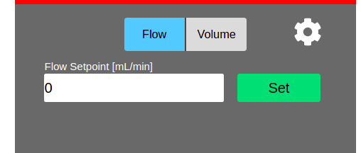

*Figure 9: PID Control Section of User Interface, note the gear icon in the top right.*

Once this button is pressed, a window will appear with fields to fill in PID tuning parameters. The Controller has default gains in place, so this procedure is optional if the response to a change in setpoint is desirable.

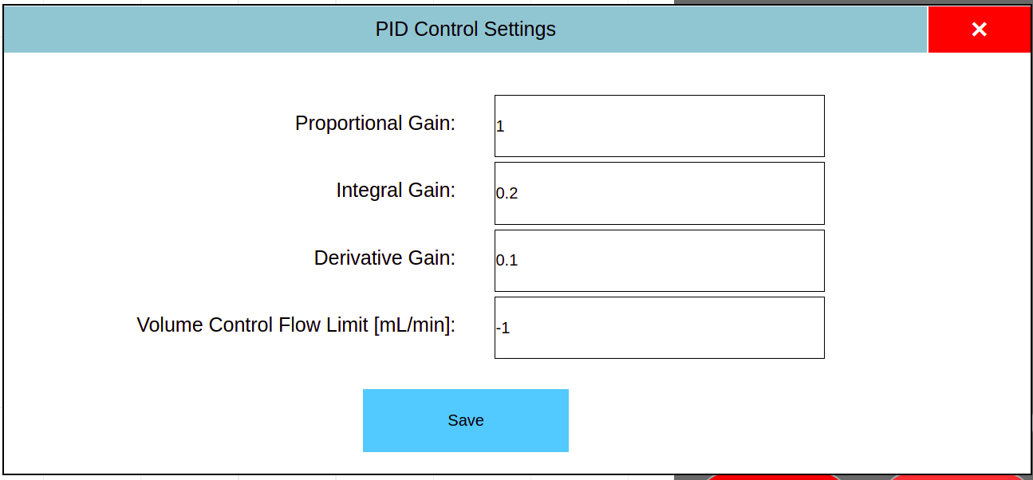

*Figure 10: PID Configuration Options*

Upon pressing any of the boxes, a keypad will appear on screen allowing the user to set the desired parameter. Volume Control Limit simply limits the flow rate during a fluid dispense run. The save button can then be pressed to confirm user configured PID parameters, and the window will close.

Please see our YouTube video on PID

https://www.youtube.com/watch?v=m9D81uW98jI

### Setting Desired Flow Rate (Setpoint)

With the device in Flow Control mode (“Flow” button colored blue in PID section), the desired flow rate can be set using the box labeled “Flow Setpoint [mL/min].

Once a desired flow rate is entered, the Blue “Set” button can be pressed. Once pressed, it will turn green, the red line on the graph will go to the setpoint, and the controller will drive the pump to maintain that flow rate.

## 

*Figure 11: PID Section in Flow Mode after setting a desired 120mL/min flow rate*

### Dispensing A Set Volume of Liquid

The FCS Data controller features a mode to dispense a user defined volume of liquid. To Set the controller to this mode, simply press the “Volume” button in the PID section of the interface.

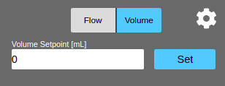

*Figure 11: PID Section in Volume Dispense Mode*

The procedure for dispensing liquid is similar to setting a static flow rate: simply enter the desired volume and press “Set”.

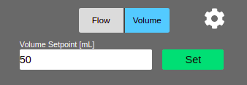

*Figure 12: PID Section after starting a dispense run of 50 mL*

After setting a desired volume to dispense, the start button should be pressed to start dispensing liquid. The start button will then turn to “stop” Once the desired volume has been dispensed, the button will be changed back to “start”. This can be pressed any number of times to dispense the set amount of liquid. Stop can also be pressed as the FC is dispensing liquid, which will pause the dispensing process, not restart it (e.g if set to 50 mL, stopping it at 30 mL will set the remaining volume to dispense to 20 mL). To reset it at this point (restart dispensing 50mL), the Tare button should be pressed.

### Calibrating Dispensed Volume

If the actual dispensed volume does not match the desired volume, the Calibrate button can be pressed in Volume mode. This allows the user to set the actual volume dispensed compared to the desired (previously set) volume. The controller will then calculate a ratio between the desired and actual volumes, maintaining the calibration for any volume setpoint.

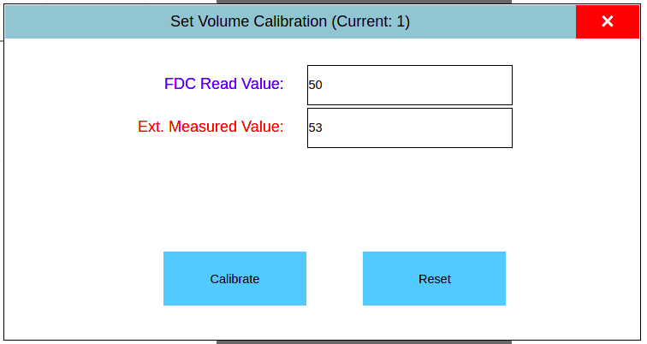

*Figure 13: Volume Calibration (set to 50mL, actually dispensed 53 mL). Notice default calibration ratio of 1*

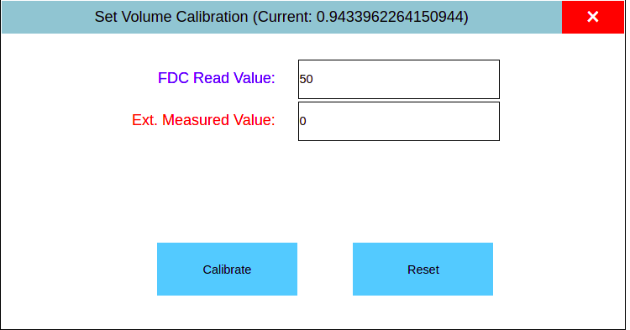

*Figure 14: After Pressing calibrate in Fig. 13. Notice the ratio is now less than 1 (controller will dispense less on next run)*

***Note: Changing Modes (Flow/Volume) will stop the pump and zero accumulated volume re******adings.***

## III. Connecting To WiFi

The FCS Controller software includes an application that interfaces with a mobile phone to connect the Controller to a wireless internet connection. This connection can then be used for remote monitoring and updating of the Controller’s firmware, and is also used to derive a valid timestamp for data.

The Unit may also be connected to the internet via the Ethernet port, which is as simple as plugging it in.

The procedure to connect the Controller to a wireless network is as follows:

1. Using a mobile phone, open WiFi settings and connect to “FlotekDC”. The passphrase for this connection is “flotekwl”
2. A sign-in page should now pop up and prompt the user to select a WiFi connection and enter the password for that network.
3. Once the network information has been correctly entered, the Controller is now connected to the internet and the “FCS DC” WiFi should disappear.