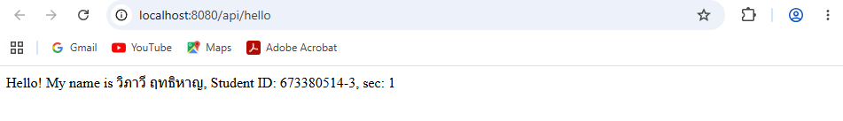
http://localhost:8080/api/hello

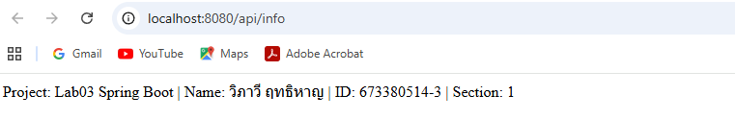
http://localhost:8080/api/info

