7.7 7.8

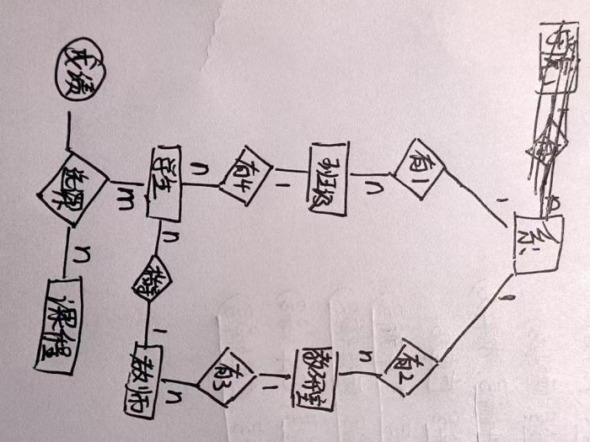 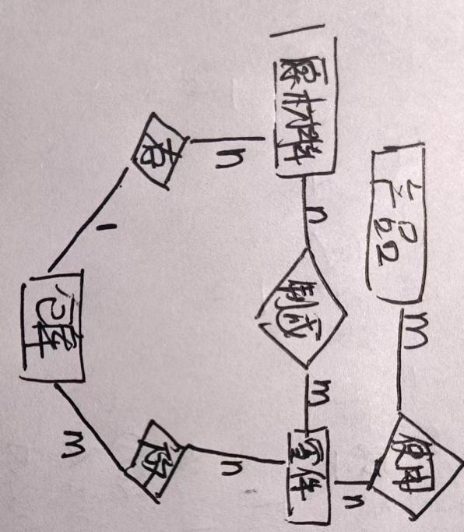

7.9

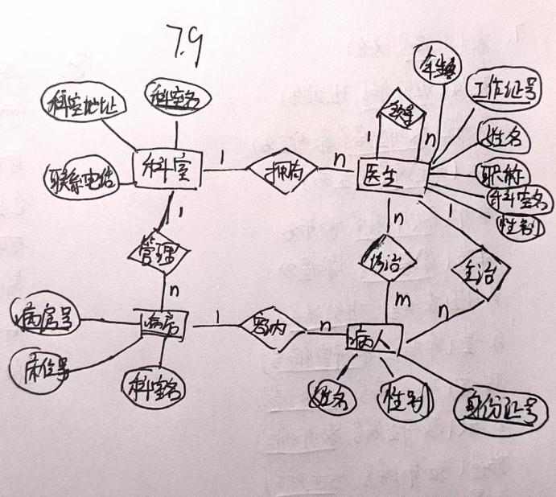

7.11

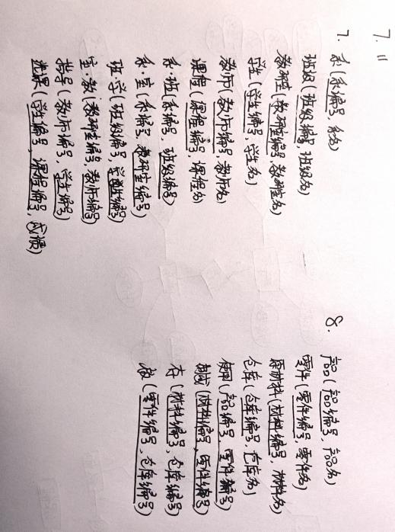

10.2

1. 20000/40 = 500 次磁盘读写
2. B+树3层，每层均有I/O，所以总共要 3+1=4次磁盘读写
3. R需要500块，S需要40块，设有K块内存可用，K-1块存放S，1块存放R，故总共需要 $\left\lceil \frac{40}{K−1}\right\rceil ∗500 + 40$ 块
4. 若已经排好序则只需要 500+40 = 540块，若无序则需要先排序，对R和S排序需要2 * 500 * (log2500 + 1) + 2 * 40 * (log240 + 1) ，后再加540块

10.3

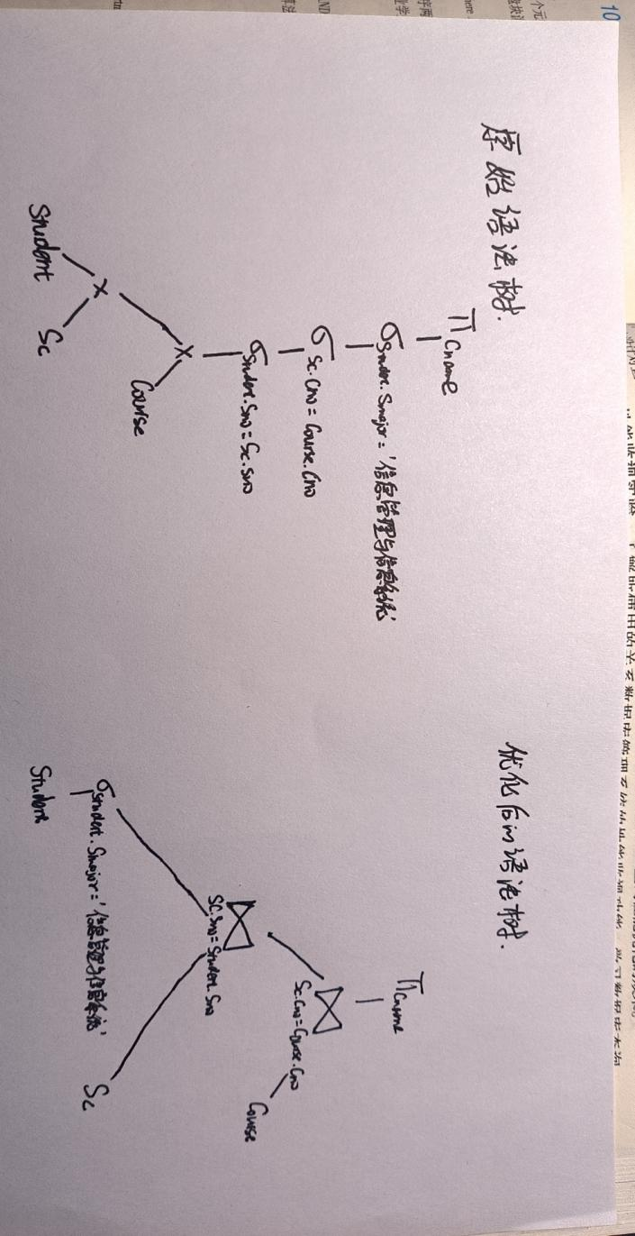

10.4

1. 对Teacher表进行全表扫描，查找满足Tsex=’女’的元组
2. 因为Dno有B+树索引，所以扫描B+树找到Dno=301的索引项，然后顺着B+树顺序找到Dno<301的索引，再根据这些索引找到对应元组
3. 对Work表进行全表扫描，查找满足Year<>’2000’的元组
4. 扫描B+树找到Year=2000的索引，在顺着B+树找到Year>2000的索引，根据这些索引找到元组后再遍历元组查找满足Salary<5000的元组
5. 对Work表进行全表扫描，查找满足Year<2000或Salary<5000的元组

11.4

1. T1 和T3重做，T2和T4回滚
2. T1 重做，T2和T3回滚
3. T1 重做，T2和T3回滚
4. T1 重做，T2回滚

11.5

1. A = 8 B = 7 C = 11
2. A = 10 B = 0 C = 11
3. A = 10 B = 0 C = 11
4. A = 10 B = 0 C = 11
5. A = 10 B = 0 C = 11
6. A = 0 B = 0 C = 0

12.10.1

T1T2T3 -> 16 T1T3T2 -> 8 T2T1T3 -> 4

T2T3T1 -> 2 T3T1T2 -> 4 T3T2T1 -> 2

故共4种结果，分别是2,4,6,16

12.10.2 12.10.3

|  |  |  |  |  |  |  |  |
| --- | --- | --- | --- | --- | --- | --- | --- |
| T1 | T2 | T3 |  |  | T1 | T2 | T3 |
| Slock A |  |  |  |  | Slock A |  |  |
| Y=R(A)=0 |  |  |  |  | Y=R(A)=0 |  |  |
| Unlock A |  |  |  |  | Unlock A |  |  |
| Xlock A |  |  |  |  |  | Slock A |  |
|  | Slock A |  |  |  |  | Y=R(A)=0 |  |
| A=Y+2 | wait |  |  |  |  | Unlock A |  |
| W(A) | wait |  |  |  | Xlock A |  |  |
| Unlock A | wait |  |  |  | A=Y+2 |  |  |
|  | Y=R(A)=2 |  |  |  | W(A) |  |  |
|  | Unlock A |  |  |  | Unlock A |  |  |
|  | Xlock A |  |  |  |  |  | Slock A |
|  |  | Slock A |  |  |  |  | Y=R(A)=2 |
|  | A=Y*2 | wait |  |  |  |  | Unlock A |
|  | W(A) | wait |  |  |  | Xlock A |  |
|  | Unlock A | wait |  |  |  | A=Y*2 |  |
|  |  | Y=R(A)=4 |  |  |  | W(A) |  |
|  |  | Unlock A |  |  |  | Unlock A |  |
|  |  | Xlock A |  |  |  |  | Xlock A |
|  |  | A=Y**2 |  |  |  |  | A=Y**2 |
|  |  | W(A) |  |  |  |  | W(A) |
|  |  | Unlock A |  |  |  |  | Unlock A |
| A = 16 | | |  |  | A=4 | | |

12.10.4 12.10.5

|  |  |  |  |  |  |  |  |
| --- | --- | --- | --- | --- | --- | --- | --- |
| T1 | T2 | T3 |  |  | T1 | T2 | T3 |
| Slock A |  |  |  |  | Slock A |  |  |
| Y=R(A)=0 |  |  |  |  | Y=R(A)=0 |  |  |
| Xlock A |  |  |  |  |  | Slock A |  |
| A=Y+2 |  |  |  |  |  | Y=R(A)=0 |  |
| W(A) |  |  |  |  |  |  | Slock A |
| Unlock A |  |  |  |  |  |  | Y=R(A)=0 |
|  | Slock A |  |  |  | Xlock A |  |  |
|  | wait |  |  |  | wait | Xlock A |  |
|  | Y=R(A)=2 |  |  |  |  | wait | Xlock A |
|  | Xlock A |  |  |  |  |  |  |
|  | A=Y*2 |  |  |  |  |  |  |
|  | W(A) |  |  |  |  |  |  |
|  | Unlock A |  |  |  |  |  |  |
|  |  | Slock A |  |  |  |  |  |
|  |  | wait |  |  |  |  |  |
|  |  | Y=R(A)=4 |  |  |  |  |  |
|  |  | Xlock A |  |  |  |  |  |
|  |  | A=Y**2 |  |  |  |  |  |
|  |  | W(A) |  |  |  |  |  |
|  |  | Unlock A |  |  |  |  |  |

12.11

R3(B) R1(A) W3(B) R2(B) R2(A) W2(B) R1(B) W1(A)

交换R1(A)和W3(B) R2(B) R2(A) W2(B) R1(B)，得到

R3(B) W3(B) R2(B) R2(A) W2(B) R1(B) R1(A) W1(A)

发现这个调度sc’是可串行化的，故原调度sc是冲突可串行化的