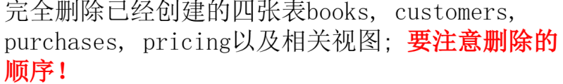

**delete** pricing

**delete** purchases

**delete** customers

**delete** books

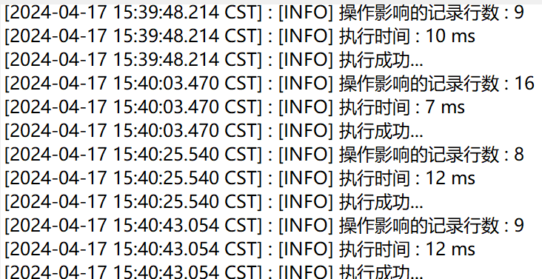

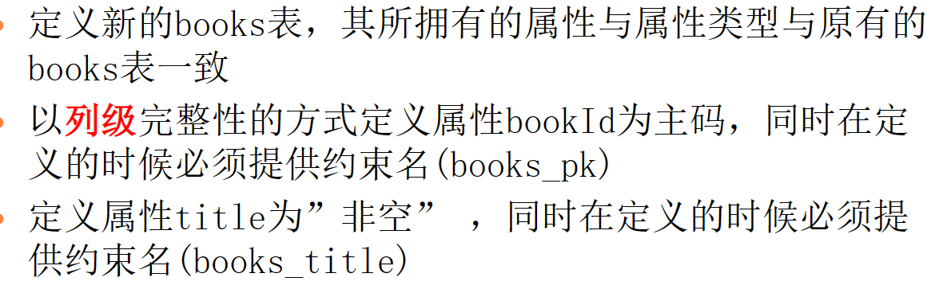

**create** **table** books(

bookid **numeric**(9,0)

**CONSTRAINT** books_pk **primary** **key**,

title **varchar**(80)

**CONSTRAINT** books_title **not** **null**,

author **varchar**(40),

**year** **int**,

category **varchar**(15));

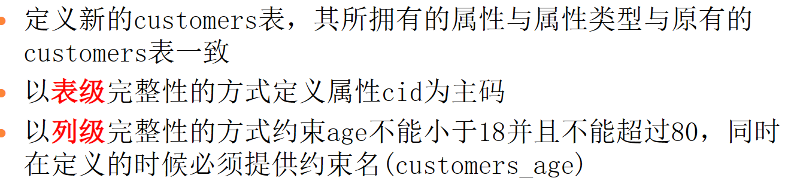

**create** **table** customers(

cid **numeric**(9,0),

cname **varchar**(40),

age **int**

**CONSTRAINT** customers_age **check**(age **between** 18 **and** 80),

yob **int**,

**primary** **key**(cid));

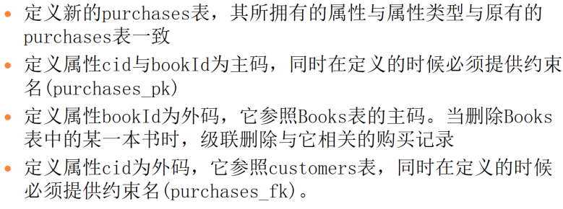

**create** **table** purchases(

cid **numeric**(9,0),

bookid **numeric**(9,0),

pdate **timestamp**,

pprice **numeric**(8,2),

**CONSTRAINT** purchases_pk **primary** **key**(cid,bookid),

**FOREIGN** **key** (bookid) **references** books(bookid) **on** **delete** **cascade**,

**CONSTRAINT** purchases_fk **FOREIGN** **key** (cid) **REFERENCES** customers(cid));

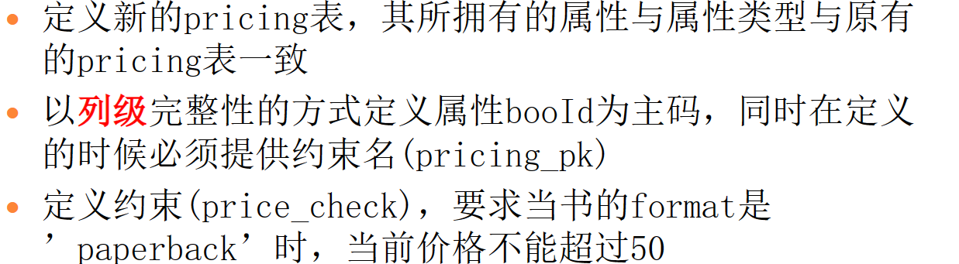

**create** **table** pricing(

bookid **numeric**(9,0)

**CONSTRAINT** pricing_pk **primary** **key**,

format **varchar**(15),

pricefornew **numeric**(9,2),

priceforused **numeric**(9,2)

**CONSTRAINT** price_check **check**((format **=** 'paperback'

**and** pricefornew**<=**50) **or** format**<>**'paperback'));

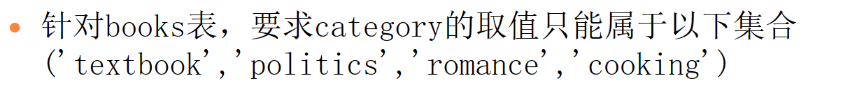

**alter** **table** books

**add** **CONSTRAINT** books_category

**check**(category **in**('textbook','politics','romance','cooking'));



**alter** **table** customers

**drop** **CONSTRAINT** customers_age;

**alter** **table** customers

**add** **CONSTRAINT** customers_age **check**(age **between** 18 **and** 85);

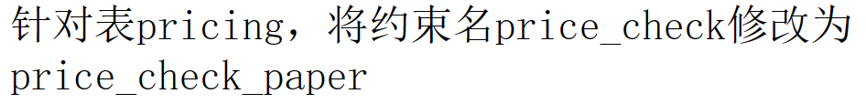

**alter** **table** pricing

**drop** **CONSTRAINT** price_check;

**alter** **table** pricing

**add** **CONSTRAINT** price_check_paper **check**((format **=** 'paperback'

**and** pricefornew**<=**50) **or** format**<>**'paperback');

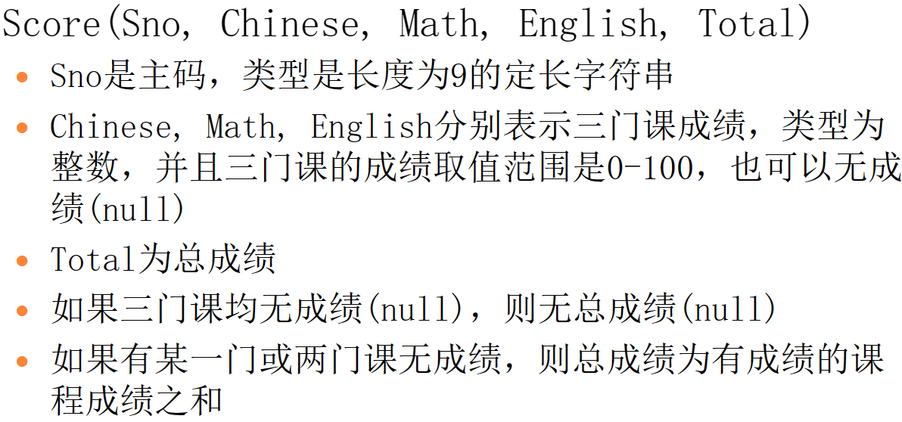

**create** **table** Score(

Sno **char**(9) **primary** **key**,

Chinese **int** **check**((Chinese **between** 0 **and** 100) **or** Chinese **is** **null**),

Math **int** **check**((Math **between** 0 **and** 100) **or** Math **is** **null**),

English **int** **check**((English **between** 0 **and** 100) **or** English **is** **null**),

Total **int** **check**(((chinese **is** **not** **null** **or** math **is** **not** **null** **or** english **is** **not** **null**) **and** total **is** **not** **null**)

**and** (Total **=** Chinese **+** Math **+** English)

**or** (chinese **is** **null** **and** math **is** **null** **and** english **is** **null** **and** total **is** **null**)));



**CREATE** **OR** **REPLACE** **FUNCTION** tri_insert_func()

**RETURNS** **TRIGGER** **AS**

$$

**DECLARE**

**BEGIN**

new.total **:=** 0;

**IF**(new.chinese **is** **not** **null**) **THEN**

new.total **:=** new.total **+** new.chinese;

**END** **IF**;

**IF**(new.math **is** **not** **null**) **THEN**

new.total **:=** new.total **+** new.math;

**END** **IF**;

**IF**(new.english **is** **not** **null**) **THEN**

new.total **:=** new.total **+** new.english;

**END** **IF**;

**IF** ((new.chinese **is** **null**) **and** (new.math **is** **null**)

**and** (new.english **is** **null**))

**THEN** new.total **:=** **null**;

**END** **IF**;

**RETURN** NEW;

**END**

$$ **LANGUAGE** PLPGSQL;

**CREATE** **TRIGGER** insert_trigger

**BEFORE** **INSERT** **ON** score

**FOR** **EACH** **ROW**

**EXECUTE** **PROCEDURE** tri_insert_func();

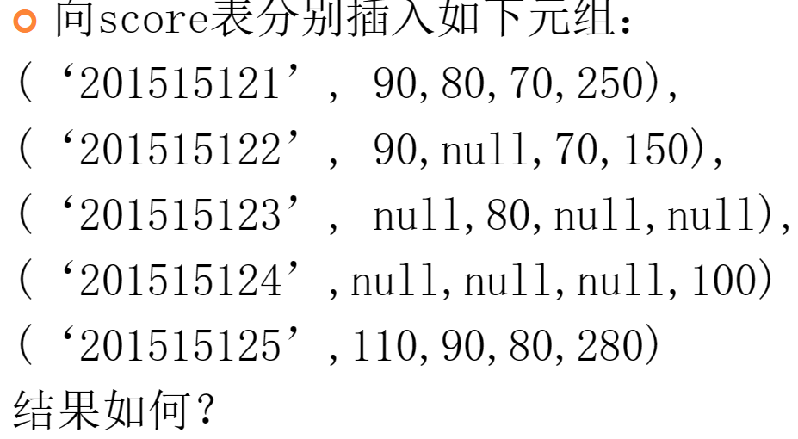

成功执行前4条，最后一条语文分数大于100被拒绝执行

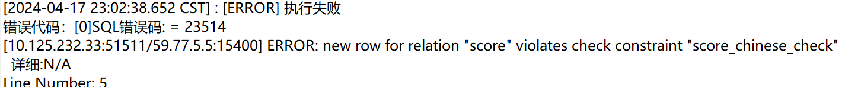

**update** score

**set** english **=** 90

**where** sno **=** '201515124'

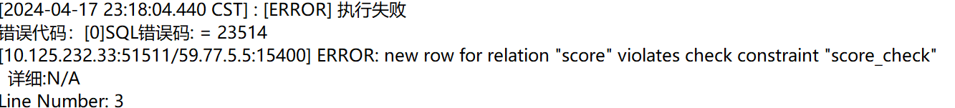

被拒绝执行



**grant** **all** **PRIVILEGES**

**on** **table** student,**class**

**to** U1

**WITH** **GRANT** **OPTION**;



**grant** **select**,**update**(address)

**on** **table** student

**to** U2

**WITH** **GRANT** **OPTION**;



**grant** **select**

**on** **table** student

**to** public;



**grant** **select**,**update**

**on** **table** student

**to** R1;



**create** **role** R1;

**grant** **select**,**update**

**on** **table** student

**to** R1;

**grant** R1

**to** U1

**with** **grant** **option**;



**grant** **select**

**on** **table** emp,dept

**to** 王明;



**grant** **insert,delete**

**on** **table** emp,dept

**to** 李勇;



**grant** **select**，**update**(sal)

**on** **table** emp

**to** 刘星;



**grant** **alter**

**on** **table** emp,dept

**to** 张新;



**grant** **all** **PRIVILEGES**

**on** **table** emp,dept

**to** 周平

**with** **grant** **option**;



**create** **view** sal **as**

**select** dept.deptno,max(sal),min(sal),avg(sal)

**from** dept,emp

**where** dept.deptno **=** emp.deptno

**group** **by** dept.deptno

**grant** **select**

**on** **view** sal

**to** 杨兰



**revoke** **select**

**on** **table** dept

**from** 王明



**revoke** **insert**

**on** **table** dept,emp

**from** 李勇



**revoke** **update**(sal)

**on** **table** emp

**from** 刘星

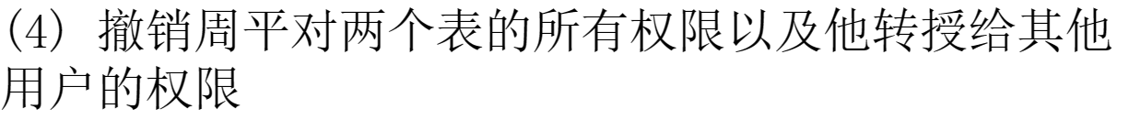

**revoke** **all** **PRIVILEGES**

**on** **table** emp,dept

**from** 周平 **cascade**