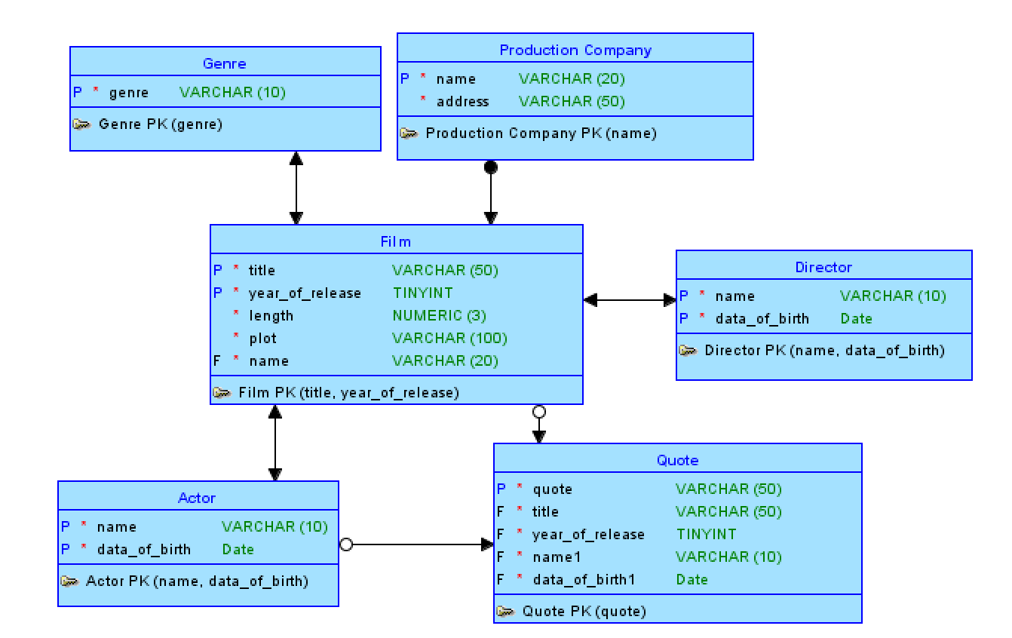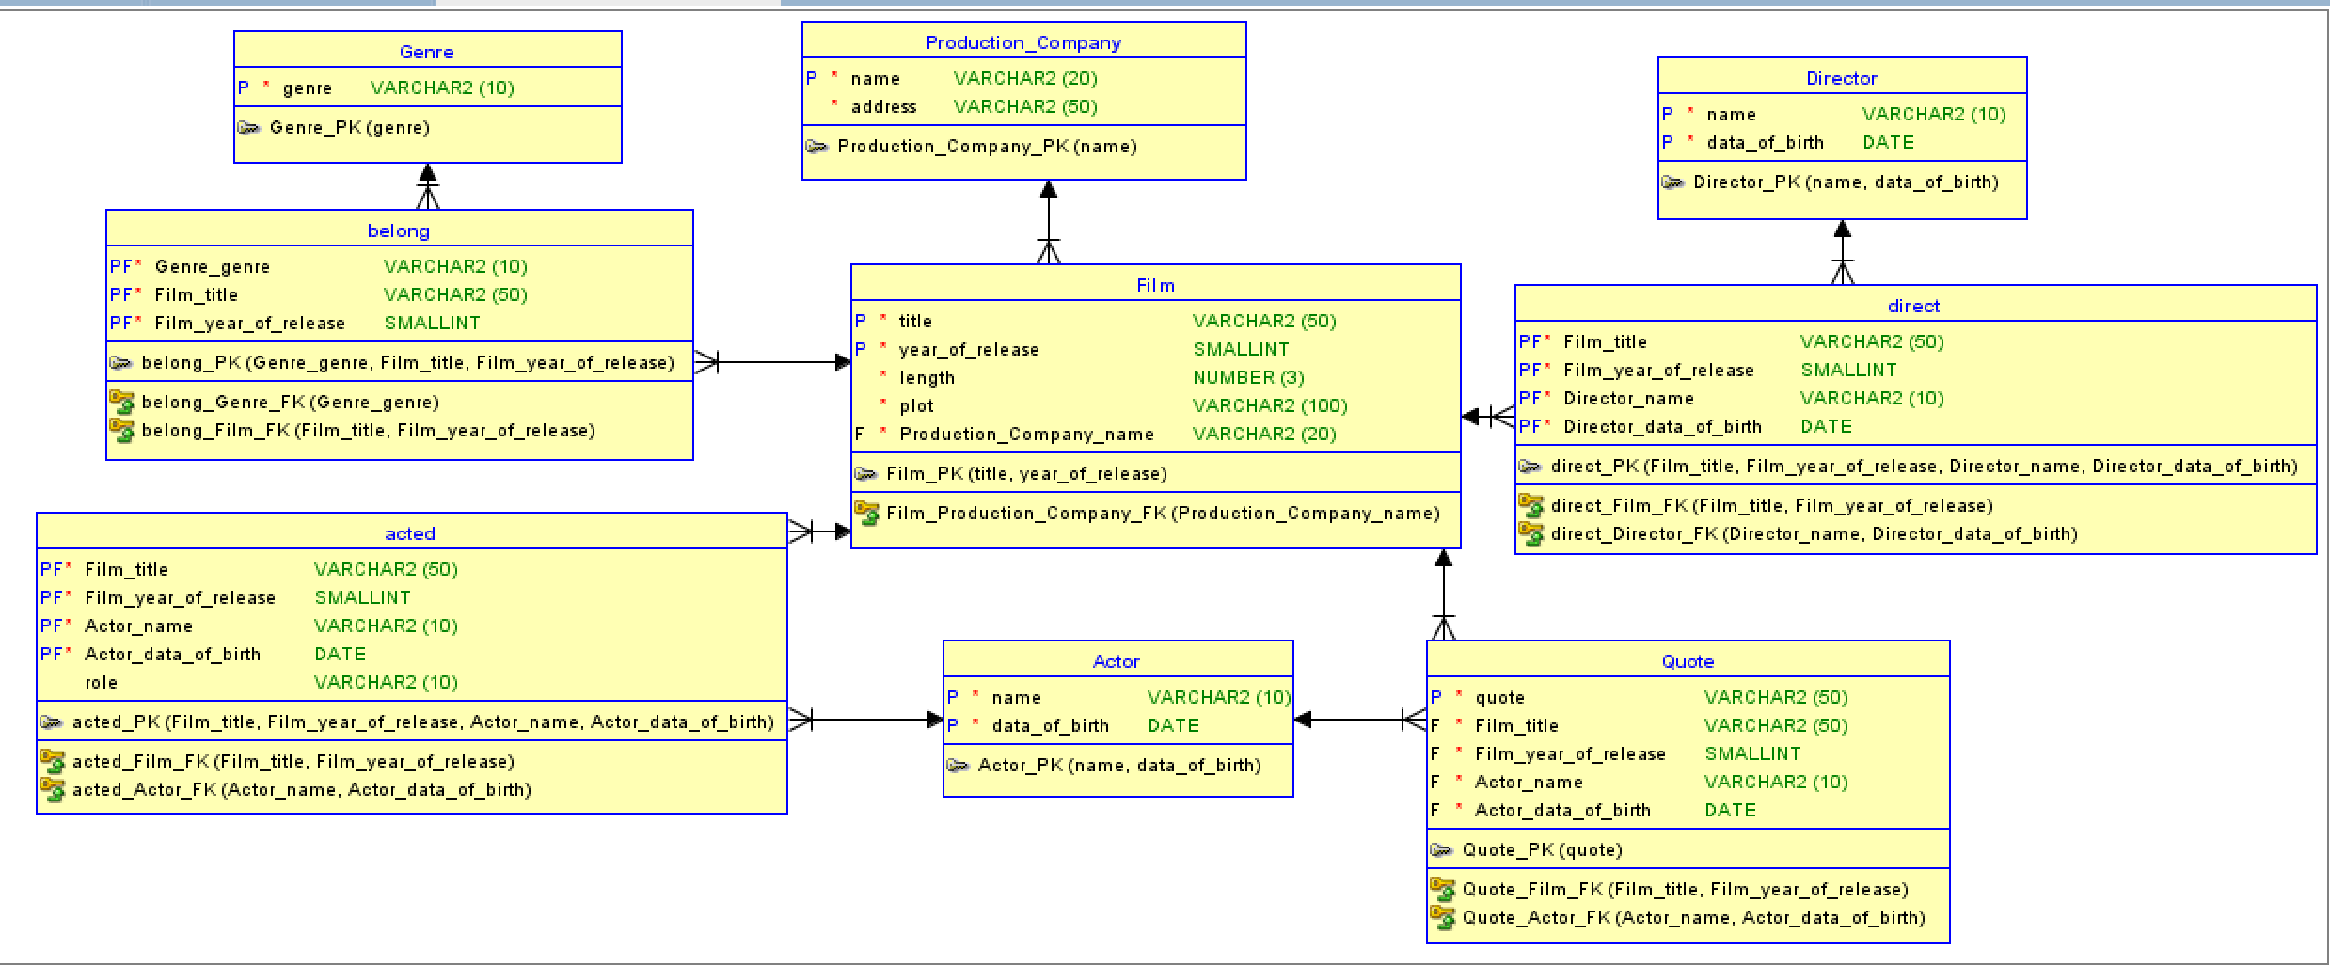

-- 生成者Oracle SQL Developer Data Modeler 17.2.0.188.1059

-- 时间: 2024-05-19 21:11:31 CST

-- 站点: Oracle Database 12c

-- 类型: Oracle Database 12c

CREATE TABLE acted (

film_title VARCHAR2(50) NOT NULL,

film_year_of_release SMALLINT NOT NULL,

actor_name VARCHAR2(10) NOT NULL,

actor_data_of_birth DATE NOT NULL,

role VARCHAR2(10)

);

ALTER TABLE acted

ADD CONSTRAINT acted_pk PRIMARY KEY ( film_title,film_year_of_release,actor_name,actor_data_of_birth );

CREATE TABLE actor (

name VARCHAR2(10) NOT NULL,

data_of_birth DATE NOT NULL

);

ALTER TABLE actor ADD CONSTRAINT actor_pk PRIMARY KEY ( name,data_of_birth );

CREATE TABLE belong (

genre_genre VARCHAR2(10) NOT NULL,

film_title VARCHAR2(50) NOT NULL,

film_year_of_release SMALLINT NOT NULL

);

ALTER TABLE belong

ADD CONSTRAINT belong_pk PRIMARY KEY ( genre_genre,film_title,film_year_of_release );

CREATE TABLE direct (

film_title VARCHAR2(50) NOT NULL,

film_year_of_release SMALLINT NOT NULL,

director_name VARCHAR2(10) NOT NULL,

director_data_of_birth DATE NOT NULL

);

ALTER TABLE direct

ADD CONSTRAINT direct_pk PRIMARY KEY ( film_title,film_year_of_release,director_name,director_data_of_birth );

CREATE TABLE director (

name VARCHAR2(10) NOT NULL,

data_of_birth DATE NOT NULL

);

ALTER TABLE director ADD CONSTRAINT director_pk PRIMARY KEY ( name,data_of_birth );

CREATE TABLE film (

title VARCHAR2(50) NOT NULL,

year_of_release SMALLINT NOT NULL,

length NUMBER(3) NOT NULL,

plot VARCHAR2(100) NOT NULL,

production_company_name VARCHAR2(20) NOT NULL

);

ALTER TABLE film ADD CONSTRAINT film_pk PRIMARY KEY ( title,year_of_release );

CREATE TABLE genre (

genre VARCHAR2(10) NOT NULL

);

ALTER TABLE genre ADD CONSTRAINT genre_pk PRIMARY KEY ( genre );

CREATE TABLE production_company (

name VARCHAR2(20) NOT NULL,

address VARCHAR2(50) NOT NULL

);

ALTER TABLE production_company ADD CONSTRAINT production_company_pk PRIMARY KEY ( name );

CREATE TABLE quote (

quote VARCHAR2(50) NOT NULL,

film_title VARCHAR2(50) NOT NULL,

film_year_of_release SMALLINT NOT NULL,

actor_name VARCHAR2(10) NOT NULL,

actor_data_of_birth DATE NOT NULL

);

ALTER TABLE quote ADD CONSTRAINT quote_pk PRIMARY KEY ( quote );

ALTER TABLE acted

ADD CONSTRAINT acted_actor_fk FOREIGN KEY ( actor_name,actor_data_of_birth )

REFERENCES actor ( name,data_of_birth );

ALTER TABLE acted

ADD CONSTRAINT acted_film_fk FOREIGN KEY ( film_title,film_year_of_release )

REFERENCES film ( title,year_of_release );

ALTER TABLE belong

ADD CONSTRAINT belong_film_fk FOREIGN KEY ( film_title,film_year_of_release )

REFERENCES film ( title,year_of_release );

ALTER TABLE belong

ADD CONSTRAINT belong_genre_fk FOREIGN KEY ( genre_genre )

REFERENCES genre ( genre );

ALTER TABLE direct

ADD CONSTRAINT direct_director_fk FOREIGN KEY ( director_name,director_data_of_birth )

REFERENCES director ( name,data_of_birth );

ALTER TABLE direct

ADD CONSTRAINT direct_film_fk FOREIGN KEY ( film_title,film_year_of_release )

REFERENCES film ( title,year_of_release );

ALTER TABLE film

ADD CONSTRAINT film_production_company_fk FOREIGN KEY ( production_company_name )

REFERENCES production_company ( name );

ALTER TABLE quote

ADD CONSTRAINT quote_actor_fk FOREIGN KEY ( actor_name,actor_data_of_birth )

REFERENCES actor ( name,data_of_birth );

ALTER TABLE quote

ADD CONSTRAINT quote_film_fk FOREIGN KEY ( film_title,film_year_of_release )

REFERENCES film ( title,year_of_release );

-- Oracle SQL Developer Data Modeler 概要报告:

--

-- CREATE TABLE 9

-- CREATE INDEX 0

-- ALTER TABLE 18

-- CREATE VIEW 0

-- ALTER VIEW 0

-- CREATE PACKAGE 0

-- CREATE PACKAGE BODY 0

-- CREATE PROCEDURE 0

-- CREATE FUNCTION 0

-- CREATE TRIGGER 0

-- ALTER TRIGGER 0

-- CREATE COLLECTION TYPE 0

-- CREATE STRUCTURED TYPE 0

-- CREATE STRUCTURED TYPE BODY 0

-- CREATE CLUSTER 0

-- CREATE CONTEXT 0

-- CREATE DATABASE 0

-- CREATE DIMENSION 0

-- CREATE DIRECTORY 0

-- CREATE DISK GROUP 0

-- CREATE ROLE 0

-- CREATE ROLLBACK SEGMENT 0

-- CREATE SEQUENCE 0

-- CREATE MATERIALIZED VIEW 0

-- CREATE SYNONYM 0

-- CREATE TABLESPACE 0

-- CREATE USER 0

--

-- DROP TABLESPACE 0

-- DROP DATABASE 0

--

-- REDACTION POLICY 0

-- TSDP POLICY 0

--

-- ORDS DROP SCHEMA 0

-- ORDS ENABLE SCHEMA 0

-- ORDS ENABLE OBJECT 0

--

-- ERRORS 0

-- WARNINGS 0