- 使用SQL语句重作实验3.ppt中对数据的增、改、删操作。
增
insert into books values(110,'Fundamentals of Database Systems','Ramez Elmasri',2011,'textbook')
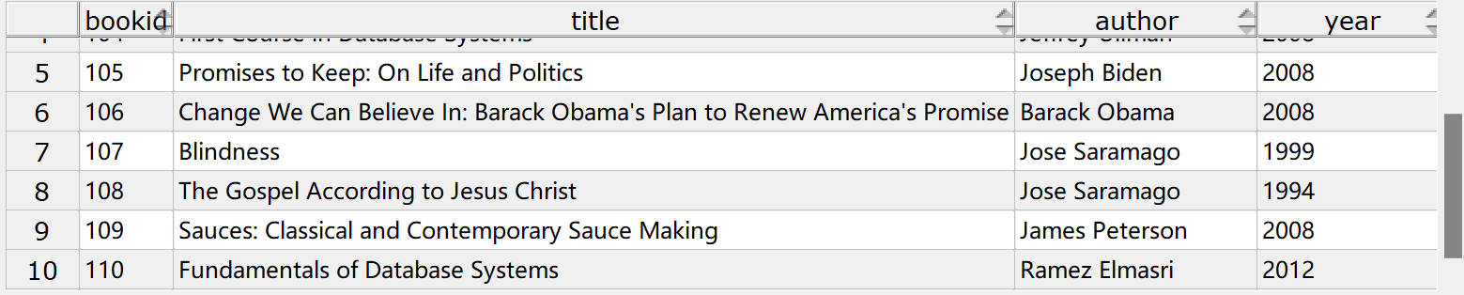
改
update books
set year = 2012
where bookid = 110
删
delete
from books
where bookid = 110
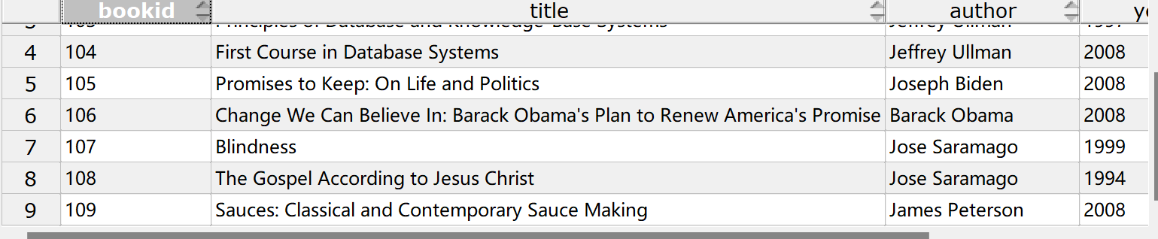
- 建立视图cus_book1, 反映出所有买书的客户id、所买的书名以及所花费用。
create view cus_book1 as
select purchases.cid, books.title, pprice
from purchases, books
where books.bookid = purchases.bookid
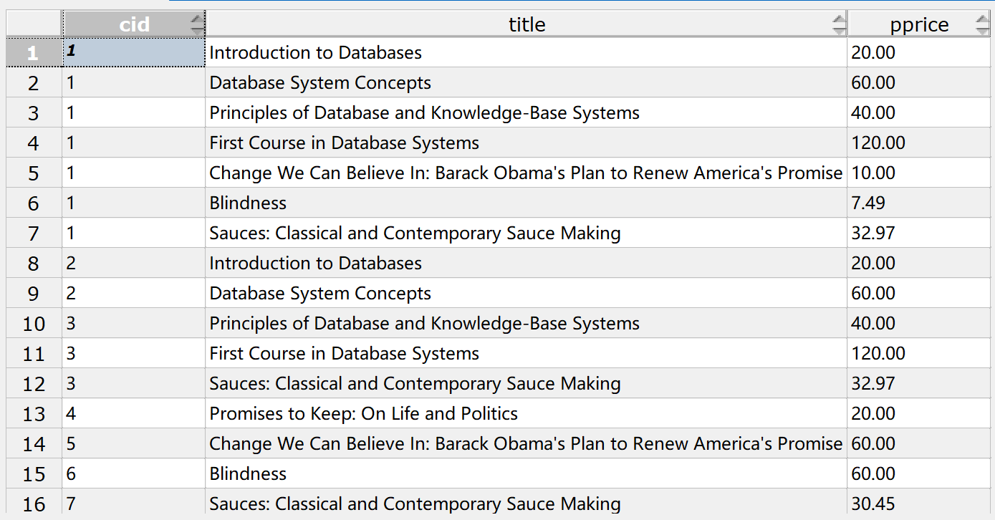
- 建立视图young_cus，反映年龄在18到35间客户的信息，查询young_cus。
create view young_cus as
select *
from customers
where age between 18 and 35

select *
from young_cus
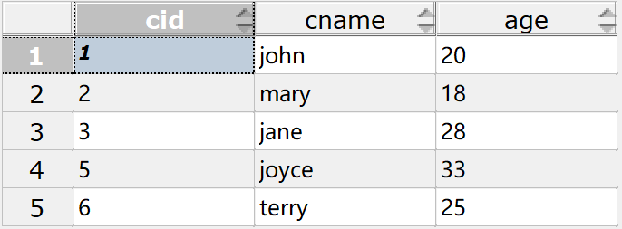
- 使用视图cus_book1建立视图cus_book2, 反映出所有买书的客户id、客户姓名、购书总开销，然后进行如下操作：
create view cus_book2 as
select cus_book1.cid, cname, sum(pprice)
from cus_book1, customers
where cus_book1.cid = customers.cid
group by cus_book1.cid,cname
  - 查询cus_book2, 按总开销降序输出所有信息。
select *
from cus_book2
order by sum desc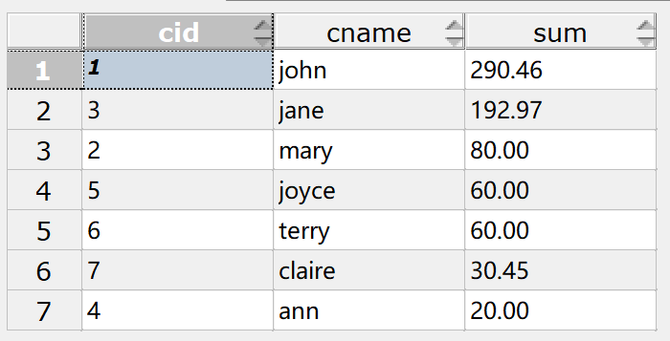
  - 彻底删除视图cus_book1，写出删除语句。
drop view cus_book1 cascade
  - 查询cus_book2, 结果如何？
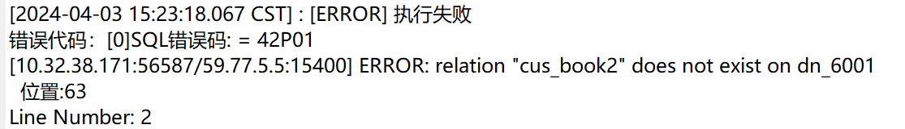
- 为customers表增加新的一列YOB, 类型整数。
alter table customers add YOB int
- 使用从系统获得的当前年份和age属性值计算每一个客户的出生年份，并写入YOB属性。
update customers
set YOB = extract(year from CURRENT_DATE) - age
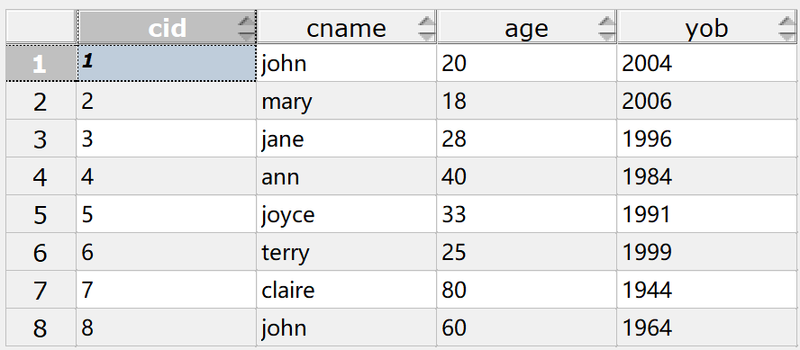
- 查询young_cus，结果如何？与之前查询的结果有什么区别？
select *
from young_cus
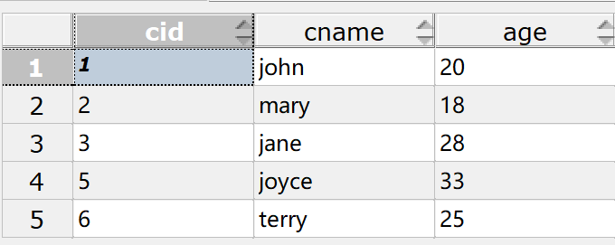
8. 完成课后作业：第三章 4，5，9
S表的定义，其中SNO的类型是定长字符串，长度为4；SNAME的类型是变长字符串，长度为20；STATUS的类型是整数；CITY的类型是变长字符串，长度为8。SNO是主码。
CREATE TABLE S(
SNO CHAR(5) PRIMARY KEY,
SNAME VARCHAR(20),
STATUS INT,
CITY VARCHAR(8))
P表的定义，其中PNO的类型是定长字符串，长度为4；PNAME的类型是变长字符串，长度为20；COLOR的类型是定长字符串，长度为4；WEIGHT的类型是整数。PNO是主码。
CREATE TABLE P(
PNO CHAR(4) PRIMARY KEY,
PNAME VARCHAR(20),
COLOR CHAR(4),
WEIGHT INT)
J表的定义，其中JNO的类型是定长字符串，长度为4；JNAME的类型是变长字符串，长度为20；CITY的类型是变长字符串，长度为8。JNO是主码。
CREATE TABLE J(
JNO CHAR(4) PRIMARY KEY,
JNAME VARCHAR(20),
CITY VARCHAR(8))
SPJ表的定义，其中SNO、PNO、JNO的类型均是定长字符串，长度为4；QTY的类型是整数；（SNO, PNO, JNO）是主码；SNO是外码，参照S表主码；PNO是外码，参照P表主码；JNO是外码，参照J表主码。
CREATE TABLE SPJ(
SNO CHAR(4),
PNO CHAR(4),
JNO CHAR(4),
QTY INT,
PRIMARY KEY(SNO,PNO,JNO),
FOREIGN KEY(SNO) REFERENCES S(SNO),
FOREIGN KEY(PNO) REFERENCES P(PNO),
FOREIGN KEY(JNO) REFERENCES J(JNO))
按照教材（第六版）P65的4个表向数据库中插入基础数据。
SELECT DISTINCT SNO
FROM SPJ
WHERE JNO = 'J1'
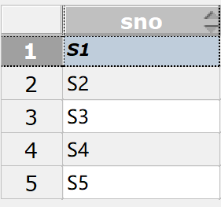
SELECT DISTINCT SNO
FROM SPJ
WHERE JNO = 'J1' AND PNO = 'P1'
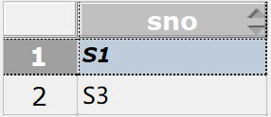
SELECT DISTINCT SNO
FROM SPJ, P
WHERE SPJ.JNO = 'J1' AND SPJ.PNO = P.PNO AND P.COLOR = '红'
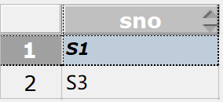
SELECT DISTINCT JNO
FROM SPJ
EXCEPT
SELECT DISTINCT JNO
FROM SPJ,S,P
WHERE SPJ.SNO = S.SNO AND SPJ.PNO = P.PNO AND P.COLOR = '红' AND S.CITY = '天津'
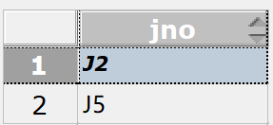
SELECT DISTINCT JNO
FROM SPJ X
WHERE NOT EXISTS
(SELECT *
FROM SPJ Y
WHERE SNO = 'S1'
AND NOT EXISTS
(SELECT *
FROM SPJ Z
WHERE Z.PNO = Y.PNO AND Z.JNO = X.JNO));
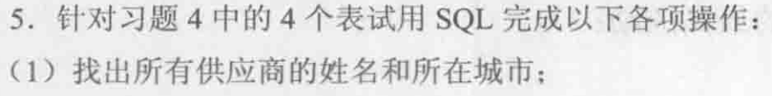
SELECT SNAME,CITY
FROM S
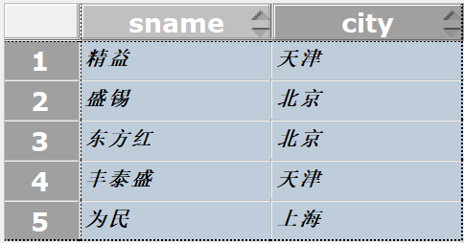
SELECT PNAME, COLOR, WEIGHT
FROM P
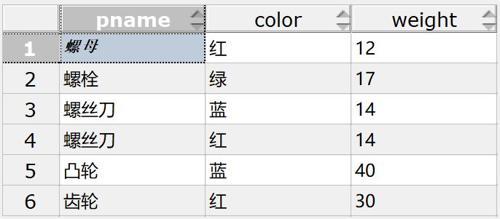
SELECT JNO
FROM SPJ
WHERE SNO = 'S1'
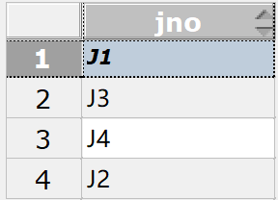
SELECT PNAME,COUNT(SPJ.PNO)
FROM SPJ,P
WHERE JNO = 'J2' AND SPJ.PNO = P.PNO
GROUP BY PNAME
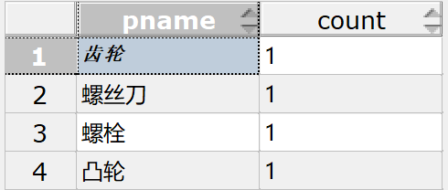
SELECT DISTINCT PNO
FROM SPJ,S
WHERE SPJ.SNO = S.SNO AND S.CITY = '上海'
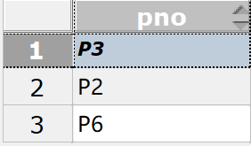
SELECT DISTINCT JNAME
FROM SPJ,S,J
WHERE SPJ.SNO = S.SNO AND S.CITY = '上海' AND SPJ.JNO = J.JNO
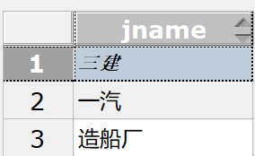
SELECT DISTINCT JNO
FROM SPJ
WHERE JNO NOT IN(
SELECT JNO
FROM SPJ,S
WHERE SPJ.SNO = S.SNO AND S.CITY = '天津')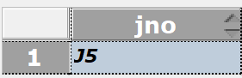
UPDATE P
SET COLOR = '蓝'
WHERE COLOR = '红'
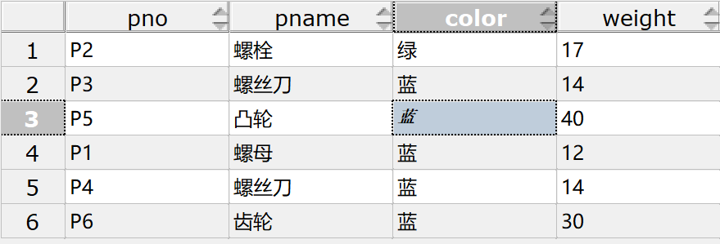
UPDATE SPJ
SET SNO = 'S3'
WHERE SNO = 'S5' AND PNO = 'P6' AND JNO = 'J4'
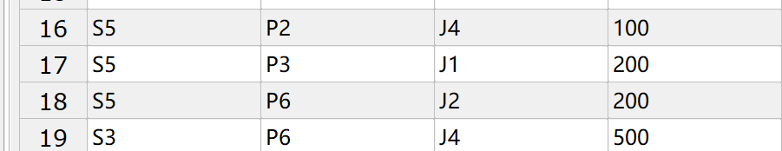
INSERT
INTO SPJ(SNO,JNO,PNO,QTY)
VALUES('S2','J6','P4',200)
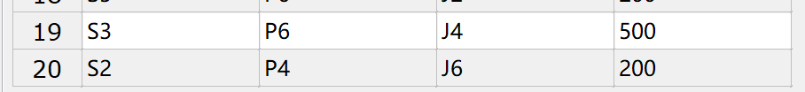
DELETE
FROM SPJ
WHERE SNO = 'S2'
DELETE
FROM S
WHERE SNO = 'S2'
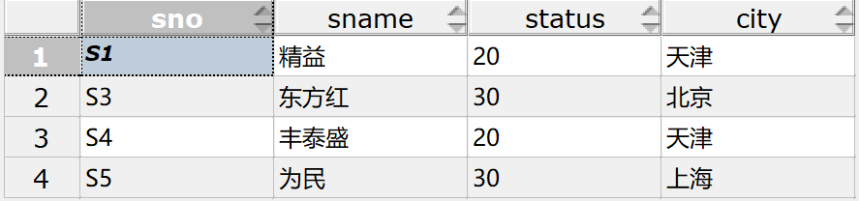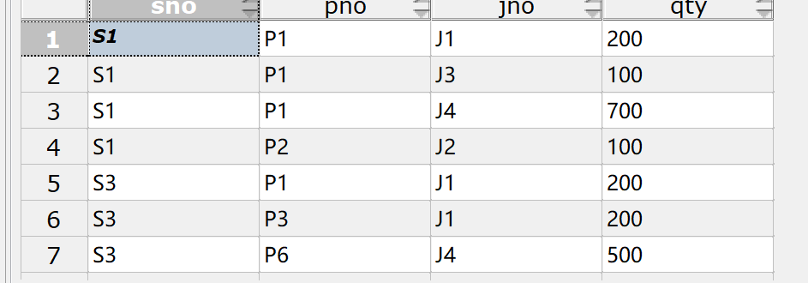
CREATE VIEW SUPPLY AS
SELECT SNO,PNO,QTY
FROM SPJ,J
WHERE J.JNAME = '三建' AND J.JNO = SPJ.JNO
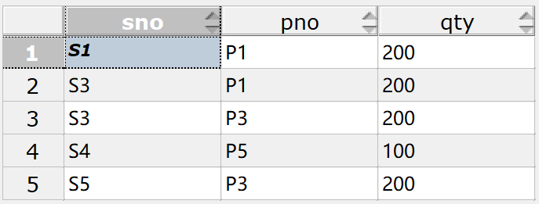
SELECT PNO,SUM(QTY)
FROM SUPPLY
GROUP BY PNO
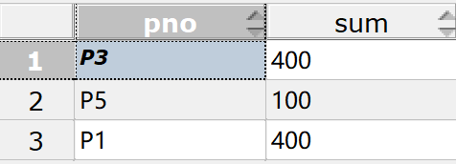
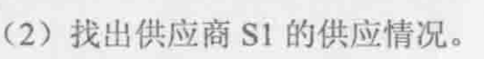
SELECT *
FROM SUPPLY
WHERE SNO = 'S1'
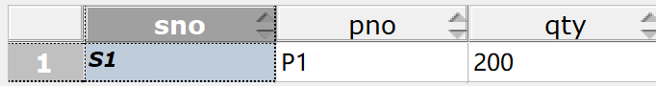
注意：
- SPJ表中的数据不全，只要是满足SPJ定义的数据都是合法数据。在写查询语句的时候要全面考虑。
- 关于第2章习题6（5）的理解：假如S1提供了零件P1,P2，只要找出至少用了P1，P2的工程号，这些零件不必须是S1提供的。
- 第5题，要先做⑪，再做⑩。

