Technical Review & Architecture Specification
  - Next-Gen Clinical Site Onboarding (Agentic RAG & Event-Driven)

1. System Architecture Overview
The target architecture transitions the onboarding tracker from a fragile, localized file system into a resilient, globally distributed platform. By decoupling transactional state management from document storage and analytical reads, the system supports high concurrency and scales to manage upwards of ~50,000 active site workflows without locking or latency degradation.

Architecture Flow Diagram:
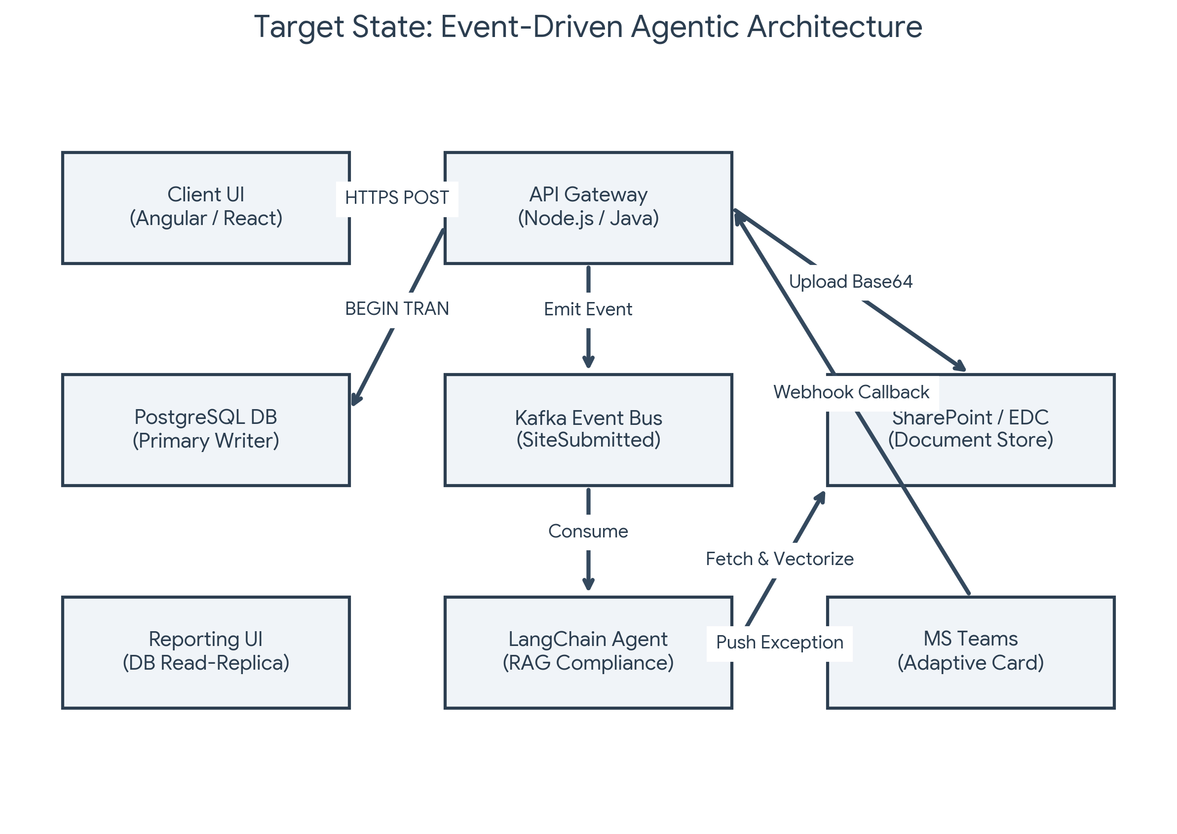

2. Component Technology Stack
Layer | Technology | Engineering Rationale
Client / UX | Angular / React | Delivers a component-driven Single Page Application (SPA) for manual intake, regional dashboarding, and administrative controls.
API Gateway | Node.js / Java | Manages inbound HTTP traffic, enforces Enterprise SSO token validation, and acts as the primary webhook receiver for asynchronous approval actions.
Transactional State | PostgreSQL | Provides absolute ACID guarantees. Enforces row-level security and utilizes JSONB for maintaining the complex, hierarchical state of site submissions.
Event Orchestration | Apache Kafka | Completely decouples write operations from AI processing and analytics, preventing the primary database from bottlenecking during heavy asynchronous document checks.
AI / RAG Engine | LangChain + Vector DB | Autonomously parses unstructured investigator PDFs against embedded clinical compliance manuals to determine approval eligibility.
Document Store | SharePoint / EDC | Serves as the enterprise blob storage. Bypasses the database entirely to prevent bloat when handling massive clinical data artifacts.
Human Interface | MS Teams Adaptive Cards | Pushes actionable JSON payloads directly to approvers, enabling zero-friction, one-click state transitions without requiring secondary portal logins.

3. Data Layer & 21 CFR Part 11 Compliance
Regulatory compliance dictates that no record can be mutated without a permanent, tamper-evident trail. Relying on simple database triggers is insufficient for distributed environments. Instead, the Node.js API handles state transitions transactionally, writing both the new state and the audit log simultaneously.
The following PostgreSQL schema defines the immutable audit ledger. It captures the exact actor context, time, and full JSON payloads of the state before and after the mutation, sealed with a cryptographic signature.
CREATE TABLE clinical_audit_log (
audit_id UUID PRIMARY KEY DEFAULT gen_random_uuid(),
site_id UUID REFERENCES clinical_sites(site_id),
actor_id VARCHAR(255) NOT NULL,
action_type VARCHAR(50) NOT NULL,
old_state JSONB, -- Complete previous row snapshot
new_state JSONB, -- Complete updated row snapshot
permission_context JSONB, -- RBAC role and SSO session data
cryptographic_signature TEXT NOT NULL, -- Tamper-evidence hash
created_at TIMESTAMPTZ DEFAULT NOW()
);

4. Agentic RAG Document Processing (SharePoint ETL)
To eliminate the manual bottleneck of reading thousands of compliance documents, the AI layer acts as the primary validation gatekeeper.
1. Intake & Extraction: Upon submission via the React/Angular UI, the API routes the raw PDF files (Investigator CVs, NDAs) directly into a secured SharePoint directory.
2. Vectorization: A background ETL workflow chunks these documents and stores the embeddings in a vector database.
3. Validation: The LangChain Orchestrator Agent executes a RAG workflow, cross-referencing the newly submitted credentials against your internal clinical policy vectors.
4. Decision Routing: If the documents match the requirements perfectly, the agent issues an API call to PostgreSQL to advance the state machine to 'Approved'. If discrepancies are found, it kicks the workflow to the exception queue.

5. Frictionless Approvals via Adaptive Cards
When the AI flags an exception (e.g., an outdated credential), it does not send a passive email. It dispatches a structured Adaptive Card directly to the regional operations channel via MS Teams.
The approver receives the context and can execute the state change directly within the chat client. The Action.Submit block below defines the authenticated POST request sent back to the API.
{
"type": "AdaptiveCard",
"version": "1.4",
"body": [
{
"type": "TextBlock",
"text": "⚠️ Pending Compliance Approval",
"weight": "Bolder",
"size": "Medium"
},
{
"type": "FactSet",
"facts": [
{ "title": "Site ID:", "value": "US-4092" },
{ "title": "Investigator:", "value": "Dr. Sarah Chen" },
{ "title": "AI Risk Score:", "value": "High - License Expiry < 30 Days" }
]
}
],
"actions": [
{
"type": "Action.Submit",
"title": "Approve Exception",
"style": "positive",
"data": {
"action": "approve",
"siteId": "US-4092",
"actorRole": "Regional_Director"
}
},
{
"type": "Action.Submit",
"title": "Reject / Request Updates",
"style": "destructive",
"data": {
"action": "reject",
"siteId": "US-4092",
"actorRole": "Regional_Director"
}
}
]
}

