Detailed Technical Architecture & Design Review

1. Executive Architecture & Tooling Summary
This technical specification outlines the production-grade architecture for an AI-assisted clinical research metadata ingestion service. The system guarantees zero data loss, strict immutability, row-level error visibility, and automated schema inference using a Human-in-the-Loop AI workflow.

1.1 End-to-End Architecture Flow with Tooling Stack
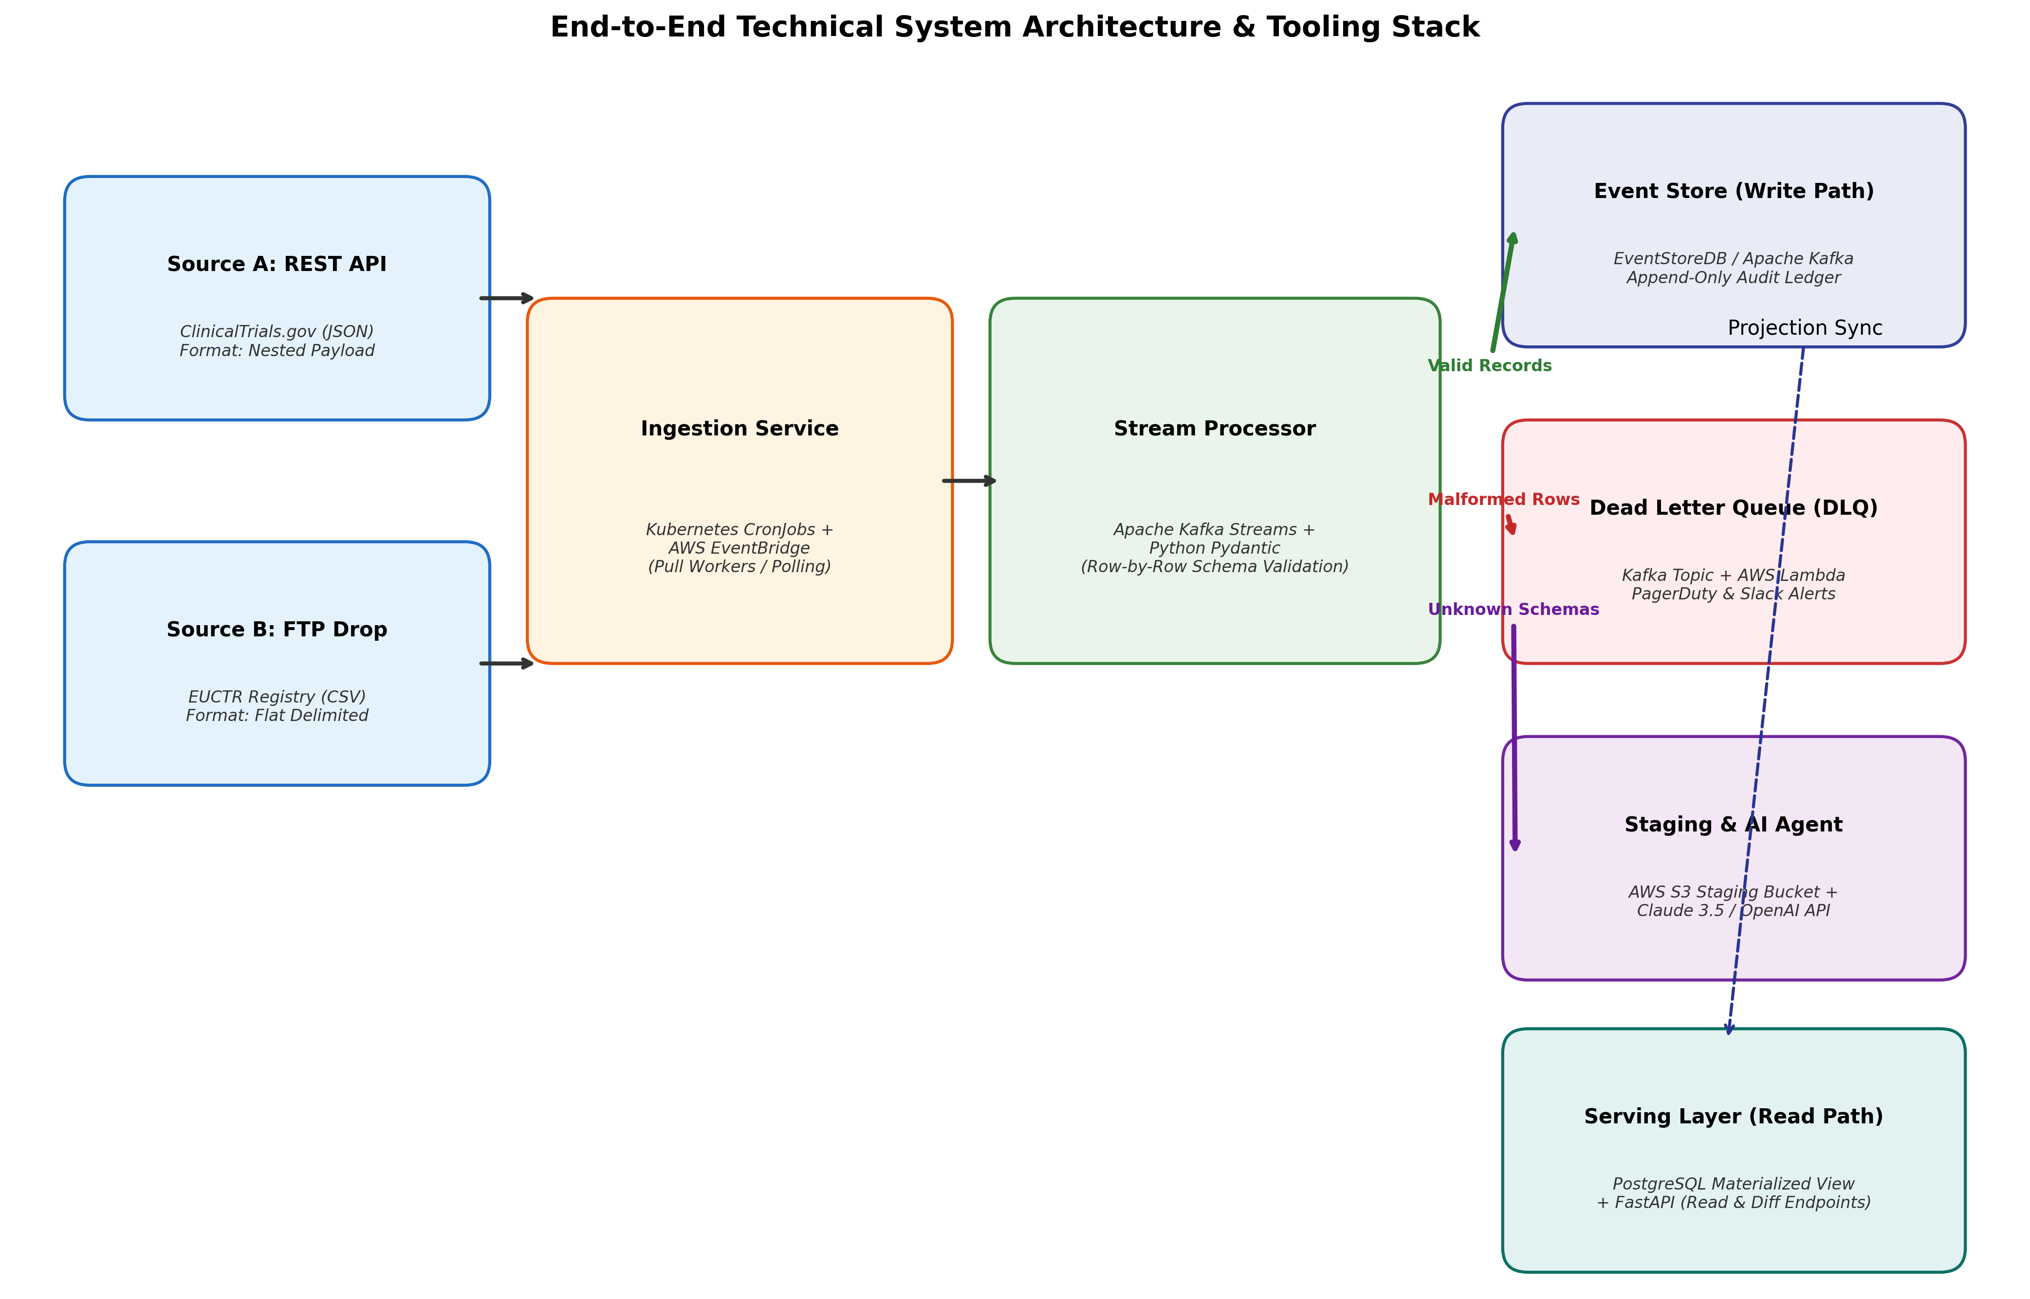

1.2 Tooling Stack Breakdown
Layer / Component | Technology / Tool | Architectural Responsibility
Data Sources | ClinicalTrials.gov REST API, Regional CSV Drops | Originating semi-structured research metadata
Ingestion Workers | Kubernetes CronJobs + AWS EventBridge | Pull-based polling and initial payload ingestion
Stream Processing | Apache Kafka + Kafka Streams | Row-by-row parsing, routing, and adapter management
Data Validation | Python Pydantic v2 | Declarative schema validation and error surface generation
Immutable Event Store | EventStoreDB / Apache Kafka | Append-only ledger of all research state mutation events
Serving Store (CQRS) | PostgreSQL (Materialized Views) | Query-optimized read model and diff calculations
Read & Diff API | FastAPI / Python | Exposes canonical endpoints and /diff?since=timestamp
Dead Letter Queue | Kafka Topic + AWS Lambda | Isolates malformed records with attached error context
Alerting Surface | PagerDuty + Slack Webhooks | Notifies data owners of row-level validation failures
AI Schema Agent | AWS S3 + AWS Lambda + Claude 3.5 Sonnet / GPT-4o | Asynchronous schema inference on unknown source shapes
Human Steward UI | React.js + Tailwind CSS | Interactive dashboard for reviewing AI proposals and approving mappings

2. AI Schema Mapping Visual Workflow & Implementation
When an unrecognized source shape arrives (e.g., Source C with unique header naming conventions), the stream processor routes the payload to a quarantine staging area rather than failing the batch or dropping data.

2.1 Step-by-Step AI Mapping Flowchart
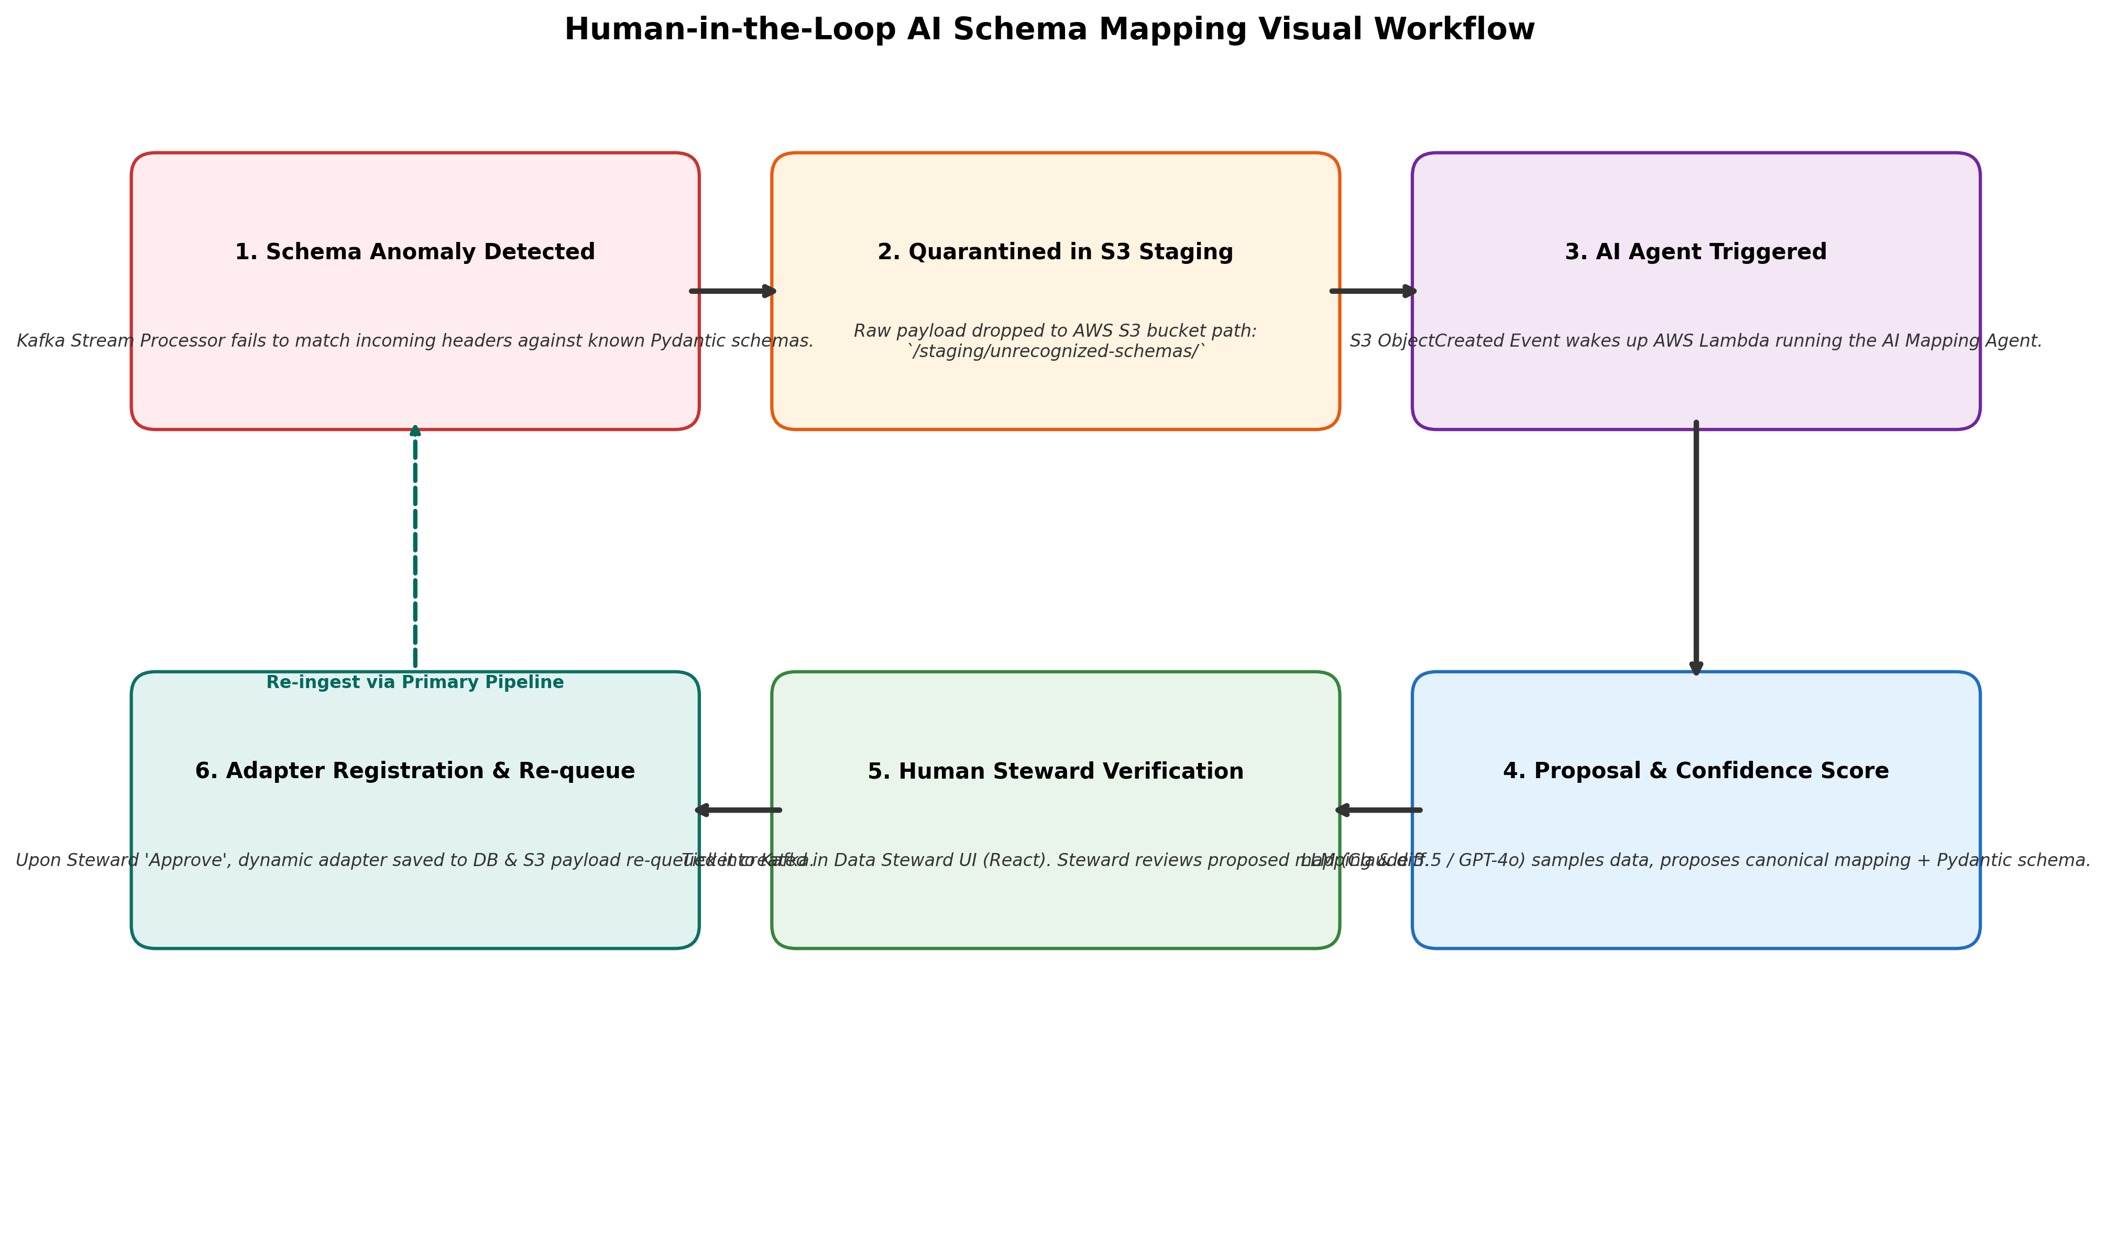

2.2 Responsible AI & Human-in-the-Loop (HITL) Rules
- Zero Autonomous Schema Mutation: The AI agent is strictly sandboxed. It generates mapping proposals but never directly modifies production database schemas or dynamic adapters.
- Confidence Scoring Thresholds: Proposals with confidence scores above 85% are highlighted for quick human approval; proposals below 85% flag specific ambiguous fields for manual correction.
- Deterministic Verification: Prior to steward approval, the proposed mapping is tested against a sample batch using Pydantic to ensure syntax and type compatibility.

3. Observability & Real-Time Dashboard Metrics
The system provides clear observability into ingestion health, DLQ error rates, and canonical data distributions.
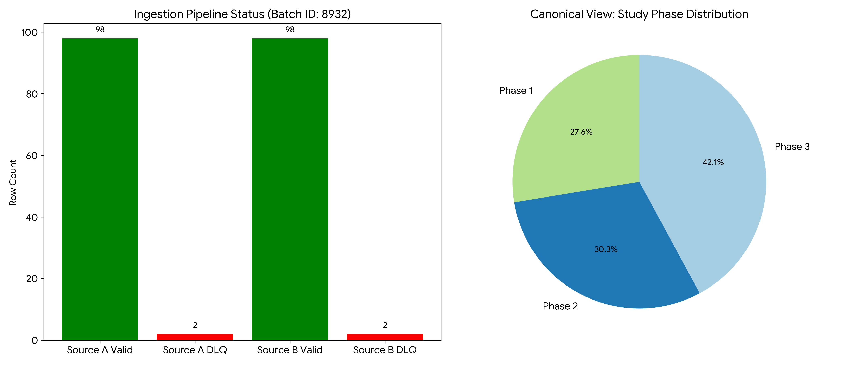

2.3 Data Steward Verification UI (Mockup)
The following mock UI demonstrates the Human-in-the-Loop interface. When the AI agent finishes proposing a schema mapping for an unrecognized payload, it pauses execution and generates a ticket. The Data Steward can review the raw data against the AI's canonical mapping, verify the confidence score, and approve the payload for re-ingestion.
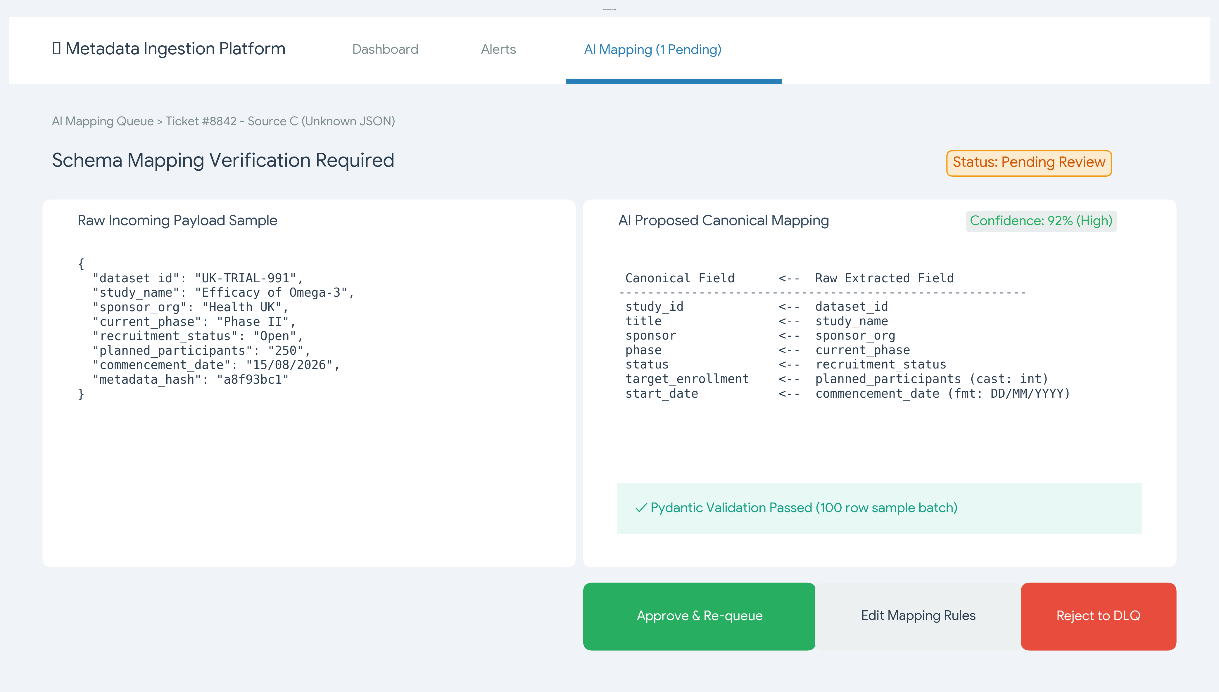

4. API Contracts & Structured Logging

4.1 Immutable Event Serving (Read API & Diff Endpoint)
The FastAPI implementation below demonstrates the CQRS read model and the event-sourced diff endpoint, satisfying the requirement to serve a canonical read API and a 'diff since timestamp' endpoint without expensive relational database joins.
from fastapi import FastAPI, Query
from datetime import datetime
from typing import List
app = FastAPI(title="Clinical Metadata API")
@app.get("/api/v1/studies", response_model=List[CanonicalStudy])
async def get_all_studies():
"""Returns the canonical, validated view of all ingested research studies."""
return db.query_materialized_view("SELECT * FROM canonical_studies_read_model")
@app.get("/api/v1/studies/diff", response_model=List[StudyEvent])
async def get_study_diffs(since: datetime = Query(..., description="ISO-8601 Timestamp")):
"""
Queries the append-only Event Store directly.
Returns all state changes (e.g., TargetEnrollmentUpdated) that occurred after the timestamp.
"""
events = event_store.get_events_since(timestamp=since)
return events

4.2 Structured Error Logging (DLQ Payload)
When declarative Pydantic validation fails, the stream processor emits a structured JSON log to the Dead Letter Queue. This payload ensures clear error surfaces are maintained and bad rows are explained, not swallowed.
{
"timestamp": "2026-09-24T19:15:00Z",
"level": "ERROR",
"component": "KafkaStreamProcessor",
"adapter": "EUCTR_CSV_v1",
"event": "VALIDATION_FAILURE",
"raw_payload": {"dataset_id": "EU-882", "planned_participants": "TBD"},
"error_surface": [
{
"loc": ["target_enrollment"],
"msg": "Input should be a valid integer, unable to parse string as an integer",
"type": "int_parsing"
}
]
}

