**Website Building: Basic Layout**



HTML - First web page

The following exercise contains the following subjects:

* HTML

**Instructions**

Build a simple HTML profile page that must include at

least the following HTML tags:

* An image of yourself
* A header and sub-header with your name and your job title (you can put programmer now)
* A description of yourself
* A list of your social links

**Extra:**

* A button

Here is an [example](https://obrm-personal-site-demo.netlify.app/)

**Find a good picture**

Prepare your profile image file before starting to code. For this exercise, you can use your profile picture from Facebook, and save it in an images folder.

Your file structure should be something like this:

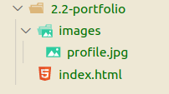

You can use [Font Awesome](https://fontawesome.com/) to find awesome icons (e.g for

social networks). It’s a super useful library because all of

the icons are fonts, making it really easy to resize them,

change their color, and even add animations to them! All

you have to do is create a kit and embed the script you get

from them into your head element. [Get started now](https://fontawesome.com/start).

**Indent or die**

Take your time to indent your HTML carefully. HTML code

has a lot of nesting. If you don’t indent, it will be very hard

to understand the structure of your code.

Which code is easier to understand?

This one: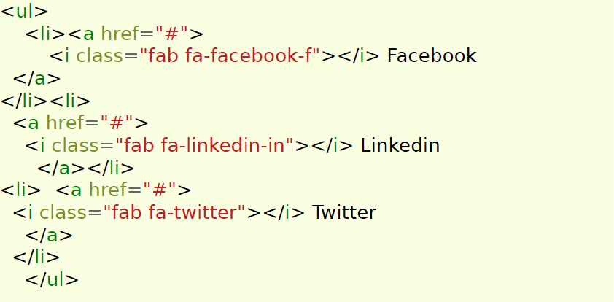

Or this one:

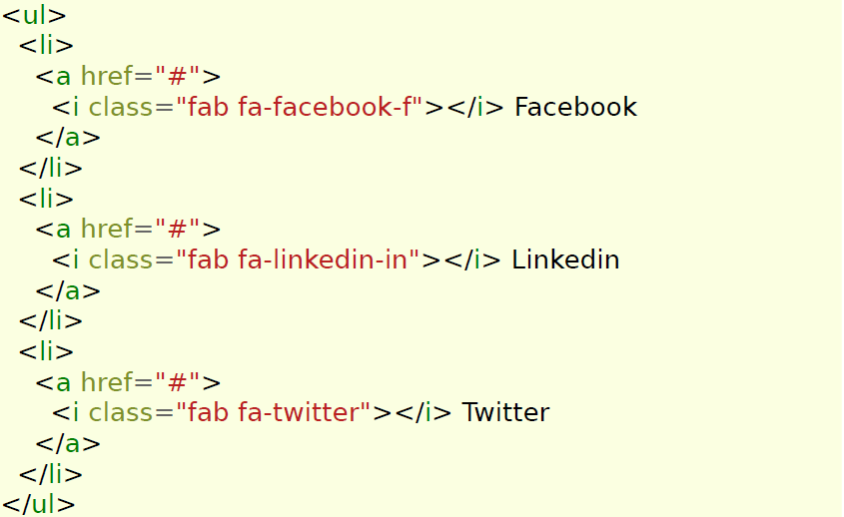

Indent your HTML! Your code should look like a **V formation**

**of ducks ↓**

