**Intro**

Runes of Ede is a story driven, competitive LCG focusing on the history of a forgotten planet, Ede. You, and those who decide to come along this journey, will get to dive through the archives of the forgotten planet and learn of the powerful Runes harnessed by the mightiest Marvels, most vicious Savages, most brilliant Intellects, and the most gifted Mystics this universe has ever seen.

For more information on the story behind Runes of Ede, visit:

Also, looking for a community to engage with, check us out here:

FB

Twitter

Discord

Website

**Deck Construction**

**Stockpile -** consists of 18 Runes that act as your life as well as your main resource. When 9 of your Runes have been broken – you lose the game. Each stockpile can play up to 9 Ancient Runes – Ancient Runes are immensely powerful and have unique effects that trigger once they are broken, or they can have their effects resolved while in your resource area.

When a Rune is in your resource area, it can be exhausted (turned sideways) to help pay for Units, Events, etc.

**Ex:** I have 5 Runes in play in my resource area, and I want to play Bale, Steadfast, a 3 cost Unit. I will exhaust 3 of my Runes and attempt to play him. Now I have 2 readied (in upright position) Runes remaining.

**Ancient Runes**

When in your resource area Ancient Runes can have their effects resolved during the Main Phase by paying the associated cost, and then turning the card to its backside. Once flipped to its backside, an Ancient Rune has the same abilities as a standard Rune of the matching color.

**Ex:** Using the above Ancient Savage Rune; during your Main Phase you can exhaust 3 of your Runes, including the Ancient Savage Rune being activated, resolve the printed ability, and then flip the Ancient Rune to its backside.

When an Ancient Rune is broken (placed in your damage area from an attack), the printed ability resolves without having to pay the associated costs.

**Archive –** your Archive must contain a minimum of 40 cards and consists of a combination of Events and Units. You can play up to 3 copies of any single card, unless otherwise stated. If your deck runs out of cards, you lose the game.

**Units**

Units have a few attributes to be aware of:

* Top left-hand corner contains the cost of the card
* On the right side of the image, you’ll notice some runes pictured. This is the specified cost. This means that the card above, Dean, Stroke of Genius costs requires that 4 runes are exhausted and two of them must be blue (the color of the Intellects).
* The middle of the card states what type of card it is. In this case Dean, Stroke of Genius is classified as a “Legendary Unit” (more on that later).
* Below that is the actual ability box that describes what the card does.
* On the bottom right of the card is where the card’s power is located.
* You’ll notice some Units have an image of lightning bolts in the ability box. This means that these cards may be played at any time.

**A player can only have 1 copy of a given Unit in play at a time.**

**Legendary Units**

In Runes of Ede there are featured characters that have the classification of “Legendary Unit”. A Legendary Unit offers their controller a ***once per game*** ability to discard an extra copy of a Legendary Unit in hand to do one of the following:

* If the Legendary Unit is in play and would be targeted by an effect, you may drop a copy of the same Unit in your discard pile to negate that effect.
* When attempting to play a Legendary Unit, you may drop a copy of the same Unit in your discard pile to stop the opposing player from using a counter in response to the Unit coming into play.
* During your Main Phase, if you have a Legendary Unit in play, you may drop a copy of the same Unit in your discard pile to draw 2 cards.

**Unit – Token**

In Runes of Ede, Savages can generate an army of Savage Warriors to swarm the battlefield. Savage Warrior Tokens have no costs (the same as costing 0), 1000 base power, and are still considered a Unit for effects. The major difference is that you can have multiples of the same Unit – Token in play at the same time.

**Events**

Events contain the following attributes:

* Top left-hand corner contains the cost of the card
* On the right side of the image, you’ll notice some runes pictured. This is the specified cost. This means that the card above, Calculation costs requires that 1 rune be exhausted and that one must be blue (the color of the Intellects).
* Middle of the card states what type of card it is, in this case Calculation is an “Event”.
* Below that is the actual ability box that describes what the card does.
* You’ll notice some events have an image of lightning bolts in the ability box. This means that these cards may be played at any time.

**Something to Remember When Playing a Unit or Event**

When playing a Unit or Event card, an opportunity arises for the opposing player to respond. If the player declines the opportunity, the card resolves.

If the player does choose to respond, this then creates an opportunity for the original card’s controller to respond. This process repeats until both players decline, then all cards resolve in order of newest to oldest.

**Game Setup**

Your **Stockpile** and **Deck** should be placed in different spots on your board. Once each deck has been randomized, roll dice to determine who will go first. Each player will then draw 5 cards from the top of their archive and are able to use 1 mulligan. To mulligan you place any number of cards in your hand at the bottom of your archive, then draw back up to 5 cards in hand.

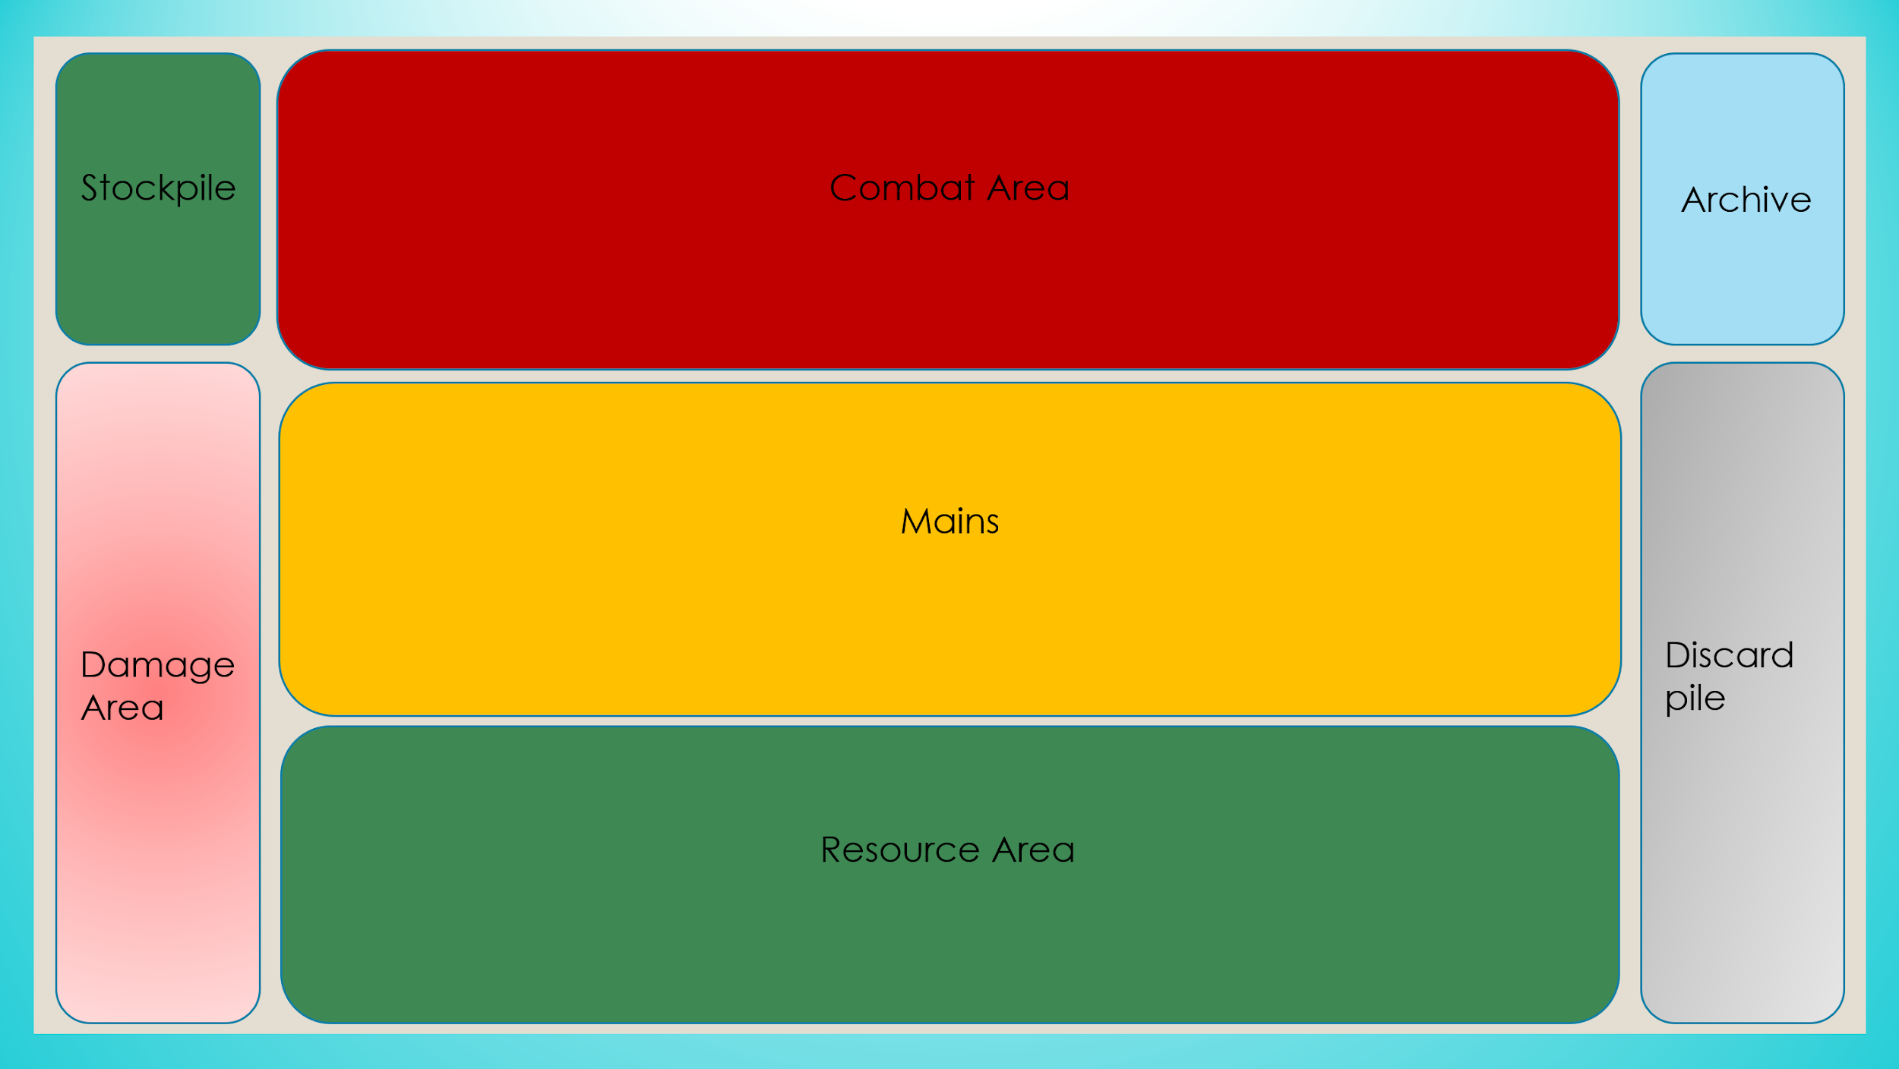

**Maximum Hand Size – 7 cards:** If at the end of your turn you have 8 or more cards in hand, you must

**Turn Structure**

**Start-up, Ready all cards you control, unless otherwise stated, then you *may* place the top card of your Stockpile into your resource area, then draw a card from the top of your archive.**

**Whoever goes first will not be able to draw a card on their first turn. \***

**Main 1 –**

* Play Units, Events, activate rune abilities from your resource area, etc.

**Combat –**

**Unless otherwise stated, all Units will not be able to attack the turn they are played**

* Active player declares attacks one at a time by moving the attacking Unit into the combat area and exhausting it, unless otherwise stated.
* Active player exhausts a Unit they wish to attack (unless otherwise stated).
  + If no block occurs, a Rune is broken by placing the top card of the stockpile into its owner’s damage area.
  + If an Ancient Rune is broken, the controller may resolve the effect.
* Defending players declare blocks by lining up their readied Unit against the attacking Unit in the combat area.
  + Once blocks are declared the attacking player has priority to play any Events that can be played at any time. If the attacking player passes, the defending player then has priority to play any events that can be played at any time. If both players pass priority, proceed to damage calculation.
  + Damage is calculated simultaneously by measuring corresponding power ratings. If the attacking card’s power is greater than the defending card’s power, the defending card is destroyed and placed in its owner’s discard pile. If this is reversed, then the attacking card is destroyed and placed in its owner’s discard pile.
* Repeat this process until the active player chooses to end their combat phase.

**Turn player’s effects have priority – this comes up frequently with the interaction of Might and Reaper being activated at the same time post battle. The turn player’s effect will resolve first.**

**Units may block multiple times as long as they have power remaining\***

**When a Unit with 5000 power or more breaks a Rune, it breaks two instead.**

**Main 2 –**

* Play Units, Events, activate rune abilities from your resource area etc.

**End –**

* When the active player ends their turn, all power is restored to all Units, any effects lasting until end of turn dissolve, and the active player discards down to 7 cards, if necessary.

**Keep in mind that the turn player’s effects will resolve first.**

**Keywords –**

**Bounce –** return to its owner’s hand from the battlefield.

**Counter –** the specified card being played is placed in its owner’s discard pile instead of being played.

**Critical –** if this card’s attack is not blocked it breaks two runes, and if it is partially blocked, it still breaks a rune.

**\*Partially blocked means if it is blocked by a unit with less power\***

**Destroy –** place the Unit from play into its owner’s discard pile.

**Devastate -** If this card’s attack is not blocked it breaks 3 runes, and if it is partially blocked, it still breaks 2.

**Draw X -** draw X number of cards one at a time from the top of your archive.

**Drop X -** place X cards from hand into your discard pile.

**Research X –** look at the top X cards of your deck, you place any number of them at the top or bottom of your archive in any order.

**Mastery –** during your turn when you play an event, exhaust target Unit.

**Might –** the first time each turn this card destroys a Unit in a battle, this card gains 1000 power.

**Mill X –** place the top X cards from your archive into your discard pile.

**Rage –** this card may attack the turn it is played.

**Reaper -** when this Unit is removed from play, target unit gets -1000 power.

**Removed -** when a card is removed from play for any reason.

**Restore –** choose the specified card type from your discard pile and add it to your hand.

**Revive –** choose the specified card and play it onto your battlefield.

**Rummage X –** look at the top X cards of your archive for the specified card. Then place the remaining cards on the bottom of your archive in any order.

**Archetype 101 –**

**Savages**

Savages offer an aggressive strategy that relies on the use of **Rage** and swarming the battlefield early to break as many runes as possible before the opponent has a chance to turn the tide.

**Marvels**

Marvels offer a more mid-range/aggressive strategy reliant on ramping early and harnessing **Might** to grow larger over the course of the game and take over the battlefield with their overwhelming presence.

**Mystics**

Mystics offer a more mid-range/control strategy reliant on smaller Units with unique effects to disrupt the opponent, alongside the use of **Reaper** to shrink the opposing player’s Units to hold them off until they can take over the battlefield.

**Intellects**

Intellects offer a more controlling strategy reliant on counters and disruption to keep the opponent off-balance until they can take over the battlefield and leverage **Mastery** to clear the way for their best attackers to get through.

**Stone**