# Developer – Nikhil Kumar Singh

# **PDF Form Filler**

# INTRODUCTION

The PDF Form filler will ease one of the task to automate the filling out of immigration PDF Forms. This is very simple with just on the click of a button the required filled in form may be obtained.

# REQUIREMENTS

1. To automate some of the daily tasks. One of them is filling out immigration PDF forms. The specific PDF Form to be filled using data from the database.
2. PDF Form filled automatically and a new version generated with all its fields filled out.

# Recommendations:

1. You can use any programming language to accomplish this task;
2. You’re free to use any 3rd party API/library, but you must include all detailed info about it;
3. You must include detailed information about how to run your project.

# Output:

* The same PDF with some data filled in

# PDF File

<https://catalogue.servicecanada.gc.ca/apps/EForms/pdf/en/ESDC-EMP5624.pdf>

# SOFTWARE DESIGN

1. Software is designed in 3 layers
   * 1 – the backend Database Layer from where the record is to be fetched
   * 2 – the middle Business Layer which integrates the backend to the front end layer
   * 3 – the front end which is a Windows Application Form
2. The Windows Form will consist of an “input browse text field (Original PDF)” to get the pdf form and an “output browse text field (Edited PDF Path)” to set the location/folder where the filled form may be saved.
3. The Windows Form will contain One Button “Generate Edited PDF” to fill the pdf form automatically.
4. The PDF Form contains editable fields with Key Value Pairs.
5. Based on the Keys that represent specific field i.e. Text or CheckBox or RadioButton, the respective fields are to be populated.
6. An external Open Source Library “iTextSharp” is required to achieve the task, referred as dll reference.
7. The design will be like:

Data from Database

(Currently used some junk data. Once decided will use the provided dataset)

Data fed to XML File present in FileResources Folder with name “PDFFormDetails.xml”. This XML File is the interface between Database and the application. This XML file consist of key, which is similar to the text file key value so as to link it to the text file. The XML file contains value for all keys which is the value provided by the database. The XML file contains the desc field to describe the utility of the same filed

Data read from XML File name “PDFFormDetails.xml”

Data Keys checked with the text file present in FileResources Folder with name “pdfFillerKeysValues.txt” having key value pair. The text file consist of the field id of the editable fields of the PDF file and a text which resemble as key to the linked XML file.

iTextSharp library which is an Open Source, is used to read original PDF file with name “ESDC-EMP5624.pdf”.

With the same iTextSharp dll, PDFStamper is used to stamp the values present in the XML file which is linked to the text file which further has the field IDs of the PDF file editable fields.

|  |
| --- |
| **DATABASE** |
| Parameter_Value |
|  |

|  |
| --- |
| **XML File** |
| Key |
| Value |
| Desc |

|  |
| --- |
| **Text File** |
| PDF FieldID |
| Key |

|  |
| --- |
| **PDF File** |
| PDF FieldID |
|  |

# TECHNICAL DOCUMENTATION

1. The PDF Form contains editable fields with Key Value Pairs.
2. Based on the Keys that represent specific field i.e. Text or CheckBox or RadioButton, the respective fields are to be populated.
3. An external Open Source Library “iTextSharp” is required to achieve the task, referred as dll reference.
4. The iTextSharp Library used to read the PDF File, then some of the required values stamped or edited or updated or inserted.
5. The same iTextSharp Library used to loop through each key value pair fields.
6. The input for reference PDF Form file considered always same, since only one reference file provided.
7. All the editable fields in the PDF is having keys, which represent their IDs, the same referred, while updating the fields.
8. Each Keys or Field IDs may be stored in an xml file with a recognizable value. The same xml file referred while getting the Keys for the field update.
9. Data value read from the XML File (“PDFFormDetails.xml”) which may contain more than 1 pdf form data with the Element Tag “PDFFields”. Each XML Element with tag “PDFField” carries 3 parameters – 1st is key which contains key to the PDF file editable fields, 2nd is value which it takes from the database. 3rd is desc to know detail about the respective PDFField.

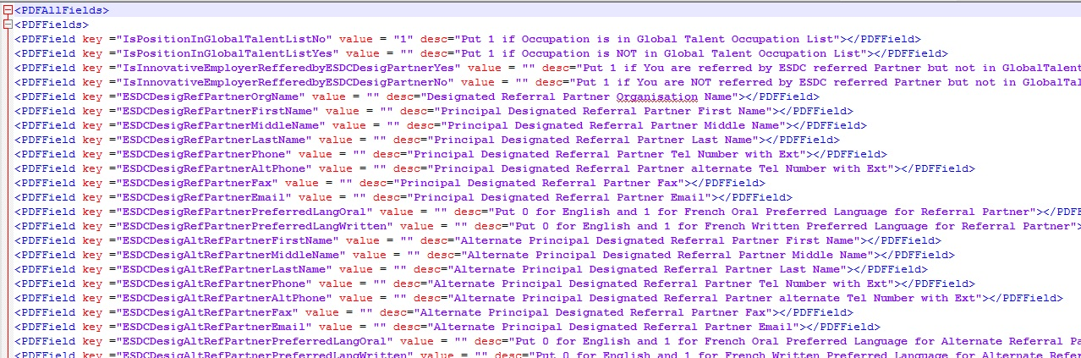

1. The XML file on one hand points to database to get the field value. On the other hand it also points to a text file with name “pdfFillerKeysValues.txt” which contains PDF file Acrofield IDs and a Key to point to the XML file separated by a tab character.

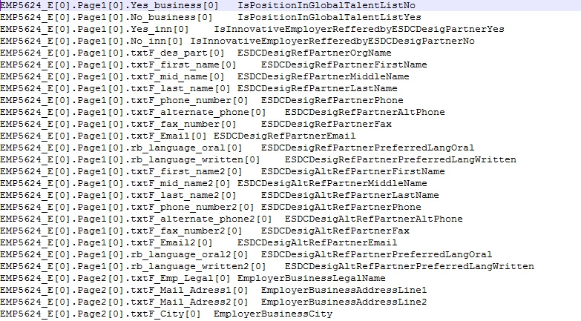

1. The text file read and then iterated through each line of key and field ID pairs. The same key referred to the xml file to get the value of the field.
2. The value then stamped to the PDF file and saved to the Edited PDF Path location.
3. Each PDF file named by suffixing “Employer Legal Name” in the original PDF file name.
4. The business class takes data from the database and pass on to the main application form.
5. The main application form will be updating the fields as per the data provided by the business class.

# USER DOCUMENTATION

Steps to get the application and Source Code from GitHub

1. Go to <https://github.com/wishnikhil/PDFFormFiller>

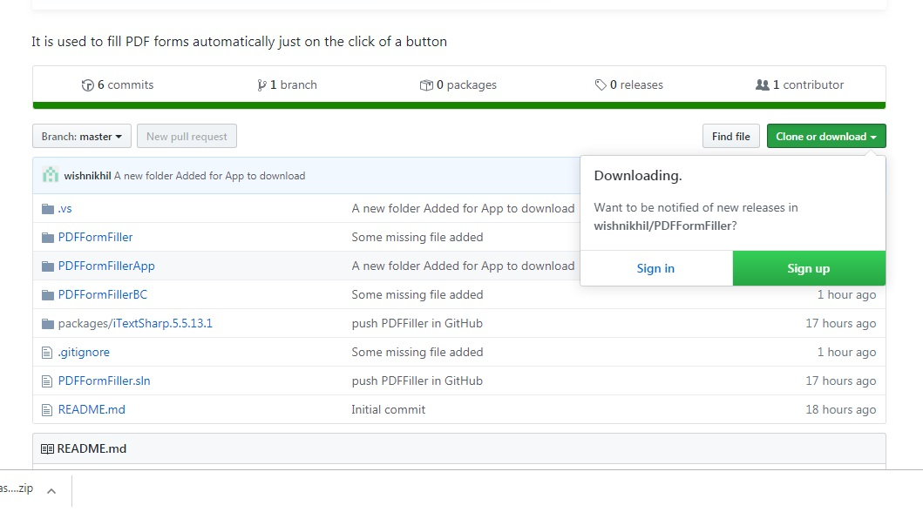

1. Download the whole Folder to get access to code or download PDFFormFillerApp to get the application
2. PDFFormFillerApp will contain 2 folders – One Documentation and Other Main Project.
3. Open Main Project to get the access to Project

Steps to Use the software:

1. Open the file PDFFormFiller.exe to launch the application

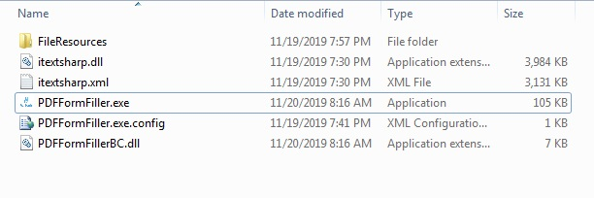

1. The Application will look like

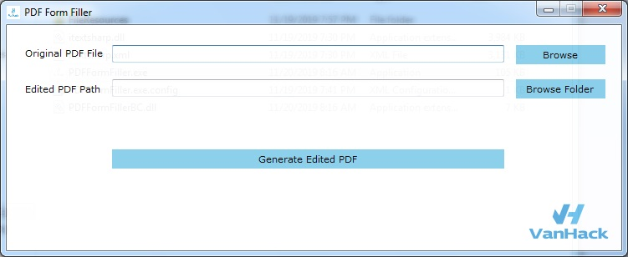

1. Clicking on Generate Edited PDF without filling the text box will generate error like this

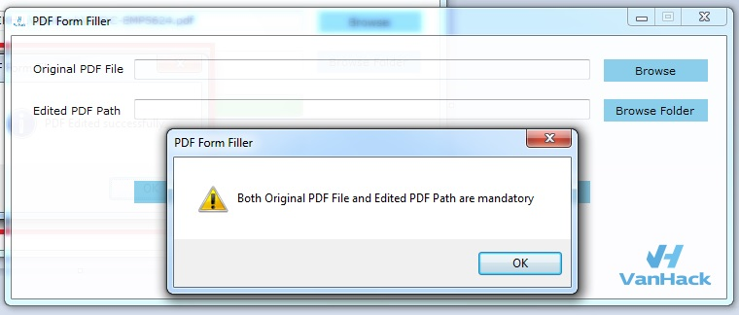

1. Fill in Original PDF File Text by clicking on Browse button, which will open a Browse window, then select the desired PDF Form Original file supposed to be with name “ESDC-EMP5624.pdf”.

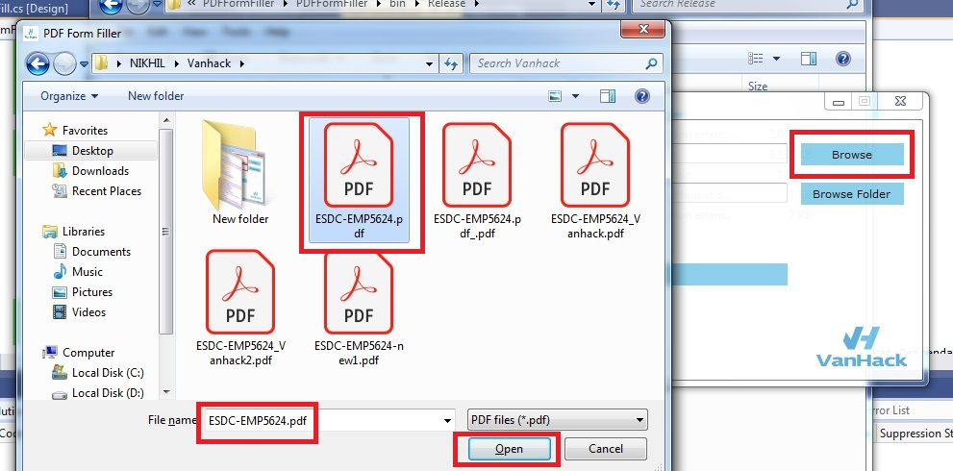

1. Fill in Edited PDF File Path by clicking on Browse Folder Button, which will open a Browse window to select the desired Folder where edited PDF Form file be saved.

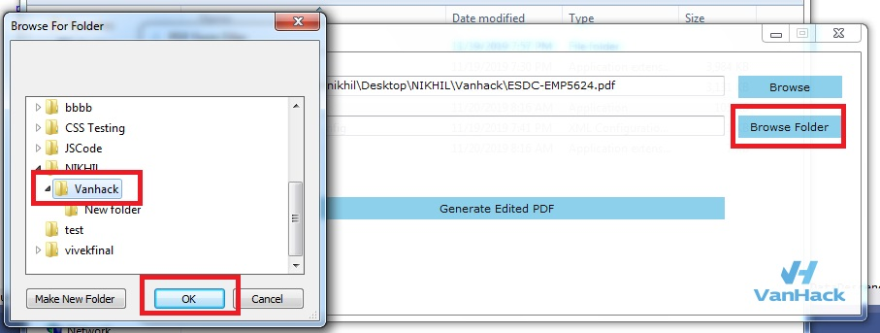

1. Click on Generate Edited PDF Button to get the desired PDF Filled Form in the directory as mentioned in the Edited PDF Path.

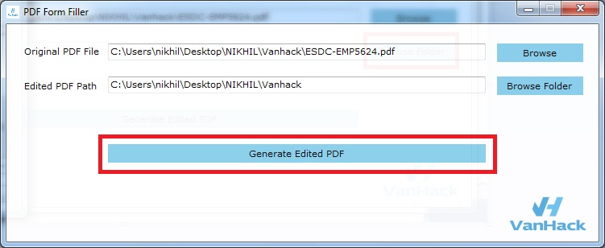

1. If succeeded following Message will display

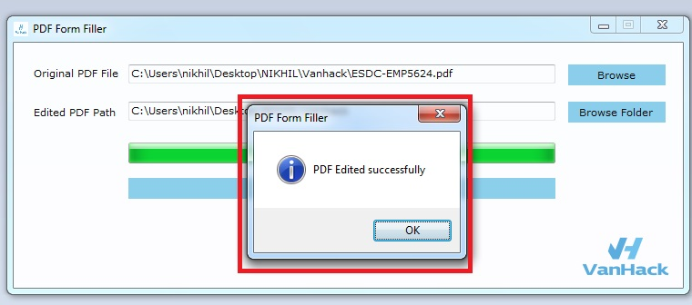

-------------------Thanks---------------------