**NCTU OS HW1 report 2018**

|  |  |  |  |
| --- | --- | --- | --- |
| 鄭俊傑 |  | 0516244 |  |

**Q1. hw1_1**

Run your code and show the difference between osh> ps –f and osh>ps –f &. You also need to explain and how to implement “&”.

|  |
| --- |
| 如果我們執行ps –f &，表示該指令會run in background，因此parent不會wait，再執行ps –f時，會發現它變成zombie process    如果我們執行ps –f，parent會wait直到該指令執行完畢，再執行ps –f，會發現該process已經被回收    Implementation:  假設輸入的指令有“&”，run_background的flag會設成true，parent不會執行waitpid指令，因此該child process會成為zombie process |

**Q2. hw1_2**

Tree format(according OS_hw1.pdf/p.12):

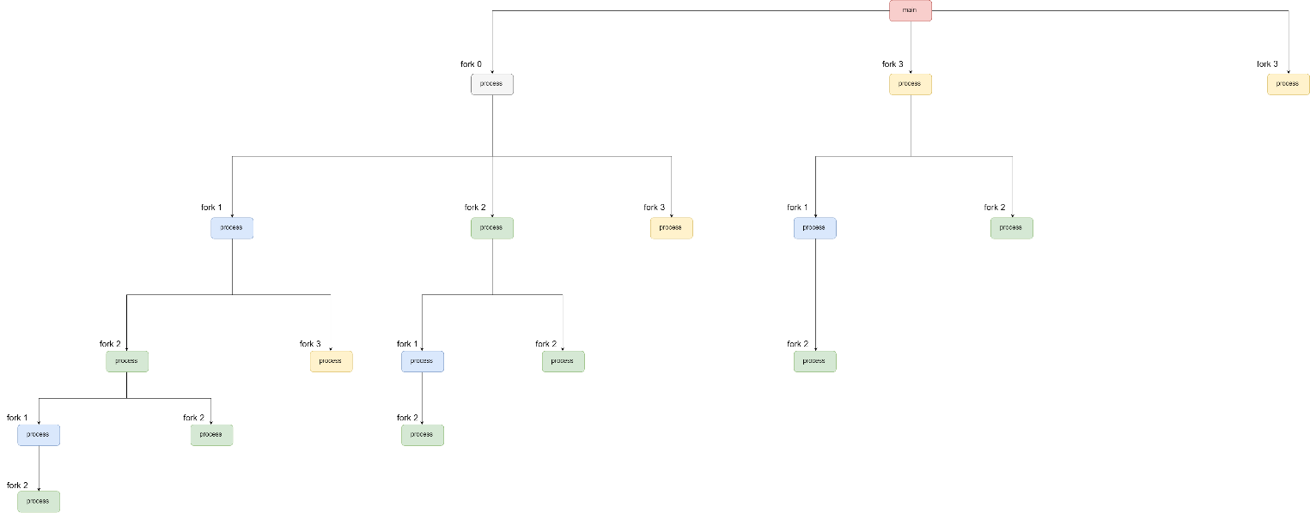

**Q3. hw1-3**

Please put your result(screen shot).

Also write down the problems you met and solutions.

|  |
| --- |
| Result |
| Problems & solutions  一開始忘了讓parent wait，輸出順序會亂而且次數不對，加了wait之後結果就正確了 |