以表格方式输出内容，类似Excel

**from** prettytable **import** PrettyTable

**逐行添加**  
table = PrettyTable([**"City name"**, **"Area"**, **"Population"**, **"Annual Rainfall"**])table.**add_row**([**"Adelaide"**, 1295, 1158259, 600.5]) table.add_row([**"Brisbane"**, 5905, 1857594, 1146.4])  
table.add_row([**"Darwin"**, 112, 120900, 1714.7])  
table.sort_key(**"City name"**)  
table.reversesort = **True**print(table)

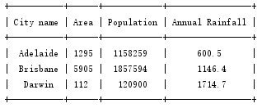

**逐列添加**

table = PrettyTable()  
column_names = ["City name", "Area", "Population", "Annual Rainfall"]  
table.**add_column**(column_names[0], ["Adelaide", "Brisbane", "Darwin","Hobart", "Sydney"])  
table.add_column(column_names[1], [1295, 5905, 112, 1357, 2058])  
table.add_column(column_names[2], [1158259, 1857594, 120900, 205556, 4336374])  
table.add_column(column_names[3], [600.5, 1146.4, 1714.7, 619.5, 1214.8])  
print(table)

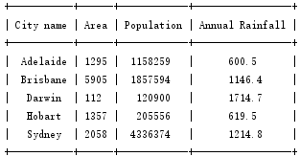

从已有文件创建

**from** prettytable **import** from_csv  
  
**with** open(**"data.csv"**, **"r"**) **as** fp:  
 x = from_csv(fp)

**输出形式**

直接输出：print(table)

无表格框输出：print(table.get_string())

选择字表：print(table.get_string(fields=["City name","Area"]))

输出前4列：print(table.get_string(start=0,end=3))

表格排序：print(table.get_string(sortby="City name",reversesort=True)

可调整选项

border：边框是否显示

header：表格第一行是否作为表头显示

align（水平对齐）：l c r

valign（垂直对齐）:t m b

table = PrettyTable(border=False,align="l")

或者

table.align["City name"] = "l"