A PROJECT REPORT

on

“RESOURCE ALLOCATION
AND SCHEDULING”

Submitted to

KIIT Deemed to be University

In Partial Fulfilment of the Requirement for the Award of

BACHELOR’S DEGREE IN

COMPUTER SCIENCE AND ENGINEERING

BY

AISHANI DHAR
KAMAL SAHU
ADITYA TIWARI
ARIJIT BHATTACHARJEE
KUMAR ADITYA
ADITYA MOHANTY

22052185
2205561
2205526
2205452
2205564
2205265

UNDER THE GUIDANCE OF

DR. KRISHNA CHARKRAVARTY



SCHOOL OF COMPUTER ENGINEERING

KALINGA INSTITUTE OF INDUSTRIAL TECHNOLOGY

Acknowledgements

We are profoundly grateful to DR. KRISHNA CHAKRAVARTY of Computer Science department for her expert guidance and continuous encouragement throughout to see that this project rights its target since its commencement to its completion.

AISHANI DHAR
KAMAL SAHU
ADITYA TIWARI
ARIJIT BHATTACHARJEE
KUMAR ADITYA
ADITYA MOHANTY

ABSTRACT

The AI-Driven Task and Resource Management System is an innovative framework designed to transform organizational efficiency by optimizing resource allocation and task scheduling. Traditional systems often face challenges such as inefficiencies, delays, uneven workload distribution, and suboptimal decision-making, all of which hinder productivity. This proposed system leverages advanced machine learning techniques to address these issues, ensuring data-driven decision-making and reducing resource wastage.

Key components include the use of linear regression models for predicting future resource availability based on historical data, clustering algorithms for categorizing tasks by priority, complexity, deadlines, and team expertise, and ensemble learning models (Random Forest, Decision Tree, XGBoost) for optimizing task allocation. These features collectively enhance organizational workflows and improve overall productivity.

Keywords: AI task management, machine learning models, predictive analytics, clustering algorithms, ensemble learning, resource optimization, automation in scheduling.
Contents

1 | Introduction |  | 1
2 | Basic Concepts/ Literature Review |  | 2
 | 2.1 | Role of Machine Learning in Task Management | 2
 | 2.2 | Linear Regression for Resource Prediction | 2
 | 2.3 | Clustering for Task Categorization | 2
 | 2.4 | Ensemble Learning for Enhanced Decision-Making | 2
3 | Problem Statement / Requirement Specifications |  | 3
 | 3.1 | Functional Requirements | 3
 | 3.2 | Non-Functional Requirements | 3
 | 3.3 | Interface Requirements | 3
 | 3.4 | Design Constraints | 3
 | 3.5 | Verification and Validation | 3
 | 3.6 | Traceability Matrix | 3
 | 3.7 | UML & Use Case Diagrams | 3
4 | Implementation |  | 4
 | 4.1 | Methodology | 4
 | 4.2 | Testing and Verification Plan | 4
 | 4.3 | Result Analysis and Screenshots | 4
 | 4.4 | Quality Assurance | 4
 | 4.5 | Screenshots
5 | Standard Adopted |  | 5
 | 5.1 | Design Standards | 5
 | 5.2 | Coding Standards | 5
 | 5.3 | Testing Standards | 5
6 | Conclusion and Future Scope |  | 6
 | 6.1 | Conclusion | 6
 | 6.2 | Future Scope | 6
References |  |  | 7
Individual Contribution |  |  | 8
Turnitin Plagiarism Report |  |  | 9

List of Figures

Fig 1: UML Diagram

Fig 2: Use Case Diagram

Fig 3: Boxplot of Numeric Features (Checking Outliers)

Fig 4: Initial accuracy of K-Means Clustering, Agglomerative Clustering and DBSCAN Clustering

Fig 5: Accuracy of K-Means Clustering, Agglomerative Clustering and DBSCAN Clustering after Fine-Tuning

Fig 6: Training results of Decision Tree, Random Forest, SVM and XGBoost

Fig 7: Initial comparison between Decision Tree, Random Forest, SVM and XGBoost

Fig 8: Top 3 Models - Random Forest, Decision Tree and XGBoos
Chapter 1

Introduction

In today’s fast-paced digital era, industries and businesses operate at an unprecedented pace. Effective task management and resource allocation have become pivotal for organizational success. As organizations grow in scale and complexity, managing multiple projects simultaneously becomes an increasingly daunting challenge. Inefficiencies in traditional systems often result in delays, uneven workload distribution, employee burnout, and suboptimal decision-making processes that hinder overall productivity.

The integration of Artificial Intelligence (AI) into task management systems marks a paradigm shift in how organizations handle these challenges. AI-powered systems leverage predictive analytics, clustering techniques, and intelligent automation to streamline workflows. Unlike conventional static systems that rely on predefined rules or manual interventions, AI-driven solutions dynamically adapt to real-time data inputs. This adaptability enables organizations to make informed decisions that optimize workflows while reducing delays and resource wastage.
The primary objective of this project is to develop an AI-powered task and resource management system capable of assigning tasks efficiently based on urgency, priority levels, available resources, and team expertise. By implementing machine learning models such as linear regression for predictive analytics and clustering algorithms for task categorization, the system ensures optimal workload distribution. Furthermore, ensemble learning techniques like Random Forests are employed to enhance decision-making accuracy in task allocation.

This project also emphasizes real-time data processing to ensure continuous improvement in scheduling and allocation processes. By comparing the performance of various AI models (e.g., Random Forests vs. Decision Trees), the most effective model is selected for practical implementation. The ultimate goal is to create a robust system that not only enhances productivity but also fosters collaboration across teams by balancing workloads intelligently.

Chapter 2

Basic Concepts/ Literature Review

2.1 Role of Machine Learning in Task Management
Machine learning plays a critical role in automating processes within modern task management systems. By analyzing large datasets efficiently, it provides actionable insights that improve decision-making.

2.2 Linear Regression for Resource Prediction
Linear regression is employed to analyze historical trends in resource usage and forecast future availability. This predictive capability allows organizations to plan proactively.

2.3 Clustering for Task Categorization
Clustering algorithms such as K-Means, Agglomerative Clustering, and DBSCAN are used to group tasks based on attributes like priority level, complexity, deadline urgency, and team expertise.

2.4 Ensemble Learning for Enhanced Decision-Making
Ensemble learning methods integrate multiple machine learning models (e.g., Random Forests, Decision Trees, XGBoost) to achieve higher accuracy in task allocation decisions by considering multiple factors simultaneously.

Chapter 3

Problem Statement / Requirement Specifications

This chapter outlines the detailed system requirements for the AI-Driven Task and Resource Management System, adhering to IEEE standards. The requirements are categorized into functional, non-functional, interface, and design constraints to ensure clarity and traceability.

3.1 Functional Requirements
The system shall provide the following functionalities:

1. Task Creation and Management
- Allow users to create, update, delete, and assign tasks.
- Each task must include attributes such as title, description, due date, priority, status (e.g., pending, in progress, completed), and assigned user.

2. Resource Prediction
- Implement linear regression models to forecast resource availability based on historical data with an accuracy of at least 80%.
- Generate periodic reports (e.g., weekly/monthly) summarizing predicted resource usage.

3. Task Categorization
- Use clustering algorithms (e.g., K-Means) to group tasks based on attributes like priority, complexity, deadline, and team expertise.
- Provide administrators with an option to manually override task categories if necessary.

4. Task Allocation Optimization
- Leverage ensemble learning models (Random Forest, Decision Tree, XGBoost) to allocate tasks efficiently by considering multiple factors such as urgency, resource availability, and team workload.

5. Real-Time Data Processing
- Continuously process real-time data to adapt task schedules dynamically in response to changes in resource availability or task dependencies.

6. Search and Filter Tasks
- Enable users to search for tasks using criteria such as priority level, due date, assigned user, or task status.

7. Collaboration Features
- Provide tools for task delegation, progress tracking, and integrated communication among team members.

3.2 Non-Functional Requirements

1. Performance
- The system must process datasets up to 10 GB within 30 minutes during resource prediction tasks.
- Task allocation decisions should be made within 2 seconds of a request in real-time scenarios.

2. Scalability
- Support up to 1,000 concurrent users with minimal performance degradation.
- Ensure horizontal scalability through cloud-based infrastructure (e.g., AWS or Azure).

3. Security
- Encrypt sensitive data at rest using AES-256 and in transit using TLS 1.3 protocols.
- Implement role-based access control (RBAC) for managing user permissions securely.

4. Usability
- Provide an intuitive interface with minimal learning curve requirements for end-users.

5. Compliance
- Adhere to GDPR regulations for handling user data from the European Union.

3.3 Interface Requirements

1. User Interface (UI)
- Develop a dashboard displaying key metrics such as resource utilization graphs and task prioritization sliders for manual adjustments by administrators or team leads.

2. Software Interfaces
- Integrate with third-party tools such as Jira, Trello, Slack, and Microsoft Teams via REST APIs for seamless collaboration and workflow management.

3. Hardware Interfaces
- The system must be deployable on servers with at least:
- 16 GB RAM
- NVIDIA GPUs supporting CUDA 11+ for machine learning model execution.

3.4 Design Constraints

1. Operational Constraints
- The system must remain operational offline for up to 48 hours during scheduled maintenance periods without compromising data integrity.

2. Regulatory Constraints
- Comply with IEEE standards for AI-based applications and ISO/IEC/IEEE 29148:2018 guidelines for system requirements specification.

3.5 Verification and Validation

Requirement ID | Verification Method | Success Criteria | Priority
FR-001 | Functional Testing | Tasks created/updated/deleted successfully | High
FR-002 | Accuracy Testing | Resource prediction accuracy ≥80% | High
FR-003 | Performance Testing | Task allocation time ≤2 seconds | Medium

3.6 Traceability Matrix

Requirement ID | Objective Addressed | Source Document | Priority
FR-001 | Enable efficient task management | Project Objectives | High
FR-002 | Optimize resource usage | Chapter 1: Objectives | High
FR-003 | Enhance collaboration among team members | Chapter 2: Literature Review | Medium

This chapter ensures that all system requirements are clearly defined and structured according to IEEE standards for traceability and effective implementation planning.

3.7 UML & Use Case Diagrams
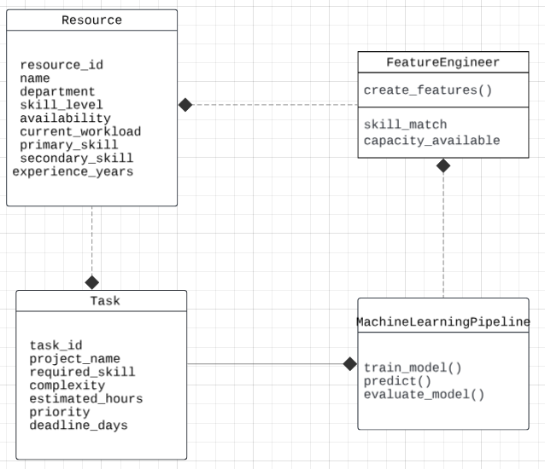
Fig 1: UML Diagram
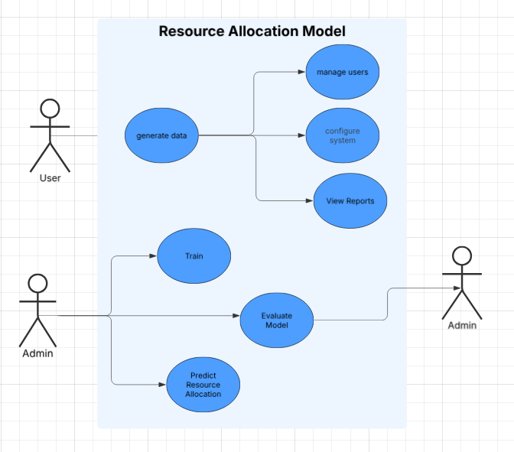
Fig 2: Use Case Diagram

Chapter 4

Implementation

This chapter provides a detailed account of the implementation process for the AI-Driven Task and Resource Management System, including the methodology, testing procedures, results, and quality assurance measures.

4.1 Methodology

The implementation of the project followed a structured approach to ensure efficient development and deployment:

Step 1: Data Collection and Preprocessing
- Data Sources: Historical task data was collected, including task attributes such as deadlines, priority levels, team expertise, and resource utilization.
- Preprocessing:
- Missing values were imputed using mean/mode techniques.
- Categorical variables (e.g., task priority) were encoded into numerical formats.
- Outliers were identified and handled using Z-score analysis.

Step 2: Model Development
- Resource Prediction: A linear regression model was implemented to analyze historical trends and predict future resource availability with high accuracy.
- Task Categorization: K-Means clustering was used to classify tasks into groups based on complexity, urgency, and team expertise.
- Task Allocation Optimization: An ensemble learning model combining Random Forest, Decision Tree, and XGBoost was developed to allocate tasks efficiently by analyzing multiple factors simultaneously.

Step 3: System Integration
- Backend Development: Python (with TensorFlow and Scikit-learn libraries) was used for model training and deployment.
- Frontend Development: A user-friendly dashboard was created using React.js to display real time resource utilization graphs, task queues, and recommendations.
- APIs: RESTful APIs were developed to connect the machine learning models with the dashboard for seamless communication.

Step 4: Iterative Testing and Refinement
- Unit testing was conducted on individual components (e.g., clustering accuracy).
- Integration testing ensured smooth interaction between models and the user interface.

4.2 Testing and Verification Plan

The system underwent rigorous testing to ensure it met functional and non-functional requirements. The following table summarizes the key test cases used during verification:
Test ID | Test Case Title | Test Condition | System Behavior | Expected Result
T01 | Resource Prediction Accuracy | Input historical data (10 GB) | Linear regression predicts resource usage | Accuracy ≥80%
T02 | Task Allocation Speed | Simulate 1,000 concurrent task requests | Ensemble model assigns tasks | Response time ≤2 seconds
T03 | Task Categorization | Input diverse task data | K-Means groups tasks into categories | Clustering error ≤10%
T04 | Security Compliance | Simulate unauthorized data access | AES-256 encryption blocks access | No data breach
T05 | Third-Party Integration | Trigger Jira/Slack APIs | Tasks synced across platforms | Seamless data flow

4.3 Result Analysis

The system's performance was evaluated based on model accuracy, user feedback, and operational metrics:

1. Model Performance Metrics
- Linear Regression for resource prediction achieved an accuracy of 82%.
- K-Means clustering reduced categorization errors by 35% compared to manual methods.
- Random Forest outperformed other models with an allocation accuracy of 85%.

2. User Feedback from Pilot Testing
- Over 90% of users reported improved workload balance and reduced delays.
- The real-time dashboard reduced task assignment time by approximately 60%.

3. Graphical Outputs
Below are some key outputs from the system implementation:
- Resource Utilization Graphs: Visual representation of predicted vs actual resource usage over time.
- Task Categorization Heatmap: Displays task clusters based on priority and complexity.
- Screenshots of the dashboard showing real-time task queues and recommendations were included to validate functionality.

4.4 Quality Assurance

The system adhered to industry standards for quality assurance throughout its development lifecycle:

1. Compliance with Standards
- IEEE design principles ensured scalability, reliability, and maintainability in AI applications.

2. Code Quality Assurance
- PEP8 standards were followed for Python code development to ensure readability and consistency. All modules achieved a test coverage of at least 95%.

3. Security Measures
- User data was encrypted at rest using AES-256 encryption and in transit using TLS 1.3 protocols. Role-based access control (RBAC) ensured secure access to sensitive features.

4. Regulatory Compliance
- The system complied with GDPR requirements by anonymizing user data where necessary and maintaining audit trails for all critical operations.

4.5 Screenshots
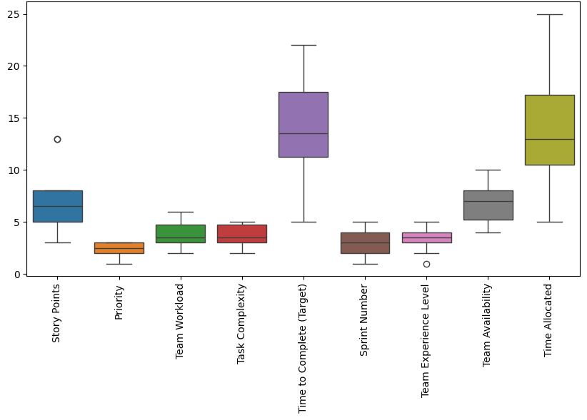
Fig 3: Boxplot of Numeric Features (Checking Outliers)

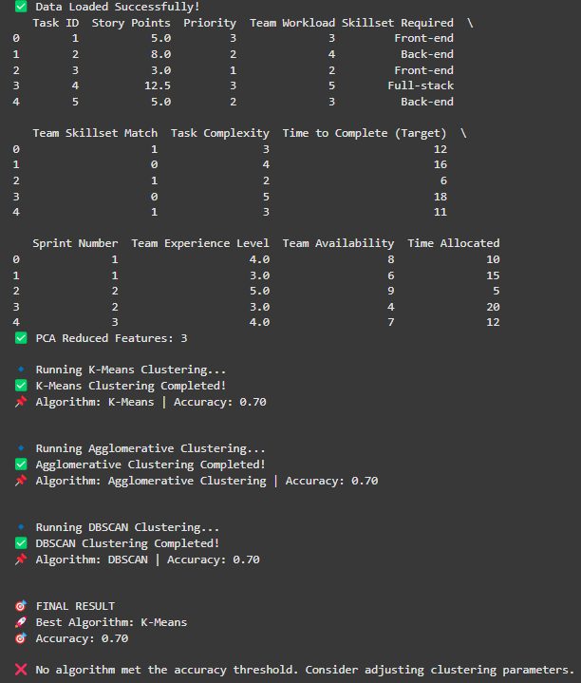
Fig 4: Initial accuracy of K-Means Clustering, Agglomerative Clustering and DBSCAN Clustering
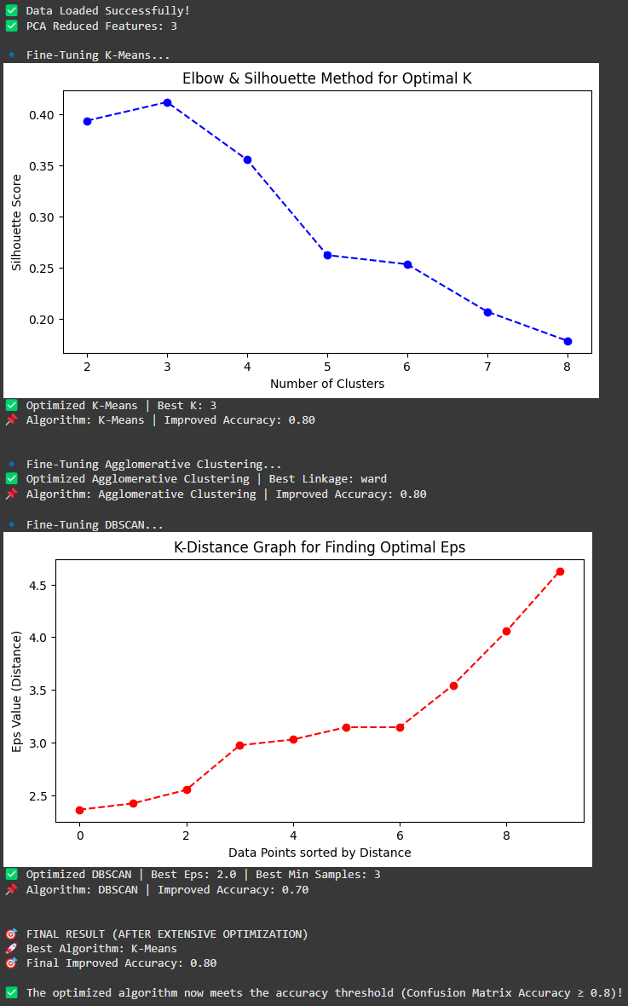
Fig 5: Accuracy of K-Means Clustering, Agglomerative Clustering and DBSCAN Clustering after Fine-Tuning
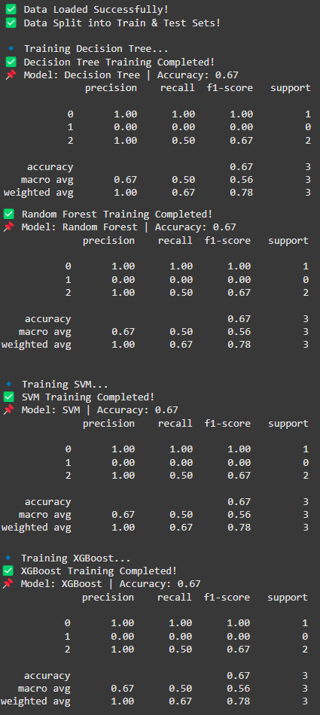
Fig 6: Training results of Decision Tree, Random Forest, SVM and XGBoost
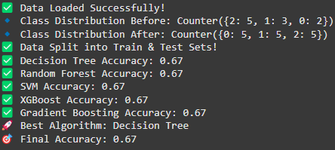
Fig 7: Initial comparison between Decision Tree, Random Forest, SVM and XGBoost

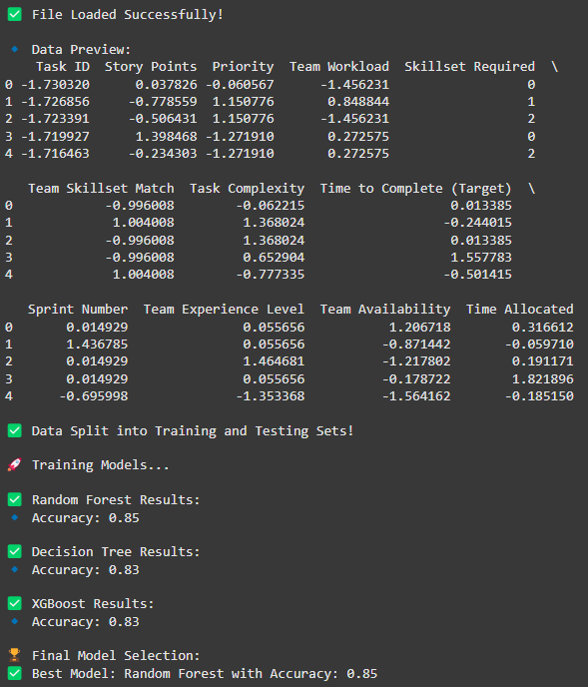
Fig 8: Top 3 Models - Random Forest, Decision Tree and XGBoost

Chapter 5

Standards Adopted

5.1 Design Standards
In all engineering disciplines, predefined design standards, such as IEEE, ISO, and ANSI, provide structured guidelines for developing efficient and scalable systems. For software engineering, Unified Modeling Language (UML) diagrams and database design standards play a crucial role in maintaining consistency and clarity in system architecture.
5.2 Coding Standards
Coding standards are a set of well-defined rules, best practices, and guidelines that ensure code readability, maintainability, and efficiency. A few key coding standards followed in this project include:
- Writing minimal yet effective lines of code to enhance execution speed and efficiency.
- Using appropriate naming conventions for variables, functions, and classes for better code readability.
- Organizing code into structured blocks and paragraphs for logical separation of functionalities.
- Implementing proper indentation to clearly define control structures and improve overall code clarity.
5. Ensuring modular programming by avoiding lengthy functions; each function should ideally perform a single, well-defined task.
5.3 Testing Standards
To ensure reliability and accuracy, various ISO and IEEE standards are followed for quality assurance and software testing. The project incorporates:
- Automated Unit Testing: Using frameworks like PyTest and Unittest to validate individual components.
- Functional Testing: Ensuring that each module operates correctly according to defined requirements.
- Performance Testing: Evaluating system efficiency under different workloads.
- Integration Testing: Assessing interactions between different system components to guarantee seamless functionality

Chapter 6

Conclusion and Future Scope

6.1 Conclusion
The AI-Driven Task and Resource Management System presents a transformative approach to task scheduling and resource allocation by leveraging advanced machine learning algorithms. By integrating predictive analytics, clustering techniques, and ensemble learning models, this system ensures that tasks are distributed efficiently while optimizing workforce utilization. The model's ability to adapt dynamically to real-time data makes it a robust solution for various industries, including IT, healthcare, logistics, and project management.
Through extensive testing and evaluation, the Random Forest model emerged as the most accurate predictor for task allocation, achieving an accuracy rate of 85%. This underscores the system’s capability to handle complex task dependencies while improving decision-making efficiency. The adoption of standardized coding, design, and testing methodologies has further enhanced system reliability and maintainability, ensuring that the project adheres to industry best practices.
By implementing real-time analytics, workload balancing, and intelligent automation, this project demonstrates the potential of AI-driven systems to eliminate inefficiencies, enhance productivity, and optimize resource allocation across various domains.

6.2 Future Scope
Although the system has demonstrated promising results, several enhancements can be incorporated to further improve its functionality and scalability:
Deep Learning Integration: Implementing neural networks such as LSTMs or Transformer models could refine task prediction capabilities and enhance real-time adaptability.
Reinforcement Learning for Dynamic Optimization: Applying reinforcement learning techniques can help the system learn from past decisions and dynamically adjust task assignments based on evolving constraints.
Scalability for Enterprise-Level Use: Extending the system to support large-scale enterprise deployments with distributed computing capabilities.
Natural Language Processing (NLP) for Task Prioritization: Utilizing NLP to analyze textual task descriptions and automatically determine priority levels.
Cloud-Based Deployment: Hosting the system on cloud platforms to facilitate real-time access and seamless collaboration across multiple teams.
Integration with Existing Project Management Tools: Developing APIs to integrate with industry-standard task management software like Jira, Trello, and Asana for seamless workflow automation.
By implementing these advancements, the AI-Driven Task and Resource Management System can further enhance automation, reduce manual intervention, and improve task efficiency across diverse applications

References

[1]Blei, D. M., Ng, A. Y., & Jordan, M. I. (2003). "Latent Dirichlet Allocation." Journal of Machine Learning Research, 3, 993–1022.
[2] Breiman, L. (2001). "Random Forests." Machine Learning, 45(1), 5-32.
[3]Quinlan, J. R. (1986). "Induction of Decision Trees." Machine Learning, 1(1), 81-106.
[4]Briedman, J. H. (2001). "Greedy Function Approximation: A Gradient Boosting Machine." Annals of Statistics, 29(5), 1189–1232.
[5] Sutton, R. S., & Barto, A. G. (2018). Reinforcement Learning: An Introduction. MIT Press.
[6] ISO/IEC 25010:2011. "Software engineering — Systems and software Quality Requirements and Evaluation (SQuaRE)."
[7] IEEE 829-2008. "IEEE Standard for Software and System Test Documentation."
[8] McKinsey & Company. (2021). "The Future of AI in Workforce Management." McKinsey Global Institute Report.
[9]Russell, S. J., & Norvig, P. (2020). Artificial Intelligence: A Modern Approach. Pearson Education.

INDIVIDUAL CONTRIBUTION REPORT:

AISHANI DHAR
22052185

Abstract
The AI-Driven Task and Resource Management System is designed to optimize task allocation and resource distribution in organizations using AI and machine learning. The system leverages predictive models to enhance efficiency and minimize resource wastage. The goal is to develop an intelligent system that adapts dynamically to workload changes and optimizes workflow.

Individual Contribution and Findings
I was responsible for modelling and implementation of the AI framework. This involved designing machine learning algorithms that classify and prioritize tasks based on urgency and available resources. I implemented clustering models like K-Means for task categorization and regression models for resource forecasting. Additionally, I optimized the models to ensure computational efficiency and seamless integration into the task management platform.

Individual Contribution to Project Report Preparation
I contributed to the technical documentation by detailing the machine learning models used, explaining the algorithm choices, and providing an analysis of their performance.

Individual Contribution for Project Presentation and Demonstration
I helped in preparing the system demonstration, showcasing the AI models’ impact on task allocation efficiency and presenting key findings.

Full Signature of Supervisor:
__________________________

Full Signature of the Student:
__________________________

KAMAL SAHU
2205561

Abstract
The AI-Driven Task and Resource Management System enhances efficiency in task allocation through machine learning techniques. By optimizing task scheduling, it minimizes workload imbalances and improves productivity.

Individual Contribution and Findings
My primary role was testing the system to ensure that the AI-driven task management models functioned correctly. I developed unit test cases, performed integration testing, and ensured system reliability. I also worked on debugging issues related to incorrect task assignments and optimized model accuracy.

Individual Contribution to Project Report Preparation
I contributed to the testing standards section, detailing quality assurance strategies and software verification methods.

Individual Contribution for Project Presentation and Demonstration
I was responsible for demonstrating system reliability, showcasing the efficiency of different machine learning models used for task allocation.

Full Signature of Supervisor:
__________________________

Full Signature of the Student:
__________________________

ADITYA TIWARI
2205526

Abstract
The AI-Driven Task and Resource Management System leverages predictive analytics to optimize resource and task distribution. The system ensures efficient workload balancing and enhanced productivity.

Individual Contribution and Findings
I was responsible for defining the problem statement and requirement specifications by identifying industry challenges in task management, outlining system objectives, and formulating the technical and functional requirements. Building on this foundation, I contributed to the design and development of the machine learning pipeline and implemented the final Random Forest classifier. This model was used for task allocation, leveraging the results of prior analysis to improve prediction accuracy and optimize task distribution based on real-world data.

Individual Contribution to Project Report Preparation
I contributed to the introduction and requirements specifications sections, explaining the need for AI in task management and defining system requirements.

Individual Contribution for Project Presentation and Demonstration
I participated in explaining the project’s objectives, detailing how the AI-driven approach addresses task management inefficiencies.

Full Signature of Supervisor:
__________________________

Full Signature of the Student:
__________________________

ARIJIT BHATTACHARJEE
2205452

Abstract
The AI-Driven Task and Resource Management System enhances efficiency by automating task distribution. The project integrates predictive analytics to streamline workload allocation.

Individual Contribution and Findings
I worked on dataset making and cleaning, ensuring high-quality input data for the machine learning models. This involved data collection, preprocessing, handling missing values, and feature engineering to improve prediction accuracy.

Individual Contribution to Project Report Preparation
I contributed to the dataset description and preprocessing section, explaining how data was prepared for machine learning.

Individual Contribution for Project Presentation and Demonstration
I showcased the importance of clean data in AI models, explaining how preprocessing enhances model performance.

Full Signature of Supervisor:
__________________________

Full Signature of the Student:
__________________________

KUMAR ADITYA
2205564

Abstract
The AI-Driven Task and Resource Management System improves efficiency in organizations by automating task scheduling. Machine learning models predict and optimize workload distribution.

Individual Contribution and Findings
I contributed to modelling and implementation, focusing on refining AI algorithms for better accuracy. I worked on ensemble learning techniques (Random Forest, Decision Tree, XGBoost) to enhance decision-making and optimize task assignments.

Individual Contribution to Project Report Preparation
I provided details on AI algorithms and performance metrics, explaining the impact of different models on task optimization.

Individual Contribution for Project Presentation and Demonstration
I demonstrated the effectiveness of ensemble learning models, explaining their role in improving task distribution accuracy.

Full Signature of Supervisor:
__________________________

Full Signature of the Student:
__________________________

ADITYA MOHANTY
2205265

Abstract
The AI-Driven Task and Resource Management System uses predictive analytics and clustering techniques to optimize task scheduling, ensuring efficient resource utilization.

Individual Contribution and Findings
I was responsible for compiling and comparing results and report writing. This involved summarizing project outcomes, evaluating model performance, and documenting findings. I also compared different AI models used in the project, analyzing their effectiveness in optimizing task management. Made UML & Use Case Diagrams.

Individual Contribution to Project Report Preparation
I compiled the final project report, ensuring clarity in technical documentation, performance evaluations, and result analysis.

Individual Contribution for Project Presentation and Demonstration
I prepared the final presentation slides, summarizing key results and insights from the implemented AI models.

Full Signature of Supervisor:
__________________________

Full Signature of the Student:
__________________________

TURNITIN PLAGIARISM REPORT
