**Mirano, Louis Joseph C. 2018110858 2ECEA**

Problem 1

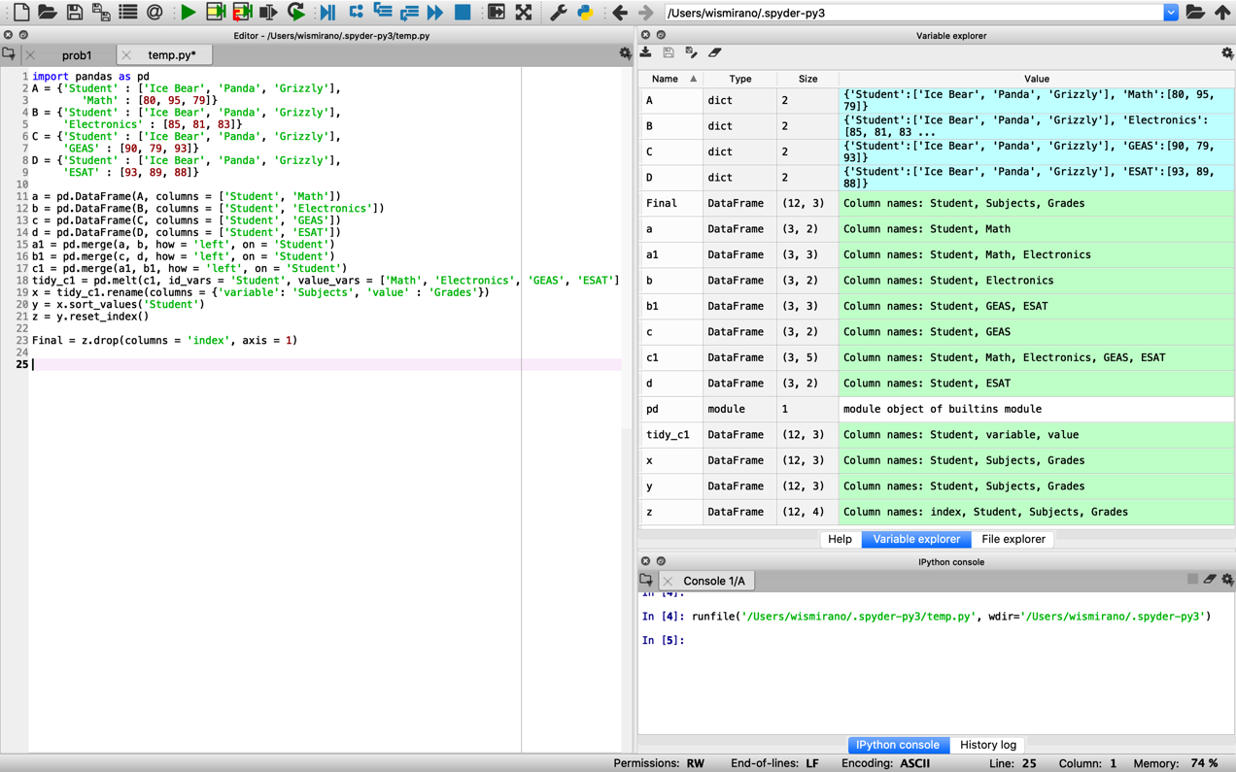

Problem 2

