Mirano, Louis Joseph C. 2018110858 2ECE-A

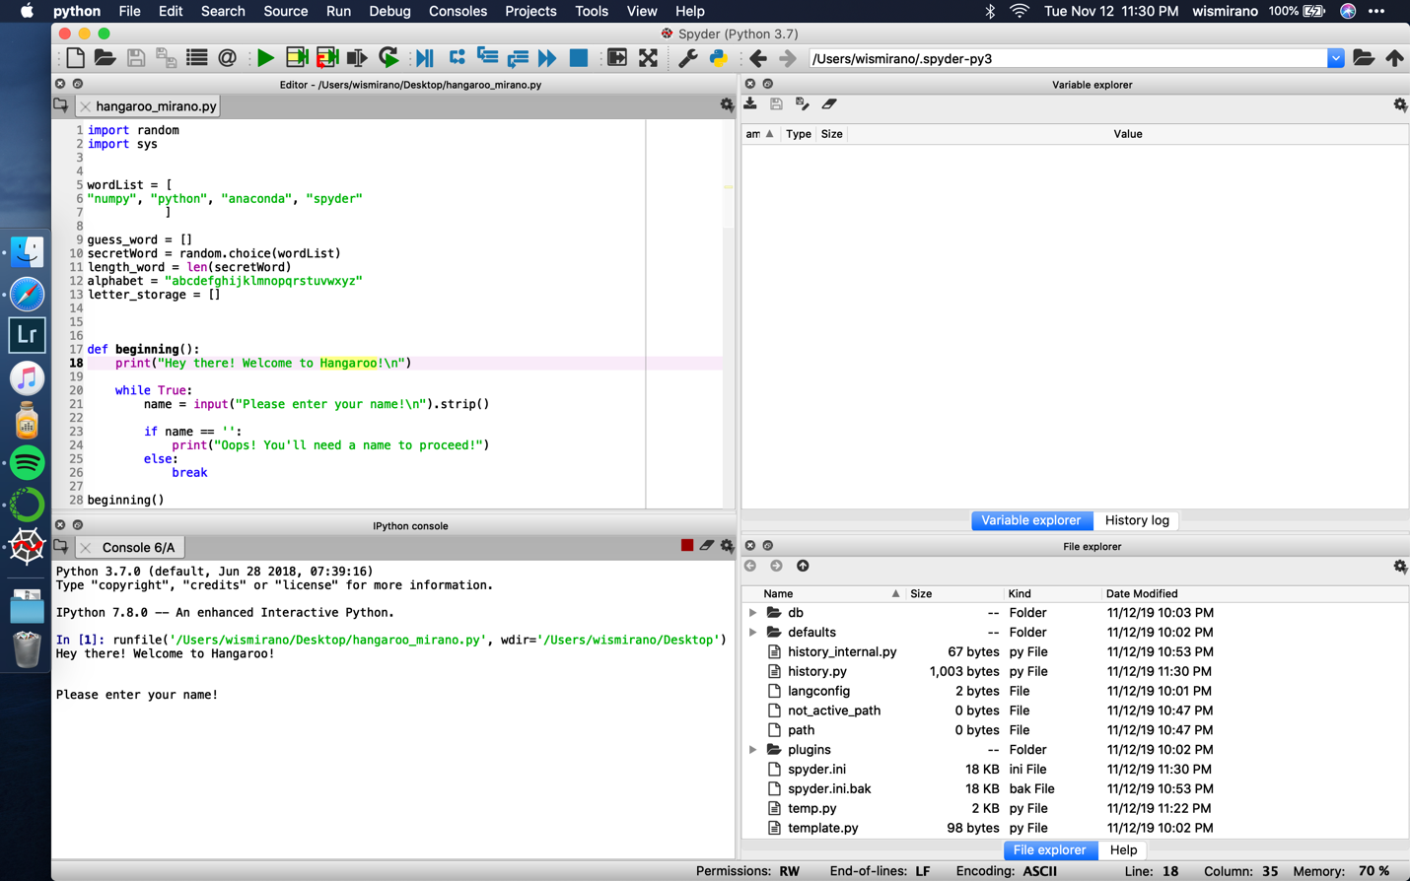

Fig 1. Start splash page; entering your name

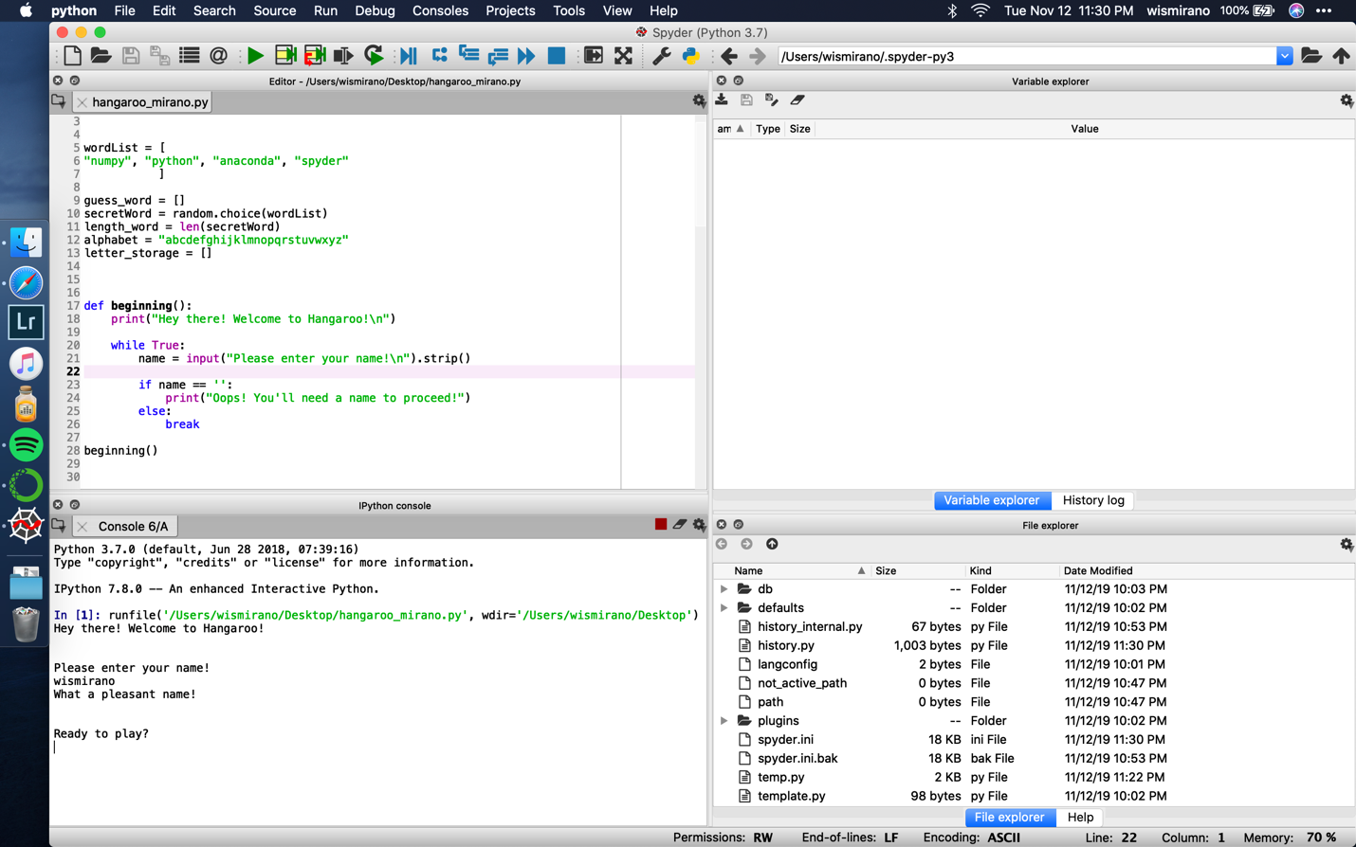

Fig 2. After entering your name:

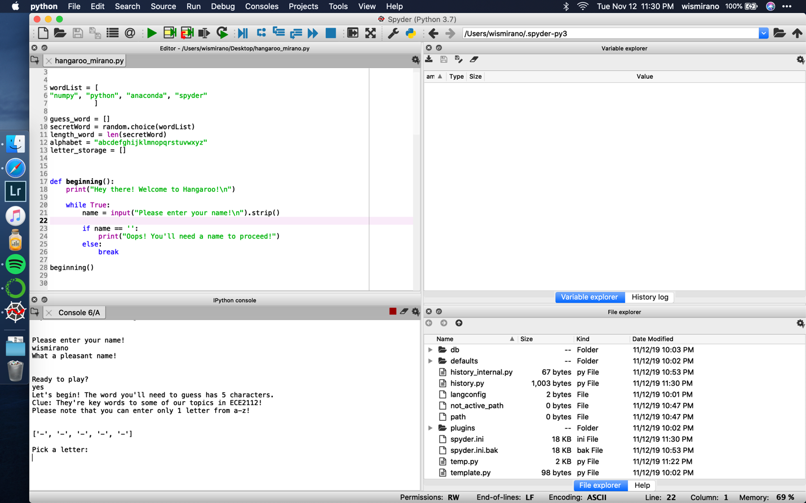

Fig 3. After entering name; start of game

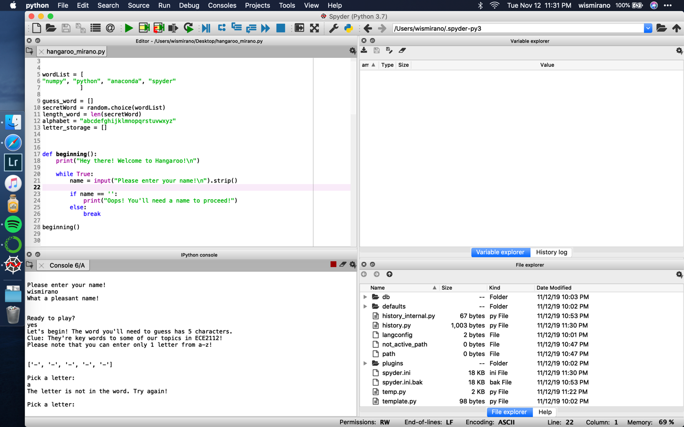

Fig 4. Entering a letter not in the word being guessed

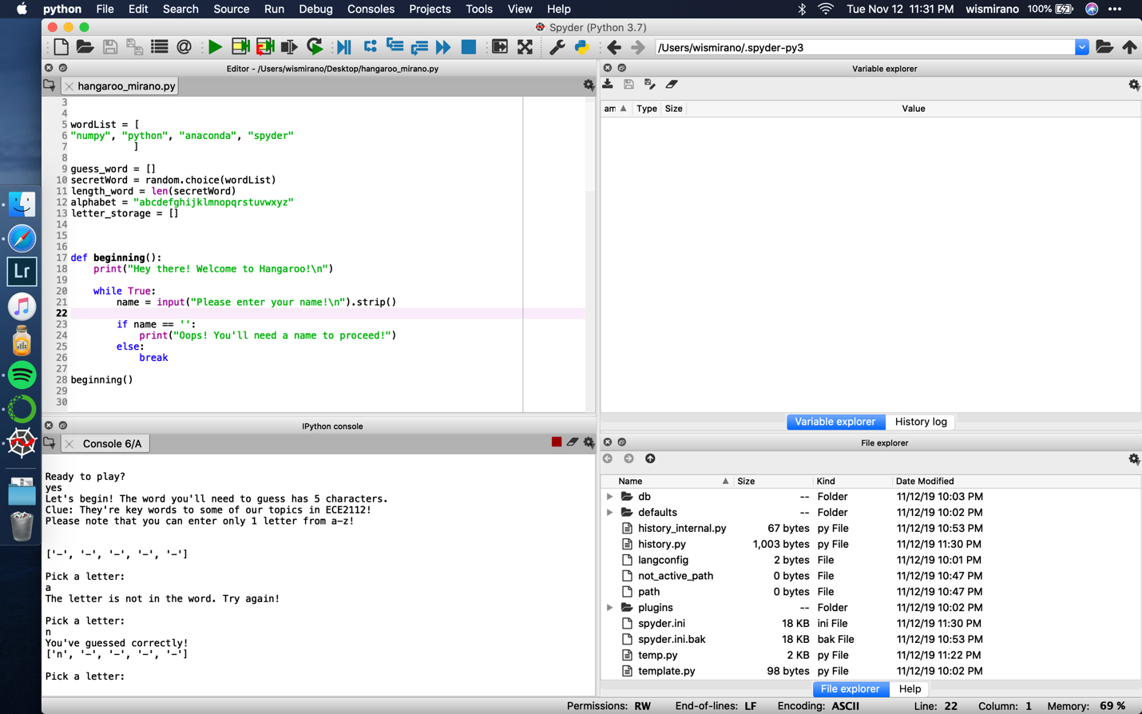

Fig 5. Picking a correct letter…

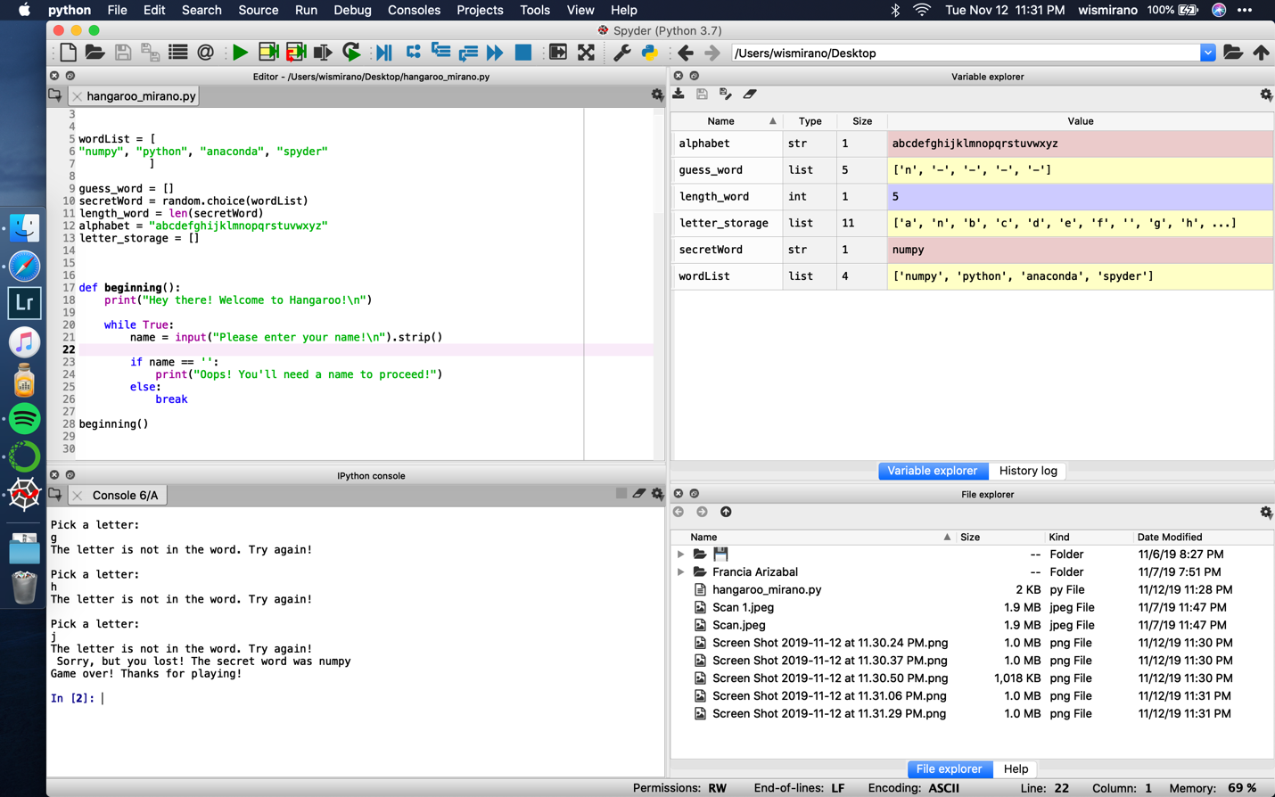

Fig 6. After losing

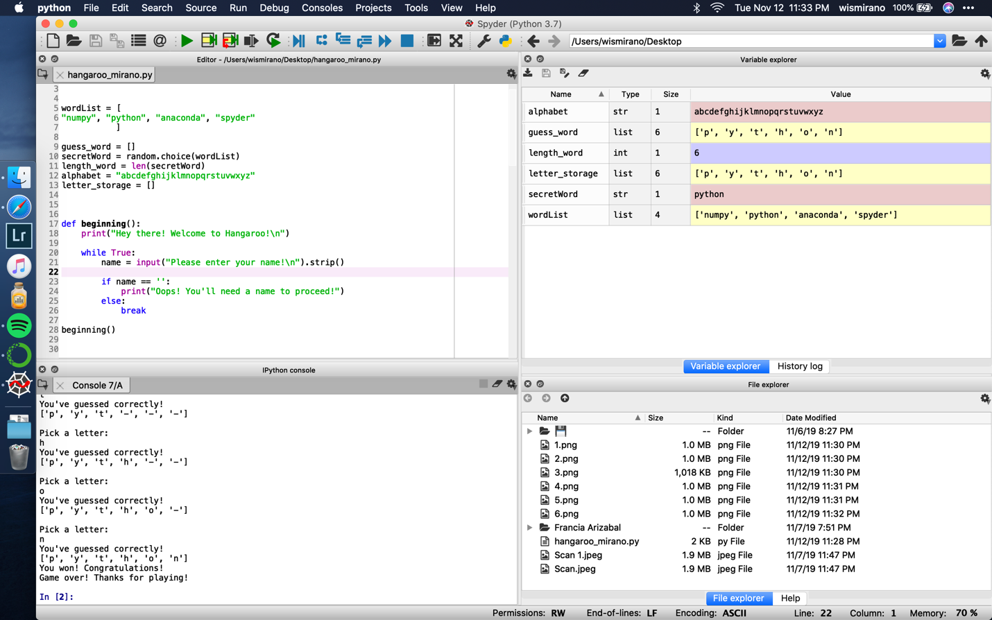

Fig 7. After winning