**1. ICON PLUS AREA TIMUR**

Lokasi ICON PLUS AREA TIMUR terletak di Jl. Niaga Raya ( Ruko Jababeka II ) Capital Bussines park 2Q Jababeka Center park, Cikarang baru- Bekasi. Alamat lengkap ICON PLUS AREA TIMUR adalah sebagai berikut :

|  |  |  |
| --- | --- | --- |
| LOKASI GI/GIS/UP/AP PLN/HRB | : | ICON +Area Timur |
| ALAMAT GI/GIS/UP/AP PLN | : | JL.Niaga Raya(Ruko Jababeka II ) Capital Bussinespark 2Q Jababeka Center park, Cikarang baru-Bekasi |
| NO TLP/FAX GI/GIS/UP/AP/ PLN/HRB | : | (021) 89836915 / (021) 89836916 |
| KOORDINAT GPS | : | S 06 17.590 / E 107 09.951 |
| NAMA SUPERVISOR/CONTACT PERSON | : | Security |
| NO TLP/FAX SUPERVISOR/CONTACT PERSON | : | (021) 89836915 / (021) 89836916 |
| JWOTS | : | - |

* 1. Peta lokasi ICON PLUS AREA TIMUR

Berikut ini adalah peta lokasi ICON PLUS AREA TIMUR

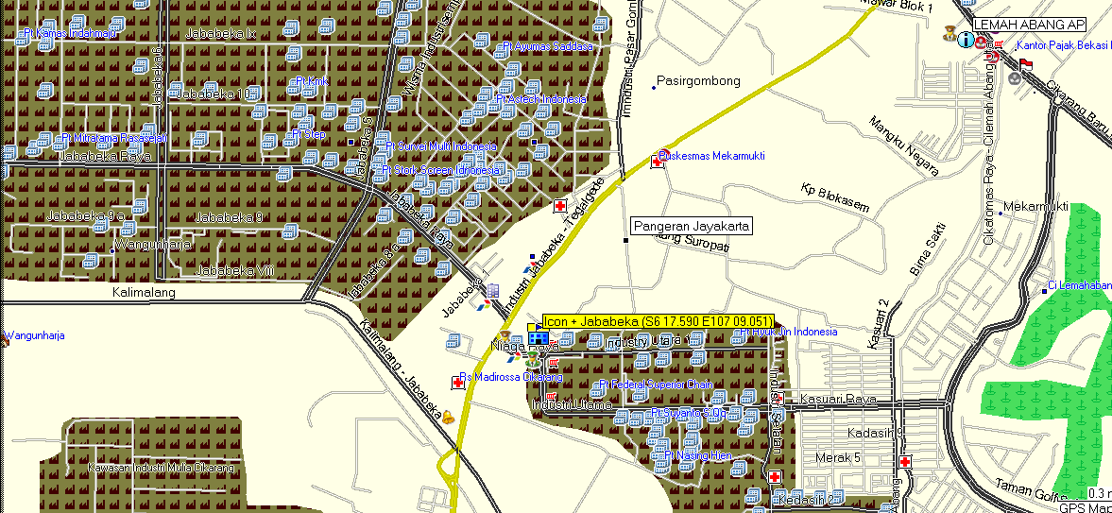

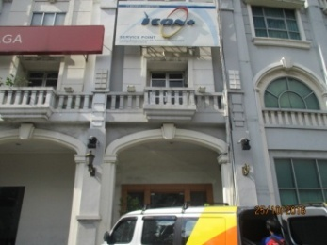

1. **Pemeliharaan PoP (Check and Clean)**

Di lokasi ICON PLUS AREA TIMUR terdapat 6 (Enam) rack 42U. Kondisi rack dan perangkat terpasang dilokasi ICON PLUS AREA TIMUR bersih dan rapih sedangkan untuk catu daya perangkat dibackup **Rectifier AEG (ACM 1000),** dan **Inverter Meta Power (MP-INV3000-J)**.

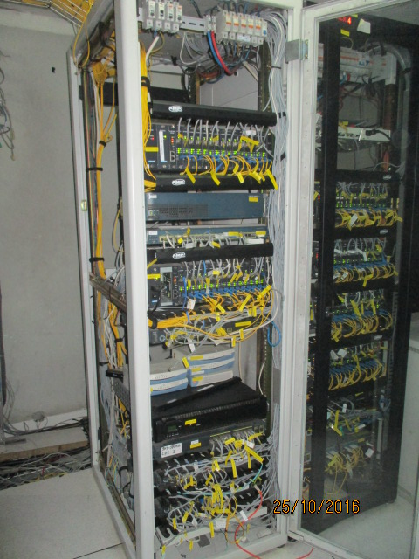

Gambar 1. Rack 1 dan Perangkat Terpasang

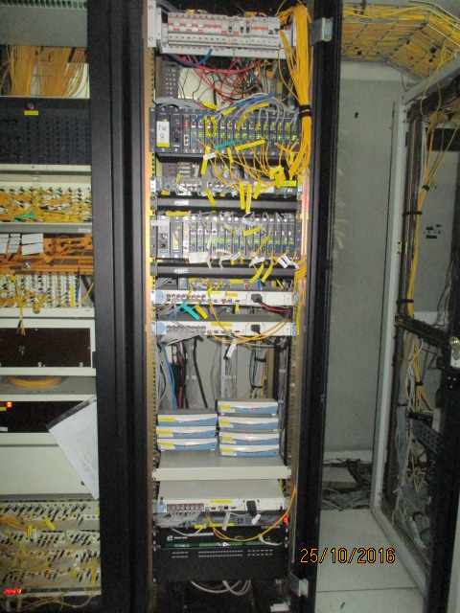

Gambar 2. Rack 2 dan Perangkat Terpasang

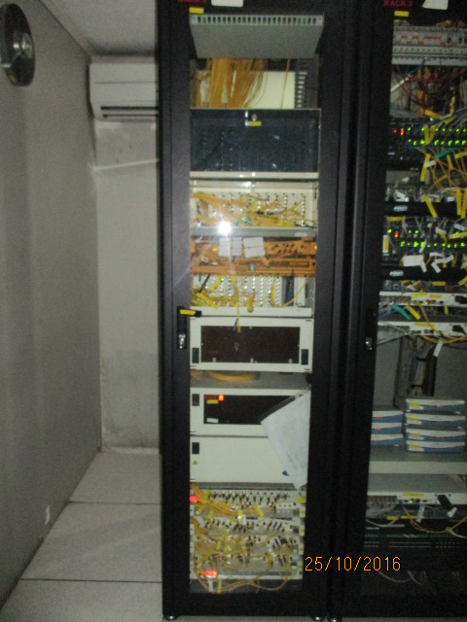

Gambar 3. Rack 3 ( ODF )

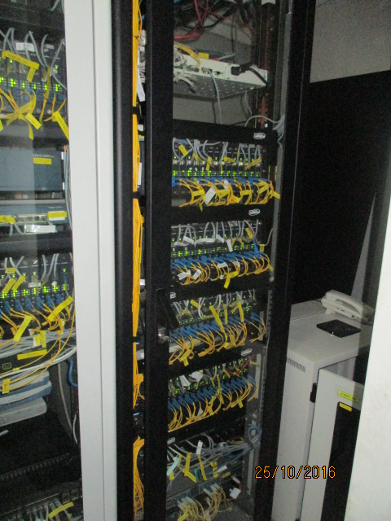

Gambar 4. Rack 4 dan perangkat terpasang

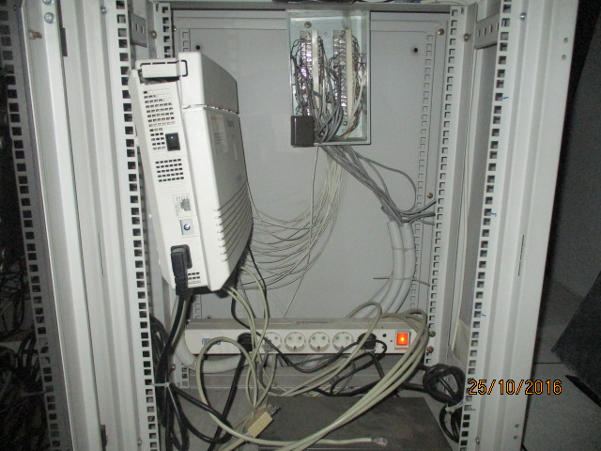

Gambar 5. Rack 5 dan perangkat terpasang

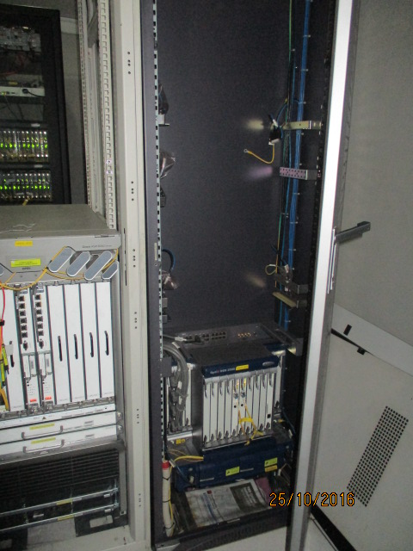

Gambar 6. Rack 6 & Perangkat Terpasang

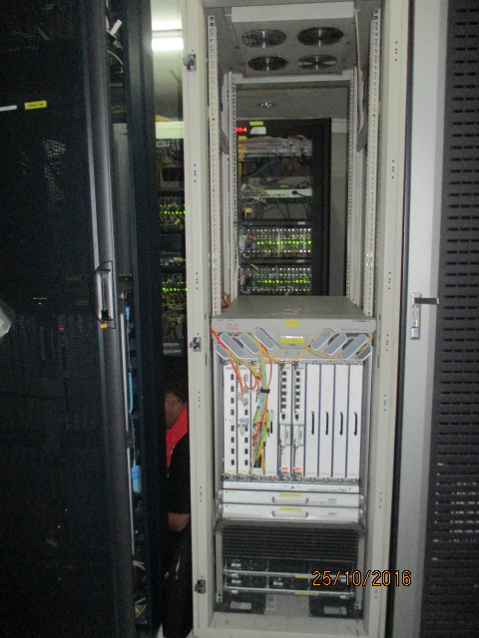

Gambar 7. Rack 7 & Perangkat Terpasang

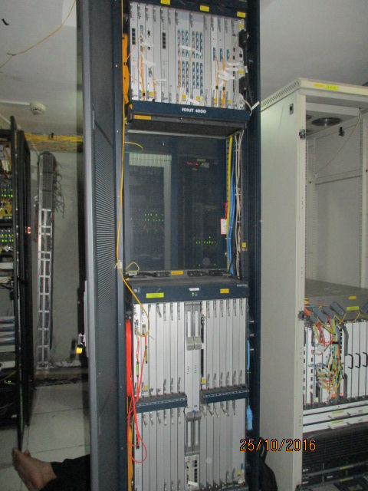

Gambar 8. Rack 8 & Perangkat Terpasang

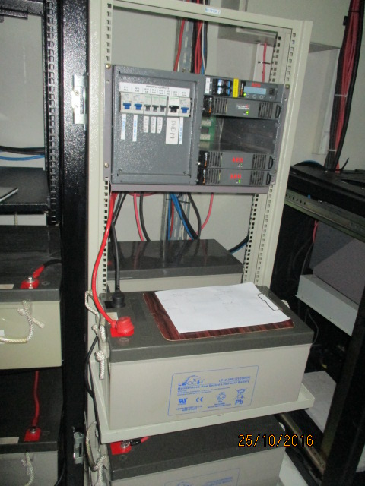

Gambar 9. Rectifier AEG ( ACM 1000 )

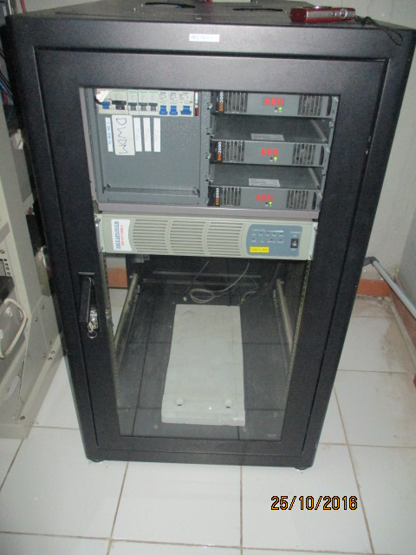

Gambar 10. Rectifier AEG ( ACM 1000 ) & Inverter Meta Power ( MP-INV3000-J )

**3. Pemeliharaan Perangkat TDM & IP**

Di lokasi ICON PLUS AREA TIMUR terdapat 6( Enam ) rack perangkat TDM & IP diantaranya adalah sebagai berikut :

**Rack 1**

|  |  |  |  |  |  |  |
| --- | --- | --- | --- | --- | --- | --- |
| **No** | **Perangkat Terpasang** | **Daya Perangkat** | **Backup Power** | **Sumber Input** | | **Keterangan** |
| **AC** | **DC** |
| 1 | Telways Modular #1 | ± 35 Watt | Rect.AEG/Inv.Meta Power | V | V | Aktif |
| 2 | Rici E1  (PLTGU Muara Tawar) | ± 10 Watt | Inverter Meta Power | V | - | Aktif |
| 3 | Ric E1  (Toyota Sugity) | ± 10 Watt | Inverter Meta Power | V | - | Aktif |
| 4 | Link Sys  (NMS CTC) | ± 10 Watt | Inverter Meta Power | V | - | Aktif |
| 5 | Telways Modular #2 | ± 35 Watt | R.AEG/I.Meta Power | V | V | Aktif |
| 6 | Cisco Catalyst 2950  (Swich UPJB) | ± 450 Watt | Inverter Meta Power | V | - | Aktif |
| 7 | Cisco Catalyst 3750 #1 | ± 450 Watt | Inverter Meta Power | V | - | Aktif |
| 8 | Cisco Catalyst 2960 | ± 450 Watt | Inverter Meta Power | V | - | Aktif |
| 9 | Cisco Catalyst 3750 #2 | ± 450 Watt | Inverter Meta Power | V | - | Aktif |
| 10 | Cisco Catalyst 3750 #3 | ± 450 Watt | Inverter Meta Power | V | - | Aktif |
| 11 | PDH OP 108  (Pt.Padi Internet) | ± 20 Watt | Inverter Meta Power | V | - | Aktif |
| 12 | PDH OP 108  (Cameron) | ± 20 Watt | Inverter Meta Power | V | - | Aktif |
| 13 | PDH OP 108  (Pt.Nestle Komp.Delta Mas) | ± 20 Watt | Inverter Meta Power | V | - | Aktif |

**Rack 2**

|  |  |  |  |  |  |  |
| --- | --- | --- | --- | --- | --- | --- |
| **No** | **Perangkat Terpasang** | **Daya Perangkat** | **Backup Power** | **Sumber Input** | | **Keterangan** |
| **AC** | **DC** |
| 1 | PDH OP 108  (RaflatacInd) | ± 20 Watt | Inverter Meta Power | V | - | Aktif |
| 2 | PDH OP 108  (Unilever Zara Vactory) | ± 20 Watt | Inverter Meta Power | V | - | Aktif |
| 3 | PDH OP 108  (No lable user) | ± 20 Watt | Inverter Meta Power | V | - | Aktif |
| 4 | PDH OP 108  (Matel 2-GI Bekasi) | ± 20 Watt | Inverter Meta Power | V | - | Aktif |
| 5 | PDH OP 108  (Pt.SaumiAsihDegusa KPPTI) | ± 20 Watt | Inverter Meta Power | V | - | Aktif |
| 6 | PDH OP 108  (Pt.Schott 16 Delta Silikon) | ± 20 Watt | Inverter Meta Power | V | - | Aktif |
| 7 | PDH OP 108  (Pt.AveryDenisson) | ± 20 Watt | Inverter Meta Power | V | - | Aktif |
| 8 | PDH OP 34  (ODC Cikarang) | ± 20 Watt | Inverter Meta Power | V | - | Aktif |
| 9 | PDH OP 34  (Pt.HITLippoCikarang) | ± 20 Watt | Inverter Meta Power | V | - | Aktif |
| 10 | PDH OP 34 (Pt.ManeInd to Karet) | ± 20 Watt | Inverter Meta Power | V | - | Aktif |
| 11 | PDH CTC  (Unilever 2) | ± 20 Watt | Rectifier AEG | - | V | Aktif |
| 12 | Catalyst 3750 #5 | ± 450 Watt | Inverter Meta Power | V | - | Aktif |
| 13 | Telways Modular #6 | ± 35 Watt | Inverter Meta Power | V | - | Aktif |
| 14 | Telways Modular #8 | ± 35 Watt | Inverter Meta Power | V | - | Aktif |
| 15 | Catalyst 2960 Series PD | ± 450 Watt | Inverter Meta Power | V | - | Aktif |
|  |  |  |  |  |  |  |
|  |  |  |  |  |  |  |
|  |  |  |  |  |  |  |

**Rack 3**

|  |  |  |  |  |  |  |
| --- | --- | --- | --- | --- | --- | --- |
| **No** | **Perangkat Terpasang** | **Daya Perangkat** | **Backup Power** | **Sumber Input** | | **Keterangan** |
| **AC** | **DC** |
| 1 | ODF | - | - | - | - | Aktif |

**Rack 4**

|  |  |  |  |  |  |  |
| --- | --- | --- | --- | --- | --- | --- |
| **No** | **Perangkat Terpasang** | **Daya Perangkat** | **Backup Power** | **Sumber Input** | | **Keterangan** |
| **AC** | **DC** |
| 1 | PDH OP 108  (Matahari Putra Prima) | ± 20 Watt | Inverter Meta Power | V | - | Aktif |
| 2 | PDH OP 108  (Pt.KiriuInd KPPTI) | ± 20 Watt | Inverter Meta Power | V | - | Aktif |
| 3 | PDH OP 34  (TP Cawang-MuaraTawar) | ± 20 Watt | Inverter Meta Power | V | - | Aktif |
| 4 | Telways Modular upe 3 | ± 35 Watt | R.AEG/I.Meta Power | V | V | Aktif |
| 5 | Telways Modular upe 4 | ± 35 Watt | R.AEG/I.Meta Power | V | V | Aktif |
| 6 | Telways Modular upe 5 | ± 35 Watt | R.AEG/I.Meta Power | V | V | Aktif |
| 7 | Telways Modular upe 7 | ± 35 Watt | R.AEG/I.Meta Power | V | V | Aktif |
| 8 | Catalyst 3750 #4 | ± 450 Watt | Inverter Meta Power | V | - | Aktif |
| 9 | Cisco ME 3600 #1 | ± 450 Watt | Inverter Meta Power | V | - | Aktif |
| 10 | Cisco ME 3600 #2 | ± 450 Watt | Inverter Meta Power | V | - | Aktif |
|  |  |  |  |  |  |  |
|  |  |  |  |  |  |  |
|  |  |  |  |  |  |  |

**Rack 5**

|  |  |  |  |  |  |  |
| --- | --- | --- | --- | --- | --- | --- |
| **No** | **Perangkat Terpasang** | **Daya Perangkat** | **Backup Power** | **Sumber Input** | | **Keterangan** |
| **AC** | **DC** |
|  |  |  |  |  |  |  |

ket. Belum ada perangkat terpasang

**Rack 6**

|  |  |  |  |  |  |  |
| --- | --- | --- | --- | --- | --- | --- |
| **No** | **Perangkat Terpasang** | **Daya Perangkat** | **Backup Power** | **Sumber Input** | | **Keterangan** |
| **AC** | **DC** |
| 1 | SDH HUAWEI OSN 2500 | - | Rectifier AEG | - | V | Aktif |

**Rack 7**

|  |  |  |  |  |  |  |
| --- | --- | --- | --- | --- | --- | --- |
| **No** | **Perangkat Terpasang** | **Daya Perangkat** | **Backup Power** | **Sumber Input** | | **Keterangan** |
| **AC** | **DC** |
| 1 | Cisco ASR 9000 | ± 450 Watt | Rectifier AEG | - | V | Aktif |

**Rack 8**

|  |  |  |  |  |  |  |
| --- | --- | --- | --- | --- | --- | --- |
| **No** | **Perangkat Terpasang** | **Daya Perangkat** | **Backup Power** | **Sumber Input** | | **Keterangan** |
| **AC** | **DC** |
| 1 | DWDM | - | Rectifier AEG | - | V | Aktif |

Perangkat TDM & IP di ICON PLUS AREA TIMUR beroperasi dengan normal. Perangkat tersebut digunakan untuk penunjang layanan ICON PLUS AREA TIMUR kepada customer ICON+.

1. **Pendataan Perangkat Power Supply**

Berikut data perangkat Power Supply ICON PLUS AREA TIMUR:

|  |  |  |  |  |  |
| --- | --- | --- | --- | --- | --- |
| **No** | **PerangkatTerpasang** | **Daya Perangkat** | **Sumber Input** | | **Keterangan** |
| **AC** | **DC** |
| 1 | Rectifier AEG (SM 2000) | ± 120 Ampere | V | - | Aktif |
| 2 | Rectifier AEG (SM 2000) | ± 160 Ampere | V | - | Aktif |
| 3 | UPS (KR 1000LC D-J) | ± 1 KvA | V | - | Aktif |
| 4 | Inverter Meta Power  (MP-INV3000-J) | ± 3 KvA | V | V | Aktif |