WiFi Hotspot

We provide of product:

Wifi Hotspot for Single & Chain Coffee shop and Cafes

Coffee shops and cafes have become prime spots for meetings and discussions. Added facility of internet patronizes customers to continue their visit for extended hours and frequent visits. Ultimately, customers are satisfied and results in increased profit of the cafe.

With the increasing popularity of the internet in cafes, there are certain challenges which need to be addressed. Offering public Wi-Fi without proper authentication process and activity logs can lead to congested network, high bandwidth consumption and cyber crime issues. So, a dedicated solution should be deployed which offers complete user authentication process with added revenue generation options to support single or multi-location cafe networks.

## Hotspot Management, User Authentication, Captive Portal and Prepaid Voucher Solution

features by which café-restaurant chains can market new offers to their customers and generate more revenue. coffee shop Wi-Fi hotspot solution is offered in appliance based form for robust and reliable performance to offer uninterrupted internet services and uncompromised service quality to customers. highly cost-efficient and scalable solution offering variety of features including hotspot billing, coffee shop bandwidth management, and user authentication to meet the needs of hotels and hotspots properties.

If you run a coffee shop you may be missing out on using some simple technology that will make your coffee shop more attractive, increases engagement with your customers and makes your marketing super easy.

What a lot of coffee shop owners don’t know is that they can attract more customers by offering guest WiFi using the internet connection they already have!

WiFi over time has become focus more on Free rather than WiFi in the restaurants and bar sector.  The former has inadvertently reduced the value and increased expectations for customers to believe it’s a new basic standard.

Freedom Hotspot has evolved the use of WiFi in the restaurant and bar sector.  Research and experience has illustrated the need for a WiFi service that fulfils two core needs:

* Simple to login for customers
* Ability to drive insight from data capture
* Optimising dwell time to maximise revenue per square metre of your seating real estate
* Leveraging WiFi technology to broadcast promotions beyond the door

Call Us today to see how we can make a difference and use Free WiFi to encourage repeat patronage and increase your customer base in new and fresh ways.

**Empowering Your Customers**

Using one of many features from Freedom Hotspot, customers can become your best ambassadors by ‘digital’ worth of mouth!  
Facebook and Twitter login -a simple login method that allowing your business to become part of their conversation to their network of friends and family  
Make waiting times more productive and engaging  
Know your customers more and engage with them during and after their visit.  Using demographics and other analytics create a customer marketing strategy that addresses them in a more focus manner.

**Wifi saloons for barbers**

# Features

## Easy to install and maintain, our Public Wi-Fi system will give your customers easy access to the Internet while you manage your business.

* Robust infrastructure with access points to cover your entire salon.
* Monitors and manages users to ensure a strong and fast connection to your Internet connection.
* Complete support from our remote help-desk.
* Secure and compliant - managing risk to your business from improper use by customers.
* Enhance your brand experience and collect marketing data at the same time.

# Saloon Wi-Fi Systems

# People is waiting time between wifi provide entertainment and usefull. So ,we provide of product quality in wifi service in Chennai.

## People have come to expect free Wi-Fi.

Clients in your salon may want fast and easy access to the Internet while enjoying your services. Perhaps they want to check up on social media, check-in or chat with their friends online.

It’s ideal for hair salons, barbers and beauty salons giving you the edge on your competition. It’s easy to install and lets your customers connect straight away with an email address.

## Happy Clients

Why not offer your customers free Wi-Fi in your salon and allow them to stay in contact with the world? They can share where they are, help promote your business and talk about their experience - perfect for clients waiting for treatments or colours. For them free Wi-Fi is something they expect in a salon. For you, it's new way to market your offers and deals.

## Better Marketing

When a clients connects to your salon Wi-Fi, they log in with either their email address or social media profile. Our Wi-Fi system allows you to analyse the demographics and habits of of the people who visit. This not only gives you additional profiling of the types of people who use your salon, but you can also use the information to send opt-in marketing messages through the system itself, or by exporting the data to your own marketing systems. This includes emails, social media messages and text message marketing.

**Wifi Internet Solution for Hospitals, Clinics, and Healthcare Centers**

With evolving technology, Healthcare segment is also tremendously changing, where-in hospitals, clinics; dispensary, medical centers, nursing homes etc are expecting their staff and employees to be mobile and actively adapted with the latest technology. With the help of this Hosptial Wifi Internet facility - patients, doctors, nurses etc can easily share prescription details, email health issues, research about drug details, forward medical history etc. and communicate using the wired or Wi-Fi internet network laid in the hospitals. And allowing internet access to guests/family members visiting the clinic to see patients at minimal cost becomes an additional revenue generating platform for hospitals. At the same time, hospital wifi solution also ensures to maintain the user activity logs in compliance with legal and security policies.

## Hospital and Healthcare Wi-Fi Hotspot Management Solution & User authentication

Healthcare Wi-Fi hotspot solution has enabled various hospitals to offer swift and secured internet access to users. solution effectively manages fair distribution of bandwidth, allows authenticated user traffic and systematic log of user surfing details. appliances are available in different range of models by which small to large healthcare centres and hospitals can select the choice of appliance, according to their user network.

**HOTSPOT WI-FI SYSTEM FOR HOSPITALS AND CLINICS**

### Installation of our Hotspot Router

Installing the router is very easy: all you need to do is connect the router to your ADSL modem and of your hospital will be immediately equipped with Wi-Fi.

### Service administration of your Wi-Fi hotspot

To start managing your Wi-Fi hotspot you must first register on this page. At this point you can log into your control panel at  or click on the login button on the menu of this site.

The main purpose of the control panel is to decide who can connect to the Wi-Fi system and how (free of charge, fee required, with certain limits etc.).

There are three ways to offer a free but controlled Wi-Fi service to customers of your hospital:

* **Access via social networks**: in this case the user can use their Facebook account, Twitter etc. to gain access to the hotspot. This mode can be used to **advertise your business.** After logging in, your advertising message will be displayed on the user's timeline so all their friends will see the message.
* **Prepaid tickets**: your customers can buy a prepaid card that contains a numeric code. This ticket will let them surf on the system for a certain period of time. For example, you can generate and print tickets that let your customers browse for 1 hour a day, for no more than 10 hours a month, or for a week without limits etc..
* **Registered users**: you can register a customer and supply a username and password. In this account you can then associate the same navigation mode just viewed to prepaid tickets.  
  The registration process can also be fully automated thanks to the **registration via SMS**: the client connects to the Wi-Fi network, enters his/her mobile number and immediately receives a password via SMS.

When the customer of your hospital connects to your Wi-Fi network and opens his/her browser, he/she will automatically be redirected to a login page (captive portal) where they can enter their details (login and password or number of prepaid ticket) or login via Social Networks (Facebook, Twitter etc ...)

**6 must-have Wi-Fi hotspot features for restaurants**

**Offering free WiFi in restaurants is a successful strategy to attract new customers.**In fact, free access to the internet in public venues, such as coffee shops, bars and restaurants, is a much-sought service among people: young people can access social networks and keep in contact with their friends, tourists can benefit from free internet access and avoid international roaming services, while business people can meet their customers in a comfortable environment. The possibility for customers to browse the web for free means they will stay longer at your location and consume more, which increases the chances they will come back again to benefit from your free Wi-Fi connection.

**1. Captive portal**

A captive portal is the web page users see before accessing a public Wi-Fi network. On this page, customers can authenticate and browse online. **Tanaza features an**[easy-to-setup and user-friendly captive portal](https://www.tanaza.com/features/captive-portal/)**for guest authentication** and allows you to choose among many login methods: authentication through email addresses and/or phone numbers, voucher-based registration, social login, etc. Furthermore, data collected through user authentication are very useful for restaurants in order to know their clientele and create customized marketing campaigns.

**2. Social login**

**Within the food industry, the success of a business success revolves around the feedback received from its customers**. Tanaza features [social login](https://www.tanaza.com/features/wifi-social-login-data-capture/) among its authentication methods, which allows users to **access a network using social networks, such as Facebook, Twitter, Instagram**, etc. Social login is very useful, as you can ask customers to**like your Facebook page or to share their position while at your location:** in this way, your social visibility will improve and word of mouth among people on social media will increase. Also, social login authentication enhances the possibilities to **gain positive reviews about your restaurant on websites like TripAdvisor and Yelp**.

#### 3. Content filtering

In order to avoid customers to access inappropriate websites while connected to your network, it is important to secure your Wi-Fi network enabling a web content filtering tool. **The**[built-in cloud-based content filtering system](http://filter.tanaza.com/customerarea/demo.php?no-login=1&lang=EN)**offered by Tanaza allows Wi-Fi hotspot providers to effectively scans content on the internet** based on a wide range of set categories. In this way, network admins can successfully manage the kind of content end users can see when browsing their network. In addition, by securing public Wi-Fi networks, **Wi-Fi hotspot providers are free from liabilities** in the case illegal activities are run from untrusted users while connected to their networks.

#### 4. Responsive login page

Building a customizable login page for your hotspot is very useful to meet your business needs: for instance, **you can attract more customers by promoting your special lunch offers, discounts, banners and videos on your login page**. The [responsive Tanaza Login Page](https://www.tanaza.com/features/splash-page-editor/) is very intuitive and allows you to create smart advertising and easily add video or image advertisements with rotation. Furthermore, the login page offered by Tanaza is highly customizable: you can create the layout, add different login buttons, show terms and conditions and require acceptance, and much more.

#### 5. Centralized management and maintenance

Tanaza is an all-in-one software that provides you with a [cloud-based centralized dashboard](https://www.tanaza.com/wi-fi-made-simple-easy-management-software/), which is very useful to **easily manage and control your Wi-Fi networks and the list of your Wi-Fi users**. Furthermore, Tanaza allows high-cost savings as it allows to use low-cost access points to craete social hotspots, consequently avoiding costs to install and maintain expensive hardware.

#### 6. Remote monitoring

It is important to be always informed about the status of your access points in order to avoid network problems that could undermine your Wi-Fi devices correct functioning.**Thanks to Tanaza, you can**[remotely monitor](https://www.tanaza.com/features/remote/)**in real time all your access points, deployed in one or multiple locations, on our cloud-based dashboard**: if an access point goes down, you will receive an email alert and you will be able to check its status through the web.

When building a network for a restaurant, Tanaza can help you choosing among a [wide range of supported multi-vendor access points](https://success.tanaza.com/s/hardware-vendors). Depending on the dimensions of the locations, you will need different devices able to cover a specific small or big area and handle a small or large number of users. **The following are the access points we suggest you deploying**:

The market is full of mobile apps of different kinds. Many of them offer information on the Internet access in various places of a city. Wi-Fi Space is becoming more and more popular for the reason that it has managed to become your mobile finder of venues that offer free wifi in your current location.

Wi-Fi Space is an [app](https://wifispc.com/mobile-apps.html) with a difference. You may have met dozens of similar products at the mobile market of apps on Android and iOS, but all of them seem to lack something in their features or suffer from malfunctioning. Wi-Fi Space’s interface is easy to understand, while the app’s work is understandable and simple.

## Wi-Fi Space in Action

Let’s say you need to find venues with free WiFi. Restaurants, for example. Wireless Internet is a big deal nowadays and you never know when and where exactly you may need it. Using Wi-Fi Space you will navigate the surrounding area on a subject of hotspots. The app will specify your location showing a digital map and you marked with a special icon on it. Walking or driving down the street the map will change with your moving. Except for the icon of your location you will see red, yellow and green icons of various public organizations and venues that have free wifi or require a password for using their network.

The green-colored icon means it is a library or restaurant with free WiFi, where you will need no password to enter the network. The yellow-colored venue will require a password to log in, while red icons mean a limited wifi hotspot, which means that the password is secret and known only by a limited group of people. Passwords are regularly shared by the app’s users, and you can join the community, too. The information is constantly updating.

Pubs with free Wi-Fi are preferred by today’s consumers, too. It is far better to watch your favorite team playing and simultaneously share their results with your friends in social networks right here and right now. Bars with free Wi-Fi are liked by visitors, too, for the reason you can take a picture of your happy group of friends and publish it on Instagram in a few seconds.

Always stay online with Wi-Fi Space in any situation and area! And join our club, too. Help our team of developers make the app even better via your feedback and useful comments.

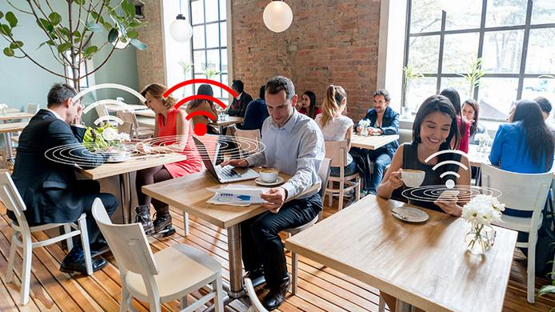

## Restaurants that Have Free WiFi in Your Area

Restaurants that have free WiFi in your area can be found just in one touch thanks to the installed [Wi-Fi Space](https://wifispc.com/). Having a dinner with your sweetheart or a family banquet you may need Internet for staying in touch with your partners. Or you can be one of those users who like to picture themselves in various places they’ve visited.

**How does it work for setting up wifi in bus, what do you need?**

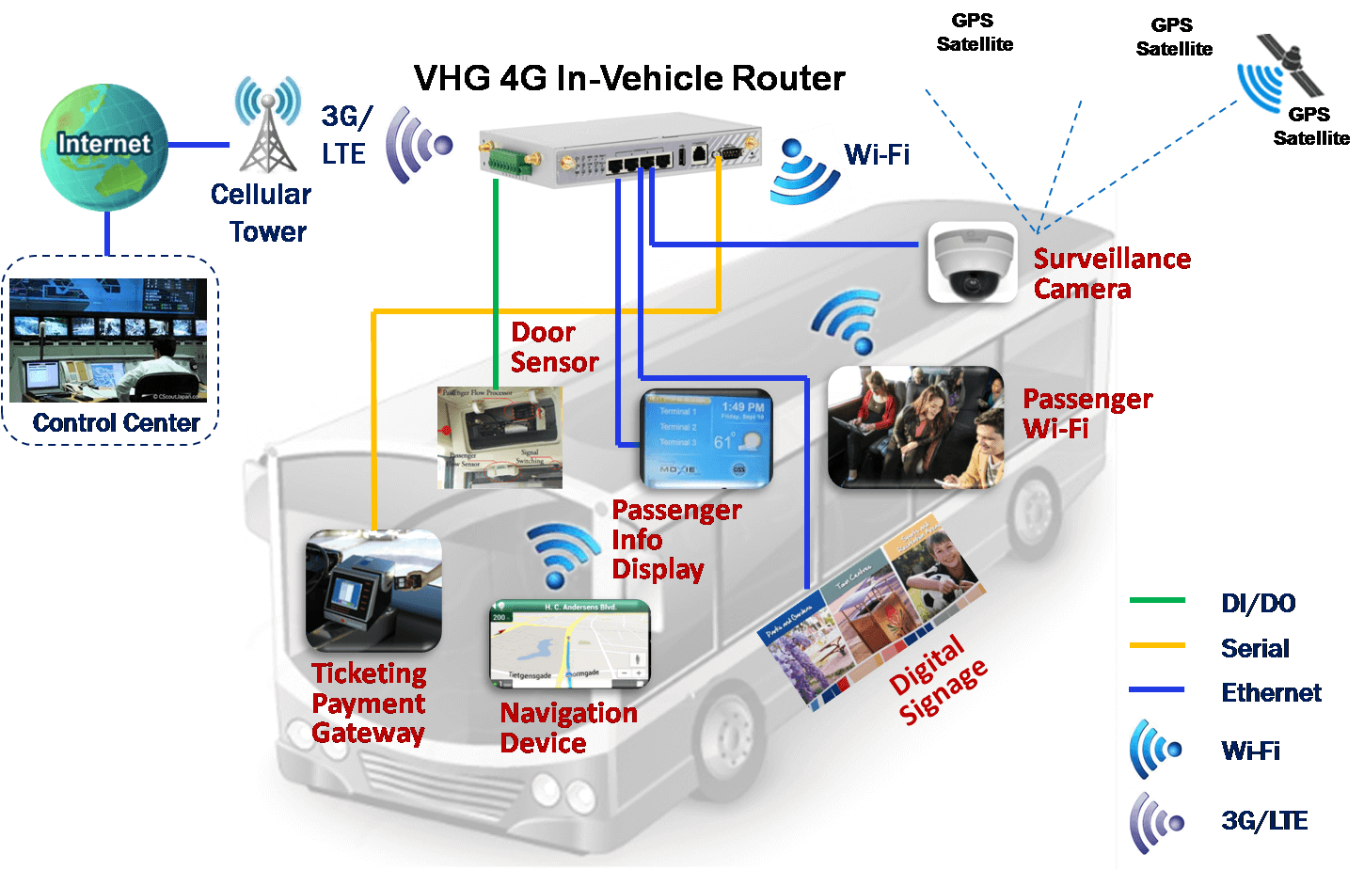

You need a WiFi router/access point, powered either directly from the 12v (24v) from the bus electrical system, or from an inverter that allows you to plug-in the original power brick. Configuration for clients is the same as for in any other WiFi location like a home.  
  
The uplink is more problematic, because obviously DSL/cable cannot be available in a moving vehicle, and so it's a problem to (a) maintain connectivity and (b) get enough bandwidth to be useful to a number of users sharing the link on the bus.  
  
Satellite will most likely be too expensive for any useful amount of bandwidth, and its also difficult to keep the antenna pointed at the satellite on a moving vehicle. 3G (or 4G if available) is probably the most cost effective solution, but in a built-up area the signal strength varies considerably over time due to signal fade.   
  
Some off-the shelf WiFi routers are equipped with a USB port that allows you to directly plug-in a 3G modem dongle: this is normally positioned as a back-up or "fail-over" port that allows the router to automatically switch from DSL to 3G if the land network fails. These routers offer a cheap way to experiment with WiFi on-the-move.  
  
There is a wireless system defined specifically for vehicles, called IEEE 802.11p, designed for vehicle-to-vehicle and vehicle-to-roadside communication from fast-moving vehicles, complete with technologies for fast hand-over between base stations. It really only exists as an academic research topic today.

**WiFi Hotspot Wireless Application Solutions for Vending Machine/ATM**

 Self-help vending machine is a terminal that applied in populated area where people can self-service and pay, its convenience has become a trend in life.

      Self-help vending machine is located in subway, factory and buildings, these places is filled with young people who have a strong demand for access to Internet.

Self-help vending machine with Four-Faith industrial 3g/4g router embedded can provide free WIFI, thus every self-help device is a WIFI hotspot itself, enable to provide internet service for space within 100 meters and support 64 users connection at the same time. By providing high speed internet access for all kinds of value-added service, self-service operators can bare interests from it.

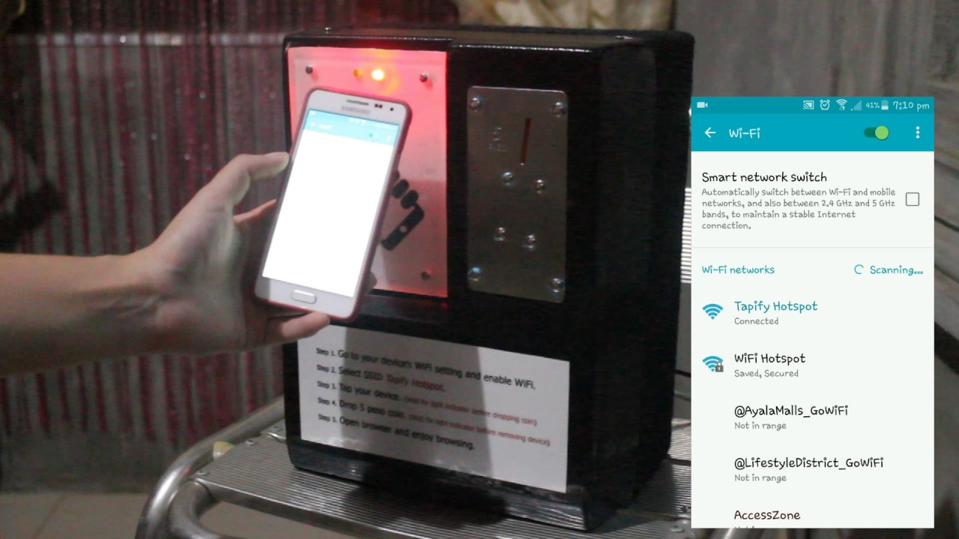

With the operating & managing cloud platform for Four-Faith Industrial 3G 4G Router, operators can monitor the operation status of every Vending Machine equipment in real-time, thus the organization, scheduling and monitoring work is more efficient and accurate.

Self-help Vending Machine with Four-Faith industrial router embedded can provide free WIFI, thus every self-help device is a WIFI hotspot itself, enable to provide internet service for space within 100 meters and support 64 users connection at the same time. By providing high speed internet access for all kinds of value-added service, self-service operators can bare interests from it.

Wifi hotspot in self –help vending machine:

Fast realize wired and wireless network double backup, switch time 25 seconds.

Support IPSEC, OPENVPN variety of encryption methods, to ensure the security and stability of the communication data.

Support 2 to 4 local LAN access, sets of charging pile can communication with platform as long through a router;

Support dual SIM card, flexible meet the different applications.

Bulks of self-service stores can be networked for management through Four-Faith advanced internet technology and industrial wireless communication products.Operators can see all stores’ operating status by analyzing data of sales, equipment operation and video monitoring, these data are sent to managing center by wireless network. Including the real time monitoring of every self-service vending machine, thus to achieve smart management on arranging stock and replenishment.

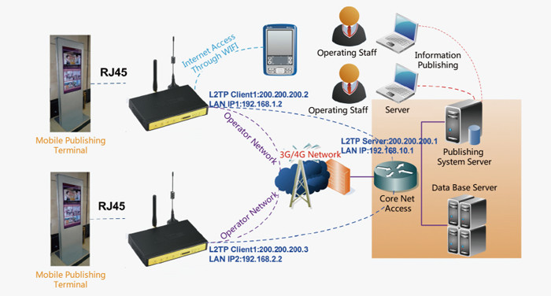

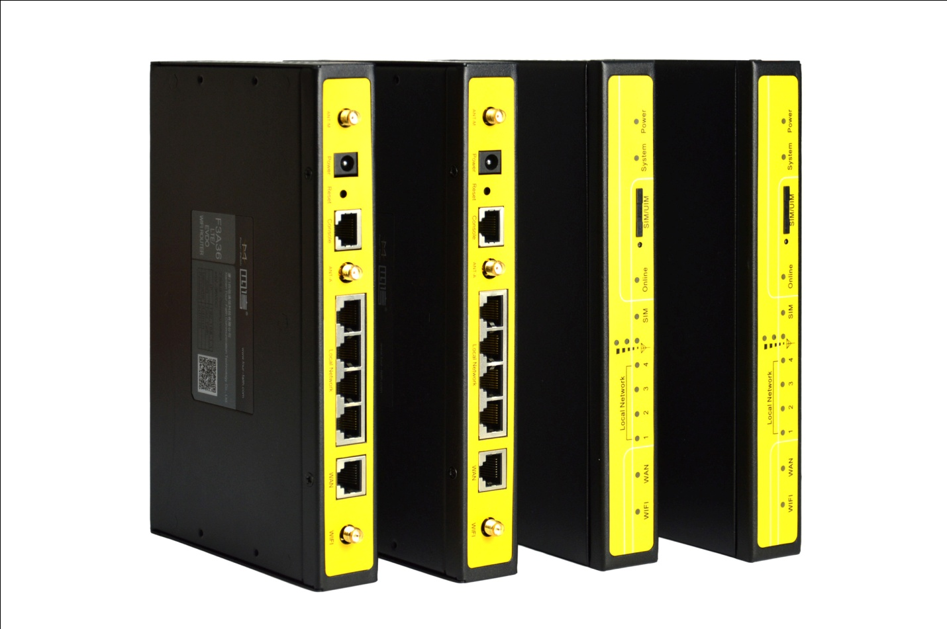

Through Four-Faith industrial Router network, scattered screen info of self-service terminals are centralized and managed. Total networking screen can reach 10,000, and info including ads, news, weather forecast, bank exchange rate, notification, etc.. These info can be issued simultaneously and efficiently, thus make self-service terminals become an important media for info display and communication, covers target population.

**Wifi Hotspot Solution for Single & Multi-Location University Campuses**



Campus is With the increasing demand for internet access in educational campuses due to evolving standard of education and flexibility offered by the Internet - universities, colleges, educational institutes etc., are keenly stepping forward to setup secured and stable wired or Wi-Fi network campus for their students. As per the current market trend, most of the students like to carry 3-4 devices with them like mobile, tablets, laptops, ipods etc. with them to campus. As these devices devour bandwidth, colleges and universities are struggling hard to keep up with the bandwidth demand. Educational campuses have major requirements of user access control, control over bandwidth consumption, and differentiated policy control for management faculty’s access and student’s access. These campuses with wired and wireless internet access require seamlessly roaming facility to access internet from class room to library to labs and residential areas. Laying complete network with different vendor solution would be very costly effort and difficult to manage while technical issues. Education institutes require cost-efficient comprehensive solution that offers all the advance facilities and features in single platform with single point of contact for technical support.

## School, College and Hostels Internet Access, Bandwidth Shaping, Hotspot Management and User Log Reports Solution

Enables educational institutes to provide regulated internet access to users in classrooms, libraries and also wifi hotspot access in dorms through extensive bandwidth controls over excessive usage. This ensures a reduction in costs as well as bandwidth consumption. 24online also ensures that the college campus wifi hotspot network is available for only students, staffs, faculties etc., by allowing authenticated users to access the internet network and avoids malicious login in the network. offers dynamic package creation feature by which one can easily provide different package for students and faculties as per their need. Also offers the freedom to easily roam from Wi-Fi network to wired network without logging using its login-once feature. Also offers extensive reporting graphical as well as printable format to understand the usage of users