**Data Manipulation Language (DML) Checkpoint**

**AJMI Wissal**

* **Relational model**

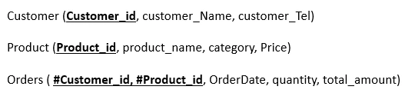

* Tables

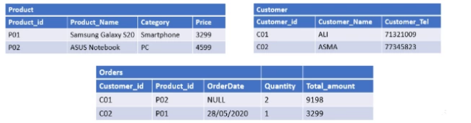

* **Insert data into table**
* **Customer**

**INSERT INTO** Customer **VALUES** (‘C01’, ‘ALI’, ‘71321009’);

**INSERT INTO** Customer **VALUES** (‘C02’, ‘ASMA, ‘71345823’);

* **Product**

**INSERT INTO** Product **VALUES** (‘P01’, ‘Samsung Galaxy S20’, ‘Smartphone’, ‘3299’);

**INSERT INTO** Product **VALUES** (‘P02’, ‘ASUS Notebook’, ‘PC’, ‘4599’);

* **Orders**

**INSERT INTO** Orders **(Customer_id, Product_id, Quantity, Total_amount)**

**VALUES** (‘C01’, ‘P01’, ‘NULL’, ‘2’, ’9198’);

**INSERT INTO** Orders **VALUES** (‘C01’, ‘P02’, ‘28/05/2020’, ‘1’, ‘3299’);