Useful Mathematical
Facts

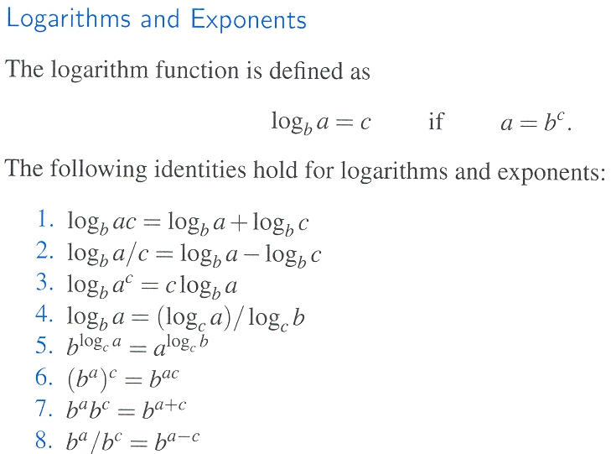

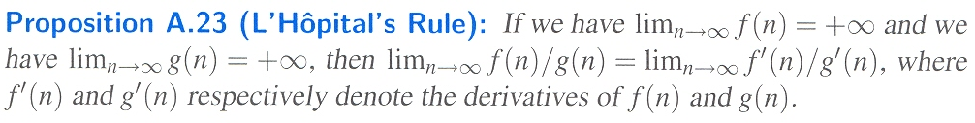

The following are some facts about summations that arise often in the analysis of data structures and algorithms:

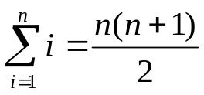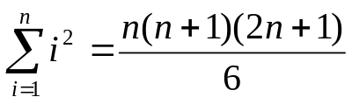
Another common summation is the geometric sum, for any fixed number 0 < a.

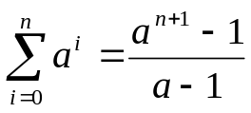 For any real number 0 < a.

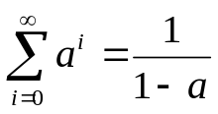 For any real number 0 < a < 1.

The Big-Oh Notation

Let f(n) and g(n) be functions mapping nonnegative integers to real numbers. We say that f(n) is O(g(n)) if there is a real constant c > 0 and integer constant n₀ ≥ 1 such that
f(n) ≤ cg(n), for n ≥ n₀

This notation provides away of saying that the growth rate of f(n) is “less than or equal” to the growth rate of g(n).

The Big-Omega Notation

Let f(n) and g(n) be functions mapping nonnegative integers to real numbers. We say that f(n) is Ω(g(n)) if there is a real constant c > 0 and integer constant n₀ ≥ 1 such that
f(n) ≥ cg(n), for n ≥ n₀

This notation provides away of saying that f(n) grows at a rate that is greater than or equal to that of g(n).

The Big-Theta Notation

This is a notation that allows us to say that two functions grow at the same rate, up to constant factors. We say that f(n) is big-Theta of g(n) if f(n) is O(g(n)) and f(n) is Ω(g(n)).

