**TU858 SDEV2004 Software for the Global Market (5 ECTS)**

**Continuous Assessment Semester 2 2023-2024**

**Individual Project Documentation**

**C21404706**

**Wissam Hadjarab**

**Include a table of contents here (If you use the headings in this document you can just update the table below. If not and you use headings styles you can generate this in Word: go to the References -> Table of Contents choose an automatic style).**

Table of Contents

Introduction 1

Personas 2

Design 3

Internationalization Strategy 4

Prototype 5

# Introduction

Insert here the details of the project you were assigned:

Identify which personas were used and the short outline of the project you were assigned.

# Language: Korean

# Culture: High Uncertainty Avoidance, Collectivist

|  |  |
| --- | --- |
|   **Kim Da-mi** | Age: 45  Location: Soeul, South Korea.  Education: Masters in Business Administration  Occupation: Marketing Manager  Income: ₩98M  Pronouns: She/Her  Lifestyle: Married with three children, strong work ethic, enjoys activities with family and friends, studying for PhD part-time. |
| *“Strength lies not in the absence of fear, but in the ability to navigate uncertainty with wisdom and unity, safeguarding what matters most – our family's well-being. Within each journey lies the chance to strengthen our familial ties and unveil the splendour of connection once more.”* | |
| **Motivation** | |
| Travelling with her husband, children and parents, Kim is motivated by a desire to ensure a seamless, safe, and culturally enriching experience for everyone. She wants to build connections to new surroundings but seeks familiarity when travelling permitting everyone to have a worry-free experience. Kim likes to conduct extensive research in advance of travelling, planning her journey meticulously and using sound and safe travel options. | |
| **Brand Affiliations**  Prefers brands that offer reliability, assurance, family-friendliness, cultural connection, and comfort. Prefers guided tours and activities offered by well-know tour operators and providers. | |
| **Psychographics** | **Communication Style** |
| * Family orientated:   Committed to her family and activities to build a connection within families in the community, likes to share experiences with her family.   * Organised and Reliability:   Likes to plan to ensure ease and safety e.g. when travelling and detailed orientated to assure stress-free experiences for her and family.   * Culturally invested:   Fondness to travel shows curiosity and desire to explore new cultures and share with her family whilst also adhering importance to her own culture. | * Detailed:   As per her planning and detailed orientated behaviour, clear formatted structure way of communicating would be adequate to present information.   * Warm:   Gentle communication and tone to convey information that listens to family and community needs.   * Practical:   Reliable information to ensure reliability and to prioritize problem solving and decision making. |
| **Behaviour and Social Norms** | **Frustrations and Pain Points** |
| * Family-centred:   Behaviour, schedule, and choices will revolve around her family and needs to ensure well-being and supporting relatives and community.   * Conscious of safety:   Desire to have safe experience for her family to minimize risks and also make it easier concerning family’s welfare.   * Respectful:   Desire to build connections in the community and outside in new places and cultures depicts cultural sensitivity and respect to individuals and steer clear from insensitive behaviour. | * Work-life balance:   Can face time constraints as trying to balance the load of working whilst also taking care of a family and being involved in family and communities’ welfare.   * Uncertaintiy:   Anxiety or stress can result as per her detailed oriented nature and can face frustration with delays, health concerns etc affecting her and her family.   * Pressure:   Faces pressure to meet high expectations, both professionally and personally due to her strong work ethic in career success or experiences for her family. |

# Language: Swedish

# Culture: Low Uncertainty Avoidance, Individualist

|  |  |
| --- | --- |
|   **Lars Johansson** | Age: 45  Location: Stockholm. Sweden.  Education: MSc. In Software Development  Occupation: IT Project Manager  Income: SEK 700,000  Pronouns: He/Him  Lifestyle: Single, career-focused, health-conscious, self-motivated |
| *“Embrace the unknown, for in the uncharted lies the adventure of a lifetime. Let your individual spirit guide you through the wonders of our world, where every step is a discovery and every moment a testament to your courage.”* | |
| **Motivation** | |
| As a solo traveller, Lars is motivated by the desire to expand his cultural knowledge and to experience the local lifestyle. Lars sees travel as an opportunity for personal growth. He seeks adventure, new experiences, and the opportunity to meet interesting people. He likes flexibility in both planning his journey and adapting it when travelling to tailor his experience to his needs and desires in the moment. | |
| **Brand Affiliations**  Likes outdoor and adventure brands. Prefers brands that offer unique and local experiences, focusing on sustainability and eco-friendliness. Looks for quality experience when staying in hotels and eating out. | |
| **Psychographics** | **Communication Style** |
| * Personal growth:   Need to travel solo and experience different cultures invokes open-minded eagerness to step out of comfort zone.   * Environmental conscious:   Preference for sustainable and eco-friendly brands as well as interest for outdoor activities seems to indicate prioritization of environmental responsibility.   * Independent lifestyle:   Single status along with self-motivated lifestyle suggest value of independence and personal freedom | * Inspirational:   His motivational quote suggests informal and inspirational communication that encourages new experiences and challenges.   * Adaptive:   Flexibility in travel and adapting to new suggestions indicate willingness to different perspective and preferences – communication based on needs of the situation.   * Value-driven:   Prioritizing eco-friendliness indicate values-driven communication style that’s in alignment with personal beliefs. |
| **Behaviour and Social Norms** | **Frustrations and Pain Points** |
| * Individualism:   Preference for solo travel and personal growth is valued in Sweden and further prioritizes his own needs over group expectations.   * Flexible:   Desire for flexible travel suggests a comfort of uncertainty and tailors’ experiences to current desires.   * Eco-friendly:   Outdoor and adventuristic behaviour reflect societal emphasis on environmental consciousness in Sweden and considers environmental impact of his actions. | * Difficulty finding connection:   Desire to meet interesting people and experience local lifestyle in travels can cause struggle to make meaningful connections and relations which could lead to isolation.   * Lack of eco-awareness in travel:   Frustration from lack of commitment to sustainability in travel industry and can encounter challenges finding accommodation, activities etc.   * Work and personal balance:   Can struggle to find balance between professional responsibilities and desire for adventure which can lead to stress and feeling of imbalance. |

# Design

Persona 2 Kim:

How might we question:

1. How might we enhance the safety and security measures of family travels like Kim?
2. How might we create cultural experiences that cater to Kim’s desire for familiarity and connection?
3. How to make planning process efficient for busy professionals like Kim – who value meticulous planning and reliable options?

Hypotheses:

1. Implement safety protocol and providing real-time updates during travel to ensure ease of mind and confidence.
2. Offering packages or offers with family – orientated activities and comforts to strength family bonds.
3. User friendly app tailored to busy professionals.

Persona 1 Lars:

How might we question:

1. How to facilitate meaningful cultural exchanges and connections for solo travellers like Lars?
2. How might we provide flexible travel options that allow Lars to customize his journey based on his interest and preferences?
3. How might we leverage technology to enhance Lars’ travel experience and empower him to navigate unfamiliar destinations confidently?

Hypotheses:

1. Implement platform for solo travellers to connect with local communities and participate in authentic cultural experiences will enrich Lars’ travel adventure.
2. Offering customizable travel packages with flexible itineraries and activities that will help Lars to design his own unique travel experiences tailored to his interests.
3. Developing a mobile app with features like offline maps, real-time translation and personalized recommendations will support Lars in exploring new destinations independently and with ease.

# Internationalization Strategy

For my folder structure I had each different aspect of the website saved into a different directory with its associated files.

The main directory I set up that contains all the main files and folders of the project – app. A sub-folder was used named assets where all static files were stored such as the images used, stylesheet, js, css etc.

I also set up other sub- directories from another sub-directory that has all includes needed from the different blocks of code for each supported language included and where base and index html files are stored. These templates are stored in a Template folder where each file may have its own localization and can use a templating engine that supports localization directly within the templates themselves. A messages sub-directory is included as well that contains message files or dictionaries for localization. I left the configuration files used for the application without a sub-directory, so it is easily accessible.

To ensure correct localized content appears for users and to handle all of the files I implemented session variables and use the language preference to load the appropriate localized content for the user. I included language-specific stylesheets in the HTML document based on the user’s selected language. The directory structure helps organize language specific stylesheets and dynamically link the right stylesheet in the HTML document along with images within the assets folder.

I organized the templates content into language specific directories within my templates folder and use rendering application that supports localization to load the appropriate template based on the user’s language.

For my user to change the language I have provided an interface for users to change their language preference done with a dropdown selector toggle button. When the user selects a different language it loads corresponding language resources and also has a global icon for one of the languages.

# Prototype

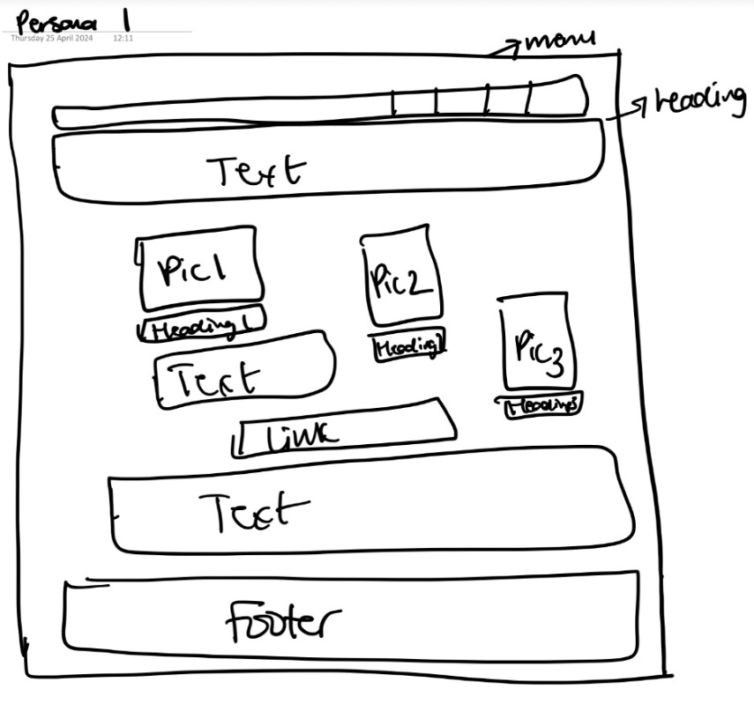Document your implementation choices:

* Briefly explain someone can test your web page to verify your design.
* Refer to the relevant aspects of the prototype implemented.

For my designs I drew up a wireframe to depict the site.

For persona 1 I included dark colours with a more modern look to the page as catered to a more niche audience, being a middle- aged solo traveller. It includes pictures of solo travellers like himself as he is always looking for new connections and others like him as explained in his profile and will draw him in making him feel that the website is for his interests. It also has the information easily accessible and quick to use.

For persona 2 I included bright colours that is more suited to a family which creates a warm environment when she is booking to reduce stress. It also includes pictures of young families like hers with different backgrounds as she values culture. The information and layout is also different and catered more toa family with family deals, activities and safety, ensuring a stress free booking to know everything is together.