Steps for Using Docker Compose
- Install Docker and Docker Compose
Make sure Docker and Docker Compose are installed on your machine. You can check the installations using the following commands:
docker –version
docker-compose –version
Create the docker-compose.yml File
Create a file named docker-compose.yml in your desired directory. Paste the following content into this file:
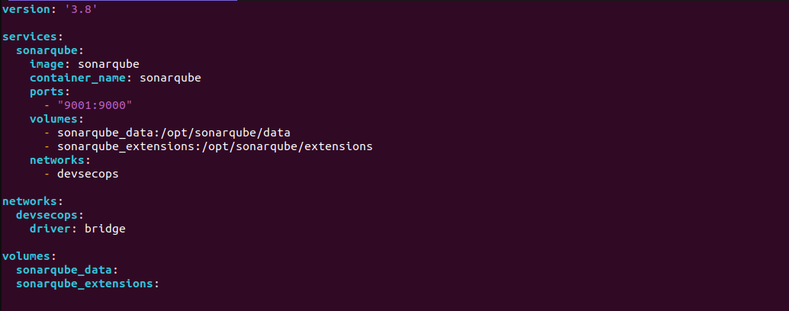
Explanations:
- version: '3.8': Specifies the version of the Docker Compose file format.
- services: Defines the services to be deployed. Here, the sonarqube service is defined with:
  - image: Uses the official SonarQube Docker image.
  - container_name: Names the container for this service.
  - ports: Maps port 9000 of the container to port 9001 on the host.
  - volumes: Mounts volumes to persist data and extensions.
  - networks: Associates the service with the devsecops network.
- networks: Defines a network named devsecops using the bridge driver.
- volumes: Defines volumes sonarqube_data and sonarqube_extensions used to persist data.

Start the Services
Open a command line in the directory containing the docker-compose.yml file and run the following command to start the services:
docker-compose up -d

- This command lists the running containers along with their status.
- Access the Application
You can access SonarQube by opening a web browser and visiting http://localhost:9001. The port 9001 on your host is mapped to port 9000 on the SonarQube container.

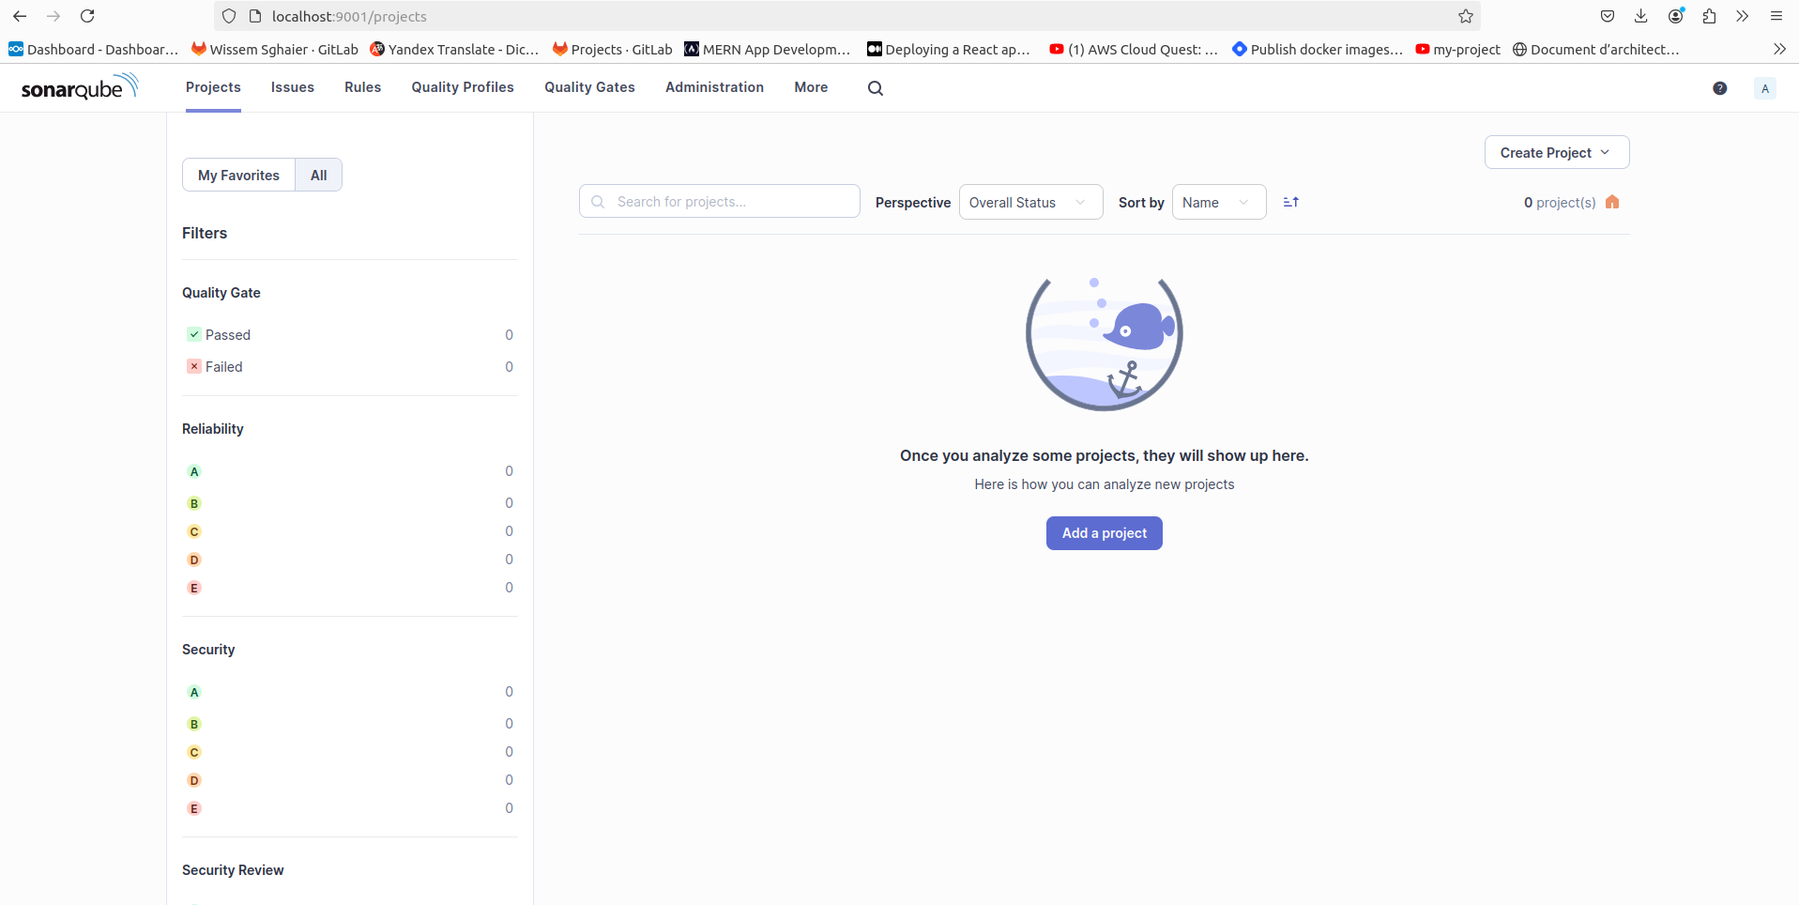

Create the docker-compose.yml File
Create a file named docker-compose.yml in your desired directory. Paste the following content into this file:

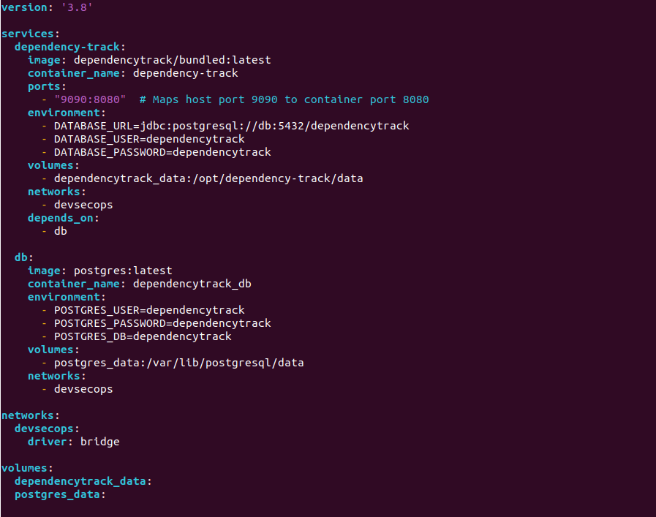
- Explanations:
- version: '3.8': Specifies the Docker Compose file format version.
- services: Defines the services to be deployed. Here, two services are defined:
  - dependency-track:
    - image: Uses the dependencytrack/bundled:latest Docker image.
    - container_name: Names the container dependency-track.
    - ports: Maps port 8080 of the container to port 9090 on the host.
    - environment: Sets environment variables for the service.
    - volumes: Mounts a volume to persist data.
    - networks: Associates the service with the devsecops network.
    - depends_on: Specifies that dependency-track depends on the db service to start first.
  - db:
    - image: Uses the postgres:latest Docker image.
    - container_name: Names the container dependencytrack_db.
    - environment: Sets environment variables for the PostgreSQL database.
    - volumes: Mounts a volume to persist database data.
    - networks: Associates the service with the devsecops network.
- networks: Defines a network named devsecops with the bridge driver.
- volumes: Defines volumes dependencytrack_data and postgres_data to persist data.
Start the Services
Open a command line in the directory containing the docker-compose.yml file and run the following command to start the services:
docker-compose up -d

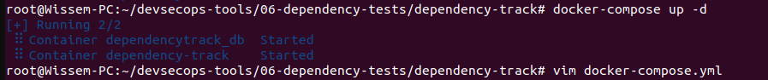
Access the Application
You can access SonarQube by opening a web browser and visiting http://localhost:9090/dashboard. The port 9090 on your host is mapped to port 9090 on the Dependency-track container.
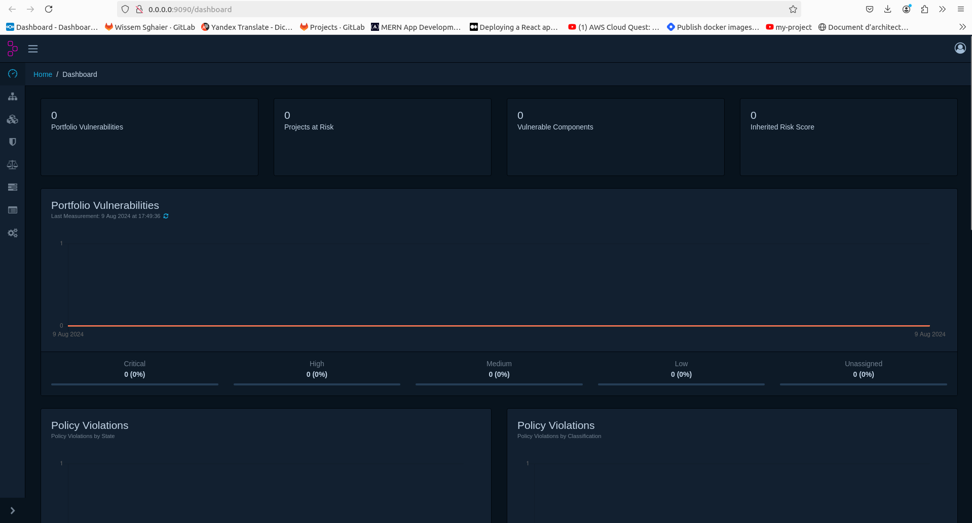

Create the docker-compose.yml File
Create a file named docker-compose.yml in your desired directory. Paste the following content into this file:
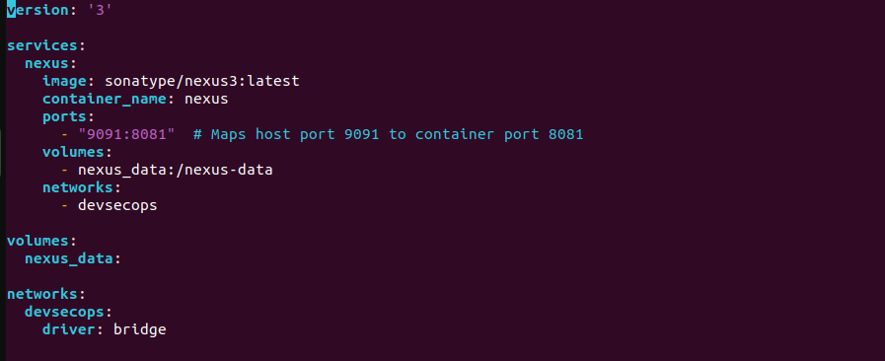
Explanations:
- version: '3': Specifies the Docker Compose file format version.
- services: Defines the services to be deployed. Here, the nexus service is defined with:
  - image: Uses the sonatype/nexus3:latest Docker image for Nexus Repository.
  - container_name: Names the container nexus.
  - ports: Maps port 8081 of the container to port 9091 on the host. This allows you to access Nexus on port 9091 on your local machine.
  - volumes: Mounts a volume nexus_data to persist Nexus data.
  - networks: Associates the service with the devsecops network.
- volumes: Defines a volume named nexus_data for persisting Nexus data.
- networks: Defines a network named devsecops using the bridge driver.
- Start the Services
Open a command line in the directory containing the docker-compose.yml file and run the following command to start the services:
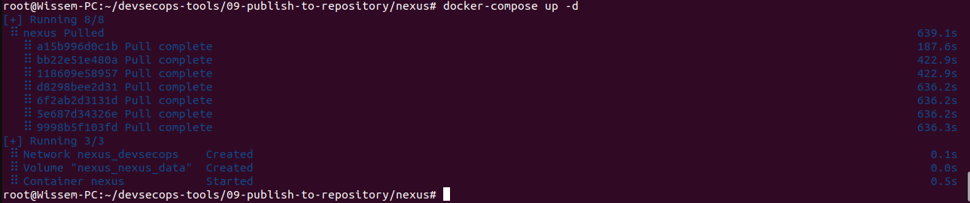
docker-compose up -d
Access the Application
You can access the Nexus Repository Manager by opening a web browser and visiting http://localhost:9091. Port 9091 on your host is mapped to port 8081 on the Nexus container.

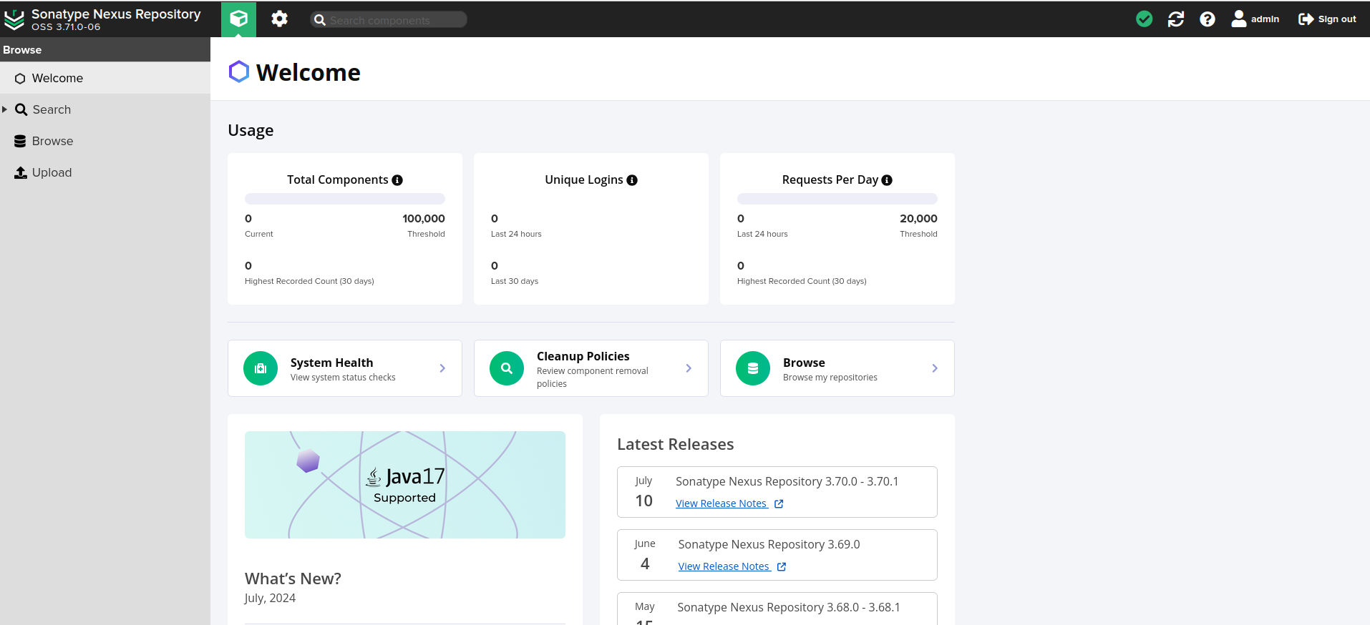

Create the docker-compose.yml File
Create a file named docker-compose.yml in your desired directory. Paste the following content into this file:
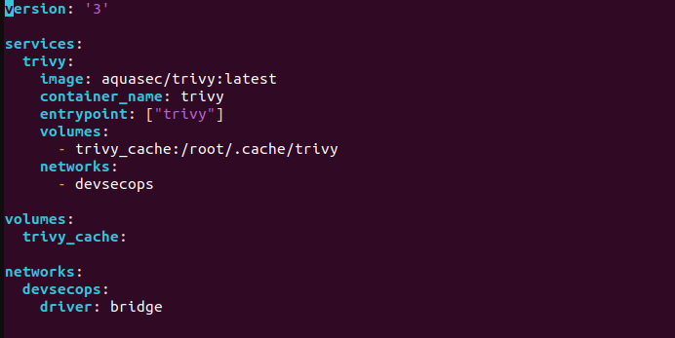

Explanations:
- version: '3': Specifies the version of the Docker Compose file format.
- services: Defines the services to be deployed. Here, the trivy service is defined with:
  - image: Uses the aquasec/trivy:latest Docker image for Trivy, a vulnerability scanner.
  - container_name: Names the container trivy.
  - entrypoint: Sets the entrypoint for the container to the trivy command, allowing you to specify the command to run when the container starts.
  - volumes: Mounts a volume trivy_cache to persist Trivy cache data, which can speed up subsequent scans.
  - networks: Associates the service with the devsecops network.
- volumes: Defines a volume named trivy_cache for persisting cache data.
- networks: Defines a network named devsecops using the bridge driver.
Start the Services
Open a command line in the directory containing the docker-compose.yml file and run the following command to start the services:

docker-compose up -d
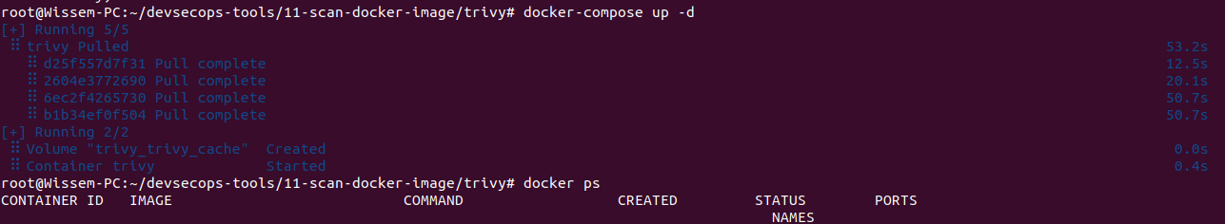
Using Trivy
Once the Trivy container is running, you can execute commands in it using docker exec. For example, to scan a Docker image for vulnerabilities, use:
docker-compose logs trivy
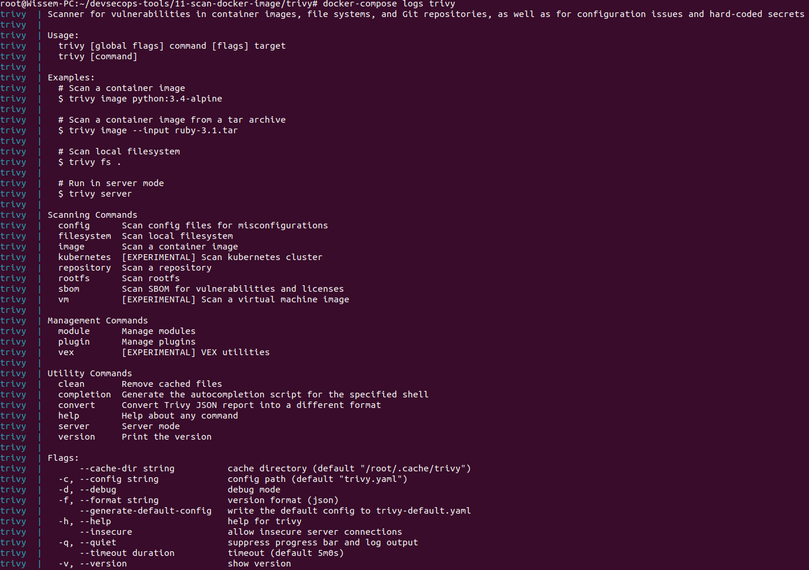
docker exec trivy trivy image your-image:tag

Create the docker-compose.yml File
Create a file named docker-compose.yml in your desired directory. Paste the following content into this file:
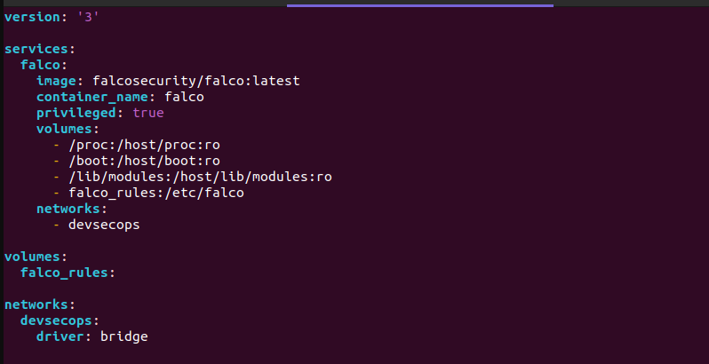
Explanations:
- version: '3': Specifies the Docker Compose file format version.
- services: Defines the services to be deployed. Here, the falco service is defined with:
  - image: Uses the falcosecurity/falco:latest Docker image for Falco.
  - container_name: Names the container falco.
  - privileged: true: Grants the container elevated privileges, which is necessary for Falco to access kernel and system data.
  - volumes: Mounts directories and volumes into the container:
    - /proc:/host/proc:ro: Mounts the host’s /proc directory as read-only inside the container.
    - /boot:/host/boot:ro: Mounts the host’s /boot directory as read-only inside the container.
    - /lib/modules:/host/lib/modules:ro: Mounts the host’s /lib/modules directory as read-only inside the container.
    - falco_rules:/etc/falco: Mounts a named volume for Falco rules.
  - networks: Associates the service with the devsecops network.
- volumes: Defines a volume named falco_rules for Falco rule configurations.
- networks: Defines a network named devsecops using the bridge driver.
Start the Services
Open a command line in the directory containing the docker-compose.yml file and run the following command to start the services:
docker-compose up -d
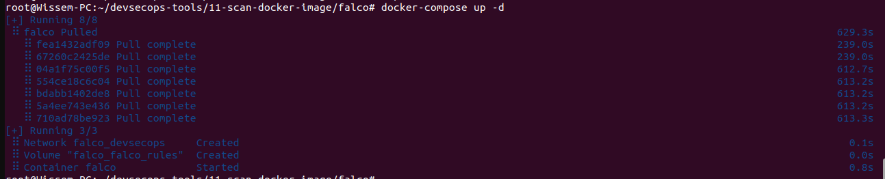
Configure Falco Rules
Falco uses rules to detect suspicious activity. The rules are typically placed in a configuration file. Since you are mounting a volume falco_rules to /etc/falco, you should ensure that the Falco rules are available in this volume. You can modify or add rules to the falco_rules volume based on your requirements.
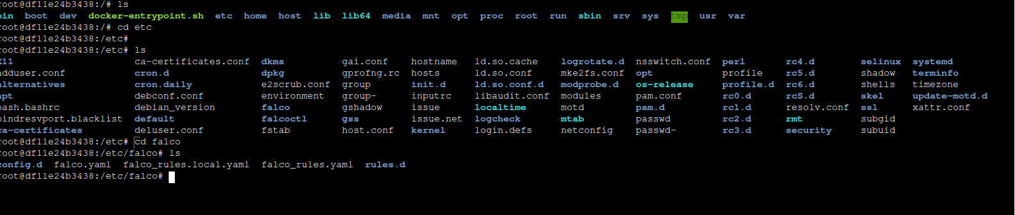

- View Falco Logs
You can view the logs of the Falco container to ensure it is running correctly and to see any potential errors or output:
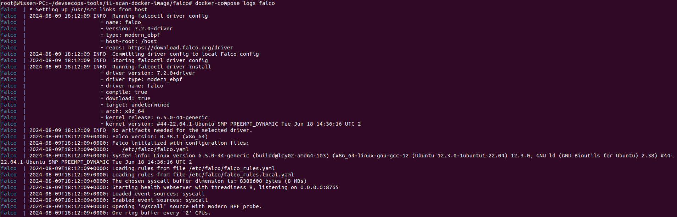
docker-compose logs falco
This will display the logs for the falco service. Look for any startup messages or errors that might indicate issues.

Check Container Health
If you want to perform a more automated health check, you can create a custom script that tests basic functionality of Falco. For example:
docker-compose exec falco falco –version
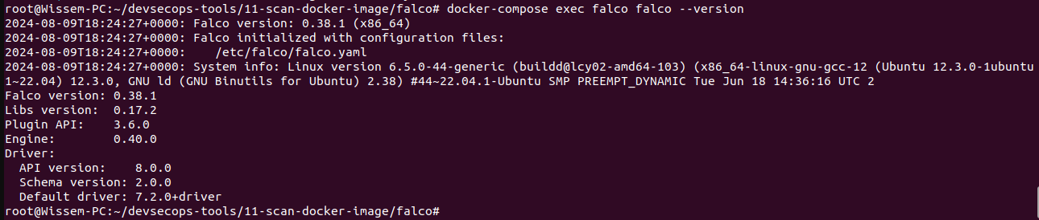
This command will return the version of Falco, confirming that Falco is installed and accessible within the container.

Create the docker-compose.yml File
Create a file named docker-compose.yml in your desired directory. Paste the following content into this file:
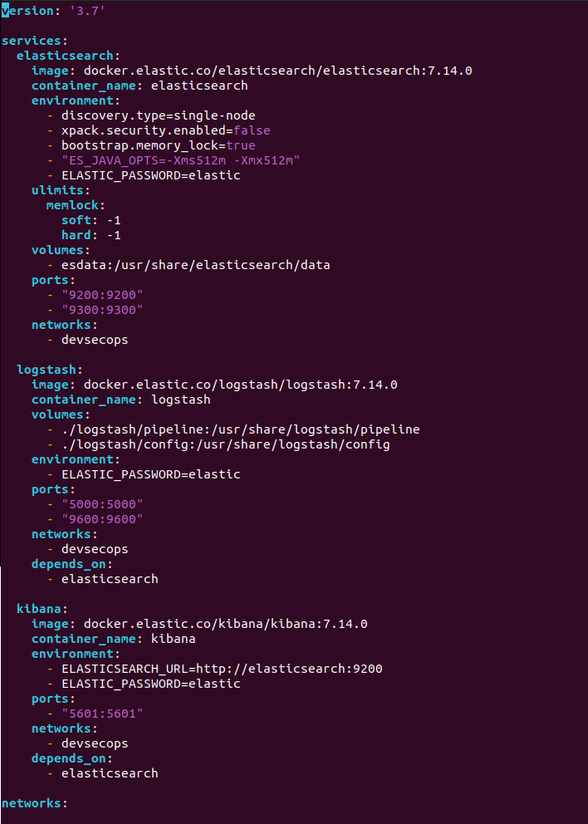

2. Explanation of the Docker Compose File
- version: '3.7': Specifies the version of the Docker Compose file format.
- services: Defines the services that will be run. Each service corresponds to a container.
  - elasticsearch:
    - image: Specifies the Docker image to use.
    - container_name: The name of the container.
    - environment: Sets environment variables inside the container.
    - ulimits: Configures resource limits for the container.
    - volumes: Mounts volumes to persist data.
    - ports: Maps container ports to host ports.
    - networks: Connects the container to a specific network.
  - logstash:
    - image: Specifies the Docker image to use.
    - container_name: The name of the container.
    - volumes: Mounts configuration files and pipelines from the host to the container.
    - environment: Sets environment variables inside the container.
    - ports: Maps container ports to host ports.
    - depends_on: Ensures that elasticsearch starts before logstash.
  - kibana:
    - image: Specifies the Docker image to use.
    - container_name: The name of the container.
    - environment: Sets environment variables inside the container.
    - ports: Maps container ports to host ports.
    - depends_on: Ensures that elasticsearch starts before kibana.
- networks: Defines the network configuration.
  - devsecops: Creates a bridge network named devsecops.
- volumes: Defines named volumes to persist data.
  - esdata: A volume used by Elasticsearch to store data.

Start the Services
Open a command line in the directory containing the docker-compose.yml file and run the following command to start the services:
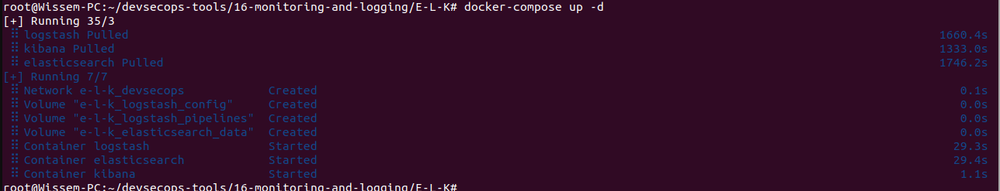
docker-compose up -d
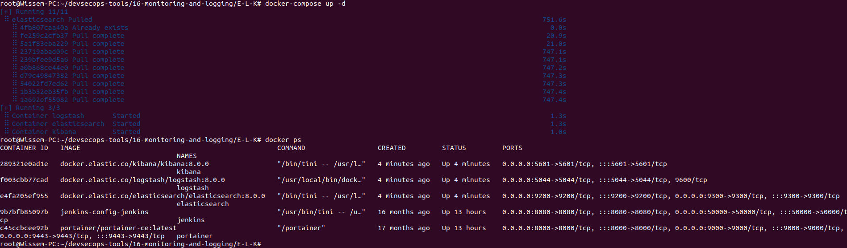

Access the ELK Stack
- Elasticsearch: Access Elasticsearch at http://localhost:9200.
- Logstash: Access Logstash at http://localhost:5044 (typically used for HTTP input and output).
- Kibana: Access Kibana at http://localhost:5601 to visualize and interact with data stored in Elasticsearch.
docker exec -it elasticsearch bin/elasticsearch-setup-passwords interactive

Access the Services:
- Elasticsearch: Open a web browser and navigate to http://localhost:9200 to access Elasticsearch.
- Logstash: Open a web browser and navigate to http://localhost:9600 to access Logstash’s monitoring interface.
- Kibana: Open a web browser and navigate to http://localhost:5601 to access Kibana.

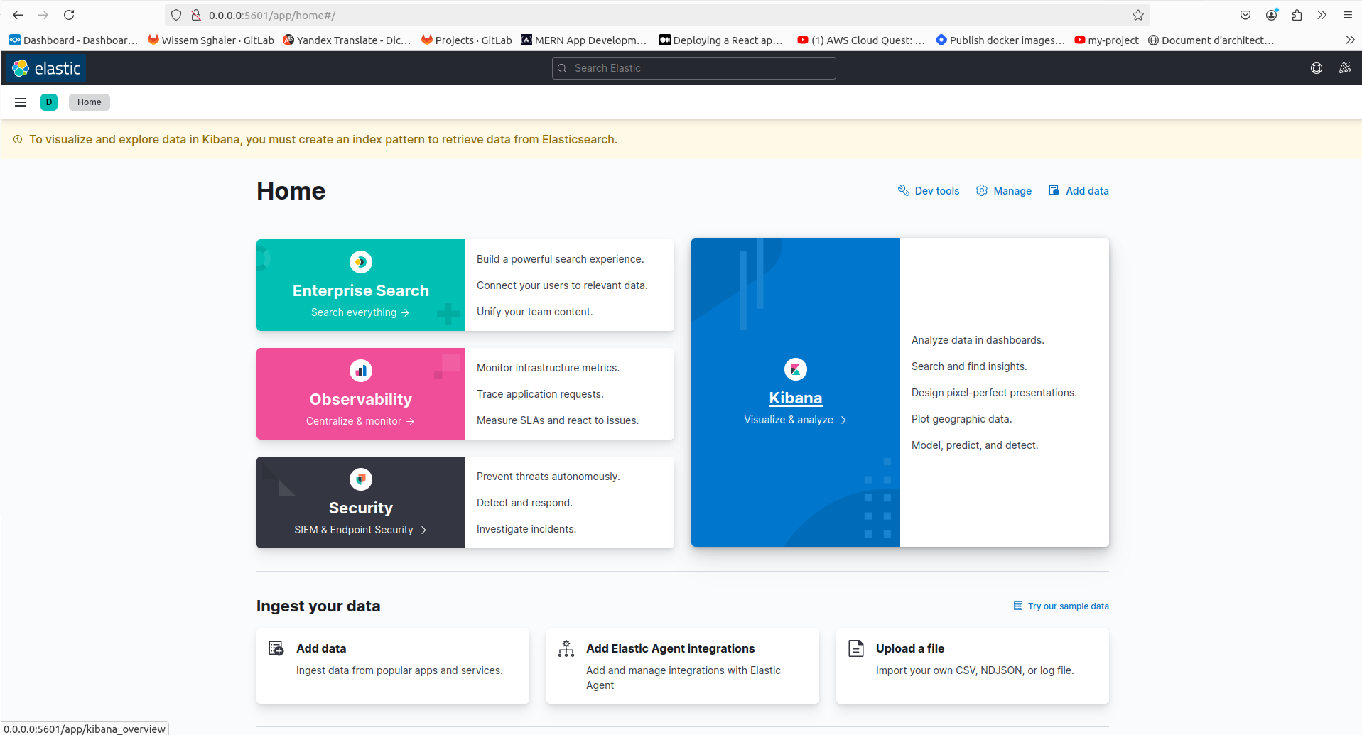

1. Create docker-compose.yml File
Save the following configuration to a file named docker-compose.yml:

profilpicture.png

version: '3'

services:
elasticsearch:
image: docker.elastic.co/elasticsearch/elasticsearch:8.0.0
container_name: elasticsearch
environment:
- discovery.type=single-node
- ES_JAVA_OPTS=-Xms2g -Xmx2g # Set heap size to 2GB
ports:
- "9200:9200"
- "9300:9300"
volumes:
- elasticsearch_data:/usr/share/elasticsearch/data
networks:
- devsecops

logstash:
image: docker.elastic.co/logstash/logstash:8.0.0
container_name: logstash
ports:
- "5044:5044"
volumes:
- logstash_config:/usr/share/logstash/config
- logstash_pipelines:/usr/share/logstash/pipeline
networks:
- devsecops

kibana:
image: docker.elastic.co/kibana/kibana:8.0.0
container_name: kibana
ports:
- "5601:5601"
depends_on:
- elasticsearch
environment:
- ELASTICSEARCH_HOSTS=http://elasticsearch:9200
- ELASTICSEARCH_USERNAME=kibana
- ELASTICSEARCH_PASSWORD=kibana
networks:
- devsecops

volumes:
elasticsearch_data:
logstash_config:
logstash_pipelines:
kibana_data:

networks:
devsecops:
driver: bridge

