CS Task02 – SE Process

# Decide whether your SE Process for implementing the MHC-PMS should be rather plan- driven or agile

**Pro agile**

* Since we have sufficient resources we can get as much feedback as we need and of course use good tools to support system development.
* Medium – size software project
* The team is small and is able to communicate well and easy.

**Pro plan – driven**

* The project requires quite detailed specification and design before implementation.
* The expected system lifetime is long
* All team members aren’t highly skilled programmers
* Safety requirements

Because of these points we decided to take a **combo** between plan – driven and agile for our project.

# 2.

**A process model**

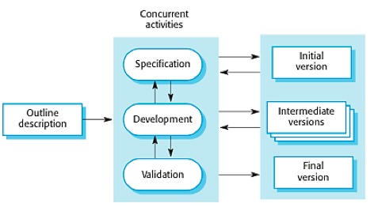

Incremental development

**For each activity the goals, tasks and potential output(s)**

|  |  |  |  |
| --- | --- | --- | --- |
| **Activity** | **Goal** | **Task** | **Output** |
| Specification | Description of product | Describe product and write specification | Specification |
| Development | Evolve/develop product | Evolve/develop product | Product |
| Validation | Checking for specifications and requirements | Comparison between specification and product | Report |
| Initial version | First test; try to fulfil the customer wishes | Software testing | Report and potential errors or required fixes |
| Intermediate versions | Second test | Testing to be sure errors are fixed | Report |
| Final version | Final version of product | --- | Final product |

**Relation among outputs of different activities**

The requirements of the customer are written down in the specification. This document is required to start developing a product. After development but still before the first test, Validation takes place. This is to be sure that all the requirements are implemented. After testing the initial version errors get fixed and missing demands are added.The final version has to fulfil all the needs of the client.

**Involvement of stakeholders**

* The customer gets involved with the management to give details about the concrete requirements.
* The management gets involved with the development team to hand over the wishes and plans of the customer.
* ****The development team is during development involved with the client to talk about his presented challenges and also with the users in the context of testing and feedback.