**Introduction**

T-type Cav3.2 channels were shown to be increasingly expressed on the membrane of nociceptive DRG neurons under diabetes that lowers threshold for their activation translated into hyperalgesia to thermal and mechanical stimuli. Inhibition of Cav3.2 activity by the blockers was shown to relieve pain symptoms, but this relief was not long-lasting. So, the goal of long-lasting relief of pain under diabetes could be reached by stable inhibition of Cav3.2 expression. To reach this goal we looked at already developed methods of the genes knockout and knockdown: CRISP-Cas9 system or siRNA- and/or miRNA-directed Cav3.2 mRNA degradation. Delivering of CRISP-Cas9 and shRNA (precursor of siRNA) or miRNA was planned on the AAV vectors packed into AAV6 viral particles, which have tropism to nociceptive DRG neurons compared to other sensory neurons, by injecting the AAV6 specimen into the corresponding nerve or into the skin of the foot near terminals of nociceptive DRG neurons. We expect effectiveness of AAV6 delivering of the construct at the level of 90-100%. To effectively inactivate Cav3.2 gene we have chosen the vector **pEJS1099: Dual-sgRNA.Design 4, Addgen #159537,** because it can stably express two single-guide (sgRNAs), affording two double-strand brakes in DNA of the gene, substantially increasing the rate of long deletions among mutations (Ibraheim et al., 2018)(Ibraheim et al., 2021). To afford two sgRNA in this vector shorter coding sequence for enzyme Cas9 was chosen – its variant Nme2 from [*Neisseria meningitis*](https://www.google.com/search?client=firefox-b-d&q=Neisseria+meningitis&spell=1&sa=X&ved=2ahUKEwiImrn2o4L6AhUcDRAIHchRCrkQkeECKAB6BAgDEDo) with PAM sequence N4CC(Ibraheim et al., 2021). It has high fidelity for the sgRNA target sequence (little or no off-target editing activity) and efficiency (Edraki et al., 2019). As Ibraheim et al. did not see visible expression of the target protein using this vector (Ibraheim et al., 2021), we would expect high mutation efficiency, including deletions and missense mutations, of the Cav3.2 gene between 80 and 100%. Because these mutations are stable, they are not expected to recover back to original sequence, we expect stable long-lasting effect of the delivered therapy with this method. For the other way of inhibition of Cav3.2 expression – by means of siRNA-directed degradation of mRNA for Cav3.2 channel we plan to clone the coding sequence for the precursor of siRNA, shRNA, into AAV vector, **Addgen #75438,** by BamHI-EcoRI sites. Based on literature data we expect roughly 50% expression inhibition of the Cav3.2 channels in this case and do not expect as long-lasting effect as for the first system, because the Cav3.2 gene remains intact and AAV vectors are not replicating by themselves and should be degraded with time by the endonucleases of the host cells. But we still wanted to check the time window of the therapeutic effect for this system.

References

Edraki, A., Mir, A., Ibraheim, R., Gainetdinov, I., Yoon, Y., Song, C. Q., et al. (2019). A Compact, High-Accuracy Cas9 with a Dinucleotide PAM for In Vivo Genome Editing. *Mol. Cell* 73, 714-726.e4. doi:10.1016/j.molcel.2018.12.003.

Ibraheim, R., Song, C. Q., Mir, A., Amrani, N., Xue, W., and Sontheimer, E. J. (2018). All-in-one adeno-associated virus delivery and genome editing by Neisseria meningitidis Cas9 in vivo. *Genome Biol.* 19, 1–11. doi:10.1186/s13059-018-1515-0.

Ibraheim, R., Tai, P. W. L., Mir, A., Javeed, N., Wang, J., Rodríguez, T. C., et al. (2021). Self-inactivating, all-in-one AAV vectors for precision Cas9 genome editing via homology-directed repair in vivo. *Nat. Commun.* 12. doi:10.1038/s41467-021-26518-y.

**Fig.1. The map of the vector pEJS1099: Dual-sgRNA.Design 4 construct, Addgen #159537. https://www.addgene.org/159537/ (A) The plasmid, which can replicate in E. coli cells is presented. It has bacterial plasmid sequence with Amp resistance gene and Ori of replication and AAV viral part flanked by two ITRs, incorporating the gene for Cas9Nme2 flanked by two NLS and two sgRNA coding fragments under U6 promotors (shown in (B)). (B) After packing in viral particles the vector looses its bacterial part and accepts the shape of a dumbbell, limited with ITRs, it is now a single-stranded DNA. (C) The sequence of the vector near promotors U6 with BspQI and BsmBI site for cloning duplexes for coding sgRNA parts is shown.**

**A**

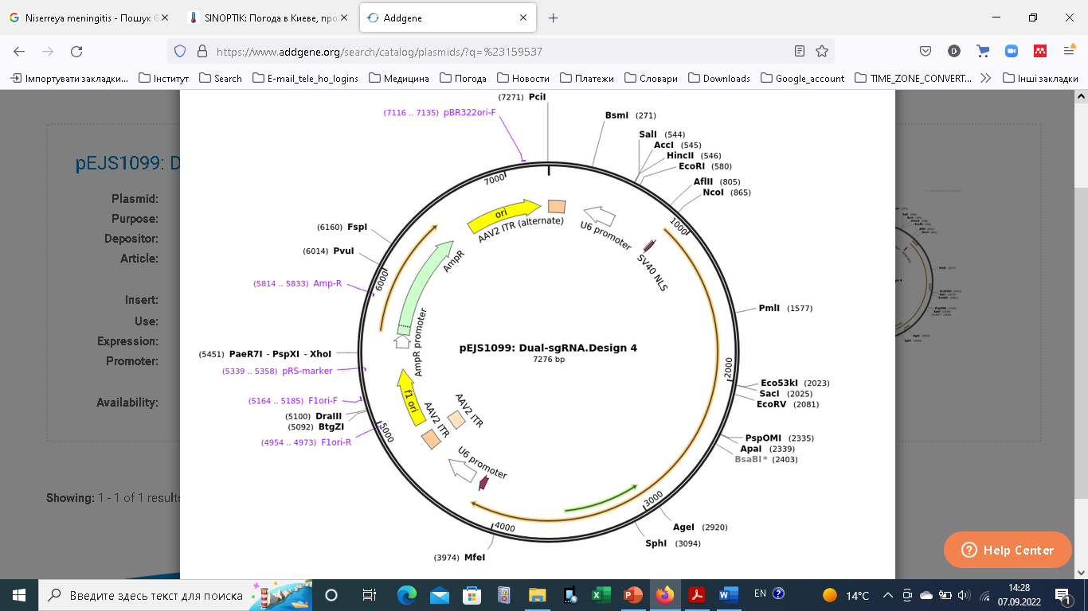

**B**

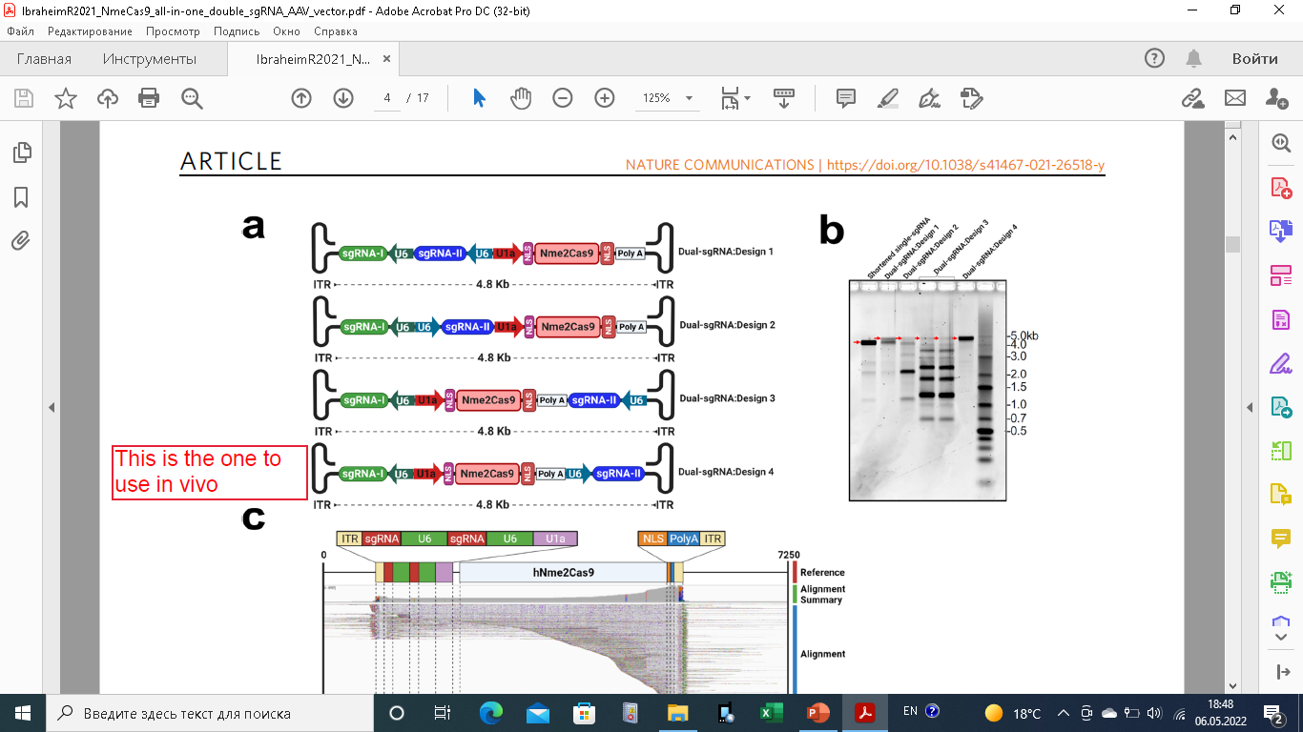

**C**

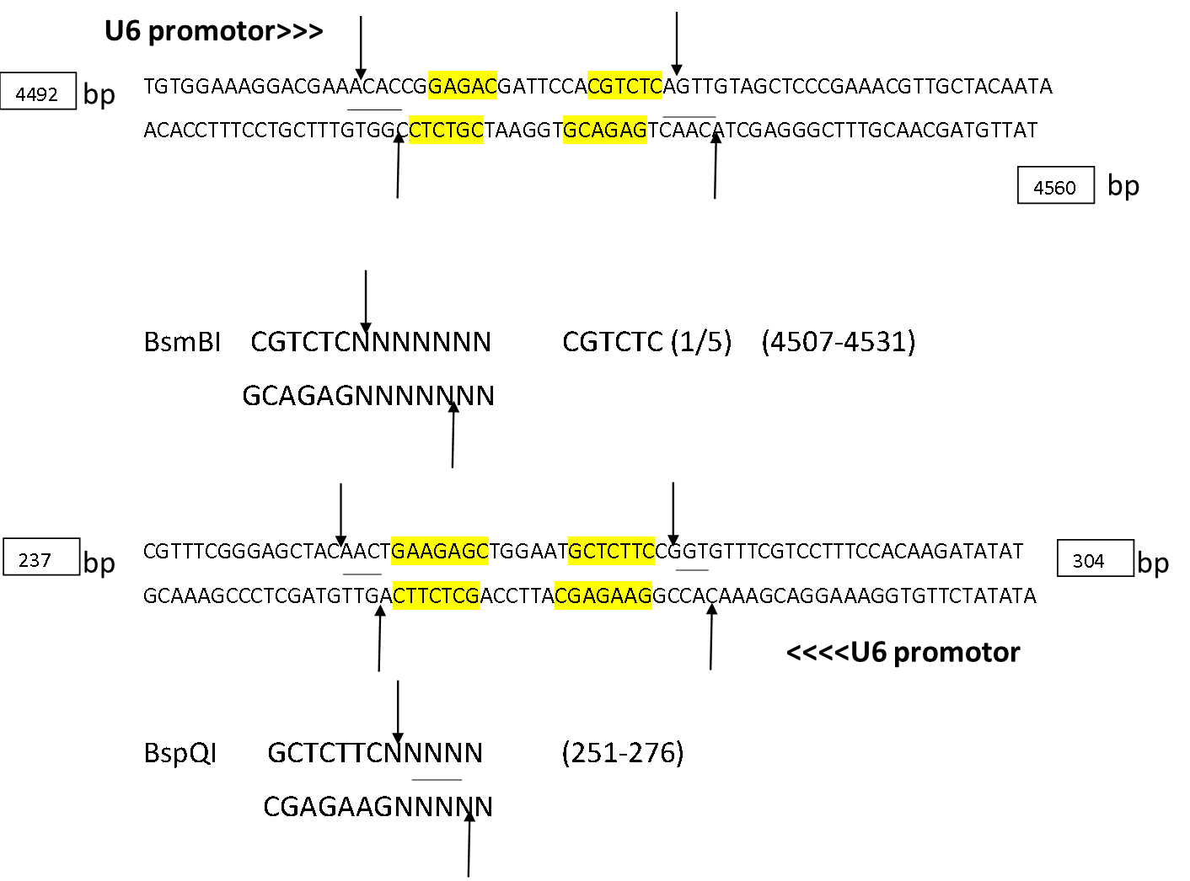

Sequence for the rat Cav3.2 - **NM153814.2** in https://www.ncbi.nlm.nih.gov/ (**chose All databases**), was used to search for Nme2Cas9-specific guide sequences **(adjacent PAM sequence N4CC**) using **CRISPdirect** program at http://crispr.dbcls.jp/. Numbers are according to **NM153814.2** sequence. **PAM sequence** (shown in green) **was shifted** aside to insert **cohesive ends** (shown in **yellow**) for the cloning of the duplex into corresponding restriction sites in right orientation to U6 promotor. Mutations for control are shown in pink.

(See Supplementary Notes, pEJS1099: Dual-sgRNA.Design 4 construct, from **Ibraheim R. et al., Self-inactivating, all-in-one AAV vectors for precision Cas9 genome editing via homology-directed repair in vivo.** NATURE COMMUNICATIONS | (2021) 12:6267 | <https://doi.org/10.1038/s41467-021-26518-y>, to where inserts are made).

**Construction of first BspQI pair of primers:**

787 - 812 -GGCCTG AACCTTCGGAACCGATGCTTCCTC-3’

BspQI CCGGAC GAAGCCTTGGCTACGAAGGAGCCA-5’ <<<UP6 promotor

So, **first BspQI pair of primers:**

5’-AACCTTCGGAACCGATGCTTCCTC-3’

5’-ACCGAGGAAGCATCGGTTCCGAAG-3’

**Scrambled Controls** (shown in pink are changed (complementary) nucleotides in the original primer sequences shown above (**see above duplex**).

787 - 812 -GGCCTG AACCTTCGGAACGCTTGCTTCCTC-3’

BspQI CCGGAC GAAGCCTTGCGAACGAAGGAGCCA-5’ <<<U6 promotor

So, **first BspQI scrambled negative control pair**

5’-AACCTTCGGAACGCTTGCTTCCTC-3’

5’-ACCGAGGAAGCAAGCGTTCCGAAG-3’

**Construction of first BsmBI pair of primers:**

1024 - 1049 - GGCCGCAACGCCTGTATCAACTGGAA

CCGGCGTTGCGGACATAGTTGACCTT

**Next, duplex was inverted to get PAM sequence in right orientation to U6 promotor (See Figure 1) and cohesive ends for BsmBI site were added (see Fig. 1).**

U6Promotor>> 5’-CACCGTTCCAGTTGATACAGGCGTT-3’ GCGGCC

BsmBI 3’-CAAGGTCAACTATGTCCGCAACAAC-5’ CGCCGG

**BsmBI first pair of primers.**

5’-CACCGTTCCAGTTGATACAGGCGTT-3’

5’-CAACAACGCCTGTATCAACTGGAAC-3’

**BsmBI scrambled negative control**

U6Promotor>> 5’-CACCGTTCCAGTTCTAACAGGCGTT-3’ GCGGCC

BsmBI 3’-CAAGGTCAAGATTGTCCGCAACAAC-5’ CGCCGG

**So, first BsmBI scrambled negative control pair of primers:**

5’- CACCGTTCCAGTTCTAACAGGCGTT-3’

5’-CAACAACGCCTGTTAGAACTGGAAC-3’

**Second pair of primers for BspQI duplex.**

**Based on sequence**

*786 - 811* 5’-TGGCCTGCTTCGGAACCGATGCTTCC (**see this sequence inverted lower to put its PAM sequence (G4CC) under U6 promotor in right orientation**)

*786 - 811* GGAAGC 5’-AACATCGGTTCCGAAGCAGGCCAC-3’

BspQI CCTTCG 3’-TAGCCAAGGCTTCGTCCGGTGCCA-5’ <<<<<UP6 promotor

**So, second pair of BspQI primers:**

5’-AACATCGGTTCCGAAGCAGGCCAC-3’

5’-ACCGTGGCCTGCTTCGGAACCGAT-3’

**Scrambled control duplex for second pair of BspQI primers:**

*786 - 811* GGAAGC 5’-AACATCGGTTCGCTAGCAGGCCAC-3’

BspQI CCTTCG 3’-TAGCCAAGCGATCGTCCGGTGCCA-5’ <<<<<UP6 promotor

**So, second pair of scrambled BspQI primers:**

5’- AACATCGGTTCGCTAGCAGGCCAC-3’

5’-ACCGTGGCCTGCTAGCGAACCGAT-3’

**Second pair of primers for BsmBI duplex:**

**Based on**

|  |  |  |  |  |  |
| --- | --- | --- | --- | --- | --- |
| *5140 - 5165* | + | 5’-[GAGATTGAGATGAACGCCGCCCTGCC-3'](http://crispr.dbcls.jp/gRNAcalc/?seq=GAGATTGAGATGAACGCCGCCCTGCC) | 55.00 % | 72.61 °C | - |

**See below: promotor U6 on the left is in right orientation to PAM sequence, so the duplex is:**

UP6 promotor >>>> 5’-CACCGGAGATTGAGATGAACGCCGC-3’ CCTGCC

*5140 - 5165* BsmBI 3’-CCTCTAACTCTACTTGCGGCGCAAC-5’

**So, the second pair of primers fort BsmBI site:**

5’-CACCGGAGATTGAGATGAACGCCGC-3’

5’-CAACGCGGCGTTCATCTCAATCTCC-3’

**Scrambled control duplex these primers for BsmBI site:**

UP6 promotor >>>> 5’-CACCGGAGATTGACTAGAACGCCGC-3’ CCTGCC

*5140 - 5165* BsmBI 3’-CCTCTAACTGATCTTGCGGCGCAAC-5’

**So, the second scrambled control pair of primers for BsmBI site:**

5’-CACCGGAGATTGACTAGAACGCCGC-3’

5’-CAACGCGGCGTTCTAGTCAATCTCC-3’

**Third pair of BspQI primers.**

**Based on**

|  |  |  |
| --- | --- | --- |
| *854 - 879* | - | 5’-[GGCCATACTACCAGACGGAGGAGGGT-3'](http://crispr.dbcls.jp/gRNAcalc/?seq=ACCCTCCTCCGTCTGGTAGTATGGCC) |
|  |  |  |

**Complementary strand has PAM sequence in right orientation for U6 promotor**

*854 - 879* GGCCAT 5’-AACACTACCAGACGGAGGAGGGTC-3’

BspQI CCGGTA 3’-TGATGGTCTGCCTCCTCCCAGCCA-5’ <<<<<UP6 promotor

**So, the third pair of primers for the BspQI site is:**

5’-AACACTACCAGACGGAGGAGGGTC-3’

5’-ACCGACCCTCCTCCGTCTGGTAGT-3’

**Scrambled control duplex for the third pair of BspQI primers:**

*854 - 879* GGCCAT 5’-AACACTACCAGTGCGAGGAGGGTC-3’

BspQI CCGGTA 3’-TGATGGTCACGCTCCTCCCAGCCA-5’ <<<<<UP6 promotor

**So, the third scrambled control pair of primers for the BspQI site is:**

5’-AACACTACCAGTGCGAGGAGGGTC-3’

5’-ACCGACCCTCCTCGCACTGGTAGT-3’

**Third pair of BsmBI primers.**

**Based on:**

|  |  |  |  |  |  |
| --- | --- | --- | --- | --- | --- |
| *4322 - 4347* | + | 5’-[AGACTCTGATATCATCGCTCAGGCCC-3'](http://crispr.dbcls.jp/gRNAcalc/?seq=AGACTCTGATATCATCGCTCAGGCCC) | 45.00 % | 68.60 °C | - |

*4322 - 4347* UP6 promotor >>>> 5’-CACCGAGACTCTGATATCATCGCTC-3’ AGGCCC

BsmBI 3’-CTCTGAGACTATAGTAGCGAGCAAC-5’

**PS the upper sequence has right orientation of the PAM sequence with respect to promotor**

**So, the third pair of primers for BsmBI site is:**

5’-CACCGAGACTCTGATATCATCGCTC-3’

5’-CAACGAGCGATGATATCAGAGTCTC-3’

**Scrambled control duplex for the third pair of BsmBI primers:**

*4322 - 4347* UP6 promotor >>>> 5’-CACCGAGACTCTGTATTCATCGCTC-3’ AGGCCC

BsmBI 3’-CTCTGAGACATAAGTAGCGAGCAAC-5’

**Primers for cloning shRNA coding sequences for knockdown Cav3.2 mRNA.**

**RNA sequence from 1-7871 bp of the** [**https://www.ncbi.nlm.nih.gov/nuccore/NM_153814.2**](https://www.ncbi.nlm.nih.gov/nuccore/NM_153814.2) **sequence was used in FASTA format in the program on the link** [**https://portals.broadinstitute.org/gpp/public/seq/search**](https://portals.broadinstitute.org/gpp/public/seq/search) **to search for potential target sequences for shRNA.**

**Figure 2. Map of the pAAV-sh[control]. From description on the site** [**https://www.addgene.org/75438/**](https://www.addgene.org/75438/) **it has Amp resistance gene for selection in E.coli strains, GFP gene under CMV promotor and AAV2 ITRs. From (Zharikov et al. 2015) its structure after packing into viral particles is presented on Fig.2C. Rat Cav3.2 mRNA coding sequence 1-7871 bp of the NM_153814.2 accession number was used to scan for potential shRNA binding sites using GPP WEB Portal Tool (https://portals.broadinstitute.org/gpp/public/).**

**A**

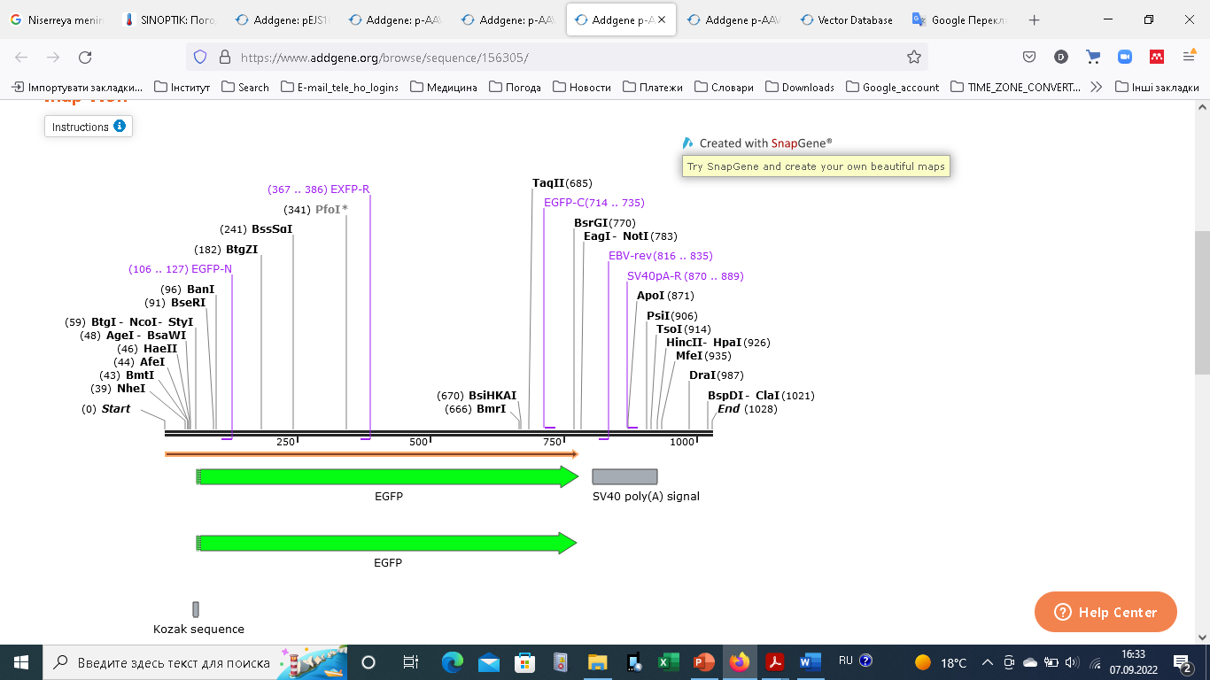

**B**

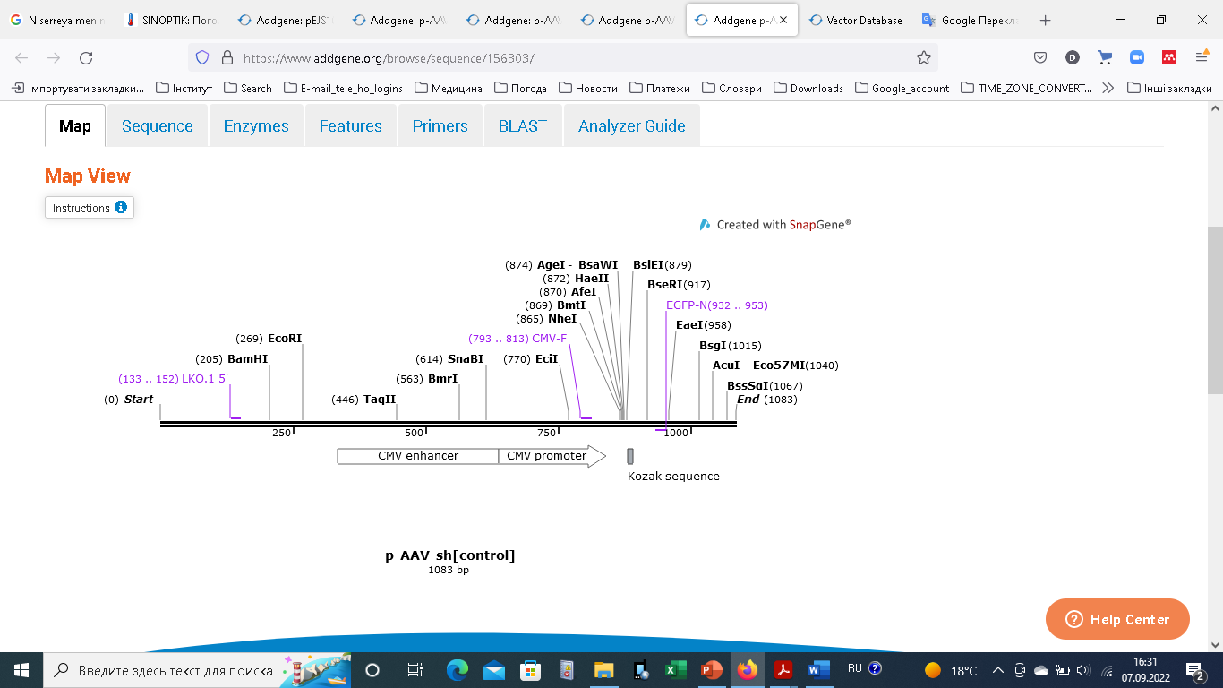

**C**

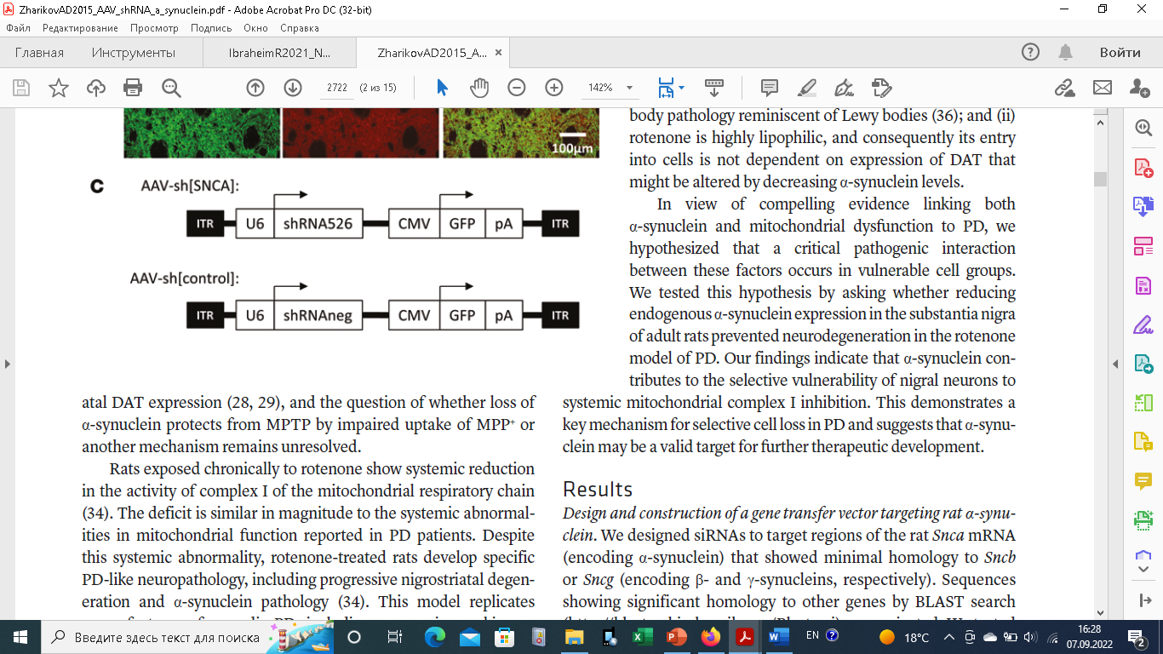

**BamHI-EcoRI shRNA primers**

**Legend for design**

**RNA sequence from 1-7871 bp of the** [**https://www.ncbi.nlm.nih.gov/nuccore/NM_153814.2**](https://www.ncbi.nlm.nih.gov/nuccore/NM_153814.2) **sequence was used in FASTA format in the program on the link** [**https://portals.broadinstitute.org/gpp/public/seq/search**](https://portals.broadinstitute.org/gpp/public/seq/search) **to search for potential target sequences for shRNA.**

**C->T, A->G changes, made for stability of structure in E. coli (Miyagishi M. et al., 2003) are highlighted in red. Insert of G nucleotide for efficient start of transcription is highlighted in blue. Restriction site nucleotides for BamHI and EcoRI are highlighted in yellow. In red are loop sequence is of miRNA-32-5p which binds Cav3.2 3-UTR by nucleotides shown in red uppercase letters. GGATCC – BamHI sequence, GAATTC – EcoRI sequence. Transcription termination sequence is highlighted in green, scrambled mutations for complementary nucleotides are shown in pink.**

**Target sequence (7840-7865 bp of NM_153814.2).**

**GCAAGGCAAATCTGAATAAACACTA**

**Forward primer 5’-GATCCGTAAGGTAAGTCTGAGTAAGCACTAGAAATAGTGTTTATTCAGATTTGCCTTGCTTTTTG-3’**

**Reverse primer 5’-AATTCAAAAAGCAAGGCAAATCTGAATAAACACTATTTCTAGTGCTTACTCAGACTTACCTTACG-3’**

**p-AAV-sh[control] sequence from site https://www.addgene.org/75438/sequences/**

**> hU6-F 5'-GAGGGCCTATTTCCCATGATT-3'**

**cGATaCaAGGCTGTTAGAGAGATAATTAGAATTAATTTGACTGTAAACACAAAGATATTAGTACAAAATA**

**CGTGACGTAGAAAGTAATAATTTCTTGGGTAGTTTGCAGTTTTAAAATTATGTTTTAAAATGGACTATCA**

**TATGCTTACCGTAACTTGAAAGTATTTCGATTTCTTGGCTTTATATATCTTGTGGAAAGGACGAG|GATCC**

**CCAATTCTCCGAACGTGTCACGTTTCAAGAGAACGTGACACGTTCGGAGAATTTTTTGG|AATTCTAGTTA**

**TTAATAGTAATCAATTACGGGGTCATTAGTTCATAGCCCATATATGGAGTTCCGCGTTACATAACTTACG**

**GTAAATGGCCCGCCTGGCTGACCGCCCAACGACCCCCGCCCATTGACGTCAATAATGACGTATGTTCCCA**

**TAGTAACGCCAATAGGGACTTTCCATTGACGTCAATGGGTGGAGTATTTACGGTAAACTGCCCACTTGGC**

**AGTACATCAAGTGTATCATATGCCAAGTACGCCCCCTATTGACGTCAATGACGGTAAATGGCCCGCCTGG**

**CATTATGCCCAGTACATGACCTTATGGGACTTTCCTACTTGGCAGTACATCTACGTATTAGTCATCGCTA**

**TTACCATGGTGATGCGGTTTTGGCAGTACATCAATGGGCGTGGATAGCGGTTTGACTCACGGGGATTTCC**

**AAGTCTCCACCCCATTGACGTCAATGGGAGTTTGTTTTGGCACCAAAATCAACGGGACTTTCCAAAATGT**

**CGTAACAACTCCGCCCCATTGACGCAAATGGGCGGTAGGCGTGTACGGTGGGAGGTCTATATAAGCAGAG**

**CTGGTTTAGTGAACCGTCAGATCCGCTAGCGCTACCGGTCGCCACCATGGTGAGCAAGGGCGAGGAGCTG**

**TTCACCGGGGTGGTGCCCATCCTGGTCGAGCTGGACGGCGACGTAAACGGCCaCAAGTTCAgCGTGTCCG**

**GCgagggcgagggcgatgccaccTACGGCAAGCTGACCCTGAAGTtcatctgcaccaccGGCAAGCTGCC**

**CGTGCCCTGGCCCaccctcgtgaccaccctgac**