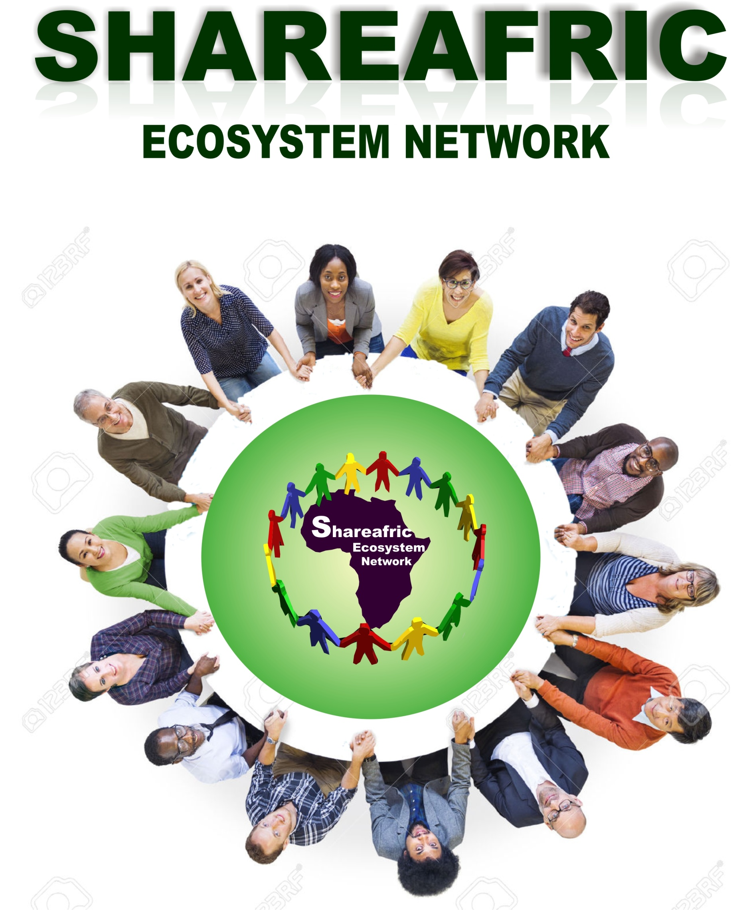

***CORPORATE BROCHURE***

***ABOUT US***

***SHAREAFRIC ecosystem limited is ffering opportunities where entrepreneurs and business owners can share data of their business opportunities and African innovations with their dream investors to collaborate for customized funding, investment and establishment of new businesses anywhere across Africa.***

***Our technology and financial instruments solutions offers direct investment in strict compliance with clients needs for funding across Africa, sharers, partners and clients will also be proud of our services in due course, with good management team, dedicated staffs, and high profile experience investors.***

***Our wealth of experience and drive to service finance and capital needs has position us to undertake and mediate for project financing especially where hopes are lost to service the financial needs of small, medium and large scale organizations operating across Africa. Our response provides answers to the capital needs of companies all sizes.***



***HOW IT WORKS***

***ShareAfric ecosystem is one of Africa’s largest corporate and socially conscious networking platform which is easy, accessible, and fast, helps you utilize the full power of social media and lets you share your African business data and investment opportunities, for co-creation, co-production, collaborations, public private partnerships and customized joint venture funding for any innovative business project across Africa.***

***OUR SERVICES***

***Our services include:***

* ***Consultancy Services***
* ***Finance brokerage and mortgage brokerage services***
* ***Real estate development financing***
* ***Joint venture equity financing***
* ***Entrepreneurs and investors networking***
* ***Property sales, marketing and development***
* ***Building and construction***
* ***Financing of real estate and mortgage transactions***
* ***Human resource trainings, capacity building and entrepreneurship development programs***

***CONSULTANCY SERVICES***

***At SHAREAFRIC we help individuals, companies, corporate organizations access and succeed in the sharing African Economy***

***SHAREAFRIC works with a network of innovation experts, technology, business development, Agriculture, real estate developments experts, researchers , funding groups, fundraisers, financial institutions to provide you with everything you need to succeed.***

***So whether you are starting up a new African company, a new NGO, new African product, African innovation, looking to improve on what your company is already doing with this new phenomenal model, so long as you are a company, large corporation or public body looking to enter the African sharing economy or exploring how you could benefit from this new phenomenal innovation, shareAfric ecosystem can help.***

***FINANCE BROKERAGE AND MORTGAGE BROKERAGE***

***We can assist in designing and implementing viable financial instrument tailored to strengthen the market share of real estate industry and all manner of organizations. We offer advisory services,***

***feasibility studies, strategic business plan and proposals***

***Development, policy development and management***

***trainings.***

***We maintain good relationship with high profile local and***

***international investors that are ready to fund all manners***

***of transactions. We also work with institutions to develop***

***new businesses, subsidiaries and affiliates springing up from your mortgage industry and general businesses for exponential growth.***

***REAL ESTATE DEVELOPMENT FINANCING***

***We provide rough land development financing for development of projects of all kind such as real-estate development, large scale agricultural development financing and commercial property development financing.***

***JOINT VENTURE EQUITY FINANCING***

***By understanding your financial needs for starting or expanding your existing business, we provide seed capital funding so as to help business owners.establish a capital base for their innovative business and give businesses the needed edge for expansion.***



***ENTREPRENEURS AND INVESTORS NETWORKING***

***SHAREAFRIC offers some of the best finance networking opportunities between investors, entrepreneurs and the best founders of the continent of Africa, one of a kind program that startups and existing businesses submit their business data with the aim to network and collaborate with their dream investors for funding opportunities that would empower their innovations to become Blue Chip Companies and employers of labour in the African sharing economy.***

***PROPERTY SALES, MARKETING AND DEVELOPMENT***

***We have established depth as a real estate company in Nigeria. Our traditional business model is based on the accomplishment of Sales and development of commercial and private properties in the real estate markets in Nigeria. We have a dynamic team of real estate marketers and developers working with wealth of experience and knowledge for the satisfaction of our partners, property owners and clients' real estate needs.***

***BUILDING AND CONSTRUCTION.***

***Our company conducts building and construction, quantity survey and architectural designs, as well as real estate consulting. The company undertakes all maintenance duties for real estate facilities and organizations and conducts all the checks and surveillance for the properties.***

***FINANCING OF REAL ESTATE AND MORTGAGE TRANSACTIONS***

***SHAREAFRIC is keen on expansion in the field of property management and development of a strong base of key customers. Building great reputation in the field of real estate investment and property management. It is our desire to see local/indigenous property owners and investors strike deals that will propel the economic development efforts of the government and organized private sector in Nigeria.***

***Our Main focus for real estate deals:***

***With us the focus is engaging in real estate development marketing activities that will ensure the satisfaction of both property owners and clients on the basis of:***

***\*Build Operate and Transfer***

***\*Leasing***

***\*Outright sale/purchase.***

***\*Provisions of finance for major real estate projects via local and foreign mortgage lenders***

***HUMAN RESOURCE TRAININGS, CAPACITY BUILDING AND ENTREPRENEURSHIP DEVELOPMENT PROGRAMS***

***We organize specialized workshop, leadership training, summit, and conferences in key areas that contribute to human capital development of the African sharing economy.***

***We offer advisory services, studies, strategic business plan and proposals***

***.***

***OUR VISION***

***Our vision is to provide adequate support information, development of policies, operational guidelines and funding network for effective execution of innovative business ideas and develop strategies for integrating them across Africa.***

***OUR MISSION***

***To provide excellent support information and***

***funding network between investors and***

***entrepreneurs that will birth effective African***

***development in a professional manner that is***

***equal to none.***

***OUR VALUES***

* ***Professionalism***
* ***Team work***
* ***Integrity***
* ***Sincerity***



***OUR PARTNERS***

* ***White bronze properties***
* ***A. H GLOBAL MAINTENANCE***

***OUR AIMS AND OBJECTIVES***

* ***To generate the database of viable businesses and investment opportunities that exists in Nigeria and across Africa.***
* ***To generate the database of corporate investors and financial institutions so as to network and share data’s of investment worthy projects that requires action investment and customized equity financing.***
* ***To assist in designing and implementing viable financial instrument tailored to strengthen the market share of real estate/mortgage industry and all manner of organizations.***
* ***To establish and network the group across all geopolitical zones of Nigeria within the next two years.***
* ***To provide professional support services that will enhance the profitability of huge Africa’s human and natural resources.***
* ***To provide opportunities for adequate funding at all levels for innovation and creativity so as to maximize the workforce of production in Nigeria.***
* ***To build the internet of trust through genuine support and systematic approach that ensures funding to all manners innovative business ideas that creates new job opportunities.***
* ***To revolutionize the training industry by creating an enabling environment for financing affordable housing, real estate transactions, tech entrepreneurs and all manner of businesses for industrial development.***
* ***To organize conferences and events that will contribute towards sustainable development in Africa.***
* ***To collaborate with relevant national and international agencies in order to ensure the co-financing and sustainability of the dreams, aspiration and ambition of Africans across the globe.***
* ***To collaborate and establish partnerships with relevant agencies and global best practices that will help towards the realization of the visions, mission, aims and objectives of our organization.***
* ***To transform the mindset of Africans from the consuming economy to a value driven productive base economy for new businesses to emerge.***



***We draw our wealth of experience from our strong management***

***team who have been able to manage, execute and handle all level***

***of transactions in the finance, real estate, outsourcing, recruitment,***

***production, procurement and logistics industries etc, we are utilizing our wealth of experience and knowledge to meet the needs of today’s organization for corporate exponential growth in the 21st century.***

***Therefore to bridge the gap created from developing a business, servicing your financial needs and business execution, Shareafric ecosystem network limited will offer various ecosystem services to meet the demand of major companies and organizations operating within Nigeria.***

***WE WORK WITH***

* ***Private investors, local and international financial institutions***
* ***Private organizations***
* ***Public organizations and government institutions***
* ***NGO’s and social enterprise***

***BENEFITS OF WORKING WITH US***

* ***Dedicated management team***
* ***Trustworthy investors***
* ***Fast and quick approval for equity deals***
* ***Excellent support ecosystem***
* ***Unlimited amount of financing & investment***
* ***Professional support from experts in all works of life.***



***HOW TO GET AN INVESTOR TO FUND YOUR BUSINESS?***

***Step 1: visit our office and collect our application form or download it online in PDF,***

***Step 2: Completely fill the form and submit it in hard copy or online***

***Step 3: Continue your business to help you qualify for funding as your investors might give you a call when you least expect it.***

***HOW TO FUND A PROJECT AS AN INVESTOR?***

***Step 1: kindly visit our office and collect our application form specifically meant for investors or visit our website [www.shareafric.com](http://www.shareafric.com) and download it in PDF***

***Step 2: completely fill the form and submit it on our email address: [investors@shareafric.com](mailto:investors@shareafric.com)***

***Step 3: you will receive the database of current sharers seeking joint venture investors.***



***SHAREAFRIC ECOSYSTEM is an initiative of SHAREAFRIC ECOSYSTE LIMITED, one of the leading ecosystem company that creates the most enabling environment which gives corporate organizations and entrepreneurs the power to share innovative business and investment opportunities in order to network with their dream investors and partners for joint venture deals of all types, the organization utilizes her wealth of experience from strong management team from both private and public sector to deliver the highest level of project financing and business execution across Nigeria.***

***As an ecosystem networking company, we offer turnkey solutions specializing in establishing business relationship between entrepreneurs and all level of investors and partners .***

***INNOVATIVE CORPORATE AND ONLINE COMMUNITY***

***Welcome to the next generation of developers and leaders in ideas, innovation, creativity, networking, investment opportunities and financial technology, if you believe in collaboration, co-creation, co-founding, joint venture, co-production for a better world, then share your project with us.***

***Share your knowledge. It is a way to achieve impossibility.” Williams Owoh***

***How can we help you today? Share your business opportunities with us, Contact us today***

***Whatsapp: 08110783009 www.shareafric.com***

***This website is coming soon***

***A production of SHAREAFRIC ECOSYSTEM LIMITED***