Expedia TravelAid Hackathon 2018



Timetable of the event

Friday

9am – 11am Setup the tables, swag bags, name tags, banners, t-shirts

11am – 12am Registration and candidates arriving

12am - 12:30pm Welcome presentation – Apple and Matt, Mariano

12:30pm – 1:30pm Lunch and Team Ice breakers (with you)

1:30pm – 2pm Challenge intro and guidance talk

**2pm – Coding starts**

5pm – 6pm office tours

6pm – 7pm Dinner

11pm – 12pm Midnight Snack

Saturday

9:30am – 10am Breakfast

**-- 11am Coding Stops**

11am – 1pm Judging the code over lunch (Judges)

1pm – 3pm Presentations (Apple and Matt)

3pm – 3:15pm Judges decide on the winners

3:15pm – 3:30pm Prizes and closing Sean

3:30pm – 4pm Departure

Food Arrivals

Friday Lunch

Time: 12am

Order: Pure

Friday Dinner

Time: 5pm

Order: Dominos and Basilico

Midnight Snack

Time: 8-9pm

Order: Sainsburys delivery

Saturday Breakfast:

Time: 9:30am

Order: Pauls / fruit

Saturday Lunch

Time: 12am

Order: Tortilla

Ice breakers

**Two Truths and a Lie**

Sit in a circle if possible or ask the speaker to move to where they can be seen if not. Each attendee takes a turn to introduce themselves by name, then states three ‘facts’ about themselves – one of which is untrue. Take a poll to see if the group can spot the lie. Then leave enough time for a brief chat between attendees (you can start this off, if that’s needed) to explore the truths.

**Five of Anything**

Give each group a prompt to start the conversation, asking for their personal top five on a simple topic of your choice: five cities they’d like to visit, their top five TV shows, five favourite meals.

**Three Career Highlights**

Some people are great at talking about themselves with positivity; others less so. This icebreaker encourages everyone to feel positive about themselves, by taking a moment to think of three great moments from their career: a successful project, a promotion, a moment of recognition. After they’ve shared in their small groups, encourage them to think about how it makes them feel, and to note any commonalities.

**Office Charades Icebreaker**

Kick off your meetings by playing a few rounds of charades where the presenters can pick only office-related things.

If you’re rusty on your charades skills, here’s a quick refresher:

Pick a “presenter” to start things off.

Ask the presenter to think of an office item or activity. They can announce the category, but that’s the last time they can talk.

Then have the presenter explain the item using only gestures. Any spoken words lead to an immediate disqualification.

Laugh a lot. All charades manuals agree the game cannot be played without lots of laughter and yelling.

**The Instagram Icebreaker**

To conduct this idea from William Joseph, just give employees a few minutes to scroll through their Instagram photos and pick a snapshot they want to share with the group. They can share the photo and explain why they picked it. This will help some personality shine through, especially if people on your team need to get to know each other.

**Connecting Stories**

Have everyone divide into small groups of 6-8 people. Ensure each table has several post-it notes and pens. The goal of the game is to connect mini-stories in an interesting way. Each person must share at least one item that connects to the other mini-stories. The longer the chain of items that can be created, the better. Write down a few words on a post-it note to keep track of each part of the story.

The first player begins by sharing an interesting memory or experience that they have. For example, one player can say: “One time, I accidentally locked myself out of the house. So then I spent the entire day at a coffee shop.”

Any other person can tell a related story that has any similar themes or elements to the previous story. For example, the next person can say, “I am a total coffee addict. Every day I drink 3 cups of coffee and it sometimes prevents me from being able to sleep at night.”

The next player, based upon the previous story shared, can say something related, such as: “I don’t sleep much at night because I play lots of computer games until early morning.”

Any person can then add to the story, by saying something like, “I also love computer games.”

To help the group remember each part of the story, write a few words on a post-it note for each part of the story chain. The more interesting or funny the story, the better.

At the end of the game, the group with the longest connected chain of stories is the winner. You may ask the group to share the entire story with the whole group. This activity is a fun way to get people to share stories, while helping people learn similarities or common interests.

**Lost on a Deserted Island**

The situation is dire — following a shipwreck, everyone has been stranded on a deserted island! Each person is allowed to bring one object to the island — ideally something that represents them or something that they enjoy. The first part of this icebreaker is simple: each person is asked to describe what object they would bring and why. This need not be realistic; if someone loves music, he or she might choose to bring a guitar, or an animal lover might choose to bring a dog, a food lover might choose to bring sirloin steaks, and so on. Encourage people to be creative.

After everyone has introduced their object and why they have chosen that object, the teambuilding portion follows. Divide into smaller groups and ask everyone to work together to improve their chances of survival by combining the various objects that they introduced. If necessary, you can add more objects, but be sure to use all the objects that everyone mentioned. If you wish, you can reward the most creative group with a prize.

Lost on a Deserted Island is an approachable way to get people to open up and share a little bit about themselves and what they enjoy or value.

Tips and Tricks

* Use Agile methods to plan and build the product. To do, work in progress, done.
* Build the simplest thing that works and build on top of it (MVP)
* To get from A to B faster than walking, don’t try to build a Ferrari straight away, build a skateboard, then a bike, then a motorbike, then a car, then a Ferrari. If you build a Ferrari first and fail then you can’t get from A to B, if you try and build the motorbike then fail, at least you have a bike to fall back on.
* Don’t code for the first few hours, plan multiple ideas in full so if you spend 3 hours coding it and it doesn’t work out, you have a fallback idea ready to go.
* Ask for help, ask the volunteers and each other! If you waste 4 hours not doing anything, when a team mate could have explained it in 1 hour, then you can both work for 3 hours, not 1 one person working for 4 hours.
* Don’t be afraid to use new technologies, try to be creative and show off what you can do, but also treat this as a learning experience.
* Take frequent breaks and enjoy your time in the offices, if you overwork yourself, you will make mistakes.
* Use git, if you don’t then you will fail.
* Get a group chat, trello and git setup so you can to share ideas and resources.

Examples and prompts

* Build an app to take all the points of interest in a country to go to and find the cheapest way between the ones of choice.
* Improve getting from the airport to the hotel with small children / a lot of luggage.
* Improve the in flight experience.
* Emergency hardware if your phone dies / dont take it - alerts a hostel or friend with location and situation
* Just put yourself in the shoes of your target market, tailor your product to their experience.

Health & Safety

Incident Reporting

All accidents/incidents/near misses/unsafe acts or conditions during an event must be reported to the Events Coordinator, onsite Facilities Team or Security Officers.

If the emergency services have been contacted directly, please notify Security so that access arrangements can be made.

First Aid

For any quick First Aid solutions, you will find a First Aid kit in all kitchen and breakout areas in both offices. First Aiders can be identified across the offices via first aid flags that are attached to their monitors.

Please note that any supplies taken from the first aid boxes should be reported to a first aider or the Facilities team so they can log the incident and ensure that items are replaced.

Emergency Evacuation

If the alarms sound during an event, all attendees should be directed to the assembly point located in the following locations:

**Angel Square:** In front of the Royal Bank of Scotland

**Angel Building:** Myddelton Square via Chadwell Street

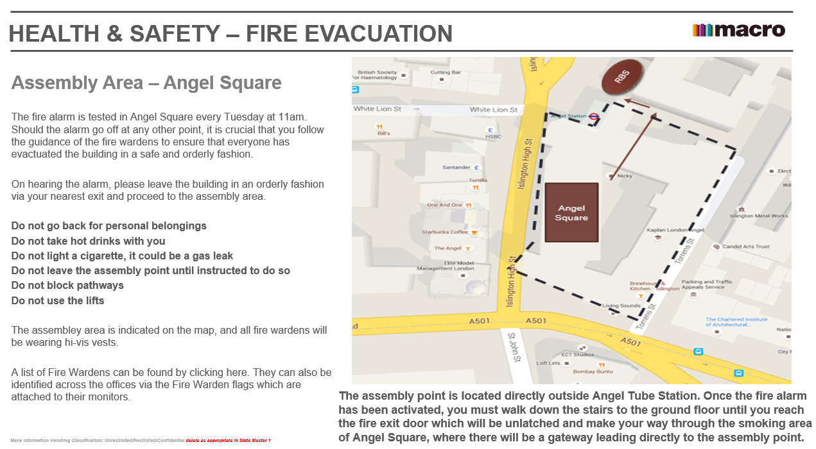Remain at the Fire Assembly Point until further instruction is provided from Fire Wardens or Security.

Teams

|  |  |
| --- | --- |
| Red  Volunteer: Marc Stevens  Adnan Salehin  Alfie Newman  Catalin Torge  Reshma Patel | Orange  Volunteer: Todor Ilivanov  Benjamin Robson  Bradley Greatrex-Jordan  Ethan Sweet  Saurav Zangeneh |
| Yellow  Volunteer: Harvey Williams  Damodara Puddu  Christine Mathiesen  Hamza Abdul Razeq  Nicholas Pezzotti | Green  Volunteer: Matthew Newberry  Haider Ali  Edward Smart  Jonathon Mounty  Pui Chan |
| Blue  Volunteer: Ana Jalba  Kevin Matsumi  Jade Cutler  Martin Noruisis  William Taylor | Purple  Volunteer: Matei David  Oliver Redeyoff  Nuh Mire  Matthew Williams  Toma-Theodor Cotuna |
| Pink  Volunteer: Jakub Uher  Uzair Ishaq  Tom Lancaster  Michelangelo Prisciano  Yoav Nir | Floating Volunteers  Sean Jackson  Nick Barker  Nathan Adams  Andreea Paduraru  Pheobe Clarke  Late Arrival – Assign Accordingly  Thongchai Wirojsakseree |

Volunteer Skills

Name: Sean Jackson

Role: Software developer intern

Familiar languages and frameworks: Java, Python, PHP Laravel, SQL, Workbench,

Other skills: Git, IntelliJ, (not really AWS) Table tennis, FIFA

Name: Jakub Uher

Role: Software developer intern

Familiar languages and frameworks: Java, SQL, Python (just a bit), Angular

Other skills: AWS, Git, IntelliJ, Bash, Elegoos

Name: Nathan Adams

Role: Data Visualisation & Insights Analyst, HCOM Business Intelligence

Familiar languages and frameworks: SQL, R, Basic Python, Basic Web Development

Other skills: Git, Tableau, FIFA, Darts

Name: Matt Newberry

Role: Software developer intern

Familiar languages and frameworks: Java, Dropwizard, Jersey, Basic Scala/Groovy

Other skills: AWS, Bash, Docker, Jenkins

Name: Nick Barker

Role: Software Developer Graduate

Familiar languages and frameworks: JavaScript, ReactJS, CSS/HTML, Scala, Java, Python

Other skills: Git, Visual Code, NodeJS, Juggling

Name: Marc Stevens

Role: Software engineer intern

Familiar languages and frameworks: Java, Kotlin, JavaScript (ReactJS), C++, VB

Other skills: AWS, Git, Bash, DS&A, Also juggling

Name: Todor Ilivanov

Role: Software developer intern

Familiar languages and frameworks: Java, Kotlin, Scala, Spring, SQL, Python

Other skills: Git, IntelliJ, Microservices

Name: Ana Jalba

Role: Graduate Software Engineer

Familiar languages: Java, Python, SQL; less familiar: JavaScript, Kotlin

Other skills: AWS, GCP (in particular BigQuery), Git, Bash, MySQL, Hive, NodeJS, Maven, guitar, breaking apps

Name: Matei David

Role: Software Engineer Intern

Familiar languages: Java, Go, JavaScript, C (no ++ :)

Other skills: AWS, Kubernetes, Git, Bash, Spring, NodeJS, and some other things

Name: Andreea Paduraru

Role: Software Developer Intern

Familiar languages and frameworks: Java, SQL, Haskell, C/C++, Python

Other skills: AWS, Bash, Hive, Maven

Name: Harvey Williams

Role: Product Analyst Intern

Familiar languages: Python, R, Java, Javascript

Other skills: React, Node, SQL, MongoDB, bit of git

Volunteers and Times

General – Friday (* late hours and back Saturday morning, ** overnight)

Interns / Grads

1. Sean Jackson **
2. Marc Stevens *
3. Todor Ilivanov **
4. Jakub Uher *
5. Nathan Adams *
6. Matthew Newberry **
7. Harvey Williams (midnight onwards)
8. Ana Maria Jalba **
9. Andreea Paduraru
10. Matei David
11. Nick Barker *
12. Methus – Photographer (fri morning and afternoon)

Dev

1. Phoebe Clarke *

Recruitment

1. Adam Tachauer
2. Matthew Wilkins *
3. Apple Capezzera *

Judges – Saturday (EPS unless otherwise specified)

Managers

1. Anselmo Rodrigues da Silva
2. Carlos Franco
3. Adrian Pasin
4. Wissam Moussa BEX

Devs

1. Clive Capisano
2. Andre Gomes
3. Chris McDowell

TravelAid Hackathon Presentation Score Card

Judge Number:

Team Name/Number:

Product Name:

|  |  |
| --- | --- |
| **Presentation Criteria** | Score |
| **Product Relevance**   * Does the idea address a real world problem? (5) * How well does the problem and solution fall within the theme? (10) * Is there a clear business model for the product? (10) | /25 |
| **Tech Stack and Finesse**   * How unique and innovative is the tech? (10) * How efficient and technologically elegant is the solution? (15) * Is the project fully functional end-to-end? (No hard coding) (25) | /50 |
| **Presentation, Communication and Demonstration**   * Are the problem and solution well communicated? (10) * How well did the product perform in the demo? (15) | /25 |
| **Total:** | /100 |

Comments or Questions:

TravelAid Hackathon Technical Score Card

Judge Number:

Team Name/Number:

Product Name:

|  |  |
| --- | --- |
| **Techincal Criteria** | Score |
| **Is the project organised well? (MVC, all in one file)** | /5 |
| **Is the code clean? (well named, tested, readable)** | /5 |
| **How tidy is the technical architecture? (server/client)** | /5 |
| **Total:** | /15 |

Comments and Questions: