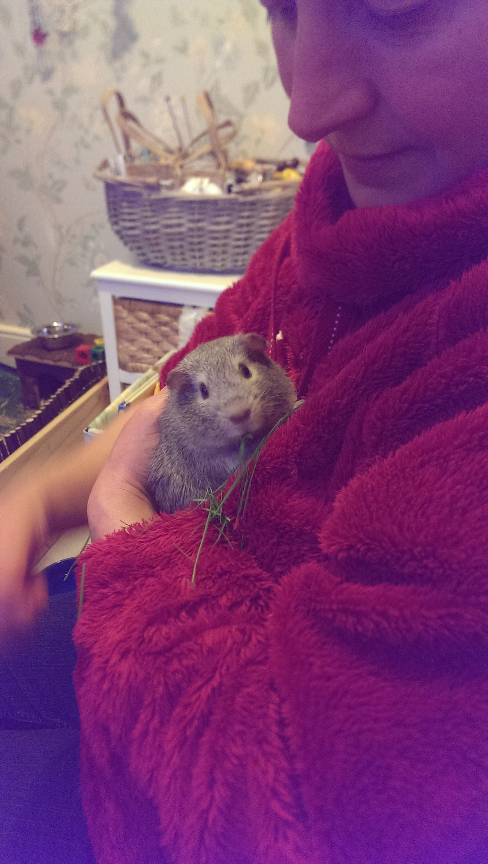

*Figure 1: A Guinea Pig Called Jane*

The paragraph that should remain