2.2 圆柱体

import java.util.Scanner;

class cylinder{

public static void main(String[] args){

Scanner scan = new Scanner(System.in);

System.out.println("输入圆柱体的半径：");

double radius = scan.nextDouble();

System.out.println("输入圆柱体的高：");

double length = scan.nextDouble();

double area = radius \* radius \* (Math.PI);

double volume = area \* length;

System.out.println("the area is " + area +"\n" + "the volume is " + volume);

}

}

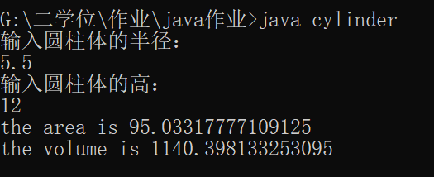

2.6

import java.util.Scanner;

class number{

public static void main(String[] args){

Scanner scan = new Scanner(System.in);

System.out.println("输入一个0~1000的整数");

int number = scan.nextInt();

int a= number % 10;

int b = (number / 10) % 10;

int c = (number / 100);

int sum = a + b + c;

System.out.println("the sum of the digits is : " + sum);

}

}

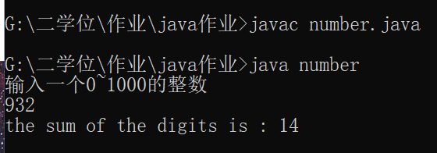

2.7 time

import java.util.Scanner;

class time{

public static void main(String[] args){

Scanner scan = new Scanner(System.in);

System.out.println("请输入一个分钟数：\n");

int minute = scan.nextInt();

int day =((minute / 60) / 24) %365;

int year = ((minute / 60) / 24) / 365;

System.out.println(minute + " " + " is " + year + " years " + day + " days");

}

}

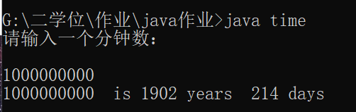

2.13

import java.util.Scanner;

class saving{

public static void main(String[] args){

Scanner scan = new Scanner(System.in);

System.out.println("请输入存款额：");

double amount = scan . nextDouble();

double yyield = 0.05;

double myield = yyield/12;

double m1 = amount \* (1+myield);

double m2 = (m1 + amount) \* (1+myield);

double m3 = (m2 + amount) \* (1+myield);

double m4 = (m3 + amount) \* (1+myield);

double m5 = (m4 + amount) \* (1+myield);

double m6 = (m5 + amount) \* (1+myield);

System.out .println("after the sixth month, the account value is: " + m6);

}

}

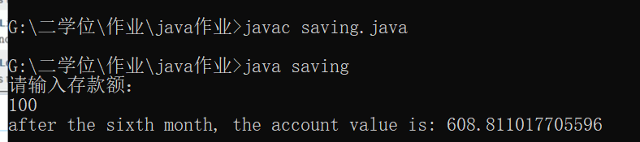

2.14

import java.util.Scanner;

class BMI{

public static void main(String[] args){

Scanner scan = new Scanner(System.in);

System.out.println("请输入您的体重(磅)：\n");

double weight = scan . nextDouble();

System.out.println("请输入您的身高(英寸)：\n");

double height = scan . nextDouble();

double kg= weight \* 0.45359237;

double m = height \* 0.0254;

double bmi = kg/(m\*m);

System.out.println("您的BMI指数是：\n" + bmi);

}

}