Mediroza General Hospital
Penetration Testing Project
External Black-Box Web Application Security Assessment
Parameter | Value
Project Name | Mediroza General Hospital Penetration Testing
Target | Mediroza General Hospital (Training Environment)
Domain | medirozahospital.com
Engagement Type | External Black-Box Assessment
Program | Networkwalks Academy — Web Application Hacking 101
Testing Platform | Kali Linux 2026.2
Completion Date | 09 September 2026
Overall Risk Rating | CRITICAL
Tester | Rana Faheem Ibrahim
Report Status | Final

Table of Contents
1. Summary
2. Goals of the Test
3. Lab Setup
4. Tools Used
5. Findings at a Glance
6. Test Walkthrough
Stage 1 — Recon
Stage 2 — Login Form SQL Injection
Stage 3 — Stealing & Cracking the Reports
Stage 4 — Backup Leak
7. How the Attack Chains Together
8. Severity Breakdown
9. Fixes & Recommendations
10. Legal Note
11. Tester & Project Overview

1. Summary
This report walks through a black-box test of Mediroza General Hospital's public website, a training target built for the Networkwalks Academy program. The focus areas were the patient login system, how uploaded PDF reports are protected, server-side configuration, and whether old or unused files were still reachable from the internet.
During testing, a basic SQL injection in the login form turned out to be enough to get into the patient portal without a password. From there, three patient PDF reports were downloaded, their weak passwords were cracked offline, and a leftover note inside one file's metadata pointed to an old backup folder — which turned out to still be publicly browsable and contained a full, unencrypted SQL dump with staff and shareholder data.

Findings Summary
Code | Issue | Severity | Why It Matters
F1 | Login bypass via SQL injection | Critical | Anyone can log in as a patient without credentials
F2 | Easily-cracked PDF passwords | High | "Protected" medical reports open in seconds offline
F3 | robots.txt lists hidden paths | Low | Tells attackers exactly where to look
F4 | PDF metadata left in place | Medium | Leaked an internal note about backup location
F5 | Public directory listing + SQL dump | Critical | Full staff PII and shareholder records exposed
Overall rating: Critical — two separate issues (the login bypass and the open backup folder) each lead to serious data exposure on their own, and they can also be chained together.

2. Goals of the Test
- Enumerate the live site without disrupting it
- Find hidden or forgotten paths and backup files
- Check whether login and session handling can be bypassed
- Try SQL injection against every input field reachable from the login page
- See what happens once inside — can patient files be reached?
- Check whether the PDF password protection on those files actually holds up
- Look for leftover metadata or comments inside downloaded files
- Confirm whether the web server allows directory browsing
- Work out what internal data would actually be exposed if this were real
- Write up practical, prioritized fixes

3. Lab Setup
Item | Detail
Target | medirozahospital.com (training environment)
Test Type | External, black-box
Attacker OS | Kali Linux 2026.2 (VirtualBox)
Browser | Mozilla Firefox
Web Server | LiteSpeed
Backend | PHP + MySQL
File Types Reviewed | PDF
Method | Manual testing, backed up with automated scanning
Finished | 09 September 2026

4. Tools Used
Tool | Used For
WHOIS | Domain registration lookup
nslookup | DNS resolution
DNSRecon | DNS/subdomain enumeration
curl | Manual HTTP requests & header checks
Nmap | Port/service scanning
Gobuster | Directory/file brute-forcing
ExifTool | PDF metadata inspection
NetworkWalks Hash Calculator | Pulling password hashes from protected PDFs
NetworkWalks Password Cracker | Dictionary attack against those hashes

5. Findings at a Glance
# | Finding | Ref | Severity | Impact
1 | SQL injection bypasses login | F1 | Critical | Full account takeover, no credentials needed
2 | PDF encryption keys easy to crack | F2 | High | Confidential reports readable by anyone with the file
3 | robots.txt reveals internal paths | F3 | Low | Helps attackers map the app faster
4 | Metadata comment left in PDFs | F4 | Medium | Exposed internal backup path/author info
5 | Directory listing + SQL dump reachable | F5 | Critical | Staff salaries, IDs, shareholder data all exposed

6. Test Walkthrough

Stage 1 — Recon
Basic footprinting was done first, to understand the target before touching any forms:
whois medirozahospital.com
nslookup medirozahospital.com
dnsrecon -d medirozahospital.com
curl -I https://medirozahospital.com
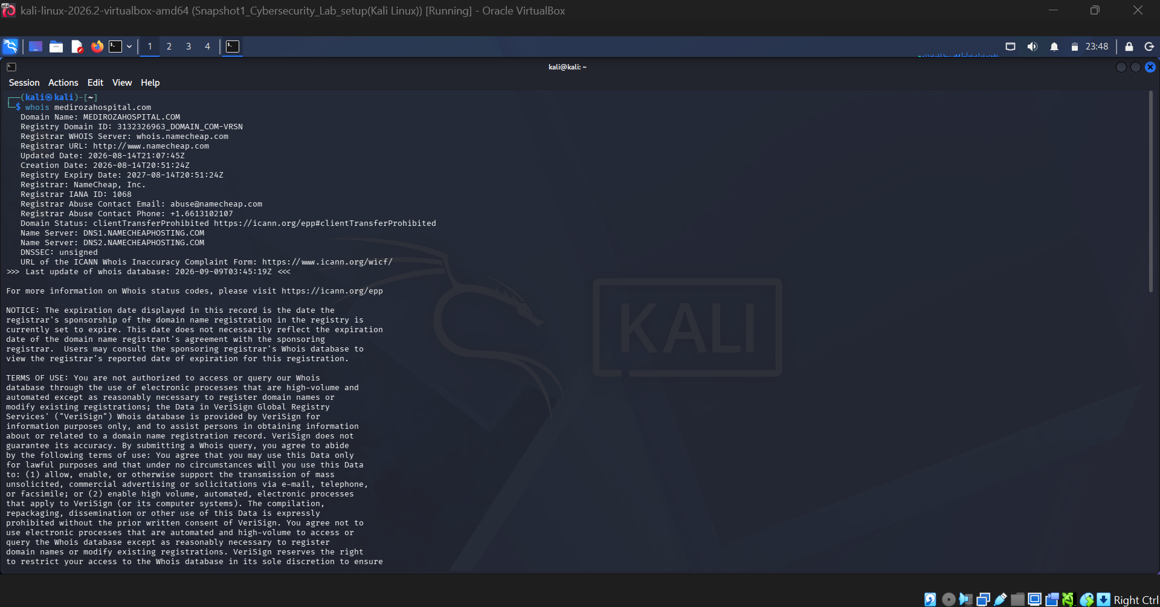
Figure 1 — WHOIS lookup for medirozahospital.com
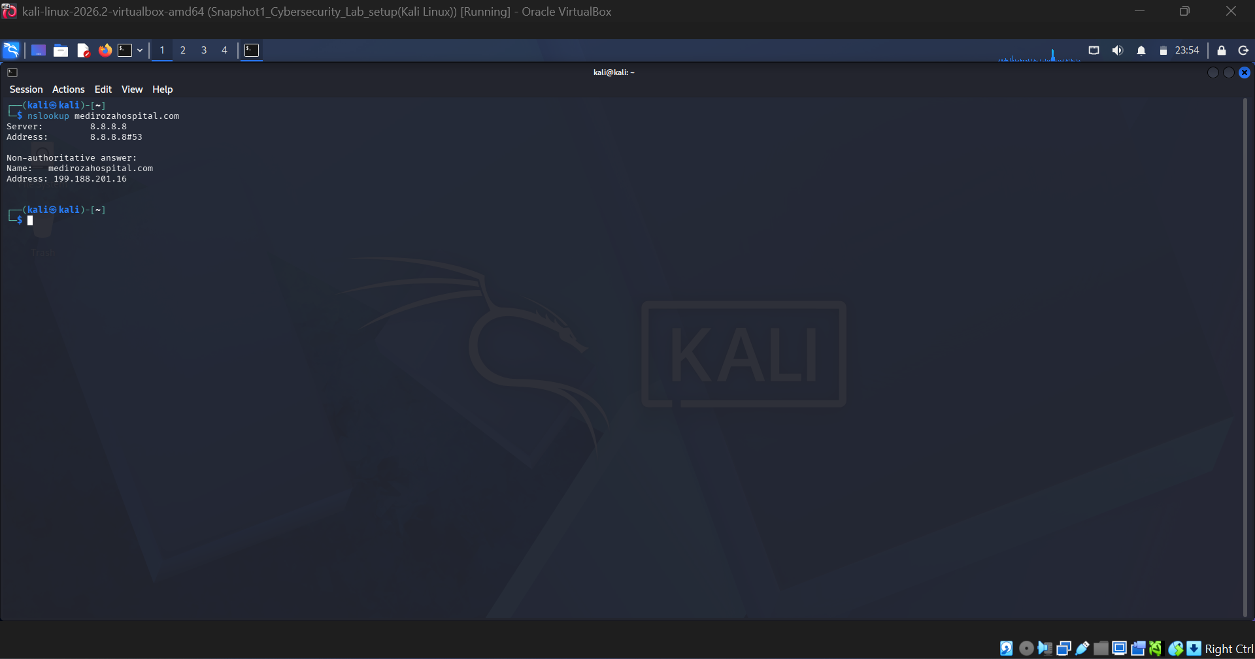
Figure 2 — nslookup DNS resolution
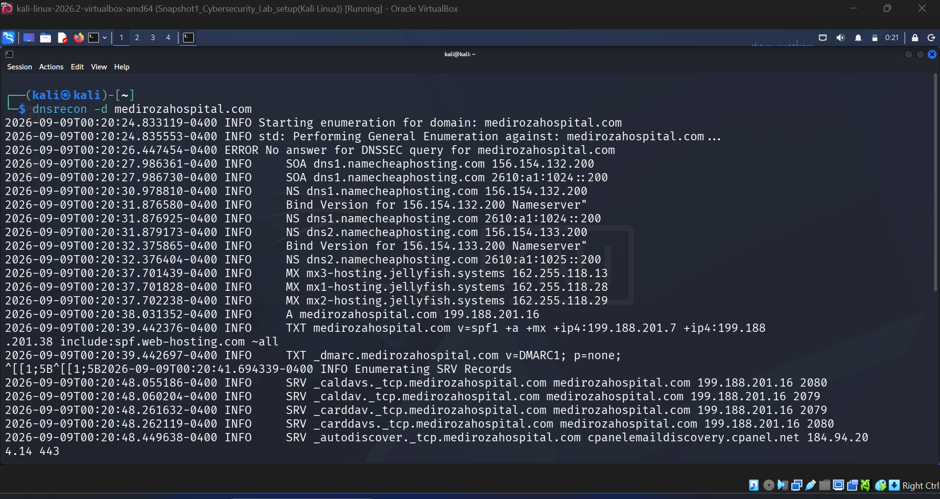
Figure 3 — DNSRecon domain/subdomain enumeration
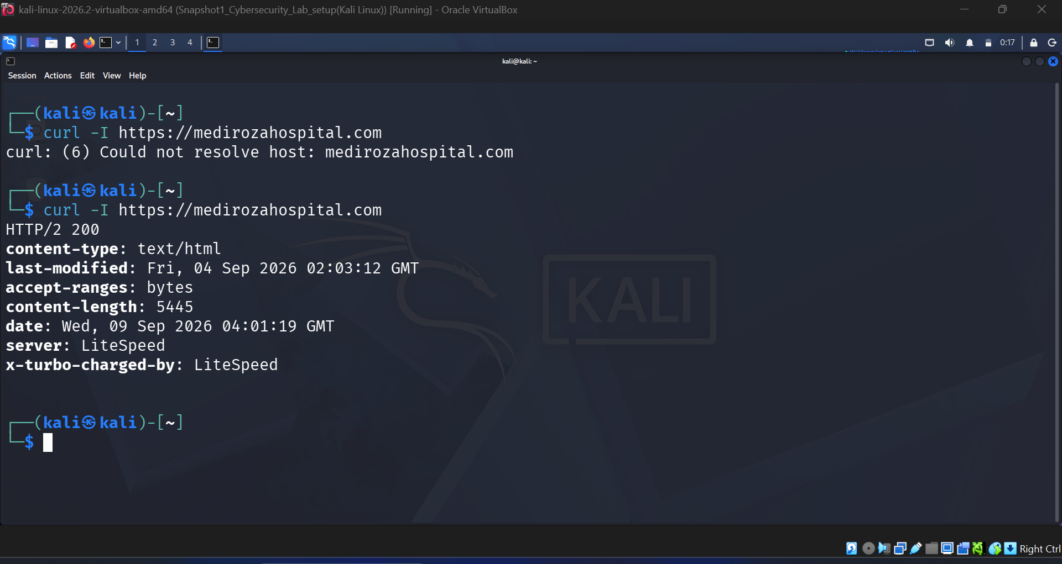
Figure 4 — HTTP response headers via curl
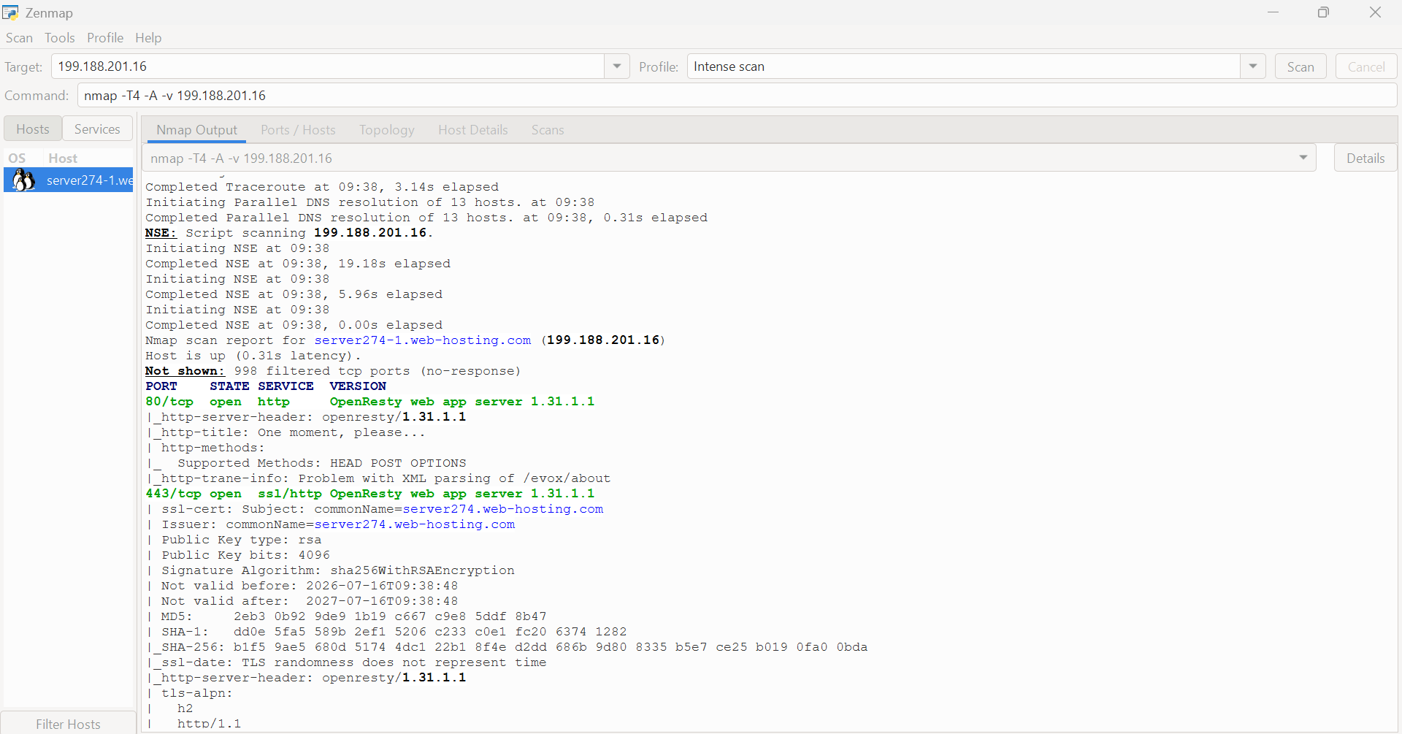
Figure 5 — Nmap port and service scan
Next, directory brute-forcing with Gobuster to look for anything not linked from the site itself:
gobuster dir \
-u https://medirozahospital.com \
-w /usr/share/wordlists/dirb/common.txt \
-x php,txt,bak,zip \
--exclude-length <wildcard_length> \
-o gobuster_result.txt
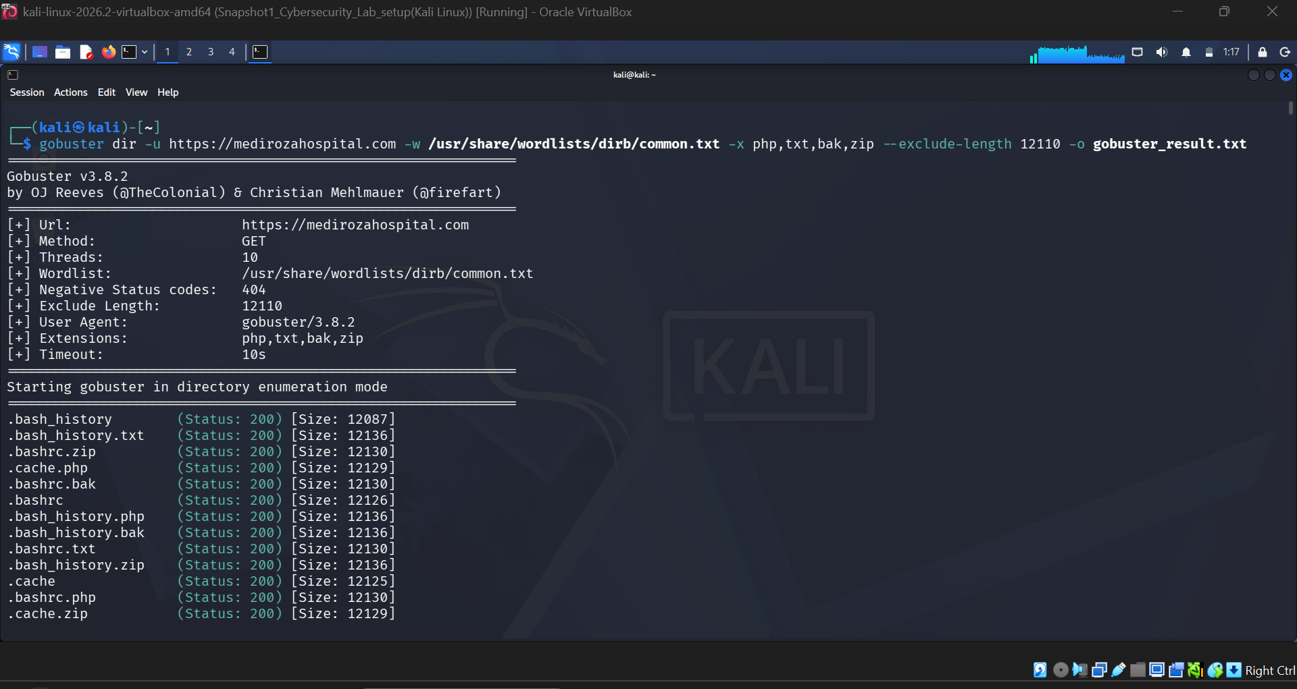
Figure 6 — Gobuster command execution
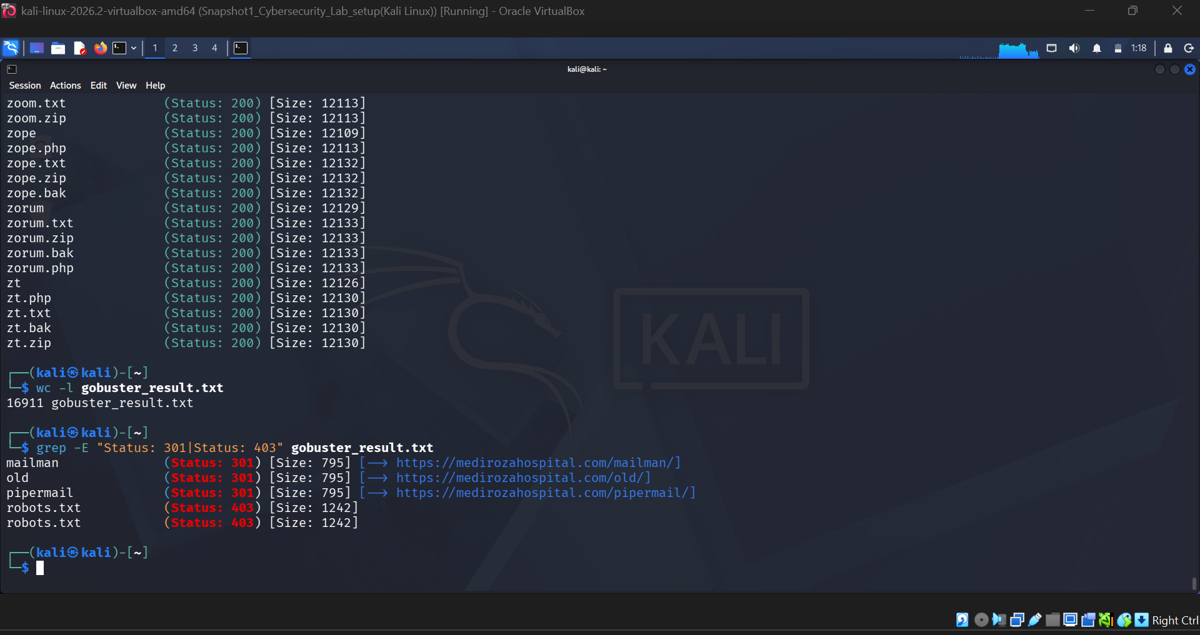
Figure 7 — Gobuster discovery results
That turned up a few paths worth checking manually: /old/, /mailman/, /pipermail/, /robots.txt.
Checking robots.txt directly confirmed it, and also handed over a map of "hidden" folders for free:
User-agent: *
Disallow: /patient/
Disallow: /staff/
Disallow: /old/
Sitemap: https://medirozahospital.com/sitemap.xml
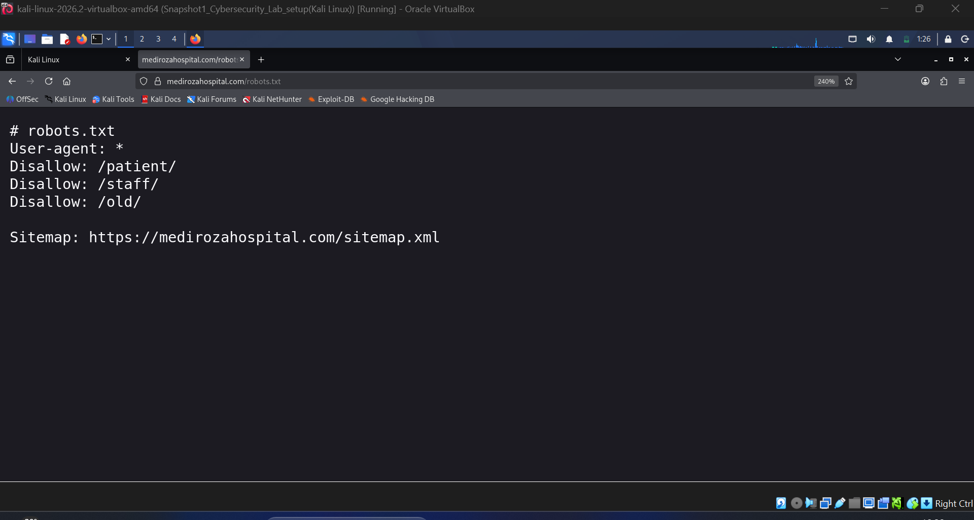
Figure 8 — robots.txt content
robots.txt is a polite request to crawlers, not an access control — so listing /old/, /patient/, and /staff/ here just saves an attacker the trouble of guessing.

Stage 2 — Login Form SQL Injection
Testing the patient login with an invalid username first returned a specific error:
Username not found
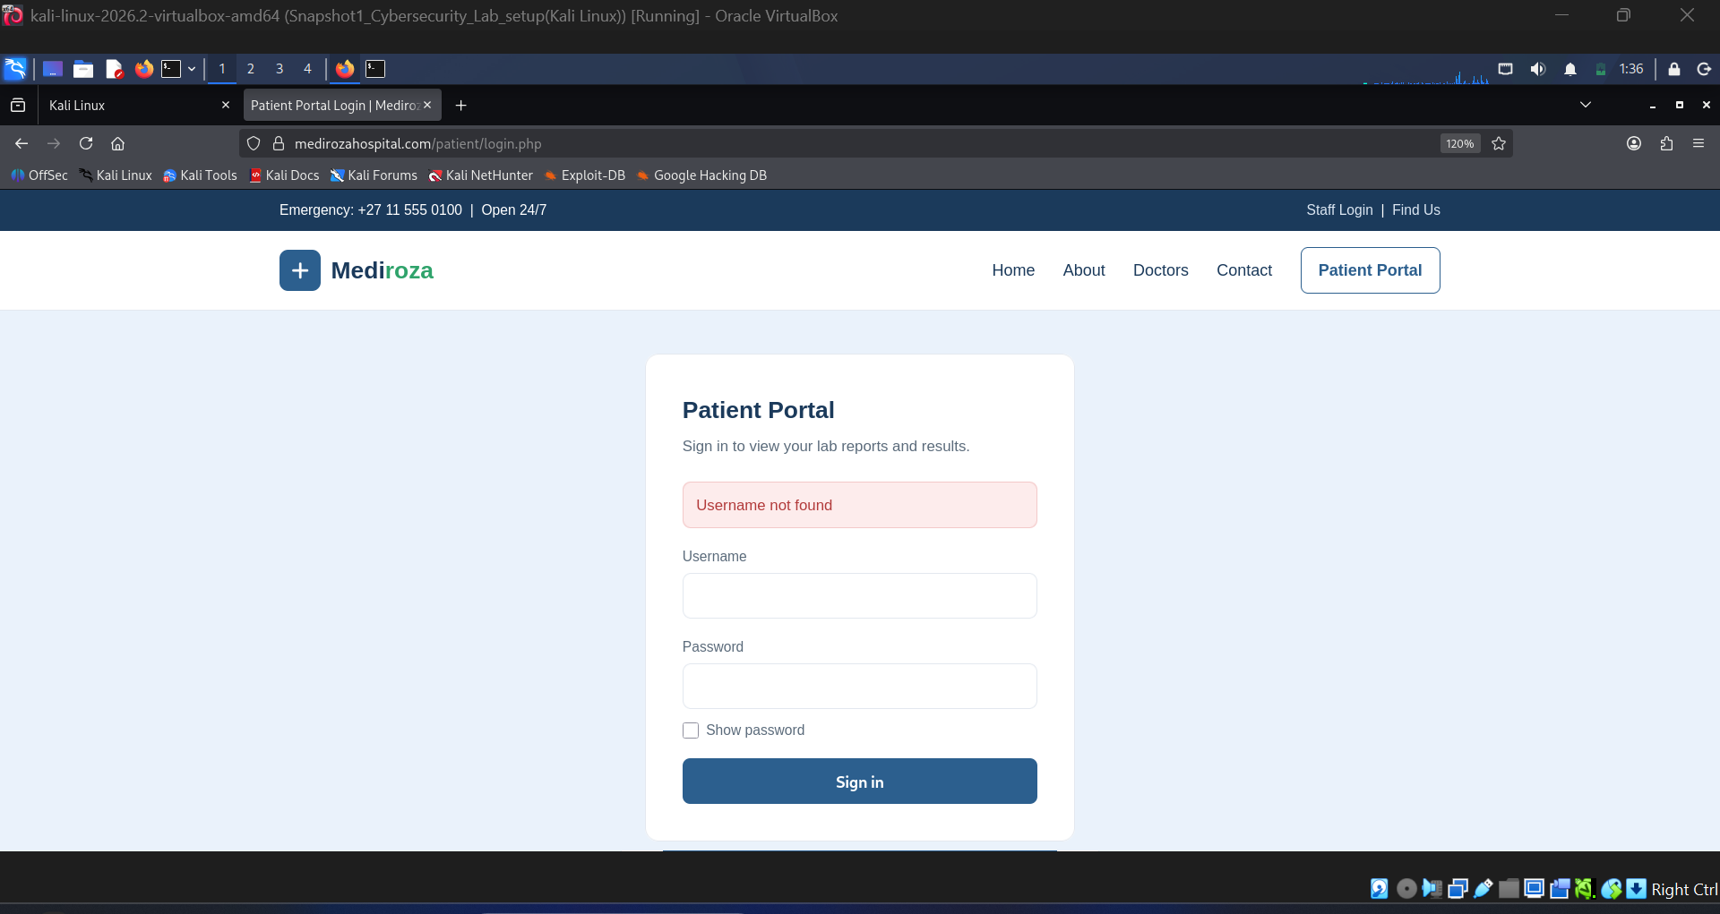
Figure 9 — Baseline login error disclosing username validity
That kind of precise feedback lets an attacker enumerate valid usernames (CWE-203) — a small leak, but a useful one for the next step.
Trying a single quote in the username field broke the query outright:
Warning: mysqli_query(): You have an error in your SQL syntax;
check the manual that corresponds to your MySQL server version
for the right syntax to use near ... at line 1
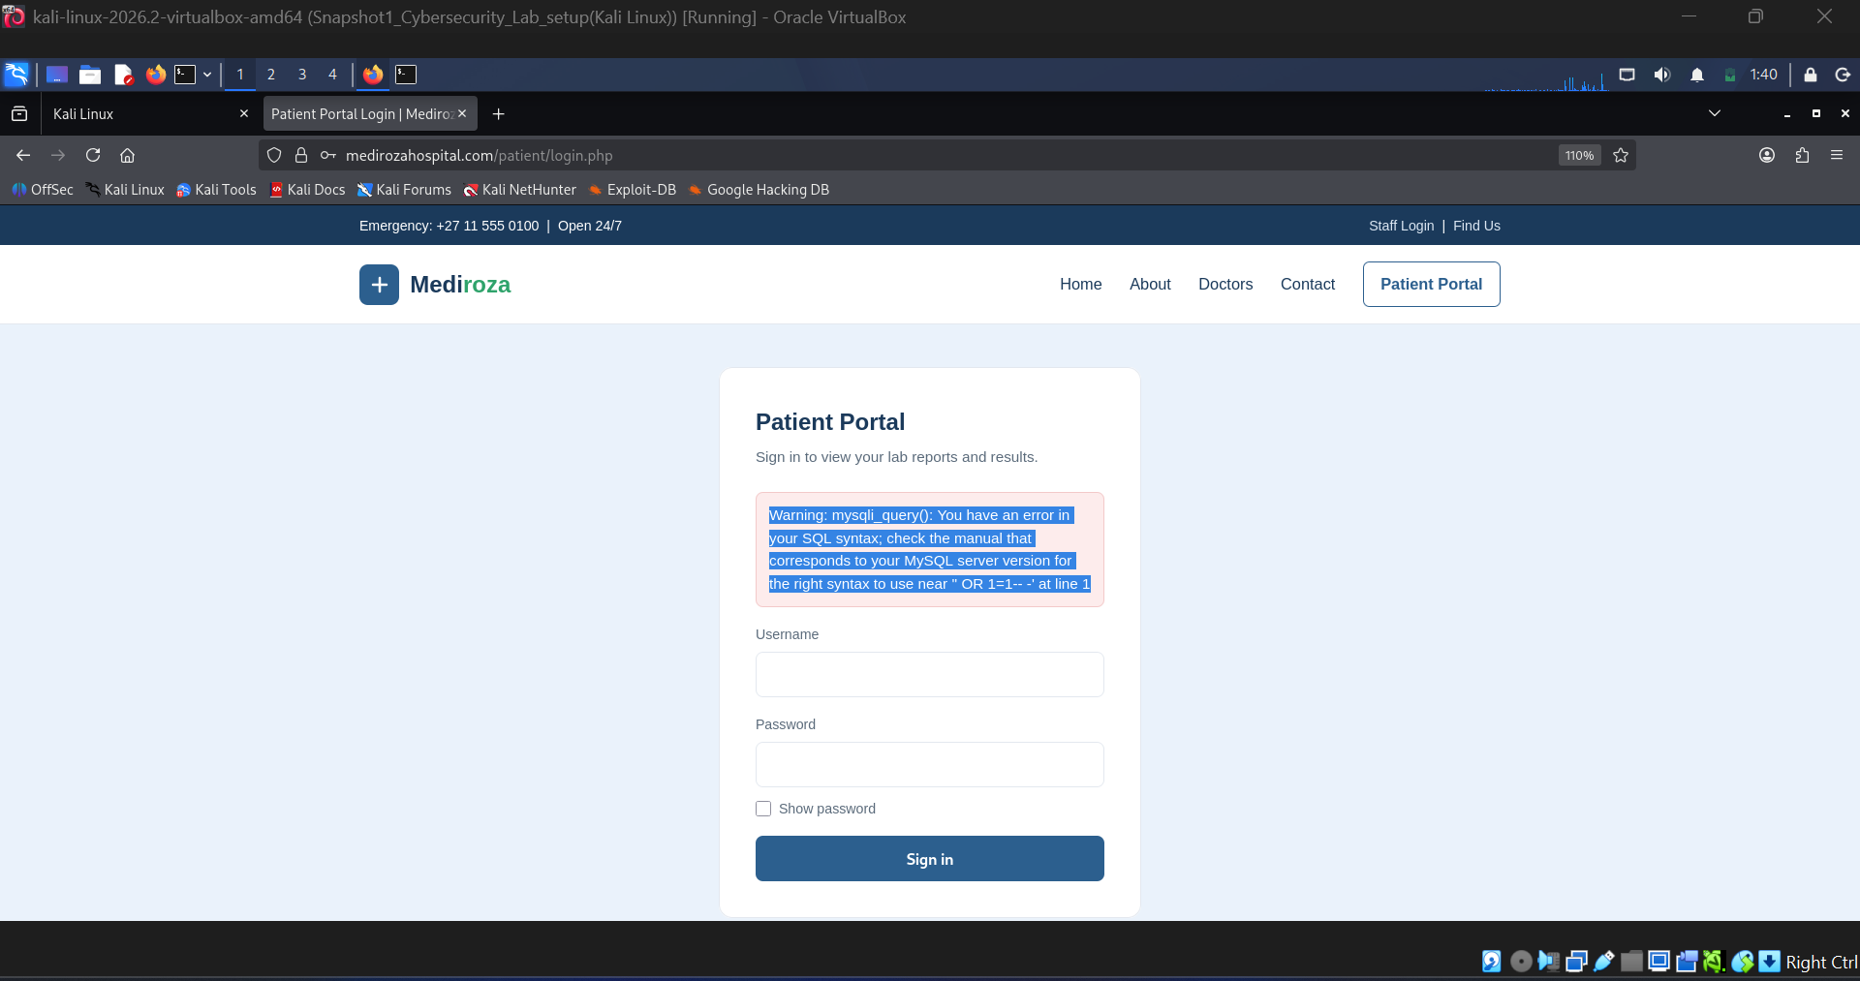
Figure 10 — Raw MySQL syntax error returned by the login form
That confirms the backend is building SQL queries by concatenating raw input (CWE-89) — a classic SQL injection setup.
From there, a simple boolean payload (admin'--) in the username field was enough to log in without ever supplying a valid password:
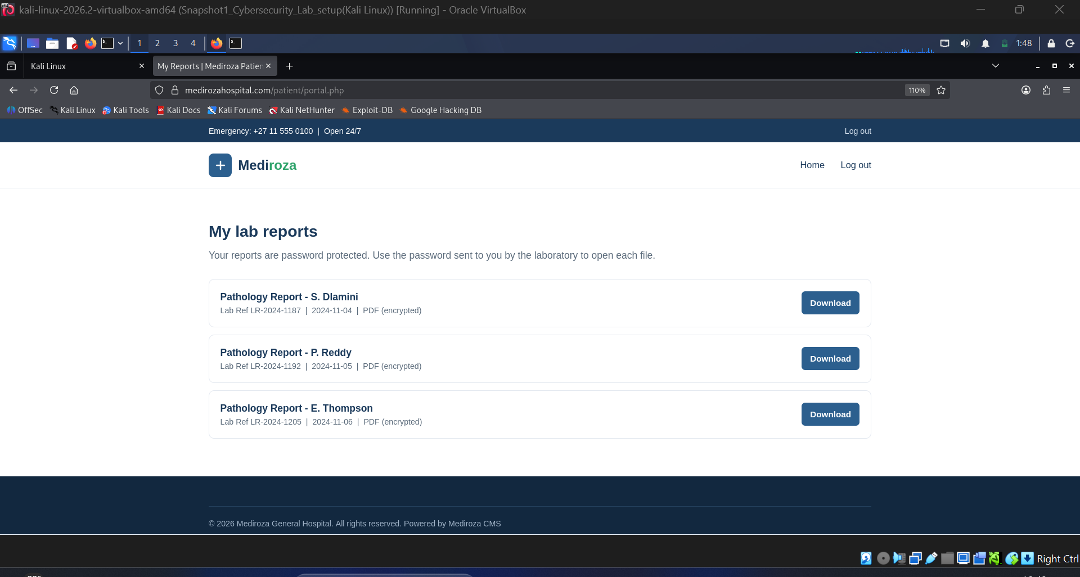
Figure 11 — Authenticated patient portal accessed via SQL injection bypass
Inside, three patient records were sitting in the portal:
Patient Record | Lab Ref
S. Dlamini — Pathology Report | LR-2024-1187
P. Reddy — Pathology Report | LR-2024-1192
E. Thompson — Pathology Report | LR-2024-1205

Stage 3 — Stealing & Cracking the Reports
All three PDFs were downloaded for a closer look — each one was protected with a user-level PDF password.
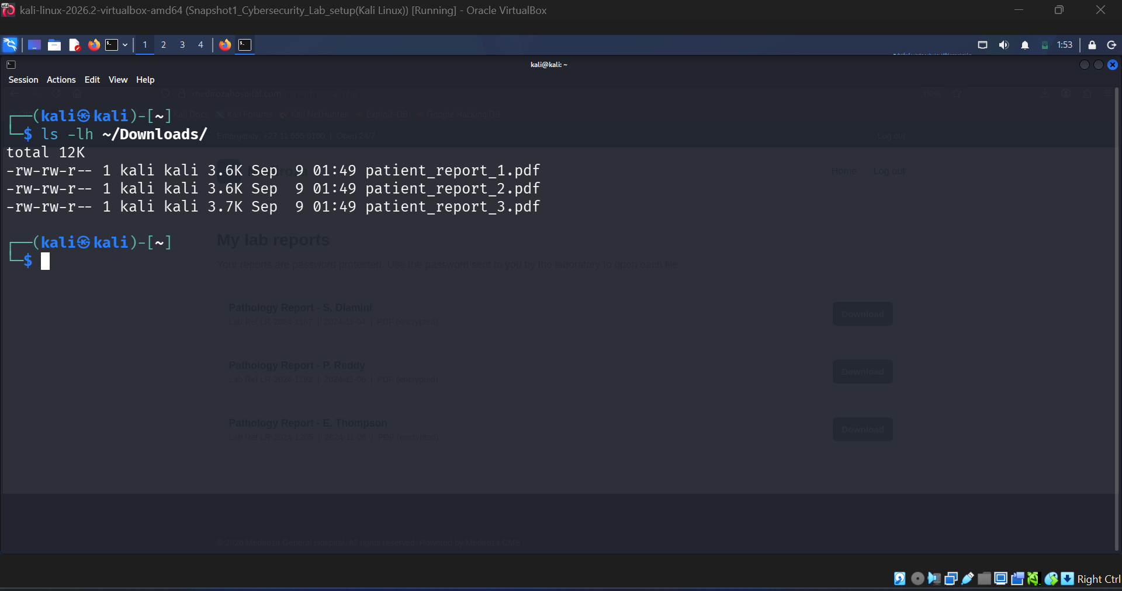
Figure 12 — Downloaded patient report PDFs
The encryption keys were pulled from each file and run through a dictionary attack:
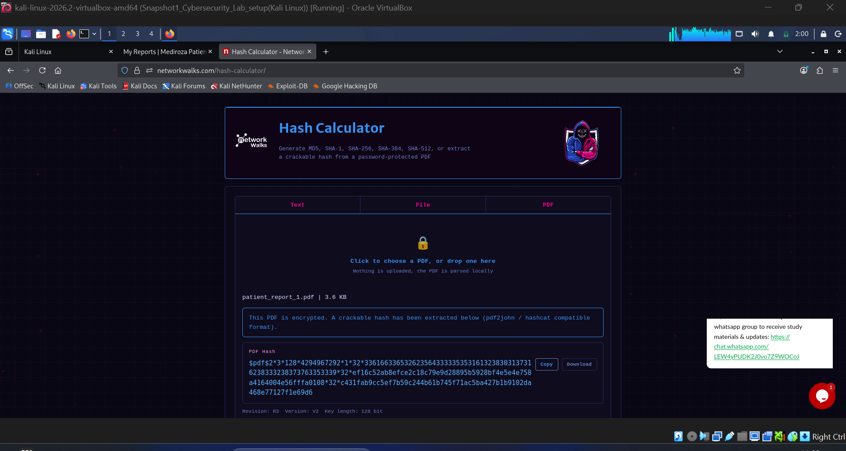
Figure 13 — PDF encryption hash extraction
File | Encryption | Result | Time to Crack
patient_report_1.pdf | R3 / V2 / 128-bit | Cracked | < 5 sec
patient_report_2.pdf | R3 / V2 / 128-bit | Cracked | < 5 sec
patient_report_3.pdf | R3 / V2 / 128-bit | Cracked | < 5 sec
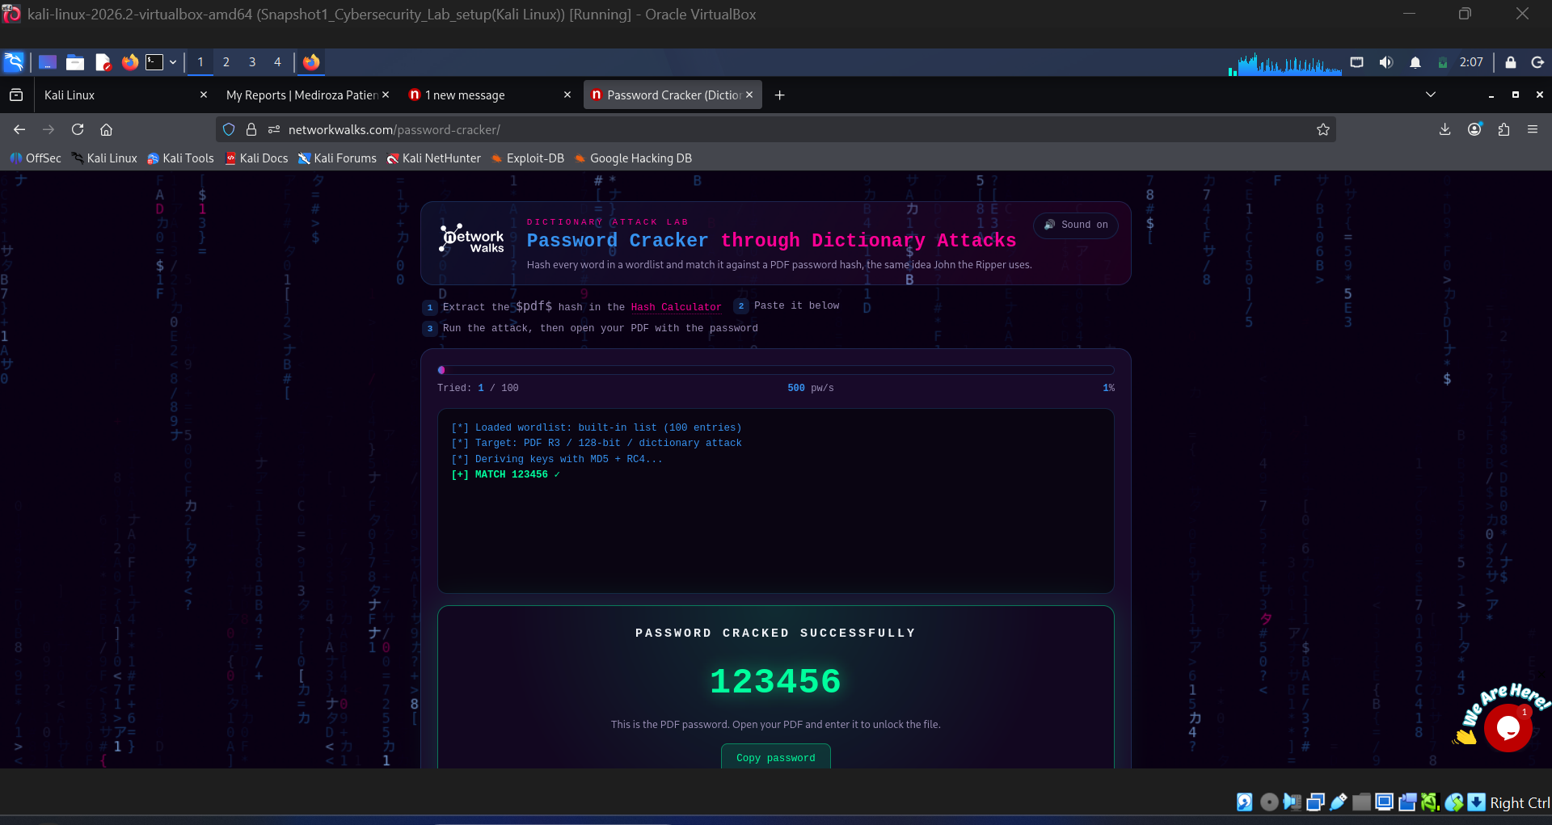
Figure 14 — Password recovery for patient_report_1.pdf
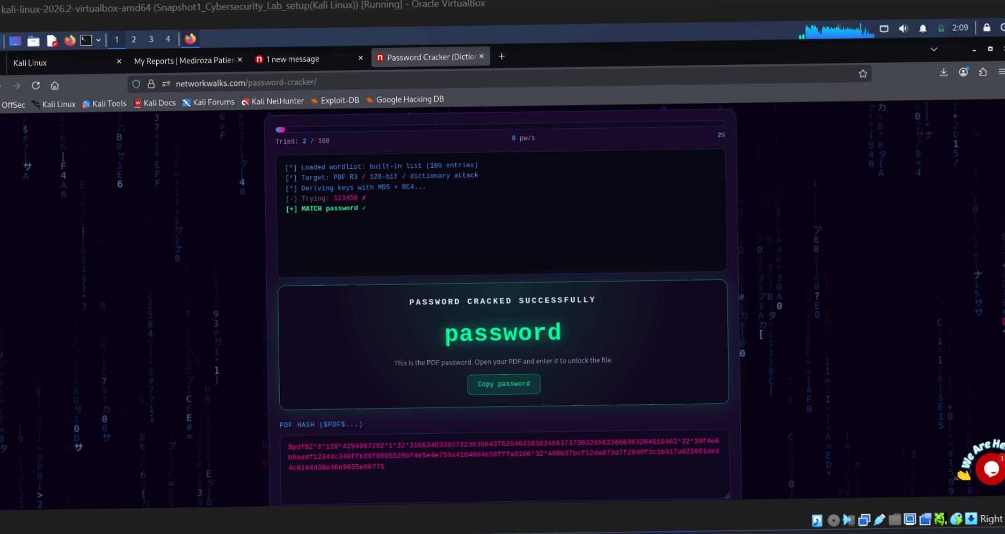
Figure 15 — Password recovery for patient_report_2.pdf
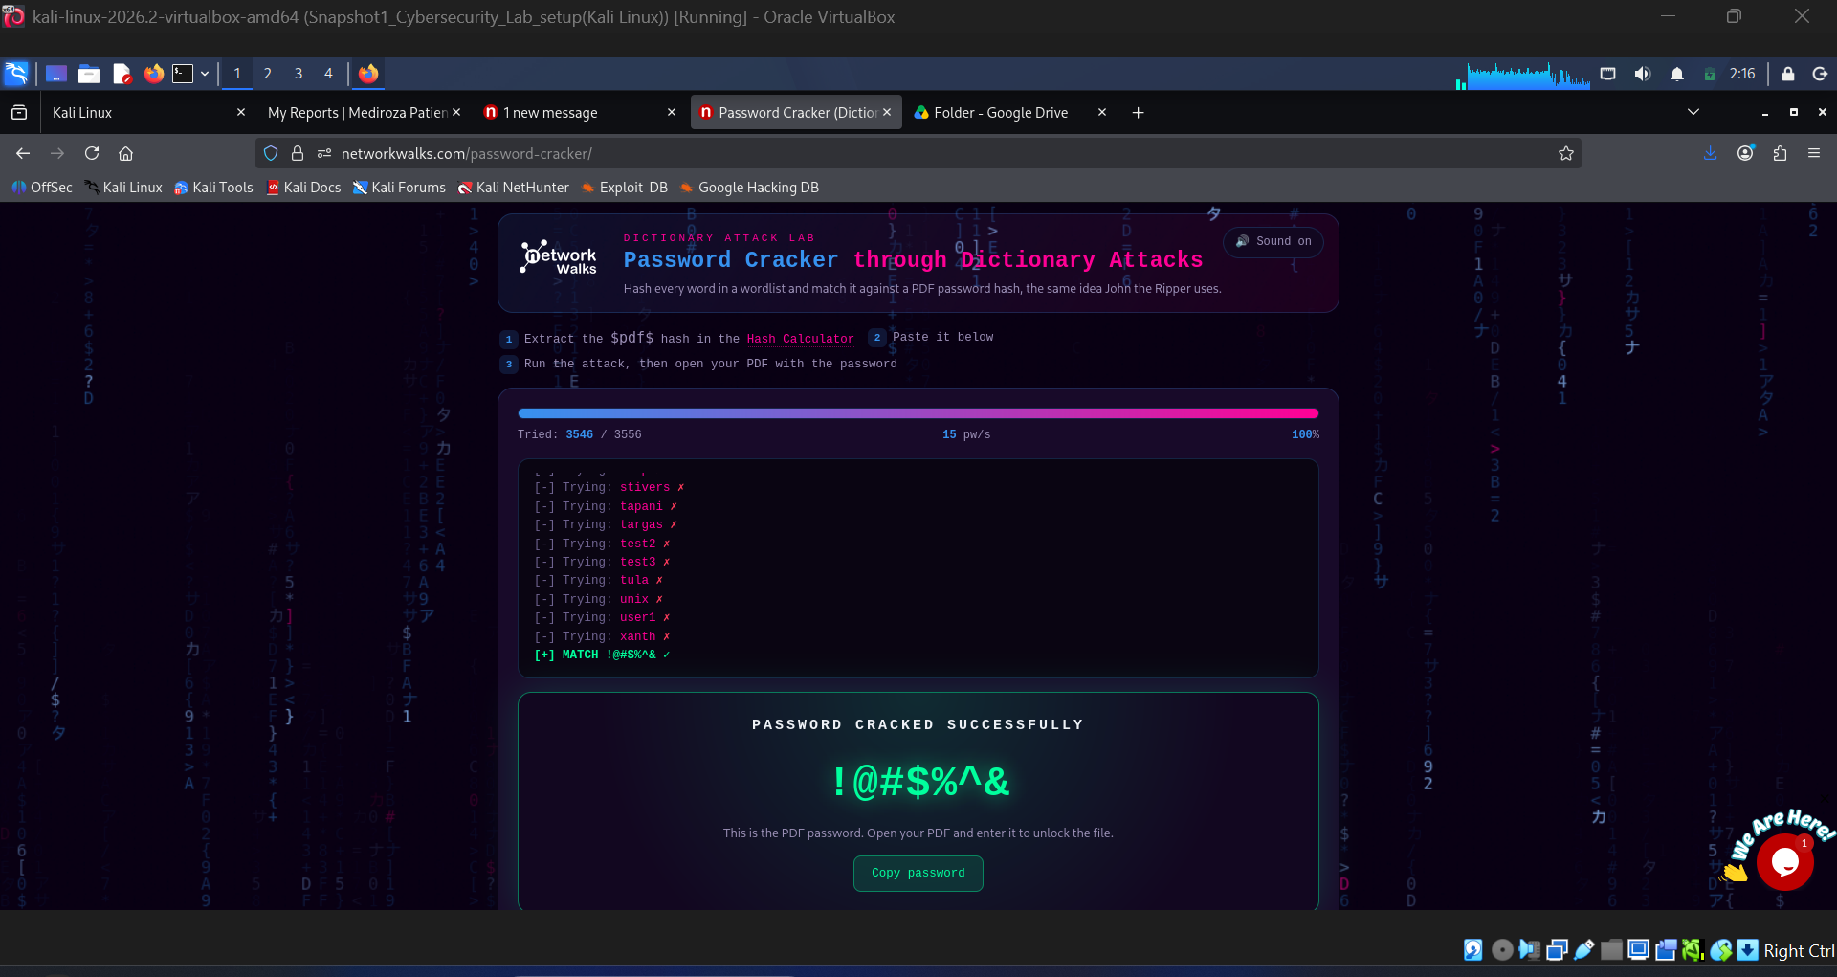
Figure 16 — Password recovery for patient_report_3.pdf
All three passwords were short and guessable — the kind of thing a small wordlist clears instantly, which makes the "encryption" more of a formality than a real control.
With the passwords in hand, all three reports opened right up:
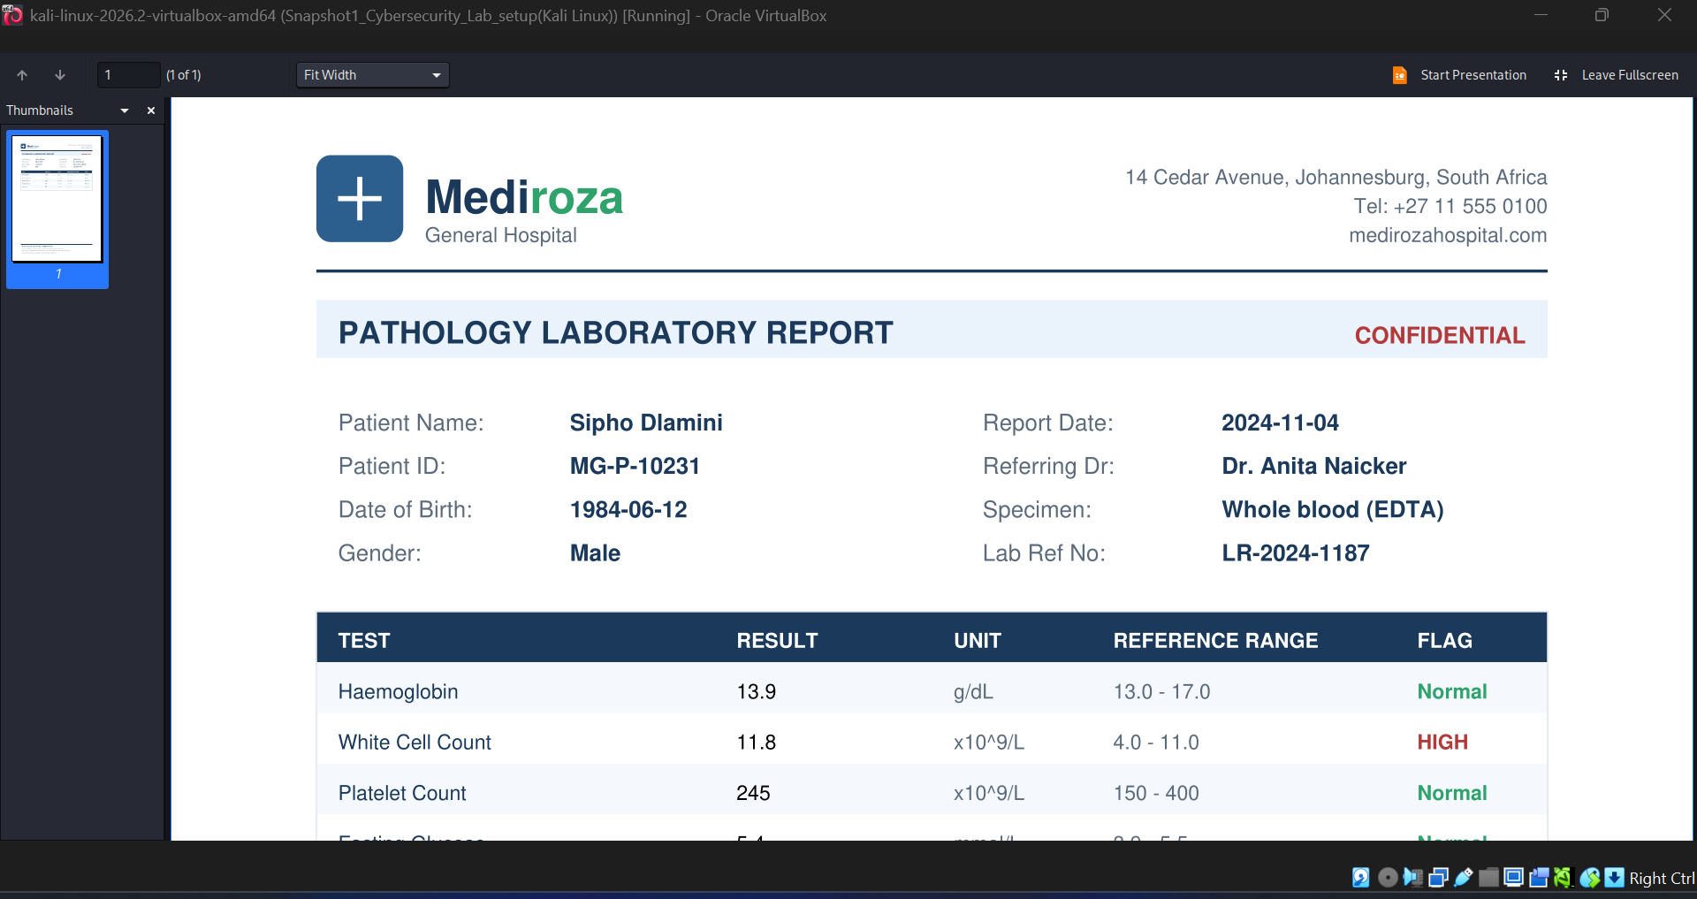
Figure 17 — Decrypted content of patient_report_1.pdf
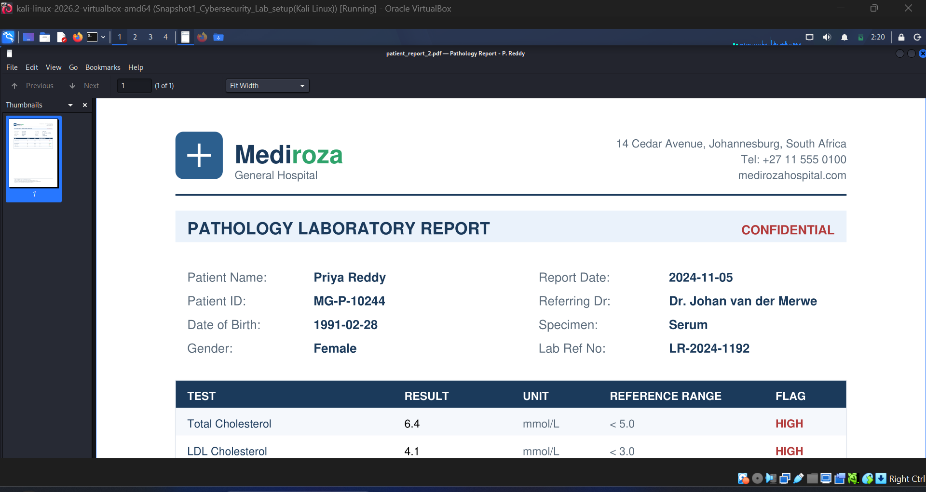
Figure 18 — Decrypted content of patient_report_2.pdf
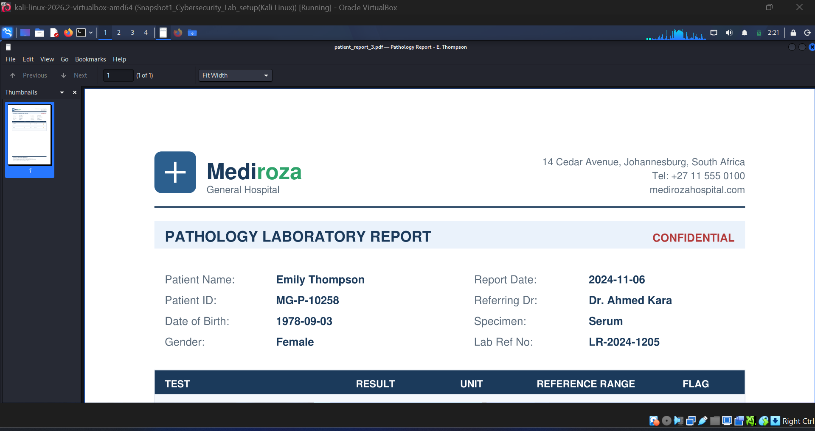
Figure 19 — Decrypted content of patient_report_3.pdf
Each one contained full patient names, dates of birth, lab results, and clinical notes — exactly the kind of data this control was supposed to protect.

Stage 4 — Backup Leak
Running the recovered password through ExifTool against one of the PDFs turned up more than expected — a leftover internal comment:
exiftool -password '<recovered_password>' patient_report_3.pdf
Comments: DB backup moved to /old before site migration, do not delete
Author: j.malik
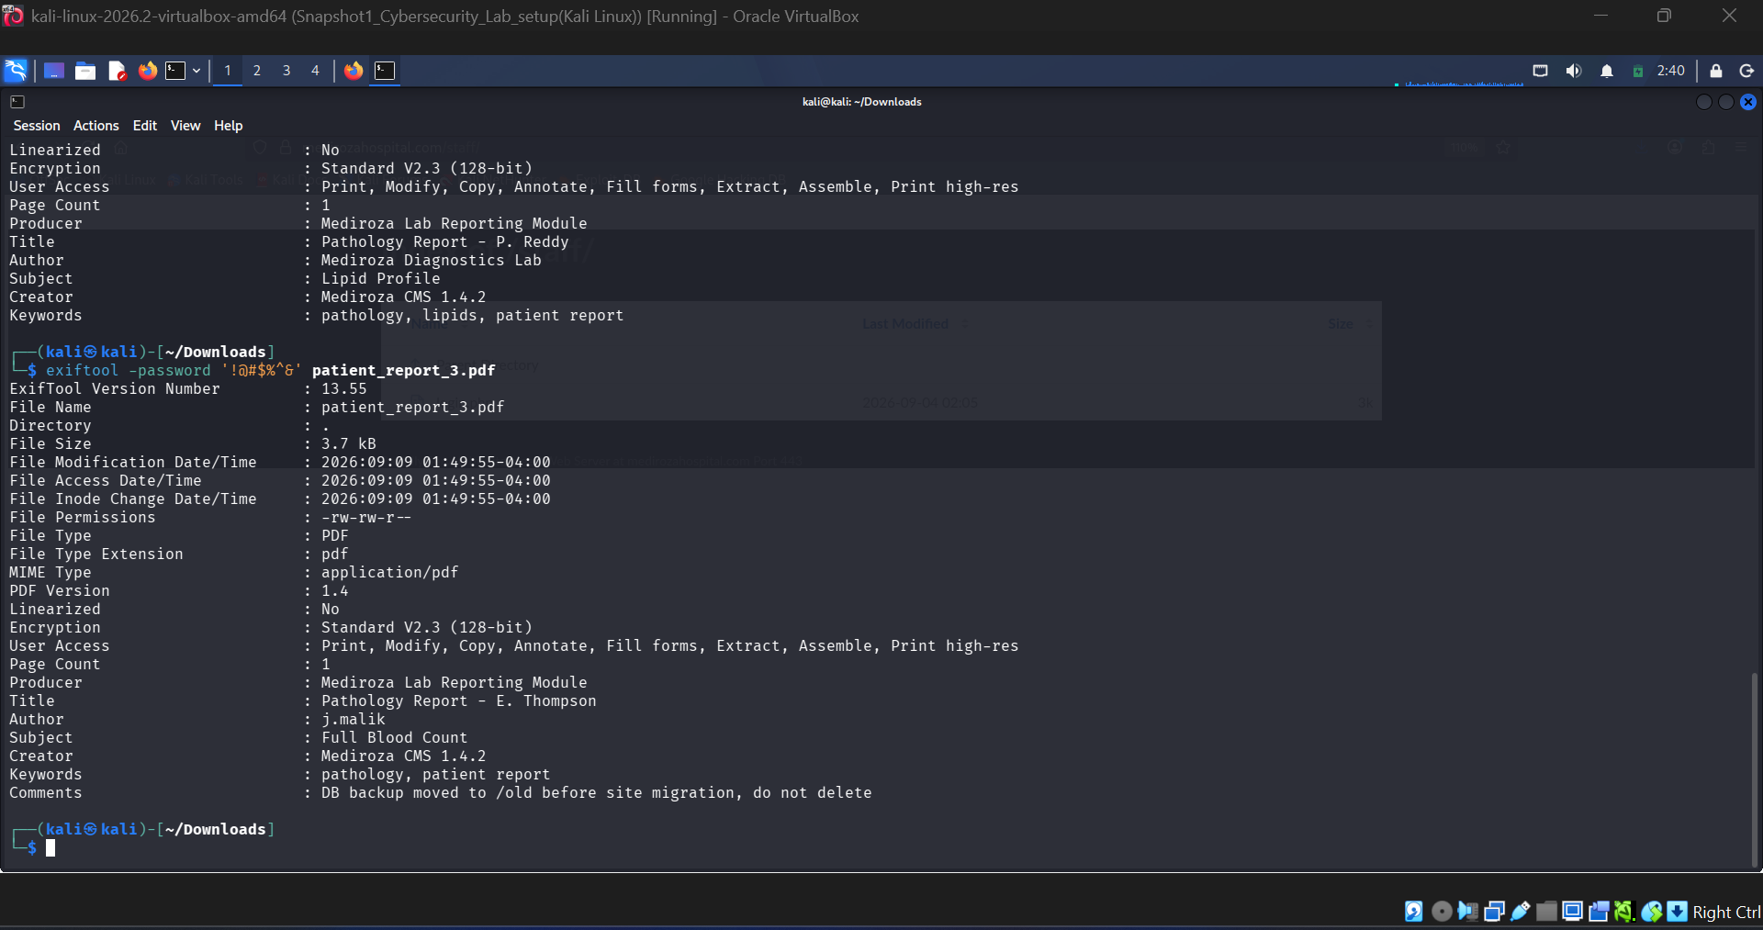
Figure 20 — ExifTool metadata disclosing an internal migration note
That comment pointed straight at /old/ — which, sure enough, had directory listing turned on:
curl -s -i https://medirozahospital.com/old/
No login, no restriction — just a plain file index, including a SQL dump sitting right there:
mediroza_db_backup_2019.sql
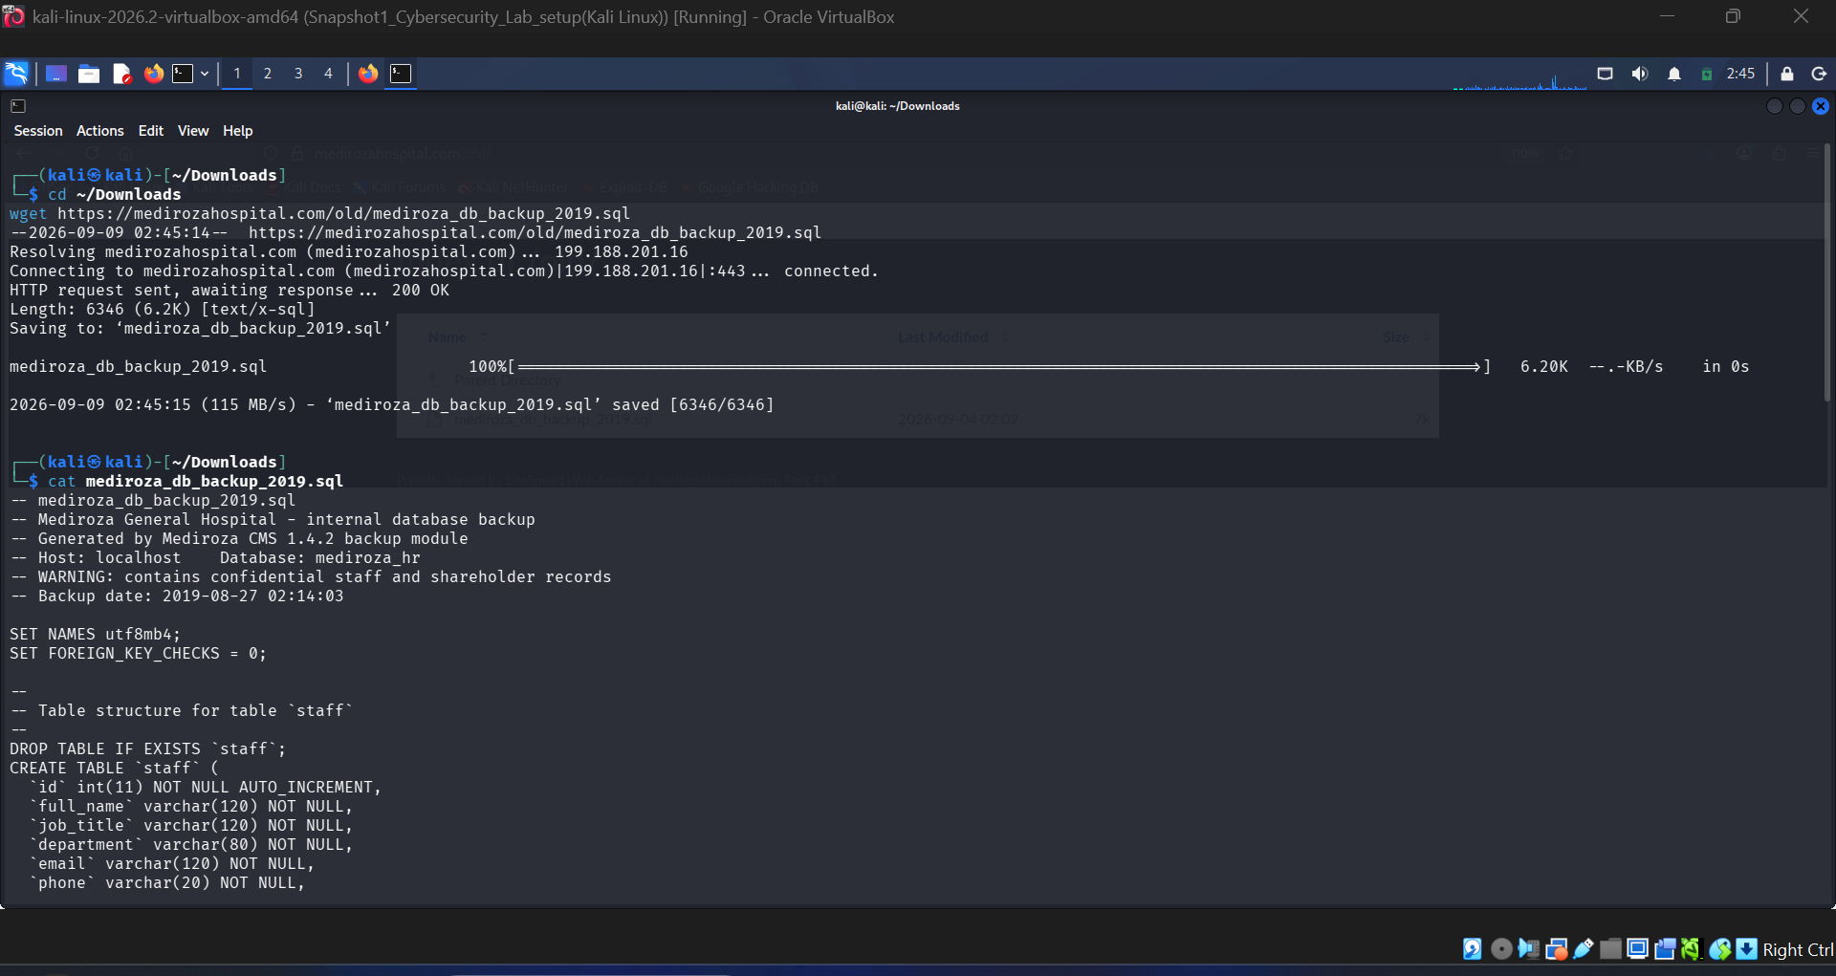
Figure 21 — Contents of the exposed SQL backup file
Opening the dump showed two tables worth flagging:
- staff — around 30 employee records: names, ID numbers, salaries, roles, work emails
- shareholders — investor names, ownership stakes, share classes
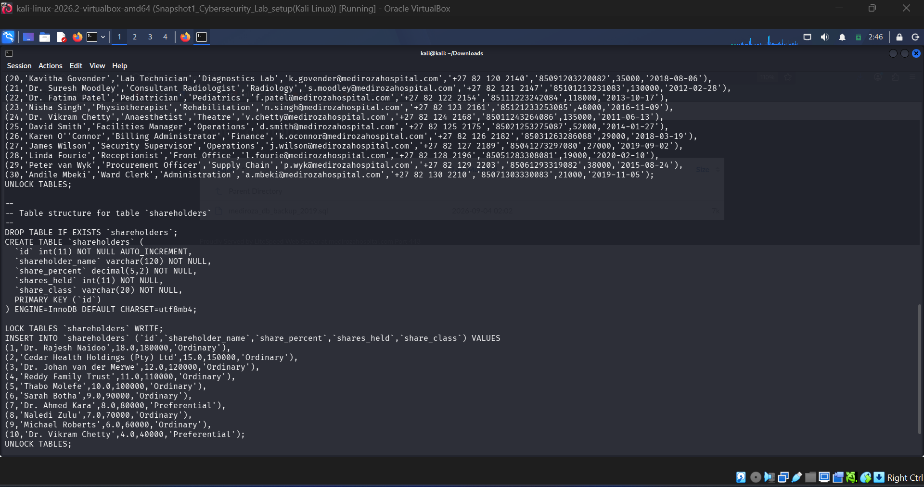
Figure 22 — Shareholder and staff records recovered from the SQL dump

7. How the Attack Chains Together
Two independent weaknesses — the login form and the leftover backup folder — both lead to serious data exposure on their own, but a metadata comment ended up linking one to the other:
robots.txt discloses /patient/ /staff/ /old/
|
+-- Patient login (SQLi) --> Portal access --> 3 PDFs downloaded
| |
| Weak passwords cracked
| |
| Patient health data exposed
|
+-- /old/ open directory --> SQL dump downloaded --> Staff PII +
shareholder data exposed

8. Severity Breakdown

Critical

SQL Injection Login Bypass — CWE-89, OWASP A03
Unsanitized input lets an attacker rewrite the query logic and skip authentication entirely.

Open Backup Directory
A .sql dump sitting in a publicly browsable folder, no authentication required.

High

Weak PDF Passwords
Short, predictable passwords mean the "encryption" barely slows down an offline attack.

Medium

Metadata Left in Exported Files
Internal comments and author tags give away infrastructure details.

Verbose SQL Errors
Raw database errors make it easier to build a working injection payload.

Low

robots.txt Path Disclosure
Lists exactly the folders meant to stay hidden.

9. Fixes & Recommendations
- Use prepared statements everywhere — parameterized queries on every endpoint that touches user input neutralize the SQLi issue.
- Turn off directory listing — Options -Indexes (Apache) or the LiteSpeed equivalent, so nobody gets a free file browser.
- Keep backups out of the web root — .sql/.bak/archive files have no business living in public_html/.
- Use strong, random PDF passwords — short, predictable strings defeat the purpose of encrypting the file.
- Strip metadata before publishing files — author names, internal comments, and file paths shouldn't ship with a public PDF.
- Don't rely on hidden paths for security — every request should be authorized server-side; robots.txt isn't an access control.

10. Legal Note
Everything in this report describes testing performed against a training target inside an authorized academy lab, for learning purposes only. Testing any system without explicit, written permission is illegal.

11. Tester & Project Overview
Tester: Rana Faheem Ibrahim — Networkwalks Academy, Web Application Hacking 101
Parameter | Value
Project Name | Mediroza General Hospital Penetration Testing
Program | Networkwalks Academy — Web Application Hacking 101
Findings Covered | F1, F2, F3, F4, F5
Primary Focus | Web Application Security Assessment
Status | Final — Fully Documented

