Comparative DCF: Incremental GDP Impact
AI vs. Trump 2.0 vs. US-Iran War (illustrative, order-of-magnitude)
Author: Claude (Opus 4.7) Date: 2026-05-03 Base year: 2026 (year 1 = 2026; PV as of start-of-2026) Units: real USD trillions, ex-inflation discount rates Channels: mechanism + oil-price
Executive summary
Under central-case assumptions, with year 1 = 2026 and PV measured as of start-of-2026: AI's incremental GDP has a present value of $47.10T (global, 30-year explicit + Gordon terminal, discount rate 6%; oil channel contributes -$1.13T). Trump 2.0's incremental US GDP has a present value of -$1.13T (20-year horizon, discount rate 5%; oil channel contributes $0.03T). A US-Iran kinetic war has a present value of -$2.28T in incremental global GDP (10-year horizon, discount rate 5%; oil channel contributes -$1.25T and is the dominant transmission mechanism). Conditional on the war occurring — not probability-weighted.
The order of magnitude is the headline: AI's PV is roughly 42x the absolute size of Trump 2.0's net GDP impact and 21x the absolute size of an Iran war shock. Even after loosening AI assumptions toward Acemoglu-style skepticism, AI dominates by at least one order of magnitude in our central case — because it is a long-duration productivity shock compounded over decades, while political and geopolitical shocks act on shorter horizons with bounded amplitude.
Sanity check vs. dot-com era forecasts. The synthesized 1999-2000 consensus forecast for the internet's incremental global GDP, when FV'd to 2026 dollars (CPI x1.85), has a PV of $42.91T. Today's AI forecast at $47.10T is only 1.10x larger — effectively the same order of magnitude. See section 4 for the detailed comparison.
Scenario | Horizon | Discount | Mechanism PV | Oil PV | Terminal PV | Total PV
AI (global) | 30 y | 6% | $25.02T | -$1.13T | $23.22T | $47.10T
Trump 2.0 (US) | 20 y | 5% | -$1.16T | $0.03T | $0.00T | -$1.13T
US-Iran war (global) | 10 y | 5% | -$1.03T | -$1.25T | $0.00T | -$2.28T

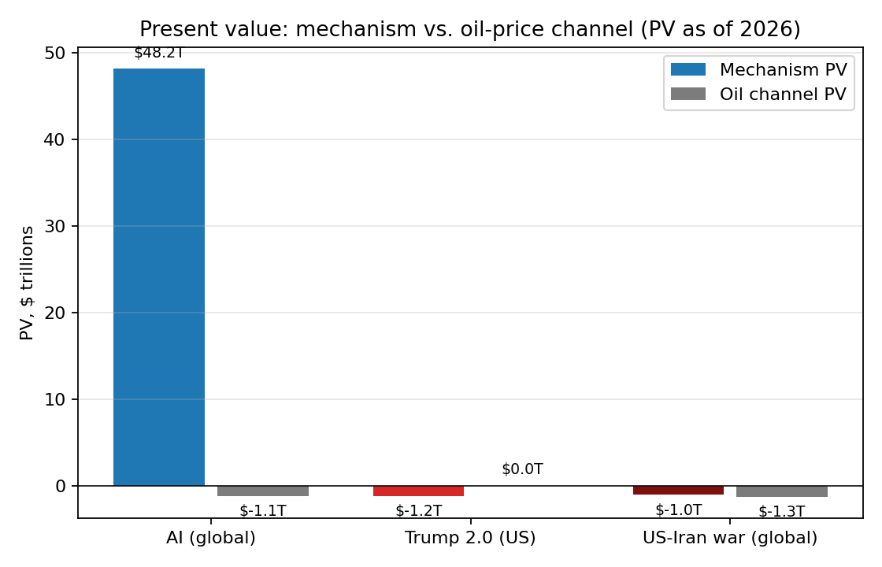

Methodology
I model each scenario as an annual stream of incremental GDP relative to a no-event counterfactual, starting in 2026, then discount to a present value as of start-of-2026 using a real (ex-inflation) discount rate. PV = Σ ΔGDP_t / (1+r)^t, with a Gordon-growth terminal value where economic fundamentals justify it (only AI). For the political and war scenarios, the impact decays inside the explicit horizon, so no terminal value is added.
Two channels are aggregated for each scenario: (a) the core mechanism (productivity, policy, conflict) and (b) an oil-price channel that converts a $/bbl deviation vs a $75 baseline into GDP impact via an oil-to-GDP elasticity (0.15% global GDP per $10/bbl sustained for global scenarios; 0.05% US GDP per $10/bbl for the now oil-balanced US). This makes the oil-driven portion of each scenario's PV explicit.
Three deliberate choices shape the comparison: (1) AI is global and very long-horizon, while Trump 2.0 is mostly US and 4-20y, while the Iran war shock is global but front-loaded and short. (2) The discount rate is held between 5-6% real to keep magnitudes comparable, then varied in sensitivity tables. (3) War PV is conditional on occurrence, not probability-weighted; if you assign a probability p, multiply by p for an expected value.
Charts
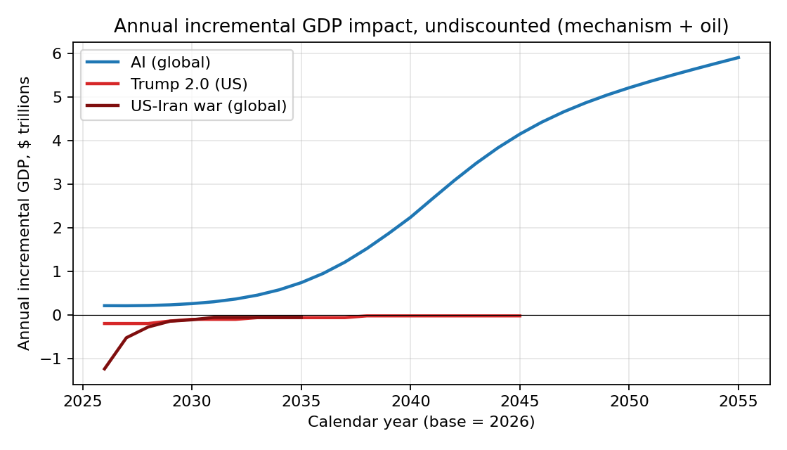

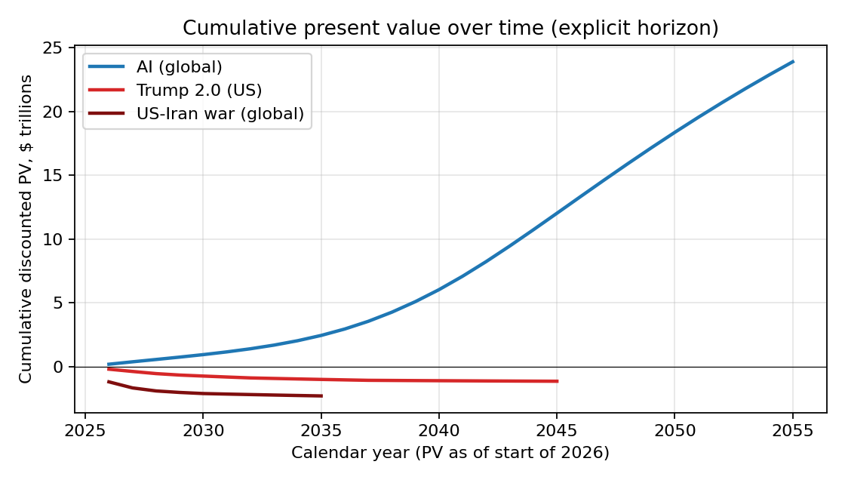

Oil-price assumption per scenario
Three different oil tracks. The Iran-war track is a sharp spike that dominates that scenario's PV. The AI track is a slow, persistent rise from datacenter energy demand. The Trump 2.0 track is a small drop from US production growth and tariff-driven demand softening, fading after the term.
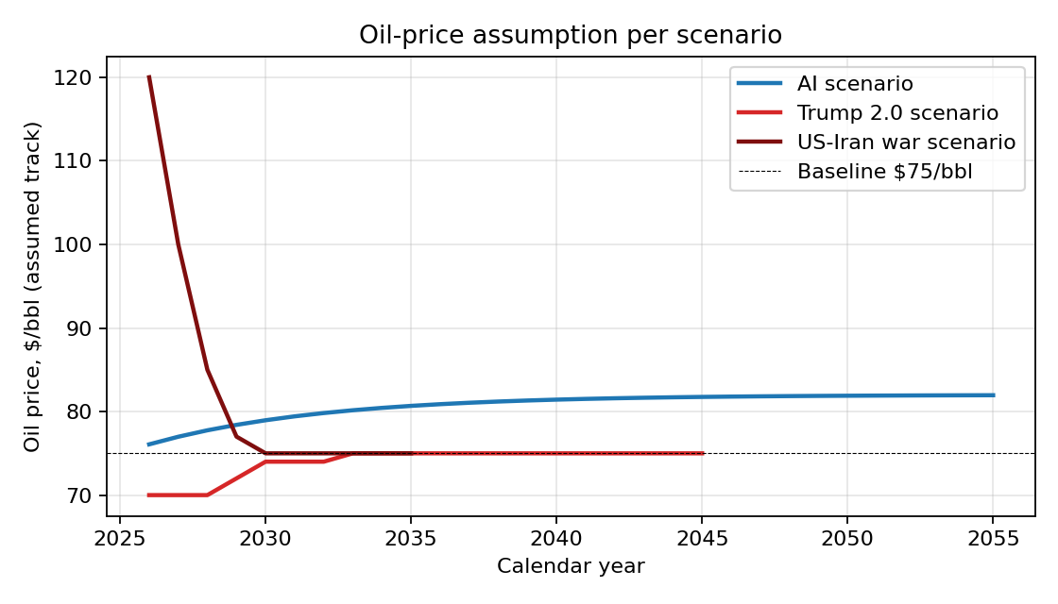

1) AI — global incremental GDP
Assumptions
Parameter | Value
Global GDP base (2026) | $110T
Adoption profile | Logistic ramp; $0.2T (2026) -> $4.5T (2040)
Post-peak growth | +2%/yr through 2055
Explicit horizon | 30 years (2026-2055)
Terminal growth | 1.5% real
Real discount rate | 6%
Oil channel | Datacenter electricity demand pushes WTI +$7/bbl by 2035, persists
Anchors | Goldman Sachs 2023 (~7% global GDP / 10y); McKinsey 2023 ($13-25T/yr by 2040); PwC 2017 ($15.7T by 2030)

Result: Explicit-horizon PV $23.88T + terminal PV $23.22T = total PV $47.10T. Of which the oil channel contributes -$1.13T (a small drag from datacenter-driven oil prices). The terminal value is large because a permanent productivity uplift compounds forever; even at 6% real discounting, a $7-8T perpetual annual delta is worth on the order of $100T+ in present value terms.
Sensitivity (total PV, $T)
Peak $T/yr by 2040 \ Discount | 4% | 6% | 8% | 10%
$2.0T | $48.04T | $21.08T | $11.79T | $7.45T
$4.5T | $109.06T | $47.10T | $25.83T | $15.94T
$8.0T | $194.50T | $83.52T | $45.48T | $27.82T
$12.0T | $292.15T | $125.15T | $67.94T | $41.40T

Caveats: (i) Acemoglu (MIT, 2024) argues only 0.5% cumulative TFP gain over 10 years — an order of magnitude lower than the central case. (ii) Excludes distributional, employment, and existential-risk side effects, which are not GDP-additive but materially affect welfare. (iii) Capex needed to realize the gain (datacenters, energy, chips) is subtracted from output but not netted here.

2) Trump 2.0 — US incremental GDP
Assumptions (level effects on US GDP)
Parameter | Value
TCJA extension / corporate tax | +0.4% of US GDP (Tax Foundation)
Tariffs (broad + targeted) | -0.8% of US GDP (Penn Wharton, Yale Budget Lab)
Immigration restriction | -0.4% of US GDP (CBO labor force)
Deregulation | +0.3% of US GDP
Deficit / higher real rates | -0.2% of US GDP
Net peak (mechanism) | -0.7% of US GDP
US GDP base (2026) | $29T
Profile | Full peak y1-3 (2026-28), handoff y4 (2029), decay through 2045
Real discount rate | 5%
Oil channel | WTI -$5/bbl during term (drill-baby-drill + tariff demand softening)
Oil GDP elasticity | 0.05% US GDP per $10/bbl (US is roughly oil-balanced)

Result: Total PV -$1.13T, of which mechanism is -$1.16T and oil channel is $0.03T (cheaper oil is a small positive offset). The sign of the mechanism is negative in the central case but the magnitude is small relative to AI: a 0.7% level shock on a $29T economy that decays over 20 years is ~$2-2.5T undiscounted, ~$1-1.5T discounted. Reasonable bull cases (deregulation > tariff drag) flip the sign without changing the order of magnitude.
Sensitivity (total PV, $T)
Peak %GDP \ Discount | 3% | 5% | 7%
-1.5% (bear) | -$2.72T | -$2.45T | -$2.23T
-0.7% (base) | -$1.25T | -$1.13T | -$1.03T
0% | $0.03T | $0.03T | $0.03T
+0.7% (bull) | $1.31T | $1.18T | $1.08T

Caveats: (i) Excludes spillovers to non-US economies (likely negative via tariff retaliation but partially offset by reshoring). (ii) Treats policy as a level shock; if Trump 2.0 alters the long-run global trade architecture (durable bloc-formation), the persistent drag could be larger and longer. (iii) Excludes any AI-policy interaction; deregulation around energy/datacenters could be a meaningful AI tailwind.

3) US-Iran war — global incremental GDP
Assumptions (conditional on conflict, central case)
Parameter | Value
Oil price track (channel) | $75 (2026) -> $120 Y1 -> $100 Y2 -> $85 Y3 -> $77 Y4 -> baseline
Oil-to-GDP elasticity | 0.15% global GDP per $10/bbl sustained
Strait of Hormuz / shipping (mech) | -0.2% of global GDP, year 1 only
Direct US fiscal cost (mech) | $300-700B over 5y (mid $500B), -0.05% global GDP/yr
Financial conditions tightening (mech) | -0.2% of global GDP, year 1 only
Long-tail Mid-East instability (mech) | -0.05% of global GDP, years 6-10
Global GDP base (2026) | $110T
Real discount rate | 5%
Probability weighting | NOT applied (conditional PV)

Result: Total PV -$2.28T, of which the oil channel alone is -$1.25T (~55% of the total). Non-oil mechanism channels (Hormuz shipping, fiscal cost, financial tightening, instability) contribute -$1.03T. Front-loaded: ~70% of the loss falls in years 1-3 (2026-2028). If you assign a 20% probability of an actual kinetic war over the next 4 years, the expected-value PV is roughly -$0.46T; at 5%, -$0.11T.
Sensitivity (total PV, $T) — conditional
Severity \ Discount | 3% | 5% | 7%
0.5x (limited strikes) | -$1.19T | -$1.14T | -$1.09T
1.0x (base) | -$2.38T | -$2.28T | -$2.19T
1.5x (extended air war) | -$3.58T | -$3.42T | -$3.28T
2.5x (Hormuz closure) | -$5.96T | -$5.70T | -$5.46T

Caveats: (i) Hormuz closure is a fat-tail scenario: ~20% of global oil and ~30% of LNG transit. A 3-month closure could push the shock to multiples of the central case. (ii) Excludes nuclear escalation (non-modelable in DCF terms). (iii) Excludes regional spillovers to Israel-Lebanon, Yemen-Saudi shipping. (iv) Defense Keynesian-stimulus offset is small (~0.05% US GDP) and embedded in the fiscal-cost line.

4) Benchmark: dot-com era internet forecast (1999-2000)
Are today's AI GDP forecasts unprecedented, or do they look like every other transformative-tech hype cycle? To check, I built a synthesized 1999-2000 consensus optimistic forecast for the internet's incremental global GDP, computed its DCF as of 2000 in 2000 dollars, then re-expressed in 2026 dollars (FV factor x1.85, US CPI cumulative 2000→2026). Same DCF mechanics as AI: 30y explicit horizon, Gordon terminal at 1.5%, 6% real discount rate.
Forecast assumptions (in 2000 dollars)
Parameter | Value
Global GDP base (2000) | $33T nominal
Year 1 (2001) starting delta | $0.15T (2000$)
Peak delta (year 18, ~2018) | $2.5T/yr (2000$)
Adoption profile | Logistic ramp; +2%/yr post-peak
Explicit horizon | 30 years (2001-2030)
Terminal growth | 1.5% real
Real discount rate | 6%
FV factor 2000$ → 2026$ | x1.85 (US CPI)
Anchors | Goldman Sachs (Hatzius, 1999): Internet adds ~0.5% to global growth permanently. Forrester 2000: $6.8T global B2B e-commerce by 2004. Cisco/U.Texas (1999): Internet economy $850B in 2000. WEF 'Long Boom' thesis.

Result — the punchline
 | PV in 2000 dollars | PV in 2026 dollars (FV x1.85)
Explicit-horizon PV | $10.99T | $20.33T
Terminal PV | $12.21T | $22.58T
Total PV | $23.19T | $42.91T
AI 2026 forecast (for reference) | — | $47.10T
Ratio AI / Internet (in 2026$) | — | 1.10x

In 2026-dollar terms, the late-1990s internet forecast had a present value of roughly $42.91T, versus today's AI forecast of $47.10T. The AI forecast is only 1.10x larger — effectively the same order of magnitude, possibly within the noise of either model's assumption set. This is the most important calibration in the report: when adjusted for inflation and put into the same DCF framework, today's AI GDP forecasts are NOT obviously larger than what serious analysts believed about the internet at the peak of the dot-com bubble.

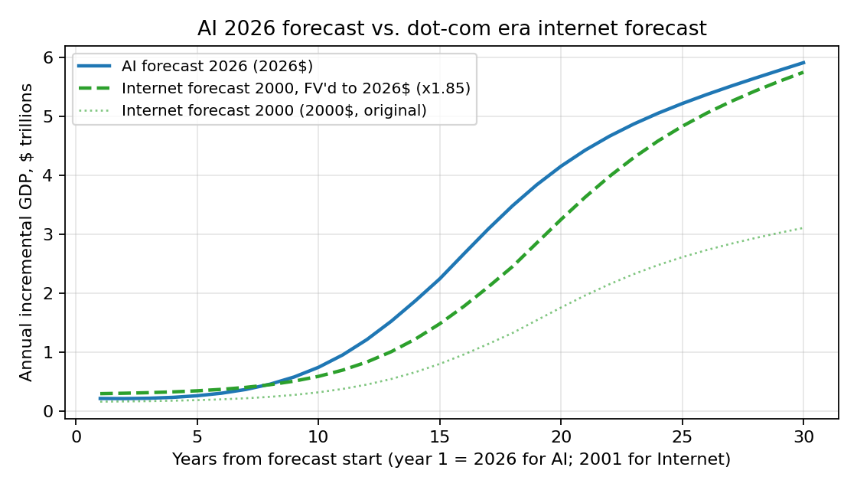

What this comparison does and does not say
It does NOT say AI is a bubble or that current forecasts are wrong. The actual realized internet GDP impact (BEA digital-economy series, 2000-2024) ended up being a meaningful fraction of the optimistic 2000 forecast — perhaps 50-70% of it. The dot-com bust was a valuation event, not a GDP event. So a forecast PV of ~$43T (2026$) for the internet was, ex-post, not crazy — a substantial fraction was actually delivered.
It DOES say: (i) Forecasts of 'total GDP a transformative tech will add' are remarkably similar across cycles when normalized to real units. The forecasted ceiling moves with global GDP, not with the technology. (ii) The base rate for these forecasts being substantially right exists but is lower than the forecasters thought. (iii) If AI's realized impact is 50-70% of the central forecast (matching internet's hit rate), the realized PV is still in the $25-35T range — smaller than the headline but still ~10-20x larger than Trump 2.0 or an Iran war.
Caveats on the internet number: (i) The 2000-era forecast is a synthesized consensus, not any single published number. Different anchors give a range of $25-65T (2026$) for the PV. (ii) The 6% real discount rate is anachronistic-friendly: 1999-2000 nominal long rates were ~6% with low inflation expectations, so a real discount of 4-5% would be more historically faithful and would push the PV higher (to $50-60T in 2026$). At 4% real discounting, the internet PV would actually exceed the AI PV.

Comparison & interpretation
Four observations matter more than any single number:
1. Duration dominates magnitude. AI's PV is ~42x Trump 2.0's not because the annual flow is ~42x larger — at peak it's only ~22x — but because AI compounds over a 30-year explicit horizon plus a perpetual terminal value, while Trump 2.0 decays inside 20 years and the war shock decays inside 10. DCF rewards persistence heavily.
2. Sign is contested only for Trump 2.0. AI's central PV is robustly positive across plausible parameterizations (it stays positive even if you halve the peak and double the discount rate). The Iran-war PV is robustly negative. Trump 2.0 is the only scenario where reasonable analysts disagree on the sign, because the policy bundle nets several large opposing forces.
3. The framing arbitrages probability. AI is treated here as a near-certainty (the technology exists; deployment is the question). The war is conditional on occurrence. If you probability-weight (e.g., 20% chance of war) and risk-weight (apply a higher discount rate to AI for deployment risk), the gap narrows but does not close. AI remains the dominant economic force in every scenario where it is not actively suppressed.
4. AI's forecast is not historically unprecedented. The 2000-era internet forecast, FV'd to 2026 dollars, has a PV of ~$42.91T — only 1.10x smaller than today's AI forecast of $47.10T. At a more historically appropriate 4% real discount rate, the internet forecast PV would actually exceed AI's. Read this two ways: it is reassuring (productivity-tech forecasts have a track record of partial delivery), and cautionary (forecasters systematically over-anchor on global GDP rather than on the technology's actual diffusion curve).
What this analysis is NOT
Not a welfare analysis: GDP omits distribution, leisure, environmental stocks, and existential risk. Not a forecast: assumptions are deliberate central cases anchored to published estimates. Not investment advice. Not probability-weighted for the war scenario. The headline ratios are stable across reasonable assumption changes; the absolute numbers should be read as orders of magnitude (one significant figure).

