**Experiment 3:** One case study on building Data warehouse/Data Mart

**Aim:** Implementation of all dimension table and fact table based on experiment 1 case study

**Theory:**

Case study:

All Libraries may create a data warehouse that keeps the record of the magazines, books issued by them to the library members with respect to dimensions that include time, publisher, book details, author details, member details, etc. These dimensions help keep track of measures around the month or the year and find out values like 'books issued this month' or 'books issued in the last two years' and other details about those measures.

The case study delves into the essence of data mining, underscoring its pivotal role in unearthing concealed patterns, trends, and interconnections within these measures and dimensions

Dimensional Modeling:

Dimensional Data Modeling is one of the data modeling techniques used in data warehouse design. The concept of Dimensional Modeling was developed by Ralph Kimball which is comprised of facts and dimension tables. Since the main goal of this modeling is to improve the data retrieval so it is optimized for SELECT OPERATION. The advantage of using this model is that we can store data in such a way that it is easier to store and retrieve the data once stored in a data warehouse. The dimensional model is the data model used by many OLAP systems.

Elements of Dimensional Data Model

Facts:

Facts are the measurable data elements that represent the business metrics of interest. For example, in a sales data warehouse, the facts might include sales revenue, units sold, and profit margins. Each fact is associated with one or more dimensions, creating a relationship between the fact and the descriptive data.

Dimension:

Dimensions are the descriptive data elements that are used to categorize or classify the data. For example, in a sales data warehouse, the dimensions might include product, customer, time, and location. Each dimension is made up of a set of attributes that describe the dimension. For example, the product dimension might include attributes such as product name, product category, and product price.

Attributes:

Characteristics of dimension in data modeling are known as characteristics. These are used to filter, search facts, etc. For a dimension of location, attributes can be State, Country, Zipcode, etc.

Fact Table:

In a dimensional data model, the fact table is the central table that contains the measures or metrics of interest, surrounded by the dimension tables that describe the attributes of the measures. The dimension tables are related to the fact table through foreign key relationships

Dimension Table:

Dimensions of a fact are mentioned by the dimension table and they are basically joined by a foreign key. Dimension tables are simply de-normalized tables. The dimensions can be having one or more relationships.

Table creation outputs:

create table author(author_id int primary key, author_name varchar(50), author_country varchar(30))

insert into author values(1,'Paulo Coelho','Germany')

insert into author values(2,'Arundhita Roy','India')

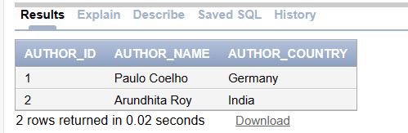

create table book(book_id int primary key, title varchar(100), category varchar(50), author_id int, price varchar(30), release_date date)

ALTER TABLE book

ADD CONSTRAINT fk_authors

FOREIGN KEY (author_id)

REFERENCES author(author_id)

INSERT INTO BOOK (BOOK_ID, TITLE, CATEGORY, AUTHOR_ID, PRICE, RELEASE_DATE)

VALUES (1, 'Eleven', 'fiction', 1, 200, TO_DATE('2020-08-22', 'YYYY-MM-DD'));

INSERT INTO BOOK (BOOK_ID, TITLE, CATEGORY, AUTHOR_ID, PRICE, RELEASE_DATE)

VALUES (2, 'Cosmic Odyssey', 'science fiction', 2, 150, TO_DATE('2021-05-10', 'YYYY-MM-DD'));

INSERT INTO BOOK (BOOK_ID, TITLE, CATEGORY, AUTHOR_ID, PRICE, RELEASE_DATE)

VALUES (3, 'The Enigmatic Puzzle', 'mystery', 1, 180, TO_DATE('2019-11-15', 'YYYY-MM-DD'));

INSERT INTO BOOK (BOOK_ID, TITLE, CATEGORY, AUTHOR_ID, PRICE, RELEASE_DATE)

VALUES (4, 'Love in Bloom', 'romance', 2, 220, TO_DATE('2022-02-14', 'YYYY-MM-DD'));

INSERT INTO BOOK (BOOK_ID, TITLE, CATEGORY, AUTHOR_ID, PRICE, RELEASE_DATE)

VALUES (5, 'Realm of Dreams', 'fantasy', 1, 250, TO_DATE('2023-07-01', 'YYYY-MM-DD'));

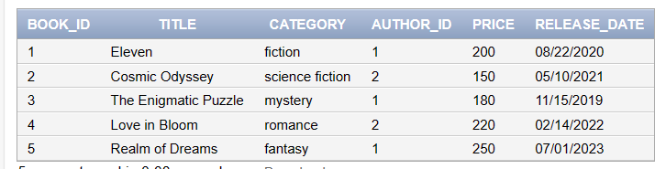

create table location(location_id int primary key, city varchar(30), state varchar(30), country varchar(30), zipcode varchar(10));

INSERT INTO location (location_id, city, state, country, zipcode)

VALUES (1, 'Mumbai', 'Maharashtra', 'India', '400001');

INSERT INTO location (location_id, city, state, country, zipcode)

VALUES (2, 'Delhi', 'Delhi', 'India', '110001');

INSERT INTO location (location_id, city, state, country, zipcode)

VALUES (3, 'Bangalore', 'Karnataka', 'India', '560001');

INSERT INTO location (location_id, city, state, country, zipcode)

VALUES (4, 'Chennai', 'Tamil Nadu', 'India', '600001');

INSERT INTO location (location_id, city, state, country, zipcode)

VALUES (5, 'Kolkata', 'West Bengal', 'India', '700001');

INSERT INTO location (location_id, city, state, country, zipcode)

VALUES (6, 'Hyderabad', 'Telangana', 'India', '500001');

INSERT INTO location (location_id, city, state, country, zipcode)

VALUES (7, 'Pune', 'Maharashtra', 'India', '411001');

INSERT INTO location (location_id, city, state, country, zipcode)

VALUES (8, 'Ahmedabad', 'Gujarat', 'India', '380001');

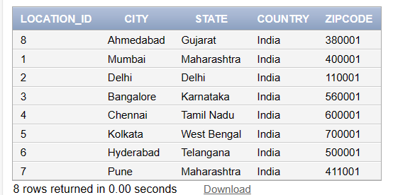

create table publisher(publisher_id int primary key, name varchar(100));

insert into publisher values(1,'Hiten publications')

insert into publisher values(2,'Sawan publications')

insert into publisher values(3,'vrajesh publications')

insert into publisher values(4,'Samarth publications')

insert into publisher values(5,'Raghyav publications')

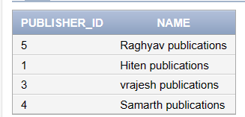

create table time(time_key int primary key, date_ date, day varchar(15), month varchar(20), year varchar(10))

INSERT INTO time (time_key, date_, day, month, year)

VALUES (1, TO_DATE('2023-08-01', 'YYYY-MM-DD'), 'Monday', 'August', '2023');

INSERT INTO time (time_key, date_, day, month, year)

VALUES (2, TO_DATE('2023-08-02', 'YYYY-MM-DD'), 'Tuesday', 'August', '2023');

INSERT INTO time (time_key, date_, day, month, year)

VALUES (3, TO_DATE('2023-08-03', 'YYYY-MM-DD'), 'Wednesday', 'August', '2023');

INSERT INTO time (time_key, date_, day, month, year)

VALUES (4, TO_DATE('2023-08-04', 'YYYY-MM-DD'), 'Thursday', 'August', '2023');

INSERT INTO time (time_key, date_, day, month, year)

VALUES (5, TO_DATE('2023-08-05', 'YYYY-MM-DD'), 'Friday', 'August', '2023');

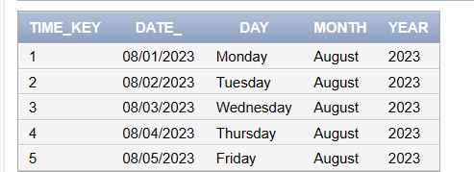create table customer_city(cus_city_id int primary key, cityname varchar(30), zipcode varchar(10), state varchar(30), country varchar(30))

insert into customer_city values(1,'ulhasnagar','421002','Maharashtra','India')

insert into customer_city values(2,'ambernath','421506','Maharashtra','India')

insert into customer_city values(3,'badlapur','421509','Maharashtra','India')

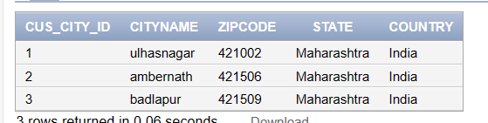

create table customer(customer_id int primary key, name varchar(50), age int, cus_city_id int, phone varchar(20))

ALTER TABLE customer

ADD CONSTRAINT fk_custcity

FOREIGN KEY (cus_city_id)

REFERENCES customer_city(cus_city_id);

insert into customer values(1,'Hiten',19,1,'9898989898')

insert into customer values(2,'Sawan',19,2,'9898989898')

insert into customer values(3,'VRajesh',19,3,'9898989898')

insert into customer values(4,'Raghav',19,3,'9898989898')

insert into customer values(5,'Hiten',19,1,'9898989898')

insert into customer values(6,'Samrht',19,1,'9898989898')

insert into customer values(7,'Akash',19,1,'9898989898')

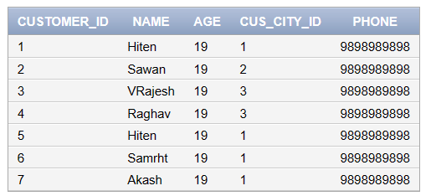

create table issues(issue_id int primary key,book_id int, cust_id int, time_key int, location_id int, publisher_id int, units_issued int)

ALTER TABLE issues

ADD CONSTRAINT fk_book

FOREIGN KEY (book_id)

REFERENCES book(book_id);

ALTER TABLE issues

ADD CONSTRAINT fk_cust

FOREIGN KEY (cust_id)

REFERENCES customer(customer_id);

ALTER TABLE issues

ADD CONSTRAINT fk_tie

FOREIGN KEY (time_key)

REFERENCES time(time_key);

ALTER TABLE issues

ADD CONSTRAINT fk_location

FOREIGN KEY (location_id)

REFERENCES location(location_id);

ALTER TABLE issues

ADD CONSTRAINT fk_publisher

FOREIGN KEY (publisher_id)

REFERENCES publisher(publisher_id);

insert into issues values(1,1,1,1,1,1,100)

insert into issues values(3,3,3,3,3,3,230)

insert into issues values(4,4,4,4,4,4,220)

insert into issues values(5,4,2,4,4,3,220)

insert into issues values(6,4,2,4,4,3,220)

insert into issues values(7,1,2,4,4,3,120)

insert into issues values(8,1,2,3,4,3,120)

