**Experiment 4**

**Aim: Implementation of OLAP operations: Slice, Dice, Rollup, Drilldown and Pivot based on experiment 1**

**Theory:**

Case study:

All Libraries may create a data warehouse that keeps the record of the magazines, books issued by them to the library members with respect to dimensions that include time, publisher, book details, author details, member details, etc. These dimensions help keep track of measures around the month or the year and find out values like 'books issued this month' or 'books issued in the last two years' and other details about those measures.

The case study delves into the essence of data mining, underscoring its pivotal role in unearthing concealed patterns, trends, and interconnections within these measures and dimensions

OLAP:

OLAP stands for On-Line Analytical Processing. OLAP is a classification of software technology which authorizes analysts, managers, and executives to gain insight into information through fast, consistent, interactive access in a wide variety of possible views of data that has been transformed from raw information to reflect the real dimensionality of the enterprise as understood by the clients.

OLAP implement the multidimensional analysis of business information and support the capability for complex estimations, trend analysis, and sophisticated data modeling. It is rapidly enhancing the essential foundation for Intelligent Solutions containing Business Performance Management, Planning, Budgeting, Forecasting, Financial Documenting, Analysis, Simulation-Models, Knowledge Discovery, and Data Warehouses Reporting. OLAP enables end-clients to perform ad hoc analysis of record in multiple dimensions, providing the insight and understanding they require for better decision making.

OLAP Operations:

OLAP operations:

There are five basic analytical operations that can be performed on an OLAP cube:

1. Slice: It selects a single dimension from the OLAP cube which results in a new sub-cube creation. In the cube given in the overview section, Slice is performed on the dimension Time = “Q1”.

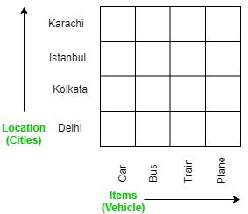

**Fig 4.1 Slice**

2. Dice: It selects a sub-cube from the OLAP cube by selecting two or more dimensions. In the cube given in the overview section, a sub-cube is selected by selecting following dimensions with criteria:

Location = “Delhi” or “Kolkata”

Time = “Q1” or “Q2”

Item = “Car” or “Bus”

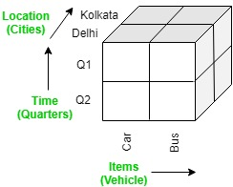

**Fig 4.2 Dice**

3. Roll up: It is just opposite of the drill-down operation. It performs aggregation on the OLAP cube. It can be done by:

Climbing up in the concept hierarchy

Reducing the dimensions

In the cube given in the overview section, the roll-up operation is performed by climbing up in the concept hierarchy of Location dimension (City -> Country).

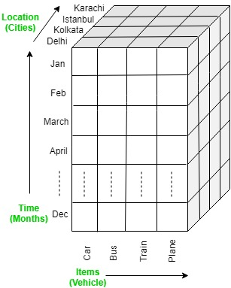

**Fig 4.3 Roll up**

4. Drill down: In drill-down operation, the less detailed data is converted into highly detailed data. It can be done by:

Moving down in the concept hierarchy

Adding a new dimension

In the cube given in overview section, the drill down operation is performed by moving down in the concept hierarchy of Time dimension (Quarter -> Month).



**Fig 4.4 Drill-Down**

5. Pivot: It is also known as rotation operation as it rotates the current view to get a new view of the representation. In the sub-cube obtained after the slice operation, performing pivot operation gives a new view of it.

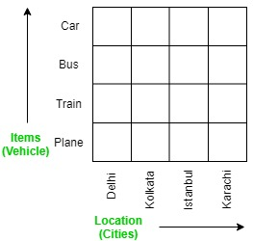

**Fig 4.5 Pivot**

**Output:**

Materialized View:

CREATE MATERIALIZED VIEW mv_issues_summary

REFRESH FAST

AS

SELECT location_id, time_key, SUM(units_issued) AS total_units_issued FROM issues

GROUP BY location_id, time_key;

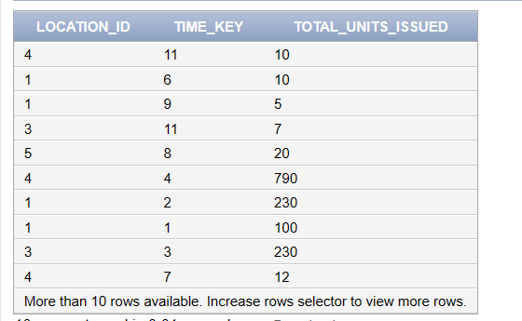

Slice:

SELCT i.location_id,l.city,sum(i.units_issued) FROM issues i INNER JOIN location l on i.location_id = l.location_id GROUP BY i.location_id,l.city ORDER BY i.location_id

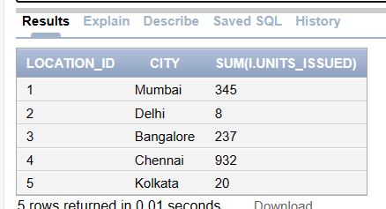

Dice:

SELECT location_id, time_key, SUM(units_issued) AS total_units_issued

FROM issues

WHERE location_id = 1 AND time_key<=10 GROUP BY location_id, time_key;

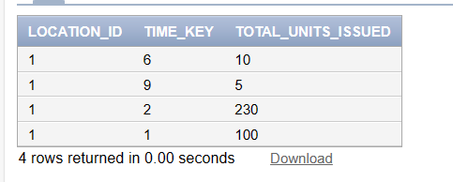

Rollup:

SELECT year, SUM(units_issued) AS total_units_issued FROM issues JOIN time ON issues.time_key = time.time_key GROUP BY year;

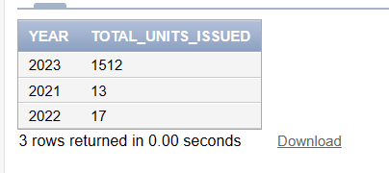

Drilldown:

SELECT date_, SUM(units_issued) AS total_units_issued FROM issues JOIN time ON issues.time_key = time.time_key GROUP BY date_;

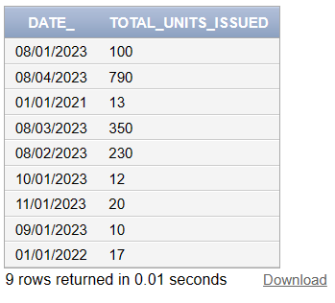

Pivot:

SELECT location_id,

SUM(CASE WHEN time_key = 1 THEN units_issued ELSE 0 END) AS day1_units,

SUM(CASE WHEN time_key = 2 THEN units_issued ELSE 0 END) AS day2_units,

SUM(CASE WHEN time_key = 3 THEN units_issued ELSE 0 END) AS day3_units,

SUM(CASE WHEN time_key = 4 THEN units_issued ELSE 0 END) AS day4_units,

SUM(CASE WHEN time_key = 5 THEN units_issued ELSE 0 END) AS day5_units

FROM issues

GROUP BY location_id;

