TITLE TBA (Epic Kangaroo Quest (of doom (of darkness))of epicness)
TKITE-1 Projekt Simon Almgren, Henrik Alburg, Arvid Karlsson, Sean Pavlov

1 Introduction

1.1 Purpose of application
The goal is to create a fun and challenging computer game for a little more advance gamers. The application is also supposed to be for everyone else but the focus is still to make it challenging for the advanced gamers.

1.2 General characteristics of application

The application will be a desktop, standalone (non-networked), single-player application
with a graphical user interface for the Windows/Mac/Linux platforms.

The game is a side scrolled 2D platform game that is level-based. The high-score will be saved when the player finish the game or more likely dies. If the game is canceled the player will have to start over from the beginning. There will be no possibility to save the game, so it has to be finished during one play through.

1.3 Scope of application
The application does include computer-based enemies. You can only play the game
alone. The application does not save interrupted games or collect any statistics (high score or other). See Possible future direction

1.4 Objectives and success criteria of the project
To create a fully functional game with at least one playable level that the player can play through. The level should be a tutorial level that introduce the player to every function in the game.
1.5 Definitions, acronyms and abbreviations

GUI, graphical user interface.
Java, platform independent programming language.
JRE, the Java Run time Environment. Additional software needed to run an Java
application.
Level, one map that the player has to accomplish to get to the next level

2 Requirements
2.1 Functional requirements
1. Check highscore
2. Change inputkeys.
3. Start a new game.
1.Walk left or right.
2. Jump.
3. Use items
4. Exit.

2.2 Non-functional requirements
2.2.1 Usability
It is supposed to be easy to move and learn to move freely as well as jumping. We are going to test the game out on 3 people with different computer habits.
2.2.2 Reliability
While playing the game should run smoothly and dont crash.
2.2.3 Performance
There should be an “instantfeeling” when controlling the kangaroo without overheating the comupter.
2.2.4 Supportability
Everything in the game should be tested manually and we aim on having 10-20 hours played in-game.
2.2.5 Implementation
The users of this application have got to have JRE installed to be able to run the game.
2.2.6 Packaging and installation
Our game should not have to be installed on the computer using it. It should be ran by a java file.
2.2.7 Legal
There should not be any legal issues except from maybe our fonts.
2.3 Application models
2.3.1 Use case model
See APPENDIX for UML diagram and textual descriptions.

2.3.2 Use cases priority
  - HIGH
    - Start Game
    - Move
    - Collision
  - MEDIUM
    - Options
  - LOW
    - Pause
    - Item

2.3.3 Domain model
See APPENDIX

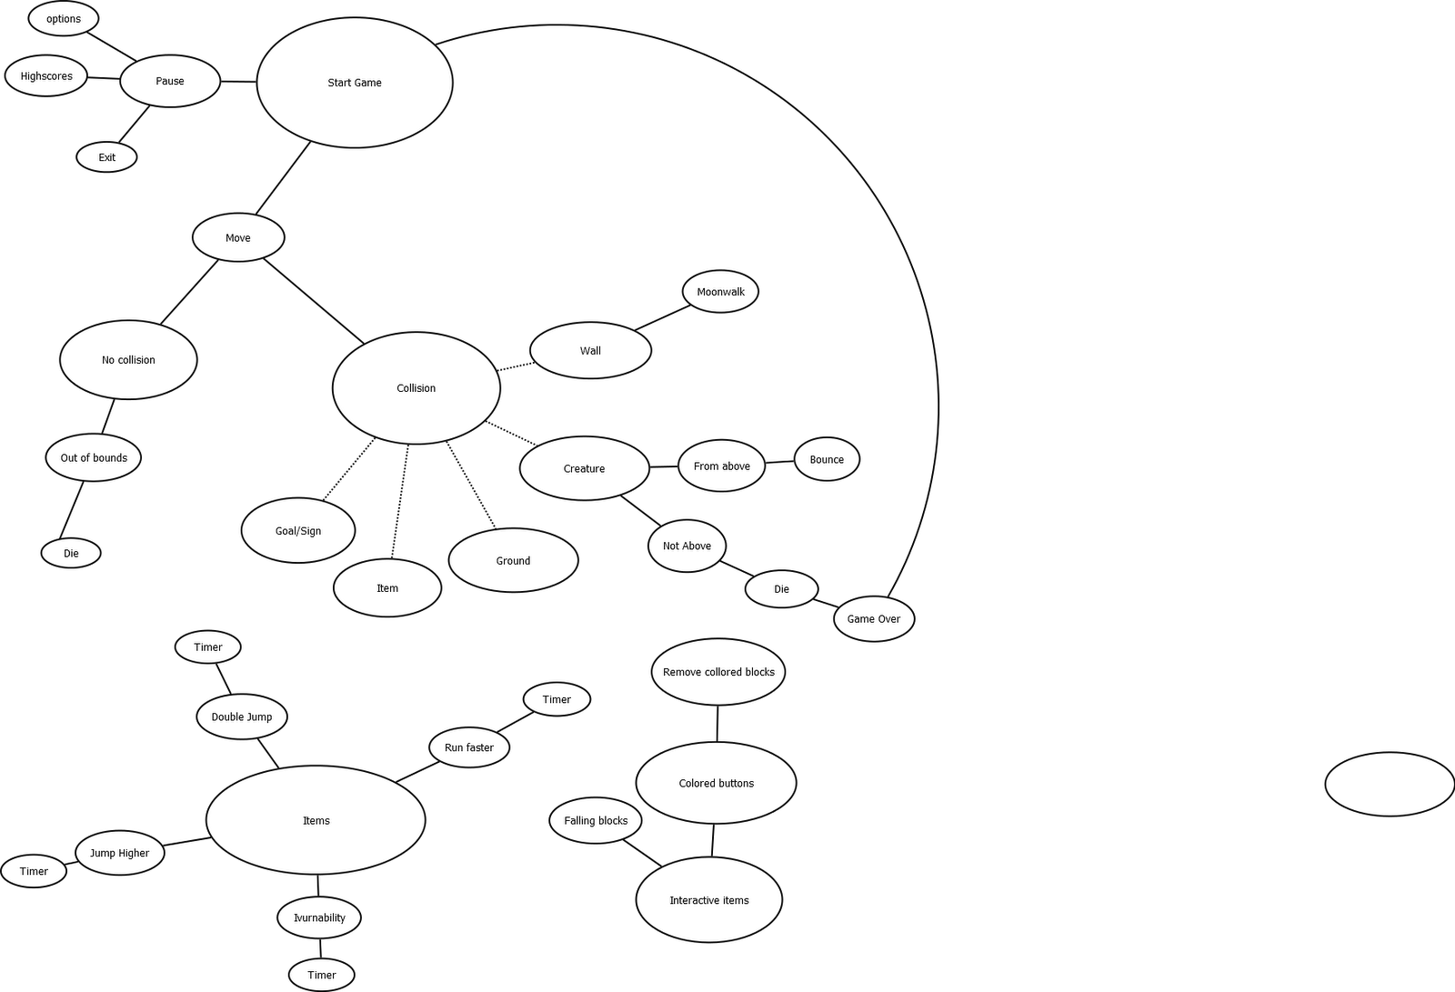

2.3.4 User interface
Application will use a fixed GUI following standard conventions. The size will be locked to 1024x576, which should work on most computers. We shall have a counter that counts the amount of time that the player have died. There shall also be an icon that shows if the player has an item or not. If it’s shown, the icon shall also tell the player what kind of item he/she is carrying. See APPENDIX for screens and navigational path's.

