System design document for Kangaroo Project
Table of Contents
Version: 0.1
Date: 16-4-12
Author: Henrik Alburg, Simon Almgren
This version overrides all previous versions.
1 Introduction
1.1 Design goals
1.2 Definitions, acronyms and abbreviations
•GUI, graphical user interface.
• Java, platform independent programming language.
• JRE, the Java Run time Environment. Additional software needed to run an Java
application.
•MVC, a way to partition an application with a GUI into distinct parts avoiding a
mixture of GUI-code, application code and data spread all over.

2 System design
2.1 Overview
The application will use the MVC model. The controller will take input and modify the model and the view will read the model and render.

2.1.1 Rules
N/A
2.1.2 The model functionlity
In this section we explain the overall design choices.
2.2 Software decomposition
2.2.1 General
The application is decomposed into the following modules, see Figure X.
- view, is the top level package for all GUI related classes including the main window
- main, is the application entry class
- controller, taking input and changing the model
- model, the OO-model
- io, file handling
- util, tools and general utilities
- constants, application global constants

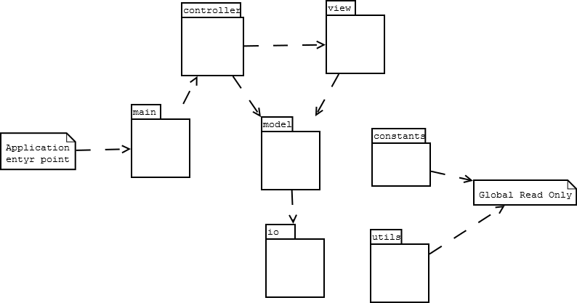
Package diagram. For each package an UML class diagram in
appendix

2.2.2 Layering
Higher layers are at the top of the figure, lower layers at the bottom. The layering is shown in the figure above.
2.2.3 Dependency analysis
As shown in figure. There are no circular dependencies.
2.3 Concurrency issues
2.4 Persistent data management
2.5 Access control and security
2.6 Boundary conditions
3 References
APPENDIX

